Versions:

Date | Versiune | Autor | Comentarii

Analisys&Design for Banking System

Content:
- General Presentation

- Theoretical Fundamentals

- IT Technology (which will be implemented)

- Functionalities

- Actors and related access rights

- Use Case Diagrams

- System Architecture

- Design (UML Diagrams)

- Operation Mode (Operation Guide, including screen-shots)

- Portability

- Competing software

- Testing and validation

1. General Presentation

Online banking (also known as M-Banking, mobile banking) is a
term used for performing balance checks, account transactions, payments
etc. via a online website. Online banking today is most often performed on
the Online Internet but can also use special programs downloaded to the
online device.
Online banking (also known as M-Banking, mobile banking) is a
term used for performing balance checks, account transactions, payments
etc. via a online website. Online banking today is most often performed on
the Online Internet but can also use special programs downloaded to the
online device.
Online banking is a term used for performing balance checks, account transactions, payments etc. via an online website. Online banking today is most often performed on the Internet but can also use special programs downloaded to an online device.
The Banking System is an application for maintaining a person's account in a bank. this project shows the working of a banking account system and cover the basic functionality of an online banking application. The purpose was to develop a project for solving financial applications of a customer in banking environment in order to nurture the needs of an end banking user by providing various ways to perform banking tasks. It also allows to enable the user’s work space, to have additional functionalities which are not provided under a conventional banking project. The Banking System undertaken as a project is based on relevant technologies. The main aim of this project is to develop software relevant for an online banking application.

- Theoretical Fundamentals

Web 2.0 is the name used to the describe the second generation of the world wide web, where it moved static HTML pages to a more interactive and dynamic web experience. Web 2.0 is focused on the ability for people to collaborate and share information online via social media, blogging and Web-based communities.
Web 2.0 signaled a change in which the world wide web became an interactive experience between users and Web publishers, rather than the one-way conversation that had previously existed. It also represents a more populist version of the Web, where new tools made it possible for nearly anyone to contribute, regardless of their technical knowledge.
The meaning of the term Web 2.0 has evolved over time, but it has come include social media as a major component. Although community has always been a part of the web, new web applications such as AJAX and more modern browsers began providing opportunities for people to express themselves online as never before, and to combine applications to create a more integrated web. By 2005, the term Web 2.0 was well-established, and companies such as Google made huge strides to integrate information online. For example, a website that reviews restaurants may use social media, user-generated content, photographs from Flickr, Google maps, and content from around the web to create a more complete user experience.
The web uses applications, sometimes called applets, to make the experience of using the internet that much more enjoyable. Take Twitter, for example. On the surface, the concept is simple: you use the interface to send a message via a tweet to your followers, but an Application Programming Interface (API) allows you to go even deeper and use apps that have been created by third party developers, such as Twitterific, which allows users to tweet directly from their desktops rather than using the internet site.

- IT Technology

This project will be implemented using Java language as it encapsulates concepts that will be needed in the Banking System application development.
To be an Object Oriented language, any language must follow at least the four characteristics.
- Inheritance: It is the process of creating the new classes and using the behavior of the existing classes by extending them just to reuse the existing code and adding the additional features as needed.
- Encapsulation: It is the mechanism of combining the information and providing the abstraction.
- Polymorphism: As the name suggest one name multiple form, Polymorphism is the way of providing the different functionality by the functions having the same name based on the signatures of the methods.
- Dynamic binding: Sometimes we don't have the knowledge of objects about their specific types while writing our code. It is the way of providing the maximum functionality to a program about the specific type at runtime.
As the languages like Objective C, C++ fulfills the above four characteristics yet they are not fully object oriented languages because they are structured as well as object oriented languages. But in case of java, it is a fully Object Oriented language because object is at the outer most level of data structure in java.
Java uses native code usage, and lightweight process called threads. In the beginning interpretation of byte code resulted the performance slow but the advance version of JVM uses the adaptive and just in time compilation technique that improves the performance. Multithreading programming is a very interesting concept in Java. In multithreaded programs not even a single thread disturbs the execution of other thread. Threads are obtained from the pool of available ready to run threads and they run on the system CPUs.

The used IDE will be Eclipse.
The database used will be created using MySQL Server (back-end part).
The building of the user interface(front-end) is created with Java Server Pages (JSP), which communicate with the server using Java Servlets.

- Functionalities

Administration Operations

The Internet Banking administration operations are the operations available to a bank agent to maintain customers, fees and delegate groups. The administration operations include: maintain customer details, maintain transaction fees. The maintain transaction operations provide the bank agent with the facility to apply and maintain details of transactions based on transaction type, account type and customer type. The maintain customer details operations provides the bank agent with the facility to view, add and amend personal details that are held for a customer by the bank.

Customer Self-Service Operations

The customer self-service operations are the Internet Banking operations which are available to a customer over the web. The Internet Banking self-service operations include online registration, account enquiry, funds transfer operations, service operations such as view transaction history.

Online Registration
Provides the bank customer with the facility to register online for Internet Banking. The customer is identified and then inputs preferences as to the configuration of their online banking profile. The customer sets up login and password details. The system records the new online registration.

Login
A user logs on to the system by providing a userId and password. The system verifies the password and checks the user’s profile before allowing the user access to the system. Once access has been provided, the application can request what privileges are authorized when necessary. Once a user is logged in they have access to all the privileges assigned to their roles.

View Balance
For each account that the customer has online access to the system retrieves and displays the following: Account Number, Account Nickname, Account Type, Account Balance and Available Funds.

Account History
Provides the customer with the facility to enquire on an account in relation to its movements. Movements on the account may be financial transactions such as deposits, withdrawals, direct debits, standing orders, payments, cheques drawn or charges.

Transfers
Provides the functionality to process the following types of transfers from an account held by a customer:
- Inter account transfer: a funds transfer between two accounts held by the same customer within the bank
- Internal funds transfer: a funds transfer between two accounts held by different customers within the bank

- Actors and related access rights

- Administrator
This actor is the person administrating the banking system. The administrator is the one responsible for maintenance of the application. He is the one who can add/delete a customer and view all transactions based on customer demand.

- Customer
This actor is the person who benefits from the banking system. The customer is the one the application is intended to be used by. Thus, the user can register and log in, enquire the balance of his account, transfer funds to other accounts, ask for transaction history.

- Use Case Diagrams

- Use case for administrator
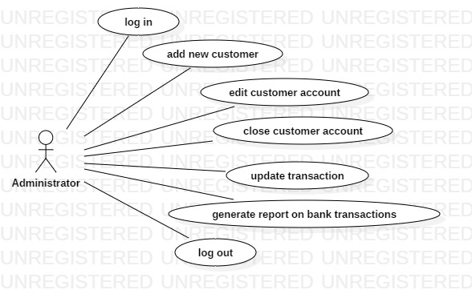
Description:
Actor: administrator
Precondition: the administrator has an account
Postcondition: the data added by the administrator will be correct
Behavior: The administrator is in charge with the maintenance of the system. In the server-side of the application the administrator will enter data about the application, customers, transactions. The new data will be validated and if everything is correct, it will be added to the database.

- Use case for customer
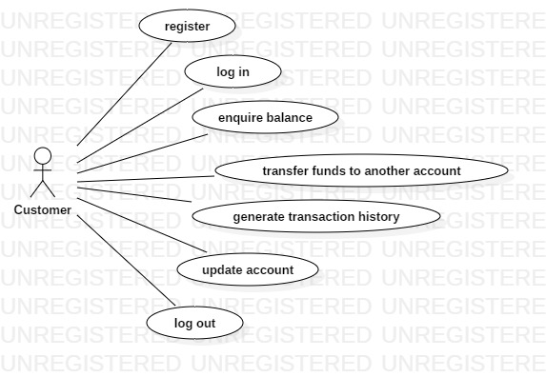

Description:
Actor: Customer
Precondition: -
Postcondition: the data manipulated by the customer will be correct
Behavior: For the scenarios where the customer registers, transfer funds or updates his account the data will have server validation. If the information is correct, it will be added to the database. For the other scenarios there will be no need of validation.

- System Architecture

The de sign of this app follows a layered design architecture. The 4 packages are:
model, presentation(view), dataAccessLayer and controller. Therefore, the
model package is represented by the classes Customer and Administrator. These
classes are the ones which contain as attributes all the fields that can be found in
the corresponding tables from the database. The dataAccessLayer is the package
that contains the classes that handle the connectivity between the database and the
model classes. It contains the ConnectionFactory class, the AbstractDAO,
CustomerDAO and AdminDAO classes. The presentation package, represented by the classes View and Controller, follows the typical MVC pattern. Thus, The View class is responsible for the graphic user interface design. The Controller acts on both model and view, and in addition it also uses the dataAccessLayer classes. It also controls the data flow between what the database already has and what the user updates or introduces.

Design patterns

I decided to use the Factory design pattern which is applied to the classes from the dataAccessLayer, which assure the connectivity with the data base.
Factory method is a creational design pattern, i.e., related to object creation. In Factory pattern, we create object without exposing the creation logic to client and the client use the same common interface to create new type of object.
The idea is to use a static member-function (static factory method) which creates & returns instances, hiding the details of class modules from user.
A factory pattern is one of the core design principles to create an object, allowing clients to create objects of a library in a way such that it doesn’t have tight coupling with the class hierarchy of the library.
Thus, we can observe the design in the following diagram relative to my project:

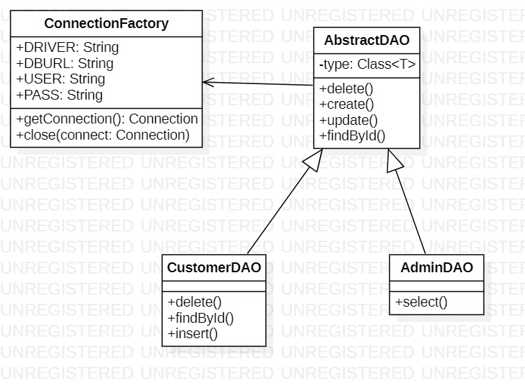

- Design

- Database diagram

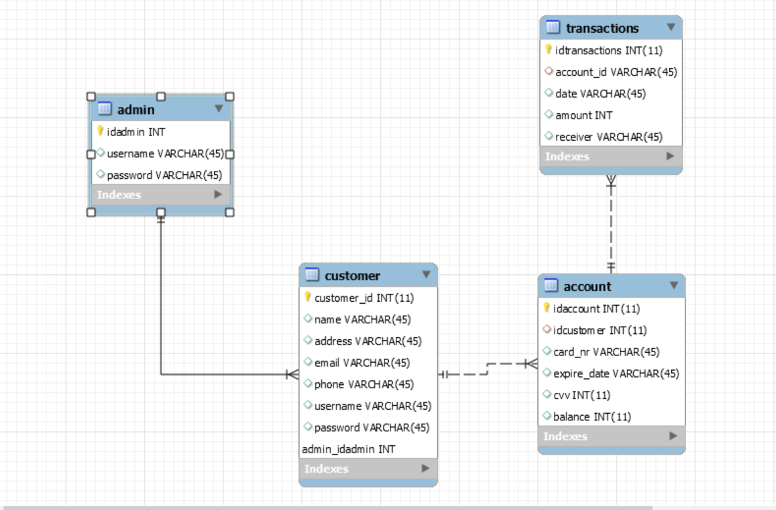

- Activity diagram

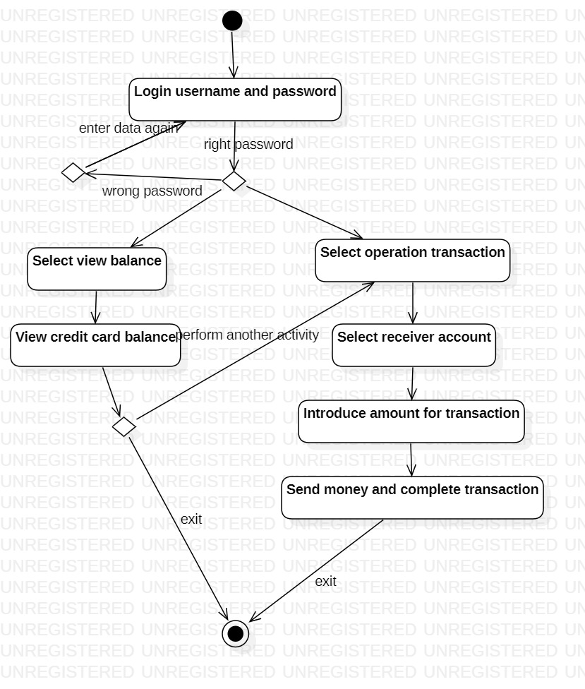

- Class diagram

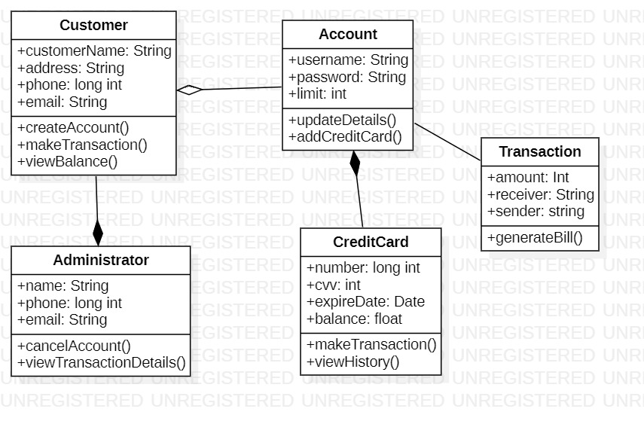

- Package diagram

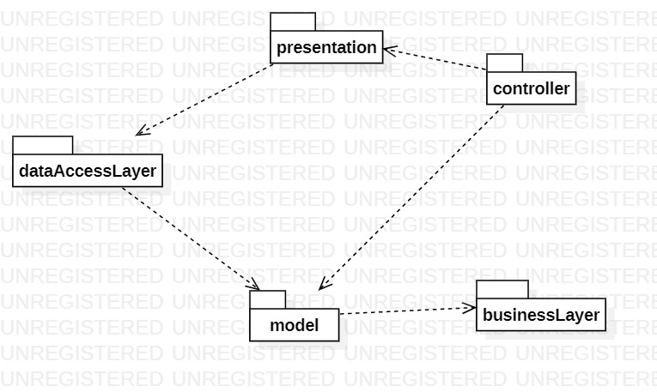

- Object diagram

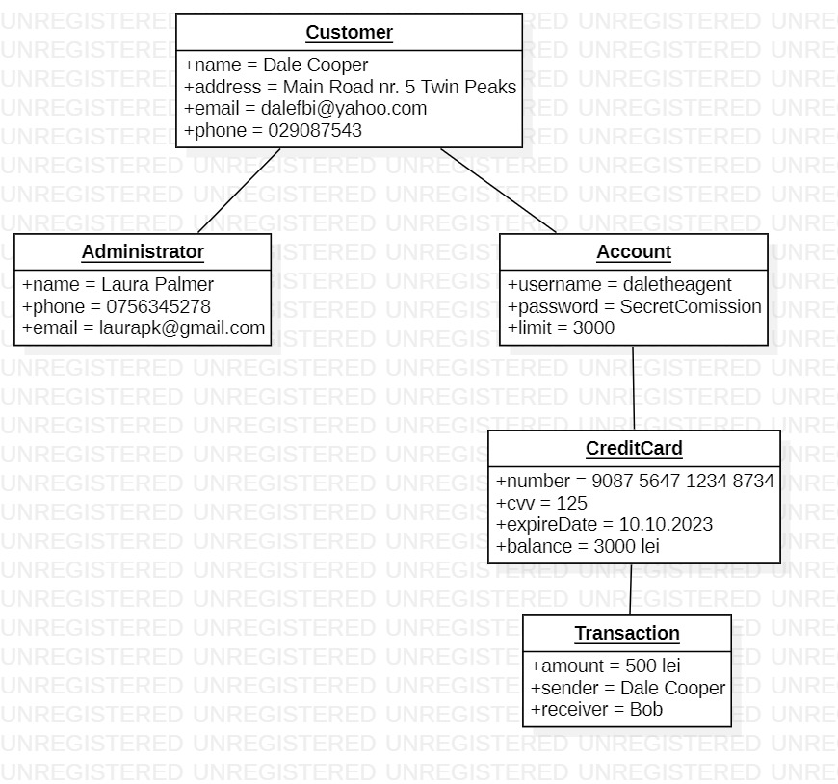

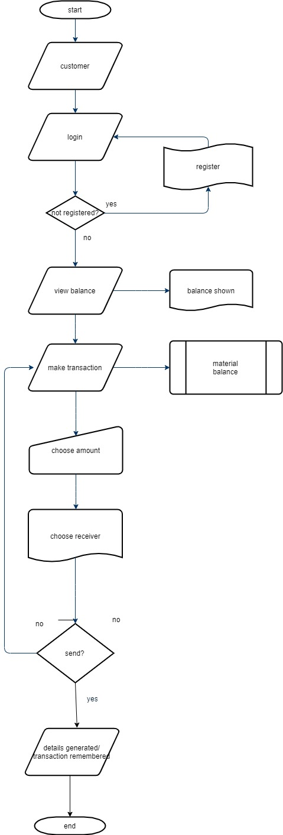

- Flow diagram

- Sequence diagram

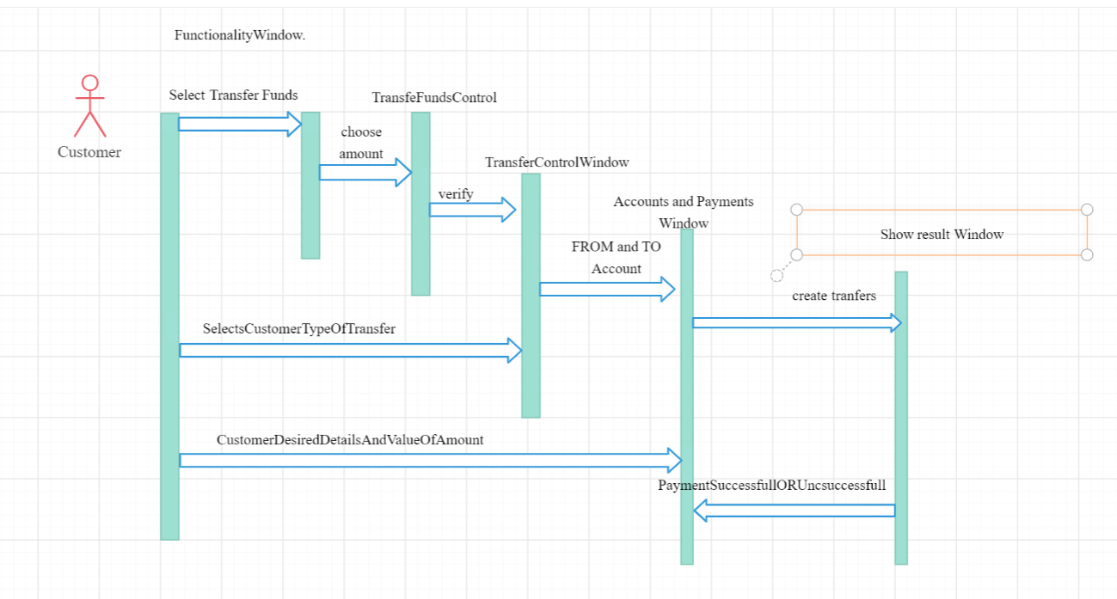

- Operation Mode

Each actor that enters the website can login to his account. In case he does not have one, he can register and input his information. Once registered and logged in, the customer can perform the operations described above, in the Functionality section.

- Portability

The project is used for internet applications, so it does not need to be portable. In case the administrator needs to move the online site on another server domain, he will need to port the database and the application on a server with the same programs (SQL Server and Eclipse).

- Competing software

Internet Banking is all about knowing our customer need and provide them with the right service at the right time through right channel 24/7 day a week.
Being “electronic”, it not only provides its customers with faster and better facilities, it even reduces the manual overhead of accounts maintenance. During recent years, many banks turned to this solution for their customers and now provide reliable online banking. Such an example is set by Banca Transilvania, who has an app called BTpay, which can perform all the operations presented here.

- Testing and validation

Test cases considered:

- Testing the functionality of customer operations:
  - Whether the user can see the transactions history
  - Whether the user can enquire his account balance
  - Whether the user can transfer money to other accounts
  - Whether the user can navigate through the home page and choose what he wants to do next

- Testing the functionality of the register page
  - Whether the user can fill in the data
  - Whether when submitting the data the validators prevent entering wrong data
  - If the user submits valid data, whether it is registered
- This can be verified by the admin.

- Testing the functionality of the login page
  - If the user fills in the password that corresponds to the password in the database tied to that user account
  - If the user fills in the username that corresponds to the username in the database tied to that user account
  - He can login into his account

- Testing the functionality of the admin page
  - Whether the admin can see all the transactions that took place over the webpage
  - Whether the admin can register a new customer to the application based on request
  - Whether the admin can delete a customer from the database in case he didn’t respect the policy or based on demand

