Version overview

Date | Version | Author | Comment
 | ….. | …….. | …….

System requirements for Banking System

1 Introduction 2
2 General view of actors and use cases 2
3 Detailed description of actors and use cases 2
3.1 Actors 2
3.1.1 Administrator 2
3.1.2 Customer 3
Type: ……….. 3
3.1.3 Provider 3
3.2 Use cases 3
3.2.1 Use Case Diagram for Actor1 3
3.2.2 Use Case Diagram for Actor2 3
3.2.3 Use Case Diagram for Actor3 4
3.2.4 Use Case Diagram for Actor_{n} 4
4 Glossary – used terms 5

Introduction

The project presented in this document is a banking management system. The application enables customers to perform simple banking transactions. This application provides employees with the possibility to perform banking transactions, manage customer accounts in an efficient manner. The primary aim of this application is to provide an improved and secured bank transaction system, which envisages the future expansion, and modification, which is necessary for a core sector like banking.

General view of actors and use cases
The actors are mainly the administrator and the customer.

Actor | Type | Description
Administrator | Human | The person administrating the banking system, which is able to manage customer accounts.
Customer | Human | Performs general operations over the system, such as transactions, depositing money, balance enquiry.

Detailed description of actors and use cases

Actors

Administrator

Type: human
Detailed description:
This actor is the person administrating the banking system. The administrator is the one responsible for maintenance of the application. He is the one who can add/update/edit a customer and edit or update a transaction based on customer demand. The administrator can also generate a report.

Where is used:
This actor is used in the: “Administrator page” use case
. “Administrator Log-in “use case.
“Administrator Log-out” use case.
“Deleting a Customer in the Database” use case
“Editing Customer Info in the Database” use case
“Entering a New Customer into the Database” use case
“Editing a Transaction in the Database” use case

Customer

Type: human
Detailed description:
This actor is the person who benefits from the banking system. The customer is the one the application is intended to be used by. Thus, the user can register and log in, enquire the balance of his account, transfer funds to other accounts, see transaction information/report, ask for transaction history.
Where is used:
This actor is used in the: “Customer Register” page
“Customer Log-in “use case.
“Customer Log-out” use case.
“Enquire balance” use case
“Transfer money to an account” use case
“Generate transaction history/report” use case

Use cases

Use Case Diagram for Administrator
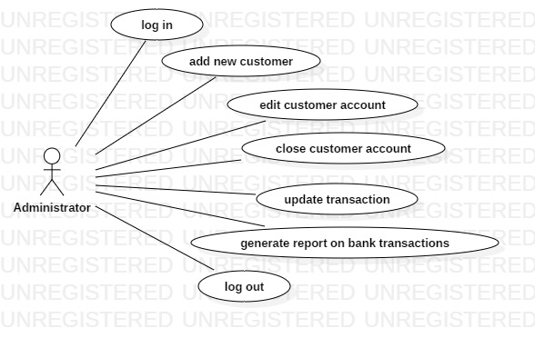

Description:
Actor: administrator
Precondition: the administrator has an account
Postcondition: the data added by the administrator will be correct
Behavior: The administrator is in charge with the maintenance of the system. In the server-side of the application the administrator will enter data about the application, customers, transactions. The new data will be validated and if everything is correct, it will be added to the database.

Use Case Diagram for Customer

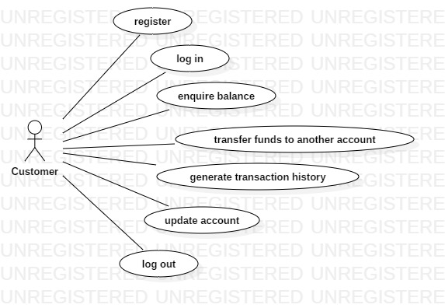

Description:
Actor: Customer
Precondition: -
Postcondition: the data manipulated by the customer will be correct
Behavior: For the scenarios where the customer registers, transfer funds or updates his account the data will have server validation. If the information is correct, it will be added to the database. For the other scenarios there will be no need of validation.

Glossary – used terms

Term | Use cases | Description
Administrator account  authentication | Administrator Log-in use case | Contains all the information needed by the administrator that wants to authenticate itself in the system using a user password schema
Customer account authentication | Customer Log-in use case | Contains all the information needed by a user that wants to authenticate itself in the system.
Maintenance file | Administrator page case | Contains all the information used by the system.
Transfer funds | Customer option to manipulate his funds use case | Allows the user to transfer funds to another account of the bank.
Transaction history | User / Administratoruse case | It is used for viewing the transactions made by an account of the bank.

Term Groups | Included terms and term groups | Description
Authentication | Administrator password authentication, Customer password authentication | Defines a general group of credentials used in the authentication process

