**Question 1**  
1. Levels of abstraction in computer systems. Principle of equivalence and its practical consequences. Relevant units of measurements and **powers of magnitude**.

**Levels of abstraction in computer systems are electronic circuits, digital design, computer architecture, machine language, compiler, operating systems, application program.**

**The principle of equivalence of hardware and software states that anything that can be done with software can also be done with hardware and vice versa but that doesn’t mean that the same task will take the same time or the same amount of resources. Some units of data are bit, nibble, Byte, kilobyte, megabyte, gigabyte, terabyte, petabyte,**

2. Representation of numerical Information on a computer. Signed and unsigned numbers, precision. Floating point errors.

**Binary digits can represent unsigned integers from 0 to 2N-1. Popular choices: 8, 16, 32, 64 bits. Signed Magnitude Representation is a method for encoding integer, where the highest bit is used for sign and the rest for magnitude. 1 denotes a negative sign (‘-’) and 0 a positive sign (‘+’). Signed numbers use sign flag or can be distinguish between negative values and positive values. Whereas unsigned numbers stored only positive numbers but not negative numbers. The floating-point format needs slightly more storage (to encode the position of the radix point), so when stored in the same space, floating-point numbers achieve their greater range at the expense of precision. Double Precision FP IEEE 754 has 64 bits overall length, The exponent takes 11 bits, so a bias is 1023 instead of 127, Around 15 significant decimal digits. Errors in the FP case arise from the mantissa bit number insufficiency. It is true for large numbers, as those are further amplified by the exponent power. For small values, this is not a problem, for example, 210 can be represented precisely. Due to rounding in the mantissa fields there might be cases where the FP figures will not be identical.**

3. Numbering systems, information units. Decimal, binary, ternary and hexadecimal numbering systems, their usage. Conversion.

**Most recently used counting system bases: 10, 2, 8, 16. Octal numbers use only the digits 0-7, while hexadecimal numbers use all ten base-10 digits (0-9) and the letters a-f (representing the numbers 10-15). Both Octal and Hexadecimal systems are used for the convenience of Programmers to concisely represent large strings of binary digits. First step to convert decimal to another numbering system is − Divide the decimal number to be converted by the value of the new base. Step 2 − Get the remainder from Step 1 as the rightmost digit (least significant digit) of new base number. Step 3 − Divide the quotient of the previous divide by the new base. Here are the steps to convert hex to decimal: Get the decimal equivalent of hex from table. Multiply every digit with 16 power of digit location. (zero based, 7DE: E location is 0, D location is 1 and the 7 location is 2) Sum all the multipliers.**

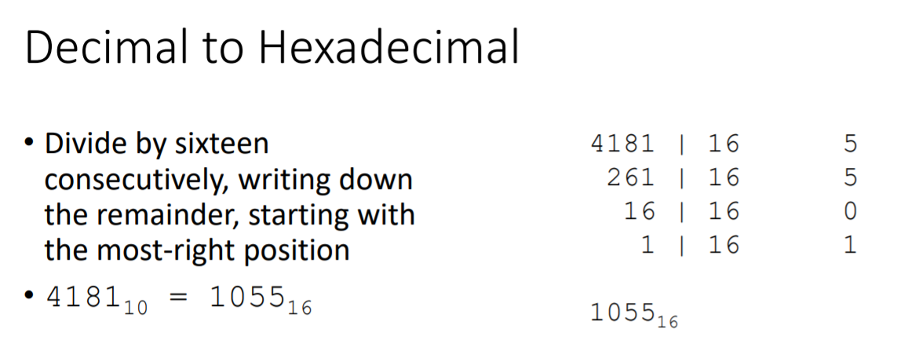

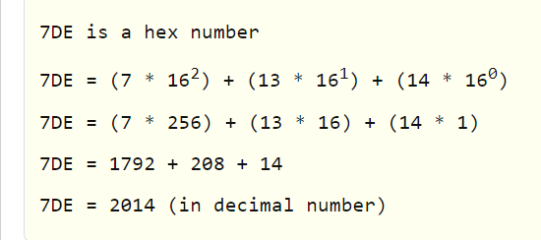

4. Representation of symbolic information in the computer. Symbolic encodings. Popular encodings, their advantages and disadvantages.

**Unicode is a universal character set, it’s a standard that in one place defines all the characters needed for writing the majority of living languages in use on computers. in Unicode there are a number of ways of encoding the same character. The encoding forms that can be used with Unicode are called UTF-8, UTF-16, and UTF-32. For example, the letter á can be represented by two bytes in one encoding and four bytes in another. UTF-8 uses 1 byte to represent characters in the ASCII set, two bytes for characters in several more alphabetic blocks, and three bytes for the rest of the BMP. Supplementary characters use 4 bytes. UTF-16 uses 2 bytes for any character in the BMP, and 4 bytes for supplementary characters. UTF-32 uses 4 bytes for all characters. Each format has its own set of advantages and disadvantages with respect to storage efficiency (and thus also of transmission time) and processing efficiency. UTF-8 is very efficient at encoding plain English text (same as ASCII). If your user base is likely to be mostly, say, Chinese, you will be much better off using UTF-16.**

5. Implementation of logical and mathematical functions in hardware, logic elements. Registers, memory cells, logical circuits, adders, etc.

**Logic elements are the small electronic subsystems that perform the logic decisions of NOT, AND, OR, and so on, which are incorporated inside any piece of digital electronic equipment. A logic gate is a device that acts as a building block for digital circuits. They perform basic logical functions that are fundamental to digital circuits. In a circuit, logic gates will make decisions based on a combination of digital signals coming from its inputs. Most logic gates have two inputs and one output. A number system is a format to represent numbers in a certain way. The binary number system is used in computers and electronic systems to represent data and it consists of only two digits which are 0 and 1. The decimal number system is the most commonly used number system around the world which is easily understandable to people. Registers are a type of computer memory used to quickly accept, store, and transfer data and instructions that are being used immediately by the CPU. The memory cell is the fundamental building block of computer memory. The memory cell is an electronic circuit that stores one bit of binary information and it must be set to store a logic 1 (high voltage level) and reset to store a logic 0 (low voltage level). Logic circuits include such devices as multiplexers, registers, arithmetic logic units (ALUs), and computer memory, all the way up through complete microprocessors, which may contain more than 100 million gates. An adder is a digital circuit that performs addition of numbers. In many computers and other kinds of processors adders are used in the arithmetic logic units or ALU.**

6. Physics basics of the computer - logic gates and their implementation. Semiconductors, transistors. CMOS circuits, their properties.

**Logic gates implementation or logic representation of Boolean functions is very simple and easy form. The implementation of Boolean functions by using logic gates involves connecting output of one logic gate to the input of another gate. Commonly used Logic Gates are: AND, OR, NAND and NOR gates. Semiconductors are materials which have a conductivity between conductors (generally metals) and nonconductors or insulators (such as most ceramics). Semiconductors can be pure elements, such as silicon or germanium, or compounds such as gallium arsenide or cadmium selenide. A transistor is a semiconductor device used to amplify or switch electrical signals and power. Because the controlled (output) power can be higher than the controlling (input) power, a transistor can amplify a signal. Some transistors are packaged individually, but many more are found embedded in integrated circuits. CMOS circuits use a combination of p-type and n-type metal–oxide–semiconductor field-effect transistor (MOSFETs) to implement logic gates and other digital circuits. CMOS always uses all enhancement-mode MOSFETs (in other words, a zero gate-to-source voltage turns the transistor off).**

7. Computer specifications, computer construction overview. Typical characteristics of a modern computer.

**In computer engineering, computer architecture is a set of rules and methods that describe the functionality, organization, and implementation of computer systems. The architecture of a system refers to its structure in terms of separately specified components of that system and their interrelationships. Computer hardware specifications are technical descriptions of the computer's components and capabilities. Processor speed, model and manufacturer. Processor speed is typically indicated in gigahertz (GHz). The higher the number, the faster the computer. Random Access Memory (RAM), This is typically indicated in gigabytes (GB). The more RAM in a computer the more it can do simultaneously. Hard disk (sometimes called ROM) space. This is typically indicated in gigabytes (GB) and refers generally to the amount of information (like documents, music and other data) your computer can hold. Other specifications might include network (ethernet or wi-fi) adapters or audio and video capabilities. characteristics of a modern computer are speed, accuracy, storage, automatic functioning, versatility, cost-effectiveness, diligence, no-intelligence, user-friendly, entertainment.**

8. System on a chip. Architecture overview, principles, applications. Typical smartphone, its components.

**SoCs can be applied to any computing task. However, they are typically used in mobile computing such as tablets, smartphones, smartwatches and netbooks as well as embedded systems and in applications where previously microcontrollers would be used. Where previously only microcontrollers could be used, SoCs are rising to prominence in the embedded systems market. Tighter system integration offers better reliability and mean time between failure, and SoCs offer more advanced functionality and computing power than microcontrollers. Mobile computing based SoCs always bundle processors, memories, on-chip caches, wireless networking capabilities and often digital camera hardware and firmware. SoCs are being applied to mainstream personal computers as of 2018.[8] They are particularly applied to laptops and tablet PCs. Typical smartphone has display, battery, system-on-a-chip, storage, camera, modems, sensors, speakers and operating system.**

9. Processors, their construction,  characteristics, role in the computer, principles of operation. Difference between synchronous and asynchronous systems.

**The main part of a computer is the CPU (central processing unit), which can be represented divided into 3 different components: Control unit, Arithmetic and logic unit (ALU), Registers. The control unit is that part used for taking the instructions from the main memory, for their recognition. It also takes care of the general control of processor operation. The arithmetic-logical unit is that part that performs the elementary operations required by the control unit according to the instructions received. The internal registers, on the other hand, are very high-speed memory cells on which the CPU and the ALU act directly. The control information and temporary results of the operations carried out by the ALU are stored in these registers. There are different types of register, the most common are: Program Counter (PC) – it is the register that points to the next instruction to be executed by the CPU and Instruction Register (IR) – it is the register that contains the instruction to be executed. Synchronous and asynchronous transmissions are two different methods of transmission synchronization. Synchronous transmissions are synchronized by an external clock, while asynchronous transmissions are synchronized by special signals along the transmission medium.**

10. Computer memory hierarchy, types, units and volumes. Registers, cache, RAM, drives, and removable media storage. Computer system organization.

**The total memory capacity of a computer can be visualized by hierarchy of components. The memory hierarchy system consists of all storage devices contained in a computer system from the slow Auxiliary Memory to fast Main Memory and to smaller Cache memory.**

**Auxillary memory access time is generally 1000 times that of the main memory, hence it is at the bottom of the hierarchy.**

**The main memory occupies the central position because it is equipped to communicate directly with the CPU and with auxiliary memory devices through Input/output processor (I/O).  
Register memory is the smallest and fastest memory in a computer. It is not a part of the main memory and is located in the CPU in the form of registers, which are the smallest data holding elements. A register temporarily holds frequently used data, instructions, and memory address that are to be used by CPU.  
Removable media is a type of storage device that can be removed from a computer whilst the system is running. Examples include: USB memory sticks. External hard drives. CDs.**

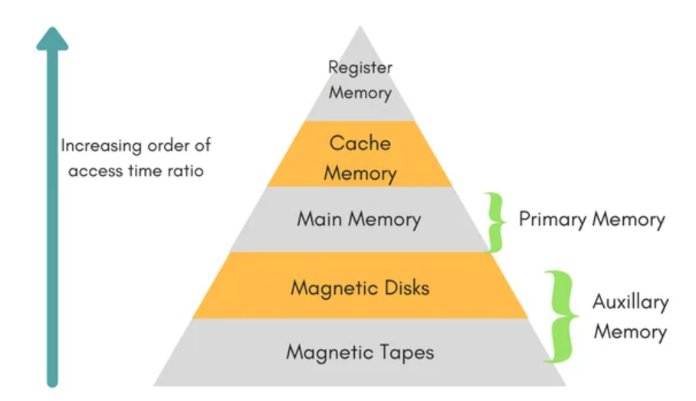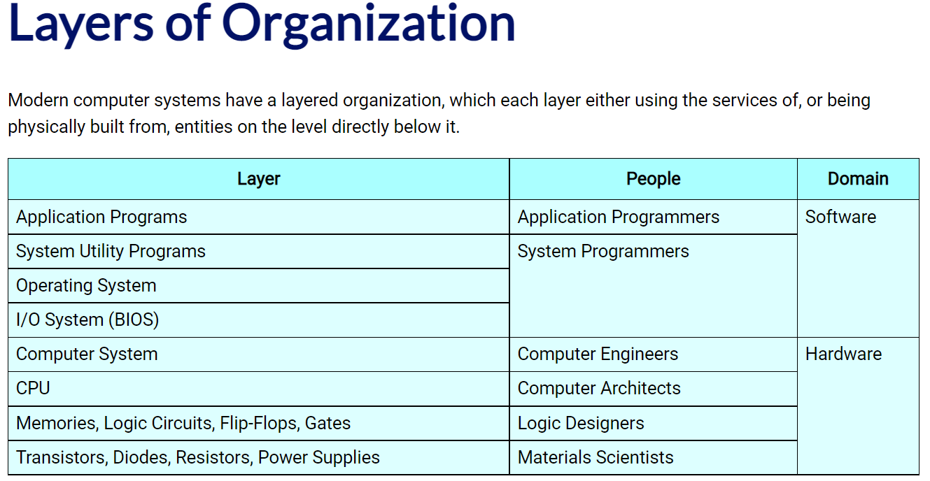

11. Volatile and non-volatile memory, CMOS memory and its role. HDD and SSD - working principles, characteristic comparison. RAID storage.

**Volatile memory is the type of memory in which data is lost as it is powered-off. Non-volatile memory is the type of memory in which data remains stored even if it is powered-off. The CMOS is a physical part of the motherboard: it is a memory chip that houses setting configurations and is powered by the onboard battery. The CMOS is reset and loses all custom settings in case the battery runs out of energy, Additionally, the system clock resets when the CMOS loses power. A hard disk drive (HDD) is a traditional storage device that uses mechanical platters and a moving read/write head to access data. A solid state drive (SSD) is a newer, faster type of device that stores data on instantly-accessible memory chips. Redundant Array of Independent Disks (RAID) is a storage technology that creates a data loss fail-safe by merging two or more hard disk drives (HDDs) or solid-state drives (SSDs) into one cohesive storage unit, or array.**

12. Data encoding - basic principles, necessity, popular encodings used in communication between PC components.

**On electronic devices like computers, data encoding involves certain coding schemes that are simply a series of electrical patterns representing each piece of information to be stored and retrieved. For instance, a series of electrical patterns represents the letter “A.” Data encoding and decoding occur through electronic signals, or the electric or electromagnetic encoding of data. In data encoding, all data is serialized, or converted into a string of ones and zeros, which is transmitted over a communication medium like a phone line. Serialization must be done in such a way that the computer receiving the data can convert the data back into its original format.**

13. Motherboards, chipsets, their specifications. Motherboard form factors, components.

**Living on the motherboard, a PC's chipset controls the communication between the CPU, RAM, storage and other peripherals. The chipset determines how many high-speed components or USB devices your best motherboard can support. Chipsets are usually comprised of one to four chips and feature controllers for commonly used peripherals, like the your keyboard, mouse or monitor. The form factor determines the specifications on how a motherboard is built, from the size, shape, casing, power supply, mounting holes, and the overall layout. The most common form factor is ATX, which evolved to mini-ATX, nano-ATX, pico-ATX, and further. There are many components found in a motherboard. Some of them are major motherboard components while others are not, some of them are keyboard and mouse, USB, parallel port, CPU chip, RAM slot, floppy controller, IDE controller, PCI slot.**

14. Extension slots and cards, connectors, peripherals

**An expansion slot refers to any of the slots on a motherboard that can hold an expansion card to expand the computer's functionality, like a video card, network card, or sound card. There are different kind of ports like for USB, Keyboard, mouse, storage, disk, network, communication, audio, video and power. There are three kinds of peripherals: input, input/output, and output devices. Some common computer peripherals include keyboards, mice, tablet pens, joysticks, scanners, monitors, speakers, printers, external hard drives, and media card readers.**

15. Historic display types, main two display types today, their working principles, comparison of consumer characteristics.

**Some of legacy type display types are CRT Display, The Glass Teletype, RGB, MultiSync, VGA. Nearly every monitor sold today is either LCD or OLED. The biggest difference between the two is in how they work. With OLED, each pixel provides its own illumination so there's no separate backlight. With an LCD, all of the pixels are illuminated by an LED backlight. That difference leads to all kinds of picture quality effects, some of which favor LCD, but most of which benefit** **OLED. LCD usually cost less and can still provide excellent picture quality.**

**Question 2**  
• Integer transformation from base N numbering system into base K numbering system. Example: convert number 111 from base 13 into base 7. **351**

***http://extraconversion.com/base-number/base-13/base-13-to-base-7.html***  
• Fraction conversion from base N numbering system into base K numbering system. Example: convert number 0.75 from decimal numbering system into binary **0.01111**

***https://www.rapidtables.com/convert/number/decimal-to-binary.html***  
• Binary arithmetic’s: addition, subtraction, multiplication, division. Example: add numbers 101 and 11 and multiply those by 10 (all in binary) **10000  
*https://www.calculator.net/binary-calculator.html?number1=1000111&c2op=%2B&number2=111100&calctype=op&x=80&y=26***  
• Decoding encoded text using the table (and vice versa). Example: Encode string "Ok" using ASCII table and write the result as a string of hexadecimal numbers. **4F 6B  
*https://ascii.cl/***  
• Data encoding: encoding the signal using a specific encoding (and vice versa). Example: encode hexadecimal number 4C using NRZI (or 3b/4b). **???**

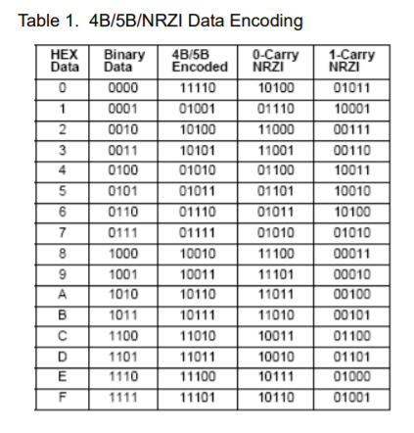

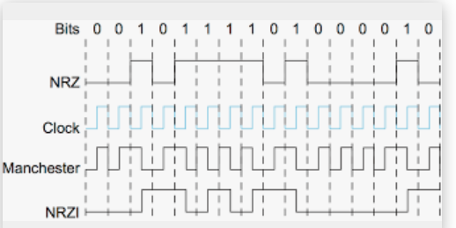

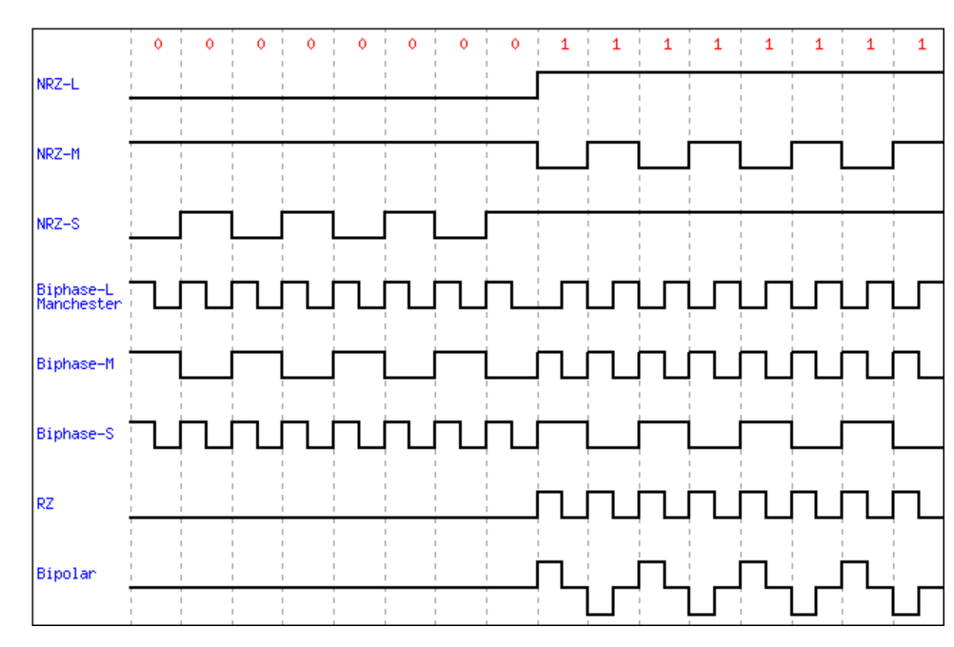  
• Number conversion to IEEE 754 floating point single-precision standard (and vice versa). Example: represent number 234.1234 as a IEEE 754 floating point (give the result in hexadecimal) **436a1f97 (bez pirmajiem diviem 0X)  
*https://www.h-schmidt.net/FloatConverter/IEEE754.html***• Construct a logic gate implementing the given operation. Example: construct a gate for (A NAND B) OR NOT(C) **???**

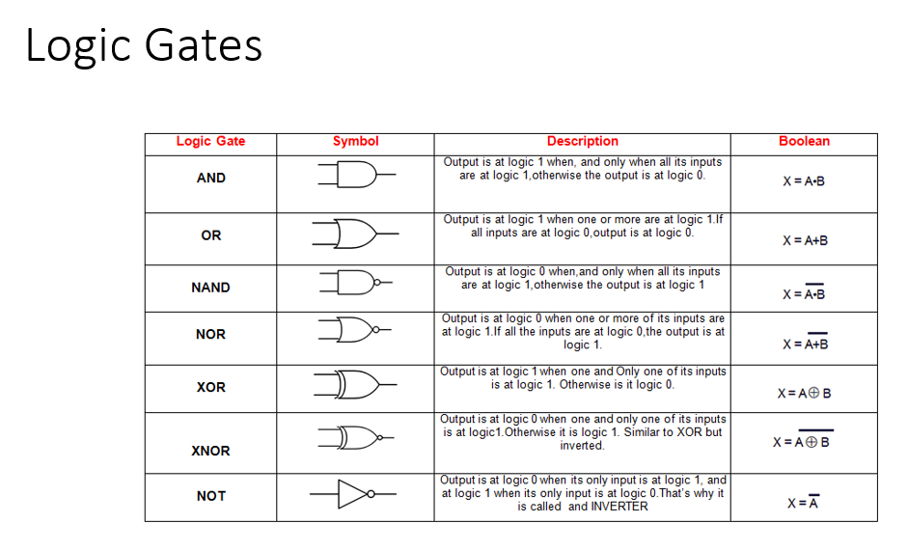

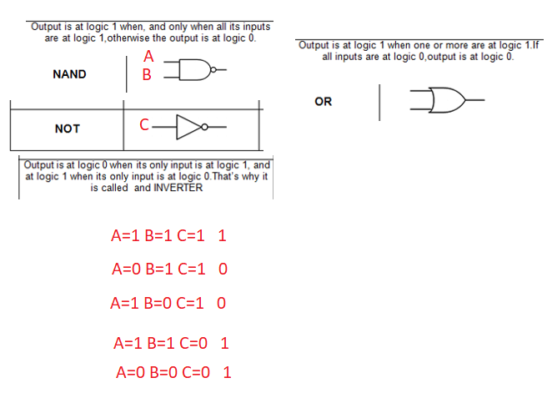

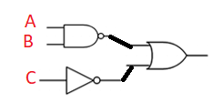

• Establish the output of the given logic circuit upon the specific input. Example: **X**

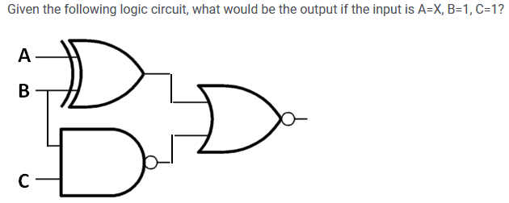

***https://en.wikipedia.org/wiki/Logic_gate***