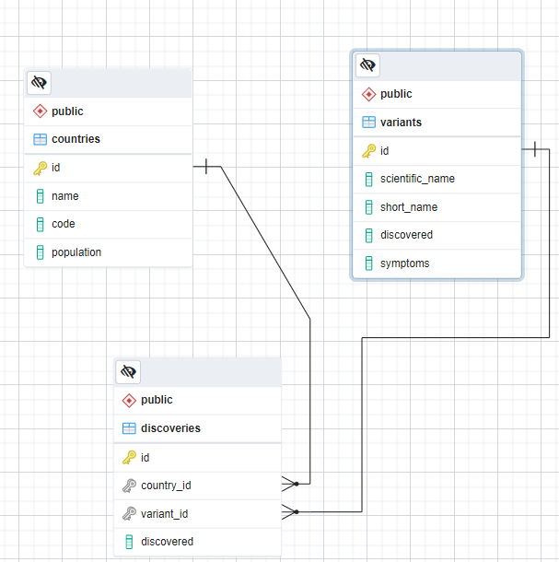

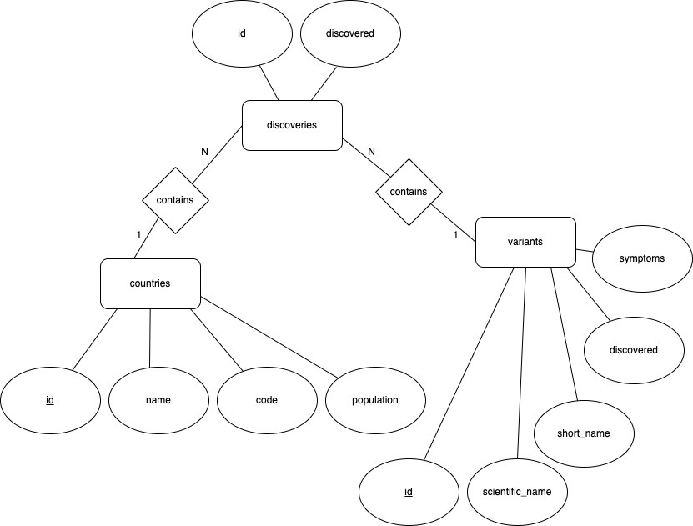

1. OLTP is using simple standardized queries (for example insert, update, delete) while OLAP is used for large and complex SELECT statements.

OLTP response times are very small, usually miliseconds, while OLAP response times can reach seconds, minutes and hours

2. CRM is using information gained from Data warehouse to analyze customer profiles.

CRM can use that information for marketing.

For example, an email about new computers in a store can be sent to customers frequently buying new computers instead of sending them to everyone of sending them to random customers.