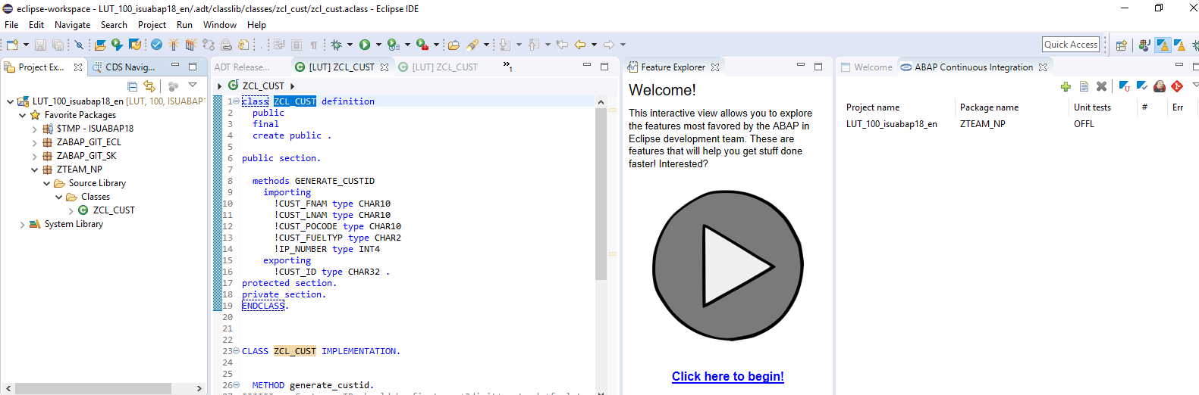

Figure Showing my project and class in eclipse

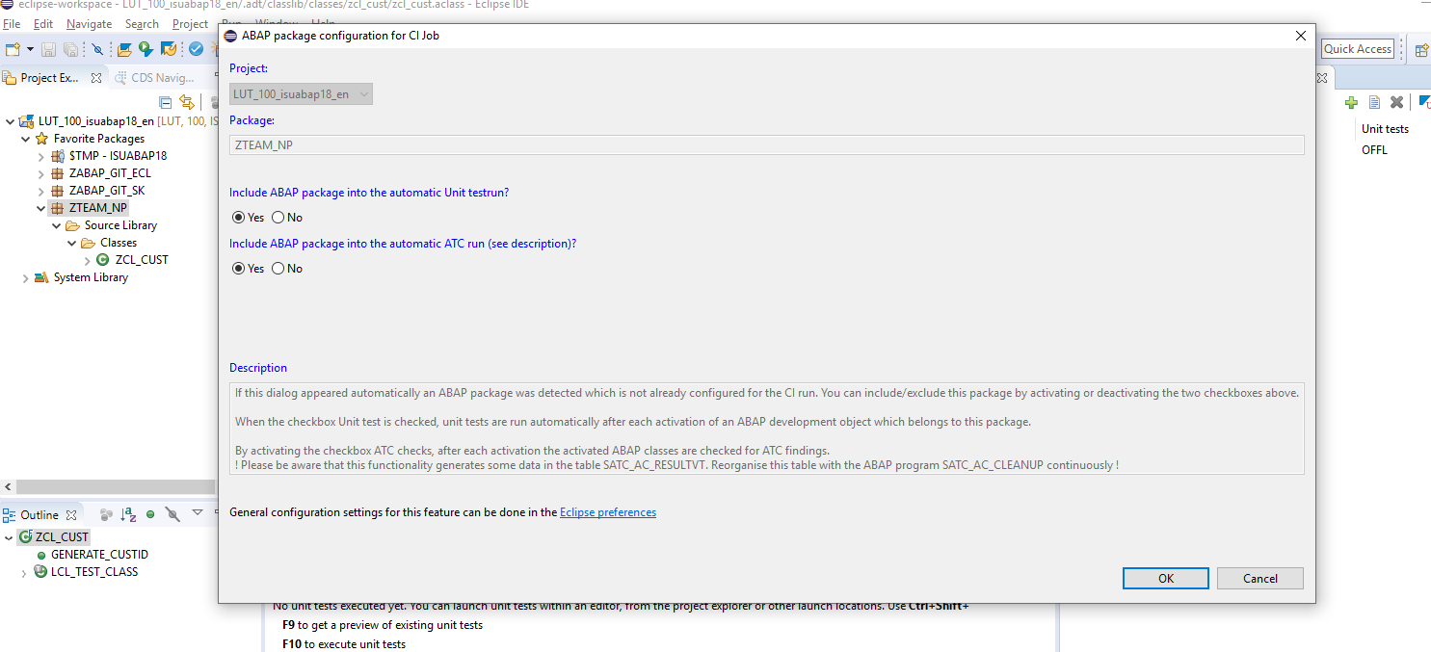

Figure Showing my configuration for the package

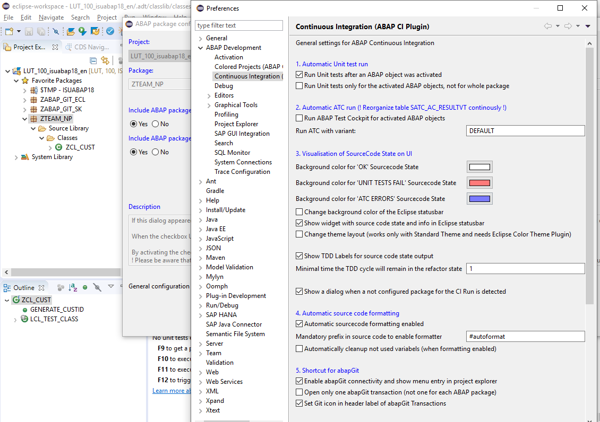

Figure Showing eclipse preferences

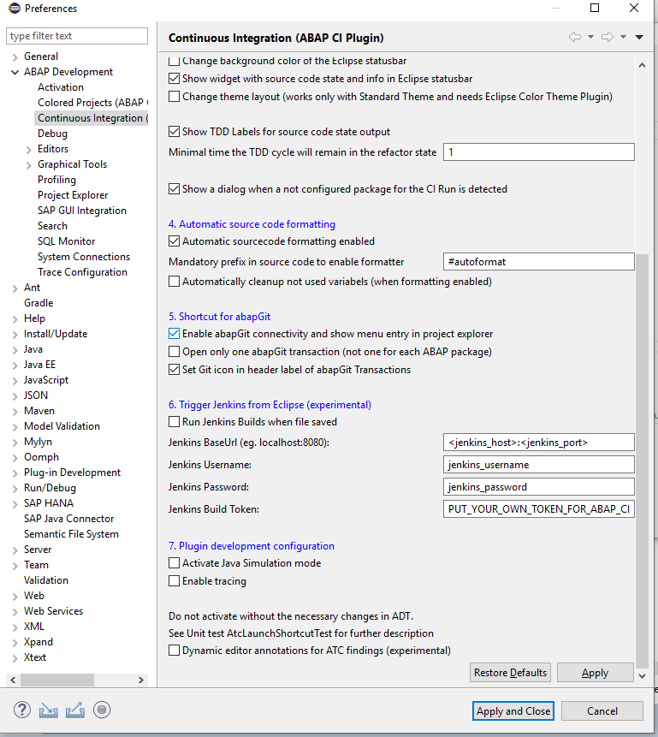

Figure Showing eclipse preferences scrolled down

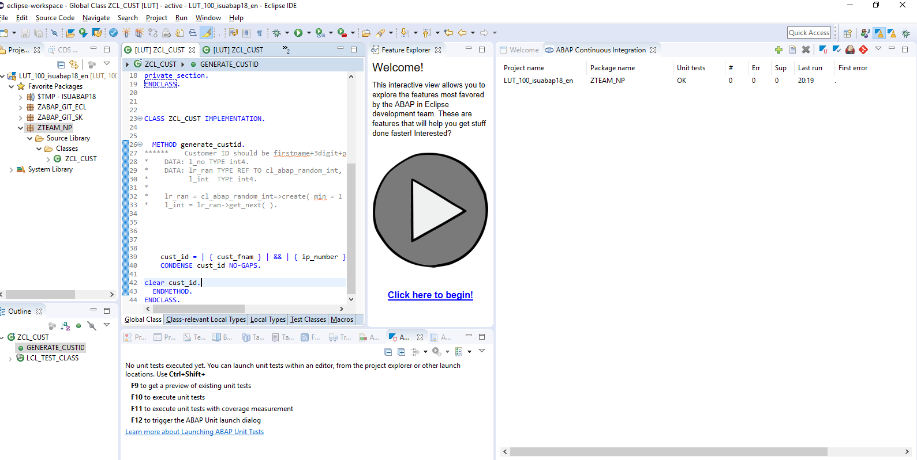

Figure Changed the code at line no 42 by clearing the output

But unit test section of ABAP CI integration perspective changing from ‘OFFL’ to ‘OK’ but actually unit test is not getting executed as it is not showing error.

Now executing the class with ABAP unit class

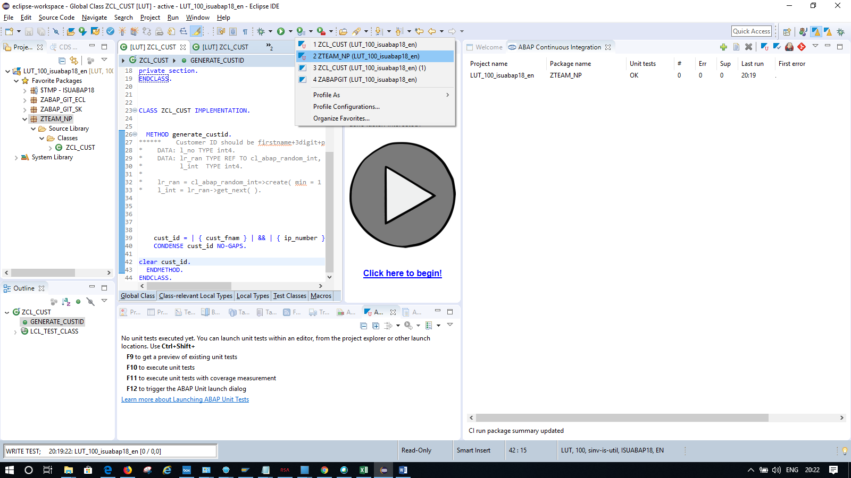

Figure Executing unit test

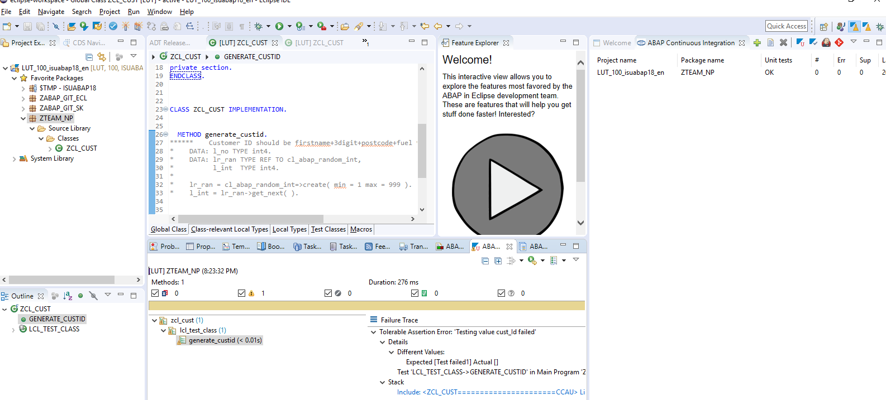

Figure Showing assertion error

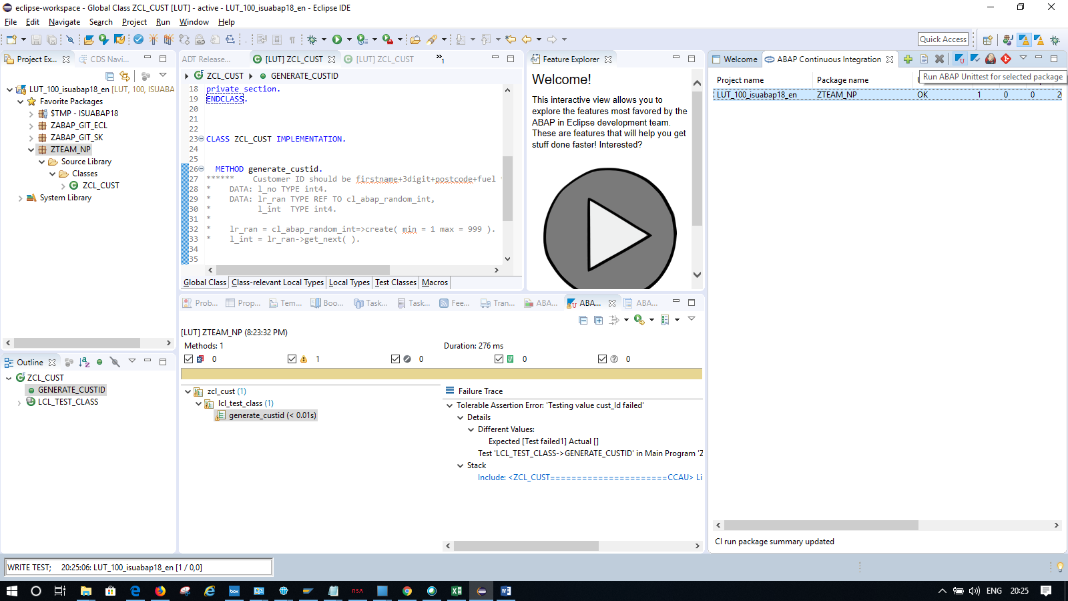

Figure If I click on the above button (Run ABAP unti test for selected package) in ABAP continuous integration perspective then only it is getting executed. But not showing any error message.

Please advice. I need when I activate my class that time abap unit test should be executed and updated the error count in the ABAP continuous integration perspective.

Please help.