Auto-generated report from BCEAweb

Version: 21 December, 2024

# Economic Analysis

This section contains a summary of the economic evaluation.

## Cost-effectiveness analysis

This sub-section presents a summary table reporting basic economic results as well as the optimal decision, given the selected willingness-to-pay threshold $k=25000$.

Cost-effectiveness analysis summary   
   
 Reference intervention: Intervention1  
 Comparator intervention(s): Intervention2  
 : Intervention3  
 : Intervention4  
   
 Optimal decision: choose Intervention1 for k < 200  
 Intervention2 for 200 <= k < 300  
 Intervention4 for k >= 300  
   
   
 Analysis for willingness to pay parameter k = 25000  
   
 Expected net benefit  
 Intervention1 10263  
 Intervention2 17423  
 Intervention3 22289  
 Intervention4 28182  
   
 EIB CEAC ICER  
 Intervention1 vs Intervention2 -7160.3 0.056 158.66  
 Intervention1 vs Intervention3 -12026.5 0.006 195.77  
 Intervention1 vs Intervention4 -17919.7 0.000 198.33  
   
 Optimal intervention (max expected net benefit) for k = 25000: Intervention4  
   
 EVPI 1545.1

## Cost-effectiveness plane

The following graph shows the cost-effectiveness plane. This presents the joint distribution of the population average benefit and cost differential, $\left(Δ_{e},Δ_{c}\right)$.

Each point in the graph represents a ‘potential future’ in terms of expected incremental economic outcomes. The shaded portion of the plane is the ‘*sustainability area*’. The more points lay in the sustainability area, the more likely that the reference intervention will turn out to be cost-effective, at a given willingness to pay threshold, $k$ (in this case selected at $k=$ 25000)

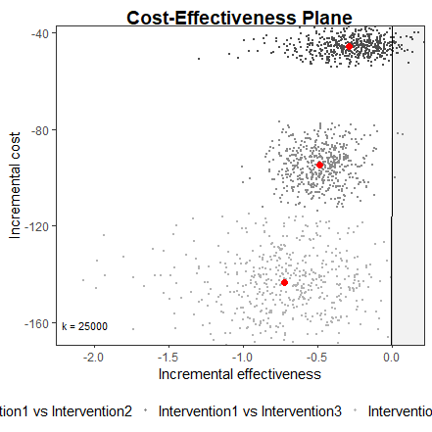

# Probabilistic Sensitivity Analysis

This section presents the results of Probabilistic Sensitivity Analysis (PSA). PSA is used to assess the impact of parameter uncertainty on the decision-making process.

## Called from: eval(expr, envir, enclos)

## Cost-effectiveness acceptability curve

The following graph shows the cost-effectiveness acceptability curve (CEAC). The CEAC represents the proportion of ‘potential futures’ in which the reference intervention is estimated to be more cost-effective than the comparator. Thus, it can be interpreted as the ‘probability of cost-effectiveness’.

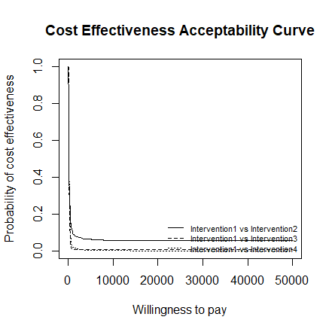

## Cost-effectiveness acceptability frontier

