ESM 201 Assignment 1

Brad Anderson

February 15, 2018

In order to compare and contrast the population trajectories between a developing nation and a developed nation and explore the explanatory variables affecting them, single and multiple linear regression was utilized. For both Uganda, a developing nation, and France, a developed nation, a simple linear model was created to explore the per capita growth rates (dN/Ndt) as a function of population size (N) and a multiple linear regression model was created to explore significant explanatory variables affecting the per capita growth rates (dN/Ndt).

**Uganda**

Figure 1 shows the per capita growth rate from 1961 to 2006 with two models, one for the decline in dN/Ndt in the 1960s and one for the increasing dN/Ndt later in the century. According to this model of current growth, Uganda will not reach the carrying capacity (K) because the per capita growth rate is increasing at the same time total population increases (y = 5.43e-05x + 3.14e-02). The diagnostic plots for these two linear models show that assumptions are met.

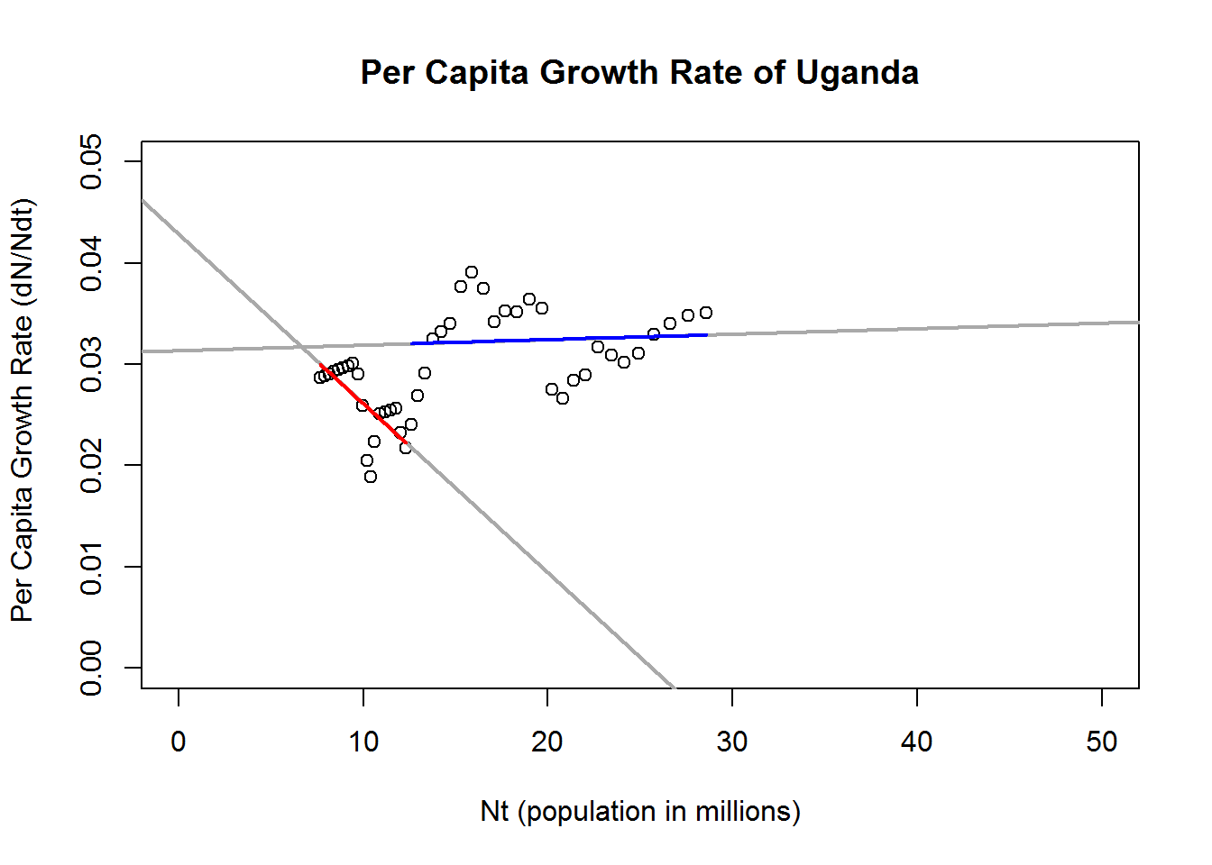

Figure : Red model: Blue model: y = 5.43e-05x + 3.14e-02

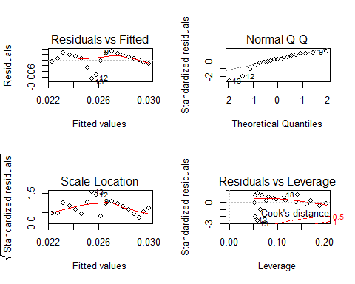

Figure : Diagnostic plots for linear model one (red)

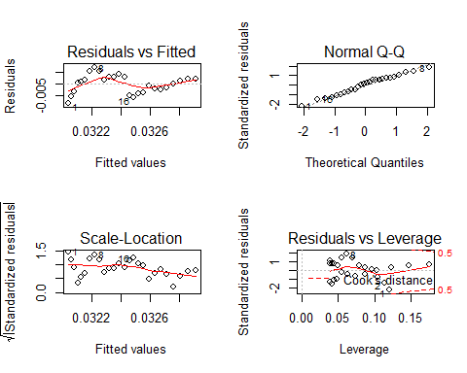

Figure : Diagnostic plots for linear model two (blue)

The model (professor salary = 4492 ∗ (Sex: Male) + 13,723 * (Rank: Associate Professor) + 47,403 (Rank: Professor) + 68,224 (US Dollars)) explains a significant amount of variance in professor salary (F(4, 392) = 79.18, *p* < 0.001, *R2* = 0.44). This multiple linear regression reveals that professor salary is significantly predicted by rank (*p* < 0.001) and discipline (*p* < 0.001), but not by sex (*p* = 0.24). Therefore, on average, associate professors make $13,723 more and full professors make $47,403 more than assistant professors. Professors in applied fields make $13,709 more than those in theoretical fields. Finally, though sex does not significantly predict salary, males still earn $4,492 more than females.

|  |  |
| --- | --- |
|  | |
|  | *Dependent variable:* |
|  |  |
|  | dNNdt |
|  | |
| food_pc | -0.023*** |
|  | (0.008) |
|  |  |
| education | 0.012** |
|  | (0.004) |
|  |  |
| population | -0.002** |
|  | (0.001) |
|  |  |
| Constant | 0.278*** |
|  | (0.083) |
|  |  |
|  | |
| Observations | 42 |
| R2 | 0.379 |
| Adjusted R2 | 0.330 |
| Residual Std. Error | 0.004 (df = 38) |
| F Statistic | 7.722*** (df = 3; 38) |
|  | |
| *Note:* | *p<0.1;****p<0.05;***p<0.01 |