**Memorandum**

To: Presidential Offices of X and Y

From: Andrew Steinkruger & Brad Anderson, United Nations Environment Programme

Re: Air Pollution Reduction

**Summary**

Country X has committed to halving their carbon emissions in support of the Paris Accord agreements on climate change. Here we analyze the efficiency of three options to meet this goal: a cap on carbon, a tax on carbon, and a carbon cap and trade program. Our analysis shows that the cap and trade program most efficiently meets these goals.

**Problem Statement**

To meet Paris Accord commitments, country X must cut carbon emissions in half, from 600 tons to 300 tons. The options being analyzed are a cap on carbon, a tax on carbon, and a cap and trade system. A further complication arises when we introduce country Y, which has no obligation to reduce emissions, into the cap and trade analysis. This situation mirrors the current debate on the equity difference between developed countries, which have enjoyed many years of unrestricted carbon emissions, and developing countries, which have not.

**Analysis & Results**

In order to analyze the costs and benefits of each carbon solution, we needed to produce demand curves for carbon emissions for each of the four sectors. Using R, we first used linear regression (marginal cost ~ abatement) to determine the abatement coefficient (Appendix A, Equation 1); this was then in our estimated marginal cost curve for each sector (Appendix B, Figure 1). We then reversed these models (Appendix A, Equation 2) in order to produce each sector’s demand curve for carbon emissions (Appendix B, Figure 2). The results show that at ?$/ton sector C is willing to pay the most for the first unit of carbon emissions (Figure ?). We have attached the our R code for transparency and reproducibility (Appendix C).

*Options*

* Cap Only: We calculated the difference in total benefits for sectors A, B, & C before and after the 300 ton cap on carbon was implemented by integrating the marginal benefits curve for each sector. This reduced the benefit by ____ for A, ____ for B, and ____ for C. This produces no government revenue.
* Tax: We aggregated the demand curve for sectors A, B, & C and then found the aggregate demand price at a quantity of 300. With a tax amount of $37.31/ton the total cost of meeting the target is _____ (Sector A = _____, Sector B = _____, Sector C = _____ ) and _____ in tax revenue is created.
* Cap & Trade: Utilizing our aggregate demand curve and the marginal cost of abatement equation for each sector we were able to determine the trading outcome that produces the most total benefit. With each sector given permits equal to 100 less than their current carbon emissions the results are as follows: Sector A = _____ permits, Sector B = _____ permits , Sector C = _____ permits

*Country Y*

* Cap & Trade: Including sector D from country Y into the carbon market has the following results: Sector A = _____ permits, Sector B = _____ permits , Sector C = _____ permits, Sector D = _____ permits

**Table 1:** Cost Comparison of Emission Reduction Options

|  |  |  |  |  |  |  |
| --- | --- | --- | --- | --- | --- | --- |
|  | Total Cost | Sector A | Sector B | Sector C | Sector D | Tax Revenue |
| Carbon Cap | 7797 | 2884 | 994 | 3919 | N/A | 0 |
| Carbon Tax | 8145 | 5509 | 3988 | 4244 | N/A |  |
| Cap & Trade Market |  |  |  |  |  |  |

**Recommendation**

A carbon cap and trade market most efficiently meets the Paris Accord commitments. We also recommend that country Y enter the market –this requires them to voluntarily set a cap on their emissions, which results in reduced global carbon emissions. However, it must be considered that country X will inevitably purchase carbon permits from country Y, this will result in more emissions in country X and less in country Y; more emissions signal greater industrial activity and more job growth. County Y would benefit from reduced emissions and revenue from selling the permits, but might undergo reduced industrial activity.

**Appendix A:** Equations

**Equation 1**: Marginal Cost of Abatement for Each Sector.

https://lh3.googleusercontent.com/tn6bUp9AxJhAoLBzNP7DBmpU4vkHD9gAHGkuKir9Rjqi8-RKcgKMsEf8-ypG-CWptmNCKrny-dqZtJ0XrqO6dqvX7toxuKt9L171ZymwEcsqY6bpW1TZeDLgWuljoOXHtTFZvZOw

**Equation 2:** Each Sector’s Demand Curve for Pollution



**Appendix B:**

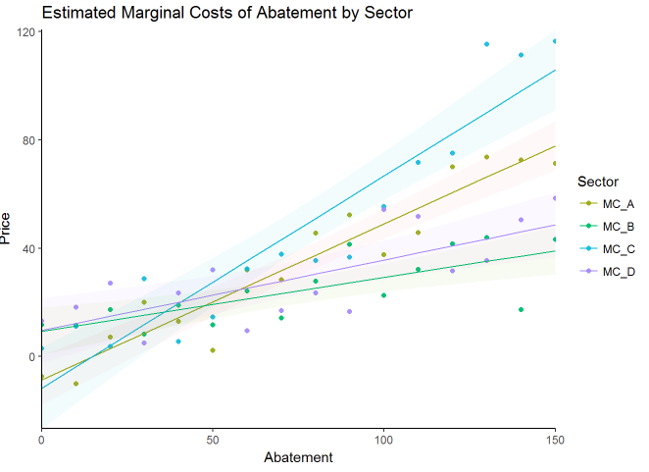

Figure 1

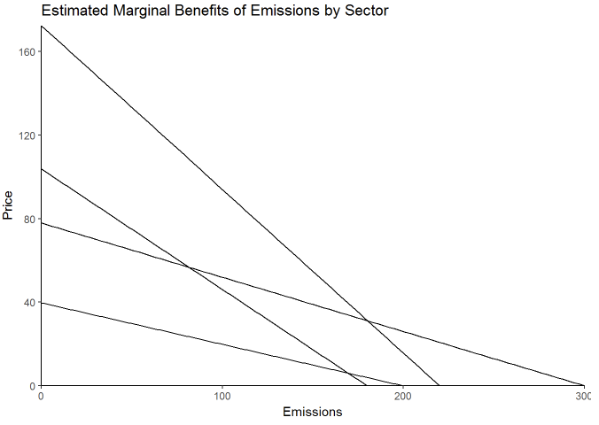

Figure 2

**Appendix C:** R Code