This flower is black and white
The lens is colored
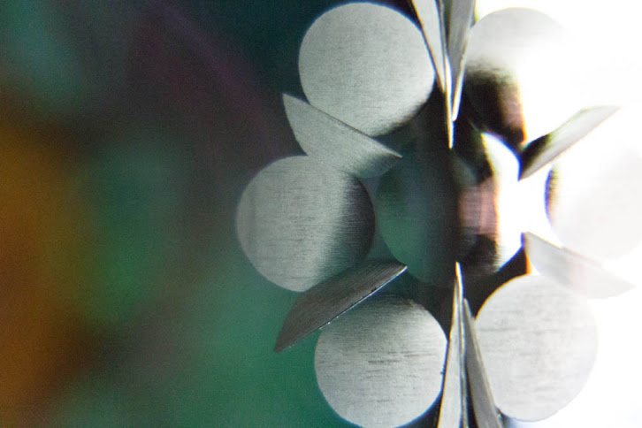
Photo © Florent Aide
This simple LibreOffice document is not a py3o.template and is just here to show you how you can use py3o.fusion server to transform your ODT documents to PDF.

