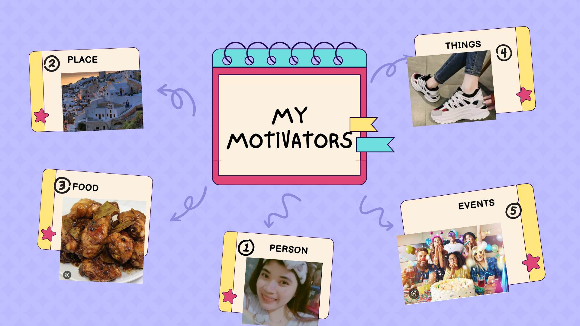

My illustration above means a lot. I have my favorite place to go when the moment of breakdowns hit me. I like peaceful places. It helps me to cool down my mind and it gives me positive plan for my future. I really like eating “adobong manok”, because it relieves my stress and motivates me to eat more rice. It’s really motivating to have new things, like shoes. Its motivate me to go to school, work, travel etc. My favorite events is birthday, because I’m happy seeing people unlocked new pages on their lives it gives me different feeling of happiness. I have a lot of people, places, things, events food that motivates me. However, besides of those mentioned motivations, I have my own self to continue my life when it’s never makes me feel loved and stop motivating me when life is getting hard. Even if everything left me behind as long as I have my self, I’ll continue to live my life no matter how hard it is. In the end I only have myself. Therefore, focus on yourself, don’t depend on others, be independent person. Set yourself as your main motivation.