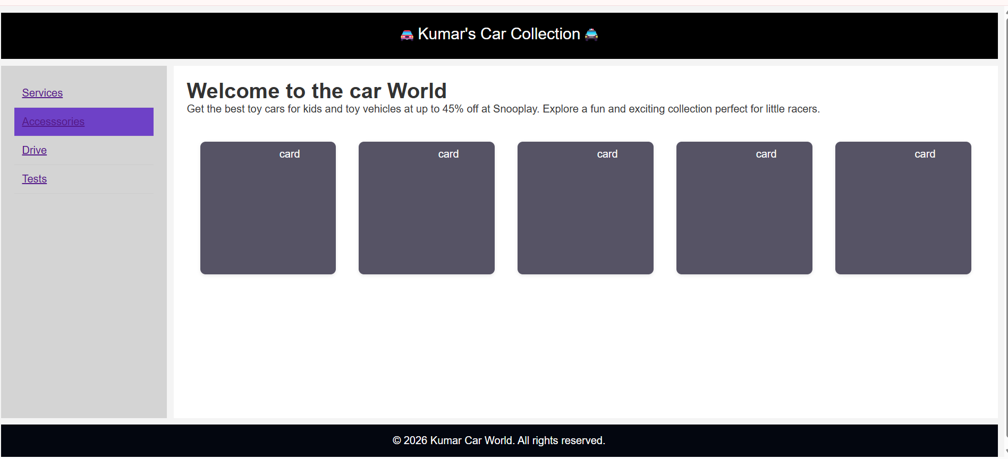
Fig:Page
In The Above Picture I Created a webpage by using basic html tags like header,aside,list,anchor,and footer.And I implement grid styles and hover and some selectors and as well as by using div tags I divides the contents into some cards and applying css styles


Figures:Front(Heads),Back(Tails)
By using animations like transistion and transform and some 3d animations like persespective (3d property) I designed a coins which indicated a heads and tails(front and backside).mainly it works by using property transform:rotate(180deg)
