HTML Lists, Tables, Framesets, and Forms

1. Lists
HTML lists are used to organize information systematically on web pages. There are three main types of lists:
- Ordered List (<ol>): Displays items in a specific order using numbers, alphabets, or Roman numerals.
- Unordered List (<ul>): Displays items with bullet points, without any specific sequence.
- Lists improve readability and structure content clearly.

2. Tables
HTML tables are used to present data in a structured row and column format.
- <table>: Defines the table
- <tr>: Defines a table row
- <th>: Defines a table header cell
- <td>: Defines a standard table cell
- <caption>: Provides a title for the table
Tables are useful for organizing numerical data, textual information, and other content in a readable format.

3. Framesets
A frameset is used to divide the browser window into multiple sections, called frames, where each frame can display a different HTML document. Framesets use the <frameset> and <frame> tags and can be arranged using the rows or cols attributes.
Note: Framesets are deprecated in HTML5, and <iframe> is recommended for modern web design.

4. Forms
HTML forms are used to collect input from users through form controls such as text boxes, radio buttons, checkboxes, drop-down lists, and buttons. Forms use the <form> tag and its associated input elements. They are essential for user interaction and data submission on websites.

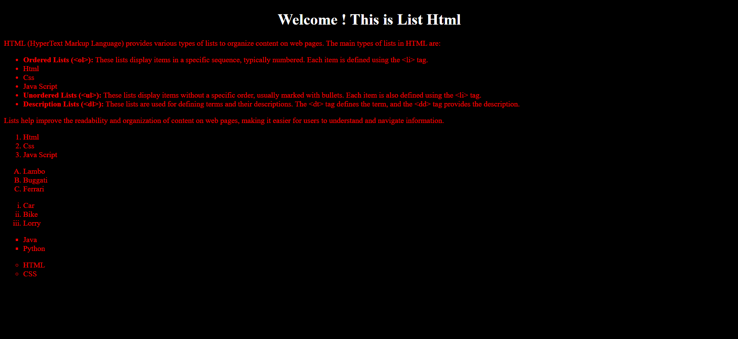

Fig:Lists
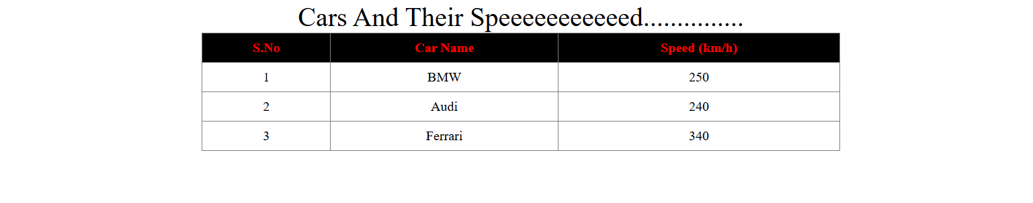
Fig:Table And CAption
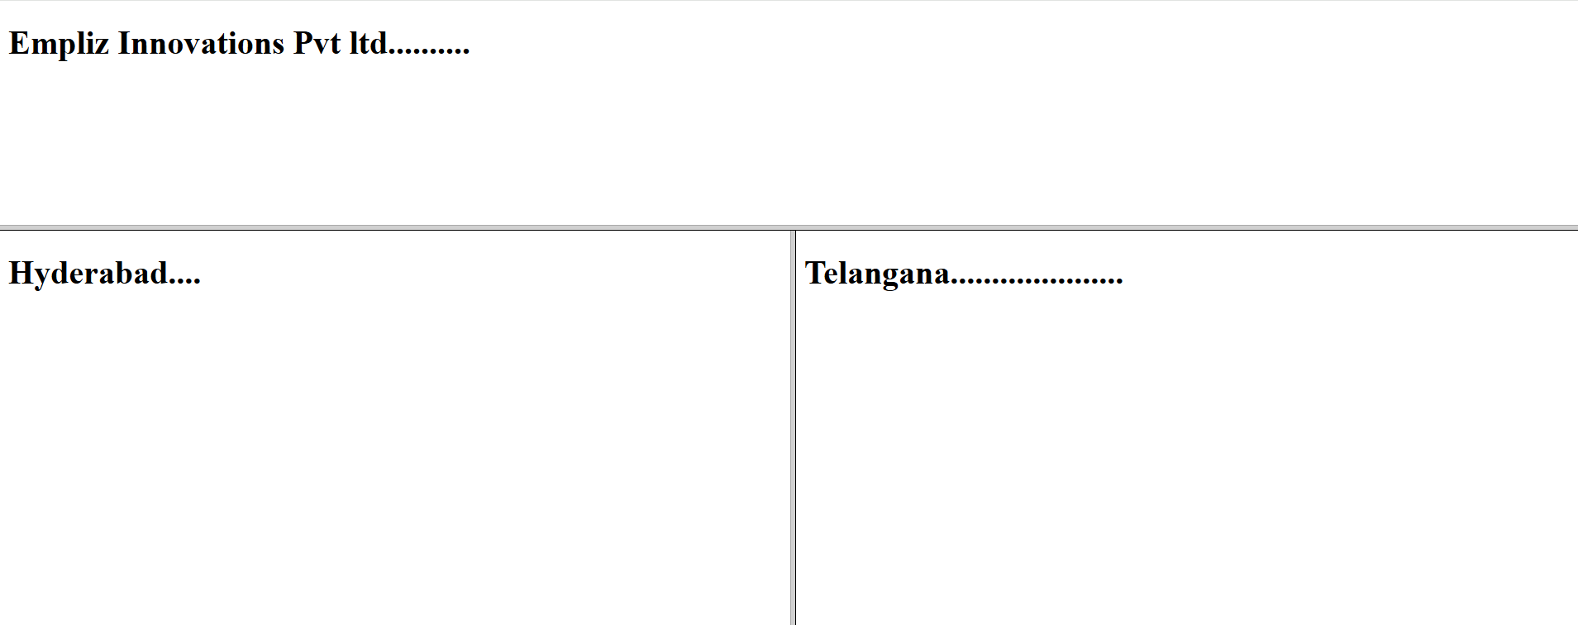
Fig:FrameSets

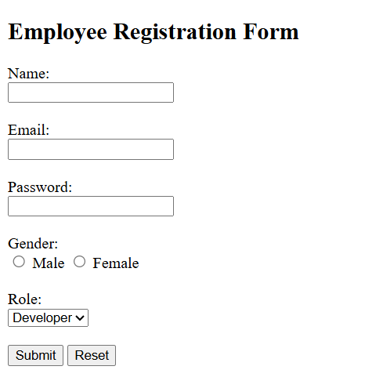
Fig:Form

Fig:Form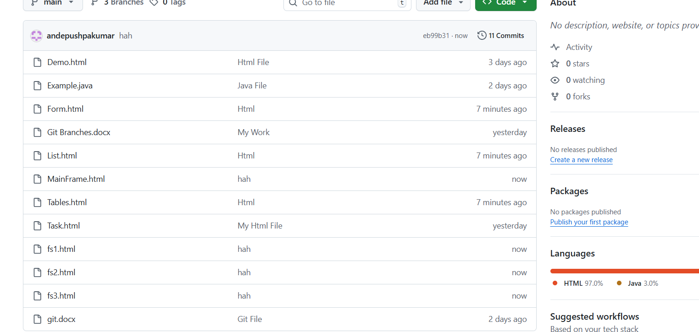
Fig:Files In git Repo

