Project Report

## Title of your game

*Obstacle Course Race*

## Your name

*Lexi Anderson*

## Is your game 2D or 3D?

*2D*

## What genre is your game?

*Racing*

## What is the most relevant game to yours (insert images here)

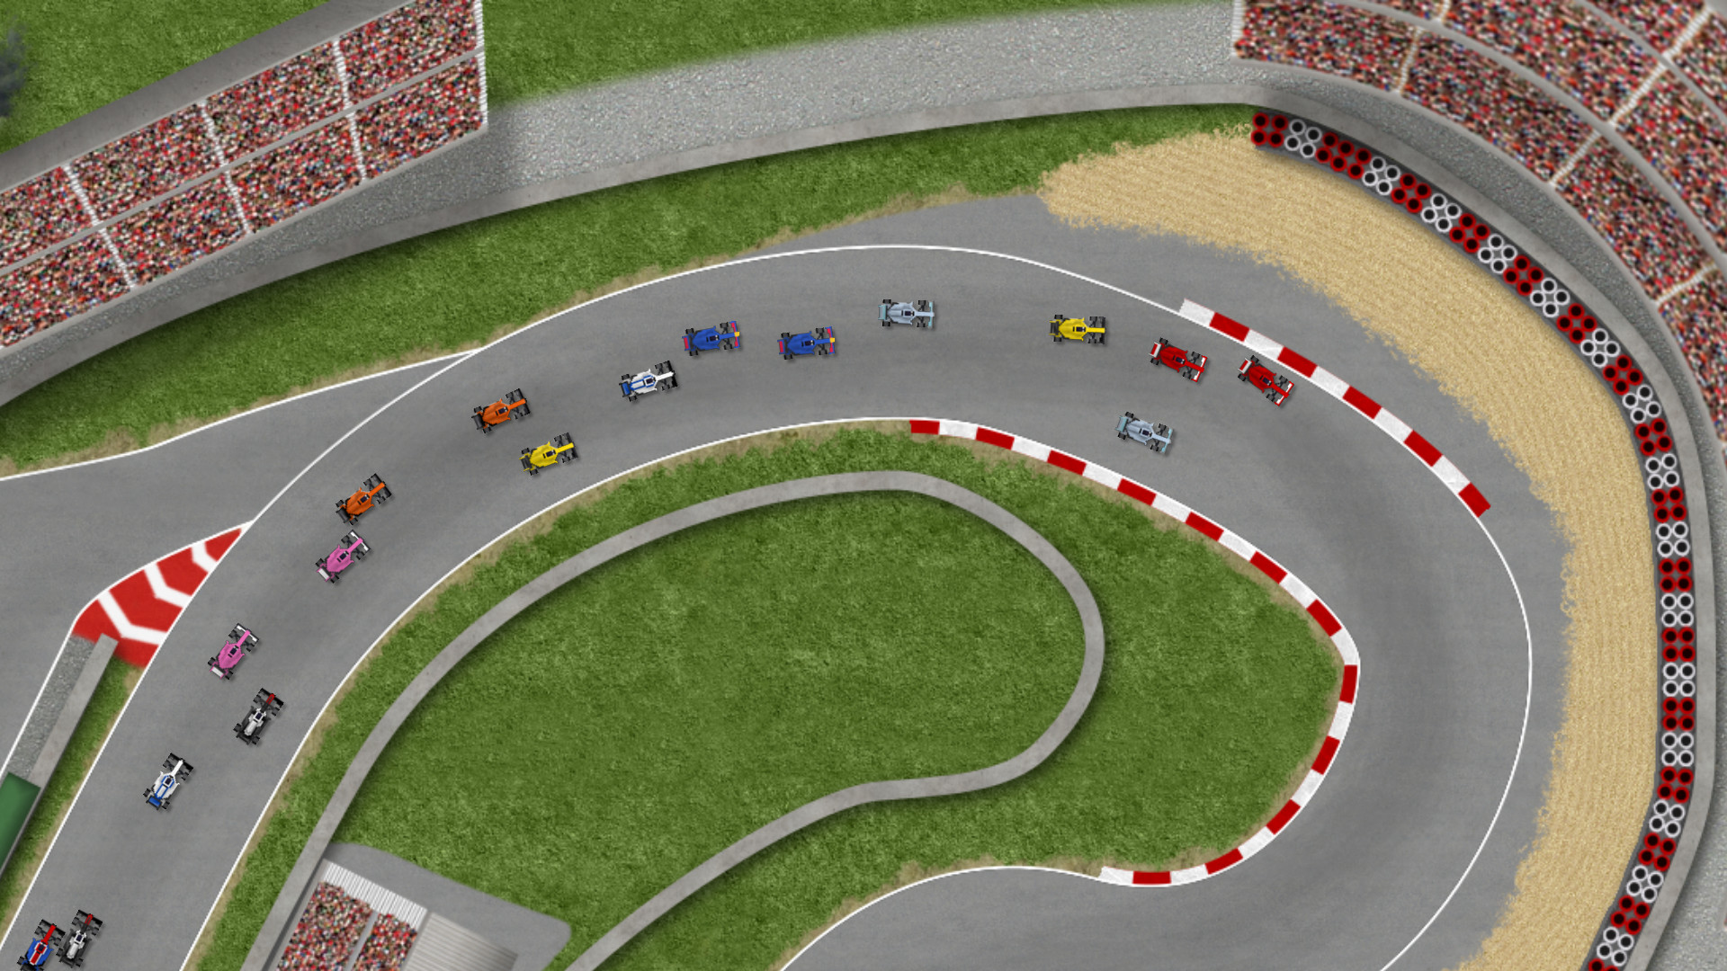

*Ultimate Racing 2D (another top down 2D racer)*

## Detailed description of Gameplay

*The player operates a car on a race track. They must drive one lap around the track as fast as they can. Driving into the grass will slow down the car significantly, so players should try to steer carefully.*

## List of all User Controls (don’t miss any)

*UP arrow key – Accelerate*

*LEFT/RIGHT arrow keys – Turn left/right*

## Object of the game (how to win the game)

*The player wants to complete a lap around the track as quickly as possible.*

## How to lose the game (how to die)

*There is no way to lose or die in this version; players are simply aiming to beat their top scores.*