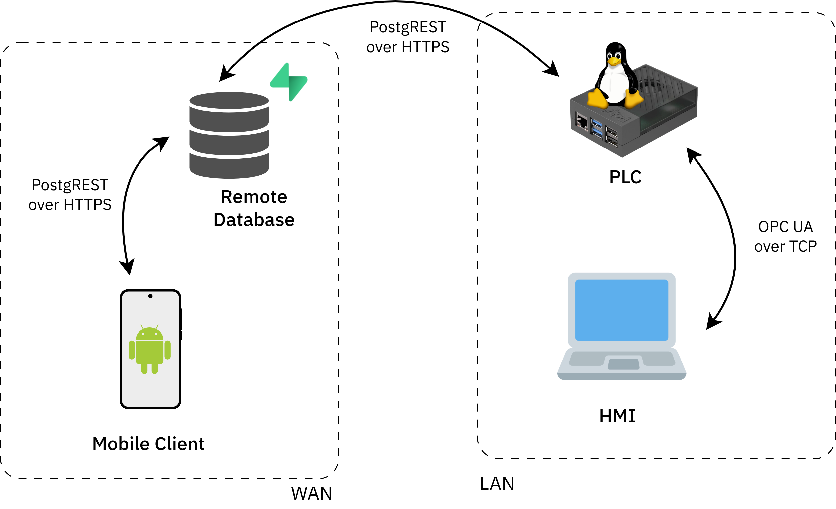
Integrated System
Puralan Poinsompuu

Hardware and Software Architecture
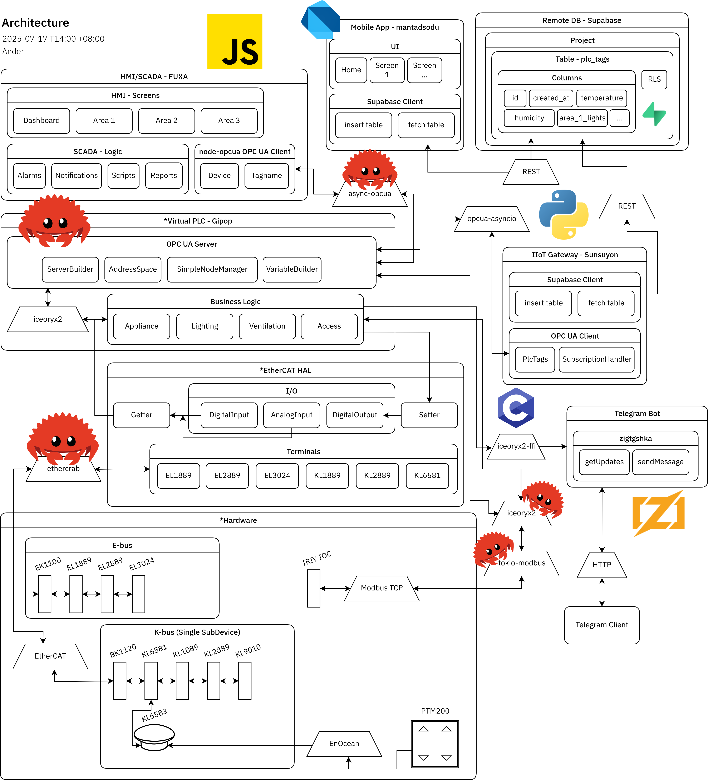
Wayawaal Doliwan om Tonsian

Topology
Woyooput

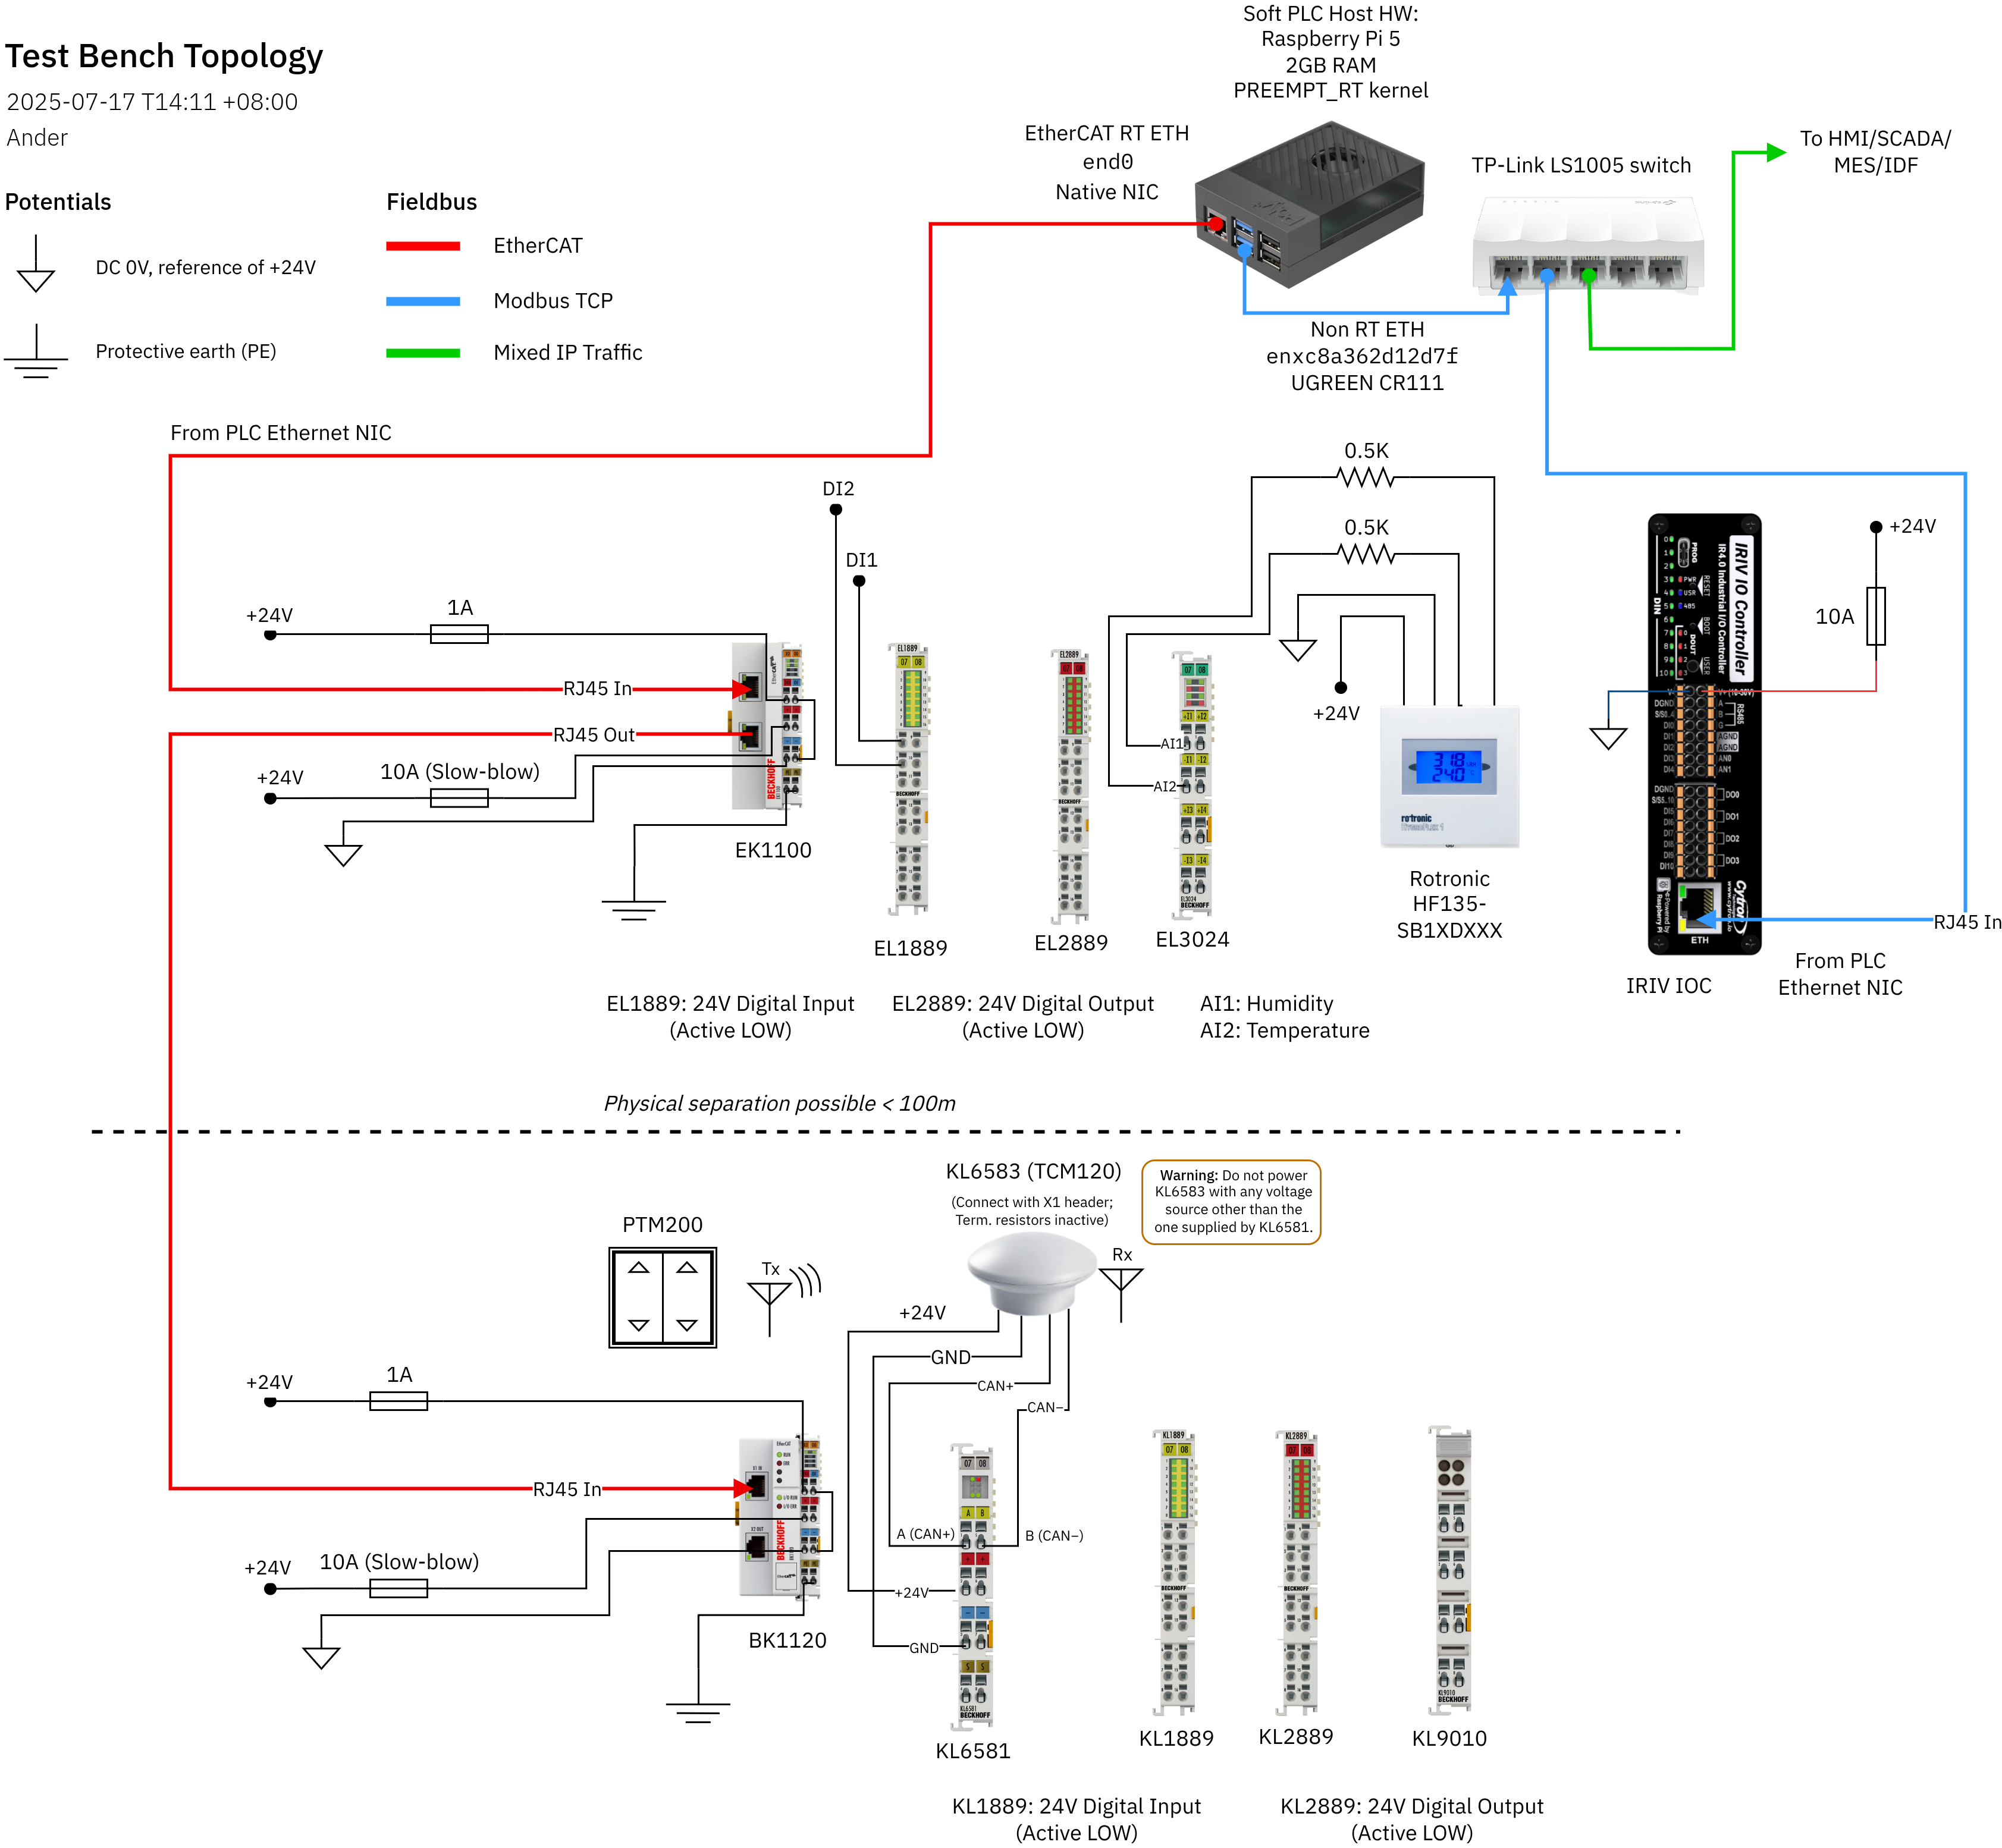

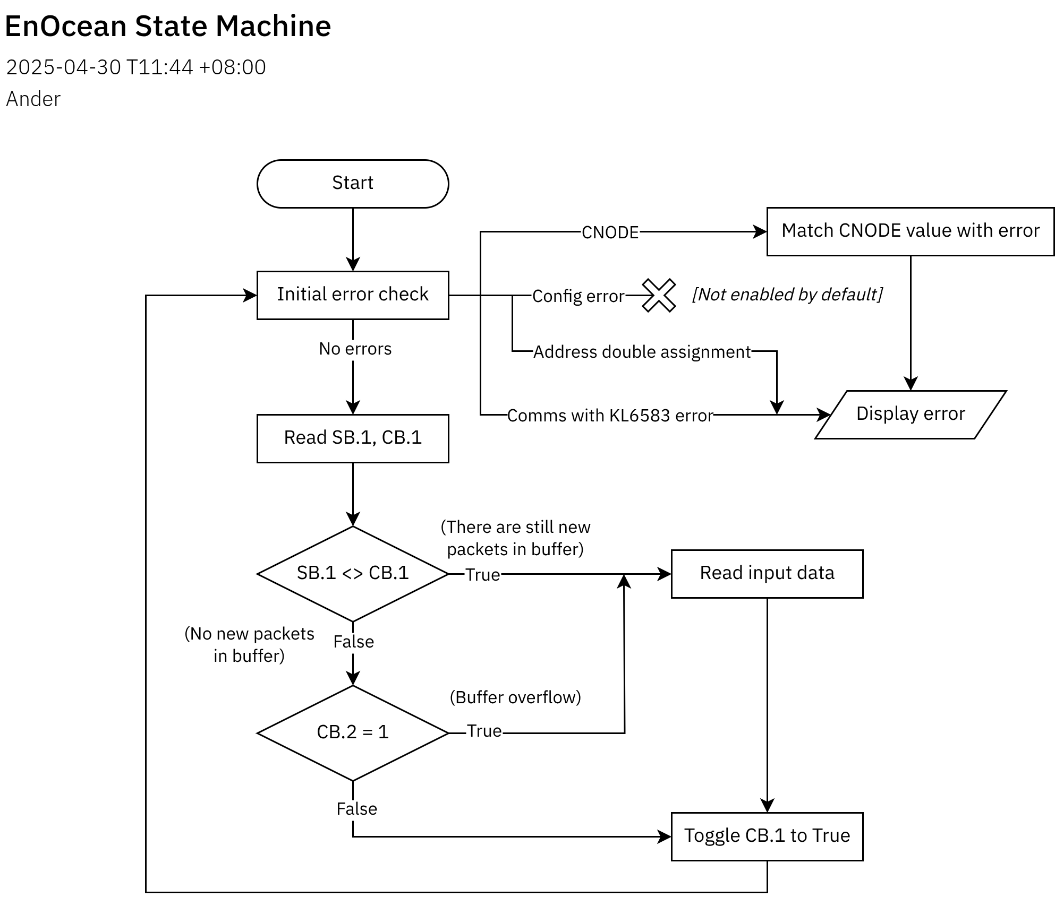
EnOcean State Machine
Pamot Titindo EnOcean

