EuroSkills
Test Project
IT Network Systems Administration (39)
Module B – Microsoft Environment

Submitted by:
Gen Lee EE
José Alves PT
Silvio Papic HR
Valentin Creton FR

INDEX

INTRODUCTION 4
LOGIN 4
SYSTEM CONFIGURATION 4
GENERAL CONFIGURATIONS 4
DESCRIPTION OF PROJECT AND TASKS 18
INET 18
INET - Task1: DNS server 18
INET - Task2: SMTP server 31
INET - Task3: web server 41
RTR-CPH 51
RTR-CPH - Task1: Site-to-site VPN 51
RTR-CPH - Task2: RRAS FW 98
RTR-CPH - Task3: Port forwarding 103
RTR-CPH - Task4: Reverse proxy 103
RTR-CPH - Taskr: NAT (masquerade) 103
RTR-AAL 109
RTR-AAL - Task1: Site-to-site VPN 109
RTR-AAL - Task2: NAT (masquerade) 110
DC 110
Active Directory & Identity Services 110
DC AD - Task1: Domain controller 110
DC AD- Task2: Configure sites 124
DC AD- Task3: Create OU structure 127
DC AD- Task4: Password policies 135
DC AD- Task5: ADFS 135
DC AD- Task6: Import users 135
Group Policies 135
DC GPO - Task1: Baseline Security Policy for Servers 135
DC GPO - Task2: Baseline Security Policy for Desktops 136
DC GPO - Task3: Administrative accounts 136
DC GPO - Task4: Users – Restrict Tools 136
DC GPO - Task5: Contractors – Customization 136
DC GPO - Task6: Folder Redirection 137
DC GPO - Task7: Disk Encryption 137
Name Resolution 137
DC DNS - Task1: A & AAAA records 137
DC DNS - Task2: Reverse lookup zones 138
DC DNS - Task3: Authority delegation 138
DC DNS - Task4: DNS forwarding 139
Certificate services 139
DC Certs - Task1: PKI and Root CA 139
DC Certs - Task2: CDP 163
DC Certs - Task3: AIA 163
DC Certs - Task4: OCSP 163
DC Certs - Task5: CDP and AIA on SRV2 164
DC Certs - Task6: certificate templates 164
Part 6: Enable Autoenrollment via Group Policy 172
Backups 172
DC Backups - Task1: Backup script 172
RODC 173
RODC- Task1: Promote as RODC 173
SRV2 190
SRV2 - Task1: public web server 190
SRV2 - Task2: intranet 190
SRV2 - Task3: SAML based auth app 191
SRV2 - Task4: web server certificates 191
SRV2 - Task5: iSCSI Target 191
SRV2 - Task6: Windows Event Forwarding 191
SRV1 & SRV2 192
SRV1 & SRV2 - Task1: SMB encryption 192
SRV1 & SRV2 - Task2: DFS shares 192
SRV1 & SRV2 - Task3: Bitlocker encryption 192
SRV1 & SRV2 - Task4: Prevent writing 192
SRV1 & SRV2 - Task5: Quota for roaming profiles 193
SRV1 & SRV2 - Task6: DFS replication 193
SRV1 & SRV2 - Task7: HA DHCP 193
SRV1 & SRV2 - Task8: DHCP reservation 193
DEV-PC 193
Ansible - Task1: hostname 193
Ansible - Task2: ADDS 194
Ansible - Task3: Users 194
Ansible - Task4: Web server 194
Ansible - Task5: Shares 194
Appendix A: Configuration table 196
Appendix B: Network topology 197
Appendix C: OU Structure 197
Appendix D: Password Policies 197
Appendix E: INET DNS records 198
Appendix F: DNS Authoritative Servers 198
Appendix G: ADFS successful integration 198

INTRODUCTION
The competition has a fixed start and finish time. You must decide how to best divide your time.
Please carefully read the following instructions!
This Test Project consists of the following documentation/files:
- ES2025_TP39_ModuleB.docx
- ES2025_TP39_ModuleB_Users_Skillsnet.csv
- ES2025_TP39_ModuleB_Users_Skillsdev.json
- ES2025_TP39_ModuleB_Shares.yaml
- ES2025_TP39_ModuleB_SSO_App.zip

When the competition time ends, please leave your station in a running state. The assessment will be done in the state as it is. No reboot will be initiated as well as powered off machines will not be powered on!

LOGIN
Username: Administrator
Password: Passw0rd!

SYSTEM CONFIGURATION
Language: English US
Time zone: Europe/Copenhagen
Key Map: English US

GENERAL CONFIGURATIONS

AVOID SCREEN LOCKING

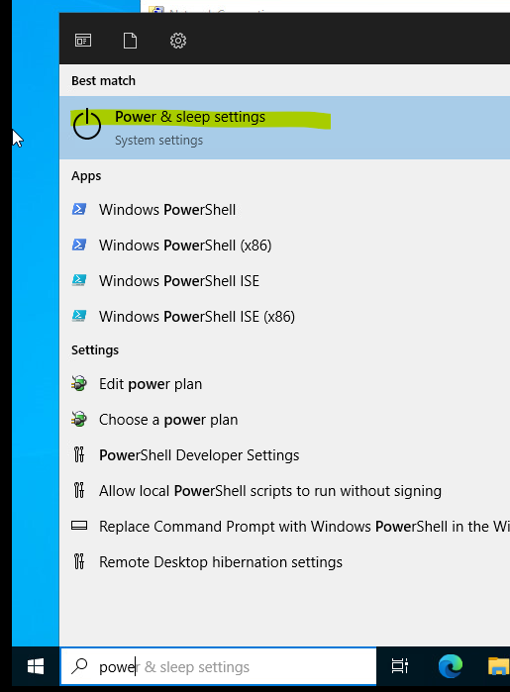

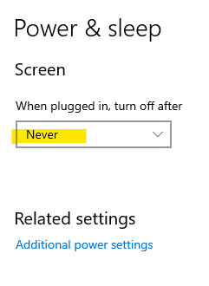

HOSTNAME:

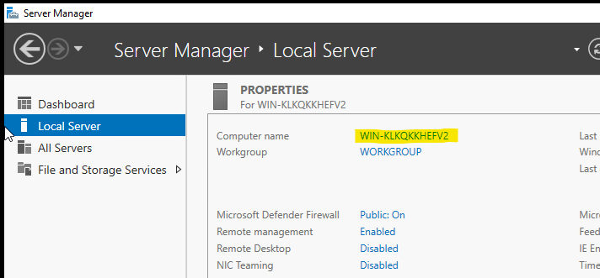

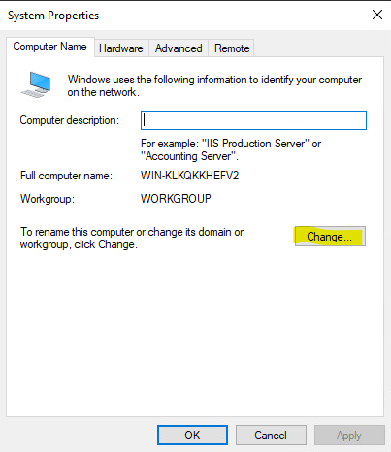

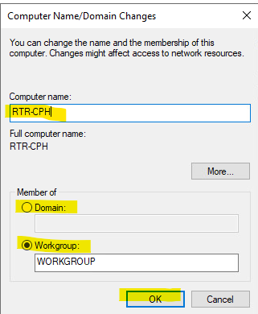

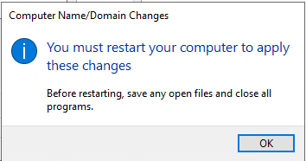

NETWORK CONFIGURATION - GUI

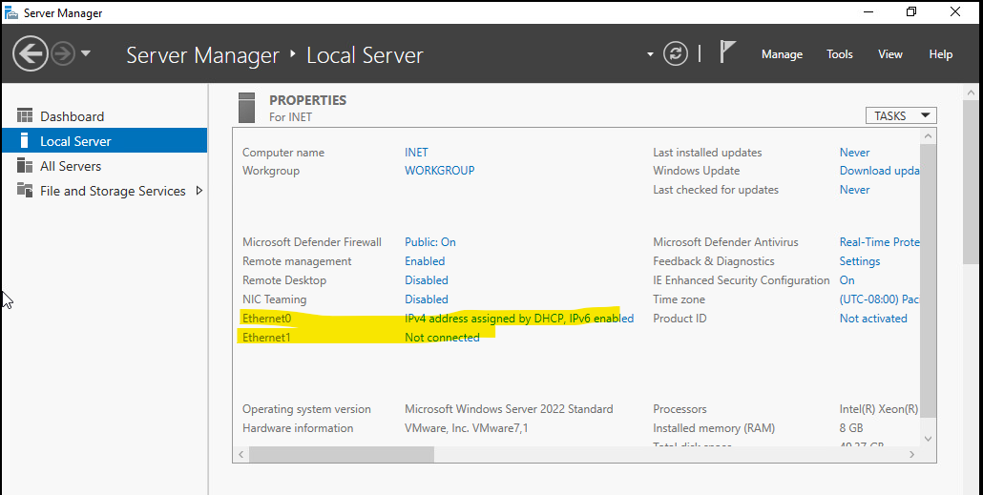

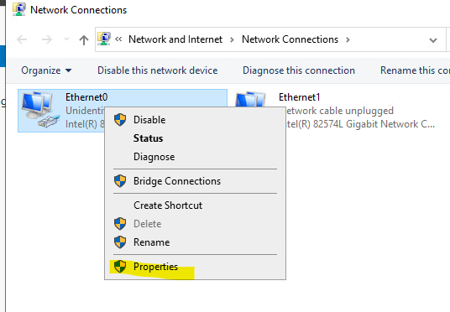

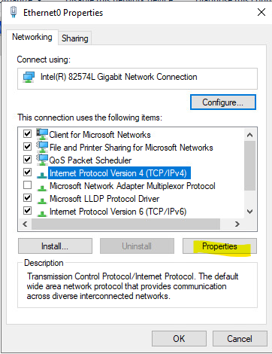

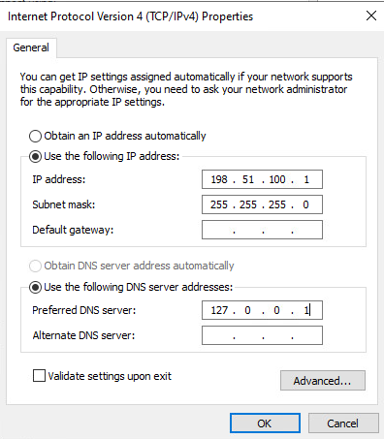

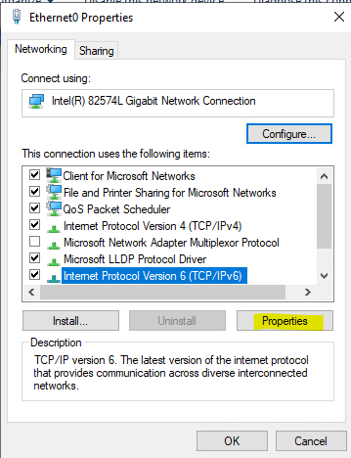

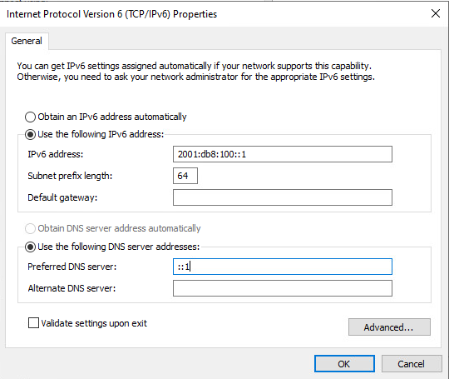

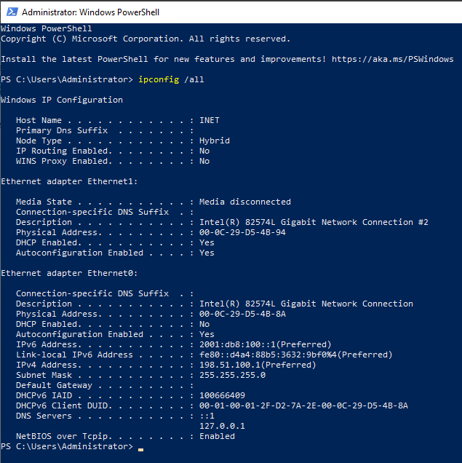

NETWORK CONFIGURATION - CORE

IPv4 via menu
IPv6 via Powershell

New-NetIPAddress -InterfaceAlias Ethernet0 -AddressFamily IPv6 -IPAddress fd01:2:1::1 -PrefixLength 64 -DefaultGateway fd01:2:1::254

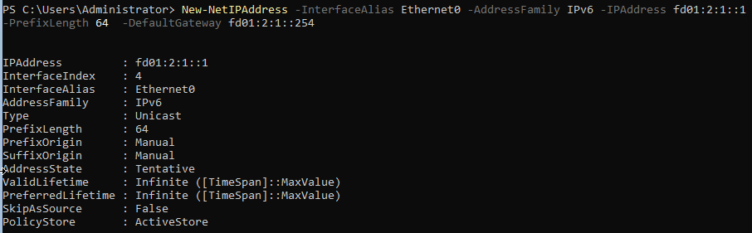

Set-DnsClientServerAddress -InterfaceAlias Ethernet0 -ServerAddresses ::1

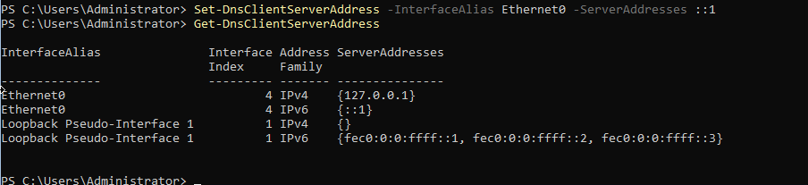

checking

ipconfig /all

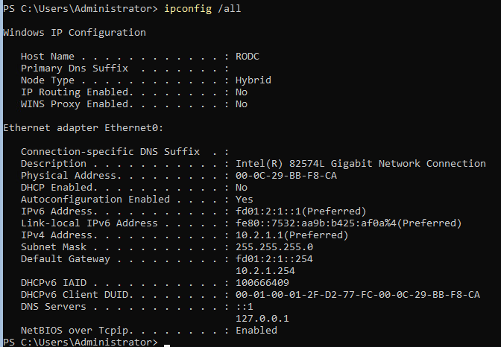

TIMEZONE

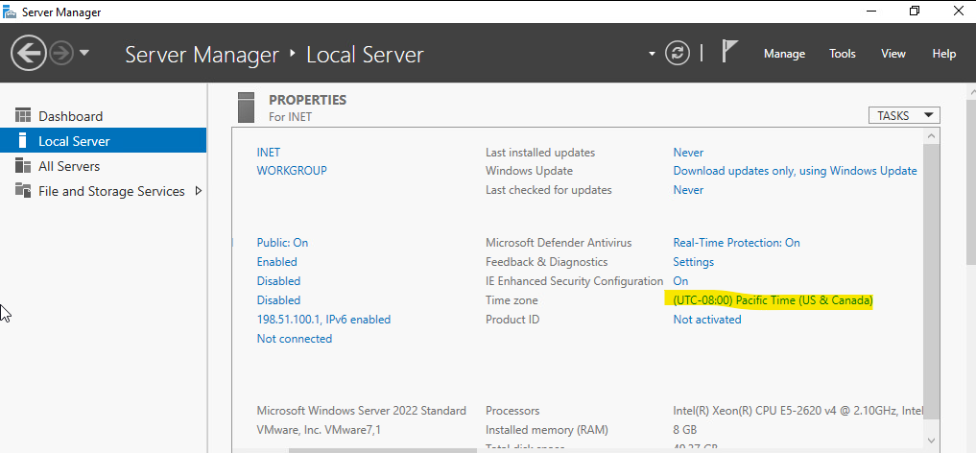

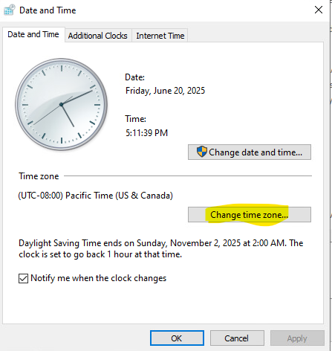

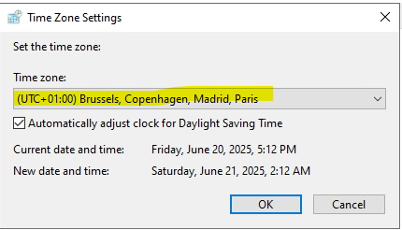

DESCRIPTION OF PROJECT AND TASKS
This project simulates a Microsoft-based enterprise network with two independent domains. You are tasked with deploying services such as Active Directory, DNS, certificate services, Group Policies, backups, automation via Ansible, and secure connectivity between sites. The environment must follow best practices and reflect real-world enterprise infrastructure.

INET
Role: Acts as external ISP – provides DNS, SMTP.
Server is preconfigured:

INET - Task1: DNS server
- Authoritative Nameserver for nordicbackup.net and skillspublic.dk domain with records according to Appendix E

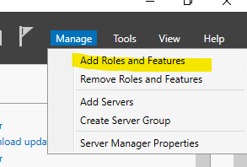

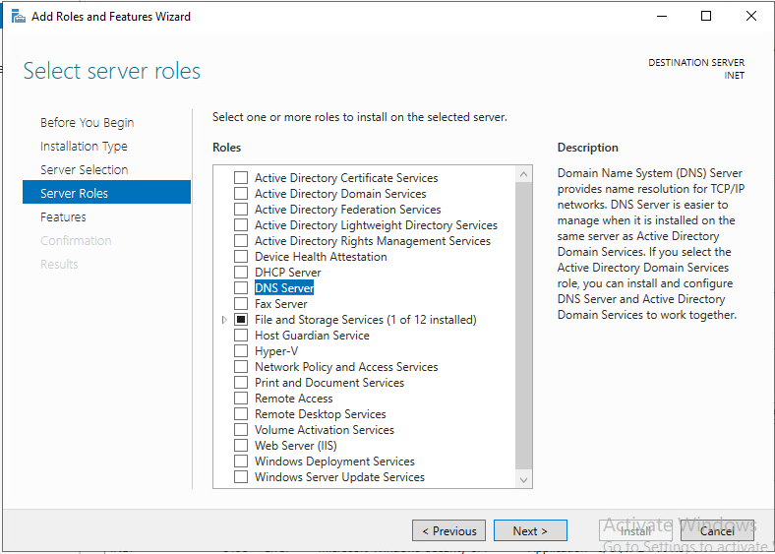

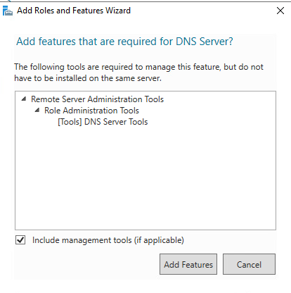

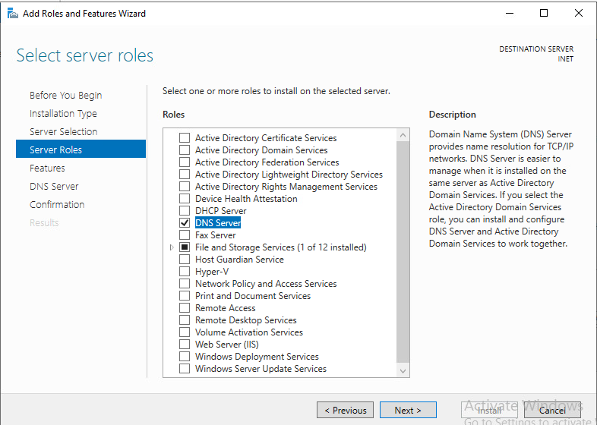

https://extratrucos.com/informatica-tecla-suprimir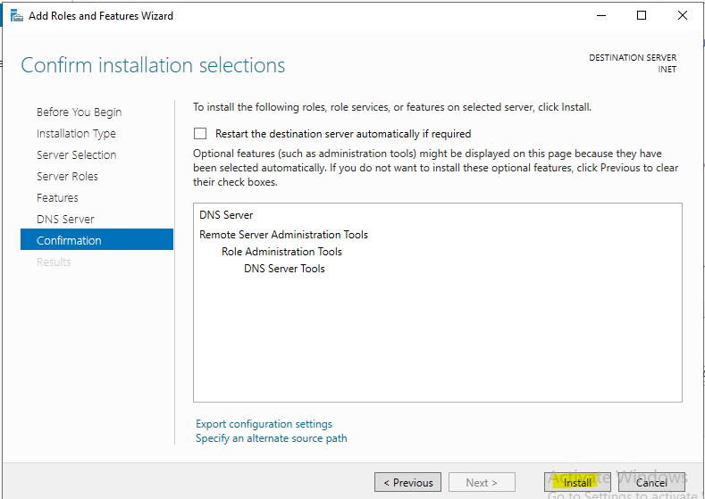

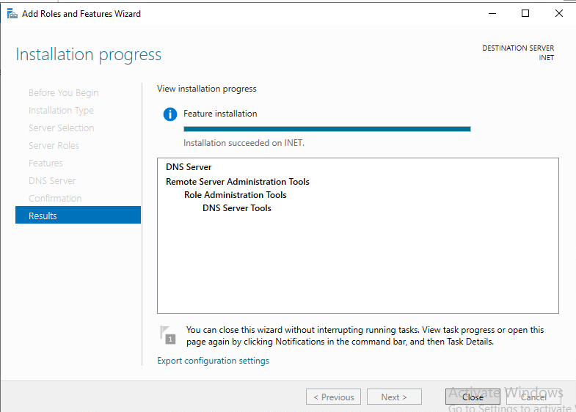

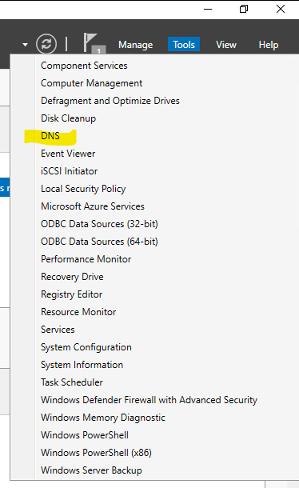

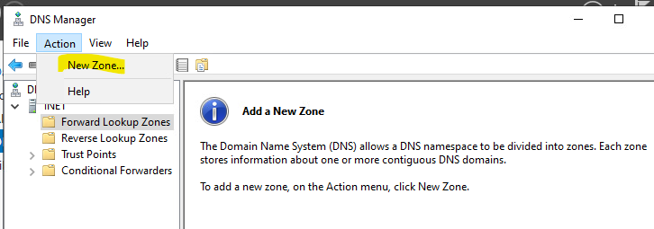

https://extratrucos.com/informatica-tecla-suprimir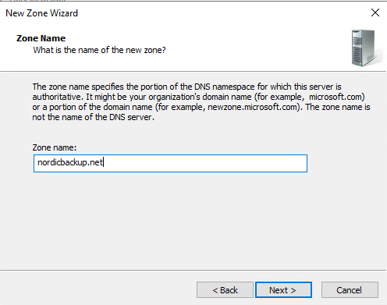

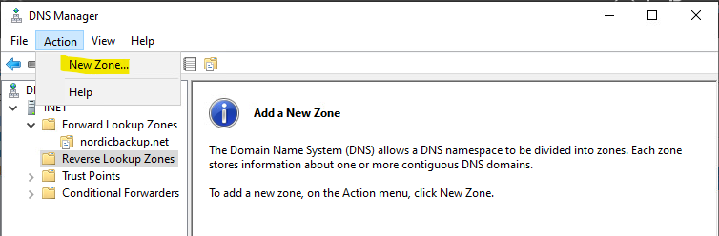

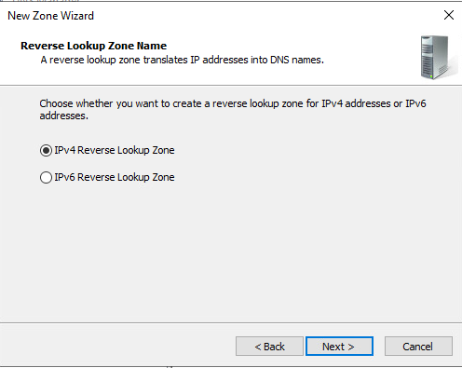

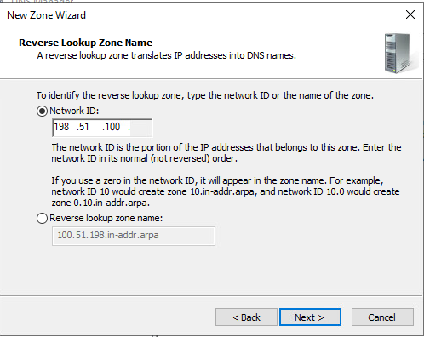

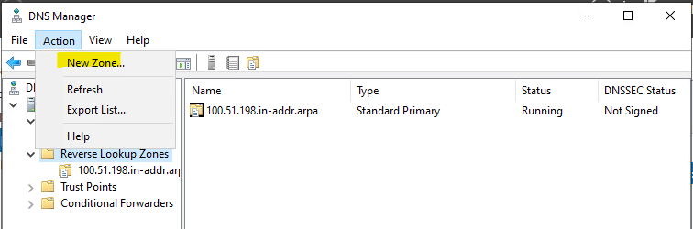

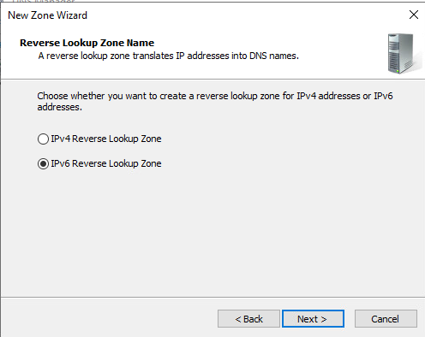

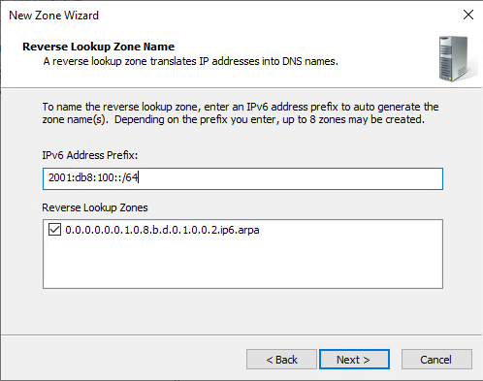

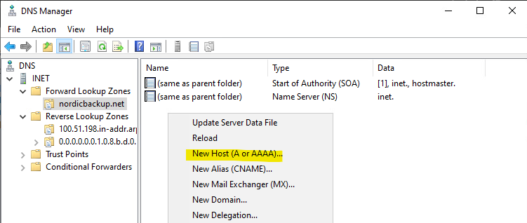

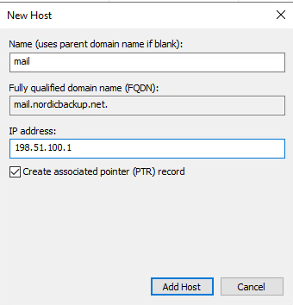

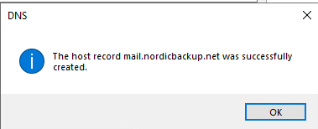

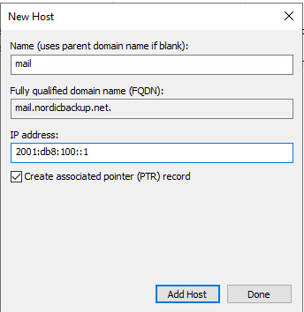



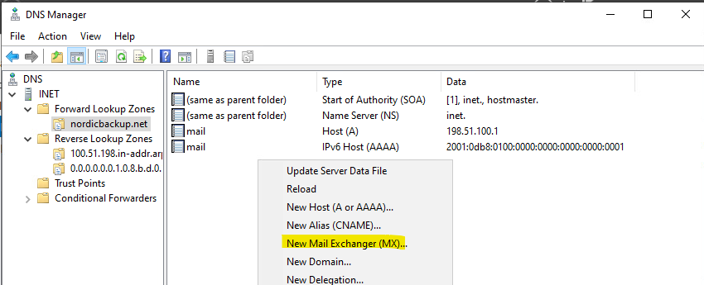

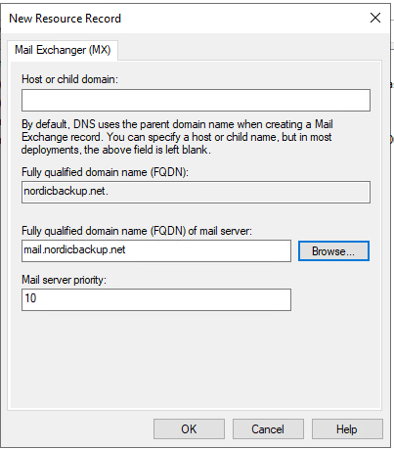

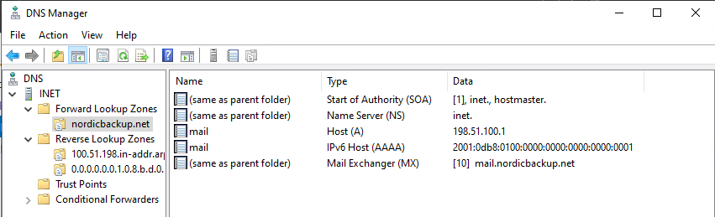

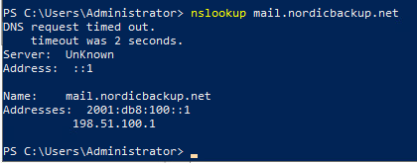

REPEAT THE PROCESS WITH skillspublic.dk domain - Here is the result:

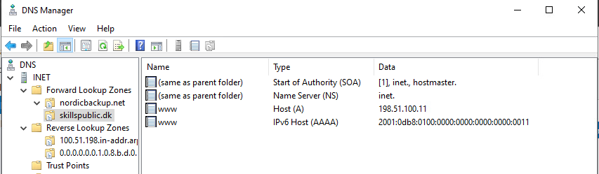

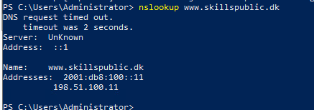

INET - Task2: SMTP server
- SMTP server for notifications

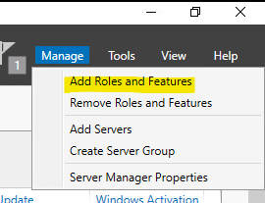

Let “Select server roles” selection as it is, DO NOT CHOOSE ANYTHING

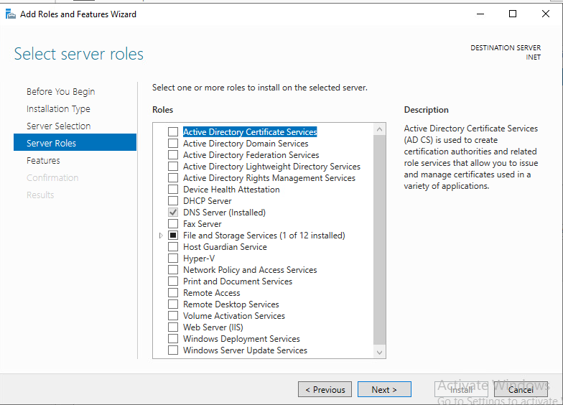

In “Features”, choose “SMTP Server”:

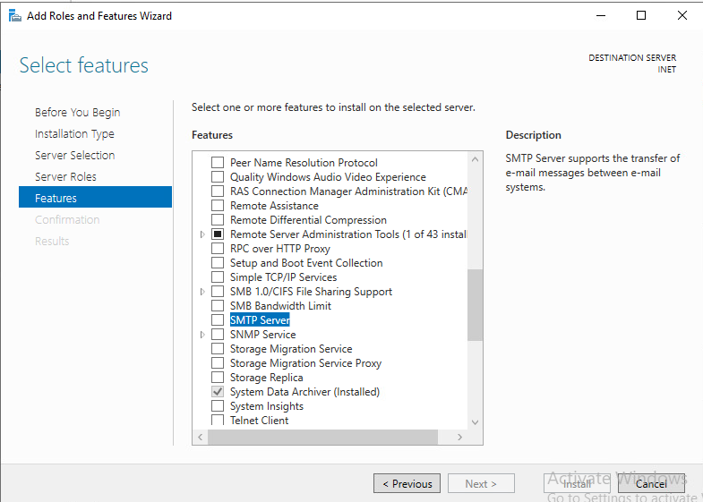

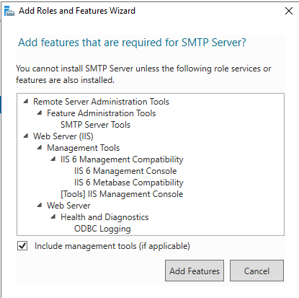

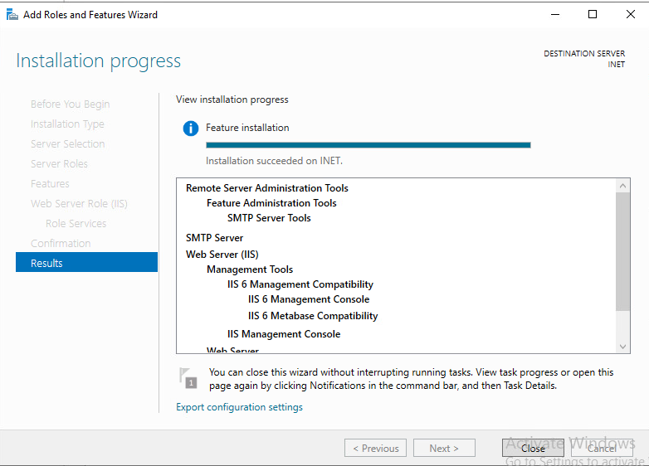

CONFIGURE

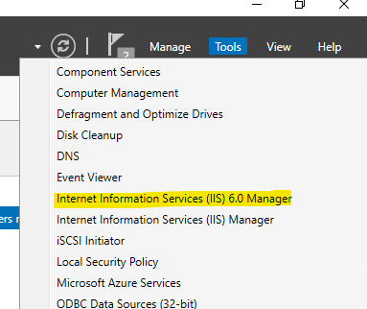

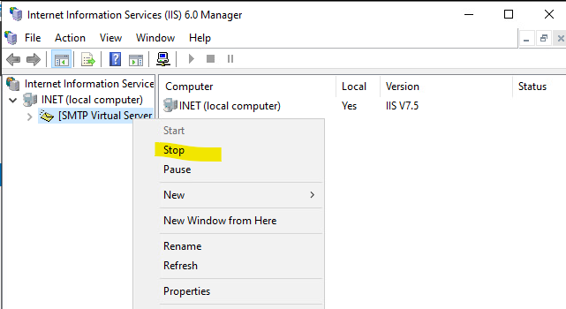

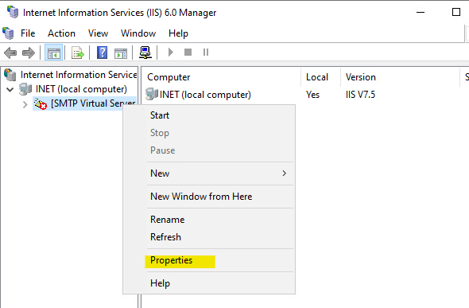

If it gives a MMC error, do this:

Open services.msc
Stop SMTPSVC service [Display Name: Simple Mail Transfer Protocol (SMTP)]
Stop IISADMIN service [Display name: IIS Admin Service]
Edit "C:\Windows\System32\inetsrv\MetaBase.xml"
Find: <IIsSmtpServer Location ="/LM/SmtpSvc/1"
Add (Settings are alphabetical): RelayIpList=""
Save file
Start IISAdmin Service
Start SMTPSVC service

Try again:



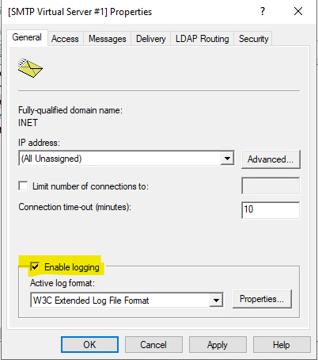

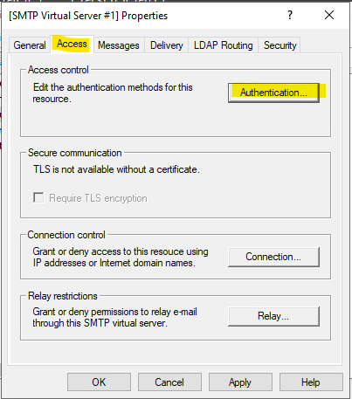

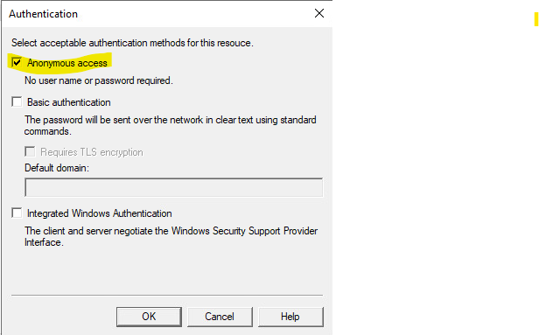

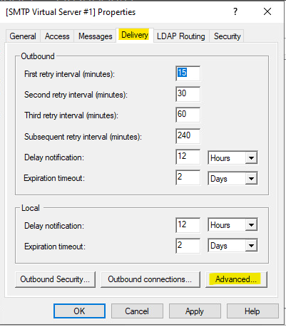

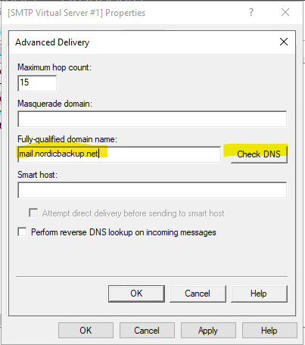

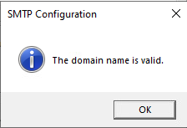

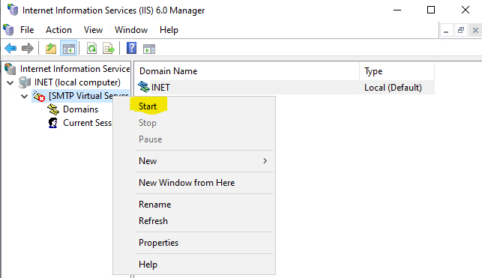

INET - Task3: web server
- Web server running on ports 80 and 8080

Main Server Role already installed with SMTP. But you must install some Common HTTP Features for the IIS to work:

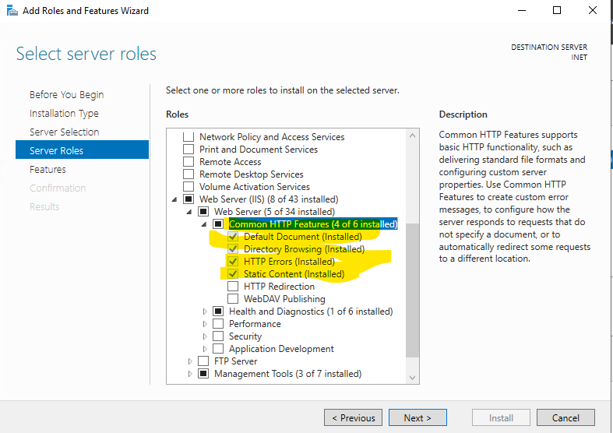

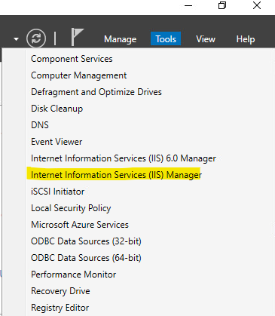

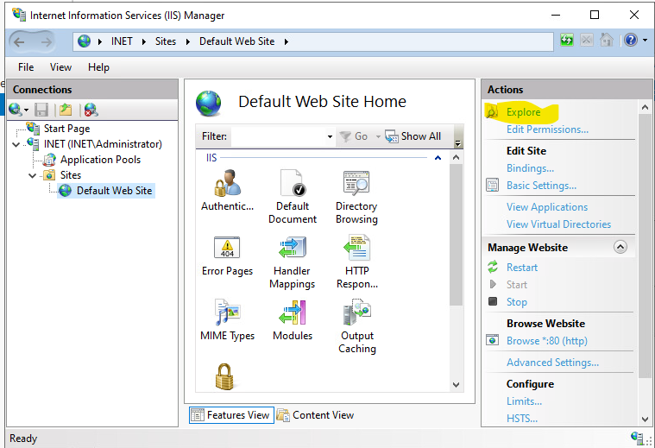

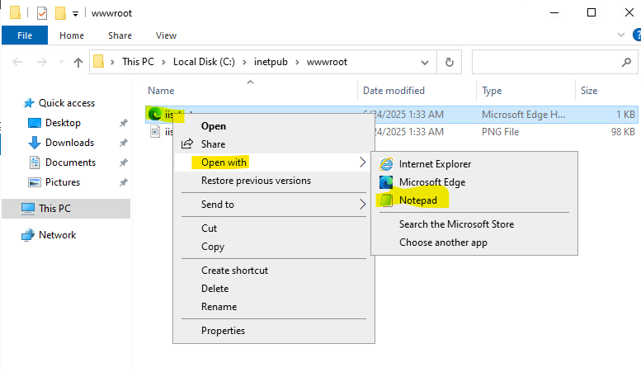

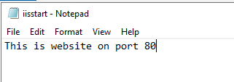

Web browser:

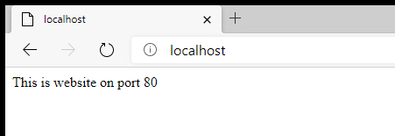

ADD website on port 8080

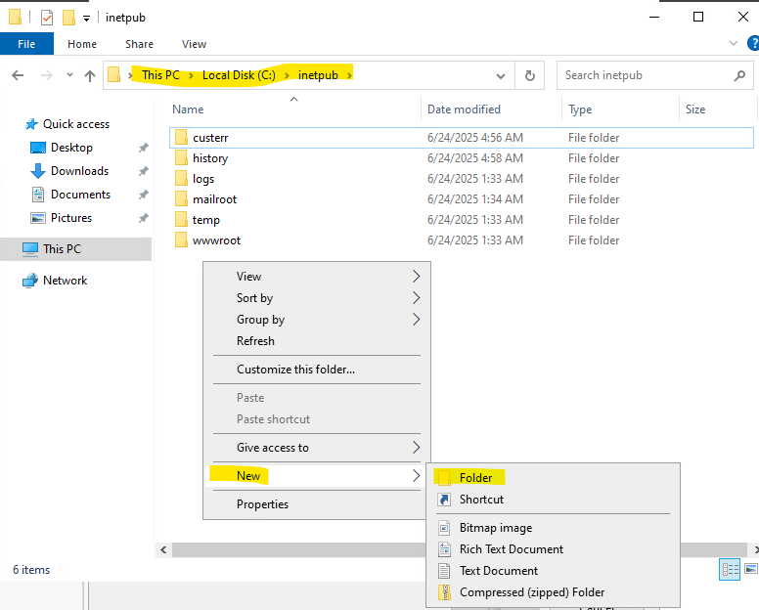

https://extratrucos.com/informatica-tecla-suprimir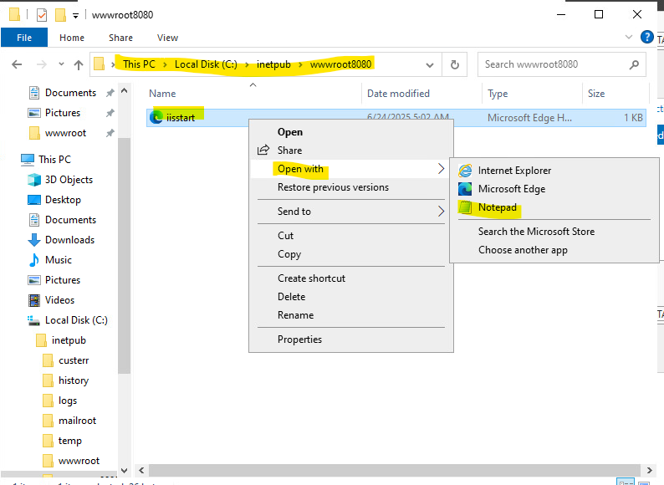

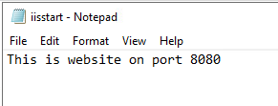

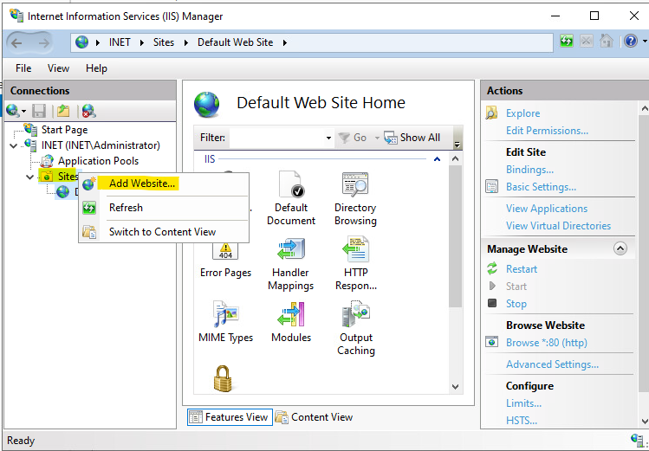

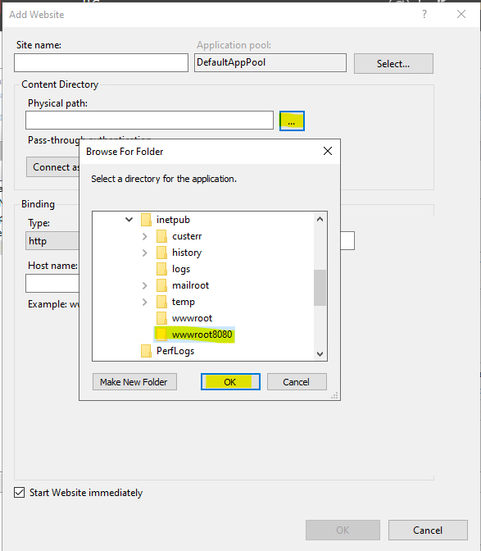

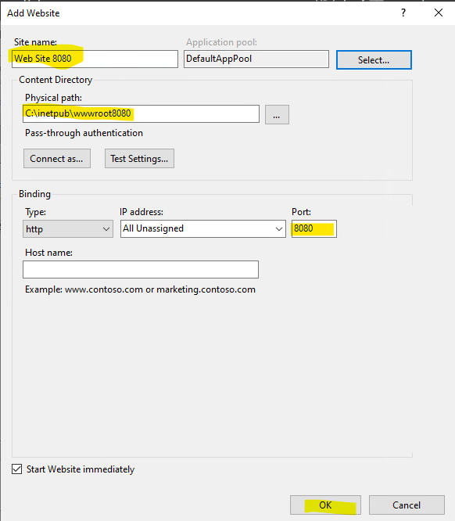

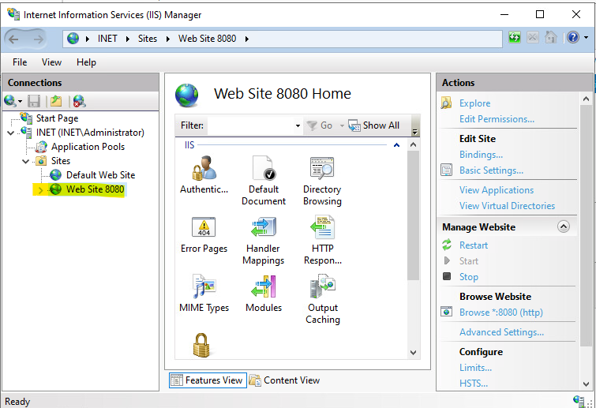

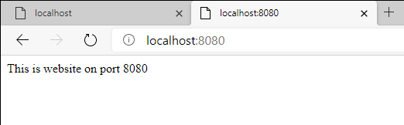

RTR-CPH
Role: HQ Router
Tasks:

RTR-CPH - Task1: Site-to-site VPN
- Configure IKEv2 Site-to-Site VPN with RTR-AAL

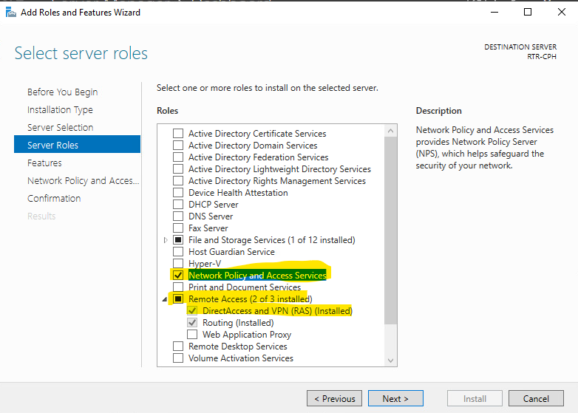

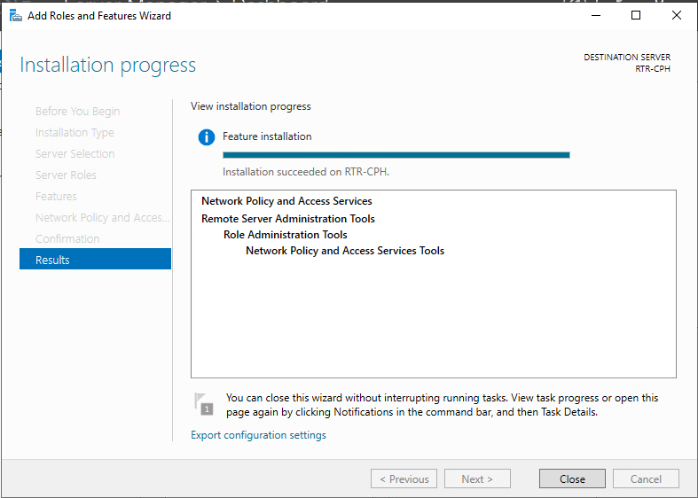

- Go to DC machine (CA) to create certs

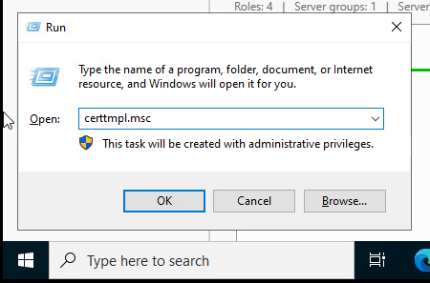

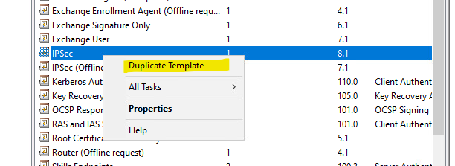

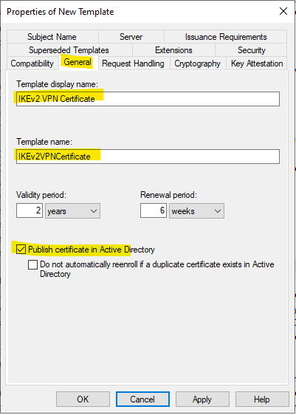

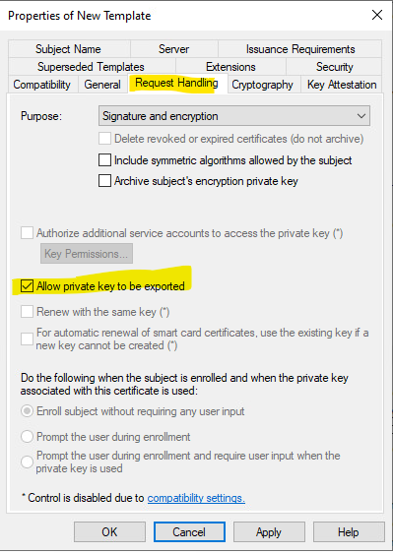

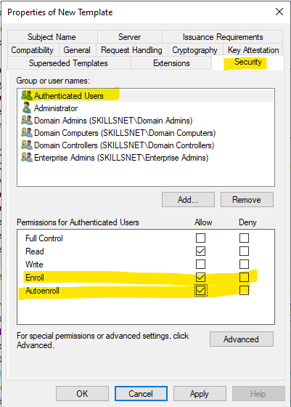

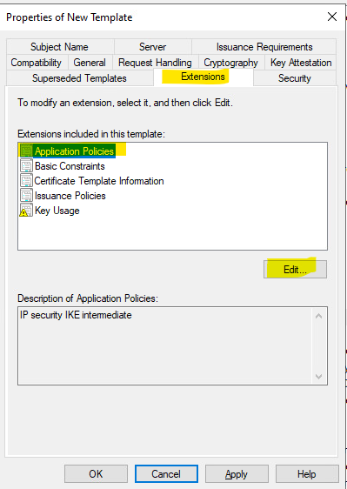

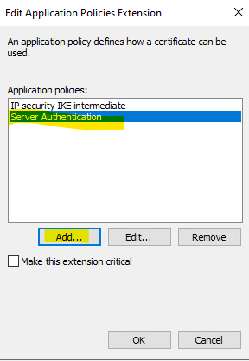

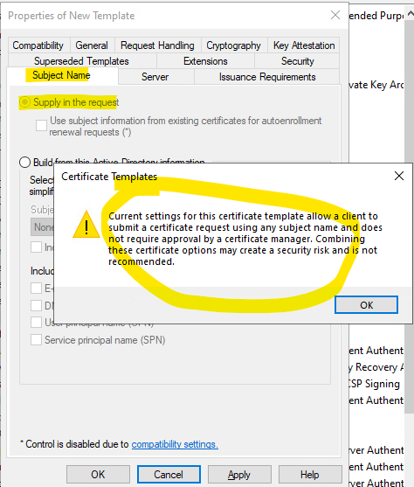

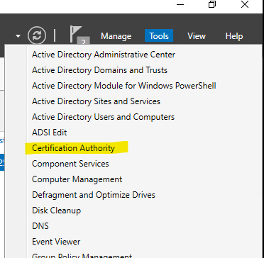

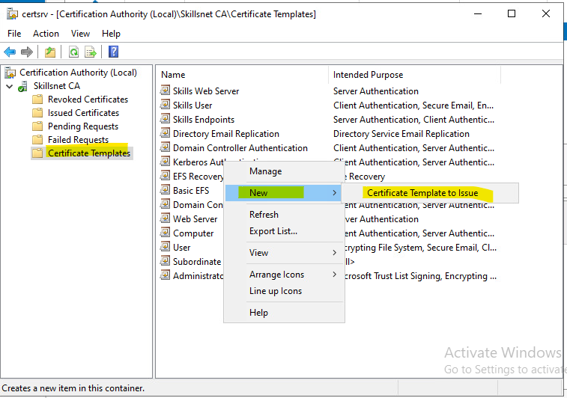

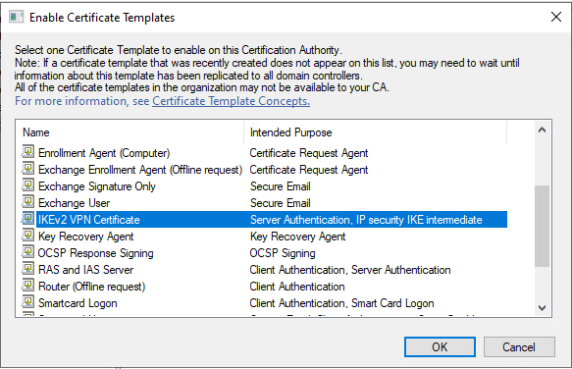

- Create certificates for RTR-CPH and RTR-AAL

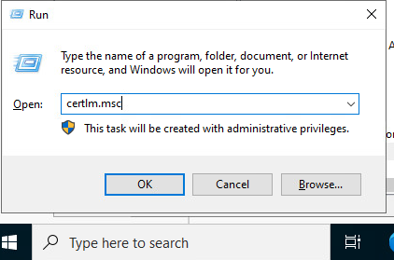

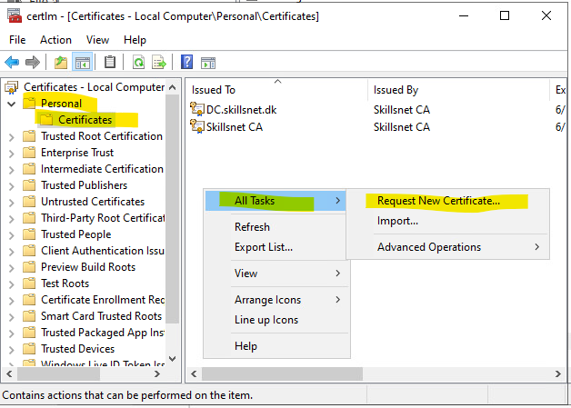

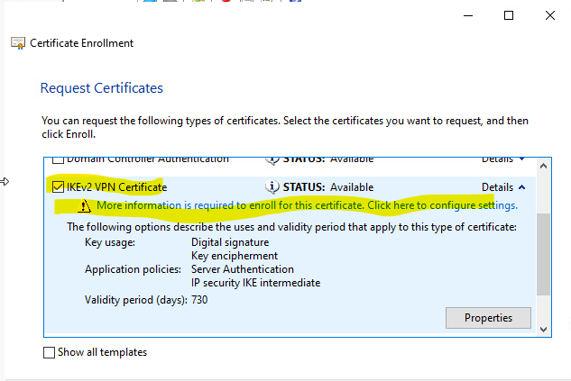

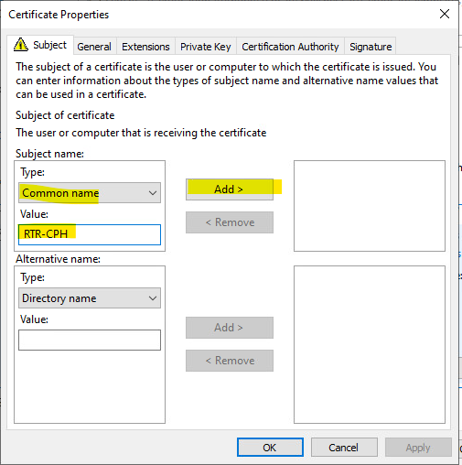

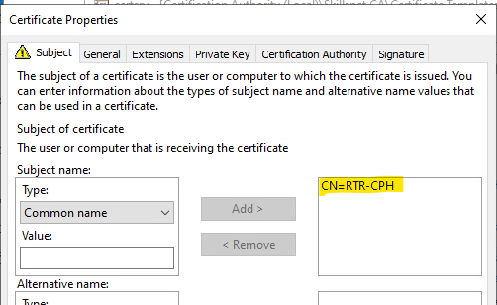

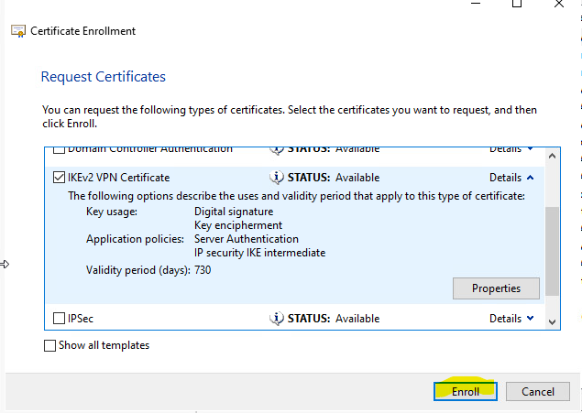

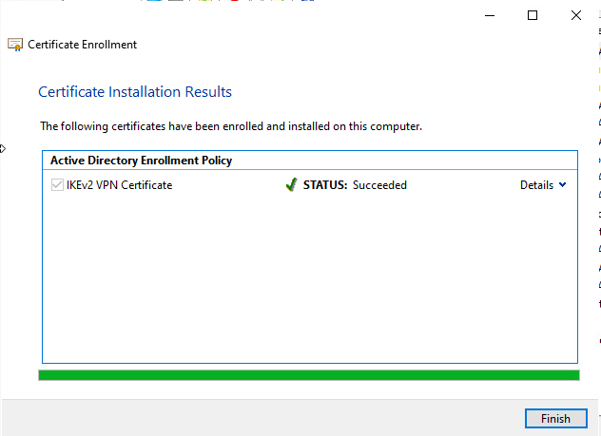

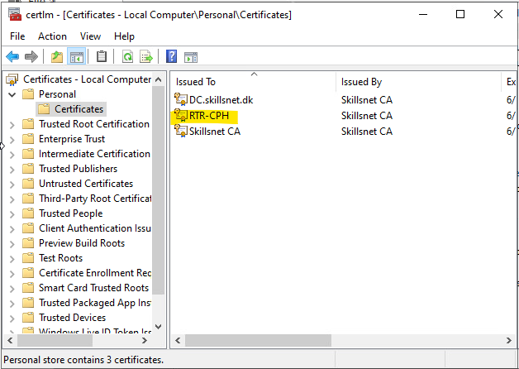

Repeat the process for RTR-AAL

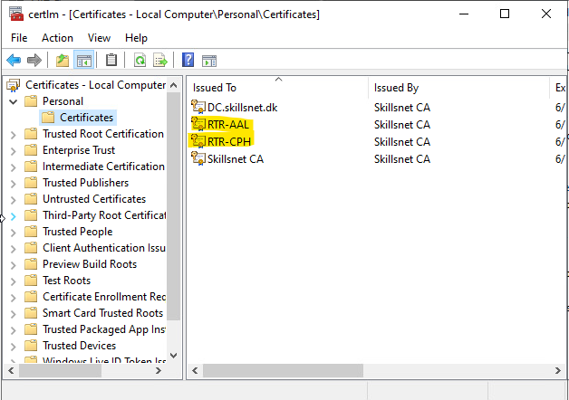

- Export certificates to shared folder (see how to in DC)

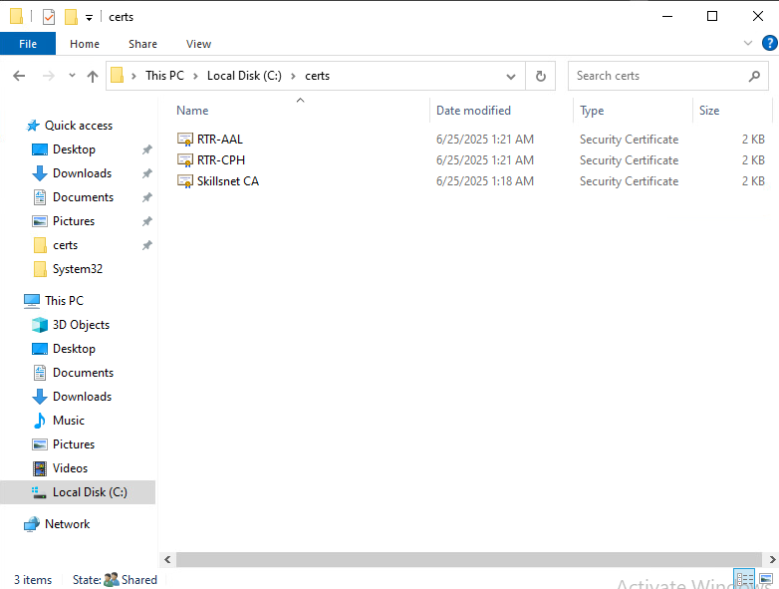

- Back to RTR-CPH

Create a shared folder to transfer certs and other things to Branch:

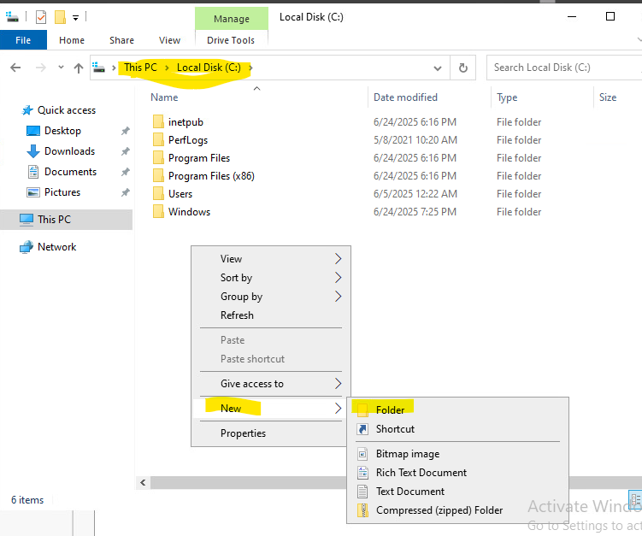

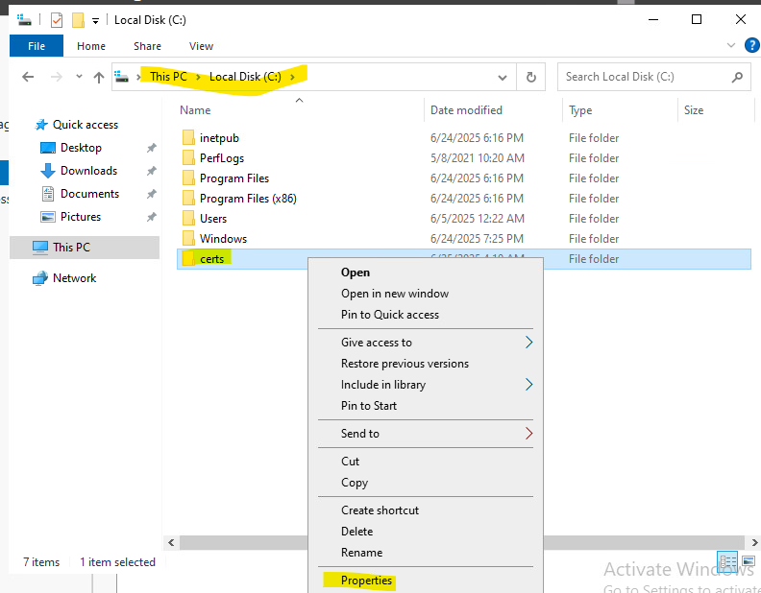

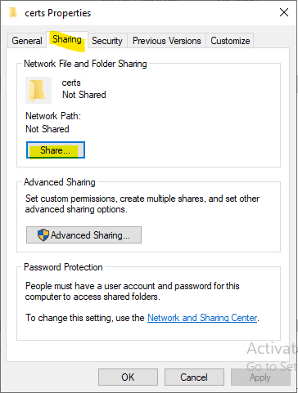

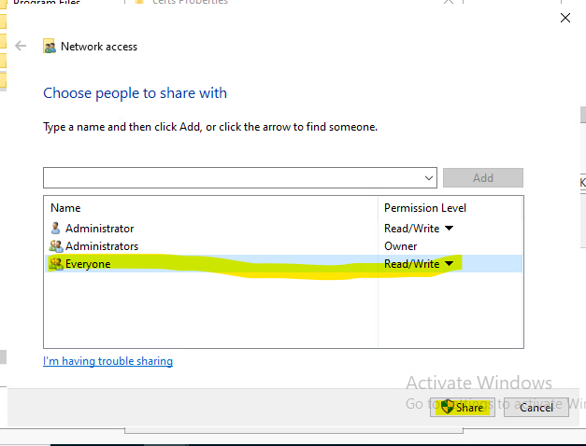

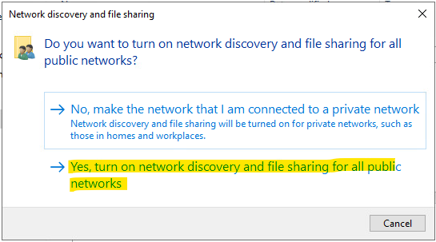

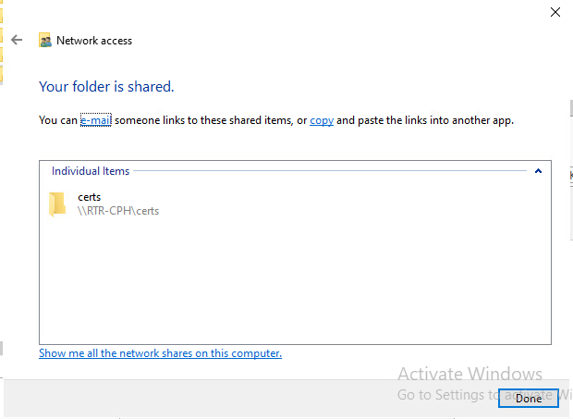

Access to the shared folder in DC and copy here RTR-CPH.cer, RTR-AAL.cer and Skillsnet CA.cer:

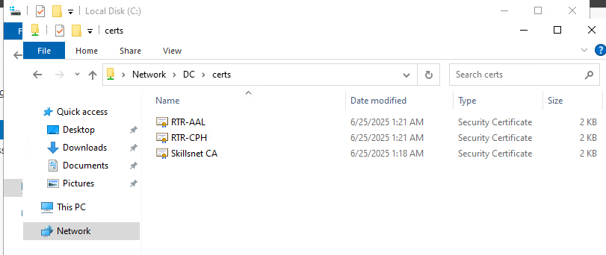

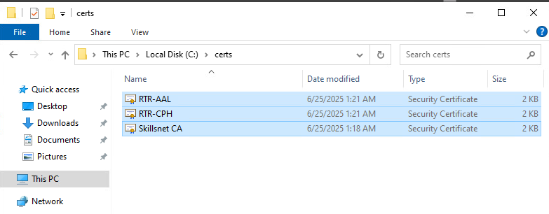

Install RTR-CPH certificate:

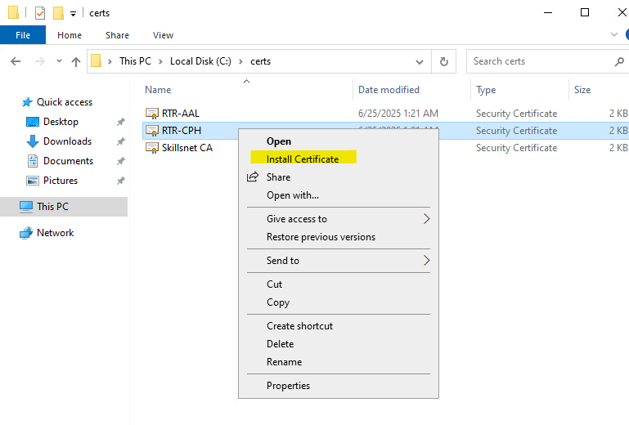

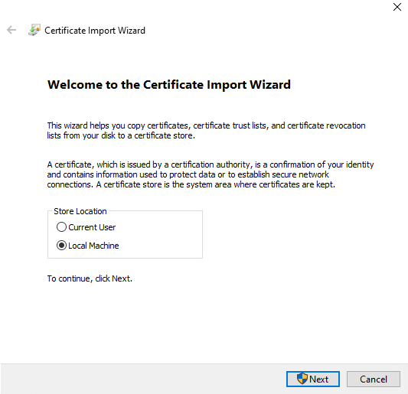

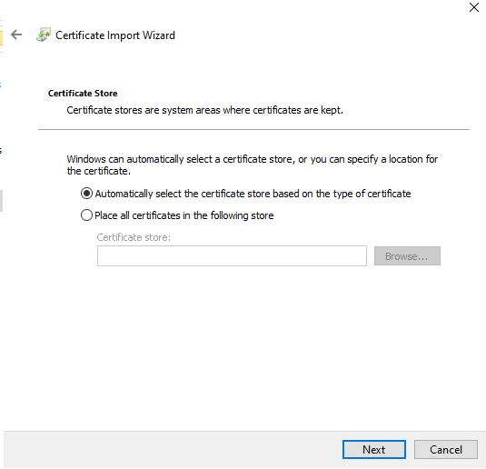

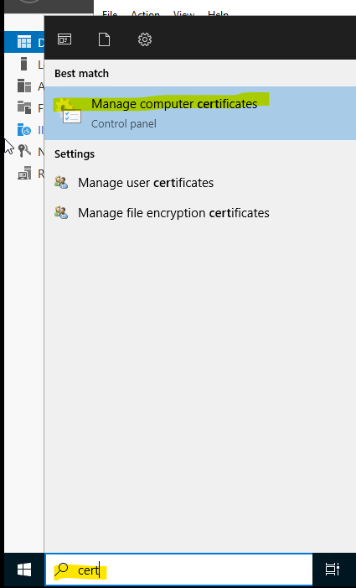

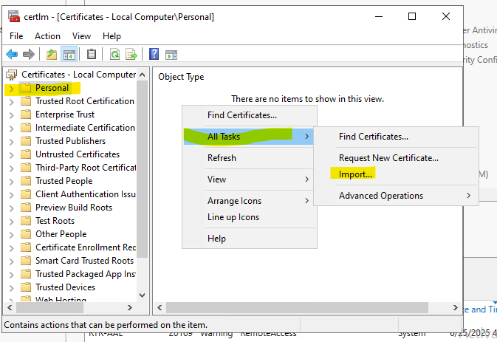

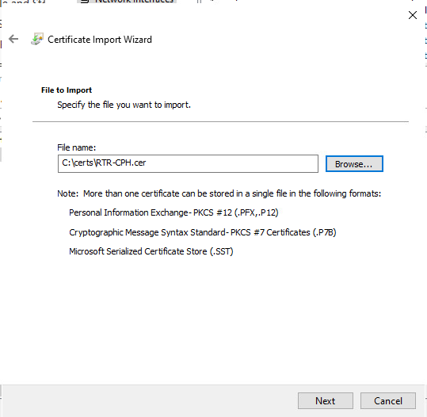

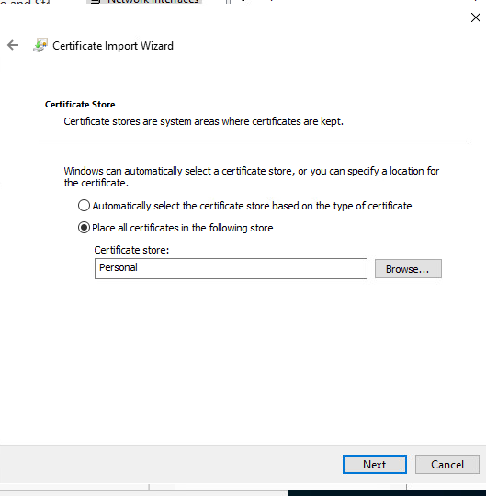

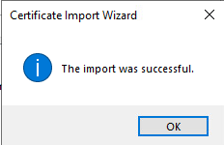

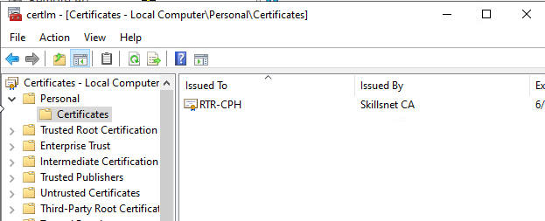

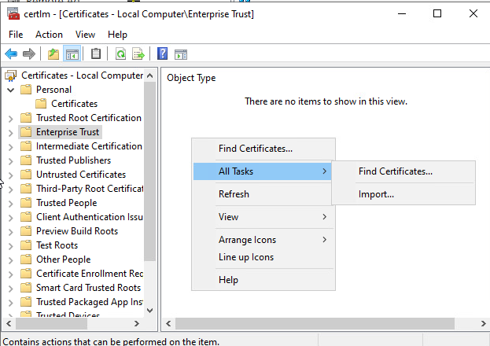

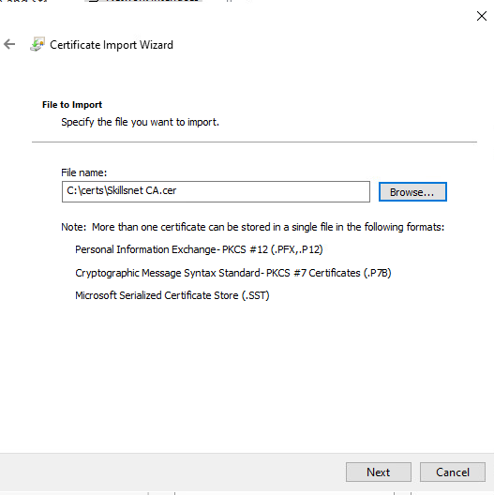

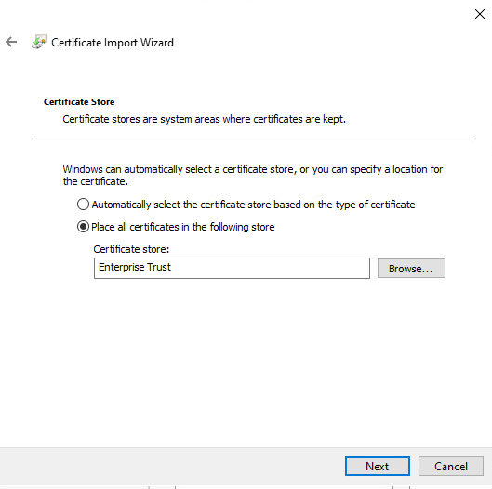

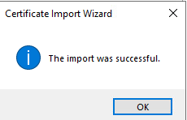

- Site-to-site VPN configuration:

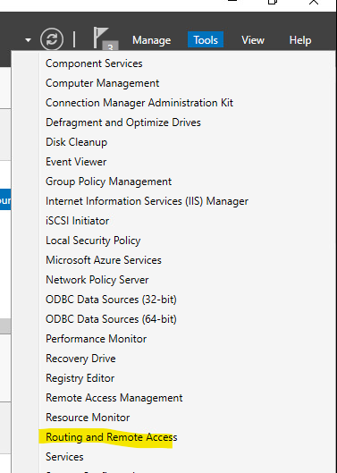

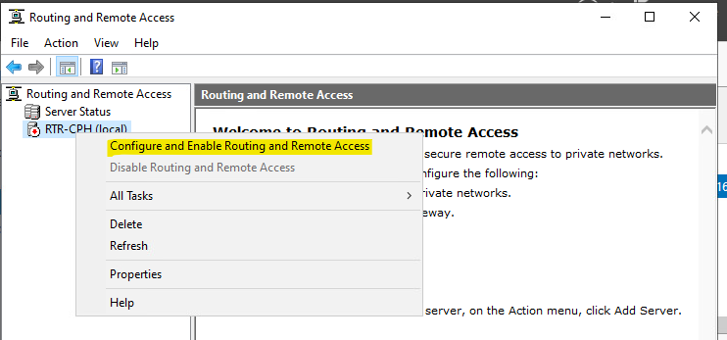

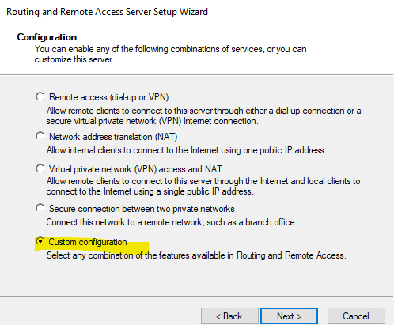

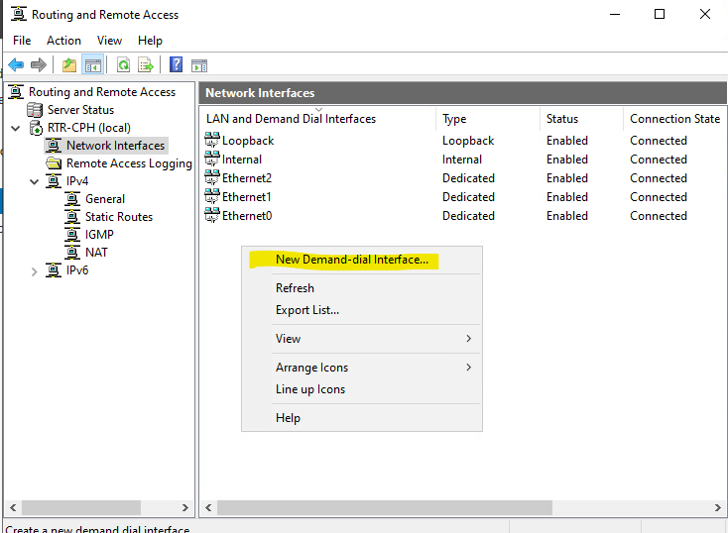

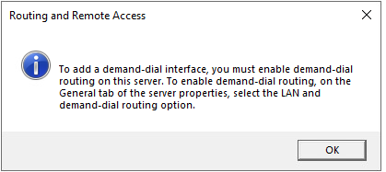

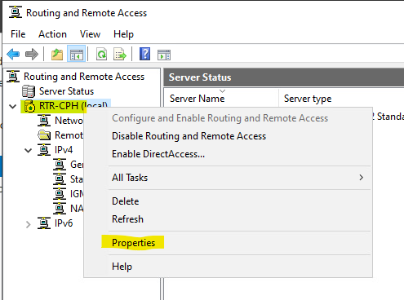

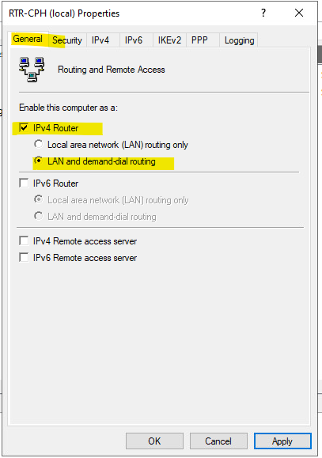

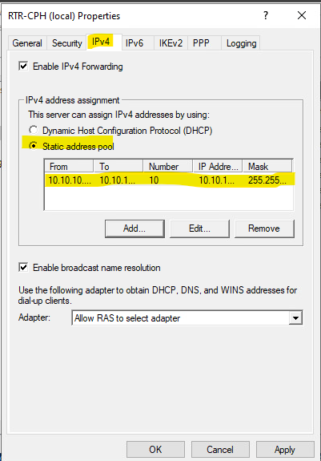

IP range: 10.10.10.11-10.10.10.20 (10 IPs)
Configuration only necessary in one extreme (for example, RTR-CPH)

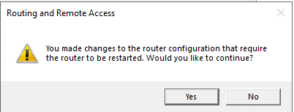

Maybe you must restart the computer.



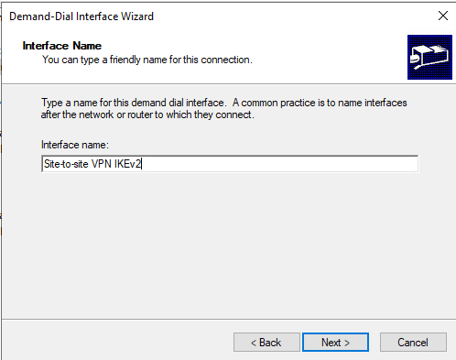

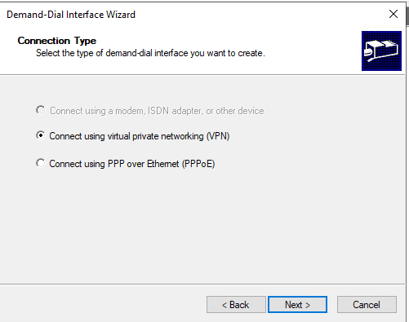

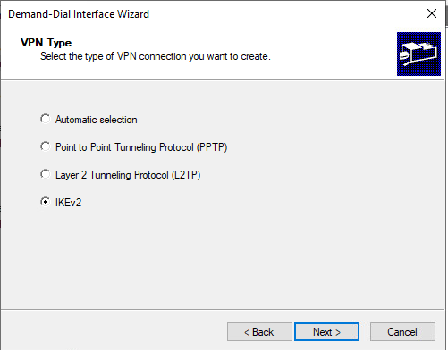

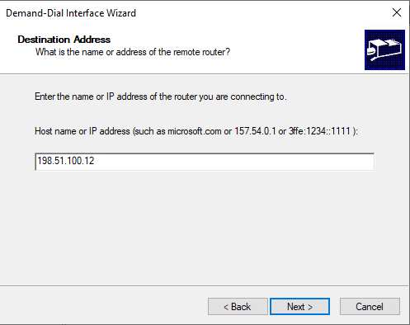

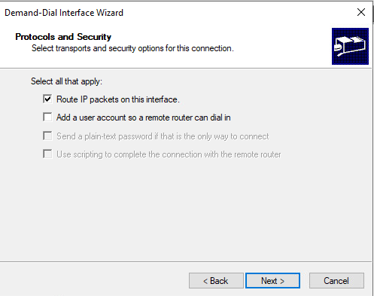

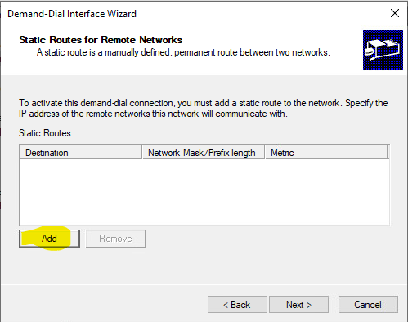

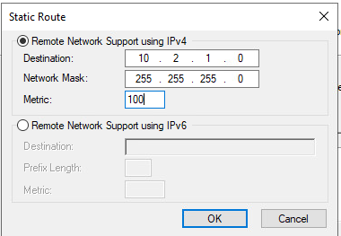

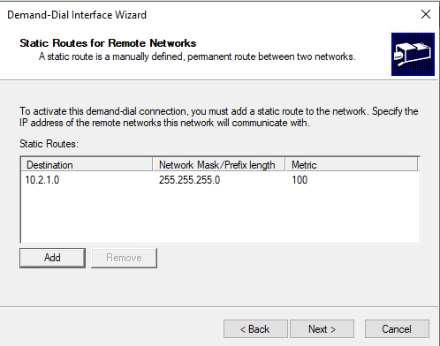

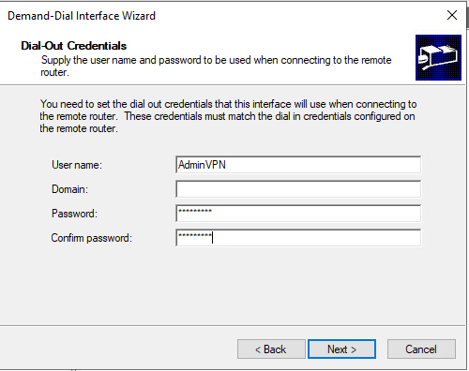

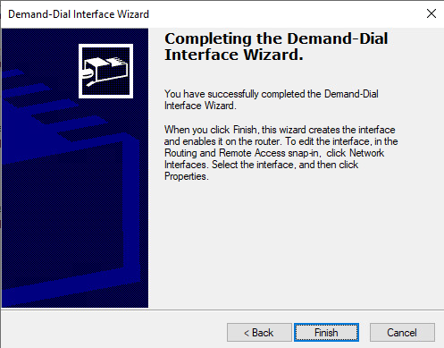

Certificates do not seem to work properly. Use PSK instead:
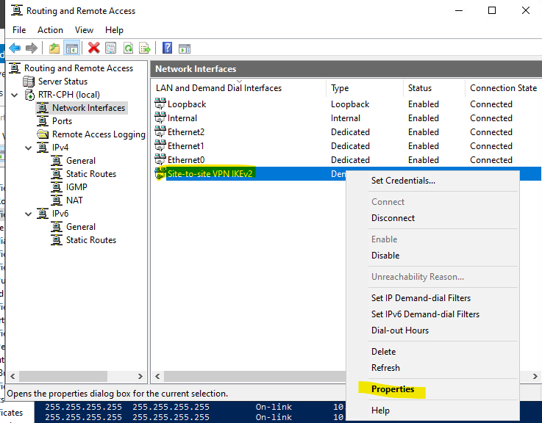

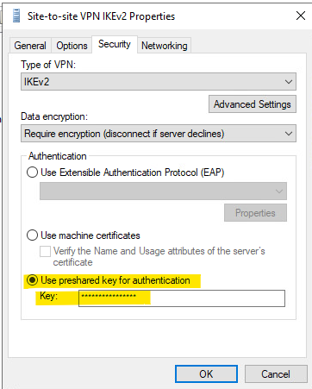

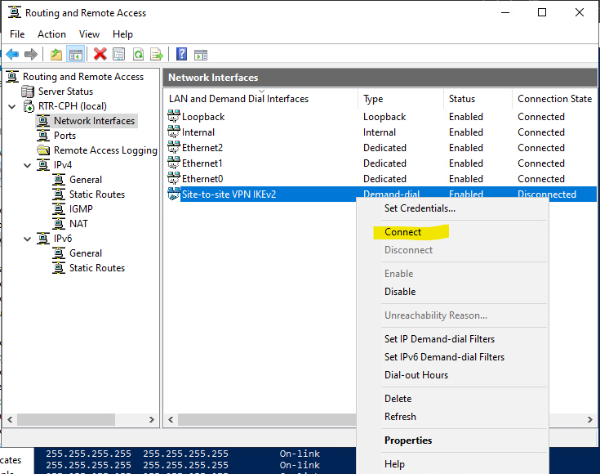

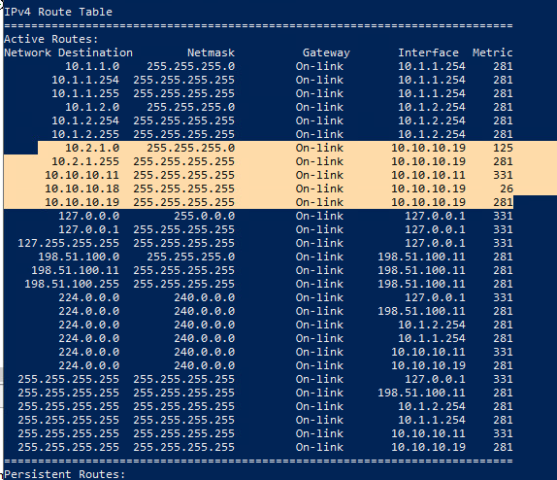

RTR-CPH - Task2: RRAS FW
- Configure RRAS firewall:
  - Block all outbound traffic to TCP port 8080
  - Block all outbound connections to WinRM

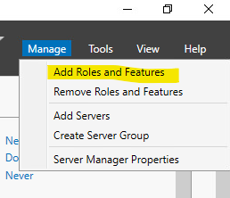

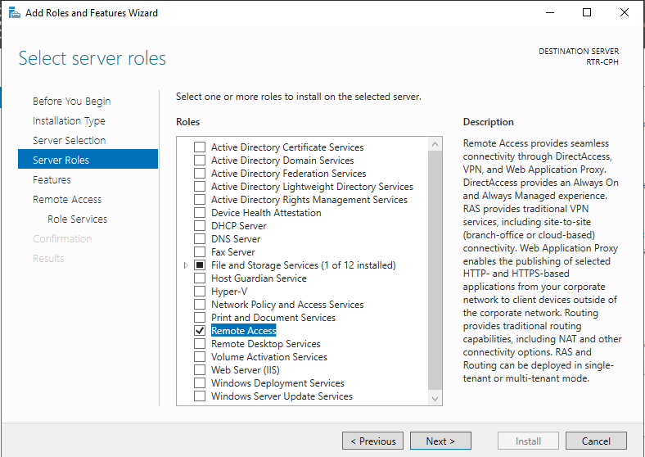

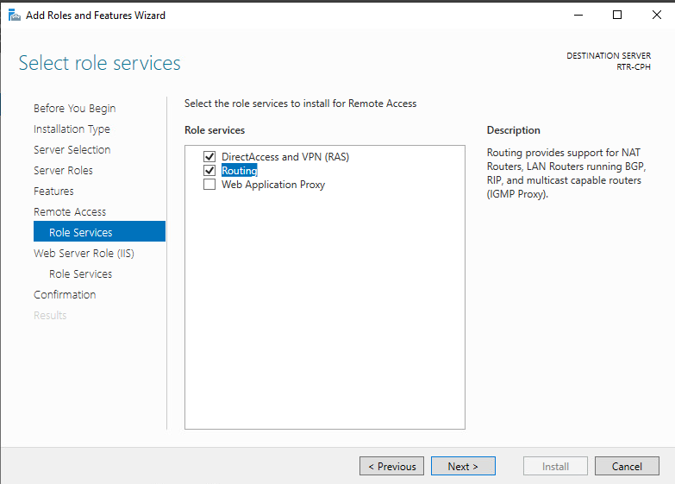

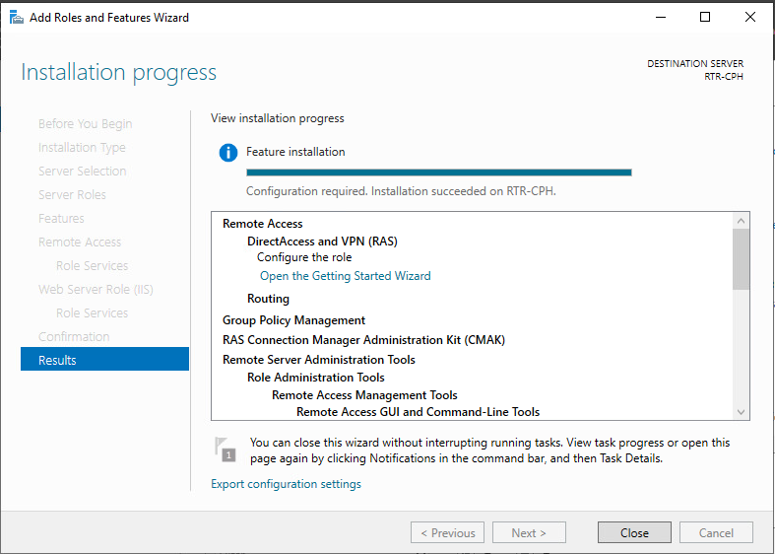

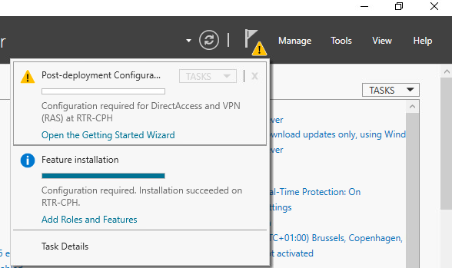

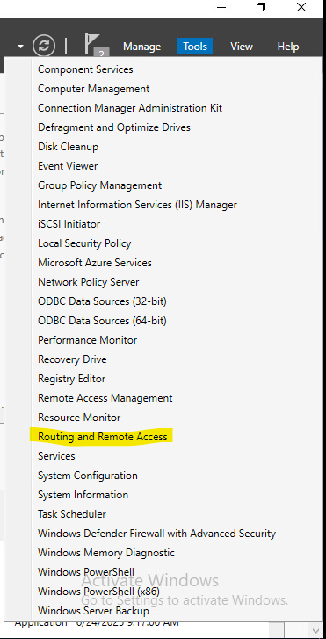

RTR-CPH - Task3: Port forwarding
- Port forward 198.51.100.11:8080 to DEV-SRV port 80

RTR-CPH - Task4: Reverse proxy
- Configure reverse proxy against www.skillsnet.dk, host it as www.skillspublic.dk

RTR-CPH - Taskr: NAT (masquerade)
- Configure NAT rules for outbound (external) connectivity



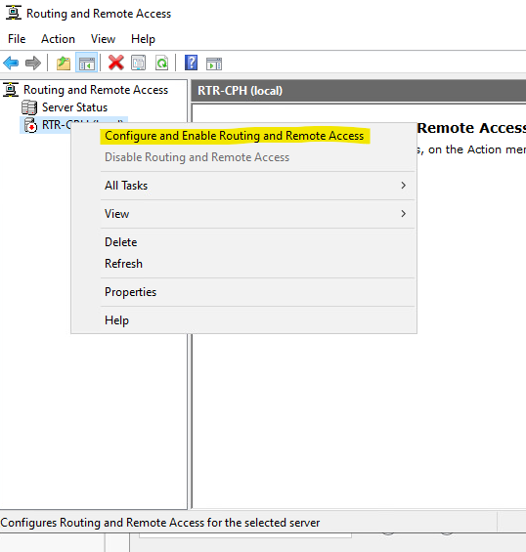

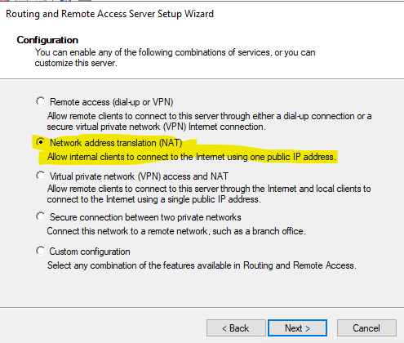

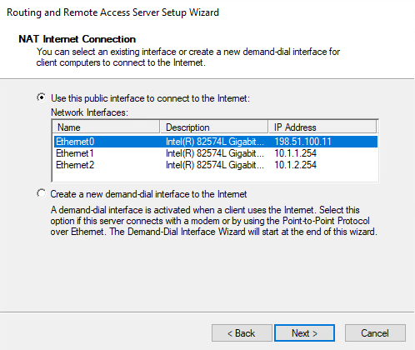

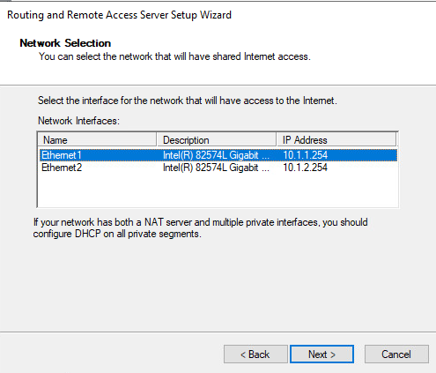

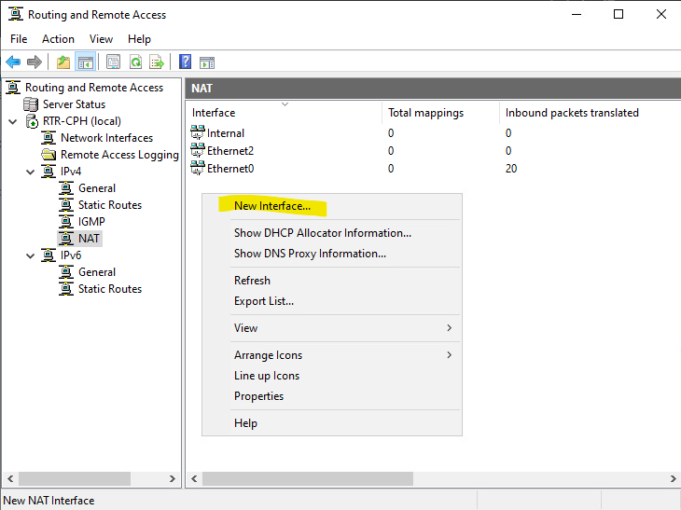

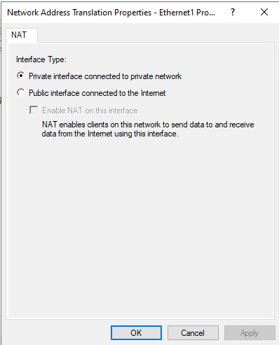

RTR-AAL
Role: Branch Router
Tasks:

RTR-AAL - Task1: Site-to-site VPN
- Configure IKEv2 Site-to-Site VPN with RTR-CPH

RTR-AAL - Task2: NAT (masquerade)
- Configure NAT rules for outbound (external) connectivity

DC
Role: Primary Domain Controller for skillsnet.dk. Provides Enterprise PKI and SAML IdP.

Active Directory & Identity Services

DC AD - Task1: Domain controller
- Don’t forget rename host to DC previously.

- Promote to DC and create domain skillsnet.dk

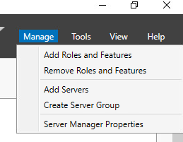

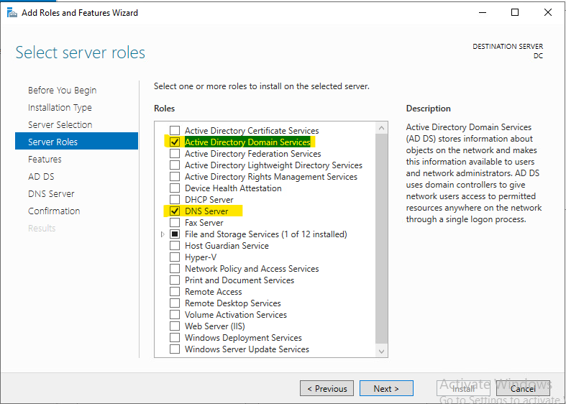

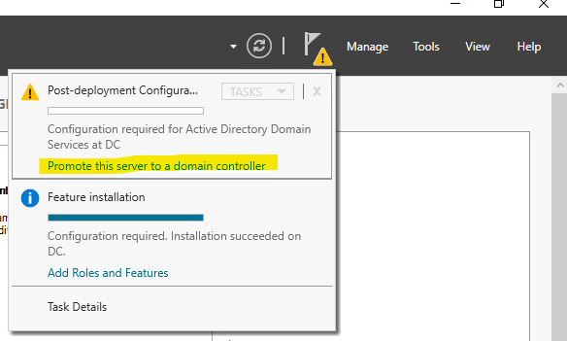

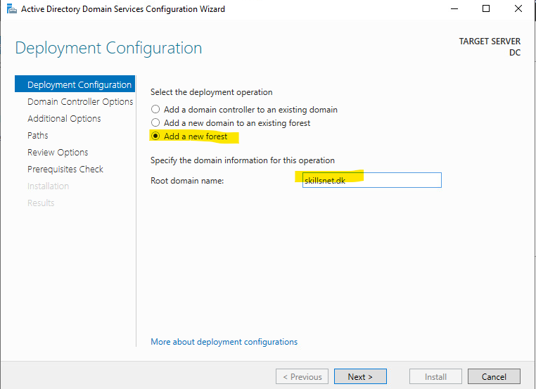

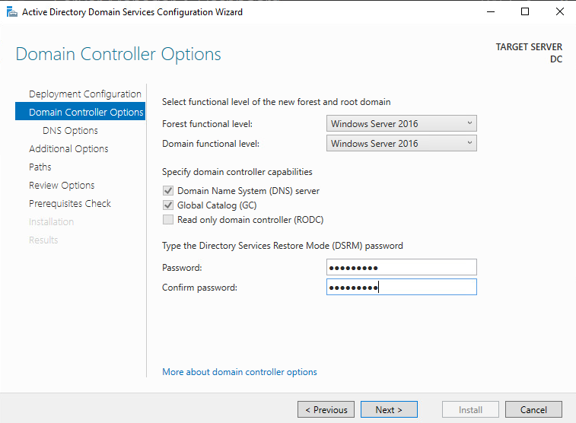

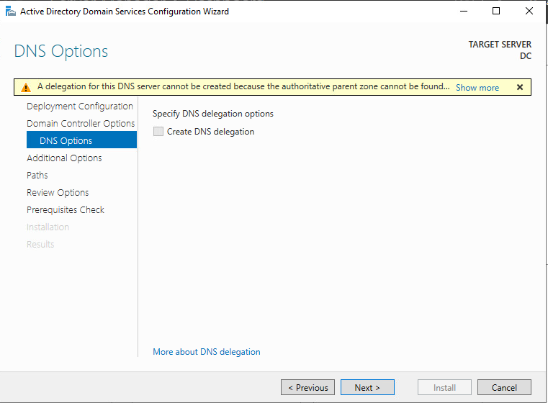

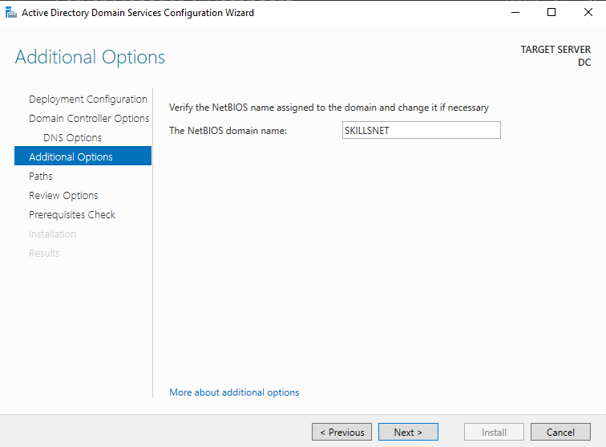

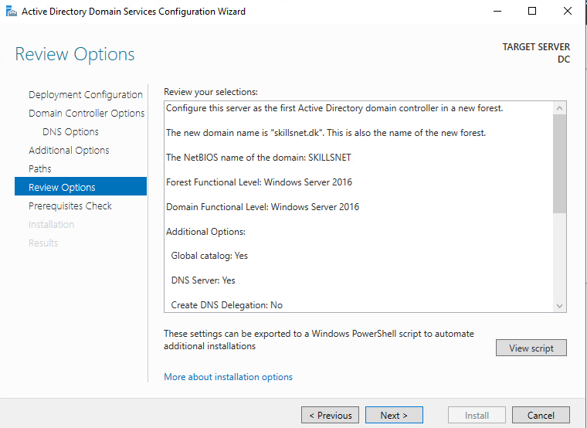

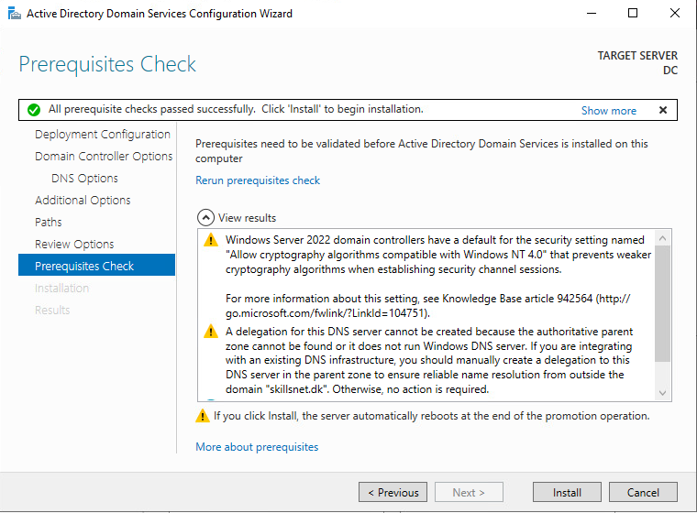

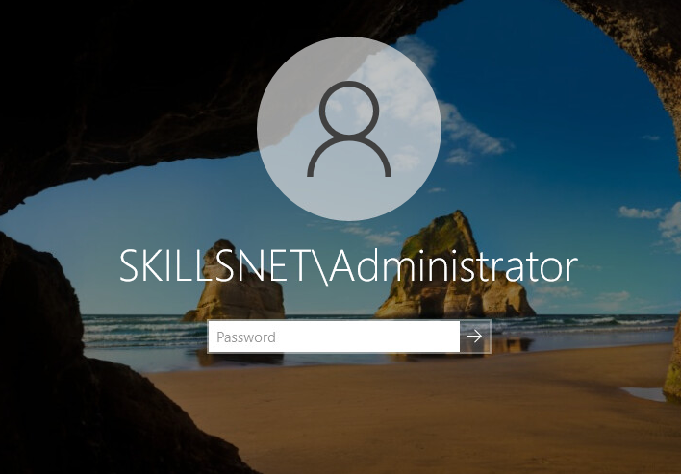

- Join machines to domain.

Notes:
- RODC needs the VPN active to join domain.

Example with GUI: SRV1

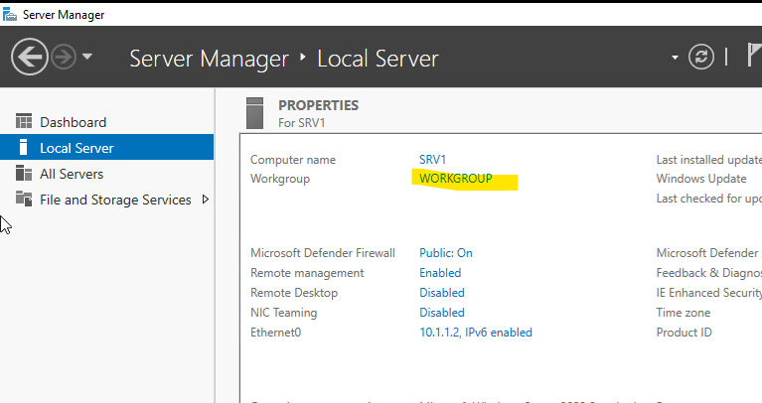

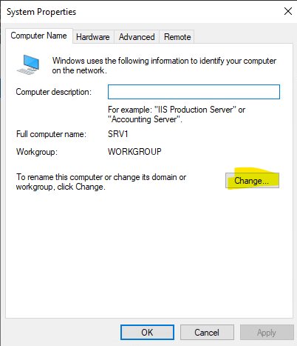

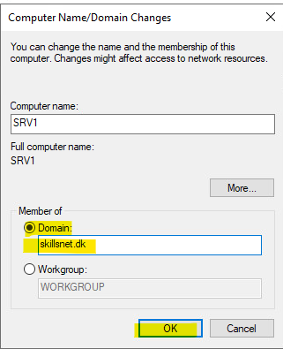

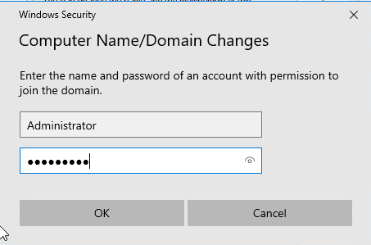

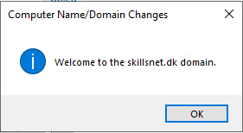

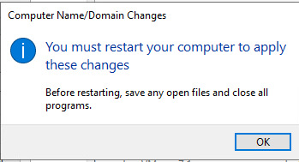

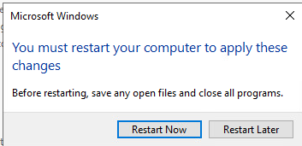

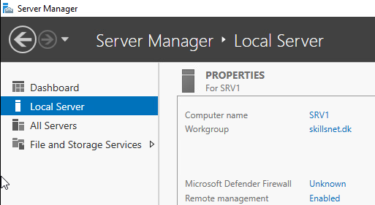

Example without GUI: SRV2

- Don’t forget to fix previously dns server to 10.1.1.1 in SRV2
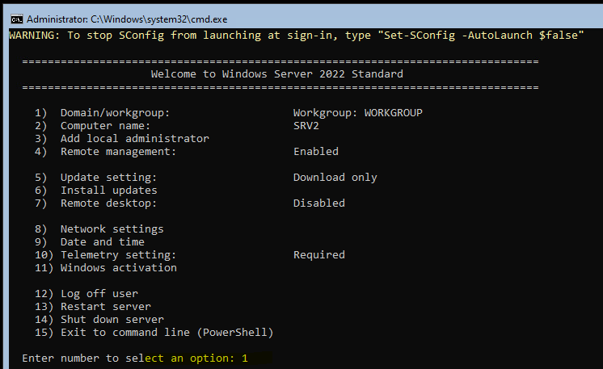

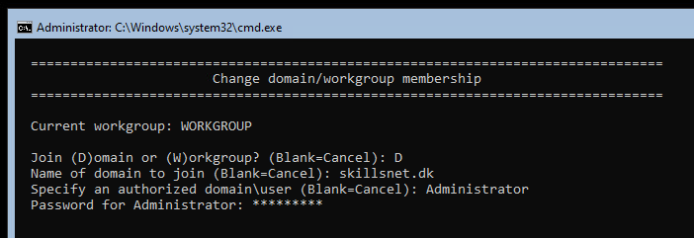

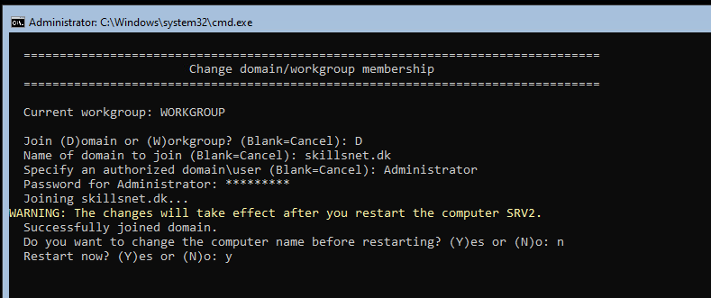

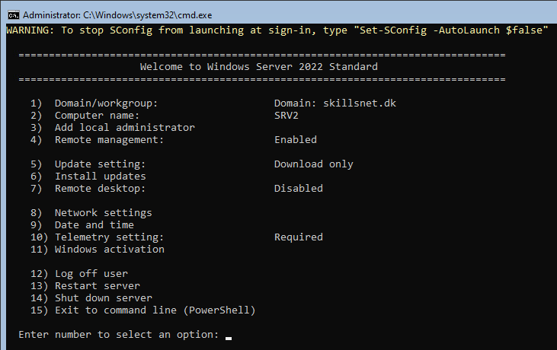

DC AD- Task2: Configure sites
- Configure Sites: Copenhagen and Aalborg; assign DC/RODC accordingly

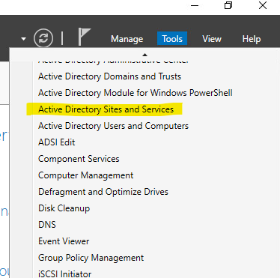

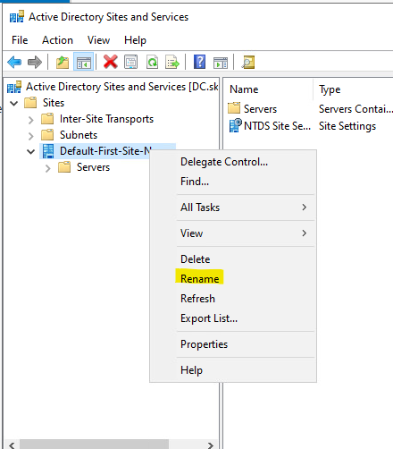

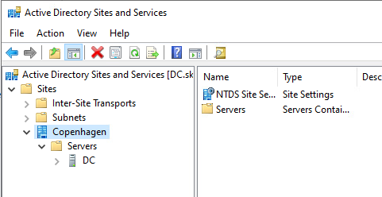

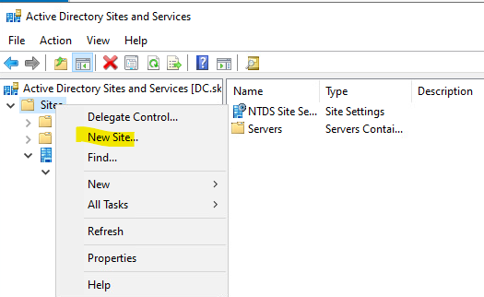

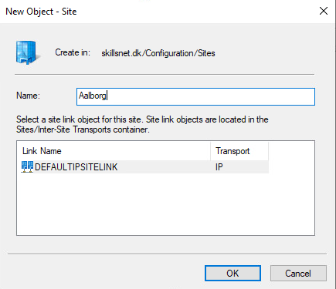

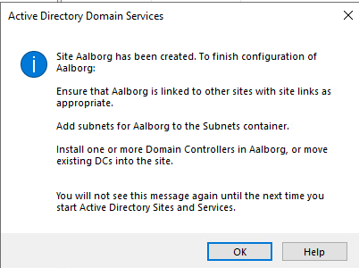

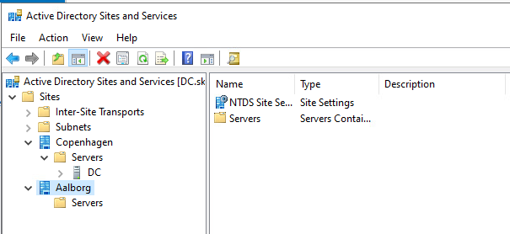

DC AD- Task3: Create OU structure
- Create OU structure according to the Appendix C

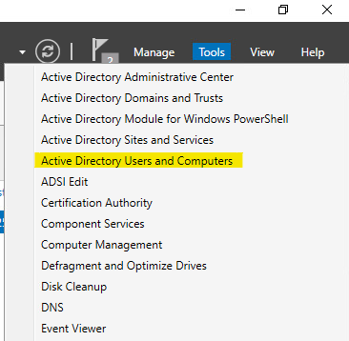

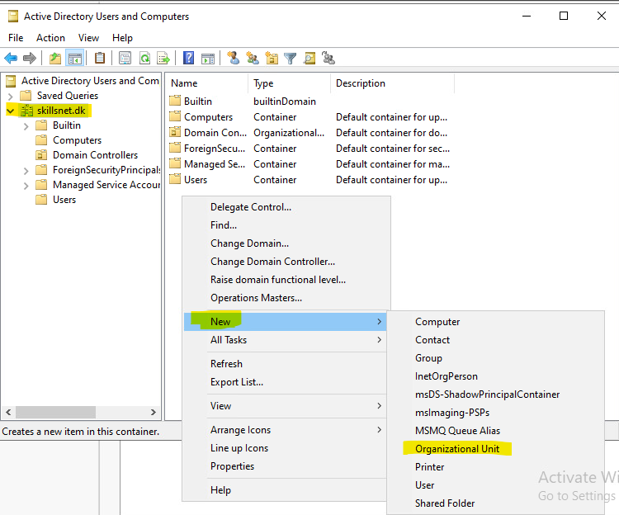

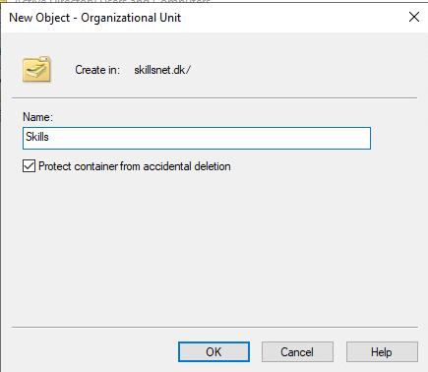

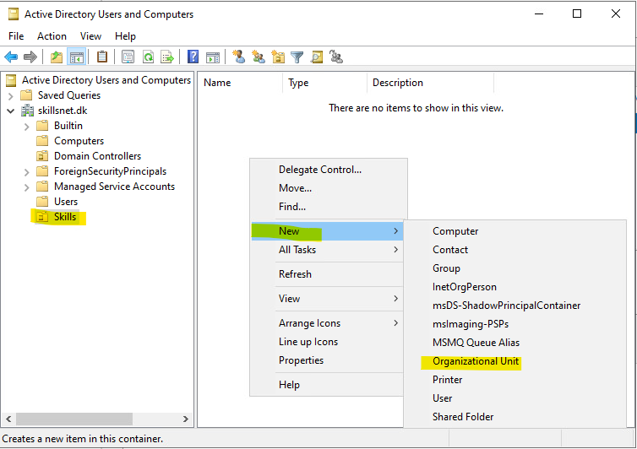

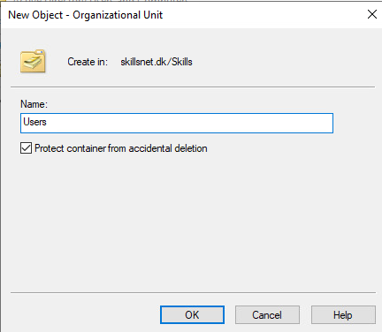

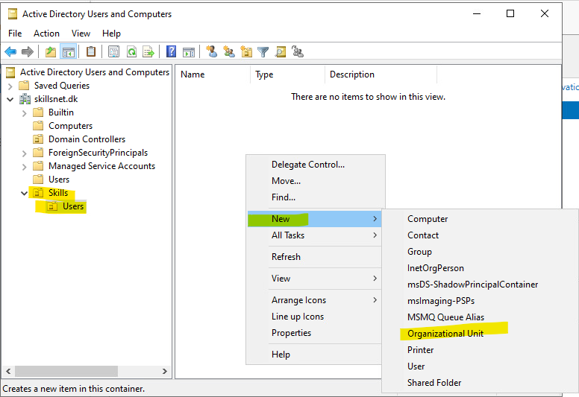

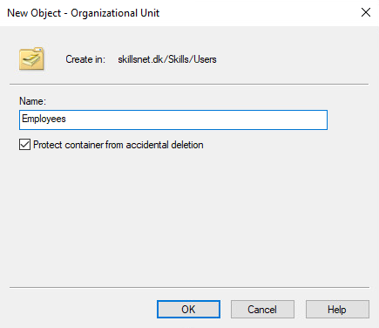

Don’t forget to change the Description:

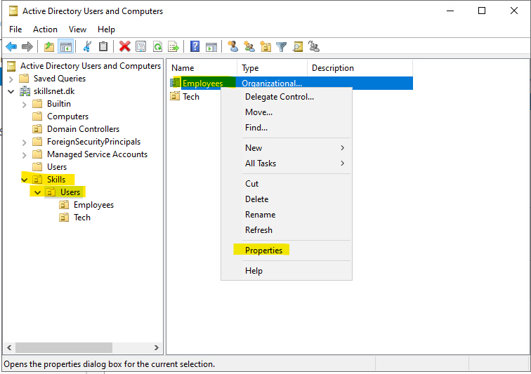

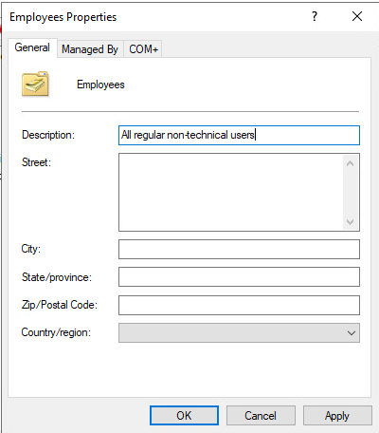

Repreat the process for all the OU structure. The result should be this:

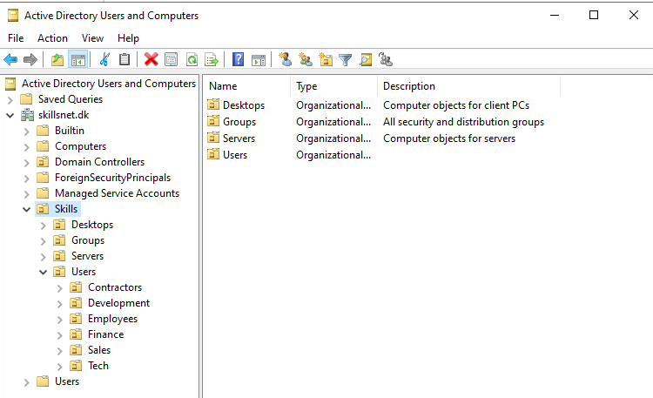

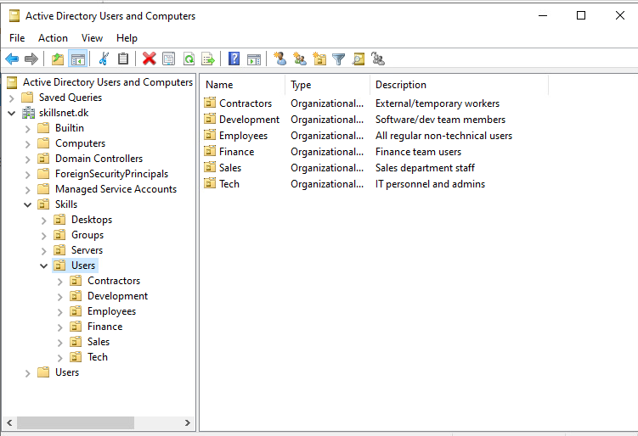

DC AD- Task4: Password policies
- Create password policies according to the Appendix D

DC AD- Task5: ADFS
- Deploy ADFS at sso.skillsnet.dk using UPN logins

DC AD- Task6: Import users
- Import users from C:\Resources\ES2025_TP39_ModuleB_Users_Skillsnet.csv
  - Ensure all users are activated and have UPN defined
  - Based on Department value, create unique groups
  - Assign users to role groups and OUs based on their Department value
  - Usernames must follow the format: Firstname.Lastname

Group Policies
Use the first bullet point in each policy block as the GPO name. The subsequent bullets define the settings required in that GPO.
Group Policies need to be mapped and configured according to best practices.

DC GPO - Task1: Baseline Security Policy for Servers
- Baseline Security Policy for Servers
  - Send NTLMv2 responses only;
  - Allow only AES256_HBA_SHA1 and future encryption types for Kerberos;
  - Audit successful and failed logons;
  - Do not store LM hash value on next password change;
  - Disallow WinRM Server and Client Basic authentication and unencrypted traffic;
  - Set high level encryption and secure RPC communication on Remote Desktop Services Host;

DC GPO - Task2: Baseline Security Policy for Desktops
- Baseline Security Policy for Desktops
  - Send NTLMv2 responses only;
  - Allow only AES256_HBA_SHA1 and future encryption types for Kerberos;
  - Set high level encryption and secure RPC communication on Remote Desktop Services Host;
  - Do not store LM hash value on next password change;
  - Disallow WinRM Server and Client Basic authentication and unencrypted traffic;
  - Turn off Microsoft consumer experiences;
  - Turn off Autoplay on all drives.

DC GPO - Task3: Administrative accounts
- Administrative Accounts
  - Grant administrative rights on desktops only to Tech users

DC GPO - Task4: Users – Restrict Tools
- Users – Restrict Tools
  - Applicable only for Sales, Finance and Contractors;
  - Disable ability to use Registry editing tools, PowerShell and Command Prompt;

DC GPO - Task5: Contractors – Customization
- Contractors – Customization
  - Login banner that reads:
Welcome to Skillsnet, you’re a contractor and all your activities are recorded. You will be legally responsible for any damage that you cause.

DC GPO - Task6: Folder Redirection
- Folder Redirection
  - Applicable only for Finance, Sales
  - Redirect all user folders to \\srv1.skillsnet.dk\Users\<username>

DC GPO - Task7: Disk Encryption
- Disk Encryption
  - Store all recovery keys for domain-joined systems in Active Directory

Name Resolution

DC DNS - Task1: A & AAAA records
- Create A and AAAA records for all relevant hosts based on the Appendix A

DNS server already installed with ADDS

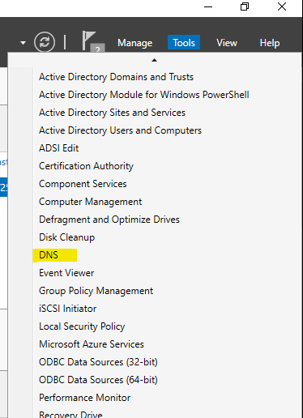

¿Susceptibles DNS Forward Records A and AAAA for skillsnet.dk?:

- skillsnet.dk 10.1.1.1
- dc.skillsnet.dk 10.1.1.1
- srv1.skillsnet.dk 10.1.1.2
- srv2.skillsnet.dk 10.1.1.3
- rodc.skillsnet.dk (Aalborg) 10.2.1.1
- client.skillsnet.dk (Aalborg) 10.2.1.10
- www.skillsnet.dk 10.1.1.3 ¿Cname de srv2?
- sso.skillsnet.dk 10.1.1.1 ¿Cname de dc?
- cdp.skillsnet.dk 10.1.1.3 ¿Cname de srv2?
- crl.skillsnet.dk 10.1.1.3 ¿Cname de srv2?
- aia.skillsnet.dk 10.1.1.3 ¿Cname de srv2?
- cacerts.skillsnet.dk 10.1.1.3 ¿Cname de srv2?
- ocsp.skillsnet.dk10.1.1.1 ¿Cname de dc?
- intra.skillsnet.dk 10.1.1.3 ¿Cname de srv2?
- app.skillsnet.dk 10.1.1.3 ¿Cname de srv2?

DC DNS - Task2: Reverse lookup zones
- Create reverse lookup zones for both IPv4 and IPv6 subnets. Enable dynamic updates for domain-joined machines

DC DNS - Task3: Authority delegation
- Delegate authority for the skillsdev.dk to the DEV-SRV

DC DNS - Task4: DNS forwarding
- Configure DNS forwarding so that all unresolved queries are forwarded to the INET server

Certificate services

DC Certs - Task1: PKI and Root CA
- Deploy an Enterprise PKI. The root Certification Authority must be named “Skillsnet CA”

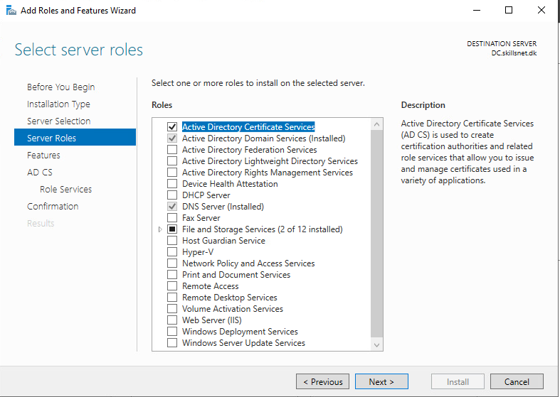

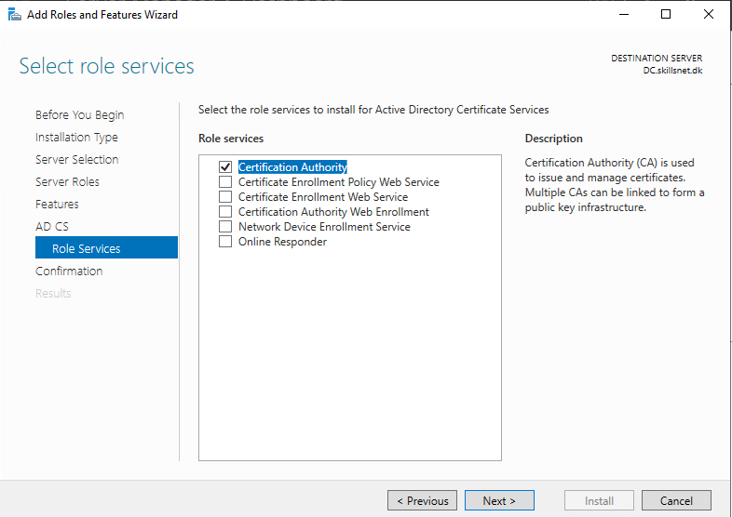

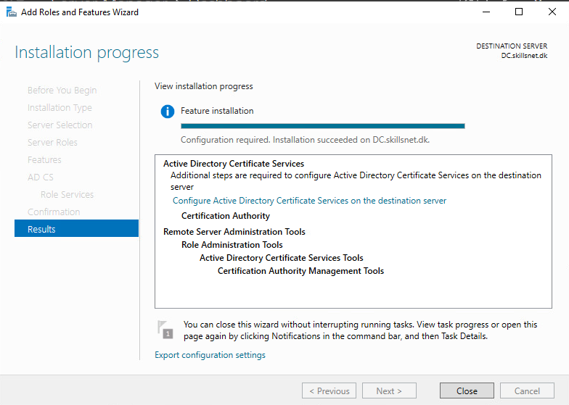

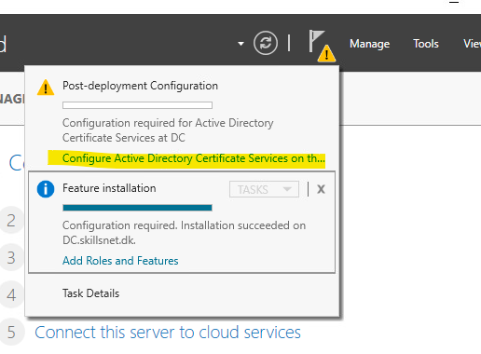

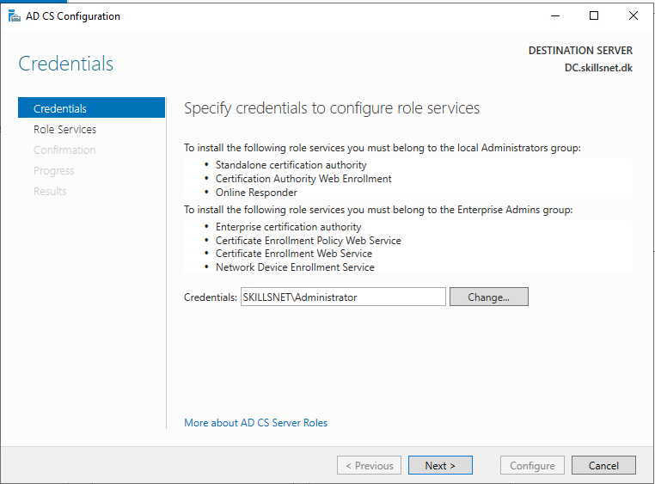

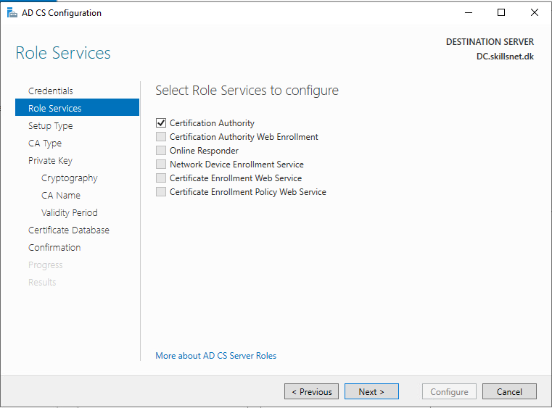

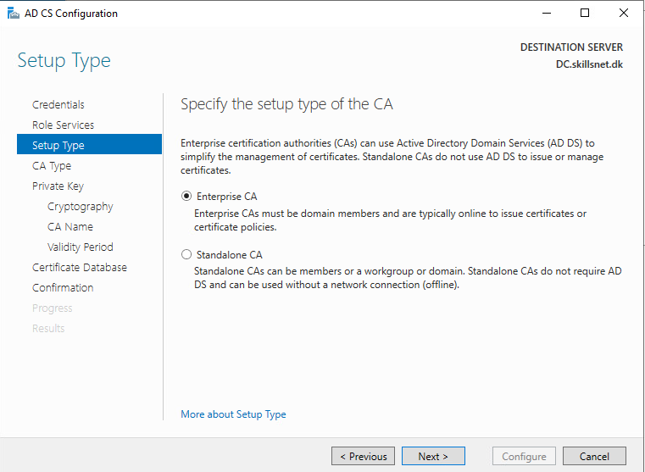

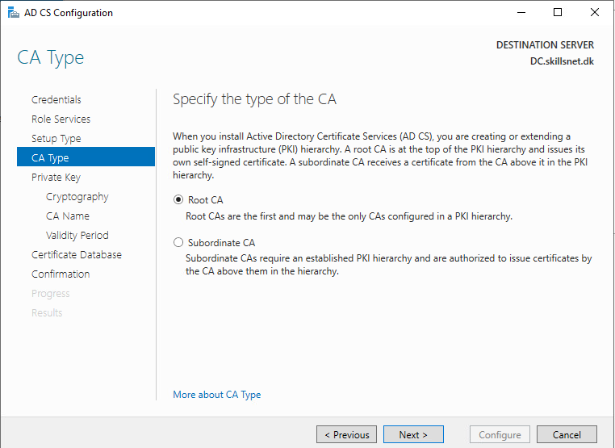

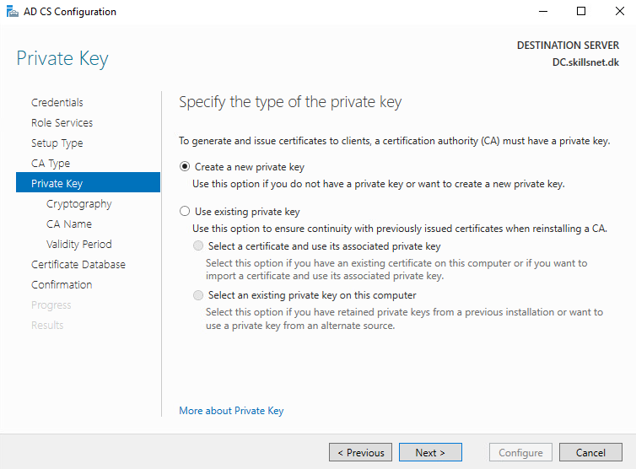

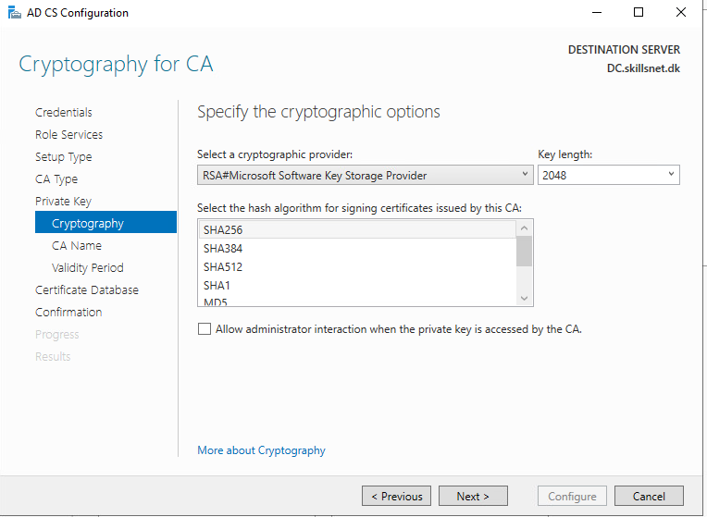

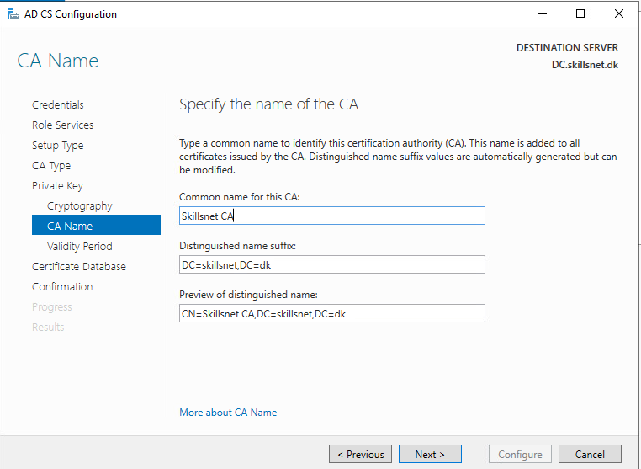

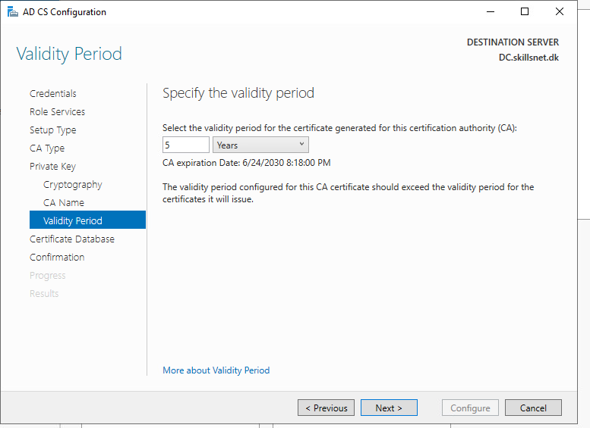

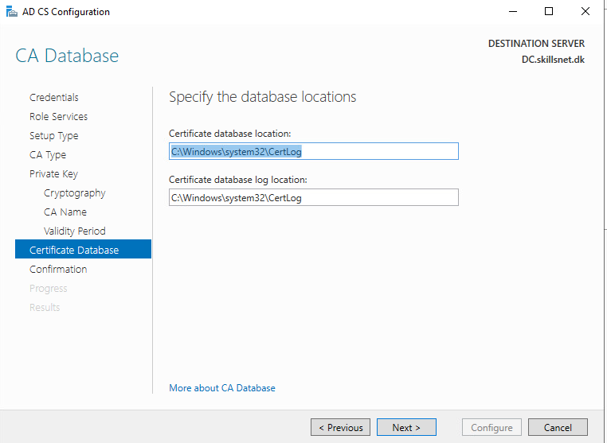

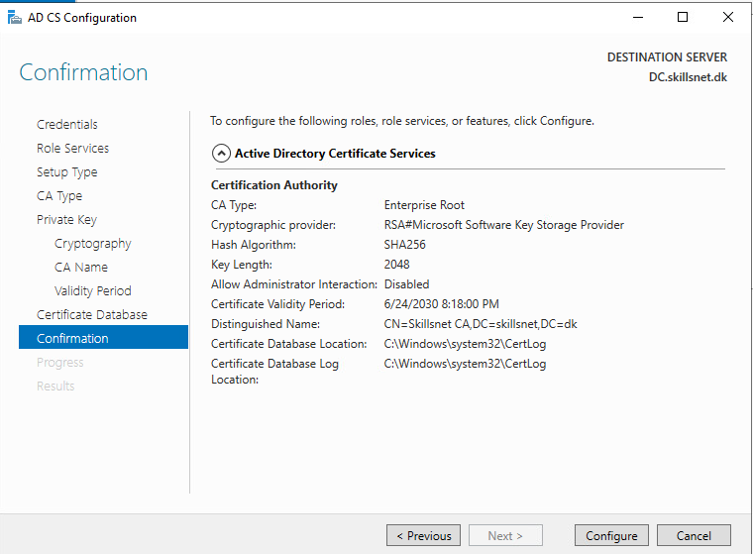

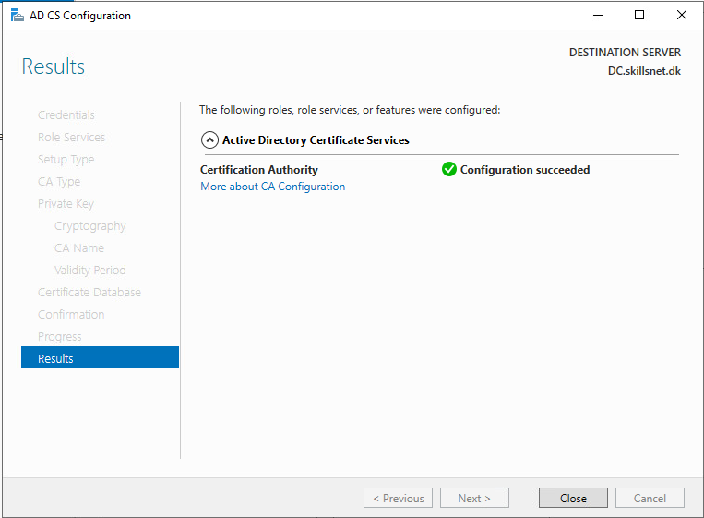

- Create a shared folder for sharing certificates

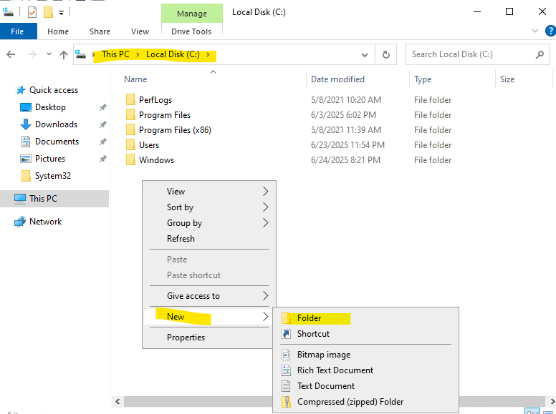

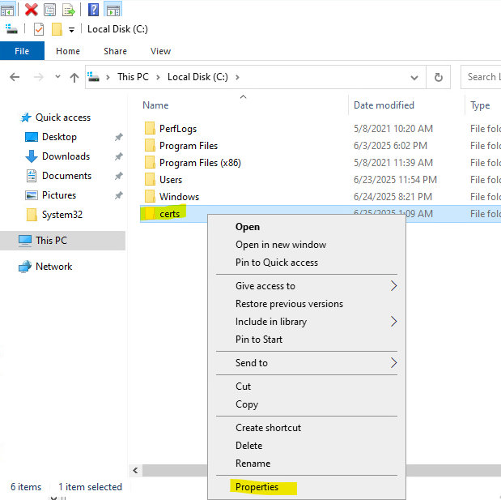

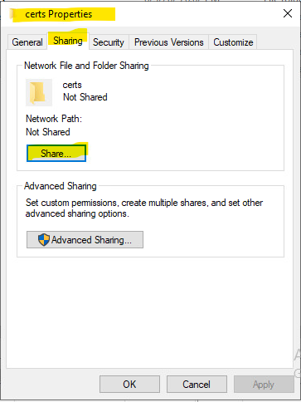

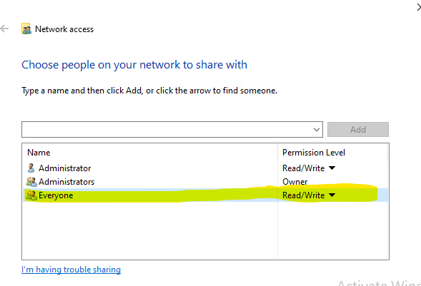
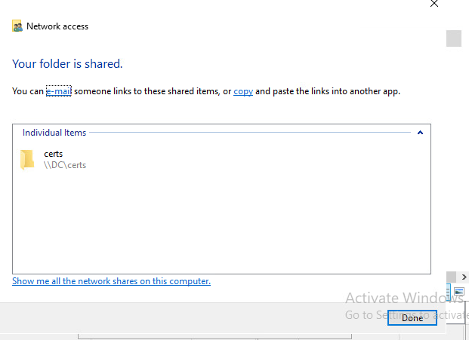

- Share the Skillsnet CA

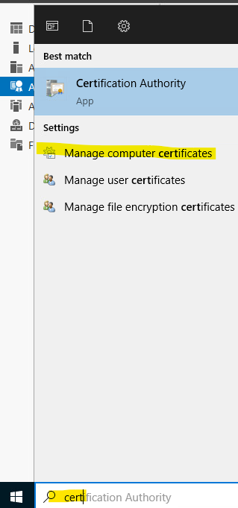

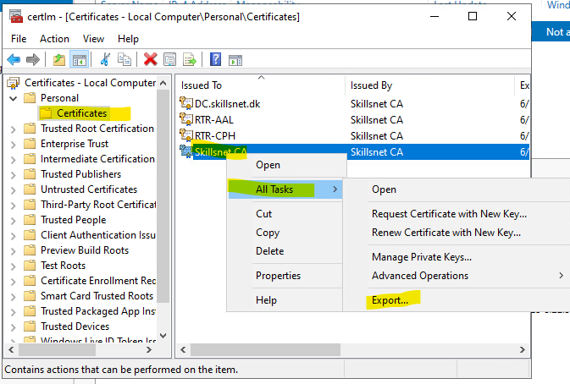

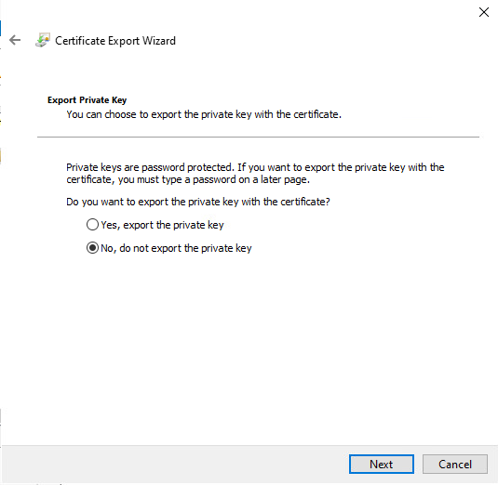

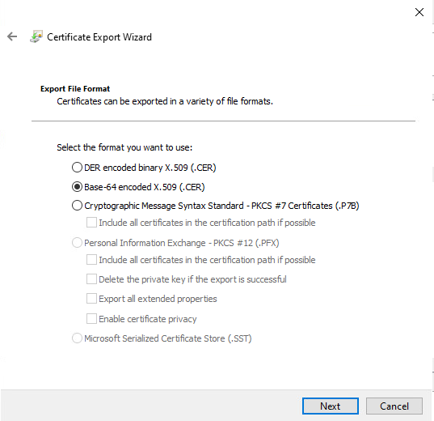

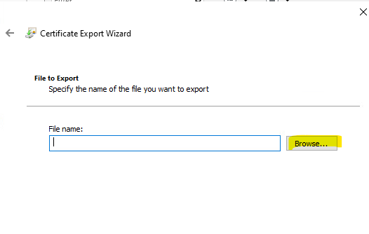

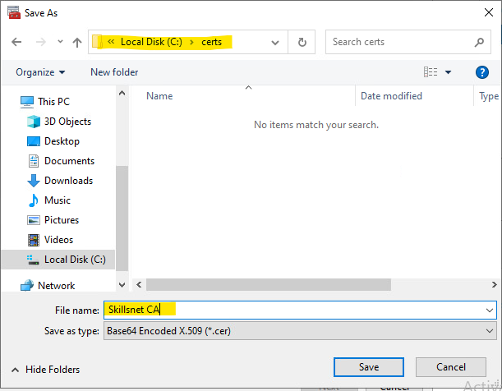

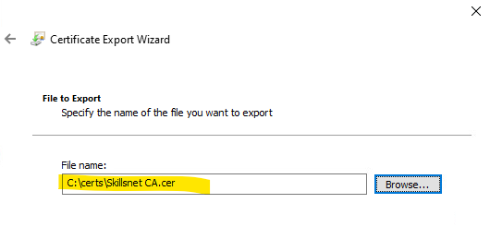

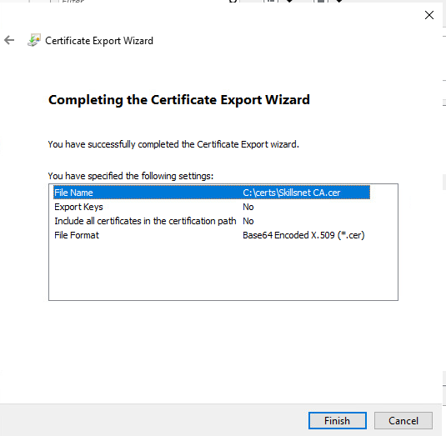

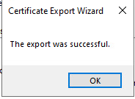

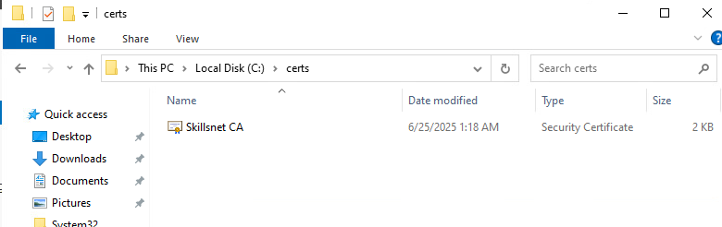

DC Certs - Task2: CDP
- Configure the CDP endpoint at http://crl.skillsnet.dk/SkillsnetCA.crl

DC Certs - Task3: AIA
- Configure the AIA endpoint at http://cacerts.skillsnet.dk/SkillsnetCA.crt

DC Certs - Task4: OCSP
- Configure the OCSP responder endpoint at http://ocsp.skillsnet.dk/

DC Certs - Task5: CDP and AIA on SRV2
- CDP and AIA certificate endpoints need to be hosted on SRV2. OCSP responder is hosted on DC.

DC Certs - Task6: certificate templates
- Create following certificate templates:
  - Skills Users – For user certificates; certificate needs to be auto-enrolled for all users
  - Skills Endpoints – For computer certificates; certificate needs to be auto-enrolled for all endpoints
  - Skills Web Server – For web server certificates



6.1. Skills Users

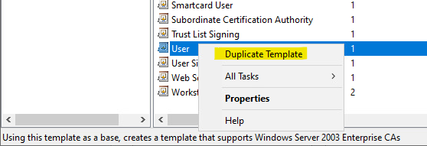

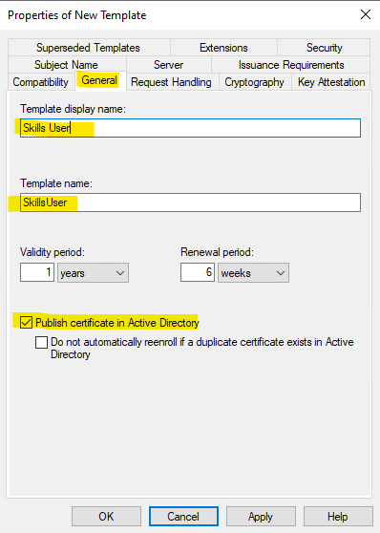

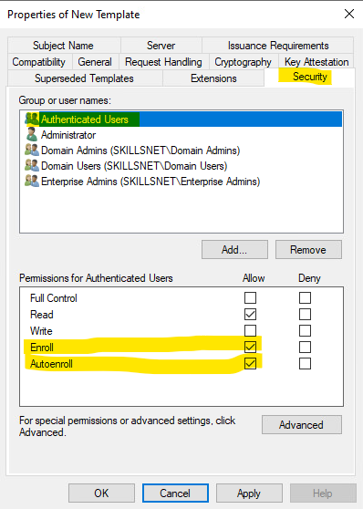

6.2 Skills Endpoints

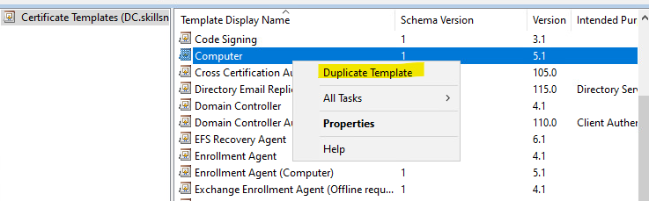

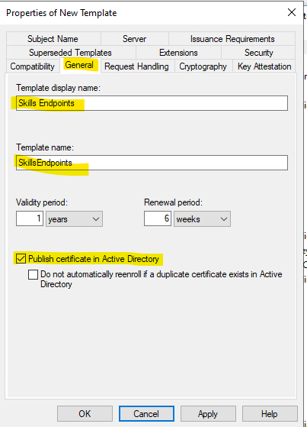

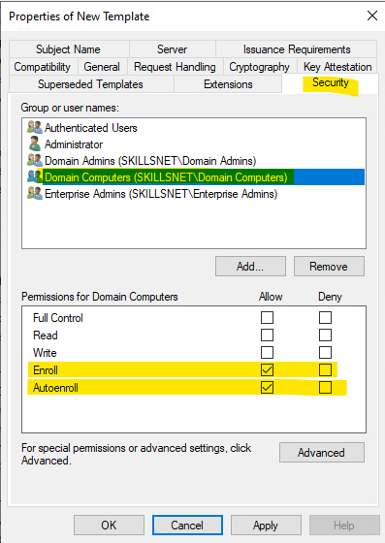

6.3. Skills Web Servers

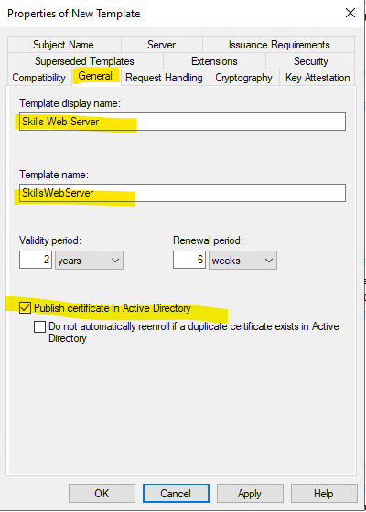

PUBLISH

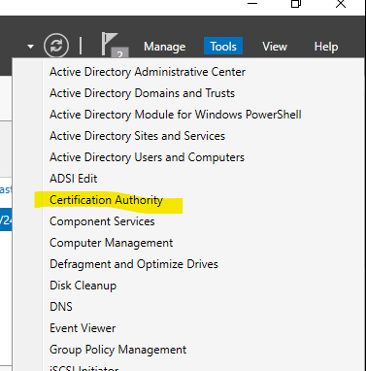

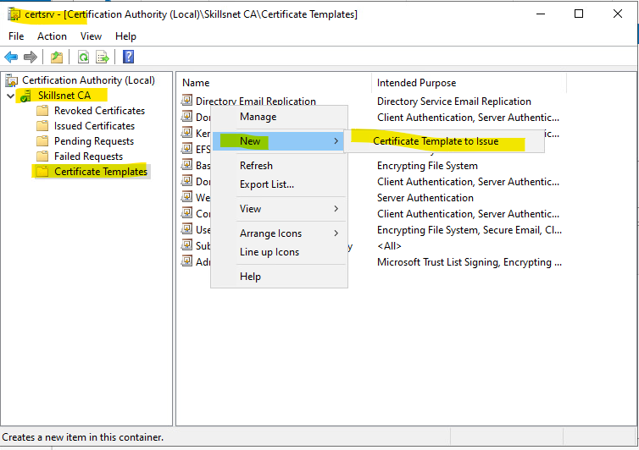

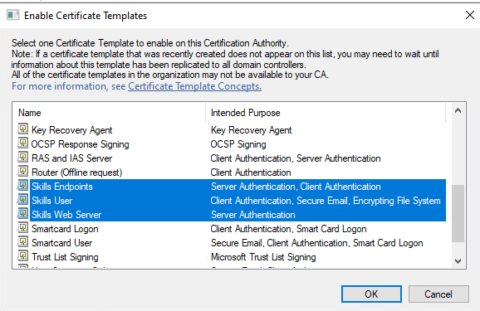

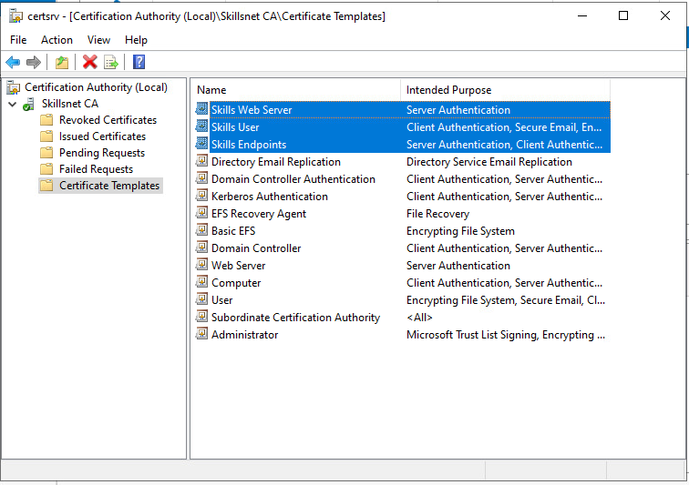

Part 6: Enable Autoenrollment via Group Policy
- Open GPMC on DC.
- Create/Edit a GPO linked to the domain.
Navigate:
pgsql
CopiarEditar
User Configuration > Policies > Windows Settings > Security Settings > Public Key Policies

  - Enable Autoenrollment for users.
- Repeat under Computer Configuration for computers.

Backups

DC Backups - Task1: Backup script
- Create a PowerShell script and save it as C:\Scripts\Backup.ps1
- The script must back up the following items:
  - C:\Backups\Users.csv – A CSV file containing the full OU path and all key user attributes (e.g samAccountName, UPN, first name, last name, etc.)
  - C:\Backups\GPOs\ - A directory containing exports of all existing Group Policy Objects
  - C:\Backups\Web\<site>\ - A directory containing web root folders served by the IIS web servers on skillsnet.dk, organized using the corresponding DNS name of each site.
- Implement email notification functionality within the script. It must send a success or failure report to: support@nordicbackup.net (You may choose the message format)
- Configure Windows Server Backup to perform scheduled backups of the entire C:\Backups directory to an iSCSI target hosted on SRV2
- Ensure the backup is scheduled to run daily at 02:00

RODC
Role: Read-Only Domain Controller to provide authentication to Aalborg site.

RODC- Task1: Promote as RODC
Task: Promote as RODC on domain skillsnet.dk

Add the management of this server to DC. In DC machine:

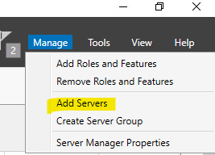

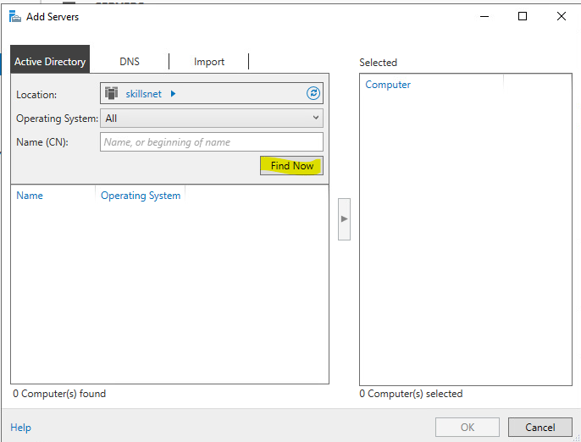

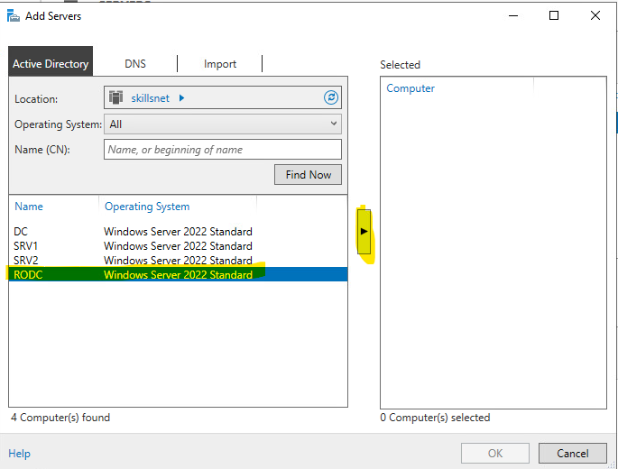

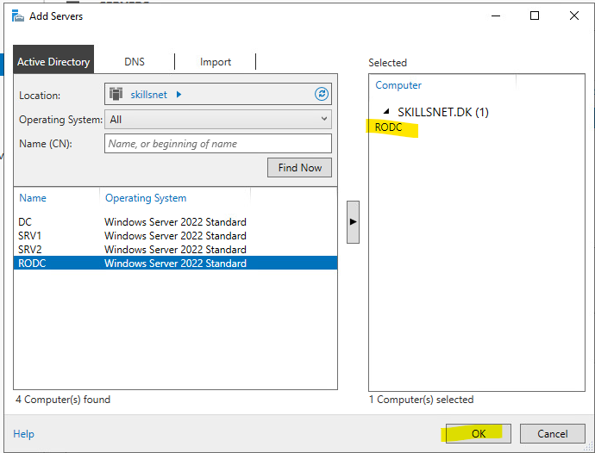

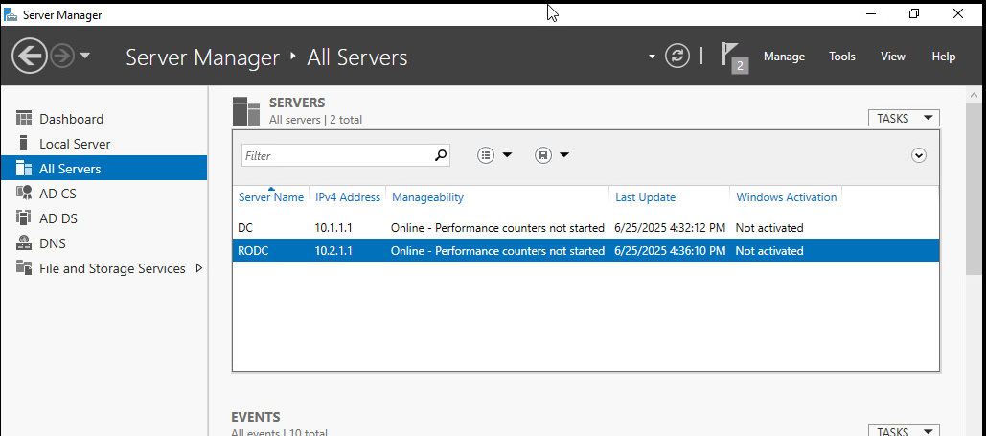

Install and configure ADDS

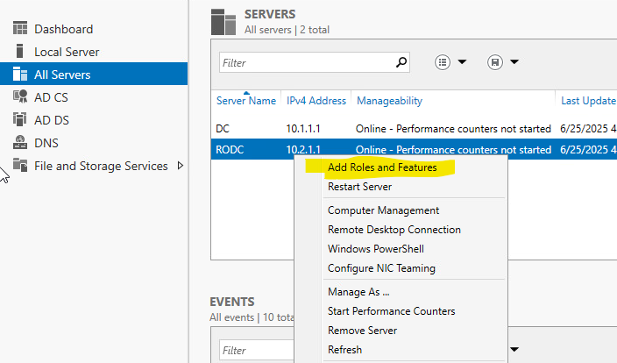

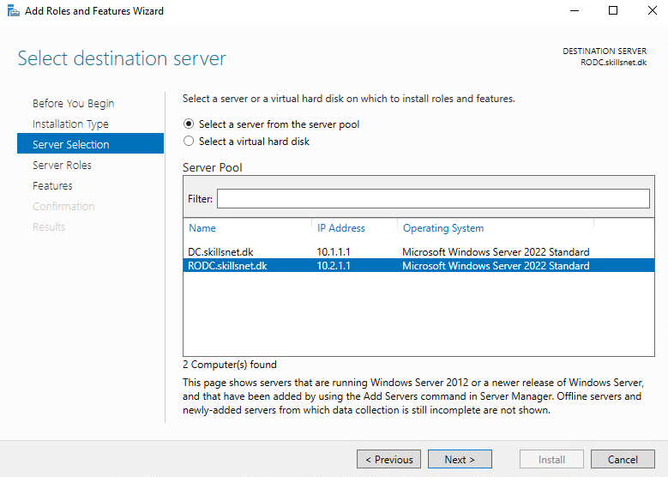

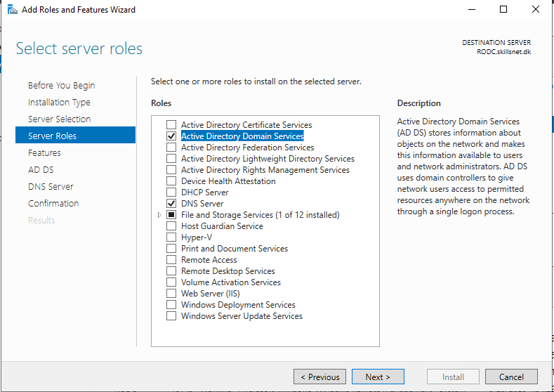

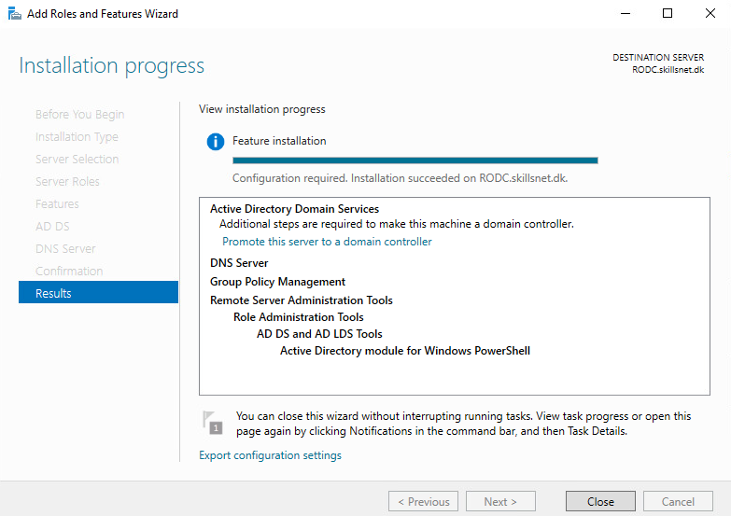

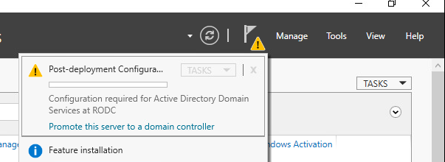

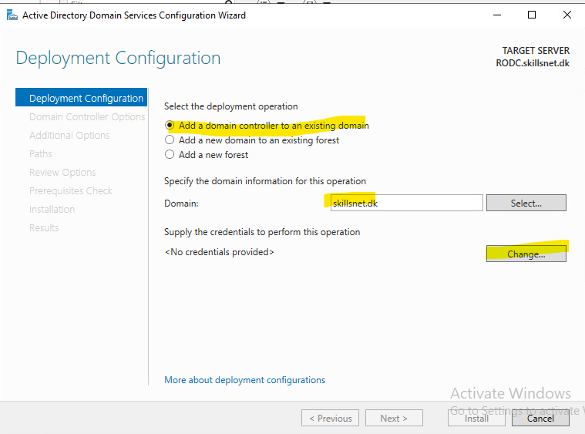

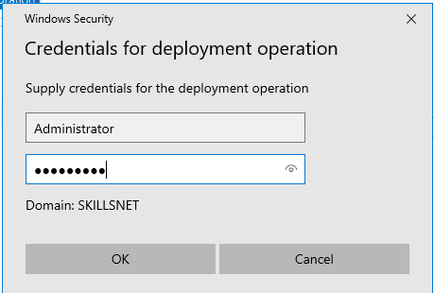

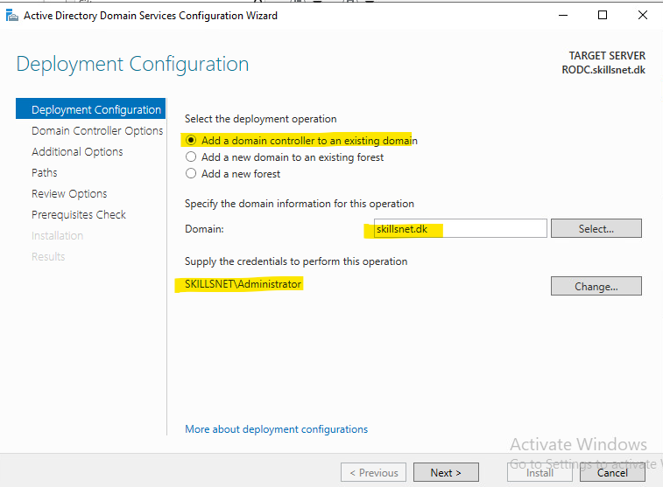

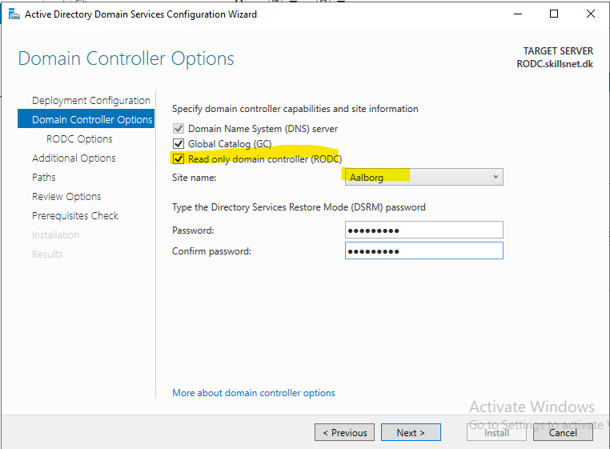

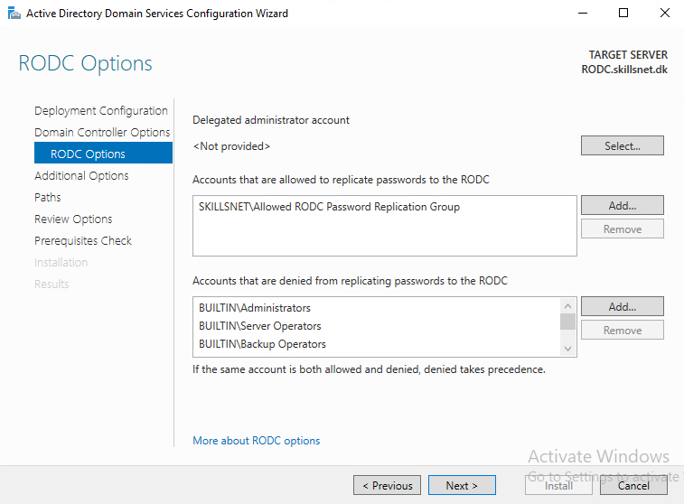

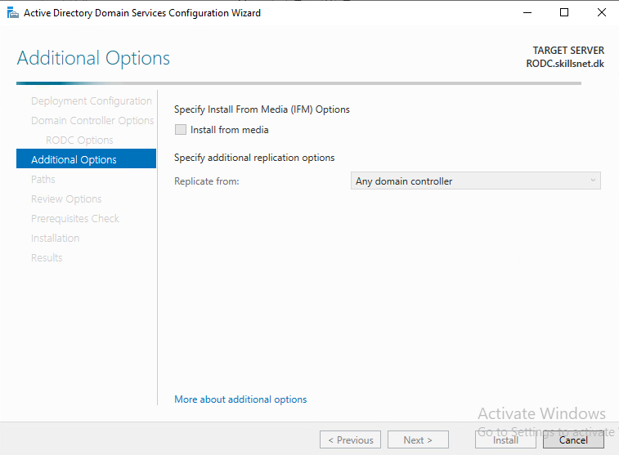

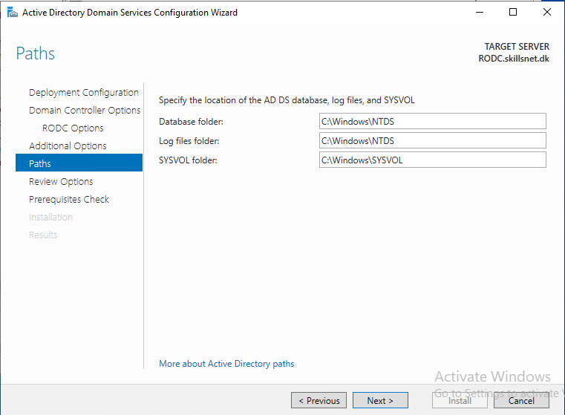

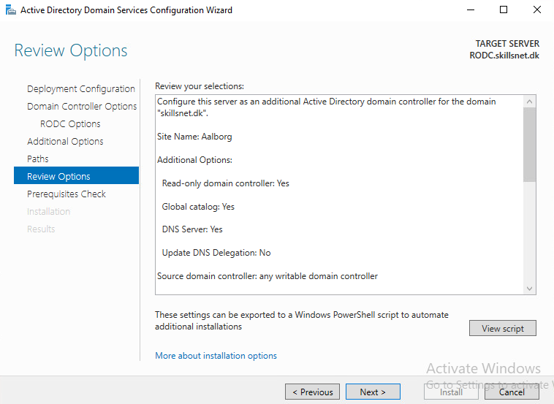

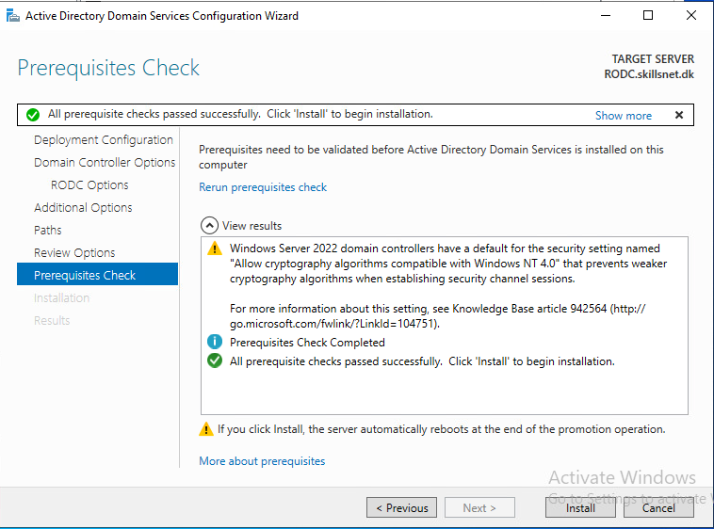

Problems with RODC, many errors. Reinstalled as DC-AAL

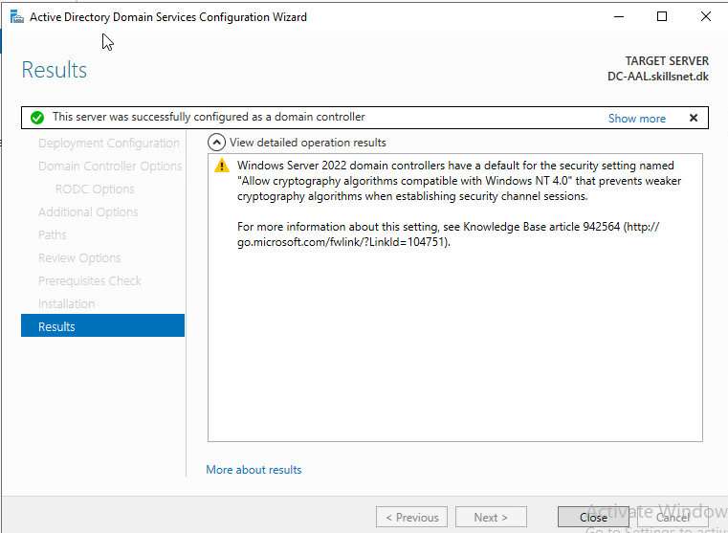

ACtive Directory Sites and Services on DC:

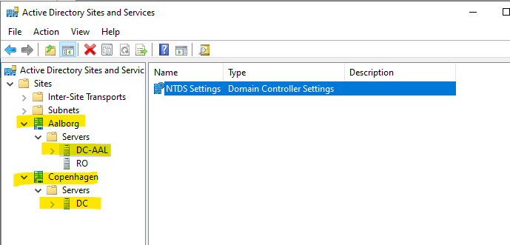

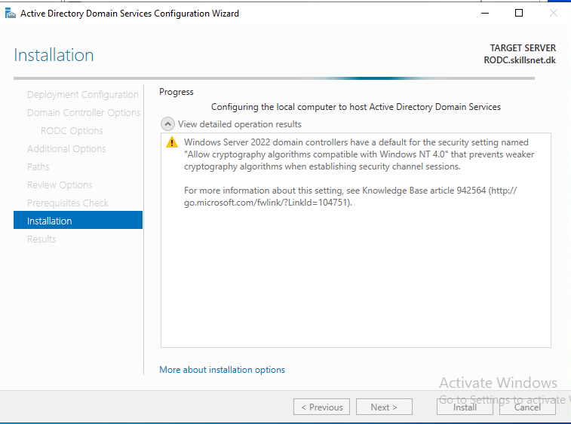

SRV2
Role: Hosts public and internal web services, provides certificate-based authentication and SAML integration, and serves as a centralized iSCSI backup target and WEF log collector.
Tasks:

SRV2 - Task1: public web server
- Host the public-facing website at www.skillsnet.dk

SRV2 - Task2: intranet
- Configure certificate-based authentication for the internal site intra.skillsnet.dk

SRV2 - Task3: SAML based auth app
- Host SAML-based authentication application site under app.skillsnet.dk (expected result at Appendix G)
  - Web App code is available at C:\Resources\ClaimsApp.zip
  - Application is preconfigured with ADFS authentication against sso.skillsnet.dk
  - ADFS relying party identifier and endpoint is https://app.skillsnet.dk
  - Site webroot must be C:\inetpub\approot\
  - ADFS needs to provide following claims:
    - Attribute: User-Principal-Name, Outgoing Claim: Name ID
    - Attribute: Surname, Outgoing Claim: Surname
    - Attribute: Display-Name, Outgoing Claim: Name

SRV2 - Task4: web server certificates
- Ensure all hosted web services use valid certificates issued by Skillsnet CA

SRV2 - Task5: iSCSI Target
- Deploy and configure an iSCSI Target to be used for centralized backups:
  - Add new disk of 12 GB for storing the backups
  - Initialize and format the disk using the ReFS file system, then mount it as the B: drive
  - Create a 10 GB iSCSI virtual disk at the following path B:\iSCSIVirtualDisks\Skillsnet-Backup.vhdx
  - Configure the virtual disk as an iSCSI Target and allow access from authorized initiator DC server

SRV2 - Task6: Windows Event Forwarding
- Configure Windows Event Forwarding
  - Use Source-Initiated subscription mode
  - Add exceptions to existing hardening guidelines only for SRV2 to make WEF work
  - Ensure all domain-joined computers are forwarding Security event logs to SRV2

SRV1 & SRV2
Role: Provide shared file services, enforce secure data storage policies, support DFS-based replication, and deliver high-availability DHCP services for internal networks.
Tasks:

SRV1 & SRV2 - Task1: SMB encryption
- Enable SMB encryption on all file shares to secure data in transit

SRV1 & SRV2 - Task2: DFS shares
- Use separate 10 GB disk on each server:
  - Initialize and format the disk using NTFS, and mount it as D:
  - This disk will serve as the data volume for all DFS shares

SRV1 & SRV2 - Task3: Bitlocker encryption
- Configure BitLocker encryption on the D:\ volume using PowerShell, ensuring it uses TPM-based protection

SRV1 & SRV2 - Task4: Prevent writing
- Prevent writing the following file types to shared folders: .exe, .com, .vbs, .msi

SRV1 & SRV2 - Task5: Quota for roaming profiles
- Configure user profile folders such that each user is assigned 512 MB quota for their roaming profile directory

SRV1 & SRV2 - Task6: DFS replication
- Set up DFS replication for \\skillsnet.dk\DFS\Users

SRV1 & SRV2 - Task7: HA DHCP
- Deploy a High-Availability DHCP failover pair that assigns IP addresses within the skillsdev.dk network range

SRV1 & SRV2 - Task8: DHCP reservation
- Configure DEV-PC to obtain its IP address via DHCP, matching its currently assigned static configuration

DEV-PC
Role: Serves as the automation control node for the DEV environment; used to configure and deploy the skillsdev.dk domain and associated services via Ansible on DEV-SRV.
Tasks:

Ansible - Task1: hostname
- 1-hostname.yaml: Configure the hostname to SRV

Ansible - Task2: ADDS
- 2-adds.yaml: Set up an AD DS environment with the domain skillsdev.dk

Ansible - Task3: Users
- 3-users.yaml: Import the predefined OU structure (Appendix C), users and groups into the domain
  - Source file /ansible/resources/ES2025_TP39_ModuleB_Users_Skillsdev.json
  - Ensure all users are activated and have UPN defined
  - Based on Department value, create unique groups
  - Assign users to role groups and OUs based on their Department value
  - Usernames must follow the format: Firstname.Lastname

Ansible - Task4: Web server
- 4-web.yaml: Deploy an IIS web server with static HTML homepage accessible at www.skillsdev.dk.
  - Homepage must have large message “Skills Development”

Ansible - Task5: Shares
- 5-shares.yaml: Configure File Server based on /ansible/resources/ES2025_TP39_ModuleB_Shares.yaml

Ansible configuration notes:
- Ansible is preconfigured on DEV-PC with an inventory file located at /etc/ansible/hosts
- Connections to DEV-SRV are available via SSH using a preinstalled key
- All required playbooks must be created and saved in the /ansible directory

Assessment notes:
- DEV-SRV will be restored to “Start” snapshot
- Playbooks will be executed in sequence from the /ansible directory

Appendix A: Configuration table

Hostname | Domain | IPv4 Address (/24) | IPv6 Address (/64)
INET | WORKGROUP | 198.51.100.1 | 2001:db8:100::1
RTR-CPH | WORKGROUP | INET: 198.51.100.11  INT: 10.1.1.254  DEV: 10.1.2.254 | INET: 2001:db8:100::11  INT: fd01:1:1::254  DEV: fd01:1:2::254
RTR-AAL | WORKGROUP | INET: 198.51.100.12  INT: 10.2.1.254 | INET: 2001:db8:100::12  INT: fd01:2:1::254
DC | SKILLSNET.DK | 10.1.1.1 | fd01:1:1::1
RODC | SKILLSNET.DK | 10.2.1.1 | fd01:2:1::1
SRV1 | SKILLSNET.DK | 10.1.1.2 | fd01:1:1::2
SRV2 | SKILLSNET.DK | 10.1.1.3 | fd01:1:1::3
DEV-PC | NOT APPLICABLE | 10.1.2.10 | fd01:1:2::10
DEV-SRV | SKILLSDEV.DK | 10.1.2.1 | fd01:1:2::1
CLIENT | SKILLSNET.DK | 10.2.1.10 | fd01:2:1::10

Appendix B: Network topology

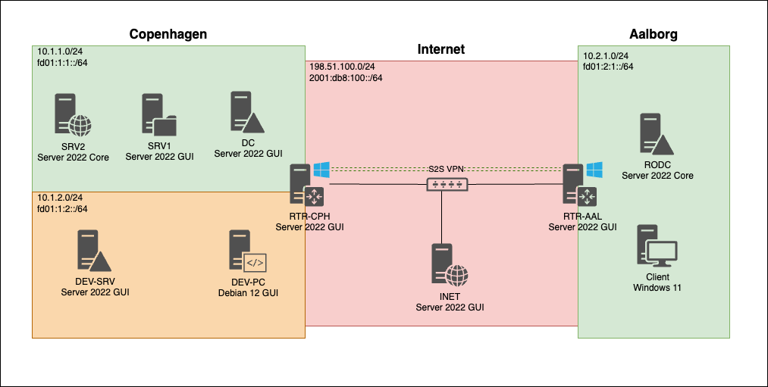
Appendix C: OU Structure
OU Path | Description
Skills\Users\Employees | All regular non-technical users
Skills\Users\Tech | IT personnel and admins
Skills\Users\Sales | Sales department staff
Skills\Users\Finance | Finance team users
Skills\Users\Development | Software/dev team members
Skills\Users\Contractors | External/temporary workers
Skills\Groups | All security and distribution groups
Skills\Desktops | Computer objects for client PCs
Skills\Servers | Computer objects for server

Appendix D: Password Policies
Policy Name | Target | Min Length | Max Password Age | Complexity | Lockout Threshold
FGPP-Users | Regular users | 12 chars | 730 days | Enabled | 5 attempts, 5 minutes
FGPP-Tech | Tech users | 20 chars | 365 days | Enabled | 3 attempts, 15 minutes
FGPP-Contractors | Contractors | 16 chars | 90 days | Enabled | 3 attempts, 30 minutes

Appendix E: INET DNS records

Record Type | Name | Value
A | www.skillspublic.dk | 198.51.100.11
AAAA | www.skillspublic.dk | 2001:db8:100::11
A | mail.nordicbackup.net | 198.51.100.1
AAAA | mail.nordicbackup.net | 2001:db8:100::1
MX | nordicbackup.net | mail.nordicbackup.net

Appendix F: DNS Authoritative Servers
DNS Zone | Authoritative Server(s)
skillspublic.dk | INET
nordicbackup.net | INET
skillsnet.dk | DC, RODC
skillsdev.dk | DEV-SRV

Appendix G: ADFS successful integration

