EuroSkills
Test Project
IT Network Systems Administration (39)
Module A – Linux Environment

Submitted by:
Janos Csoke HU
Svetlana Lapenko KZ
Igors Bumanis LV
Timotej Gruden SI
Ander Guerra ES

INDEX

INTRODUCTION 3
LOGIN 3
SYSTEM CONFIGURATION 3
RESOURCES 3
OPERATING SYSTEMS AND SOFTWARE 3
INDRUSTY COMPLIANCE 3
DESCRIPTION OF PROJECT AND TASKS 4
INET 4
R-INT 4
R-INT task1 - IP addressing/routing 4
R-INT task2 - NTP 5
R-INT task3 - DNS server 5
R-INT task4 - web server 6
HOME 6
HOME task1 - Remote access VPN 6
HOME task2 - LDAP auth 8
HOME task3 - Thunderbird email client 11
HOME task4 - Filezilla 11
General configuration 12
General config task1 - hostname 12
General config task2 - NetConfig 12
General config task3 - timezone 14
General config task4 - keyboard layout 14
General config task5 - NTP 14
HQ site (Billund) 16
R-HQ 16
R-HQ task1 - FW masquerade 16
R-HQ task2 - FW port forwarding + traffic 18
R-HQ task3 - Site-to-site VPN 19
R-HQ task4 - Remote access VPN 21
HQ-DC 24
HQ-DC task1 - Root CA 24
HQ-DC task2 -LDAP server 26
HQ-DC task3 - ZFS disk 38
HQ-DC task4 - CIFS directory share 44
HQ-DC task5 - Share automatic mount 44
HQ-SAM-1 44
HQ-SAM-1 task1 - HA DHCP 44
HQ-SAM-1 task2 - Intermediate CA 46
HQ-SAM-2 48
HQ-SAM-2 task1 - HA DHCP 48
HQ-SAM-2 task2 - scheduled backup task 49
HQ-DMZ-1 49
HQ-DMZ-1 task1 - CRL 49
HQ-DMZ-2 task1 - DNS server 49
HQ-DMZ-1 task3 - HA web server 52
HQ-DMZ-2 54
HQ-DMZ-2 task1 - HA web server 54
HQ-DMZ-2 task2 - Email server 54
HQ-DMZ-2 task3 - Zabbix monitoring (web) 59
HQ-DMZ-2 task4 - Zabbix monitoring (CPU) 61
HQ-CL 61
HQ-CL task1 - GUI 61
HQ-CL task1 - LDAP client 62
HQ-CL task3 - Thunderbird email client 65
BRANCH site (Herning) 69
R-BR 69
R-BR task1 - FW masquerade 69
R-BR task2 - port forwarding and traffic filter 71
R-BR task3 - Site-to-site VPN 72
BR-SRV 74
BR-SRV task1 - DHCP 74
BR-SRV task2 - DNS 76
BR-SRV task3 - Web server 79
BR-SRV task4 - SFTP 81
BR-SRV task5 - syslog server 81
BR-CLIENT network 82
Ansible task1 - Basic config 82
Ansible task2 - syslog 82
Ansible task3 - SNMP 82
Ansible task4 - LDAP client 82
Ansible task5 - share auto mount 82
Ansible task6 - web server 82
Appendix A: Network topology 83
Appendix B: Containers, Objects and Users 84
LDAP OUs 84
LDAP Groups 84
LDAP Users 84

INTRODUCTION
The competition has a fixed start and finish time. You must decide how to best divide your time.
Please carefully read the following instructions!
When the competition time ends, please leave your station in a running state. The assessment will be done in the state as it is. No reboot will be initiated as well as powered off machines will not be powered on!
Please use the information below for all the servers and clients.

LOGIN
Username: root localadmin
Password: Passw0rd! Passw0rd!
Use the string Passw0rd! as password everywhere where a password, passphrase etc. is needed. Pay attention to the zero sign in the string that replaces the capital letter O!

SYSTEM CONFIGURATION
Region/time zone: Europe/Copenhagen
Locale: English US (UTF-8)
Key Map: English US

RESOURCES
You will find the topology and the IP addressing on Appendix A. The list of the users to be created can be found on Appendix A. Both are located at the end of this document.

OPERATING SYSTEMS AND SOFTWARE
Every system in this task uses Debian 12. Every VM you see in the topology chart on Appendix A is preinstalled on the physical host, named accordingly. The hosts use VMware ESXi as a virtualization platform, and you can connect to the resources using your PCs with vSphere Web Client or VMware Workstation also.
You can connect to the ESXi host with esxi.local URL.
The pre-installed VMs contain only the base system and a few additional packages (see in the software section), you can install additional software using virtual optical disks.
For testing purposes, all VM have been installed with the following test tools: smbclient, curl, lynx, dnsutils, ldap-utils, ftp, lftp, wget, nfs-common, rsync, telnet, traceroute, tcptraceroute, tcpdump, net-tools, cifs-utils.
ssh is also installed and configured in all the machines, so all of them are accessible via SSH for easy testing. At the end of the competition time, please be sure that all the machines are accessible.
You can find Debian install ISOs in the datastore.

INDRUSTY COMPLIANCE
The test project does not always give you an exact specification. In these situations, you have the chance to choose which software to use, which path to follow - you will find information on the tasks about the paths you can choose from. The more sophisticated a solution is the better mark you are going to get for it.

DESCRIPTION OF PROJECT AND TASKS
You are a new IT Engineer of the Lego APS company. The goal of your next project is to build the whole IT infrastructure of the company, which is divided into two different sites, located in Herning and Billund cities.

INET

R-INT
All the configurations in R-INT computer are already done, and you should not touch them. Configurations Include:

R-INT task1 - IP addressing/routing
- IP addressing and routing.

apt install resolvconf

nano /etc/network/interfaces

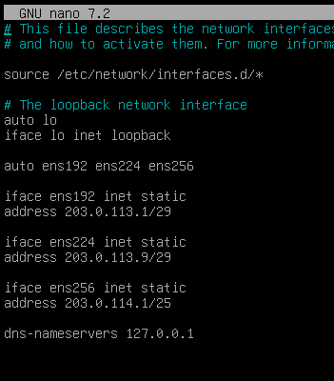

systemctl restart networking

Activate routing
nano /etc/sysctl.conf

#Comment out this line
net.ipv4.ip_forward=1

sysctl -p

R-INT task2 - NTP
- NTP server on ntp.nordictech.dk.

timedatectl set-timezone Europe/Copenhagen

apt install ntpsec

nano /etc/ntpsec/ntp.conf
#comment out the line
#tos minclock 4 minsane 3

# line 34 : comment out default settings
#pool 0.debian.pool.ntp.org iburst
#pool 1.debian.pool.ntp.org iburst
#pool 2.debian.pool.ntp.org iburst
#pool 3.debian.pool.ntp.org iburst

systemctl restart ntpsec

# verify status
ntpq -p

R-INT task3 - DNS server
- DNS server for nordictech.dk domain.

apt install bind9
nanano /etc/bind/med.conf.local
zone "nordictech.dk" {
type master;
file "/etc/bind/db.nordictech.dk";
};
zone "billund.lego.dk" {
type forward;
forwarders {203.0.113.2;};
};
zone "herning.lego.dk" {
type forward;
forwarders {203.0.113.10;};
};

nano /etc/bind/db.nordictech.dk
$TTL 86400
@ IN SOA ntp.nordictech.dk. root.nordictech.dk. (
1 ; Serial
604800 ; Refresh
86400 ; Retry
2419200 ; Expire
86400 ) ; Negative Cache TTL
;
@ IN NS ntp.nordictech.dk.
ntp IN A 203.0.113.1
www IN A 203.0.113.1

systemctl restart bind9

R-INT task4 - web server
- Web server for www.nordictech.dk website.

apt install nginx

nano /var/www/html/index.nginx-debian.html

<h1>Welcome to NordicTech Denmark!</h1>

HOME

HOME task1 - Remote access VPN
- Configure a Remote Access VPN connection to R-HQ. The VPN connection builds up automatically when starting this computer.

Step 1: Install openvpn
apt install openvpn

Step 2: certificates and keys. Assure that these files are located in /etc/openvpndirectory (created in HQ-DC task 1 & HQ-SAM-1 task 2) / ta.key created in R-HQ task 4
- CHAIN-CA.crt
- HOME.key
- HOME.crt
- ta.key

Step 3: Config file:
cp /usr/share/doc/openvpn/examples/sample-config-files/client.conf /etc/openvpn/
nano /etc/openvpn/client.conf

client
dev tun
#proto udp
remote 203.0.113.2 1195

ca /etc/openvpn/CHAIN-CA.crt
key /etc/openvpn/HOME.key
cert /etc/openvpn/HOME.crt
tls-auth /etc/openvpn/ta.key 1

cipher AES-256-GCM

persist-key
persist-tun

verb 3
log /var/log/openvpn/client.log

Step 5: enable the service (auto start when boot), start the service and check

systemctl enable openvpn@client
systemctl restart openvpn@client
systemctl status openvpn@client

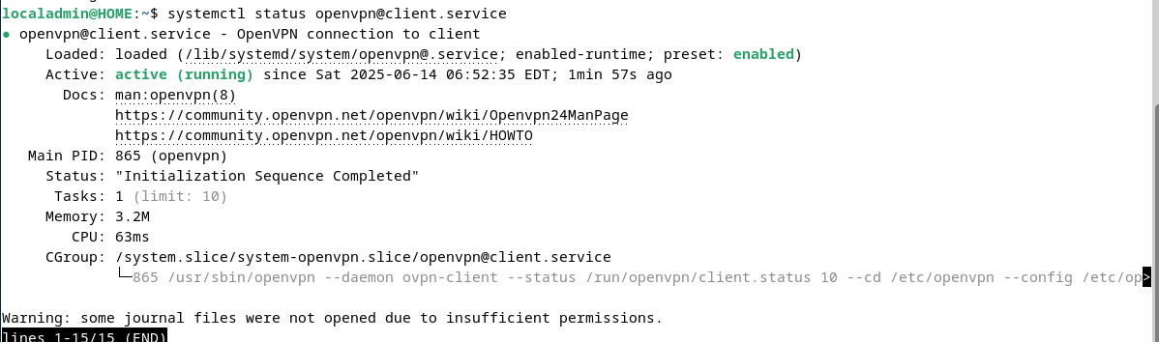

ip a
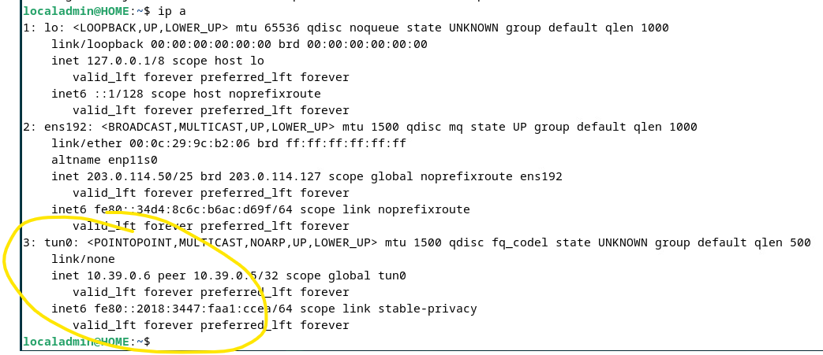

ip r
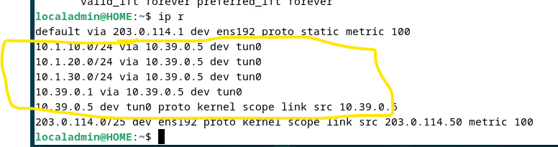
Now communication exists from HOME to HQ networks.

HOME task2 - LDAP auth
- Configure LDAP authentication using the LDAP server. Login with frida. Allow fallback to local account if VPN is down.

apt -y install libnss-ldapd libpam-ldapd ldap-utils

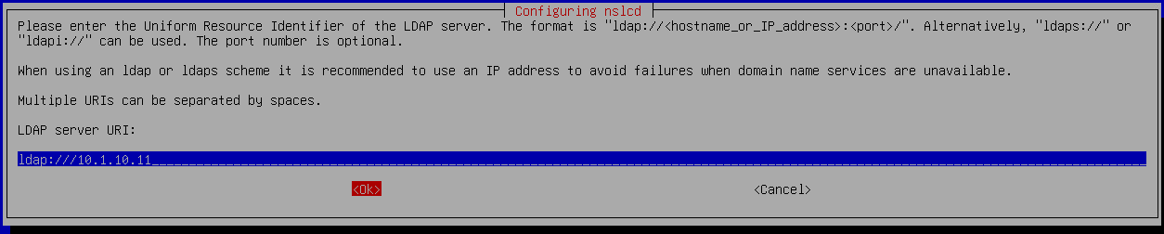

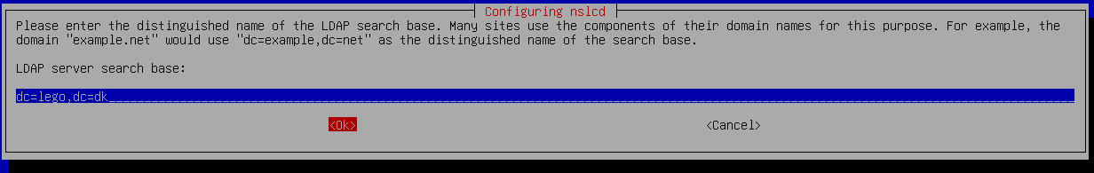

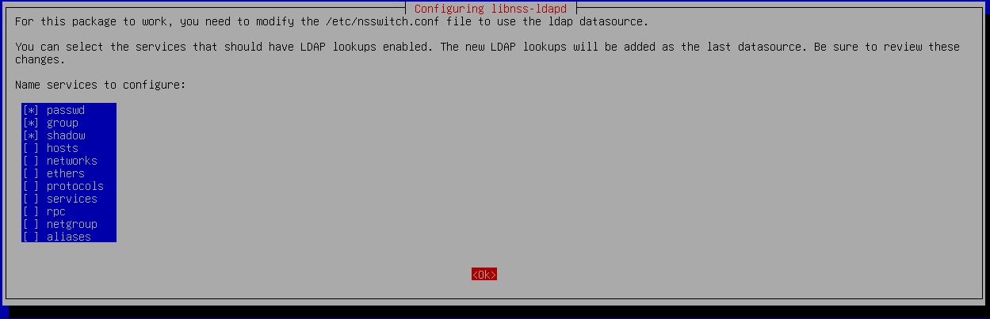

nano /etc/pam.d/common-session

# add to the end if need (create home directory automatically at initial login)
session optional pam_mkhomedir.so skel=/etc/skel umask=077

dpkg-reconfigure nslcd





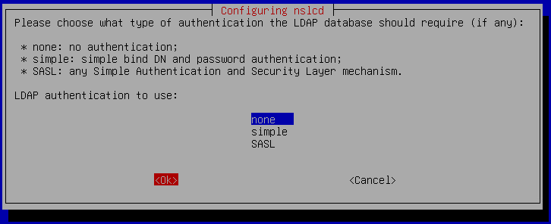

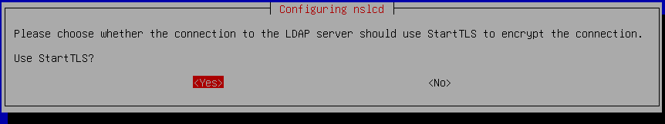

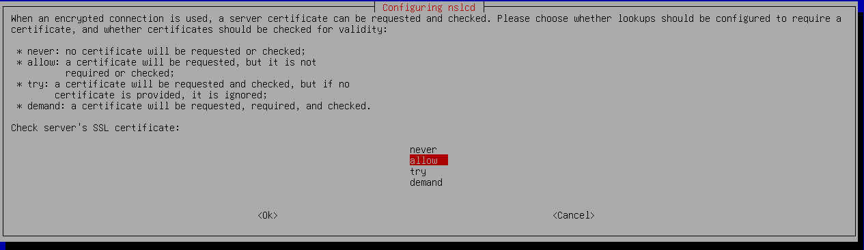

We can leave /etc/ssl/certs/ca-certificates.crt if we have added CA.crt and SUBCA.crt to system.

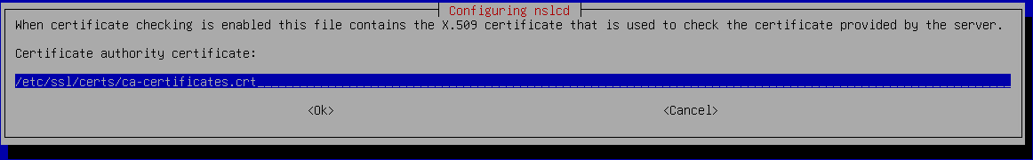

nano /etc/nslcd.conf

should be something like this:
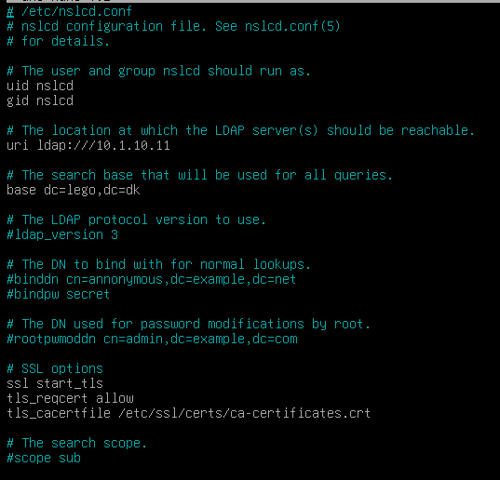

systemctl restart nscd nslcd

Check:
getent passwd | grep 400

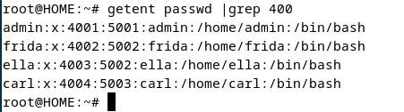

HOME task3 - Thunderbird email client
- Install Thunderbird e-mail client to use with frida@lego.dk. Send email to ella.

apt install thunderbird

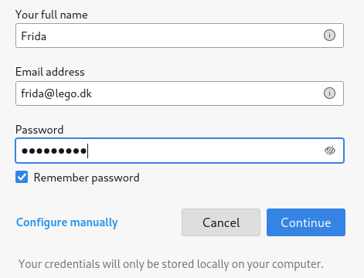

HOME task4 - Filezilla
- Install Filezilla Client and preconfigure a profile to access the SFTP server on BR-SRV.

General configuration
Set up the following on all the machines in HQ site and in R-BR:

General config task1 - hostname
- hostname (example with HQ-DC)

nano /etc/hosts
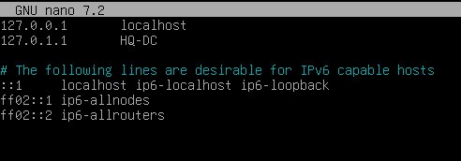

nano /etc/hostname
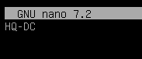

reboot

General config task2 - NetConfig
- network configuration (example with HQ-DC)

apt install resolvconf

nano /etc/network/interfaces

auto ens192
iface ens192 inet static
address 10.1.10.11/24
gateway 10.1.10.1
dns-nameservers 10.1.20.11

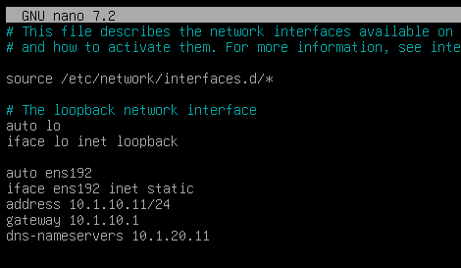

systemctl restart networking

- example with R-HQ

apt install resolvconf

nano /etc/network/interfaces

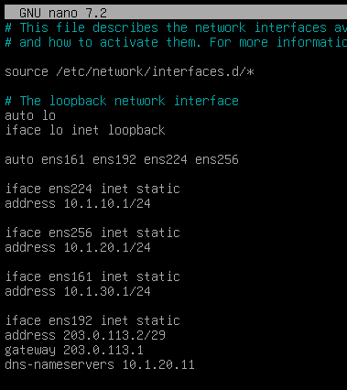

R-BR

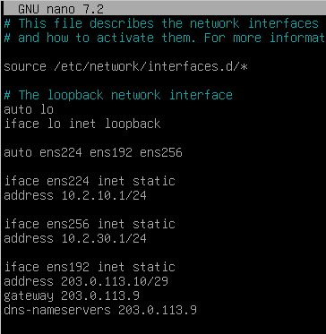

General config task3 - timezone
- time zone

timedatectl set-timezone Europe/Copenhagen

General config task4 - keyboard layout
- keyboard layout

already configured

General config task5 - NTP
Install and configure NTP server service on R-HQ and R-BR, synchronized to ntp.nordictech.dk. Sync all the machines on HQ site to R-HQ and sync BR-SRV to R-BR.

R-HQ & R-BR
apt install ntpsec

nano /etc/ntpsec/ntp.conf
#DO NOT comment out the line
tos minclock 4 minsane 3

# line 34 : comment out default settings and add R-INT as NTP server
#pool 0.debian.pool.ntp.org iburst
#pool 1.debian.pool.ntp.org iburst
#pool 2.debian.pool.ntp.org iburst
#pool 3.debian.pool.ntp.org iburst
pool ntp.nordictech.dk iburst

#if DNS is not working use this line instead
pool 203.0.113.1 iburst

systemctl restart ntpsec

# verify status
ntpq -p
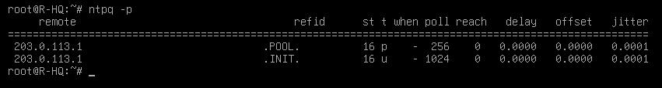

HQ-DC and the rest of the NTP clients
apt install ntpsec

nano /etc/ntpsec/ntp.conf
#DO NOT comment out the line
tos minclock 4 minsane 3

# line 34 : comment out default settings and add R-HQ as NTP server
#pool 0.debian.pool.ntp.org iburst
#pool 1.debian.pool.ntp.org iburst
#pool 2.debian.pool.ntp.org iburst
#pool 3.debian.pool.ntp.org iburst
pool 10.1.10.1 iburst

systemctl restart ntpsec

# verify status
ntpq -p
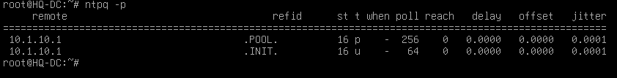

HQ site (Billund)
This is the company’s headquarter site, located in Billund, with limited server services and clients.

R-HQ
This is the edge router and firewall of the HQ site. For this reason, it should allow devices to reach each other between network segments and the Internet.
You must configure the services of this server according to the following requirements.

R-HQ task1 - FW masquerade
- Traffic from networks on HQ site cannot go to the Internet using private addressing.

Activate routing
nano /etc/sysctl.conf

#Comment out this line
net.ipv4.ip_forward=1

sysctl -p

Enable nftables

systemctl enable nftables

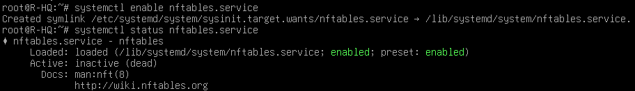

Prepare nftables configuration file. Add NAT table to /etc/nftables.conf file

cat /etc/nftables.conf

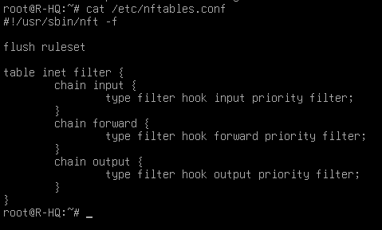

cat /usr/share/doc/nftables/examples/nat.nft >> /etc/nftables.conf
cat /etc/nftables.conf

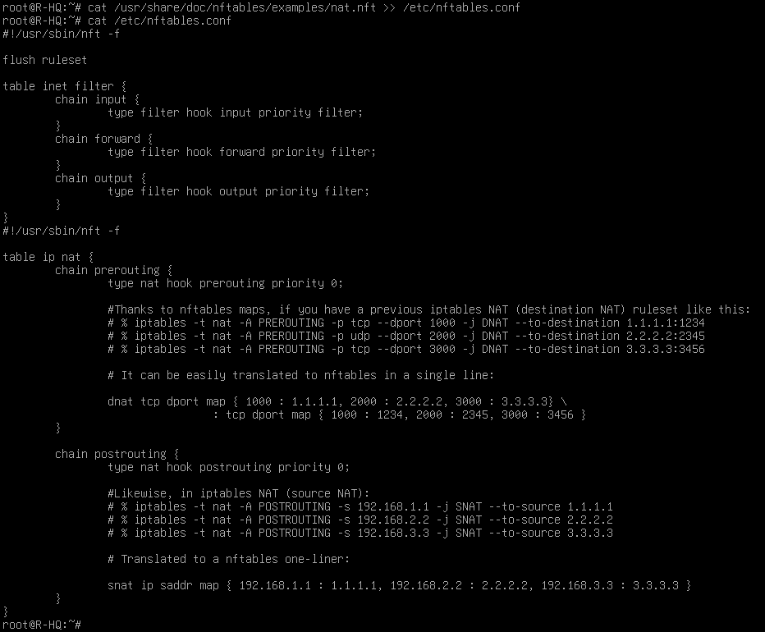

nano /etc/nftables.conf

….
table ip nat {
chain postrouting {
type nat hook postrouting priority 0;

oif ens192 ip saddr {10.1.10.0/24, 10.1.20.0/24, 10.1.30.0/24} masquerade;
}
}

systemctl restart nftables

R-HQ task2 - FW port forwarding + traffic
- Make sure the public services (DNS, mail, web) of the HQ site are accessible from the internet. Configure firewall with nftables. Incoming packets should be dropped by default. Allow minimal traffic for the services to work.
nano /etc/nftables.conf

#!/usr/sbin/nft -f

flush ruleset

table ip filter{
chain input {
type filter hook input priority filter;
policy drop;
ct state established,related accept;
udp dport {123} accept;
tcp dport {22} accept;
}
chain forward {
type filter hook forward priority filter;
policy drop;
ct state established,related accept;
udp dport 53 accept;
tcp dport { 53, 80, 443, 143, 587 } accept;
}
chain output {
type filter hook output priority filter;
policy accept;
}

table ip nat {
chain prerouting {
type nat hook prerouting priority 0;

iif ens192 dnat udp dport map {53 : 10.1.20.11};
iif ens192 dnat tcp dport map {53 : 10.1.20.11};
iif ens192 dnat tcp dport map {80 : 10.1.20.11, 443 : 10.1.20.11};
iif ens192 dnat tcp dport map {143 : 10.1.20.11, 587: 10.1.20.11};
}

chain postrouting {
type nat hook postrouting priority 0;

oif ens192 ip saddr {10.1.10.0/24, 10.1.20.0/24, 10.1.30.0/24} masquerade;
}
}

systemctl restart nftables

R-HQ task3 - Site-to-site VPN
- Ensure a secure channel between HQ and BRANCH sites. If this channel breaks, the clients of the HQ site can access the public services of BRANCH.

Step 1: Install openvpn
apt install openvpn

Step 2: certificates and keys. Assure that these files are located in /etc/openvpndirectory (created in HQ-DC task 1 & HQ-SAM-1 task 2)
- CHAIN-CA.crt
- R-HQ.key
- R-HQ.crt

Step 3: create DH and ta.key and place them in /etc/openvpn directory:

openssl dhparam -out dh2048.pem 2048
openvpn --genkey secret ta.key

Transfer ta.key to R-BR via scp:
scp /etc/openvpn/ta.key root@203.0.113.10:/etc/openvpn/

Step 4: Config file:
nano /etc/openvpn/s2s.conf

dev tun
#proto udp
#local 203.0.113.2
#port 1194
ifconfig 10.8.0.1 10.8.0.2
route 10.2.10.0 255.255.255.0
route 10.2.30.0 255.255.255.0
topology p2p

ca /etc/openvpn/CHAIN-CA.crt
key /etc/openvpn/R-HQ.key
cert /etc/openvpn/R-HQ.crt
dh /etc/openvpn/dh2048.pem
tls-crypt /etc/openvpn/ta.key
tls-server

cipher AES-256-GCM

keepalive 10 60
verb 3
log /var/log/openvpn/s2s.log

Step 5: enable the service (auto start when boot), start the service and check

systemctl enable openvpn@s2s
systemctl restart openvpn@s2s
systemctl status openvpn@s2s

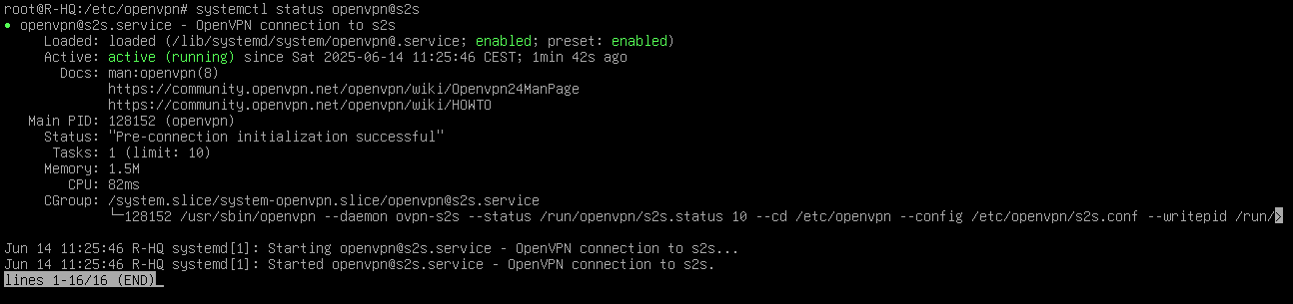

ip a

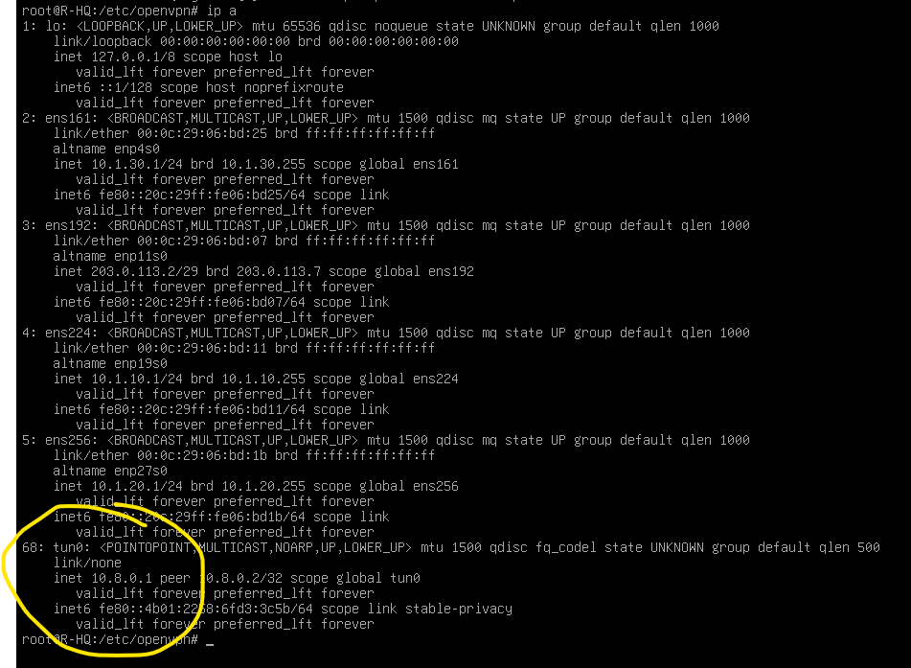

ip r

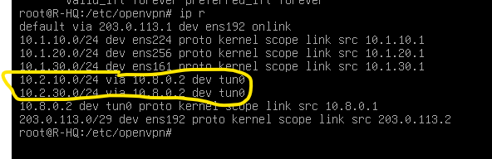

Go to R-BR task 3

R-HQ task4 - Remote access VPN
- Configure a remote access VPN service for remote workers. Make sure that VPN clients can access the same resources as the clients of the HQ site.

Step 1: Install openvpn (maybe already installed in task 3)
apt install openvpn

Step 2: certificates and keys. Assure that these files are located in /etc/openvpndirectory (created in HQ-DC task 1 & HQ-SAM-1 task 2)
- CHAIN-CA.crt
- R-HQ.key
- R-HQ.crt

Step 3: create DH and ta.key and place them in /etc/openvpn directory (maybe already created in task 3):

openssl dhparam -out dh2048.pem 2048
openvpn --genkey secret ta.key

Transfer ta.key to HOME via scp:
scp /etc/openvpn/ta.key root@203.0.113.50:/etc/openvpn/

Step 4: Config file:
cp /usr/share/doc/openvpn/examples/sample-config-files/server.conf /etc/openvpn/
nano /etc/openvpn/s2s.conf

dev tun
#proto udp
local 203.0.113.2
port 1195

ca /etc/openvpn/CHAIN-CA.crt
key /etc/openvpn/R-HQ.key
cert /etc/openvpn/R-HQ.crt
dh /etc/openvpn/dh2048.pem
tls-auth /etc/openvpn/ta.key 0

server 10.39.0.0 255.255.255.0
ifconfig-pool-persist /var/log/openvpn/ipp.txt

push “route 10.1.10.0 255.255.255.0”
push “route 10.2.10.0 255.255.255.0”
push “route 10.3.10.0 255.255.255.0”

cipher AES-256-GCM

persist-key
persist-tun

status /var/log/openvpn/openvpn-status.log

verb 3
log /var/log/openvpn/server.log

Step 5: enable the service (auto start when boot), start the service and check

systemctl enable openvpn@server
systemctl restart openvpn@server
systemctl status openvpn@server

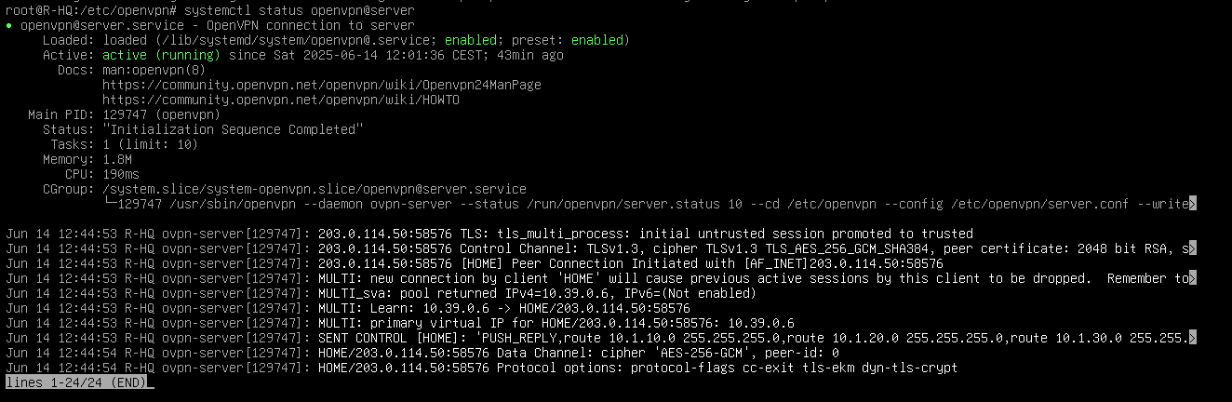

ip a

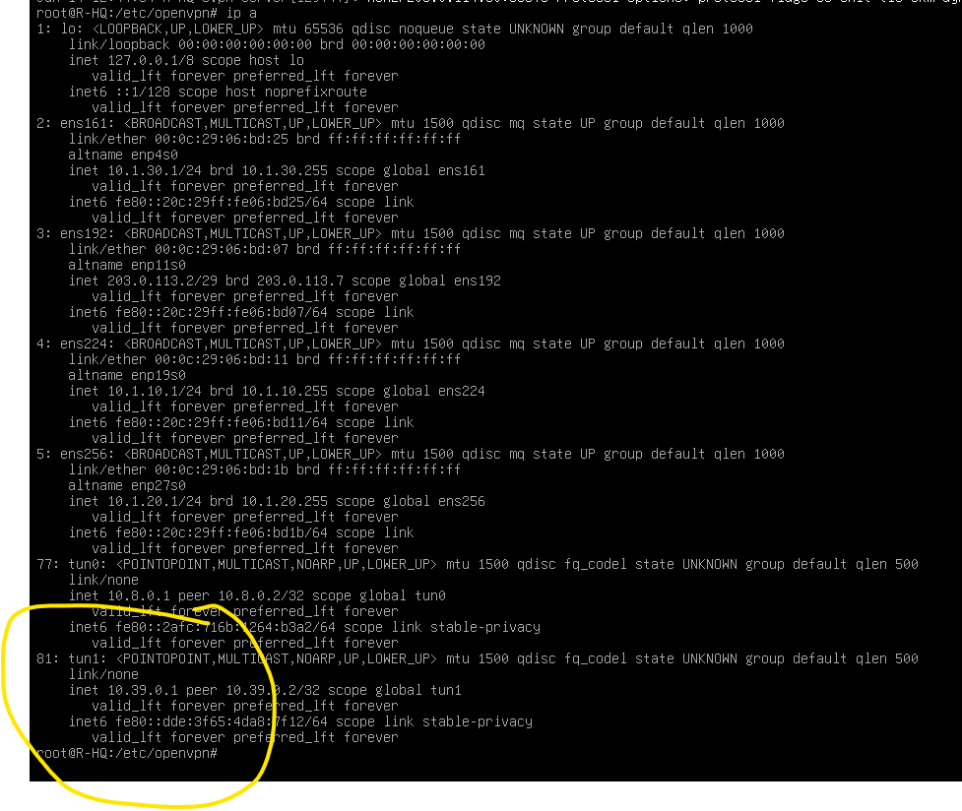

ip r

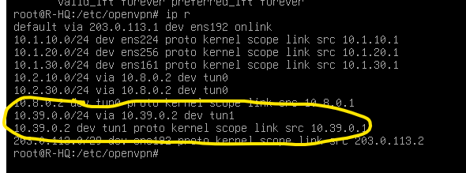

Go to HOME task 1

HQ-DC

HQ-DC task1 - Root CA
- Create a root certificate authority. Use the next parameters:
C=DK, O=Lego APS, CN=Lego APS Root CA
Place CA.crt CA certificate file in /ca folder.
This Root CA must only be used to sign the Subordinate CA certificate located on HQ-SAM-1

Step 1: Create a private key for the Root CA

mkdir -p /ca && cd /ca
######openssl genrsa -out CA.key 4096
openssl genrsa -out CA.key

Step 2: Create Certificate of the Root CA

####openssl req -x509 -new -nodes -key CA.key -sha256 -days 3650 -subj "/C=DK/O=Lego APS/CN=Lego APS Root CA" -out CA.crt
openssl req -x509 -new -nodes -key CA.key -subj "/C=DK/O=Lego APS/CN=Lego APS Root CA" -out CA.crt

Step 3: Create a private key for the Intermediate CA

####openssl genrsa -out SUBCA.key 4096
openssl genrsa -out SUBCA.key

Step 2: Create a CSR (Certificate Signing Request) for the Intermediate CA

openssl req -new -key SUBCA.key -subj "/C=DK/O=Lego APS/CN=Lego APS Intermediate CA" -out SUBCA.csr

Step 5: Sign CSR of the Intermediate CA using Root CA and get Certificate of the Intermediate CA
####openssl x509 -req -in SUBCA.csr -CA CA.crt -CAkey CA.key -CAcreateserial -out SUBCA.crt -days 3650 -extfile <(printf “basicConstraints=CA:true”)
openssl x509 -req -in SUBCA.csr -CA CA.crt -CAkey CA.key -CAcreateserial -out SUBCA.crt -extfile <(echo “basicConstraints=CA:true”)

note: basic constraints CA=true is for trusting all the chain
Step 6: In some configuration we will need a certificate chain joining CA.crt and SUBCA.crt. Create it:
cat SUBCA.crt CA.crt > CHAIN-CA.crt
Step 6: Copy Intermediate CA files (SUBCA.csr, SUBCA.key, SUBCA.crt) and CA.crt
to HQ-SAM-1
**NOTE: Previously, /ca directory should be created on HQ-SAM-1
scp SUBCA* root@10.1.10.21:/ca/
scp CA.crt root@10.1.10.21:/ca/
Step 7: Add the Root CA and the Intermediate CA certificate to the trusted root certificates
apt install -y ca-certificates
cp *.crt /usr/local/share/ca-certificates
update-ca-certificates

Repeat steps 6 (copy certs to another machine) and 7 (trust root and intermediate certificates) in each of these machines.

Go to HQ-SAM-1 to create server certificates.

HQ-DC task2 -LDAP server
- Deploy a directory service with LDAP protocol and SSL/TLS security. Create all objects listed in Appendix B.

Step 1: Following certificates and keys should be in HQ-DC machine:
- SUBCA.crt / CHAIN-CA.crt
- HQ-DC.key
- HQ-DC.crt

Step 1: Install LDAP service and first configuration

apt install slapd

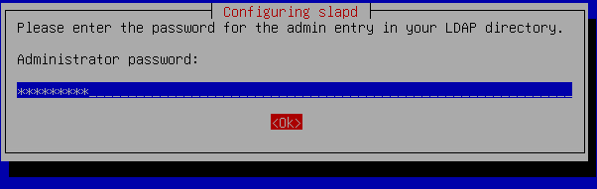

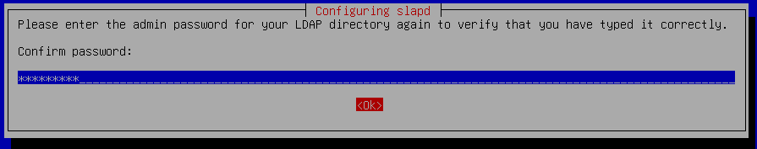

dpkg-reconfigure slapd

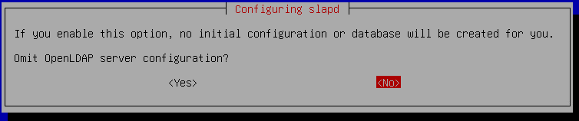

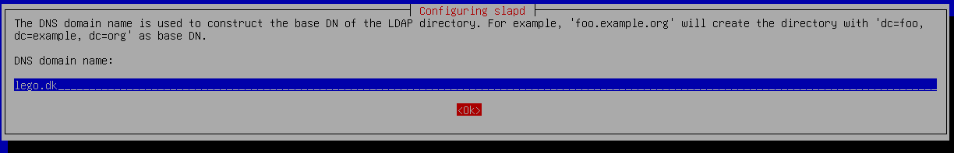

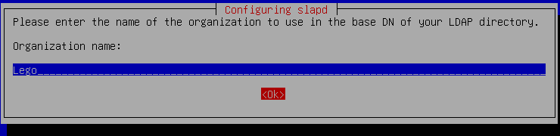

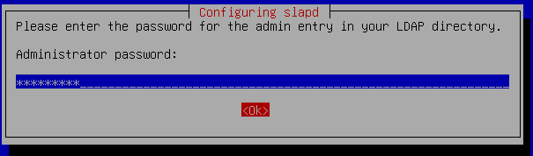

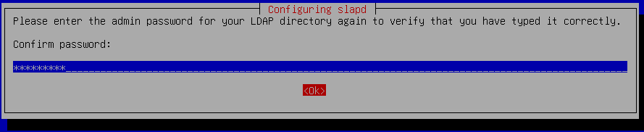



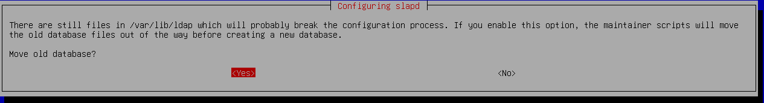

Step 2: Add OUs

nano ous.ldif

#ous.ldif
dn: ou=Billund,dc=lego,dc=dk
objectClass: organizationalUnit
ou: Billund

dn: ou=Herning,dc=lego,dc=dk
objectClass: organizationalUnit
ou: Herning

ldapadd -x -D cn=admin,dc=lego,dc=dk -W -f ous.ldif

Check

ldapsearch -x -b "dc=lego,dc=dk" -H ldap://localhost "(objectClass=organizationalUnit)"

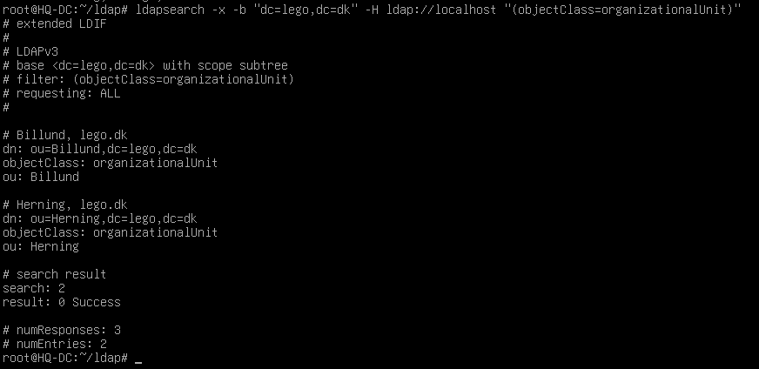

ldapsearch -x -b "dc=lego,dc=dk" -H ldap://localhost "(objectClass=organizationalUnit)" | grep dn

Step 3: Add users

touch ldapusers.ldif
slappasswd > ldapusers.ldif

nano ldapusers.ldif

#ldapusers.ldif
dn: uid=admin,ou=Billund,dc=lego,dc=dk
objectClass: inetOrgPerson
objectClass: posixAccount
objectClass: shadowAccount
cn: admin
sn: admin
userPassword: {SSHA}cUp80QP8sSTJBPoYBhOE2da7zOS69JhT
loginShell: /bin/bash
homeDirectory: /home/admin
uidNumber: 4001
gidNumber: 5001

dn: uid=frida,ou=Billund,dc=lego,dc=dk
objectClass: inetOrgPerson
objectClass: posixAccount
objectClass: shadowAccount
cn: frida
sn: frida
userPassword: {SSHA}cUp80QP8sSTJBPoYBhOE2da7zOS69JhT
loginShell: /bin/bash
homeDirectory: /home/frida
uidNumber: 4002
gidNumber: 5002

dn: uid=ella,ou=Billund,dc=lego,dc=dk
objectClass: inetOrgPerson
objectClass: posixAccount
objectClass: shadowAccount
cn: ella
sn: ella
userPassword: {SSHA}cUp80QP8sSTJBPoYBhOE2da7zOS69JhT
loginShell: /bin/bash
homeDirectory: /home/ella
uidNumber: 4003
gidNumber: 5002

dn: uid=carl,ou=Herning,dc=lego,dc=dk
objectClass: inetOrgPerson
objectClass: posixAccount
objectClass: shadowAccount
cn: carl
sn: carl
userPassword: {SSHA}cUp80QP8sSTJBPoYBhOE2da7zOS69JhT
loginShell: /bin/bash
homeDirectory: /home/carl
uidNumber: 4004
gidNumber: 5003

ldapadd -x -D cn=admin,dc=lego,dc=dk -W -f ldapusers.ldif

Check

ldapsearch -x -b "dc=lego,dc=dk" -H ldap://localhost "(objectClass=inetOrgPerson)"

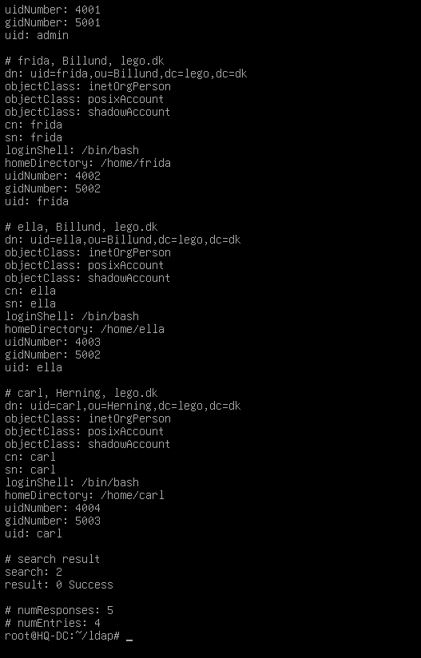

ldapsearch -x -b "dc=lego,dc=dk" -H ldap://localhost "(objectClass=inetOrgPerson)" | grep dn

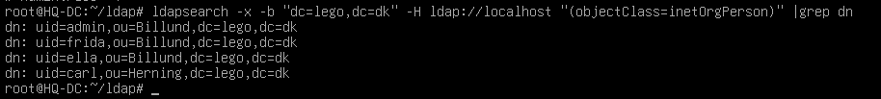

Step 4: Add groups

nano ldapgroups.ldif

#ldapgroups.ldif
dn: cn=admins,ou=Billund,dc=lego,dc=dk
objectClass: posixGroup
cn: admins
gidNumber: 5001
memberUid: admin

dn: cn=billund,ou=Billund,dc=lego,dc=dk
objectClass: posixGroup
cn: billund
gidNumber: 5002
memberUid: frida,ella

dn: cn=herning,ou=Herning,dc=lego,dc=dk
objectClass: posixGroup
cn: herning
gidNumber: 5003
memberUid: carl

ldapadd -x -D cn=admin,dc=lego,dc=dk -W -f ldapgroups.ldif
Check

ldapsearch -x -b "dc=lego,dc=dk" -H ldap://localhost "(objectClass=posixGroup)"

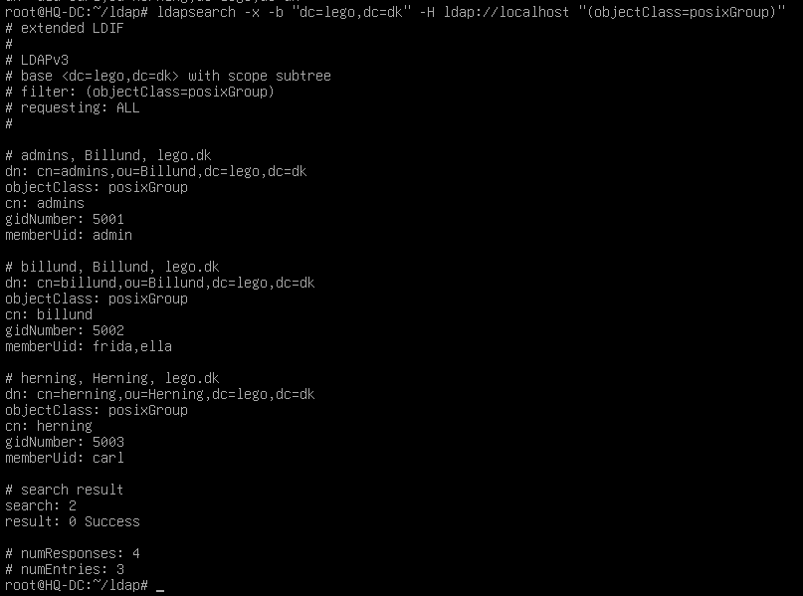

ldapsearch -x -b "dc=lego,dc=dk" -H ldap://localhost "(objectClass=posixGroup)" | grep dn

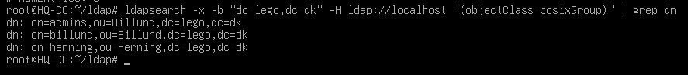

Step 5: configure LDAP over SSL/TLS

copy HQ-DC.key and HQ-DC.crt to /etc/ldap/sasl2/

chown openldap:openldap /etc/ldap/sasl2/*

ls -la /etc/ldap/sasl2/

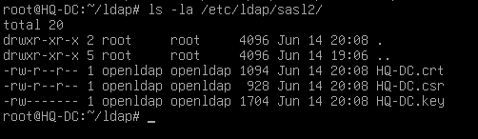

nano mod_ssl.ldif

# create new
dn: cn=config
changetype: modify
replace: olcTLSCertificateFile
olcTLSCertificateFile: /etc/ldap/sasl2/HQ-DC.crt
-
replace: olcTLSCertificateKeyFile
olcTLSCertificateKeyFile: /etc/ldap/sasl2/HQ-DC.key

ldapmodify -Y EXTERNAL -H ldapi:/// -f mod_ssl.ldif

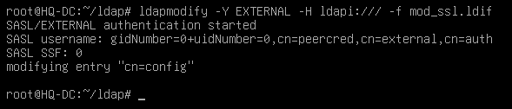

systemctl restart slapd

Step 6: Add a client

apt -y install libnss-ldapd libpam-ldapd ldap-utils







nano /etc/pam.d/common-session

# add to the end if need (create home directory automatically at initial login)
session optional pam_mkhomedir.so skel=/etc/skel umask=077

dpkg-reconfigure nslcd











We can leave /etc/ssl/certs/ca-certificates.crt if we have added CA.crt and SUBCA.crt to system.



nano /etc/nslcd.conf

should be something like this:



systemctl restart nscd nslcd

Check:

getent passwd

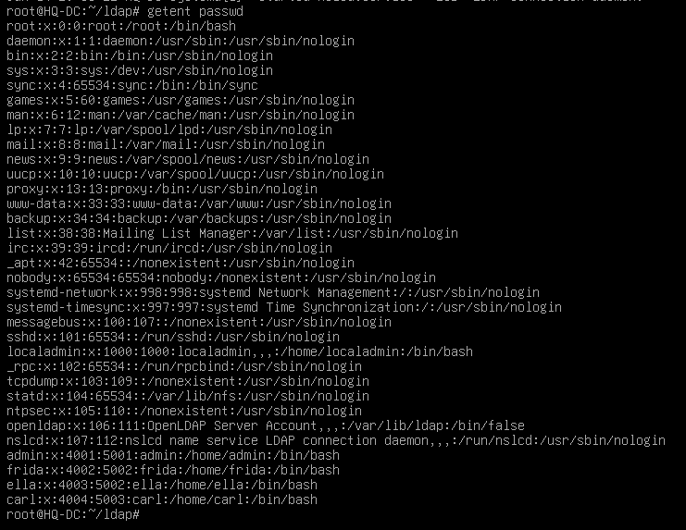

HQ-DC task3 - ZFS disk
- Add 4 new 2GB HDD to a machine. Configure software-based encrypted ZFS array and mount this to /share path.

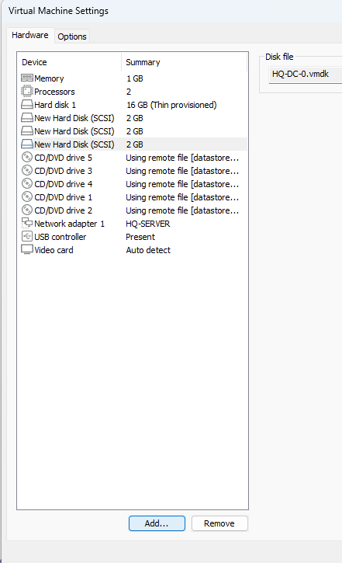

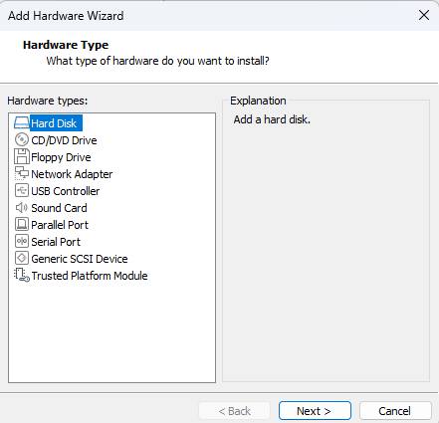

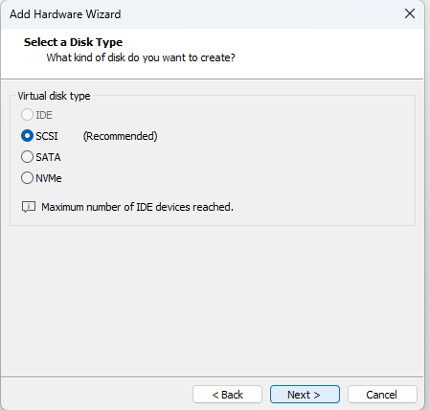

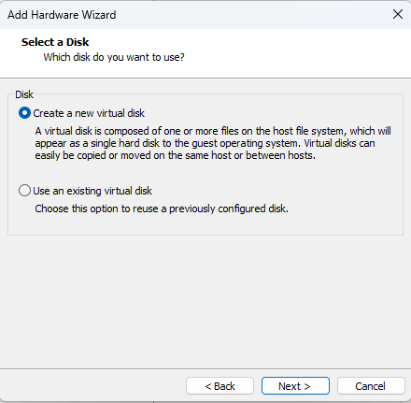

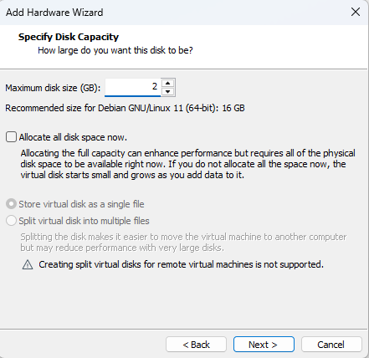

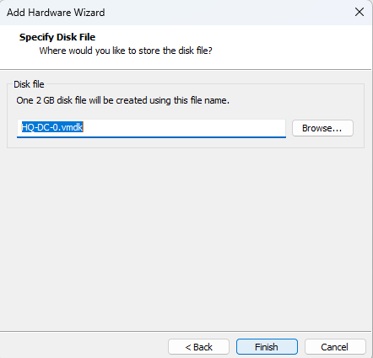

Power on the machine.

Check the HDDs:
fdisk -l

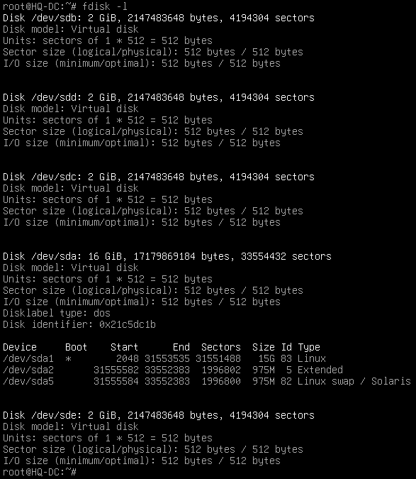

Or with

lsblk -o NAME,SIZE,TYPE,MOUNTPOINT

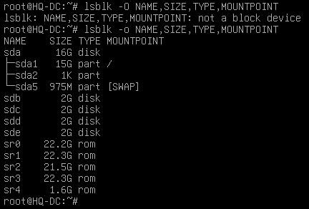

In this example, HDDs are:
/dev/sdb
/dev/sdc
/dev/sdd
/dev/sde

Create partition for each disk:
fdisk /dev/sdb
type n
press enter until you return to the main prompt
type w

zpool create RAID mirror /dev/sdb1 /dev/sdc1 mirror /dev/sdd1 /dev/sde1

zfs create RAID/smb -o mountpoint=/share -o encryption=on -o keyformat=passphrase -o keylocation=prompt

HQ-DC task4 - CIFS directory share
- Configure CIFS service for the profile directory of the corporate users. Use the /share/users/<username> as the path of the profile directories. Make sure the users can only access their own shared home folder.

HQ-DC task5 - Share automatic mount
- Enable automatic mount of network shares on clients.

HQ-SAM-1

HQ-SAM-1 task1 - HA DHCP
- Create a HA DHCP cluster with HQ-SAM-2 for the HQ-CLIENT network.

apt install isc-dhcp-server

nano /etc/dhcp/dhcpd.conf

authoritative;
failover peer "dhcp-failover" {
primary;
address 10.1.10.21;
port 647;
peer address 10.1.10.22;
peer port 647;
max-response-delay 30;
max-unacked-updates 10;
load balance max seconds 3;
mclt 1800;
split 128;
}

subnet 10.1.10.0 netmask 255.255.255.0 {
}
subnet 10.1.30.0 netmask 255.255.255.0 {
#interface ens192;
option domain-name-servers 10.1.20.11;
#option domain-name "billund.lego.dk";
option routers 10.1.30.1;
#option broadcast-address 10.1.30.255;
option ntp-servers 10.1.30.1;
#option time-offset -10800;
default-lease-time 86400;
pool{
failover peer "dhcp-failover";
range 10.1.30.21 10.1.30.120;
max-lease-time 172800;
}
}

nano /etc/default/isc-dhcp-server

INTERFACES=”ens192”

systemctl restart isc-dhcp-server

GO TO R-HQ

apt install isc-dhcp-relay

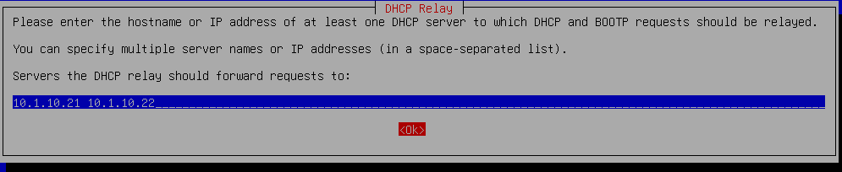

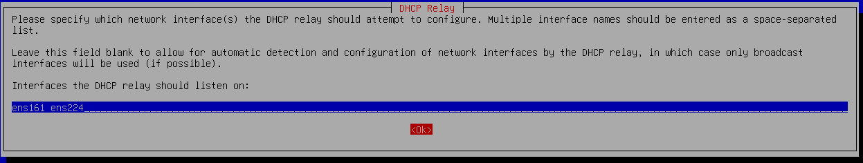

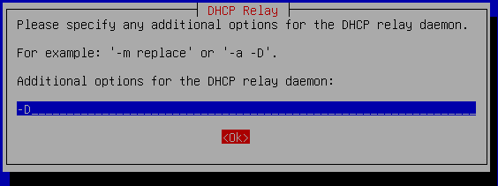

via config file

nano /etc/default/isc-dhcp-relay

SERVERS=”10.1.10.21 10.1.10.22”
INTERFACES=”ens161 ens224”
OPTIONS=”-D”

systemctl restart isc-dhcp-relay

HQ-SAM-1 task2 - Intermediate CA
- Create a subordinate certificate authority. Use the next parameters:
C=DK, O=Lego APS, CN=Lego APS Intermediate CA
Place SUBCA.crt CA certificate file in /ca folder.
The Sub CA should issue all the necessary certificates, which should contain (only and exactly) the following fields:
C=DK, O=Lego APS, CN=<FQDN>
Make sure all servers and the client applications accept the certs issued by this Sub CA.

Step 1: Create /ca directory
mkdir -p /ca && cd /ca

Go to HQ-DC, create all the necessary files and come back here
When you come back, in /ca directory should be:
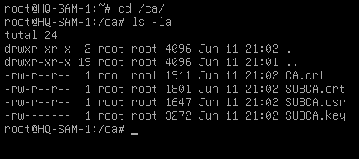

Step 2: Add the Root CA and the Intermediate CA certificate to the trusted root certificates
sudo apt install -y ca-certificates
sudo cp *.crt /usr/local/share/ca-certificates
sudo update-ca-certificates

For server certificates

Step 1: Create the server key

####openssl genrsa -out xxx.key 2048
openssl genrsa -out xxx.key

Step 2: Create the CSR (Certificate Signing Request)

openssl req -new -key xxx.key -subj "/C=DK/O=Lego APS/CN=xxx.xxx.dk" -out xxx.csr

Step 3: Sign the CSR with the Intermediate cert and generate the server crt
####openssl x509 -req -in xxx.csr -CA SUBCA.crt -CAkey SUBCA.key -CAcreateserial -out xxx.crt -days 825
openssl x509 -req -in xxx.csr -CA SUBCA.crt -CAkey SUBCA.key -CAcreateserial -out xxx.crt

Note: for some situations, maybe we must set the cert as “server” cert or a “client” cert, using one of these parameters in the command:

openssl x509 -req -in xxx.csr -CA SUBCA.crt -CAkey SUBCA.key -CAcreateserial -out xxx.crt -days 825 -extfile <(echo “extendedKeyUsage=serverAuth”)

openssl x509 -req -in xxx.csr -CA SUBCA.crt -CAkey SUBCA.key -CAcreateserial -out xxx.crt -days 825 -extfile <(echo “extendedKeyUsage=clientAuth”)

certificates to create
- www.billund.lego.dk
- www.herning.lego.dk
- mail.billund.lego.dk
- LDAP
- R-BR (for Site-to-site VPN) clientAuth
- R-HQ (for Site-to-site VPN and client-to-site VPN) serverAuth
- HOME (for client-to-site VPN) clientAuth

Last step: Move certificates to the correspondent machines using scp

HQ-SAM-2

HQ-SAM-2 task1 - HA DHCP
- Create a HA DHCP cluster with HQ-SAM-1 for the HQ-CLIENT network.

apt install isc-dhcp-server

nano /etc/dhcp/dhcpd.conf

failover peer "dhcp-failover" {
secondary;
address 10.1.10.22;
port 647;
peer address 10.1.10.21;
peer port 647;
max-response-delay 30;
max-unacked-updates 10;
load balance max seconds 3;
}

subnet 10.1.10.0 netmask 255.255.255.0 {
}
subnet 10.1.30.0 netmask 255.255.255.0 {
#interface ens192;
option domain-name-servers 10.1.20.11;
#option domain-name "billund.lego.dk";
option routers 10.1.30.1;
#option broadcast-address 10.1.30.255;
option ntp-servers 10.1.30.1;
#option time-offset -10800;
default-lease-time 86400;
pool{
failover peer "dhcp-failover";
range 10.1.30.21 10.1.30.120;
max-lease-time 172800;
}
}

nano /etc/default/isc-dhcp-server

INTERFACES=”ens192”

systemctl restart isc-dhcp-server

HQ-SAM-2 task2 - scheduled backup task
- Configure a scheduled backup of /share/users directory of HQ-DC to /backup/users directory on HQ-SAM-2 every 5 minutes.

HQ-DMZ-1

HQ-DMZ-1 task1 - CRL
- Configure CRL (Certificate Revocation List Distribution point) available in http://crl.lego.dk.

HQ-DMZ-2 task1 - DNS server
- Install and configure a DNS server for both forward and reverse lookups of billund.lego.dk domain. Configure SPF, DKIM and DMARC records for email domain. It must serve requests from the Internet as well but cannot use private addressing for that purpose. Configure this DNS server as a secondary DNS server for herning.lego.dk domain. DNS requests for other domains must be forwarded to the correct DNS server.

apt install bind9

nano /etc/bind/med.conf

#comment out default zones line

include "/etc/bind/named.conf.options";
include "/etc/bind/named.conf.local";
//include "/etc/bind/named.conf.default-zones";

nano /etc/bind/named.conf.local

acl internal {10.1.10.0/24; 10.1.20.0/24; 10.1.30.0/24; 10.2.10.0/24; 10.2.30.0/24; localhost; };
acl external {any; };

view int {
match-clients { internal; };
allow-recursion { any; };

zone "billund.lego.dk" {
type master;
file "/etc/bind/db.billund.lego.dk.int";
allow-transfer { 10.2.10.11; };
notify yes;
};

zone "20.1.10.in-addr.arpa" {
type master;
file "/etc/bind/db.10.1.20";
allow-transfer { 10.2.10.11; };
notify yes;
};

zone "herning.lego.dk" {
type slave;
masters { 10.2.10.11; };
file "db.herning.lego.dk.int";
};

zone “10.2.10.in-addr.arpa" {
type slave;
masters { 10.2.10.11; };
file "db.10.2.10";
};

include "/etc/bind/zones.rfc1918";
include "/etc/bind/named.conf.default-zones";
};

view ext{
match-clients { external; };
allow-recursion { any; };

zone "billund.lego.dk" {
type master;
file "/etc/bind/db.billund.lego.dk.ext";
allow-transfer { 203.0.113.10; };
notify yes;
};
zone "113.0.203.in-addr.arpa" {
type master;
file "/etc/bind/db.203.0.113";
allow-transfer { 203.0.113.10; };
notify yes;
};

zone "herning.lego.dk" {
type slave;
masters { 203.0.113.10; };
file "db.herning.lego.dk.ext";
};

include "/etc/bind/zones.rfc1918";
include "/etc/bind/named.conf.default-zones";
};

nano /etc/bind/db.billund.lego.dk.int

$TTL 86400
@ IN SOA www.billund.lego.dk. root.billund.lego.dk. (
1 ; Serial
604800 ; Refresh
86400 ; Retry
2419200 ; Expire
86400 ) ; Negative Cache TTL
;
@ IN NS www.billund.lego.dk.
@ IN MX 10 mail.billund.lego.dk.
www IN A 10.1.20.11
mail IN A 10.1.20.12

nano /etc/bind/db10.1.20

$TTL 86400
@ IN SOA www.billund.lego.dk. root.billund.lego.dk. (
1 ; Serial
604800 ; Refresh
86400 ; Retry
2419200 ; Expire
86400 ) ; Negative Cache TTL
;
@ IN NS www.billund.lego.dk.
11 IN PTR www.billund.lego.dk.
12 IN PTR mail.billund.lego.dk.

nano /etc/bind/db.billund.lego.dk.ext

$TTL 86400
@ IN SOA www.billund.lego.dk. root.billund.lego.dk. (
1 ; Serial
604800 ; Refresh
86400 ; Retry
2419200 ; Expire
86400 ) ; Negative Cache TTL
;
@ IN NS www.billund.lego.dk.
@ IN MX 10 mail.billund.lego.dk.
www IN A 203.0.113.2
mail IN A 203.0.113.2

nano /etc/bind/db.203.0.113

$TTL 86400
@ IN SOA www.billund.lego.dk. root.billund.lego.dk. (
1 ; Serial
604800 ; Refresh
86400 ; Retry
2419200 ; Expire
86400 ) ; Negative Cache TTL
;
@ IN NS www.billund.lego.dk.
2 IN PTR www.billund.lego.dk.
2 IN PTR mail.billund.lego.dk.
10 IN PTR www.herning.lego.dk.

REGISTROS SPF, DKIM, DMARC y SRV para SMTP e IMAP:
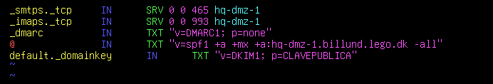
Queda pendiente desarrollar cómo obtener la clave DKIM.

systemctl restart bind9

Secondary transferred zone files will appear in /var/cache/bind/.

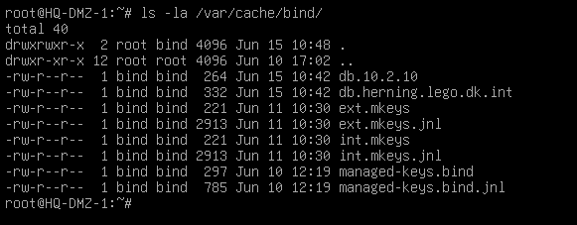

If we want to update a zone the SERIAL NUMBER MUST BE CHANGED.
To force updates we can use the following command:

rndc reload

HQ-DMZ-1 task3 - HA web server
- Install and configure a HA web service with HQ-DMZ-2. Serve the https://www.billund.lego.dk site using a valid certificate signed by the company’s Sub CA. HTTP requests must be redirected to HTTPS. Website should show the text "Welcome to Billund". For HA you must use HAproxy.

Assure that the following certs and keys are in HQ-DMZ-1 and HQ-DMZ-2:
- www.billund.lego.dk.key
- www.billund.lego.dk.crt
- CA.crt
- SUBCA.crt
- CHAIN-CA.crt

Install apache2

apt install apache2

Edit the message on the main webpage:

echo “Welcome to Billund. Site served by HQ-DMZ-1” > /var/www/html/index.html

Copy cert and key to /etc/ssl/certs and /etc/ssl/private directories:

cp www.billund.lego.dk.crt /etc/ssl/certs
cp www.billund.lego.dk.key /etc/ssl/private

Trust CA.crt and SUBCA.crt:

cp *CA*crt /usr/local/share/ca-certificates/
update-ca-certificates

Enable SSL module:

a2enmod ssl

Enable HTTPS site:

a2ensite default-ssl.conf

Configure certificate paths:

nano /etc/apache2/sites-enabled/default-ssl.conf

<VirtualHost *:80>
DocumenRoot /var/www/html
SSLEngine on
SSLCertificateFile /etc/ssl/certs/www.billund.lego.dk.crt
SSLCertificateKeyFile /etc/ssl/private/www.billund.lego.dk.key
</VirtualHost>

systemctl restart apache2

Install HAproxy
apt install haproxy
nano /etc/haproxy/haproxy.cfg
Add to the end
frontend apache_front
bind *:80
default_backend apache_backend_servers
option forwardfor
backend apache_backend_servers
balance roundrobin
server HQ-DMZ-1 10.1.20.11:80 check
server HQ-DMZ-2 10.1.20.12:80 check

HQ-DMZ-2

HQ-DMZ-2 task1 - HA web server
- Install and configure a HA web service with HQ-DMZ-1. See details there.

HQ-DMZ-2 task2 - Email server
- Configure e-mail service accessible on mail.billund.lego.dk to send and receive email for the lego.dk domain. LDAP users access their mailboxes using SSL/TLS-secured IMAP (port 143) and send emails using STARTTLS-secured SMTP (port 587).

Assure that the following certs and keys are in HQ-DMZ-2:
- mail.billund.lego.dk.key
- mail.billund.lego.dk.crt
- CA.crt
- SUBCA.crt
- CHAIN-CA.crt

Copy cert and key to /etc/ssl/certs and /etc/ssl/private directories:

cp mail.billund.lego.dk.crt /etc/ssl/certs
cp mail.billund.lego.dk.key /etc/ssl/private

Install postfix

apt install postfix

Postfix configuration while installing:
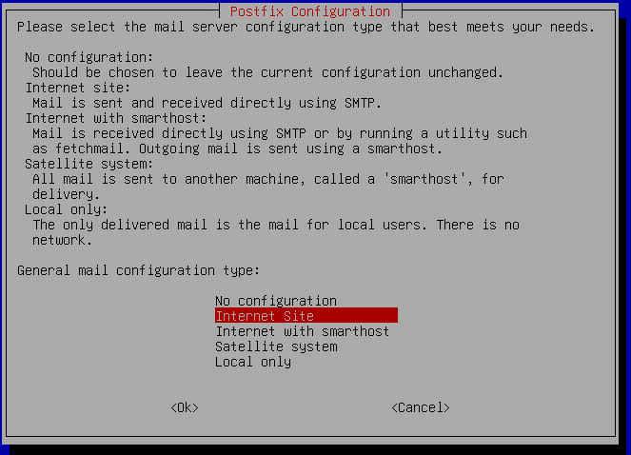

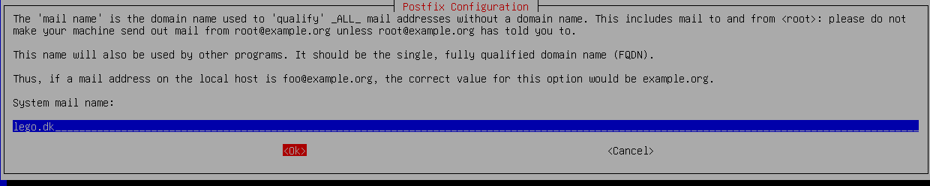

nano /etc/postfix/master.cf

Comment out and modify these lines:

#/etc/postfix/master.cf
submission inet n - y - - smtpd
-o syslog_name=postfix/submission
-o smtpd_tls_security_level=encrypt
-o smtpd_tls_wrappermode=no
-o smtpd_sasl_auth_enable=yes
-o smtpd_relay_restrictions=permit_sasl_authenticated,reject
-o smtpd_recipient_restrictions=permit_mynetworks,permit_sasl_authenticated,reject
-o smtpd_sasl_type=dovecot
-o smtpd_sasl_path=private/auth

nano /etc/postfix/main.cf

Comment out and modify these lines:

#/etc/postfix/main.cf
mynetworks = 127.0.0.0/8 [::ffff:127.0.0.0]/104 [::1]/128 0.0.0.0/0
#Enable TLS Encryption when Postfix receives incoming emails
smtpd_tls_cert_file=/etc/ssl/certs/mail.billund.lego.dk.crt
smtpd_tls_key_file=/etc/ssl/private/mail.billund.lego.dk.key
smtpd_tls_security_level=may
smtpd_tls_loglevel = 1
smtpd_tls_session_cache_database = btree:${data_directory}/smtpd_scache

#Enable TLS Encryption when Postfix sends outgoing emails
smtp_tls_security_level = may
smtp_tls_loglevel = 1
smtp_tls_session_cache_database = btree:${data_directory}/smtp_scache

#Enforce TLSv1.3 or TLSv1.2
smtpd_tls_mandatory_protocols = !SSLv2, !SSLv3, !TLSv1, !TLSv1.1
smtpd_tls_protocols = !SSLv2, !SSLv3, !TLSv1, !TLSv1.1
smtp_tls_mandatory_protocols = !SSLv2, !SSLv3, !TLSv1, !TLSv1.1
smtp_tls_protocols = !SSLv2, !SSLv3, !TLSv1, !TLSv1.1

**Nota: los parámetros de /etc/postfix/main.cf se pueden configurar con el comando “postconf -e…”, y te permite usar el tabulador para ver las opciones, por ejemplo:
postconf -e ‘smtpd_tls_cert_file = /etc/ssl/certs/mail.billund.lego.dk.crt’

Más ejemplos en https://www.linuxparty.es/10-comunicaciones/9387-instalar-y-configurar-postfix-y-dovecot-con-autenticacion-y-tls

systemctl restart postfix

Check that port 587 (postfix-SMTP) is listening:

ss -lnpt | grep master

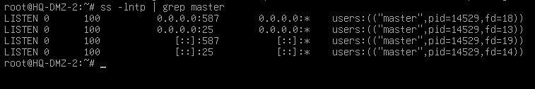

According to 30% changes, IMAP will be one of these options:
- ...using SSL/TLS-secured IMAP (port 993)...
- ...using STARTTLS-secured IMAP (port 143)...

Option A: ...using SSL/TLS-secured IMAP (port 993)...

HAPROXY POR DELANTE CON SSL

Option B: ...using STARTTLS-secured IMAP (port 143)...

Source: https://www.linuxbabe.com/mail-server/install-dovecot-imap-server-debian

Install and dovecot-imapd

apt install dovecot-imapd dovecot-lmtp

nano /etc/dovecot/dovecot.conf

protocols = imap lmtp

nano /etc/dovecot/conf.d/10-mail.conf

mail_location = maildir:~/Maildir
#mail_location = mbox:~/mail:INBOX=/var/mail/%u

nano /etc/dovecot/conf.d/10-master.conf

service lmtp {
unix_listener /var/spool/postfix/private/dovecot-lmtp {
mode = 0600
user = postfix
group = postfix
}
}
nano /etc/postfix/main.cf

mailbox_transport = lmtp:unix:private/dovecot-lmtp
smtputf8_enable = no

nano /etc/dovecot/conf.d/10-auth.conf

disable_plaintext_auth = yes
#auth_username_format = %Lu
auth_username_format = %n
auth_mechanisms = plain

nano /etc/dovecot/conf.d/10-ssl.conf

ssl = required
ssl_cert = </etc/ssl/certs/mail.billund.lego.dk.crt
ssl_key = </etc/ssl/private/mail.billund.lego.dk.key
#ssl_prefer_server_ciphers = no
ssl_prefer_server_ciphers = yes
ssl_min_protocol = TLSv1.2

nano /etc/dovecot/conf.d/10-master.conf

service auth {
unix_listener /var/spool/postfix/private/auth {
mode = 0660
user = postfix
group = postfix
}
}

systemctl restart postfix dovecot

sudo ss -lnpt | grep dovecot

HQ-DMZ-2 task3 - Zabbix monitoring (web)
- Install and configure Zabbix for monitoring the availability of https://www.billund.lego.dk webserver. When the server is down, write an alert to /monitor/webalert.log and send an email to Frida.

apt install sudo
apt install postgresql postgresql-contrib

sudo systemctl is-enabled postgresql
sudo systemctl status postgresql

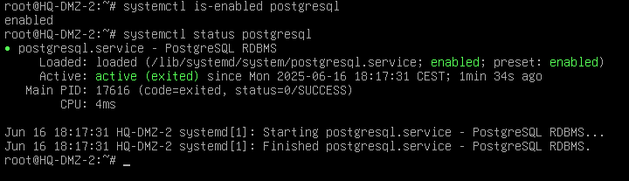

create a new PostgreSQL user 'zabbix'

sudo -u postgres createuser --pwprompt zabbix

create a new database 'zabbix' with the default owner 'zabbix'

sudo -u postgres createdb -O zabbix zabbix

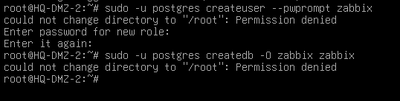

Install from ISO image:

dpkg -i zabbix-release_latest_7.4+debian12_all.deb

apt install zabbix-server-pgsql zabbix-frontend-php php8.2-pgsql zabbix-agent

apt install nginx

dpkg -i zabbix-sql-scripts_7.0.13-1+debian12_all.deb

dpkg -i zabbix-nginx-conf_7.0.13-1+debian12_all.deb

Import the database schema for Zabbix to the 'zabbix' database with the user 'zabbix'. Enter your 'zabbix' password when prompted.

zcat /usr/share/zabbix-sql-scripts/postgresql/server.sql.gz | sudo -u zabbix psql zabbix

open Zabbix configuration '/etc/zabbix/zabbix_server.conf' and Uncomment the default 'DBHost', 'DBName', 'DBUser', and 'DBPassword' with your PostgreSQL credentials.

nano /etc/zabbix/zabbix_server.conf

DBHost = localhost
DBName = zabbix
DBUser = zabbix
DBPassword = Passw0rd!

nano /etc/zabbix/nginx.conf

listen 8080;
server_name zabbix.billund.lego.dk;

systemctl enable zabbix-server zabbix-agent nginx php8.2-fpm

systemctl restart zabbix-server zabbix-agent nginx php8.2-fpm

systemctl status zabbix-server zabbix-agent nginx php8.2-fpm

ERROR

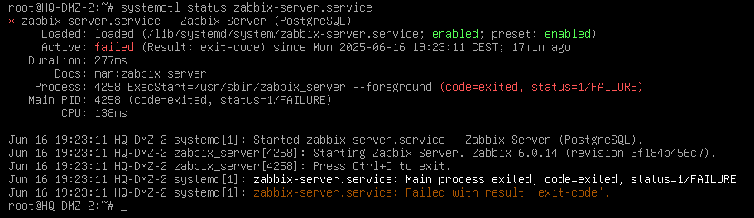

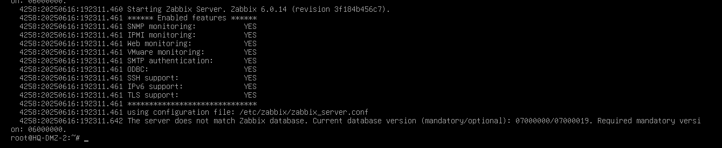

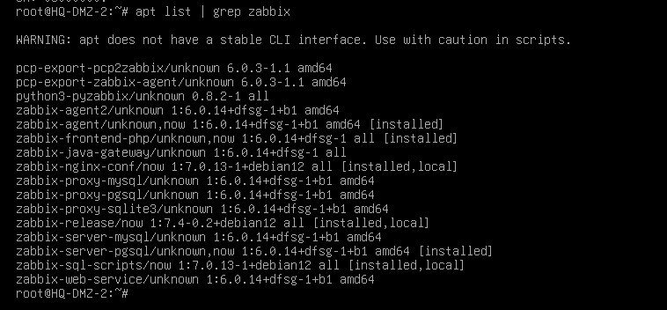

Maybe we should use zabbix-release_latest_6.0+debian12_all.deb version and all the correspondent 6.o versions. The unique 7.x versions have been downloaded and installed manually
- zabbix-release_latest_7.4+debian12_all.deb
- zabbix-sql-scripts_7.0.13-1+debian12_all.deb
- zabbix-nginx-conf_7.0.13-1+debian12_all.deb

HQ-DMZ-2 task4 - Zabbix monitoring (CPU)
- Configure Zabbix to monitor CPU usage of computers on BR-CLIENT network via SNMP.

HQ-CL

HQ-CL task1 - GUI
- Install a graphic environment of your choice.

tasksel

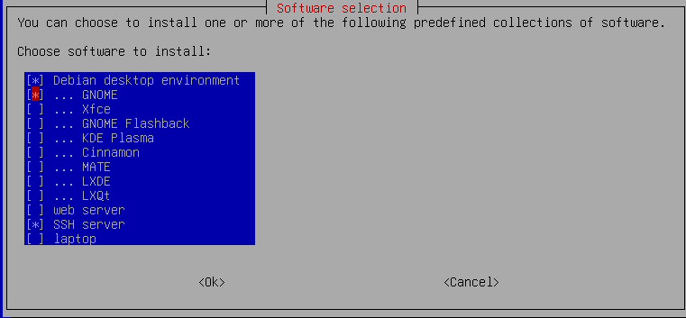

reboot

HQ-CL task1 - LDAP client
- Configure LDAP authentication using the LDAP server. Login with ella.

apt -y install libnss-ldapd libpam-ldapd ldap-utils







nano /etc/pam.d/common-session

# add to the end if need (create home directory automatically at initial login)
session optional pam_mkhomedir.so skel=/etc/skel umask=077

dpkg-reconfigure nslcd











We can leave /etc/ssl/certs/ca-certificates.crt if we have added CA.crt and SUBCA.crt to system.



nano /etc/nslcd.conf

should be something like this:



systemctl restart nscd nslcd

Check:

getent passwd

HQ-CL task3 - Thunderbird email client
- Install Thunderbird e-mail client to use with ella@lego.dk. Send email to frida.

Option B: ...using STARTTLS-secured IMAP (port 143)...

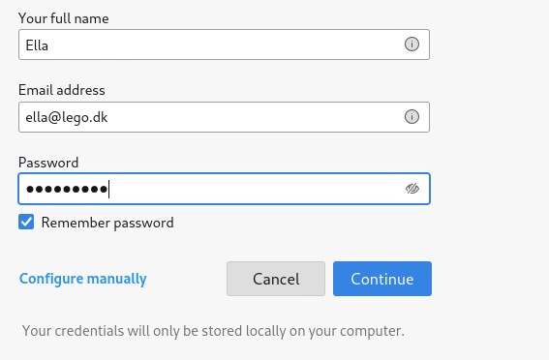

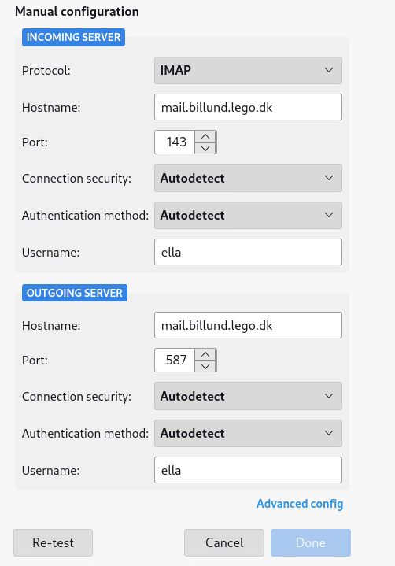

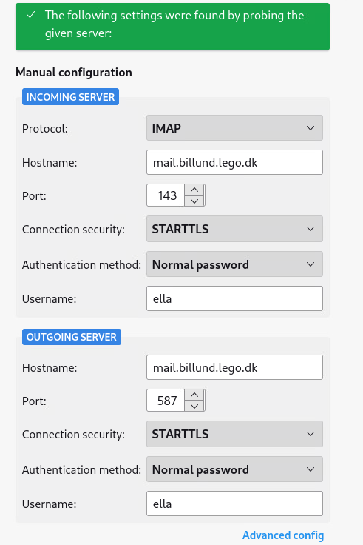

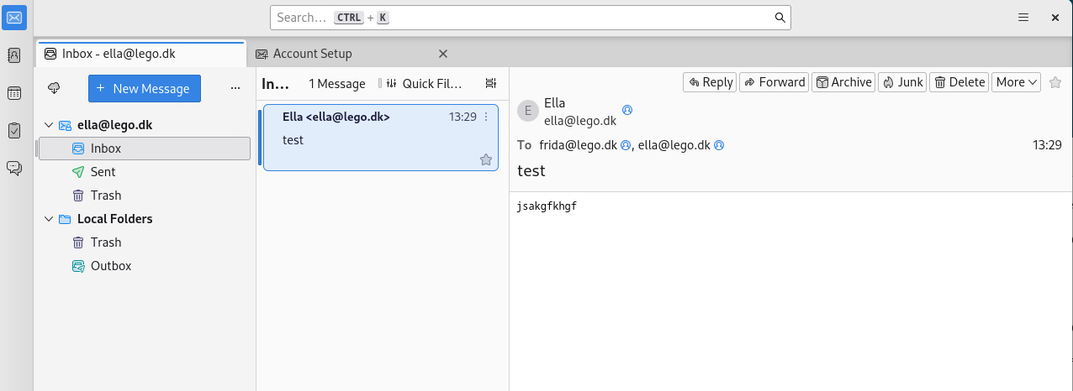

BRANCH site (Herning)
This is the company’s branch site, located in Herning, with limited server services and clients.

R-BR
This is the edge router and firewall of the BRANCH site. For this reason, it should allow devices to reach each other between network segments and the Internet.
You must configure the services of this server according to the following requirements:

R-BR task1 - FW masquerade
- Traffic from networks on BRANCH site cannot go to the Internet using private addressing.

Activate routing
nano /etc/sysctl.conf

#Comment out this line
net.ipv4.ip_forward=1

sysctl -p

Enable nftables

systemctl enable nftables

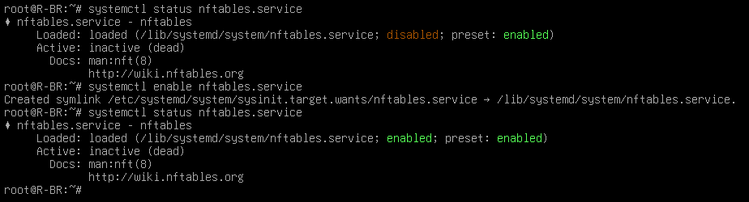

Prepare nftables configuration file. Add NAT table to /etc/nftables.conf file

cat /etc/nftables.conf

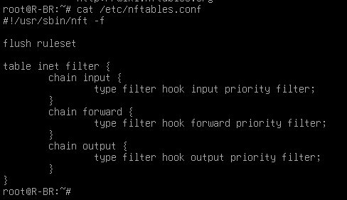

cat /usr/share/doc/nftables/examples/nat.nft >> /etc/nftables.conf
cat /etc/nftables.conf

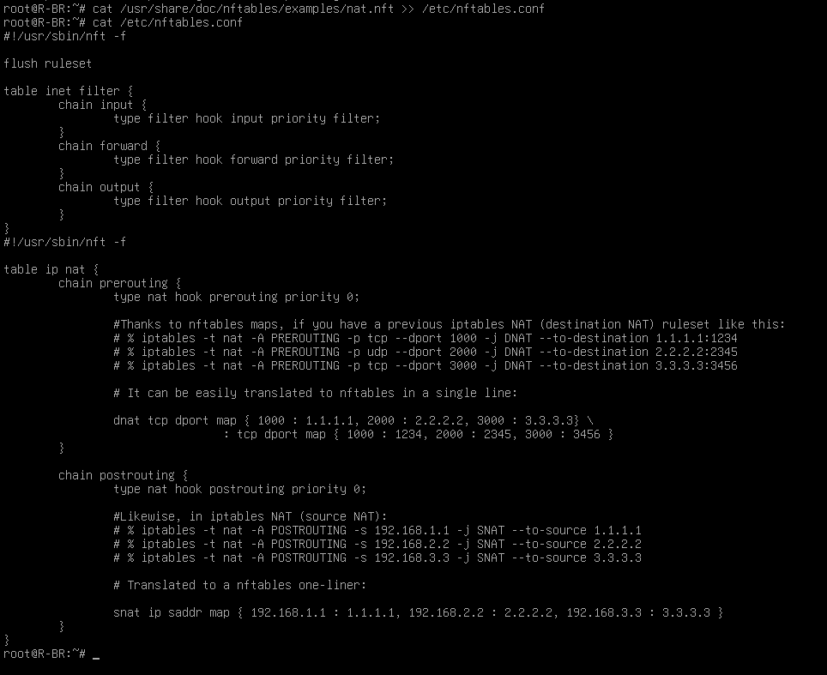

nano /etc/nftables.conf

….
table ip nat {
chain postrouting {
type nat hook postrouting priority 0;

oif ens192 ip saddr {10.1.10.0/24, 10.1.20.0/24, 10.1.30.0/24} masquerade;
}
}

systemctl restart nftables

R-BR task2 - port forwarding and traffic filter
- Make sure the public services (DNS, web) of the HQ site are accessible from the internet. Configure firewall with nftables. Incoming packets should be dropped by default. Allow minimal traffic for the services to work.

nano /etc/nftables.conf

#!/usr/sbin/nft -f

flush ruleset

table ip filter{
chain input {
type filter hook input priority filter;
policy drop;
ct state established,related accept;
udp dport {123} accept;
tcp dport {22} accept;
}
chain forward {
type filter hook forward priority filter;
policy drop;
ct state established,related accept;
udp dport 53 accept;
tcp dport { 53, 80, 443 } accept;
}
chain output {
type filter hook output priority filter;
policy accept;
}

table ip nat {
chain prerouting {
type nat hook prerouting priority 0;
iif ens192 dnat udp dport map {53 : 10.2.10.11};
iif ens192 dnat tcp dport map {53 : 10.2.10.11};
iif ens192 dnat tcp dport map {80 : 10.2.10.11, 443 : 10.2.10.11};
}

chain postrouting {
type nat hook postrouting priority 0;
oif ens192 ip saddr {10.2.10.0/24, 10.2.30.0/24} masquerade;
}
}

systemctl restart nftables

R-BR task3 - Site-to-site VPN
- Ensure a secure channel between HQ and BRANCH sites. If this channel breaks, the clients of the BRANCH site can access the public services of HQ.

Step 1: Install openvpn
apt install openvpn

Step 2: certificates and keys. Assure that these files are located in /etc/openvpndirectory (created in HQ-DC task 1 & HQ-SAM-1 task 2). ta.key created in R-HQ task 3.
- CHAIN-CA.crt
- R-BR.key
- R-BR.crt
- ta.key

Step 3: Config file:
nano /etc/openvpn/s2s.conf

dev tun
#proto udp
remote 203.0.113.2 1194
ifconfig 10.8.0.2 10.8.0.1
route 10.1.10.0 255.255.255.0
route 10.1.20.0 255.255.255.0
route 10.1.30.0 255.255.255.0
topology p2p

ca /etc/openvpn/CHAIN-CA.crt
key /etc/openvpn/R-BR.key
cert /etc/openvpn/R-BR.crt
tls-crypt /etc/openvpn/ta.key
tls-client

cipher AES-256-GCM

keepalive 10 60
verb 3
log /var/log/openvpn/s2s.log

Step 5: enable the service (auto start when boot), start the service and check

systemctl enable openvpn@s2s
systemctl restart openvpn@s2s
systemctl status openvpn@s2s

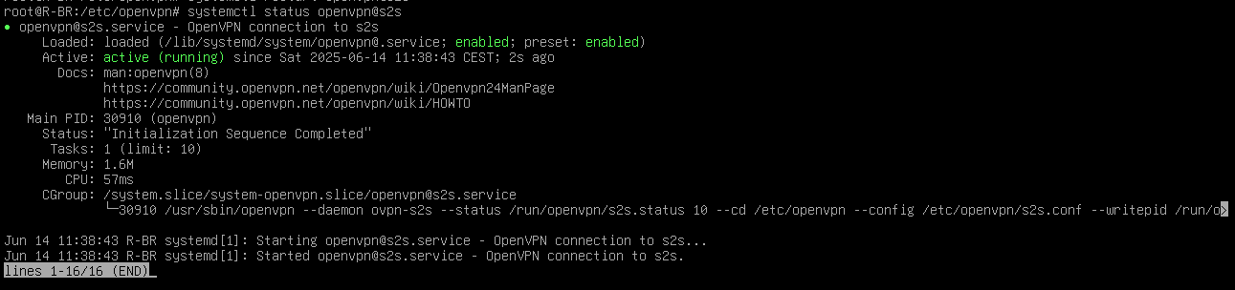

ip a

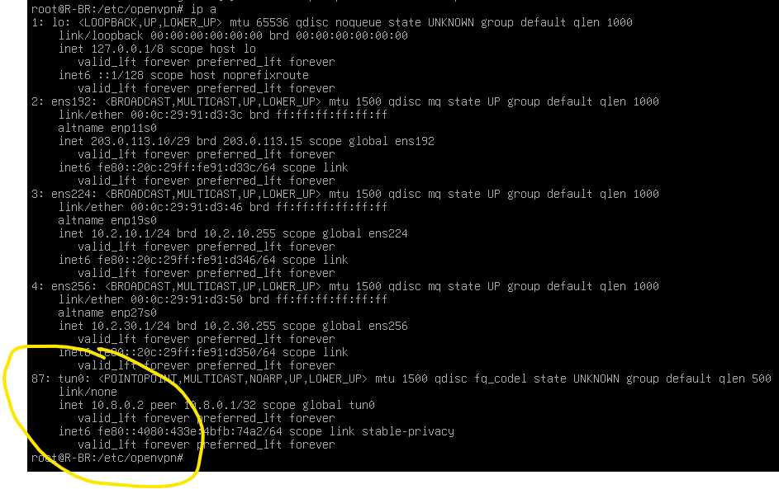

ip r

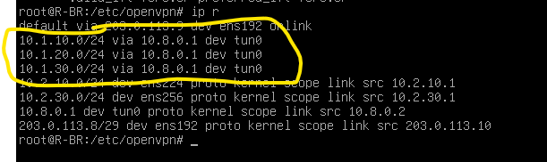

Now communication between sites is possible using private addressing.

BR-SRV
This device has GUI, VSCode preinstalled and Zeal documentation available for Ansible development.

BR-SRV task1 - DHCP
- Create a DHCP server for the BR-CLIENT network. Assure that BR-CL device always obtains 10.2.30.50/24 IP configuration for automation tasks.

apt install isc-dhcp-server

nano /etc/dhcp/dhcpd.conf

authoritative;

subnet 10.2.10.0 netmask 255.255.255.0 {
}
subnet 10.2.30.0 netmask 255.255.255.0 {
#interface ens192;
option domain-name-servers 10.2.10.11;
#option domain-name "herning.lego.dk";
option routers 10.2.30.1;
#option broadcast-address 10.2.30.255;
option ntp-servers 10.2.30.1;
#option time-offset -10800;
default-lease-time 86400;
max-lease-time 172800;
range 10.2.30.51 10.2.30.150;

}
host BR-CL {
hardware Ethernet 00:0C:29:FC:01:90;
fixed-address 10.2.30.50;
}

nano /etc/default/isc-dhcp-server

INTERFACES=”ens192”

systemctl restart isc-dhcp-server

GO TO R-BR

apt install isc-dhcp-relay

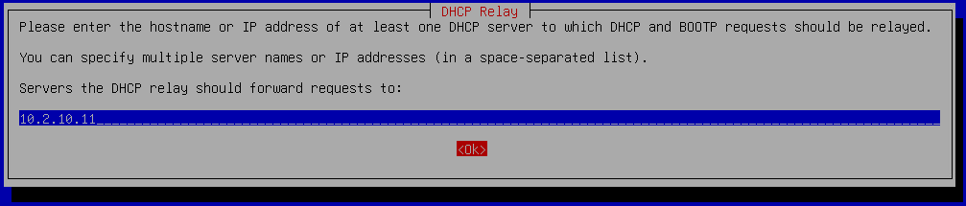

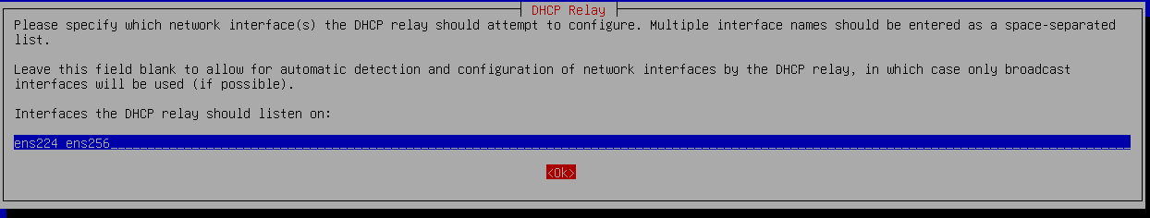

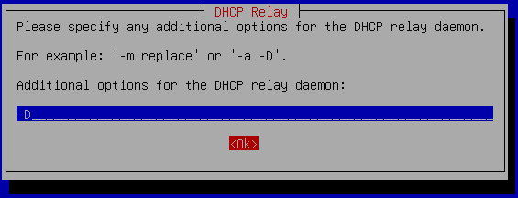

via config file

nano /etc/default/isc-dhcp-relay

SERVERS=”10.2.10.11”
INTERFACES=”ens224 ens256”
OPTIONS=”-D”

systemctl restart isc-dhcp-relay

BR-SRV task2 - DNS
- Install and configure a DNS server for both forward and reverse lookups of herning.lego.dk domain. It must serve requests from the Internet as well but cannot use private addressing for that purpose. Configure this DNS server as a secondary DNS server for billund.lego.dk domain. DNS requests for other domains must be forwarded to the correct DNS server.

apt install bind9

nano /etc/bind/med.conf

#comment out default zones line

include "/etc/bind/named.conf.options";
include "/etc/bind/named.conf.local";
//include "/etc/bind/named.conf.default-zones";

nano /etc/bind/med.conf.local

acl internal {10.1.10.0/24; 10.1.20.0/24; 10.1.30.0/24; 10.2.10.0/24; 10.2.30.0/24; localhost; };
acl external {any; };

view int {
match-clients { internal; };
allow-recursion { any; };

zone "herning.lego.dk" {
type master;
file "/etc/bind/db.herning.lego.dk.int";
allow-transfer { 10.1.20.11; };
notify yes;
};

zone "10.2.10.in-addr.arpa" {
type master;
file "/etc/bind/db.10.2.10";
allow-transfer { 10.1.20.11; };
notify yes;

};

zone "billund.lego.dk" {
type slave;
masters { 10.1.20.11; };
file "db.billund.lego.dk.int";
};

zone “20.1.10.in-addr.arpa" {
type slave;
masters { 10.1.20.11; };
file "db.10.1.20";
};

include "/etc/bind/zones.rfc1918";
include "/etc/bind/named.conf.default-zones";
};

view ext{
match-clients { external; };
allow-recursion { any; };

zone "herning.lego.dk" {
type master;
file "/etc/bind/db.billund.lego.dk.ext";
allow-transfer { 203.0.113.2; };
notify yes;
};

zone "113.0.203.in-addr.arpa" {
type master;
file "/etc/bind/db.203.0.113";
allow-transfer { 203.0.113.2; };
notify yes;
};
zone "billund.lego.dk" {
type slave;
masters { 203.0.113.2; };
file "db.billund.lego.dk.ext";
};

include "/etc/bind/zones.rfc1918";
include "/etc/bind/named.conf.default-zones";
};

nano /etc/bind/db.billund.lego.dk.int

$TTL 86400
@ IN SOA www.herning.lego.dk. root.herning.lego.dk. (
1 ; Serial
604800 ; Refresh
86400 ; Retry
2419200 ; Expire
86400 ) ; Negative Cache TTL
;
@ IN NS www.herning.lego.dk.
www IN A 10.2.10.11

nano /etc/bind/db10.2.10

$TTL 86400
@ IN SOA www.herning.lego.dk. root.herning.lego.dk. (
1 ; Serial
604800 ; Refresh
86400 ; Retry
2419200 ; Expire
86400 ) ; Negative Cache TTL
;
@ IN NS www.herning.lego.dk.
11 IN PTR www.herning.lego.dk.

nano /etc/bind/db.billund.lego.dk.ext

$TTL 86400
@ IN SOA www.herning.lego.dk. root.herning.lego.dk. (
1 ; Serial
604800 ; Refresh
86400 ; Retry
2419200 ; Expire
86400 ) ; Negative Cache TTL
;
@ IN NS www.herning.lego.dk.
www IN A 203.0.113.10

nano /etc/bind/db.203.0.113

$TTL 86400
@ IN SOA www.billund.lego.dk. root.billund.lego.dk. (
1 ; Serial
604800 ; Refresh
86400 ; Retry
2419200 ; Expire
86400 ) ; Negative Cache TTL
;
@ IN NS www.billund.lego.dk.
2 IN PTR www.billund.lego.dk.
2 IN PTR mail.billund.lego.dk.
10 IN PTR www.herning.lego.dk.

systemctl restart bind9

Secondary transferred zone files will appear in /var/cache/bind/.

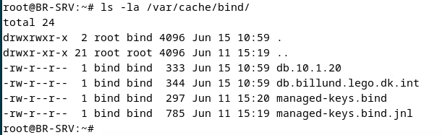

If we want to update a zone the SERIAL NUMBER MUST BE CHANGED.
To force updates we can use the following command:

rndc reload

BR-SRV task3 - Web server
- Install and configure a web service. Serve the https://www.herning.lego.dk site using a valid certificate signed by the company’s Sub CA. Website should show the text "Welcome to Herning". Remove server signatures and header tokens from web server.

Assure that the following certs and keys are in BR-SRV:
- www.herning.lego.dk.key
- www.herning.lego.dk.crt
- CA.crt
- SUBCA.crt
- CHAIN-CA.crt

Install apache2

apt install apache2

Edit the message on the main webpage:

echo “Welcome to Herning” > /var/www/html/index.html

Copy cert and key to /etc/ssl/certs and /etc/ssl/private directories:

cp www.herning.lego.dk.crt /etc/ssl/certs
cp www.herning.lego.dk.key /etc/ssl/private

Trust CA.crt and SUBCA.crt:

cp *CA*crt /usr/local/share/ca-certificates/
update-ca-certificates

Enable SSL module:

a2enmod ssl

Enable HTTPS site:

a2ensite default-ssl.conf

Configure certificate paths:

nano /etc/apache2/sites-enabled/default-ssl.conf

<VirtualHost *:80>
DocumenRoot /var/www/html
SSLEngine on
SSLCertificateFile /etc/ssl/certs/www.herning.lego.dk.crt
SSLCertificateKeyFile /etc/ssl/private/www.herning.lego.dk.key
</VirtualHost>

Configure HTTP → HTTPS redirection:

nano /etc/apache2/sites-enabled/000-default.conf

Add Redirect line:

<VirtualHost *:443>
DocumenRoot /var/www/html
Redirect / https://www.herning.lego.dk/
</VirtualHost>

Find ServerSignature and ServerTokens configuration:

grep -nr ServerSignature /etc/apache2/

grep -nr ServerTokens /etc/apache2/

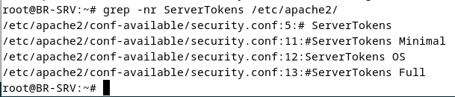

Both options are in /etc/apache2/conf-available/security.conf

nano /etc/apache2/conf-available/security.conf

Comment out “ServerTokens OS” and write “ServerTokens Prod”. Comment out “ServerSignature On” and uncomment “ServerSignature Off”:

#ServerTokens Minimal
#ServerTokens OS
#ServerTokens Full
ServerTokens Prod

ServerSignature Off
#ServerSignature On

systemctl restart apache2

Nginx
apt install nginx nginx-extras
echo “Welcome to Herning” > /var/www/html/index.html
vim /etc/nginx/nginx.conf
# Añadir lo siguiente
server_tokens off;
more_clear_headers ‘Server’;
vim /etc/nginx/sites-enabled/default
# Añadir lo pertinente al certificado y la redirección al puerto 443.
# NO HACE FALTA CONFIGURAR SERVERNAME, ES UN ÚNICO SERVIDOR QUE PUEDE RESPONDER TODO

BR-SRV task4 - SFTP
- Configure an SFTP server for LDAP user "carl" to be able to access and edit files in the web root directory.

BR-SRV task5 - syslog server
- Deploy a centralized syslog server with TLS to collect logfiles from clients on BR-CLIENT.
  - Incoming logs related to DHCP should be written to /log/dhcp.log.
  - All other incoming logs should be written to /log/dump.log.
ㅤㅤㅤㅤㅤ███████████████████████████████████████████████████████████████
apt install rsyslog
Descomentar estas líneas en /etc/rsyslog.conf:
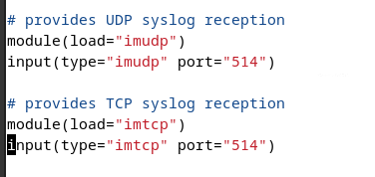
Crear un fichero /etc/rsyslog.d/10-remote.conf que tenga esto:
# Templates
$template DHCPLog,"/log/dhcp.log"
$template DumpLog,"/log/dump.log"

# Match logs that contain 'dhcp' in the message (case-insensitive)
if ($msg contains_i "dhcp") then ?DHCPLog
& stop

# Everything else
*.* ?DumpLog

Crear el directorio /log que sea de syslog:adm.

BR-CLIENT network
Clients on BR-CLIENT network will be configured automatically using Ansible playbooks from BR-SRV. For testing purposes, only BR-CL client will be used, which is already preconfigured (SSH service and SSH key authentication).
There is a preconfigured hosts file located under /etc/ansible/hosts in BR-SRV, with just one entry, the one related to BR-CL. Do not change this file. Assure that BR-CL is configured with 10.2.30.50/24 IP configuration, via DHCP or using static configuration, so the SSH connection works perfectly. You can connect with a user called 'ansible' from BR-SRV to BR-CL with a preinstalled private key.
For marking, BR-CL machine will be restored to "Start" snapshot and all playbooks will be run in order using the command “ansible-playbook playbookname.yml” in the /ansible directory of BR-SRV.
Create the following playbooks:

Ansible task1 - Basic config
- 1-basic.yml for configuring the hostname, time zone and NTP. All hosts should receive the hostname based on the "hostname" variable in /etc/ansible/hosts file and NTP should sync to R-BR.

Instead of learning by heart that messy regexps, it’ll be much easier if we manually comment “pool …” and enter “server 10.2.30.1 iburst” in /etc/ntpsec/ntp.conf server file, and then copy this file in ansible/files folder.

---
- name: Configure hostname, timezone, and NTP
hosts: all
become: yes

vars:
timezone: "Europe/Copenhagen"
files_src_dir: files
files_dst_dir: /etc/ntpsec

tasks:
- name: Set hostname
ansible.builtin.hostname:
name: "{{ hostname }}"

- name: Set timezone
ansible.builtin.timezone:
name: "{{ timezone }}"

- name: Install ntpsec for NTP
ansible.builtin.package:
name: ntpsec
state: present

- name: Copy ntp.conf to BR-CLIENT
copy:
src: "{{ files_src_dir }}/ntp.conf"
dest: "{{ files_dst_dir }}"
owner: root
group: root
mode: '0600'

- name: Comment out default pool NTP servers
ansible.builtin.replace:
path: /etc/ntpsec/ntp.conf
regexp: '^pool (.*)$'
replace: '# pool \1'

- name: Configure NTP to use R-BR
ansible.builtin.lineinfile:
path: /etc/ntpsec/ntp.conf
regexp: '^server {{ ntp_server }}'
line: "server {{ ntp_server }} iburst"
insertafter: '^#.*pool.*'
state: present

- name: Restart and enable ntpsec
ansible.builtin.service:
name: ntpsec
state: restarted
enabled: true

Ansible task2 - syslog
- 2-syslog.yml for sending log information to BR-SRV.

Ansible task3 - SNMP
- 3-snmp.yml for configuring SNMP - Zabbix should be able to read the CPU usage of this machine.

Ansible task4 - LDAP client
- 4-ldap.yml for configuring LDAP authentication using the LDAP server.

Ansible task5 - share auto mount
- 5-share.yml for configuring share directory auto mount.

Ansible task6 - web server
- 6-webserver.yml for installing and configuring a web server that will show the message "Website of <hostname>", based on the "hostname" variable in /etc/ansible/hosts file.
---
- name: Install and configure web server
hosts: all
become: yes
vars:
webpage_message: "Website of {{ inventory_hostname }}"

tasks:
- name: Install Apache web server
ansible.builtin.package:
name: apache2
state: present

- name: Ensure Apache is running and enabled
ansible.builtin.service:
name: apache2
state: started
enabled: yes

- name: Create custom index.html
ansible.builtin.copy:
dest: /var/www/html/index.html
content: "{{ webpage_message }}"
owner: root
group: root
mode: '0644'

Change proposed by Hungary’s team: The webserver must also be accessible via the HTTPS protocol.
---
- name: Install and Configure HTTP HTTPS Apache Server on BR-CLIENT
hosts: br-client
become: yes

vars:
webpage_message: "Website of {{ inventory_hostname }}"
certs_src_dir: files
ssl_cert: /etc/ssl/certs/www.crt
ssl_key: /etc/ssl/private/www.key
ssl_ca_cert: /etc/ssl/certs/ca.crt

tasks:
- name: Install Apache web server
ansible.builtin.package:
name: apache2
state: present

- name: Enable SSL module
command: a2enmod ssl
args:
creates: /etc/apache2/mods-enabled/ssl.load

- name: Copy www.crt to BR-CLIENT
copy:
src: "{{ certs_src_dir }}/www.crt"
dest: "{{ ssl_cert }}"
owner: root
group: root
mode: '0644'

- name: Copy www.key to BR-CLIENT
copy:
src: "{{ certs_src_dir }}/www.key"
dest: "{{ ssl_key }}"
owner: root
group: root
mode: '0600'

- name: Copy ca.crt to BR-CLIENT
copy:
src: "{{ certs_src_dir }}/ca.crt"
dest: "{{ ssl_ca_cert }}"
owner: root
group: root
mode: '0644'

- name: Copy ca.key to BR-CLIENT
copy:
src: "{{ certs_src_dir }}/ca.key"
dest: /etc/ssl/private/ca.key
owner: root
group: root
mode: '0600'

- name: Create SSL Virtual Host file
copy:
dest: /etc/apache2/sites-available/default-ssl.conf
content: >
<VirtualHost *:443>
DocumentRoot /var/www/html

SSLEngine on
SSLCertificateFile {{ ssl_cert }}
SSLCertificateKeyFile {{ ssl_key }}
SSLCACertificateFile {{ ssl_ca_cert }}
</VirtualHost>

- name: Enable default SSL site
command: a2ensite default-ssl
args:
creates: /etc/apache2/sites-enabled/default-ssl.conf

- name: Create custom index.html
ansible.builtin.copy:
dest: /var/www/html/index.html
content: "{{ webpage_message }}"
owner: root
group: root
mode: '0644'

- name: Enable and restart Apache
ansible.builtin.service:
name: apache2
state: restarted
enabled: true

Appendix A: Network topology
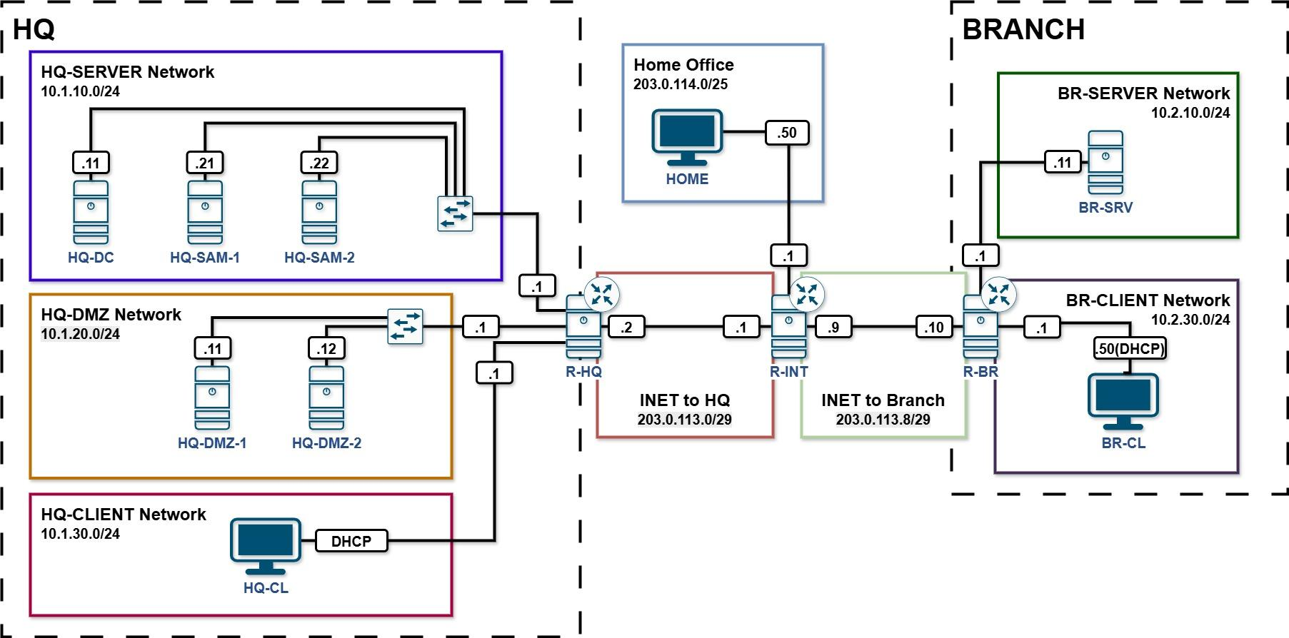

Appendix B: Containers, Objects and Users

LDAP OUs
OU name
Billund
Herning

LDAP Groups
Groups | DN
admins | CN=admins,OU=Billund,DC=lego,DC=dk
billund | CN=billund,OU=Billund,DC=lego,DC=dk
herning | CN=herning,OU=Billund,DC=lego,DC=dk

LDAP Users
Username | E-mail Address | Home Directory Location on HQ-DC | Membership | Group Membership
admin | admin@lego.dk | /share/users/admin | Billund | admins
frida | frida@lego.dk | /share/users/frida | Billund | billund
ella | ella@lego.dk | /share/users/ella | Billund | billund
carl | carl@lego.dk | /share/users/carl | Herning | herning

