## Course: Visual Analytics for Policy and Management

# 

### Final Project: Broadband Internet Access in Stevenson, WA

# 

# 

Table of Contents:

1. Background
2. Univariate plots
3. Bivariate plots
4. Multivariate plots
5. Conclusion

### Background

Stevenson, WA, is a small town of about 1500 people in the Portland Metropolitan Region. Although the small city features various natural and cultural amenities, many of its residents, businesses, and organizations have expressed dissatisfaction with local internet services. In February 2018, Stevenson City Council directed city staff to pursue the creation of a strategic plan regarding broadband infrastructure.

Broadband is high-speed internet, or internet with minimum speeds of 25 megabits per second (mbps) downloading and 3 mbps uploading, according to the US Federal Communications Commission (FCC). One of our team members, Kimberly Pearson, when interning at the City of Stevenson as the Broadband Project Coordinator, created a survey to assess current internet quality and uptake for busiesses and organizations. After sending the survey to over 150 small and medium sized businesses within city limits, 40 businesses responded, a ~26% response rate. The 40 survey questions refer to the business’ chosen Internet Service Provider, the cost of their internet service, the speeds they subscribe to, their actual experienced speeds, their satisfaction with their internet plan, and more. The results were then visualized in Tableau (see plots below).

###### Original plots: <https://public.tableau.com/profile/kimberly.pearson#!/vizhome/StevensonBusinessSurvey/Story1>

Within this report, we would like to explore the following research questions as they relate to each type of plot.

#### 1) Univariate

For our univariate plots, we wanted to examine the range of download and upload speeds offered by each Internet Service Provider (ISP) answer the following questions:

“Which ISP had the highest range of download speeds?”

“Which ISP had the highest range of upload speeds?”

We utilized two different box plots to answer these questions.

#### 2) Bivariate

For our bivariate plots, we wanted to examine the “advertised download speed” of each ISP and the recorded “download speed” of each ISP to answer the following questions:

“Which ISP most accurately advertised their download speeds?”

“Which ISP most accurately advertised their upload speeds?”

We utilized two scatterplots to answer these questions.

#### 3) Multivariate

For our first multivariate plot, we wanted to examine the relationship between “subscribed speed”, “download speed”, “upload speed”, and “satisfaction”. We specifically wanted to answer the following question:

“Does subscribed speed, download speed, and upload speed have a positive or negative effect on satisfaction, and what is the magnitude of that effect?”

We utilized a dot and whisker plot to answer this question.

For our second multivariate plot, we wanted to examine the relationship between “download speeds” and “satisfaction” by each ISP. We specifically wanted to answer the following question:

“Are higher download and upload speeds associated with higher levels of satisfaction?”

We used a heat plot to answer this question.

* Map of Washington Fixed Broadband

Go to table of contents.

### Univariate Plots

Our univariate plots are boxplots, which are…

##### Research Questions

1. “Which ISP had the highest range of download speeds?”
2. “Which ISP had the highest range of upload speeds?”

##### Explanation

We can create the plots using the following steps. Additionally, notes for each of the steps are included in the code.

1. Load the data
2. Call GGPlot2 from library
3. Create a base boxplot with the relevant variables (ISP and Download.Speed or ISP and Upload.Speed)
4. Add relevant color and the flip the axes
5. Include a title, data source, and label for each of the axes
6. Edit the location, size, color, and type style of each text element using the (theme) function
7. Edit the scale and tick marks of the relevant axes
8. Visualize our plot

# Here we load the dataset.   
link='https://github.com/marcevl/Team-Assignments/raw/master/Internet.RData'  
load(file=url(link))  
  
# Then, we call the Ggplot2 library. If Ggplot2 has not been installed yet, go to the bottom right quadrant of your screen, click install, then select ggplot2   
library(ggplot2)  
  
# We create a box plot for each ISP, illustrating the ranges of their dowload speeds.   
box1 = ggplot(Internet, aes(x = ISP, y=Download.Speed))  
  
# We add information regarding the colors of the plot, and then flip it so the axes are reversed.   
box2 = box1 + geom_boxplot(color='black',fill='white',  
 outlier.color='black',  
 outlier.size=2) + coord_flip()  
   
# Here, we add a title, caption, and change the labels on each axis.   
box3 = box2 + labs(title='Wave provides highest range of download speeds', subtitle = 'Stevenson, WA',  
 y = 'Download Speed (Megabytes/Second)',  
 x = NULL,  
 caption = 'Source: Stevenson Business and Organization Internet Survey, 2018   
 Note: Wave Outlier of 500 Mbps Omitteed')  
  
# Then, we format the location, size, color, and type style of each text element.   
box4 = box3 + theme(plot.margin=unit(c(1,1,.5,.5),'cm'),  
 plot.title=(element_text(face='bold',  
 size=15,  
 hjust=0.5)),  
 plot.subtitle = (element_text(hjust = 0.5)),  
 plot.caption=element_text(size=8, vjust = -2),  
 text=element_text(color='gray25', size = 13),  
 panel.background = element_rect(fill='white'),  
 axis.ticks.y=element_blank(),  
 axis.line.x=element_line(color='black'))  
  
# Finally, we change the scale of each axis so that we show the exact number of tick marks that we'd like.   
box5 = box4 + scale_y_continuous(breaks=seq(0,100, 10),  
 limits=c(0,100)) + scale_x_discrete(limits=c('Wave','GorgeNet','CenturyLink'))  
  
# Then, we "print" the vizualization.   
box5

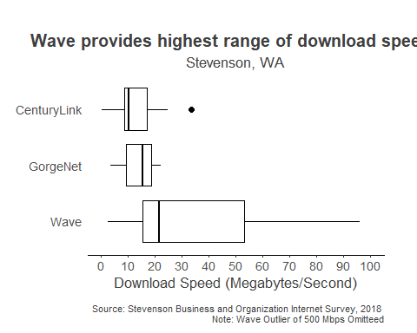

# We created a second box plot for each ISP, illustrating the ranges of their upload speeds.   
box1 = ggplot(Internet, aes(x= ISP, y = Upload.Speed))   
  
# We add information regarding the colors of the plot, and then flip it so the axes are reversed.   
box2 = box1 + geom_boxplot(color='black',fill='white',  
 outlier.color='black',  
 outlier.size=2) + coord_flip()  
  
# Here, we add a title, caption, and change the labels on each axis.  
box3 = box2 + labs(title='Wave provides highest range of upload speeds', subtitle = 'Stevenson, WA',  
 y = 'Upload Speed (Megabytes/Second)',  
 x = NULL,  
 caption = 'Source: Stevenson Business and Organization Internet Survey, 2018')  
  
# Then, we format the location, size, color, and type style of each text element.   
box4 = box3 + theme(plot.margin=unit(c(1,1,.5,.5),'cm'),  
 plot.title=(element_text(face='bold',  
 size=15,  
 hjust=0.5)),  
 plot.subtitle = (element_text(hjust = 0.5)),  
 plot.caption=element_text(size=8, vjust=-2),  
 text=element_text(color='gray25', size = 13),  
 panel.background = element_rect(fill='white'),  
 axis.ticks.y=element_blank(),  
 axis.line.x=element_line(color='black'))  
  
# Finally, we change the scale of each axis so that we show the exact number of tick marks that we'd like.   
box5 = box4 + scale_y_continuous(breaks=seq(0,100, 10),  
 limits=c(0,100)) + scale_x_discrete(limits=c('Wave','GorgeNet','CenturyLink'))  
  
# Then, we "print" the visualization.   
box5

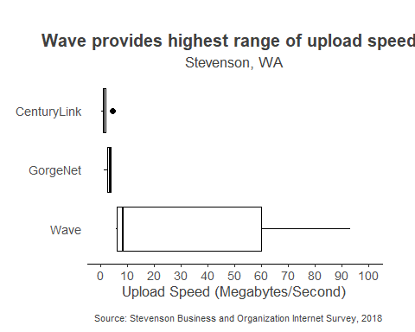

Go to table of contents.

### Bivariate plots

For our bivariate plots, we decided to create scatterplots. Scatterplots use dots to represent the values for two different variables. In our case, we wanted to compare customers’ subscribed and actual speeds.

##### Research Question

“Which ISP most accurately advertised their download speeds?” “Which ISP most accurately advertised their upload speeds?”

##### Explanation

We can create the plots using the following steps. Additionally, notes for each of the steps are included in the code.

1. First create a factor for ISP using the existing data
2. Then create a dataframe with just the relevant factors. These include subscribed speed, download speed, upload speed, and ISP
3. Subset the data to only include the ISPs of interest - Wave, CenturyLink, and GorgeNet
4. Create a baseplot of Subscribed Speeds against Upload Speeds
5. Add a scatterplot element
6. Add a reference line to measure against the Upload Speed against
7. Separate the plots by ISP using the facetwrap command
8. Modify the scale for each axis
9. Modify the title, subtitle, data source, and labels for each axes
10. Utilize the BW formatting preset
11. Format the text elements
12. Visualize our plot

# For our second plots, we create a factor, ISP, with specific levels. It is based off the original variable.   
ISP <- factor(Internet$ISP)  
str(ISP)

## Factor w/ 6 levels "AT&T","CenturyLink",..: 2 3 6 2 3 2 1 6 6 3 ...

levels(ISP)

## [1] "AT&T" "CenturyLink" "GorgeNet" "Integra" "None"   
## [6] "Wave"

# Then, we create a dataframe with just the factors that we are concerned with in these plots. It contains information for all of the ISPs.   
df1 <- data.frame(ISP, Internet$Subscribed.Speed, Internet$Download.Speed, Internet$Upload.Speed)  
names(df1) <- c("ISP", "Subscribed", "Download", "Upload")  
  
# Next, we subsetted the data to only include Wave, CenturyLink, and GorgeNet.   
df2 <- subset(df1, ISP %in% c("Wave", "CenturyLink", "GorgeNet"))  
  
# We then created a base plot of Subscribed Speeds versus Upload Speeds.   
base = ggplot(df2, aes(x=Subscribed, y=Upload))  
  
# We added a scatterplot layer.   
box1 = base + geom_point()  
  
# Then, a reference line that represents the subscribed speeds.   
box2 = box1 + geom_abline(a=0,b=45,lty=2,lwd=0.5, alpha = 0.5)  
  
# We used the command facet wrap to separate the plot into three plots, one for each ISP.   
box3 = box2 + facet_wrap( ~ ISP ,nrow = 1)  
  
# Then, we added a scale for the y axis and a scale for the x axis.   
box4 = box3 + scale_y_continuous(breaks=c(0,0,40,60,80,100,120),  
 limits = c(0, 120))  
  
box5 = box4 + scale_x_continuous(breaks=c(0,30,60,90,120,150),  
 limits = c(0, 150))  
  
# We coded for the title.   
Title = 'GorgeNet Provides the Most Accurate Advertised Upload Speeds'  
  
# We added the title, subtitle, x-axis label, y-axis label, and the caption.   
box6 = box5 + labs(title=Title, subtitle = 'Stevenson, WA',  
 x= 'Suscribed Speed (Megabytes/Second)',  
 y = 'Upload Speed (Megabytes/Second)',  
 caption='Source: Stevenson Business and Organization Internet Survey,2018') + theme_bw()  
  
# We formatted for each text element, as before.   
box7 = box6 + theme(plot.margin=unit(c(1,1,.5,.5),'cm'),  
 plot.title=(element_text(face='bold',  
 size=15,  
 hjust=0.5)),  
 plot.subtitle = (element_text(hjust = 0.5, vjust = 2)),  
 plot.caption=element_text(size=8, vjust=-2),  
 text=element_text(color='gray25', size = 11),  
 axis.line.y=element_line(color = 'black'),  
 axis.line.x=element_line(color='black'),  
 axis.text=element_text(size=8))  
  
# Finally, we "printed" the faceted scatterplot.  
box7

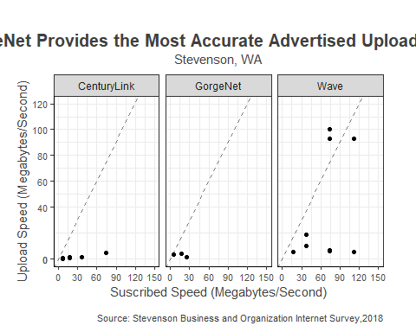

# The instructions to create the faceted scatterplot are the same as in the past plot.   
base = ggplot(df2, aes(x=Subscribed, y=Download))  
  
box1 = base + geom_point()  
  
box2 = box1 + geom_abline(a=0,b=45,lty=2,lwd=0.5, alpha = 0.5)  
  
box3 = box2 + facet_wrap( ~ ISP ,nrow = 1)  
  
box4 = box3 + scale_y_continuous(breaks=seq(0,120,20),  
 limits = c(0,120))  
  
box5 = box4 + scale_x_continuous(breaks=seq(0,120,40),  
 limits = c(0,120))  
  
Title = 'GorgeNet Provides the Most Accurate Advertised Download Speeds'  
  
box6 = box5 + labs(title=Title, subtitle = 'Stevenson, WA',  
 x= 'Suscribed Speed (Mbps)',  
 y = 'Download Speed (Mbps)',  
 caption='Source: Stevenson Business and Organization Internet Survey, 2018  
 Note: Wave Outlier of 500 Mbps Omitted') + theme_bw()  
  
box7 = box6 + theme(plot.margin=unit(c(1,1,.5,.5),'cm'),  
 plot.title=(element_text(face='bold',  
 size=15,  
 hjust=0.5)),  
 plot.subtitle = (element_text(hjust = 0.5, vjust = 2)),  
 plot.caption=element_text(size=8, vjust=-3),  
 text=element_text(color='gray25', size = 11),  
 axis.line.y=element_line(color = 'black'),  
 axis.line.x=element_line(color='black'),  
 axis.text=element_text(size=8),  
 axis.text.x = element_text(angle = 0, vjust = 0.7),  
 axis.title.x = element_text(vjust = -2, size = 10),  
 axis.title.y = element_text(size = 10, vjust = 2.5))  
box7

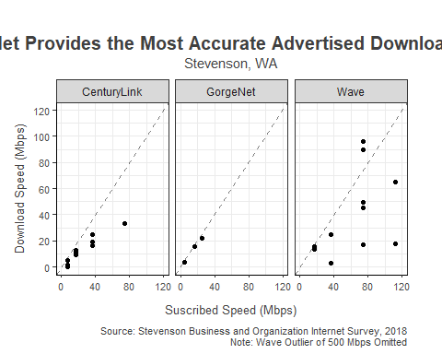

Go to table of contents.

### Multivariate Plots

We created two types of multivariate plots, a heatmap and a dot and whisker plot

Dot and Whisker Plot - This plot describes two models of regressions. The first model determines whether actual upload and download speeds affect customer’s satisfaction with speed.

Heatmap -

##### Research Question

1. Does subscribed speed, download speed, and upload speed have a positive or negative effect on satisfaction, and what is the magnitude of that effect?
2. Are higher download and upload speeds associated with higher levels of satisfaction?

##Heatmap  
  
library(scales)  
library(ggplot2)  
  
#loading data  
link='https://github.com/marcevl/Team-Assignments/raw/master/Internet2.RData'  
load(file=url(link))  
  
#changing download speed to a variable from 0-1  
Internet2$Download.Speed.Rescaled <- rescale(Internet2$Download.Speed)  
  
#adding data to data frame  
df1 <- Internet2  
  
#removing obervation with outlier  
df1 <- df1[-3,]  
  
#removing unnecessary variables from heatmap data frame  
df.heatmap <- df1[c(2,6,10,40)]  
  
#removing ISPs without many observations  
df.heatmap <- subset(df.heatmap, ISP %in% c("Wave", "CenturyLink", "GorgeNet"))  
  
#plotting heat map  
heat1 = ggplot(data = df.heatmap, aes(x = Satisfaction.Speed, y = ISP)) +  
 geom_tile(aes(fill = Download.Speed.Rescaled))  
  
heat1 = heat1 + labs(title='Satisfaction with ISP not related with Download Speed',  
 y=NULL,  
 x='Satisfaction rating',  
 caption='Source: Stevenson Business and Organization Internet Survey, 2018',  
 fill='Range of \nDownload Speeds')  
  
heat2 = heat1 + theme(plot.margin=unit(c(.5,1,1,1),'cm'),  
 plot.title=(element_text(face='bold',  
 size=15,  
 hjust=0,  
 margin=unit(c(0,0,.5,0),'cm'))),  
 plot.subtitle = (element_text(hjust = 0.5, vjust = 2)),  
 plot.caption=element_text(size=8, hjust=2, vjust = -1),  
 legend.text=element_blank(),  
 legend.background=element_rect(linetype='solid',  
 color='black'),  
 panel.background=element_rect(fill='white'),  
 text=element_text(color='black'),  
 axis.line.y=element_line(color = 'black'),  
 axis.line.x=element_line(color='black'),  
 axis.ticks=element_blank(),  
 axis.text=element_text(size=11))  
  
heat2 + scale_fill_gradient(low='lightblue',high='navy',  
 guide_colorbar(reverse=TRUE,  
 title='Download   
Speed'))

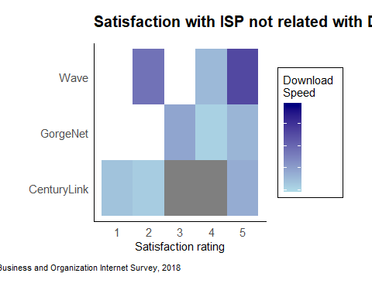

##### Explanation

We can create the dot and whisker plot using the following steps. Additionally, notes for each of the steps are included in the code.

1. Load the data
2. Call dotwhisker, broom, and dplyr from library
3. Create the first model of regression with the relevant variables (Download.Speed and Upload.Speed regressed onto Satisfaction.Speed)
4. Tidy and mutate the first model
5. Create the second model of regression with the relevant variables (Download.Speed, Upload.Speed, and Subscribed.Speed regressed onto Satisfaction.Speed)
6. Combine the models
7. Plot the models, add theme information, and add titles
8. Visualize our plot

# Here, we called three libraries that would help us make dot and whisker plots as well as   
library(dotwhisker)  
library(broom)  
library(dplyr)  
  
# We created the first model of regression for Download and Upload Speeds on Satisfaction with Speed  
model1=lm(Satisfaction.Speed~Download.Speed+Upload.Speed,data=Internet2[,-1])  
summary(model1)

##   
## Call:  
## lm(formula = Satisfaction.Speed ~ Download.Speed + Upload.Speed,   
## data = Internet2[, -1])  
##   
## Residuals:  
## Min 1Q Median 3Q Max   
## -2.4111 -0.4159 0.4289 0.5825 1.5775   
##   
## Coefficients:  
## Estimate Std. Error t value Pr(>|t|)   
## (Intercept) 3.395876 0.219081 15.501 2.49e-14 ***  
## Download.Speed 0.001154 0.008049 0.143 0.887   
## Upload.Speed 0.002786 0.007791 0.358 0.724   
## ---  
## Signif. codes: 0 '***' 0.001 '**' 0.01 '*' 0.05 '.' 0.1 ' ' 1  
##   
## Residual standard error: 1.043 on 25 degrees of freedom  
## (12 observations deleted due to missingness)  
## Multiple R-squared: 0.1219, Adjusted R-squared: 0.05169   
## F-statistic: 1.736 on 2 and 25 DF, p-value: 0.1968

# Here we tidied up and mutated the model of regression so thatwe add a column, "model," with the values of Model 1.   
model1_t = tidy(model1) %>% mutate(model = "Model 1") %>%  
 relabel_predictors(Upload.Speed = "Upload",  
 Download.Speed = "Download",  
 Subscribed.Speed = "Subscribed")

# We then created a second model of regression, this time with a fourth variable: Subscribed Speeds.   
model2=lm(Satisfaction.Speed~Download.Speed+Upload.Speed+Subscribed.Speed,data=Internet2[,-1])  
summary(model2)

##   
## Call:  
## lm(formula = Satisfaction.Speed ~ Download.Speed + Upload.Speed +   
## Subscribed.Speed, data = Internet2[, -1])  
##   
## Residuals:  
## Min 1Q Median 3Q Max   
## -2.3054 -0.3388 0.2492 0.6909 1.6888   
##   
## Coefficients:  
## Estimate Std. Error t value Pr(>|t|)   
## (Intercept) 3.1851440 0.3286583 9.691 1.38e-09 ***  
## Download.Speed 0.0010622 0.0098589 0.108 0.915   
## Upload.Speed -0.0001521 0.0093008 -0.016 0.987   
## Subscribed.Speed 0.0064991 0.0082764 0.785 0.440   
## ---  
## Signif. codes: 0 '***' 0.001 '**' 0.01 '*' 0.05 '.' 0.1 ' ' 1  
##   
## Residual standard error: 1.069 on 23 degrees of freedom  
## (13 observations deleted due to missingness)  
## Multiple R-squared: 0.145, Adjusted R-squared: 0.03353   
## F-statistic: 1.301 on 3 and 23 DF, p-value: 0.2981

# We tidied up and mutated the second model of regression to have a column called "model," with values of "Model 2"  
model2_t <- tidy(model2) %>% mutate(model = "Model 2") %>%  
 relabel_predictors(Upload.Speed = "Upload",  
 Download.Speed = "Download",  
 Subscribed.Speed = "Subscribed")

# Here we combined all the models   
allModels=rbind(model1_t, model2_t)

# Here we plot the coefficients and their confidence intervals for all models and add or change theme/text elements   
dwplot(allModels) +   
 geom_vline(xintercept = 0,   
 colour = "grey 50",   
 linetype = 2) +   
 scale_colour_grey(start = .1, end = .7) +   
 labs(y = "Independent Variables",  
title = "Relationship Between Speed Satisfaction &   
Download, Upload, and Subscribed Speed",   
 caption = "Source:Stevenson Business and Organization Internet Survey, 2018") +  
 theme(plot.margin=unit(c(1,1,.5,.5),'cm'),  
 plot.title=(element_text(face='bold',  
 size=15,  
 hjust=0.5)),  
 plot.subtitle = (element_text(hjust = 0.5, vjust = 2)),  
 plot.caption=element_text(size=9, vjust=-2),  
 text=element_text(color='black', size = 11),  
 panel.background = element_rect(fill='white'),  
 legend.title = element_blank(),  
 axis.line.y=element_line(color = 'black'),  
 axis.line.x=element_line(color='black'),  
 axis.text=element_text(size=8))

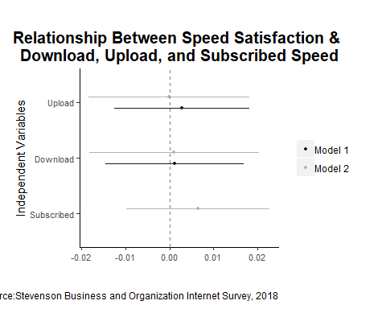

### Findings for Multivariate Plot of Regressions

Because all of the models’ confidence intervals overlapped with the value of 0 on the x-axis, neither model identifies a relationship between experienced speeds or subscribed speed and customers’ satisfaction with their speed.

### Map of Washington State Fixed Broadband Service

##### Research Question

How does fixed broadband service vary across the state of Washington?

##### Explanation

Below, we create a map of broadband service speeds in Washington, at the Census block code unit of analysis.

Go to table of contents.

### Conclusion

To conclude…

Go to table of contents.