Correction to submitted manuscript

Manuscript abc7075
Dao Thi et al.: Screening for SARS-CoV-2 infections with colorimetric RT-LAMP and
LAMP sequencing

16 May 2020

Dear Editor, dear Reviewers

Due to an oversight, we accidentally included an outdated version of Supplementary Table 1, when submitting our manuscript. Please find here the correct table:

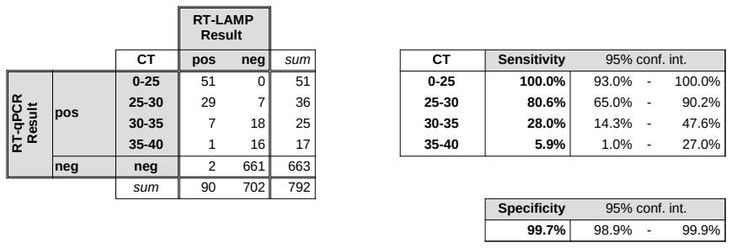
We apologize for this error.

With best regards

Simon Anders

