**Control of Grobo by Software via I²C**

v1.0 16042022 – CaptainHawk, eda

This manual can be a start for software developers to control the Grobo with a Raspberry Pi or an Arduino via I²C and some GPIO-ports. Attached you can find datasheets of the chips and sample codes for control via I²C.

We found out that most of the Grobo is controlled by two PWM-chips and one GPIO-chip. There is no microcontroller at the mainboard, the firmware to control these three chips comes via the WiFi-chip from the cloud.

**Table of Contents**

* Board Descriptions
  + 1 – LED Board
  + 2 – Upper Board
  + 3 – Lower Board

**Board Description - LED Board**

The LED board holds 6 branches of LEDs.

* 7 RB (PWM Channel 1)
* 7 B (PWM Channel 2)
* 6 C (PWM Channel 3)
* 10 R (PWM Channel 4)
* 7 W (PWM Channel 5)
* 9 DR (PWM Channel 7)

In original RB, B and C were at 85% duty and the other 3 were at 100% when we measured, don't know which stage of grow.

In the middle of the board is a LM75 I²C Temp Sensor at address 0x49.

The board is connected to the upper board with a 26-pin flat-ribbon-cable.

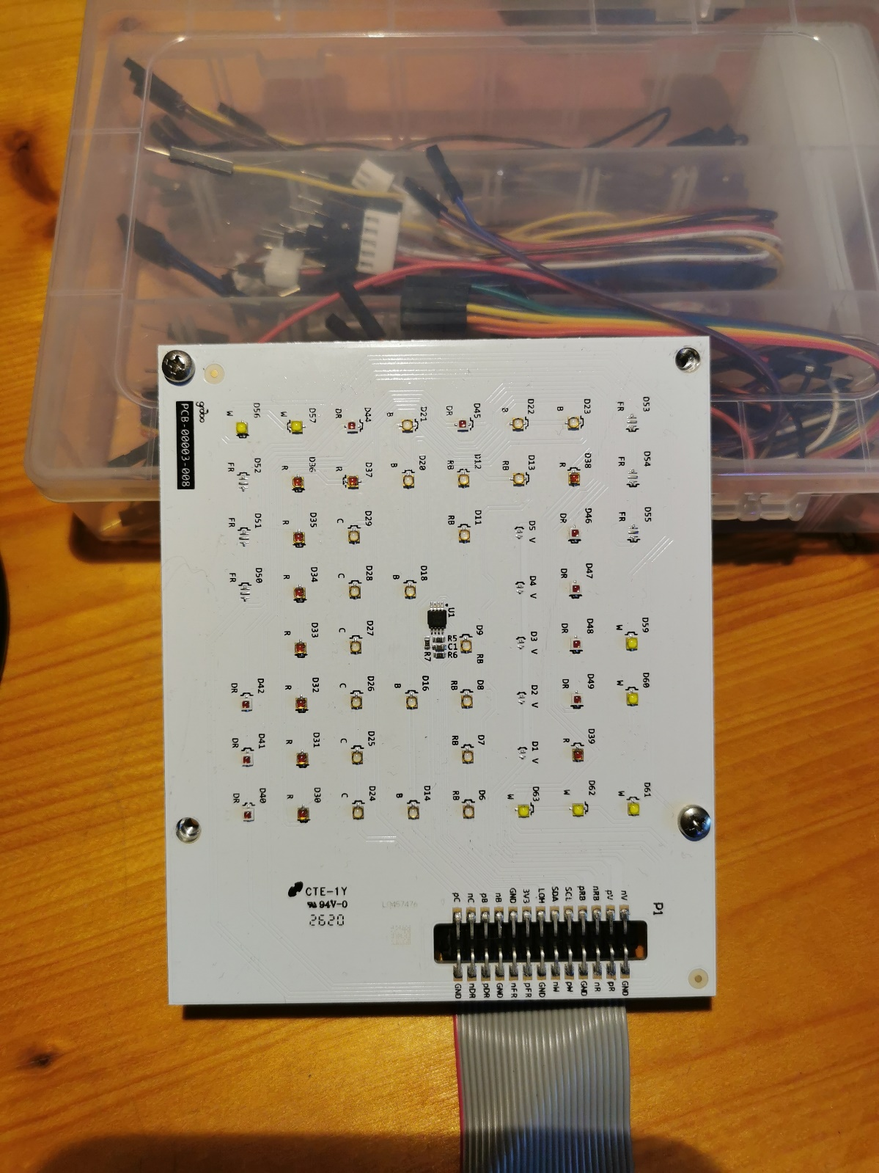

**Board Description - Upper Board**

The upper board holds:

* WiFi-chip (which is already soldered out in my imges)
* 6 led-driver controlled by one pwm-chip PCA9685 at I²C address 0x74
* Power Converters from 24V to12V, 5V and 3.3V
* Connectors for:
  + 24V power in (P1)
  + Door Lock (LOCK)
  + User Button (UBTN)
  + Exhaust Fan (FAN)
  + Led Lamp (26-pin flat-ribbon-cable)
  + Temp/Hum-sensor in the rear panel (DHTI) (Not I²C)
  + 8-pin flat-ribbon-cable-connector to the lower board
  + USB (don't now how to connect to this, maybe the most simple possibility to connect to the board and control it)

Door Lock:

Can be triggered by pulling the pin with the dot of transistor next to the connector HIGH (3v3). It is wired to the wifi-chip to pin 4 from the lower left angle. Ground line is switched by the transistor.

Exhaust Fan:

Is always on I think, can be switched off by pulling the pin with the dot of the transistor Q4 LOW. Ground line is switched by the transistor.

**Exh Fan**

**to lower board**

**24V in**

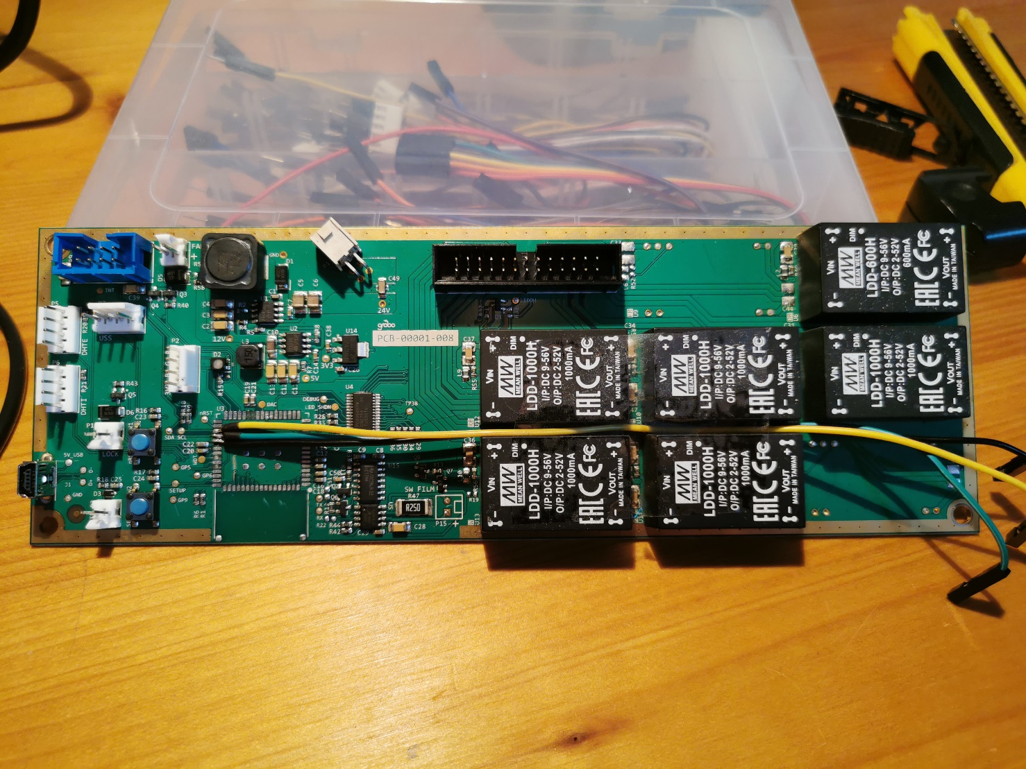

**Door Lock**

**Temp/Hum**

**User Button**

**Door Lock**

**PWM chip**

**led lamp**

**C**

**DR**

**R**

**B**

**W**

**RB**

**my way to connect to i²c**

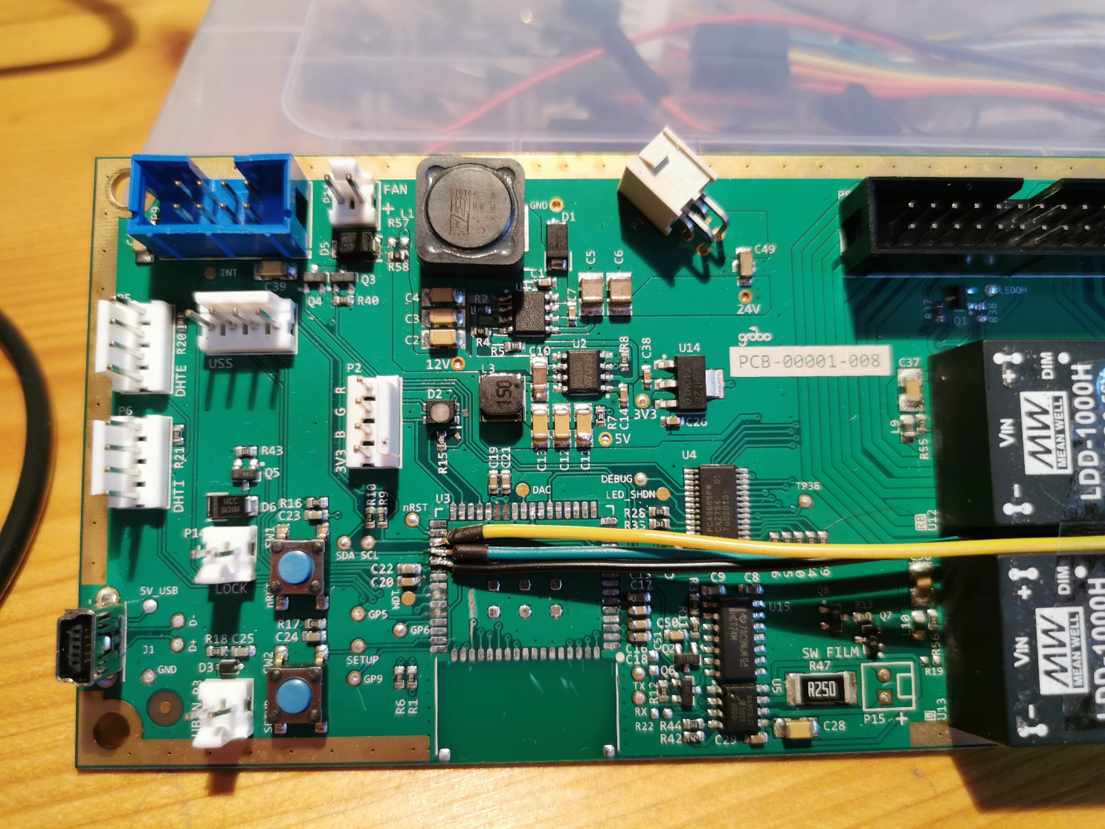

**Board Description - Lower Board**

The lower board is connected by an 8-pin fat-ribbon-cable to the upper board.

It holds:

* one pwm-chip PCA9685 at I²C address 0x76 to control pumps an fans.
* one gpio-chip MCP23008 at I²C address 0x26 for the input of the 3 water level sensors and 5 buttons that could be soldered in for control of the 5 nutrient-pumps.
* Power Converter from 5V to 3.3V
* LLC ADM3260 to convert the 3v3 I²C to 5v I²C for the PH-sensor
* PH­­­ and EC sensors
  + Atlas Scientific pH and EC stamps (red and green ‘mini’ boards by the BNC connectors)
* Connectors for
  + lower water level sensor (WLL) (GPIO Channel 5)
  + middle water level sensor (WLM) (GPIO Channel 6)
  + high water level sensor (WLH) (GPIO Channel 7)
  + nutrient pump N1 (PHU) (PWM Channel 7)
  + nutrient pump N2 (PHD) (PWM Channel 1)
  + nutrient pump N3 (A) (PWM Channel 2)
  + nutrient pump N4 (B) (PWM Channel 3)
  + nutrient pump N5 (CMG) (PWM Channel 4)
  + drain pump (DRAIN) (PWM Channel 6)
  + fill pump (FILL) (PWM Channel 5)
  + rear fan (FAN1) (PWM Channel 9)
  + rear fan (FAN2) (PWM Channel 8)
  + 8-pin flat-ribbon-cable-connector to the upper board
  + 5 solder-pins for switches which are not soldered in (GPIO Channels 0 - 4)

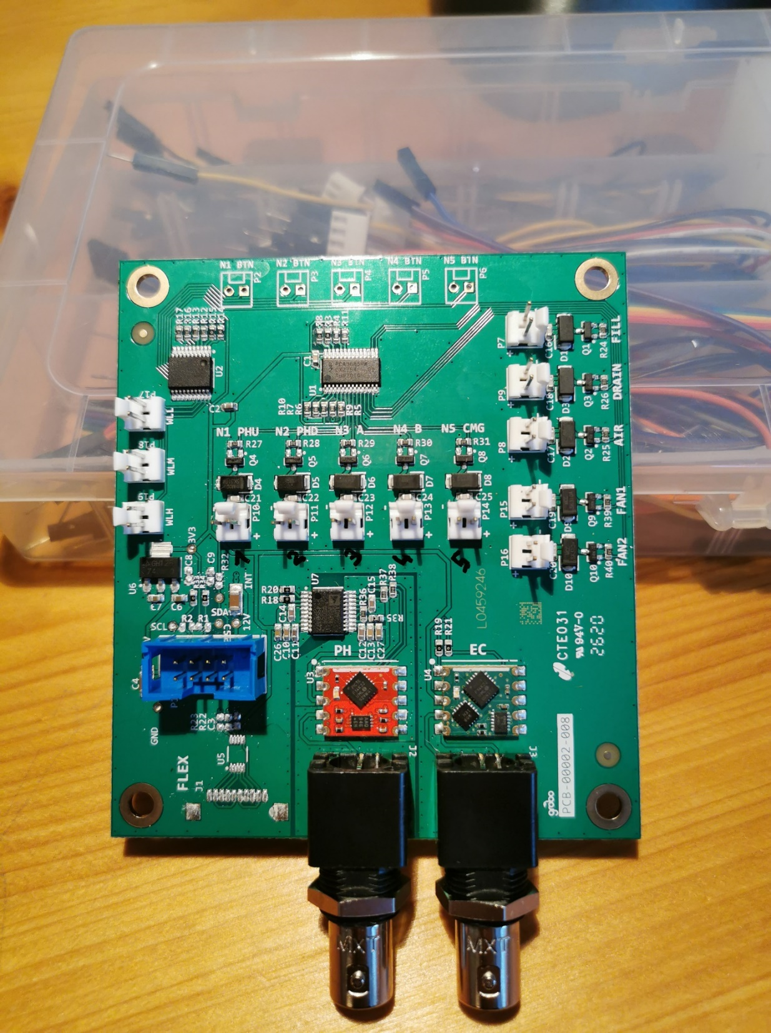

**LLC chip**

**GPIO chip**

**to upper board**

**PWM chip**