assignment1

hw1

dat = read.csv('http://dmcglinn.github.io/quant_methods/data/tgpp.csv')  
head(dat)

## plot year record_id corner scale richness easting northing slope ph  
## 1 205 1998 187 NA 100 60 727000 4080000 3 6.9  
## 2 205 1998 188 1 10 36 727000 4080000 3 6.9  
## 3 205 1998 189 2 10 34 727000 4080000 3 6.9  
## 4 205 1998 190 3 10 37 727000 4080000 3 6.9  
## 5 205 1998 191 4 10 33 727000 4080000 3 6.9  
## 6 205 1998 192 1 1 21 727000 4080000 3 6.9  
## yrsslb  
## 1 0.39  
## 2 0.39  
## 3 0.39  
## 4 0.39  
## 5 0.39  
## 6 0.39

names(dat)

## [1] "plot" "year" "record_id" "corner" "scale"   
## [6] "richness" "easting" "northing" "slope" "ph"   
## [11] "yrsslb"

2

dim(dat)

## [1] 4080 11

3

sapply(dat, class)

## plot year record_id corner scale richness easting   
## "integer" "integer" "integer" "integer" "numeric" "integer" "integer"   
## northing slope ph yrsslb   
## "integer" "integer" "numeric" "numeric"

4

dat[c(1,5,8), c(3,7,10)]

## record_id easting ph  
## 1 187 727000 6.9  
## 5 191 727000 6.9  
## 8 194 727000 6.9

5

plot(dat$scale, dat$richness, xlab = 'Scale', ylab = 'Richness', col = 'red')

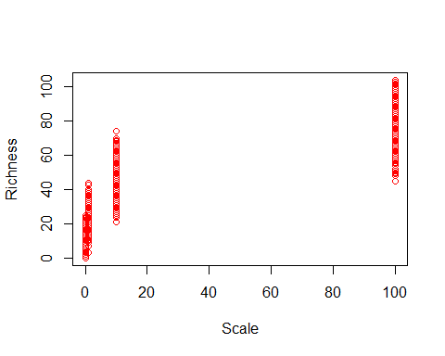  
6

plot(dat$scale, dat$richness, xlab = 'Scale', ylab = 'Richness', col = 'red', log = 'xy')

## Warning in xy.coords(x, y, xlabel, ylabel, log): 4 y values <= 0 omitted  
## from logarithmic plot

