Scattering from one screw dislocation

This document serves to define a general physical and numerical framework for understanding and modelling the scattering from individual dislocations. As such focus is on the simplest case of a screw dislocation aligned with the diffraction vector, G.

It also serves specifically to provide a model to compare to imaging data on Diamond, where the dislocation line (and hence Burgers vector) is titled by 35 deg with respect to G.

1. Geometry

Geometry of screw dislocation parallel to G
Assume a single straight screw dislocation along z-axis in the middle of an otherwise perfect single crystal. Then the displacement, u, is only along the z-direction. Here are the equations for the displacement and the strain

The displacement is only along the z-axis:

$u_{z}= \frac{b θ}{2π}= \frac{b}{2π} atan\left(\frac{y}{x}\right)$ (1)

If we assume the crystal symmetry to be simple cubic with a lattice constant d, then the positions of the atom defined by indices (k,l,m) wrt to Origo become

${\overline{r}}_{klm}= \left(kd, ld, md+\frac{d}{2π}atan\left(l/k\right) \right)$ (2)

When viewed along the z-direction the 2D- lattice in (x,y) is perfect. Furthermore, it is axially symmetric around z.

The strain components are all 0 except

$$e_{zx}= \frac{d u_{z}}{d x}= \frac{b}{2π} \frac{1}{1+{\left(\frac{y}{x}\right)}^{2}}\frac{-y}{x^{2}}= -\frac{b}{2π} \frac{y}{x^{2}+y^{2}}= -\frac{b}{2π} \frac{\sin\left(θ\right)}{r} ;$$
$e_{zy}= \frac{d u_{z}}{d y}= \frac{b}{2π} \frac{1}{1+{\left(\frac{y}{x}\right)}^{2}}\frac{1}{x}= \frac{b}{2π} \frac{x}{x^{2}+y^{2}}= \frac{b}{2π} \frac{\cos\left(θ\right)}{r}$ (3)

($ε_{xz}= \frac{e_{zx}+e_{xz}}{2}$ evidently gets a 4π in the denominator, but it is e we measure. )

Hence, locally wrt point (x₀, y₀) the displacement becomes

$u_{z}\left(x,y\right)-u_{z}\left(x_{0},y_{0}\right)= e_{zx}\left(x-x_{0}\right) + e_{zy}\left(y-y_{0}\right)= \frac{b}{2πr} \left[-\left(x-x_{0}\right)\sin{θ+\left(y-y_{0}\right)\cos{θ}}\right]$

Fig 2. Plot of eps = e_{zx}(with axis rotated by 180 deg).

Geometry of screw dislocation at an angle to G

Let the sample system (x, y, z) be defined by G. Assume the line of the dislocation is in the (x, z) plane of the sample system and define a local system (x’, y, z’) with z’ along the dislocation line. Let the angle between G and B be β. We introduce the coordinate transform

$$\left(\begin{matrix}x \\ z\end{matrix}\right)=\left(\begin{matrix}\cos{β} & \sin{β} \\ -\sin{β} & \cos{β}\end{matrix}\right)\left(\begin{matrix}x' \\ z'\end{matrix}\right)$$

Furthermore, without loss of generality, we can assume z = 0. With these definitions

$u_{z}=u_{z'}\cos\left(β\right) = \frac{b}{2π}atan\left(\frac{y}{x^{'}}\right)\cos\left(β\right)=$ $\frac{b}{2π}atan\left(\frac{y}{x\cos{(β)}}\right)\cos\left(β\right)$ (4a)
$u_{x}=u_{z'}\sin\left(β\right) = \frac{b}{2π}atan\left(\frac{y}{x^{'}}\right)\sin\left(β\right)$ = $\frac{b}{2π}atan\left(\frac{y}{x\cos{(β)}}\right)\sin\left(β\right)$ (4b)

$e_{zx}= \frac{d u_{z}}{d x}= -\frac{b}{2π} \frac{y cos⁡(β)}{({x\cos{β})}^{2}+y^{2}}$ (4c)
$e_{zy}= \frac{d u_{z}}{d y}= \frac{b}{2π} \frac{x \cos^{2}⁡(β)}{({x\cos{β})}^{2}+y^{2}}$ (4d)

$e_{xx}= \frac{d u_{x}}{d x}= -\frac{b}{2π} \frac{y sin(β)}{({x\cos{β})}^{2}+y^{2}}$ (4e)

$e_{xy}= \frac{d u_{x}}{d y}= \frac{b}{2π} \frac{x\cos\left(β\right)\sin{(β)}}{({x\cos{β})}^{2}+y^{2}}$ (4f)

All components not mentioned are 0.

There is most likely an elegant way to express this using vectors e_{z} (unit vector along z) and B.

Dark field microscopy set-up

One issue is the coherence length. The transverse coherence length is very good, while the longitudinal is given by the energy band $l_{coh}=\frac{ΔE}{E}λ,$ which is approximately 1 mu.

Another issue is the extinction depth (1/e in intensity), which is defined in [1] as

$Λ=\frac{1}{4}\frac{m}{d}\frac{v_{c}}{r_{0}\left|F\right|}$ (5)

For Diamond (111) we have d-spacing d= 2.059 Å, m=1, volume of unit cell: v_{c} = 178.2 Å³ , F = 8 f(sin(θ)/λ) = 8*f(0.35) ~8*1.9 and r₀ = 2.8 10⁻⁵ Å. Hence, Λ ∼ 10 mu.

We can distinguish between three cases:

- Thin foils. Whether in Bragg or Laue, there will be no issue with dynamical scattering. The region of the sample seen by one pixel on detector may be coherent.
- Section topography on a single crystal. In this case the incoming beam is a line beam. There will be issues with dynamical scattering. The region of the sample seen by one pixel on detector may be coherent.
- A wide open beam on a single crystal in topo-tomo mode. The intensity arriving at a pixel on the detector comes from a narrow rod though the sample. Hence, transverse to the rod direction we can assume coherence, but along the rod things add up incoherently. There will be issues with dynamical scattering.

In the following we will primarily be concerned with case 3. We note that the description in terms of a “rod“ superficially looks like the column approximation central to TEM [2, chapter 25 p 405]. However in the TEM case the incoming beam is of size Å and there is no depth resolution: so here the column is in direction incident beam. In our case, we use a wide beam but can characterize in 3D: hence our column/rod is in the direction of the diffracted beam.

In the following we shall typically assume the incoming beam is along the y-direction, and that scanning q_{y} corresponds to a rocking scan.

Experimental details
For the numerical work we will compare to an experiment conducted at beamline ID06. A Si(111) Bragg-Bragg monochromator defined a 17 keV x-ray beam (λ = 0.728 Å).

The sample was a high quality artificially grown diamond plate with a thickness of 300 μm. It was mounted in a transmission Laue geometry, using an in-plane $\left\{111\right\}$ reflection for the study. Diamond is fcc with an edge length of 3.567 Å. This implies $d=\frac{3.567}{\sqrt{3}}=2.059 Å$ , $\left|G\right|=\frac{2π}{dπ}=$ 3.051 Å⁻¹ and θ = 10.19 deg. Screw dislocations have Burgers vectors $b =\frac{1}{2}〈1 1 0〉=$ $\frac{3.567}{\sqrt{2}}=2.522$ Å. Hence, they are placed at an angle of 0.6155 rad = 35.2 deg from the diffraction vector. The corresponding Pendullösung length, and Darwin width are Λ_{g} = 35 μm and $w_{g}^{θ}$ = 0.0119 mrad (FWHM), respectively.

The incoming beam was condensed by a transfocator (Vaughan et al. 2011) at a distance of 38.7 m from the source. This was configured with seven one-dimensional Be lenses with an apex radius of curvature of 200 μm and an effective aperture of 860 μm (FWHM?). With the instrument placed 58 m from the source the divergence of the incoming beam is 0.04 mrad. Hence, the incoming divergence dominates the over the Darwin width. Our best estimate is therefore a Gaussian resolution function Δq_{y} = 0.00012 Å⁻¹ (FWHM).

A slit 4 m from the sample defined a relatively homogenous field of 0.3 mm x 0.3 mm on the sample. Hence, the full rod is illuminated.

The beam was diffracted in the horizontal plane. The objective comprised N = 72 identical parabolic Be lenslets, each with a radius of curvature of 50 μm and thickness of T= 2 mm. With distances of d₁ = 0.382 m and d₂ = 5.420 m , the magnification becomes M =16.2, the numerical aperture $NA (rms)≈ \sqrt{\frac{δ}{μ} \frac{N}{f}} \frac{M}{M+1}$ = $\sqrt{\frac{1.18E-6}{46} \frac{72}{20}} \frac{16}{17}=$ 0.286 mrad; NA (FWHM)= 0.672 mrad, and the radius-of-interest roi = 327 µm. The direct space resolution, as defined by the diffraction limit is λ/ΝΑ(FWHM) = 114 nm. The far-field detector comprises a scintillator coupled by microscope optics to a FRELON 2k x 2k CCD with a physical pixelsize of 15 µm. The objective and eyepiece in the camera implied an inherent magnification by 10, which in combination with the magnification in the x-ray objective resulted in an effective pixelsize of 93 nm. The detector was binned 2x2. From these it seems that a box-shaped spatial resolution function R_{dir} = 186 nm may be used as a simple approximation for the spatial resolution.

The NA defines the resolution in the two other dimensions of reciprocal space: Δq_{rad} =$\left|\underline{G}\right|\frac{NA}{2tan(θ)}$ = 0.0058 Å⁻¹ (FWHM) and Δq_{azim,}= $\frac{\left|\underline{G}\right|NA}{sin\left(2θ\right)}$ = 0.0060 Å⁻¹ (FWHM).

The rocking scan performed was in steps of 0.003 deg = 0.052 mrad.

2. Formalism based on incoherent and kinematical scattering

Formalism
As mentioned above we shall start by assuming the dislocation is parallel to the G-vector and along the z-axis. If we consider the lattice locally in the vicinity Ω of point (x₀, y₀) as homogeneous then we can calculate the reciprocal lattice corresponding to Ω. For simplicity let us look along a line of constant x. In direct space:

a

y
c

r
φ

x
θ

Fig 3. Sketch that shows that $\tan{φ}=\frac{c}{a}=\frac{b}{2πr}cos⁡(θ)$, cf also Eq 4.

In the (y,z) plane the lattice is distorted as follows

2d’’

2d

φ

Fig 4. definition of d’. We have y horizontal and z upwards.

The length of the direct space vector becomes shorter: d’ =d cos(φ). And it is tilted with components in y and z as (d’sin(φ), d’cos(φ)). This direct space vector corresponds to a reciprocal space vector in the same direction (direct and reciprocal space rotates together) with a length of $\frac{2π}{d^{'}}.$
Let reciprocal space be defined by G + q, where G is the Bragg peak related to the undisturbed lattice (no dislocation). Then

$\left(q_{y},q_{z}\right)=\left(\frac{2π}{d'}\sin{ϕ}, \frac{2π}{d'}\cos{ϕ}-\frac{2π}{d}\right)= \left(\left|G\right|\tan{φ}, 0\right)= \left(\frac{\left|G\right|b}{2πr}\cos{θ}, 0\right)$

Due to the cylinder symmetry also in reciprocal space, in general we have

$\left(q_{x}, q_{y},q_{z}\right)= \left(-\frac{\left|G\right|b}{2πr}\sin{θ},\frac{\left|G\right|b}{2πr}\cos{θ}, 0\right)$ (7)

We recognize the G B contrast mechanism. In practice we have a resolution of 100 nm or worse, implying that $\frac{\left|\underline{q}\right|}{\left|\underline{G}\right|}≤{10}^{-3}$. From this also follows that within experimental error $\left|G+q\right|= \left|G\right|.$

Main properties

In the context of the microscopy set up this means that for the screw dislocation along z:

- The scattering is characterized by a precesion of the G-vector in the (q_{x}, q_{y}) plane. For y=0, the G-vector is offset in direction q_{y}, for x=0, G-vector is offset in direction q_{x}.
- There is no contrast in varying θ−2θ. The objective will integrate fully over the signal in direction q_{z}.
- For fixed x, the maximum q_{y} appears at x=y, and is $\frac{Gb}{4πx}$. For $\left|x\right|≥$100 nm, this is an order of magnitude smaller than the resolution Δq_{x}.
- If properly aligned in the lab coordinate system the q-vector is constant during a topo-tomo rotation.

Integrated intensity

First we note that along the rod at distance x from the core we can invert Eq 3 to get (with C being short for b/2π):
$y=±\sqrt{\frac{Cx}{q_{y}}-x^{2}}$. (8a)
This is valid for$q_{y}∈\left[-\frac{C}{x}, \frac{C}{x}\right].$ Differentiating this with respect to $q_{y}$ gives

$dy= ∓\frac{Cx}{2{q_{y}}^{2}\sqrt{\frac{Cx}{q_{y}}-x^{2}}} dq_{y}$. (8b)

The total length of the line segment falling L(x, q_{y}) within the interval dq_{y} is therefore given by $L= 2\left|dy\right|$ (the sum of a y>0 and a y<0 segment).

Within the incoherent scattering picture, we can determine the integrated intensity I(x, q_{y}) by simply integrating the area in the (x,y)-plane that is within the instrumental resolution function.

Let us first assume that the instrumental resolution is ideal.
Fig 5. Intensity as fct of x with q_{y} as parameter. (Erroneously here b= 1.45E-10 is used.)

The curve above shows sharp lines in the real space image at a distance of x ~ b/(2πq_{y}) from the core They are not self-similar; at high q_{y} the peaks are not so sharp. However, for x>100 nm, they are very sharp.

Fig 6. Intensity as fct of q_{y} with x as parameter. (Erroneously here b= 1.45E-10 is used.)

The reverse plot of intensity as fct of q_{y} for a set of positions, x, is shown above. Sharp peaks are seen at q_{y} ~ b/(2πx).

Let us assume the spatial resolution is given by a normalized function f, and the q_{y} resolution by another normalised function g. Then

$I\left(x,q_{y}\right)= C\int_{-∞}^{∞}{f(q_{y}-u)}du\int_{-∞}^{∞}{g(x-x^{'})L\left(x^{'},u\right)dx^{'}}$
$=2C\int_{-∞}^{∞}{g(x-x^{'})dx^{'}\int_{-∞}^{∞}{f(q_{y}-u)}\frac{\left|x^{'}\right|}{u^{2}\sqrt{\frac{bx^{'}}{2πu}-{x^{'}}^{2}}}du }$

This simple formalism has the problem that the $L→∞$ when $q_{y}→0$, and hence the area also goes to Infinity. Furthermore the negative square root must be avoided. A more careful job with the limits leads to (with T being the full length of the rod) – for x’ > 0:

$I\left(x,q_{y}\right)=2C\int_{-∞}^{∞}{g(x-x^{'})dx^{'}\int_{u_{low}}^{u_{high}}{f(q_{y}-u)}\frac{\left|x^{'}\right|}{u^{2}\sqrt{\frac{bx^{'}}{2πu}-{x^{'}}^{2}}}du }$ (9)
$u_{low}=\frac{bx'}{{2π(x'}^{2}+{(T/2)}^{2})}$ ; $u_{high}=\frac{b}{2πx^{'}}$

For x’ < 0 one must swap u_{high} and u_{low}. For x in the range where one probes both positive and negative x’ s the interval needs to be broken up in parts.

Notably the effect of these terms are different:
- introducing a final spatial resolution R_{dir} evidently broadens all peaks in Fig 5 with the same amount. But in Fig 6 the high q_{y} peaks is much more broadened.
- Introducing a final width in q_{y} evidently broadens all peaks in Fig 6 with the same amount, but broadens the peaks in Fig 5 progressively more with increasing x.

Generalization G not parallel to B

We probe the change in G. Wrt Fig 4 the angle φ becomes smaller, while the contraction of the direct space lattice along x is irrelevant. Hence, we are left with the two components e_{zx} and e_{zy} as before. Repeating the exercise above we now invert Eq 4d in stead of Eq 3. Inserting the result in the equivalent of Eq 8b we obtain

$dy= ∓\frac{Cx}{2{q_{y}}^{2}\sqrt{\frac{Cx}{q_{y}}-x^{2}}}\cos^{2}{(β)}dq_{y}$.

Hence, except from a new factor cos²(β) in front, the expression for the scattered intensity is the same as for the untilted case! Eq 9 is still valid.

Comparison to experiment

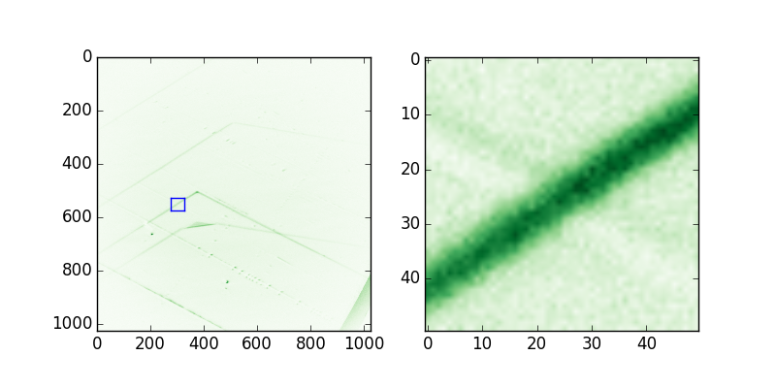
x
G, z
x’
B, z’

Fig 7. Shown is one image in the experimental rocking scan experimental data. The coordinate system is illustrated. The AOI is around 14 µm.

Fig 7 shows a zoom on actual data. 1D line profiles were made in direction x. Extrapolating from 80 pixel to 500 points, the step in these 1D scans is 28.8 nm.

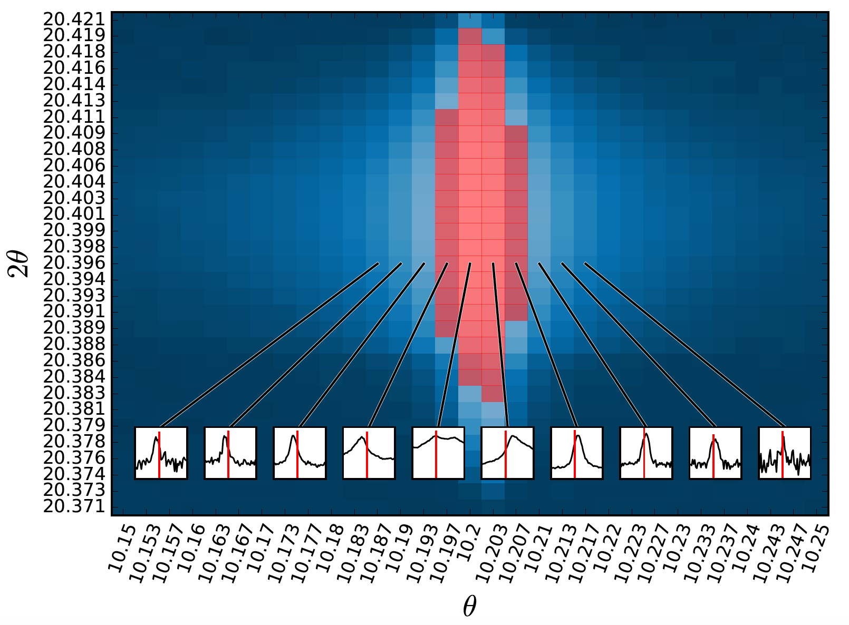
Fig 8. Overview of experimental data. The x-scans inserted represent the AOI, that is they have a range of 14 μm.

Inspection of Fig 8 reveals that
- There is a noticeable contrast (a peak) out to 5 images away from the center in the rocking scan, that is out to 0.26 mrad or q_{y} = 7.9 10⁻⁴ Å⁻¹. Inserting in x ~ b/(2πφ) we get 160 nm. Her mangler måske et cos beta eller lignende
- The widths of the peaks are of order 1 µm, substantially larger than the calculated spatial resolution. Inspection of the lower right corner of the figure to the left in Fig 7 suggests that the actual resolution is substantially better than this.

Eq 9 has been implemented in MATLAB, using the function integral2. We use the following settings: $f\left(u\right)=\frac{1}{\sqrt{2π} Δq_{y}}exp\left(-0.5{\left(\frac{u}{∆q_{y}}\right)}^{2}\right)$ with Δq_{y} =0.00012 Å⁻¹, g(x) = Box-fct with a FWHM of R_{dir} = 180 nm., T = 300 µm, b = $2.522$ Å.

Read in of profiles: matlab file: read_exp_data.m

function [intensity] = int_intensity(x0,eps0)
C = 2.522/(2*pi);
sigx = 1E-7; %in m
sig_eps = 0.5E-4;
Npoint = 200;

if (abs(eps0) - 4*sig_eps < 0)
intensity = 0;
return
end

dx = 4*sigx/Npoint;
d_eps = 4*sig_eps/Npoint;
sum_int = 0;
for ii=1:2*Npoint
x = x0 + dx*(ii-Npoint);
f = exp( -(x-x0)^2/(2*sigx^2) );
for jj=1:2*Npoint
eps = eps0 + d_eps*(Npoint-jj);
g = exp( -(eps-eps0)^2/(2*sig_eps^2) );
dummy1 = C*x/eps - x^2;
if dummy1>0
sum_int = sum_int + f*g*abs(x)/eps^2/sqrt(dummy1)*dx*d_eps;
end
end
end
intensity = C/(4*pi*sigx*sig_eps)*sum_int;
end

3. Formalism based on coherent and kinematical scattering

The analysis performed above will not be valid close to the core of the dislocation as the reciprocal space is not homogeneous within the coherence volume in that case. As the scattering from close to the core is of prime interest to us, we need to do better.

We shall use the classical procedure to determine the scattering power S for a small crystal [1]. For ease of presentation we shall assume a simple cubic lattice with lattice constant d comprising only one species of atoms. The incoming beam will be along a constant x trajectory. One issue in setting up the formalism is that the incoming wavefront is easiest to describe in the lab coordinate system, the reciprocal space in a the sample system - with the dislocation axis along z - while the rod is easiest to define in detector space.

We are going to use repeatedly the fact that

${\left|\int_{-U/2}^{U/2}{\exp\left(i u q_{u} \right)du }\right|}^{2}= \frac{\sin^{2}\left(Uq_{u}/2\right)}{\sin^{2}\left(q_{u}/2\right)}\sim {\left|U\frac{\sin\left(Uq_{u}/2\right)}{Uq_{u}/2}\right|}^{2}=U^{2}{sinc }^{2}(Uq_{u}/2).$ (10)

The HWHM of the sinc squared is 1.392, see this link, hence FWHM(q_{u}) = 2*2*1.39/U= 5.56/U.

In the sample system, at position Q = G + q in reciprocal space we have (with G being a Bragg lattice point, r_{klm} the unperturbed direct space lattice and C a constant):

$S\left(\overline{G}+\overline{q}\right)=C {\left|f\right|}^{2}{\left|\sum_{k=K1}^{K2}{\sum_{l=L1}^{L2}{\sum_{m=M1(l)}^{M2(l)}{exp(-i 2π\frac{md sinθ}{λ}) exp\left[i (\overline{G }+\overline{q}).\left({\overline{r}}_{klm}^{0}+{\overline{u}}_{klm}\right)\right]}}}\right|}^{2}$ (11)

Here the first term takes care of the phase shift due to the incoming beam being tilted at angle θ. Applying Braggs law:

= $C {\left|f\right|}^{2}{\left|\sum_{k=K1}^{K2}{\sum_{l=L1}^{L2}{\sum_{m=M1(l)}^{M2(l)}{exp(-i mπ) exp\left[i (\overline{G }+\overline{q}).\left({\overline{r}}_{klm}^{0}+{\overline{u}}_{klm}\right)\right]}}}\right|}^{2}$

Note that indices m depends on l – as the rod is at an angle θ with the sample system. Now we can substitute the atoms shifted in in the rod that is centered around z = tan(θ)y with atoms centered around z =0 if we add a phase shift of $exp(-i 2π\frac{md sinθ}{λ})= exp(-i mπ).$ Combined with the term we found above we have multiply of 2π. As a result

$S\left(\overline{G}+\overline{q}\right)$= $C {\left|f\right|}^{2}{\left|\sum_{k=K1}^{K2}{\sum_{l=L1}^{L2}{\sum_{m=M1}^{M2}{ exp\left[i \left(\overline{G }+\overline{q}\right).\left({\overline{r}}_{klm}^{0}+{\overline{u}}_{klm}\right)\right]}}}\right|}^{2}$ (12)

As we have many atoms within the inspected volume we can without loss of precision go to a continuous description. Entering the rod around (x₀, y₀, 0) we have

$S\left(\overline{G}+\overline{q}, x_{0}, y_{0}\right)$= $\frac{C {\left|f\right|}^{2}}{d^{6}}{\left|\int_{-\frac{Tx}{2}+x_{0}}^{\frac{Tx}{2}+x_{0}}{\exp\left(i {xq}_{x}\right)dx \int_{–\frac{Ty}{2}+y_{0}}^{\frac{Ty}{2}+y_{0}}{exp\left(i yq_{y}+i\left(G+q_{z}\right)\frac{d}{2π}\operatorname{atan}\left(\frac{y}{x}\right) \right)dy\int_{-\frac{Tz}{2}}^{\frac{Tz}{2}}{\exp\left(i {zq}_{z}\right)dz}}}\right|}^{2}$
$= \frac{C {\left|f\right|}^{2}}{d^{6}}{\left|\int_{-\frac{Tx}{2}+x_{0}}^{\frac{Tx}{2}+x_{0}}{\exp\left(i {xq}_{x}\right)dx \int_{–\frac{Ty}{2}+y_{0}}^{\frac{Ty}{2}+y_{0}}{\exp\left(i yq_{y}+i\left(G+q_{z}\right)\frac{d}{2π}\operatorname{atan}\left(\frac{y}{x}\right) \right)dy}}\right|}^{2}T_{z}^{2}{sinc}^{2}\left(\frac{q_{z}T_{z}}{2}\right)$ (13)

Hence, q_{z} is centered on 0 with a FWHM of 5.56/T_{z}. For $T_{z}≥100$ nm, it appears we can simplify to

$$S\left(\overline{G}+\overline{q}, x_{0}, y_{0}\right)= \frac{C {\left|f\right|}^{2}}{d^{6}}$$
${\left|\int_{-\frac{Tx}{2}+x_{0}}^{\frac{Tx}{2}+x_{0}}{\exp\left(i {xq}_{x}\right)dx \int_{–\frac{Ty}{2}+y_{0}}^{\frac{Ty}{2}+y_{0}}{\exp\left(i yq_{y}+i\frac{Gd}{2π}\operatorname{atan}\left(\frac{y}{x}\right) \right)dy}}\right|}^{2}T_{z}^{2}{sinc}^{2}\left(\frac{q_{z}T_{z}}{2}\right)$ (14)

It is instructive to consider the homogenous case above once more around (x₀, 0). This implies that $\operatorname{atan}\left(\frac{y}{x}\right) \sim \operatorname{atan}\left(\frac{y}{x_{0}}\right)\sim \frac{y}{x_{0}}.$ Hence,

$S\left(\overline{G}+\overline{q}, x_{0}, 0\right)= \frac{C {\left|f\right|}^{2}}{d^{6}}T_{x}^{2}T_{y}^{2}T_{z}^{2}{sinc}^{2}\left(\frac{q_{x}T_{x}}{2}\right){sinc}^{2}\left(\frac{T_{y}}{2}\left(q_{y}+\frac{Gd}{2πx_{0}} \right)\right){sinc}^{2}\left(\frac{q_{z}T_{z}}{2}\right)$ (15)

In short this is a product of three delta-functions, centered at (q_{x}, q_{y}, q_{z}) = (0,$-\frac{Gd}{2πx_{0}},0).$

Intensity in dark field microscopy experiment

The instrument has a finite resolution in reciprocal space. If we assume this to be an anisotropic Gaussian with rms widths (Δq_{x} , Δq_{y,} Δq_{z}), the intensity I becomes

$I\left(\overline{q, }x,y\right)$= C $\int_{-∞}^{∞}{\int_{-∞}^{∞}{\int_{-∞}^{∞}{S\left(q_{x}-u,q_{y}-v, q_{z}-w,x,y\right)\exp\left(-\frac{1}{2}{\left(\frac{u}{Δq_{x}}\right)}^{2}-\frac{1}{2}{\left(\frac{v}{Δq_{y}}\right)}^{2}-\frac{1}{2}{\left(\frac{w}{Δq_{z}}\right)}^{2}\right)du dv dw }}}$ (16)

Notably, we are taking data in the “rotation mode” which mathematically implies a change in coordinate system and a Jacobian matrix in going from S to I. In other words this introduces a Lorentz factor. We shall neglect this factor as it only is a scale factor when we are looking at the vicinity of one Bragg peak at one energy.

Above we learned that the NA of the objective is sufficiently large to integrate over the q_{x} and q_{z.}. In a handwaving way I propose things add up coherently when integrating over q_{z} and q_{y} but incoherently when integrating over q_{x.}

Combining Eqs. 14 and 16 we have the following

${I_{part}\left(q_{y},x,y\right)=C'\int_{-∞}^{∞}{du}\left|\int_{-∞}^{∞}{\exp\left(-\frac{1}{2}{\left(\frac{q_{y}-v}{Δq_{y}}\right)}^{2}\right)}dv\int_{-\frac{Rdir}{2}+x}^{\frac{Rdir}{2}+x}{\exp\left(i x'u\right)dx' \int_{–\frac{lcoh}{2}+y}^{\frac{lcoh}{2}+y}{\exp\left(i y'v+i\frac{Gd}{2π}\operatorname{atan}\left(\frac{y'}{x'}\right) \right)dy'}}\right|}^{2}$ (17)

Finally we need to integrate along the entire rod, that is the illuminated diffracted beam path projected unto the (x,y) plane in the sample system, T/cosθ, with T being the “thickness” in the lab system.

θ
Τ/cos(θ

Τ
2θ

This gives the equation we have been looking for:

$N= round\left[\frac{1}{2}\left(\frac{T}{l_{coh}\cos{θ}}-1\right) \right]$; ${I(q_{y},x)=C'\sum_{n=-N}^{N}{\int_{-∞}^{∞}{du}\left|\int_{-∞}^{∞}{\exp\left(-\frac{1}{2}{\left(\frac{q_{y}-v}{Δq_{y}}\right)}^{2}\right)}dv\int_{-\frac{Rdir}{2}+x}^{\frac{Rdir}{2}+x}{\exp\left(i x'u\right)dx' \int_{\left(n-\frac{1}{2}\right)lcoh}^{\left(n+\frac{1}{2}\right)lcoh}{\exp\left(i y'v+i\frac{Gd}{2π}\operatorname{atan}\left(\frac{y'}{x'}\right) \right)dy'}}\right|}}^{2}$ (18)

In future the four parameters in this equation should be measured with good precision: the spatial resolution R_{dir}, the coherence length l_{coh} , the resolution of the rocking curve, Δq_{y}, and the illuminated thickness, T.

We remark that both the spatial resolution and the coherence length are treated as box functions. To be more precise this should be replaced by Gaussians or similar. Likewise the beam profile may not be a box function.

Alternative optics

An increased NA will improve the spatial resolution, and allow the strain field closer to the core to be studied. There are no adverse effects: the objective will still integrate over the entire distribution in both q_{x} and q_{z}.

Numerical simulation of actual data

The aim is to calculate the intensity for say 15 x positions in the range [0.1 1.5] μm and for say 20 q_{y} positions covering the range []. For each of these we wish to sum 2N +1 = $\frac{1E-4}{1E-6\cos{θ}}$ ~10² points along the rod. In total this implies performing 15*20*100 = 30,000 4D integrals.

MATLAB has the built in function integral3, but not a specific function for 4D integrals.
have generated the function screw_scat(qx, qy, qz) based on Eq 5 in MATLAB.

Reference
- Jens Als Nielsen and Des MacMarrow. Elements of modern x-ray physics.
- D. B. Williams, B.C. Carter. Transmission X-ray microscopy. Plenum 1996.

