Uploading New Apps to the Shiny Server

Process instructions

Jeremy Anderson and matthew sparby

2014

Contents

Introduction 2

Preparing the R App Package 2

Transferring Package to the Shiny Server 4

Logging Into the Shiny Server 8

Installing the Shiny App 9

Deleting a Shiny App 10

# Introduction

This document will cover the process of uploading new apps to the Shiny server. The process requires 3 basic steps:

* Preparing the App for Transfer
* Transferring Package to the Shiny Server
* Installing the App

The following sections use an example app called “MyRApp”.

# Preparing the R App Package

1. Create a directory with the same name as your application and put the requisite files in that directory. This example shows a folder called MyRApp containing one file, server.R.

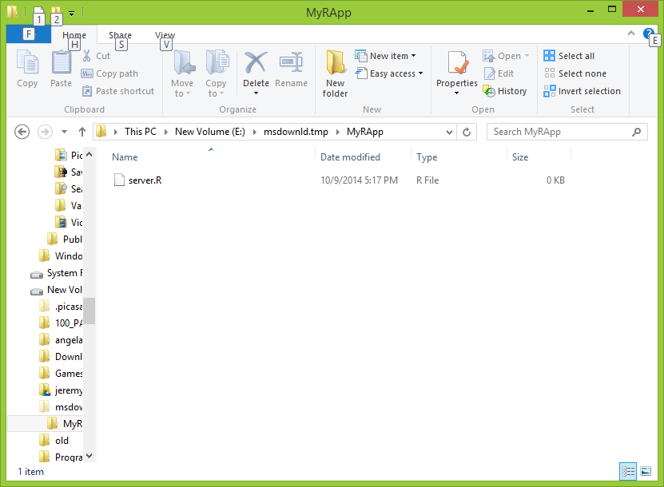  
Figure 1 - view of example R app in the explorer window.

1. Create the package by zipping up the entire app folder (not just the .R file) using any app that can create a standar .ZIP file.  This example uses the built-in ‘compressed folder’ option of MS Windows.

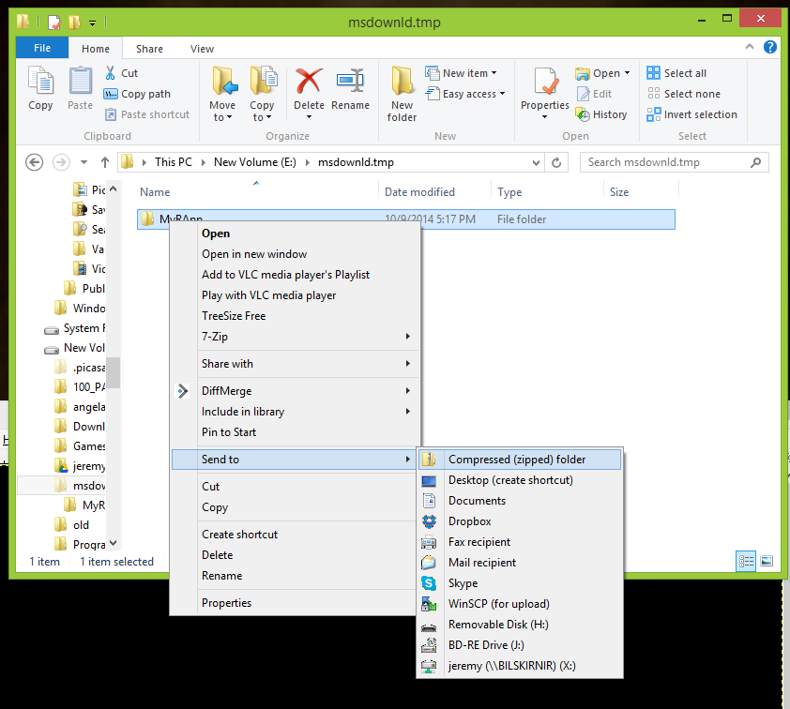

Figure 2 - Compressing the R App for transport

1. The result is a file called MyRApp.zip

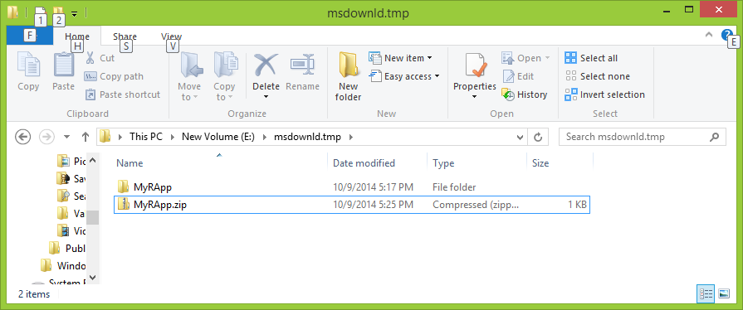

Figure 3 – Figure 3 - resulting zip file

# 

# Transferring Package to the Shiny Server

The Shiny server accepts files via Secure FTP (SFTP) or Secure Copy (SCP). Any SFTP or SCP client will work, however, this example uses the FOSS SFTP client WinSCP 5.5.5 configured for “Commander” mode which can be downloaded from [http://winscp.net/eng/index.php](http://www.google.com/url?q=http%3A%2F%2Fwinscp.net%2Feng%2Findex.php&sa=D&sntz=1&usg=AFQjCNGnMUb871F09ZEFhi5q_Ata_VlffA)

WinSCP can be configured to use public key authentication, but this example will use password authentication.

Here is the initial screen presented to the user on WinSCP launch:

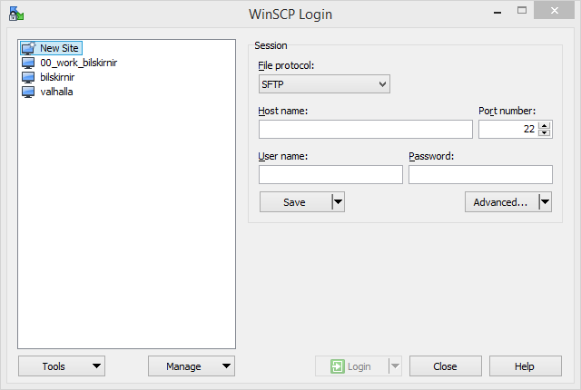

Figure 4 - Initial WinSCP screen.

Figure 4 above shows a list of configured sessions in the left pane. A new WinSCP install won’t have any sessions listed. A session for the Shiny server must be added.

1. Select “New Site” in the left hand pane as shown in Figure 4.
2. Enter the hostname or IP address, username and password into the appropriate fields.
3. Click the “Save” button located below the User name field as shown in Figure 5 below.

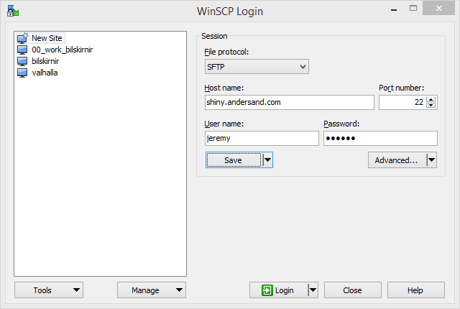

Figure 5 - WinSCP session before saving.

1. After clicking “Save” the dialog box shown in Figure 6 will appear.

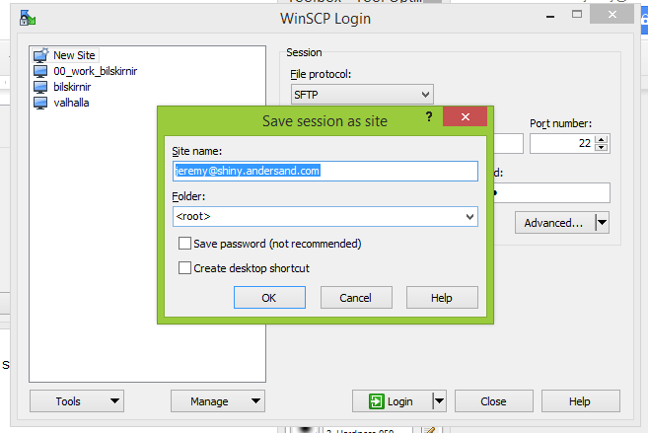

Figure 6 -- save session dialog

1. If you wish to save the password, click the checkbox next to “Save password (not recommended)” and then click OK.

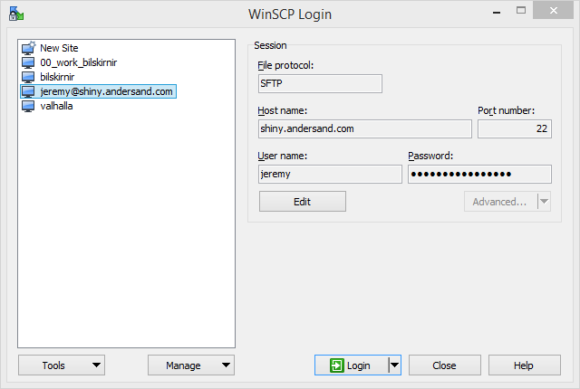  
Figure 7 – Newly Created Session in List

1. Select the newly created session from the session list and click “Login”.
2. If this is the first time connecting to this host with WinSCP, the dialog box shown in Figure 8 will appear.

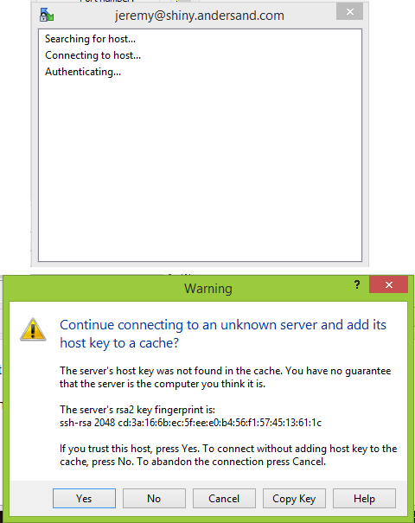

Figure 8 - Confirm Target Host SSH Key

1. If possible, confirm with the admin that the key is valid before clicking “Yes”.
2. After successful logon, the WinSCP browser window will appear. The screenshot in Figure 9 shows the local computer’s filesystem on the left and is displaying the MyRApp.zip package created earlier. The right side shows the Shiny server’s filesystem. In this example, the file will be copied to the user’s home directory (/home/Jeremy).

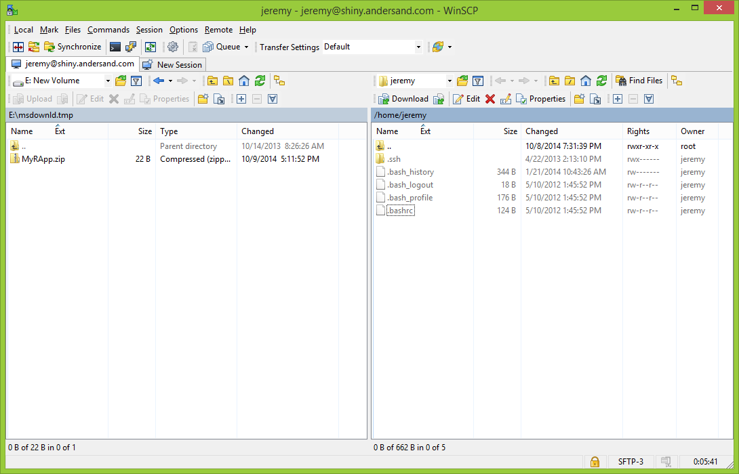  
Figure 9 - Commander View of Local and Remote Filesystems

1. To transfer the Package, drag the MyRApp.zip file from the left pane to the right pane.
2. The dialog box in Figure 10 will appear. Click “OK” to begin the transfer.

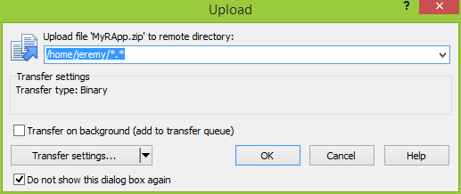  
Figure 10 - Confirm File Transfer

# Logging Into the Shiny Server

Once the package has been transferred, it’s time to log into the Shiny server. This requires a Secure Shell (SSH) client. Any SSH client will work, however, this example uses the FOSS application called PuTTY which can be downloaded from [http://www.chiark.greenend.org.uk/~sgtatham/putty/download.html](http://www.google.com/url?q=http%3A%2F%2Fwww.chiark.greenend.org.uk%2F~sgtatham%2Fputty%2Fdownload.html&sa=D&sntz=1&usg=AFQjCNFQ2hd__UNHkWv-OIsPy2eENnOjrQ)

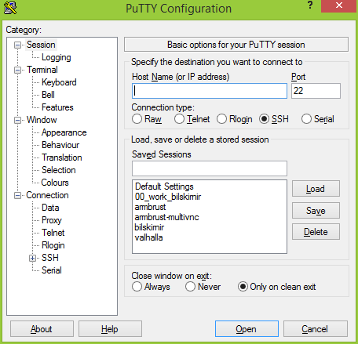

Figure 11 - PuTTY Initial Screen

Like WinSCP, PuTTY allows session configurations to be saved. The screenshot in Figure 11 shows several saved sessions, however, a new install of PuTTY will only show “Default Settings”. The first step will be to create a saved session for the Shiny server and then log into it.

1. Enter the Hostname or IP Address into the appropriate field. This example uses “shiny.andersand.com”
2. In the text box directly under “Saved Sessions” enter a name for the session, this example uses “shiny”

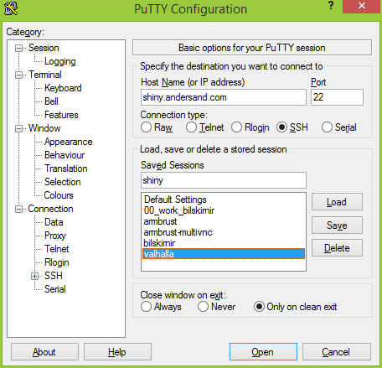

Figure 12 -- PuTTY Session Saved

1. Click the “Save” button to the right of the Saved Sessions list.
2. Click the “Open” button at the bottom of the window to open the session.
3. As with WinSCP, a Security Alert dialog as shown in Figure 13 will open the first time you connect to a new server with PuTTY. If possible, confirm with the admin that the key is valid (or, at least, match it to the key that was displayed in WinSCP) before clicking “Yes”.

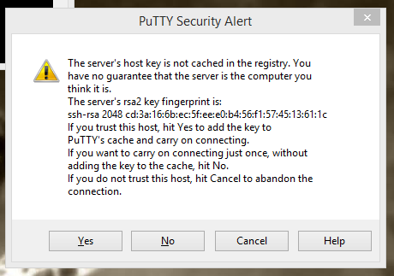

Figure 13 - PuTTY Host Key Confirmation

1. Enter the username and password when prompted.

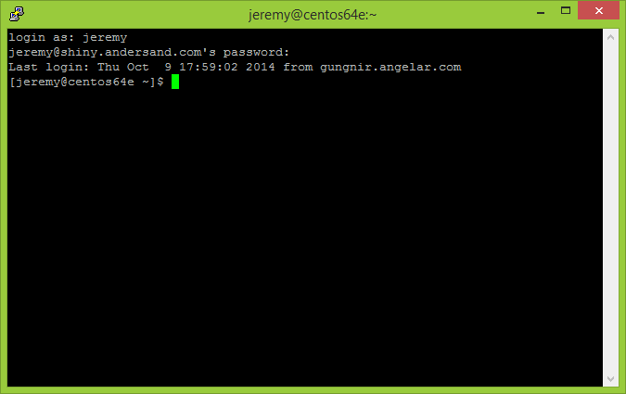  
Figure 14 - Logged Into the Server

NOTE: Even though the session name and the hostname are configured in PuTTY as “shiny”, the hostname displayed in the terminal is centos64e. This is because of how networking is configured on the server. The machine knows itself as centos64e, but DNS also knows it as shiny.andersand.com

# Installing the Shiny App

This example uses the shinyinstall script to install the app on the Shiny server. This requires sudo access.

1. From the home directory where the package was copied earlier, run the following command:

sudo /usr/local/bin/shinyinstall ./MyRApp.zip

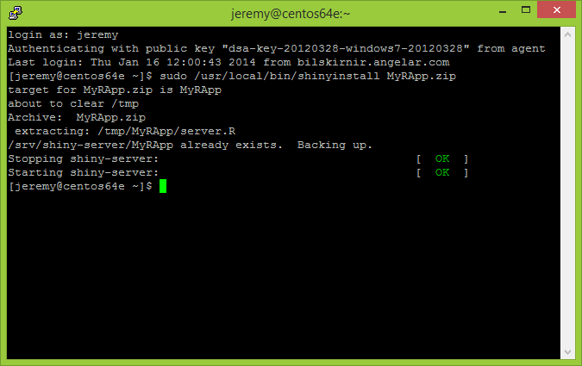

Figure 15 – shinyinstall Script Results

1. The script will first make a backup of any previous version of the app, then it will install the new app and restart the Shiny server. Figure 15 shows an example of the results that will appear as the script runs.
2. Enter the Shiny URL into a browser address bar. For the example app the URL would be <http://shiny.andersand.com/MyRApp/>

# Deleting a Shiny App

If it is necessary to remove a Shiny app, the shinyremove script can be used. As with shinyinstall, this requires sudo access. Run the script like this:

sudo /usr/local/bin/shinyremove MyRApp