July 2018 Metrics as of 26th

Jeff Anderson

July 27, 2018

# ****************************

# Month to Date Failure Info

# ****************************

# Job Failure Counts by Job

## # A tibble: 36 x 2  
## job.name total.fails  
## <fct> <int>  
## 1 PNC-DTL-PRD-MONIT-DB-ENTITY-PROCESSING-MAIN 110  
## 2 PNC-DTL-PRD-MONIT-DB-TRADE-MAIN 98  
## 3 PNC-DTL-PRD-MONIT-DB-SECURITY-MAIN 49  
## 4 PNC-MMKT-BRS-FUNDSTATION-SHADOW-NAV-CHK 49  
## 5 PNC-SLG-WSO-REPORTS-STATUS-CHK 37  
## 6 PNC-CRDU-UKCE-MIFIDII-TRANSRES-DAILY-STORE-20ARC 35  
## 7 PNC-CPRK-INVLDN-LOAN-020LOANCORELOAD 31  
## 8 PNC-ABE-BRS-PORT_SUMMARY-STGTBL-LOAD 24  
## 9 PNC-SLG-IVZOBT-WSO-CASHPRIOR-POSITION-EXT 24  
## 10 PNC-DTL-PRD-MONIT-AUTOSYS-JOBS-DAILY 22  
## # ... with 26 more rows

## Total Failures by Job Group

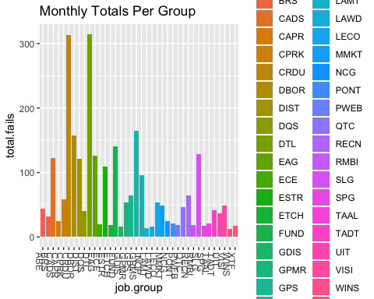

## Failures by Day by Group

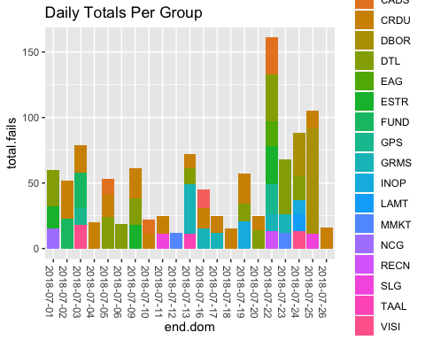

## Failures by Machine

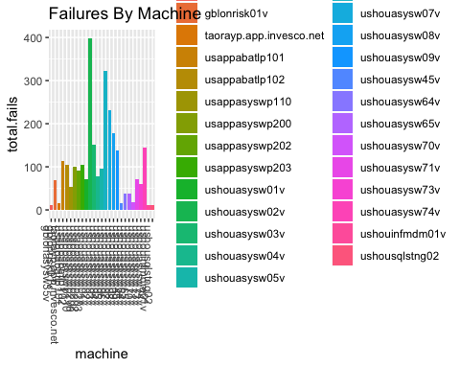

## Failures by Exit Code

## # A tibble: 37 x 2  
## exit.code total.fails  
## <int> <int>  
## 1 1 690  
## 2 1000 629  
## 3 1002 210  
## 4 255 100  
## 5 20005 79  
## 6 2 78  
## 7 5 51  
## 8 1190 46  
## 9 100 40  
## 10 1240 39  
## # ... with 27 more rows

## Total Failures by Operating System

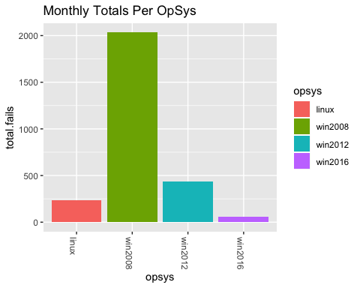

## Total Failures by Hour of Day

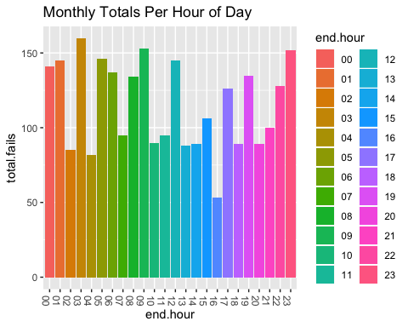

## Total Failures by Day of Week / Hour

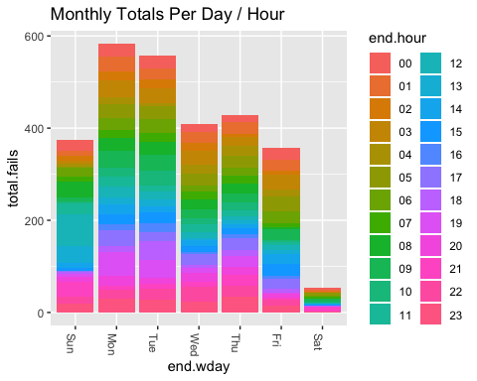

# ****************************

# Yesterday Information

# ****************************

## Yesterday Failures by Job

## # A tibble: 75 x 2  
## job.name total.fails  
## <fct> <int>  
## 1 PNC-CPRK-INVLDN-LOAN-020LOANCORELOAD 5  
## 2 PNC-GRMS-INVLDN-EAGLE_LOAD-STALE_BM_RPT 5  
## 3 PNC-DTL-PRD-MONIT-AUTOSYS-JOBS-DAILY 4  
## 4 PNC-DTL-PRD-MONIT-DB-ENTITY-PROCESSING-MAIN 3  
## 5 PNC-EAG-MSTAR-PSHARES-EXT 3  
## 6 PNC-ETCH-USDS-ETF-G10K-FROM-FILE-PREV 3  
## 7 PNC-NCG-AIMHOU-WSTIMPORTS-SHAREPOINTSQL 3  
## 8 PNC-RADD-BRS-GENERATE_ANALYTICS_SECURITIES 3  
## 9 PNC-CRDU-UKCE-MIFIDII-TRANSRES-DAILY-STORE-20ARC 2  
## 10 PNC-DIST-DES_E_D_ALLFUNDS_ICVC-100INIT 2  
## # ... with 65 more rows

## Yesterday Failures by Group

