
Jerome L. Lewis, Professor
Division of Mathematics and Computer Science

May 15, 2016

To Whom It May Concern:

I am writing on behalf of a former student, Nicole Anderson, who recently graduated from USC Upstate with a BS degree in Computer Science. I feel entitled to share some of my thoughts and feelings about this student since she took some of my classes and was a major in the MCS Division over which I presided as chair for most of the time she was a student here.

Nicole was a student of mine in two computer science courses, one of them a course in advanced data structures, with a heavy programming requirement, the other a course in algorithm analysis. I remember her for the fine work she did in both of those courses. Her programming was logical and well organized, always adhering meticulously to the specifications. She showed a great deal of initiative in the way she approached problems and was creative in her solutions. Her written work was always of the highest quality and showed a great deal of preparation and hard work. She was always in class and was always on time. She took homework and outside projects very seriously and was always prepared for class. She is able to grasp new concepts quickly, and she is able to apply new concepts to new problems effectively.

Nicole had a good attitude toward her education. While she always made good grades in my classes, she seemed just as interested in learning the material and applying it as she did in the letter-grade itself. She was well-liked by her classmates and her professors here as well. She demonstrated an ability to communicate and work well with others in those courses that required team participation. I found her to be a young woman of honesty, integrity and character. I was impressed with how well she did academically, given that she was also a very caring mother to a pre-school child, an additional responsibility she took seriously and seemed to enjoy.

In summation, I am giving Nicole a good, solid recommendation for a position in the field of computer science. She is bright, energetic, mature and hard-working, and I believe she has a lot of potential. With her good work ethic I think she has the ability to succeed wherever she is planted, and I think she will be an asset to any company that invests in her. Please contact me at 864.503.5291 if you need any further information.

Sincerely,
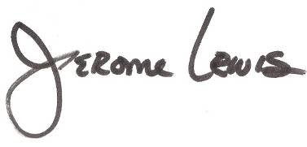
Jerome Lewis

