Dan W Anderson

<http://web7.apl.jhu.edu/~dander73/hw3/bhc_homepage.html>

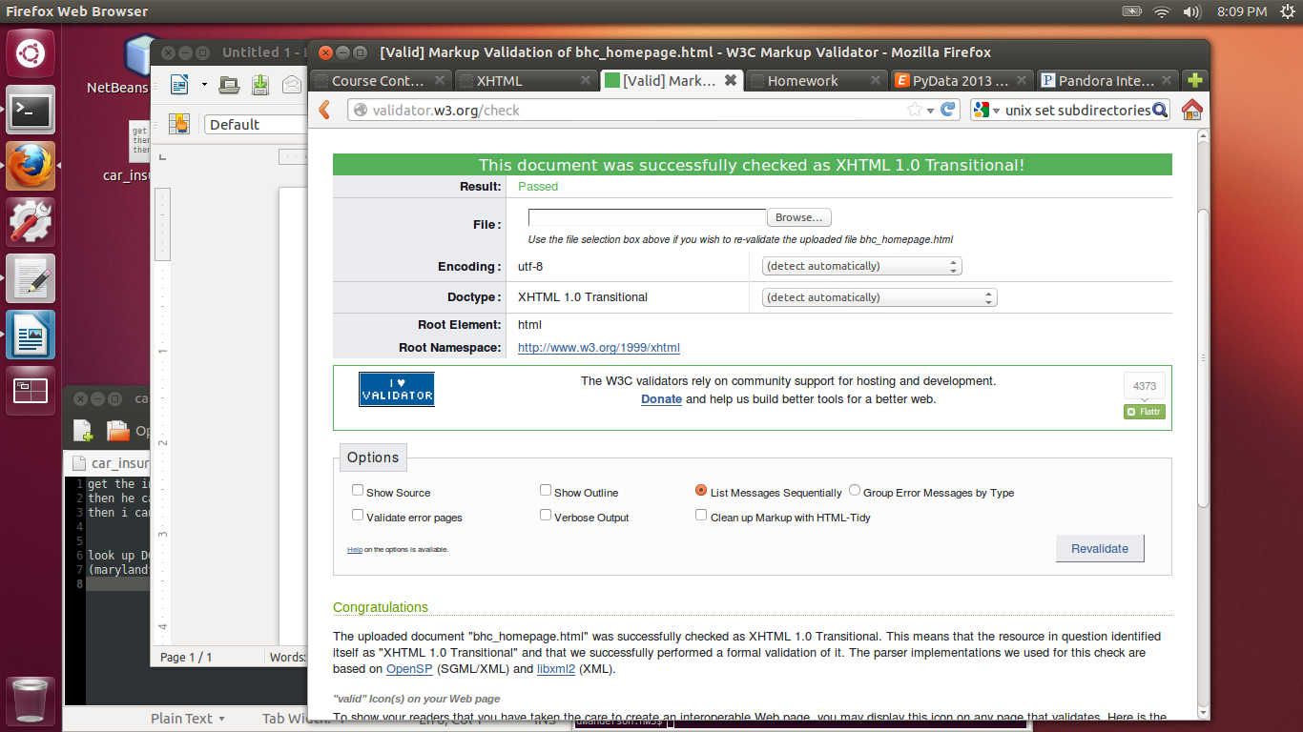

The java zip file is attached separately.

The name of the main is, well, Main.

