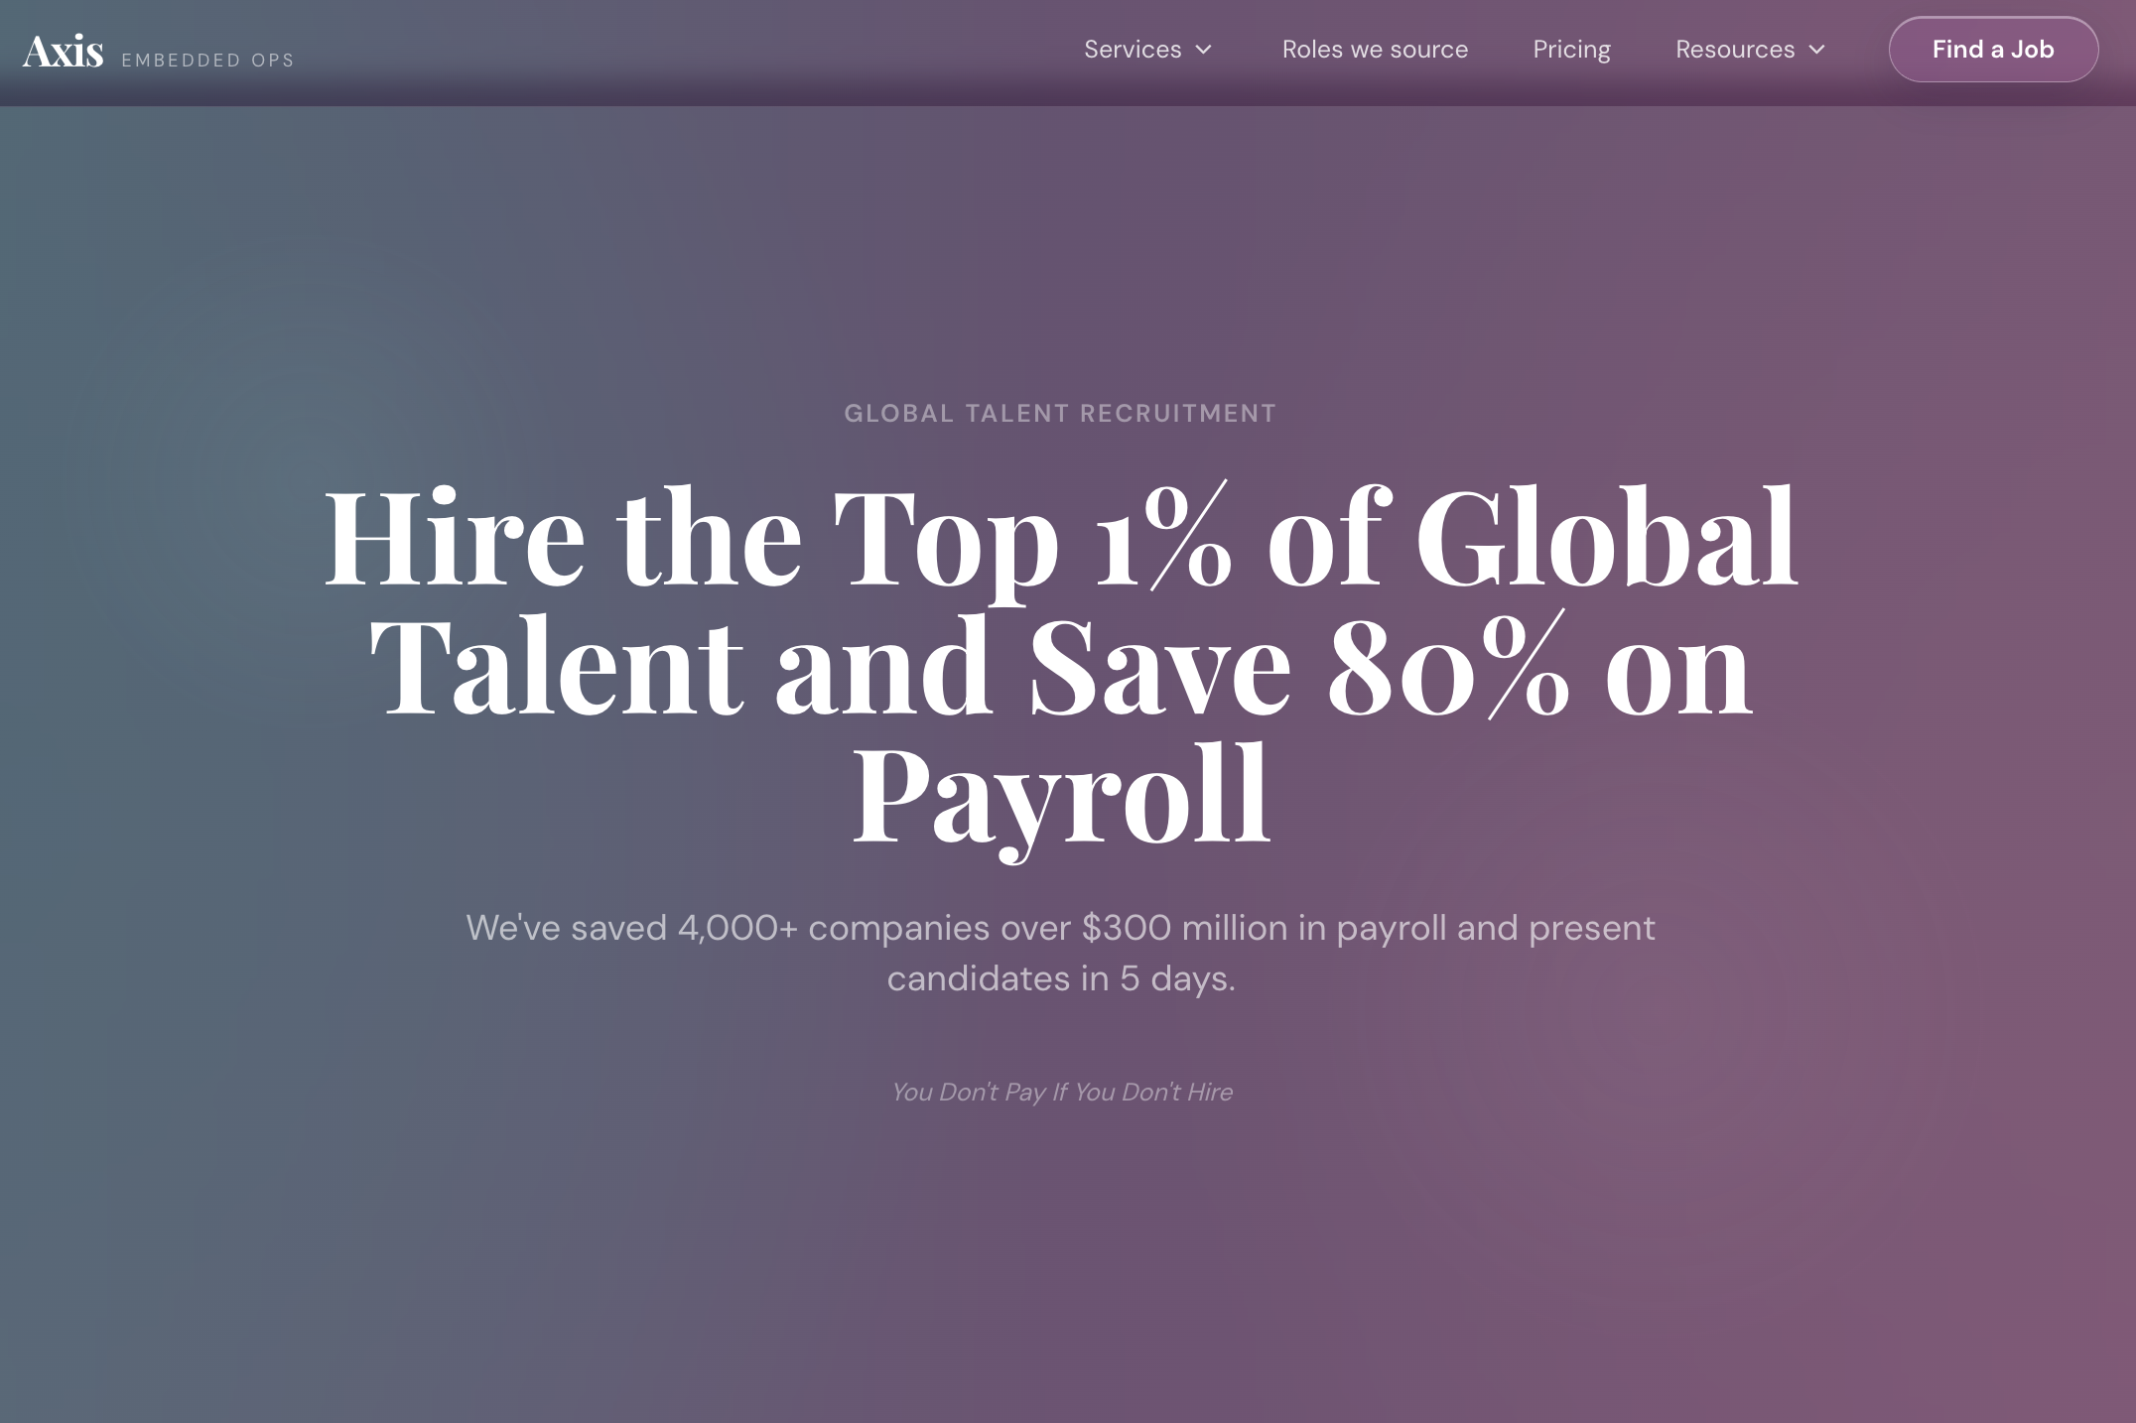
FROM: Global Talent Recruitment
TO: Embedded Global Workforce Solutions
FROM: Hire the Top 1% of Global Talent and Save 80% on Payroll
To: Access Top-Tier Global Talent— Embedded into Your Team While Reducing Payroll Costs by Up to 70%
From: We’ve saved 4,000+ companies over $300 million in payroll and present candidates in 5 days.
TO: We help business owners build high-performing remote teams that scale operations without the overhead of local hiring.
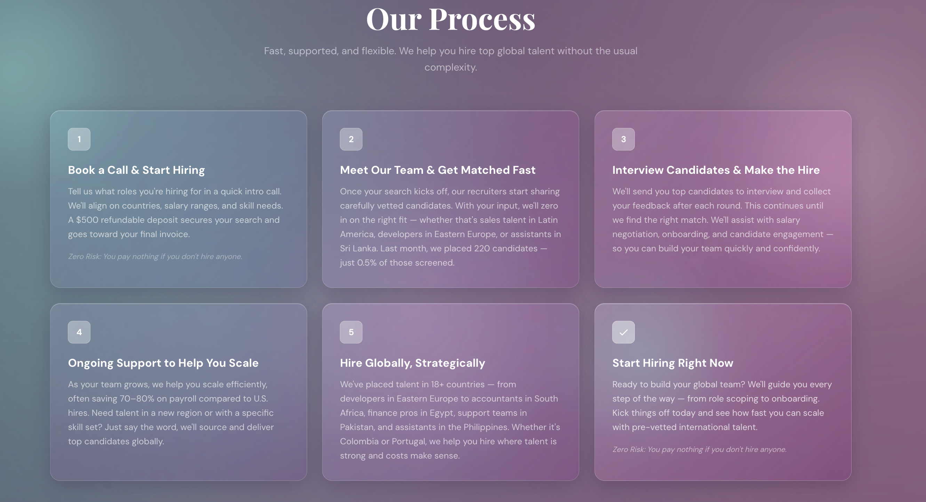
FROM: Our Process
Fast, supported, and flexible. We help you hire top global talent without the usual complexity.
TO:
Our Process
Structured. Embedded. Built for Scale.

We don’t just help you hire—we integrate high-performing global talent directly into your operations, without the friction of traditional hiring.
1 — Align & Scope the Role
We start with discovery and a focused strategy call to understand your business, workflows, and hiring objectives.
From there, we define the role, expectations, and success metrics—so every candidate is aligned from day one.
Zero-Risk Engagement — You only pay once you’ve made a successful hire

2 — Source & Curate Top Talent
Our team activates a global sourcing engine and rigorously vets candidates for skill, communication, and operational fit.
You don’t review hundreds of applicants—we deliver a curated shortlist built for performance.

3 — Interview & Select with Confidence
You meet only high-probability candidates already aligned with your needs.
We guide the process, collect feedback, and refine quickly—so you can make the right hire without delays.

4 — Embed into Your Operations
This is where AXIS is different.
We support onboarding and ensure your hire is fully integrated into your tools, workflows, and team—so they operate like a true extension of your business.

5 — Scale with Ongoing Support
As your business grows, we help you expand your team with the same level of precision and consistency.
Whether it’s new roles, new regions, or specialized talent—we keep your operations moving forward.

Start Building Your Team
Ready to scale with embedded global talent?
We guide you through every step—from role definition to full integration—so you can build a reliable, high-performing team without the complexity of traditional hiring.

Get started today and see how quickly you can expand your operational capacity.
Zero-Risk Engagement — You only pay once you’ve made a successful hire
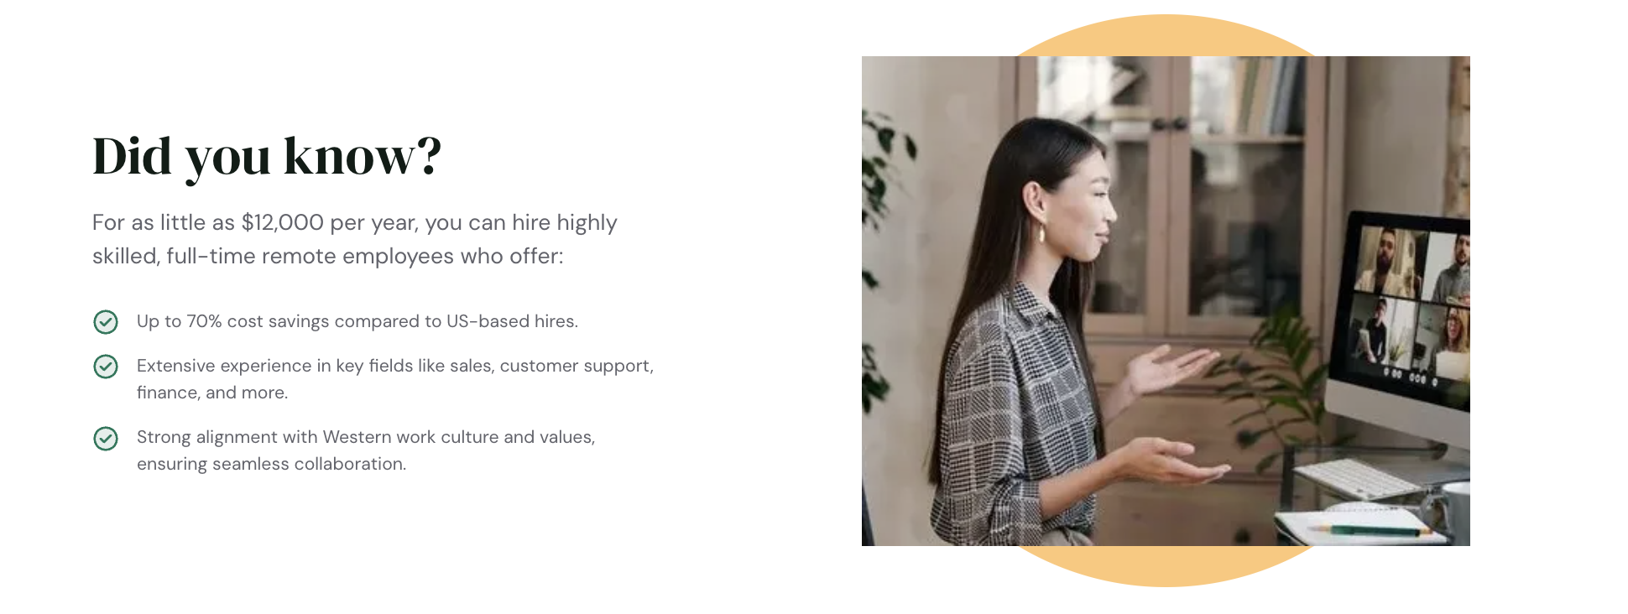

TO:
Rethinking How Teams Are Built
High-performing companies are no longer limited by local hiring.
With the right system, you can access skilled global professionals who operate as a seamless extension of your team—at a significantly more efficient cost structure.
✔ Reduce hiring costs by up to 70% without compromising quality
✔ Access experienced talent across operations, sales, support, and more
✔ Work with professionals aligned to your workflows, standards, and culture

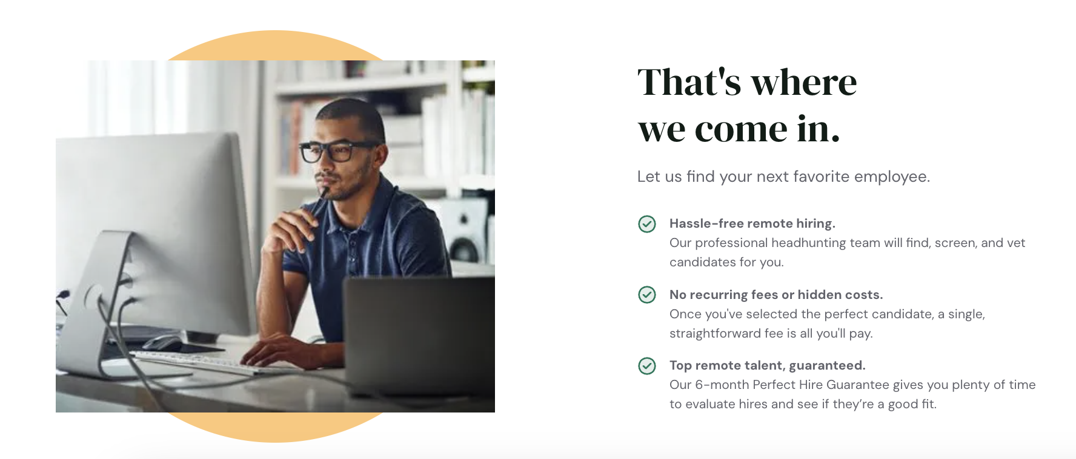
TO:
This Is Where AXIS Comes In
We don’t just help you find talent—we embed it into your operations.
From sourcing and vetting to onboarding and integration, AXIS ensures every hire is aligned, reliable, and built for long-term performance.

✔ Embedded hiring model, not traditional outsourcing
We integrate talent directly into your systems and workflows.

✔ Transparent, one-time engagement structure
No recurring placement fees or hidden costs.

✔ Performance-backed placements
We stand behind every hire with a structured guarantee and ongoing support.
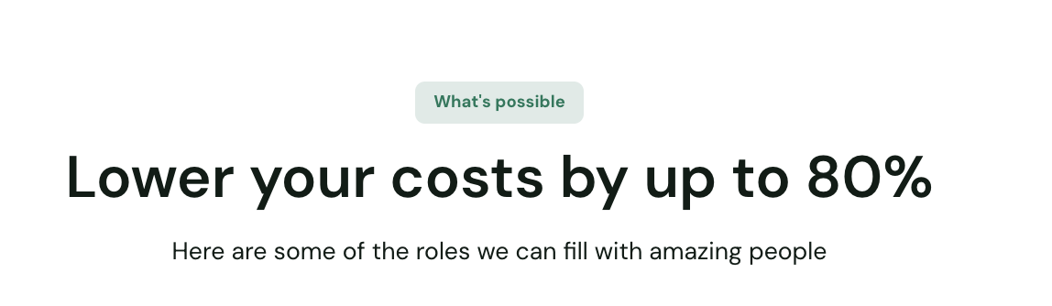
Label (Button):
What You Can Unlock
Headline:
Lower your costs by up to 80%
Here are some of the roles our clients are successfully scaling with AXIS:
The roles our clients rely on to run and scale their operations:
- Executive & Administrative Support
- Operations & Process Management
- Customer Experience & Support
- Sales Support & Lead Generation
- Marketing Execution & Coordination
- Finance & Back-Office Support
- Data, Reporting & Analytics
- CRM & Systems Management
- E-commerce Operations
- Project & Workflow Coordination
- Executive Assistants
Keep your schedule, inbox, and priorities organized so you can focus on high-impact decisions.
- Operations Coordinators
Ensure your day-to-day processes run smoothly and nothing falls through the cracks.
- Customer Support Specialists
Deliver fast, reliable support that improves customer satisfaction and retention.
- Sales Development Representatives (SDRs)
Qualify leads, manage outreach, and keep your pipeline consistently moving.
- Marketing Assistants
Execute campaigns, manage content, and support your marketing engine without delays.
- Bookkeepers & Finance Support
Maintain accurate financials, manage invoices, and keep your cash flow organized.
- Data & Reporting Analysts
Turn your data into clear insights so you can make smarter business decisions.
- CRM & Admin Support
Keep your systems clean, updated, and functioning efficiently.
- E-commerce Support
Manage orders, product listings, and customer inquiries to keep your store running smoothly.
- Project Coordinators
Track tasks, align teams, and ensure projects are delivered on time.

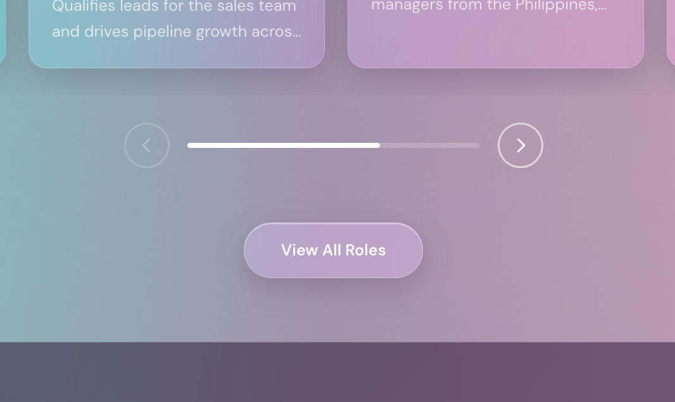

🔷 Optional Closing Line (Highly Recommended)

Replace All Roles to
(Don’t see the exact role you need?) Button
We tailor every hire to your specific business requirements.
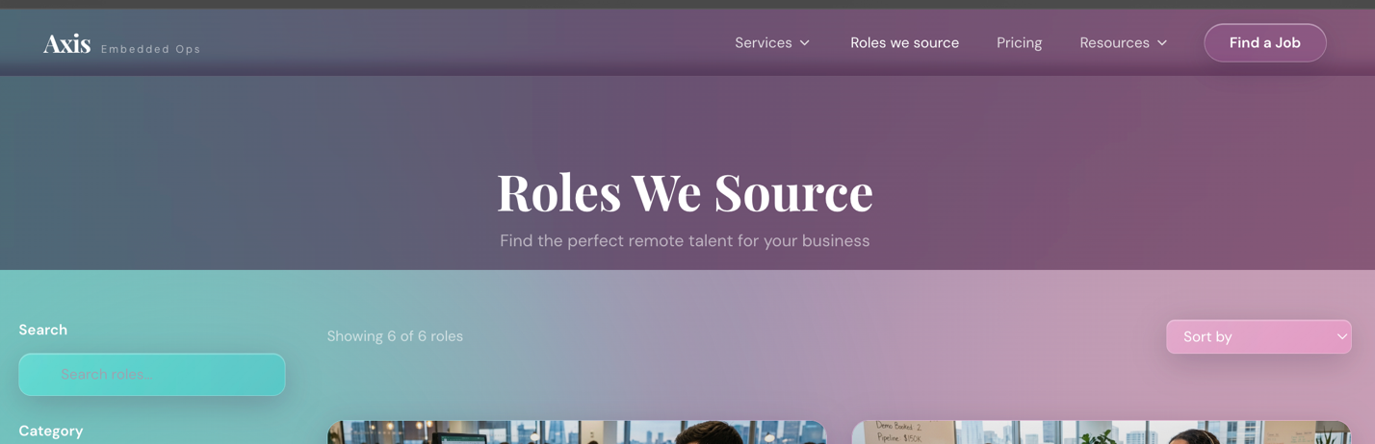
Roles We Embed
Find offshore talent built to support the way your business operates

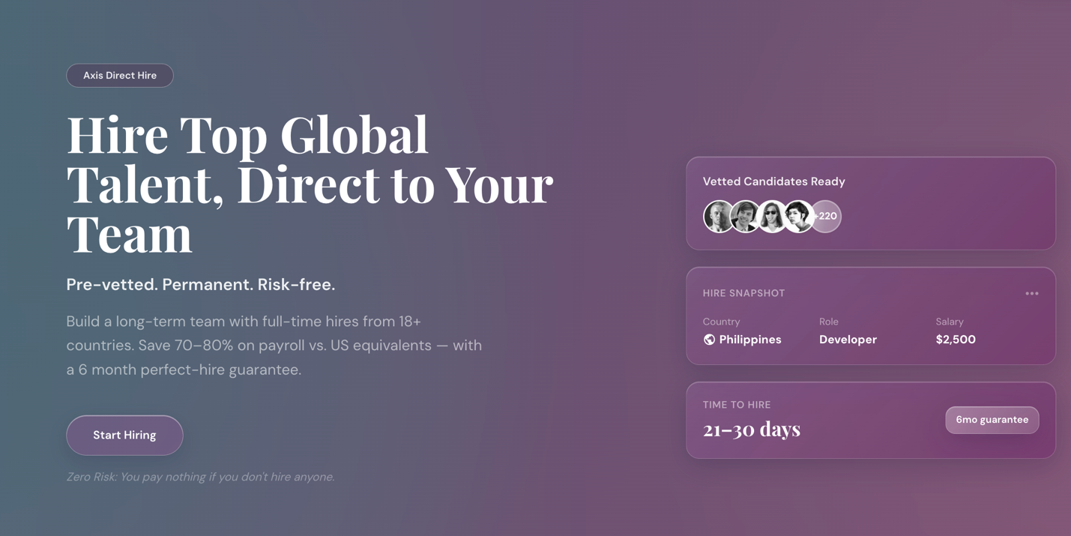

Scale Smarter with Embedded Offshore Talent from AXIS
Our direct-hire model helps growing companies build reliable offshore teams without the complexity of traditional hiring. You tell us the role, skills, and support you need — we find vetted talent ready to integrate into your operations.
Start Hiring
Zero-Risk Engagement — You only pay once you’ve made a successful hire
Note: Hire Snapshot to Project Manager $1,500 – $4,500
Time to Hire: 7days – 14 days
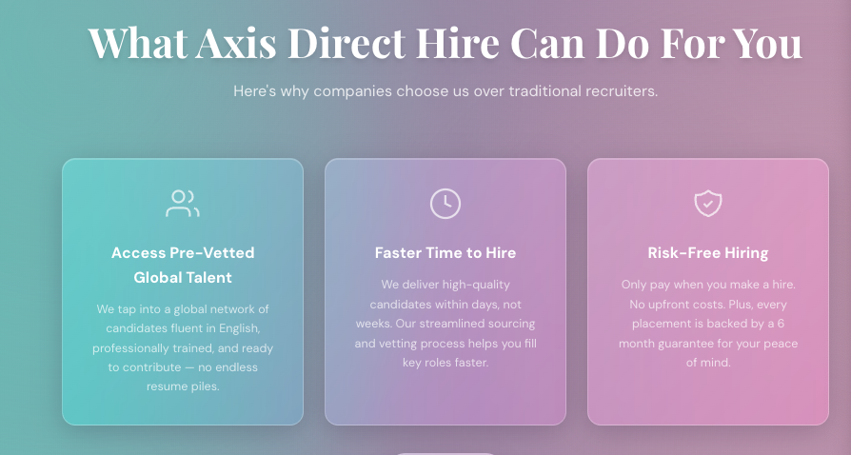
What AXIS Embedded Ops Can Do For Your Business
Built for businesses that need dependable global talent, stronger execution, and a more efficient way to grow.

Card 1
Talent Matched to Your Workflow
We source global professionals around your actual tools, communication rhythms, responsibilities, and success metrics—not just a generic job description.

Card 2
Speed Without Losing Fit
From role clarity to candidate alignment, AXIS streamlines the hiring process so you can add meaningful support faster while keeping quality at the center.

Card 3
A Lower-Risk Way to Scale
With structured vetting, clear expectations, and onboarding guidance, AXIS helps you make offshore hiring more predictable, more strategic, and easier to manage.
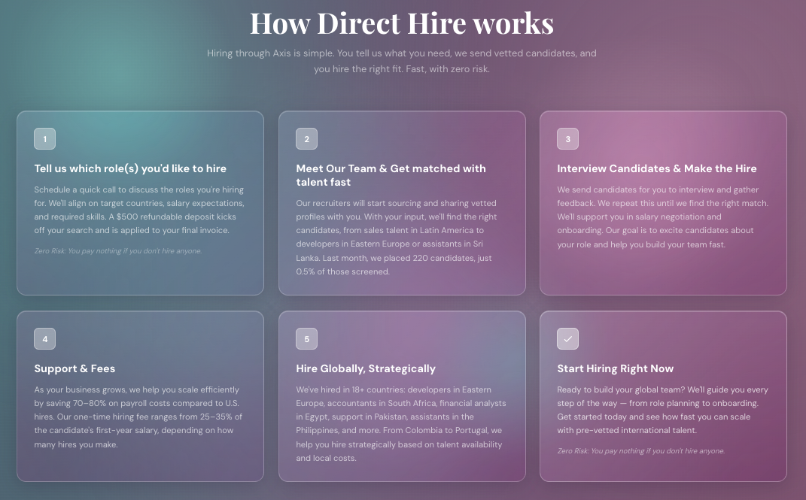

How AXIS Embedded Ops Works

Subheading
Building a global team with AXIS is simple, strategic, and designed around your operations. You tell us where your team needs more capacity, we identify the right global talent, and you hire a professional who can plug into your business with confidence.

1. Define the Role That Creates Leverage
We start with a focused strategy call to understand your business, team structure, current bottlenecks, tools, workflows, and hiring priorities.
Instead of filling a generic job title, we clarify what this person needs to own, how success will be measured, and what kind of global professional will create the most immediate operational impact.

2. Build a Targeted Offshore Talent Search
Once the role is defined, AXIS begins sourcing candidates aligned with your required skills, communication standards, work schedule, experience level, and compensation range.
We focus on candidates who are not only qualified on paper, but also capable of working inside your systems, team rhythm, and expectations.

3. Meet Vetted Candidates and Choose the Right Fit
We present aligned candidates for you to review and interview. You get to evaluate their skills, communication style, experience, and fit before making a decision.
We help coordinate the interview process, gather feedback, and refine the search until the right person is identified.

4. Align Offer, Expectations, and Onboarding
Once you select a candidate, we support the offer process and help align expectations around compensation, work hours, responsibilities, tools, communication, and performance standards.
This gives your new professional hire the clarity they need to start strong and integrate smoothly into your team.

5. Scale Your Embedded Ops Team Strategically
After your first hire is in place, AXIS can help identify additional roles that can be delegated, systemized, or expanded offshore.
Whether you need support in operations, admin, customer service, sales support, marketing, finance, recruiting, or project coordination, we help you build capacity in a structured and sustainable way.

Start Building Your Embedded Global Team
Ready to reduce workload, increase capacity, and give your team stronger operational support?
AXIS Embedded Ops helps you hire offshore professionals who are matched to your business needs, integrated into your workflows, and positioned to contribute from day one.

Button
Start Hiring With AXIS
Build smarter. Move faster. Scale with embedded global talent.
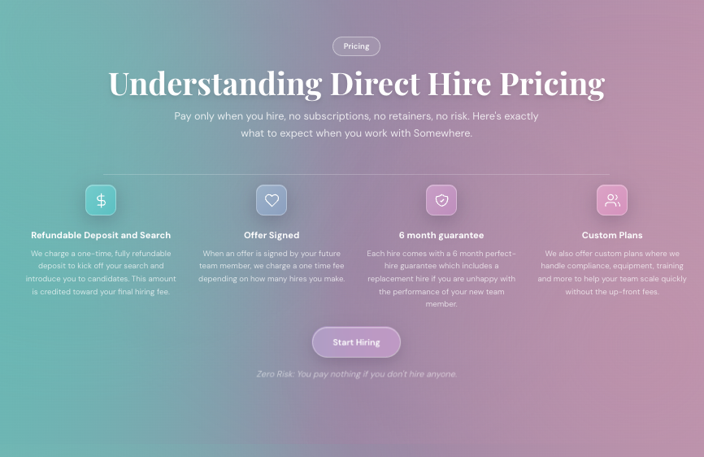

Pricing

Simple Pricing for Embedded Offshore Hiring
Transparent, success-aligned pricing designed to help you build offshore capacity without retainers, subscriptions, or unnecessary hiring risk.

Step 1

Role Strategy & Search Kickoff
We begin with a focused role strategy session to understand your hiring needs, responsibilities, workflow, compensation range, and success criteria.
A refundable search deposit may be used to begin the sourcing process and is applied toward your final placement fee when you hire.

Step 2

Hire Confirmed
You only pay the placement fee once you select a candidate and the offer is accepted.
The fee is based on the role, compensation level, and number of hires—so your investment is tied directly to successful hiring outcomes, not endless recruiting activity.

Step 3

Built-In Replacement Support
Every AXIS placement is supported by a replacement window designed to reduce hiring risk and give you confidence in the decision.
If the hire is not the right long-term fit within the agreed period, we help source a replacement based on the terms of your plan.

Step 4

Custom Growth Plans
For businesses building multiple global roles, AXIS can create a custom hiring plan that supports role planning, sourcing, onboarding coordination, team expansion, and operational scaling.
This is ideal for businesses that want to build an embedded offshore team—not just make one isolated hire.

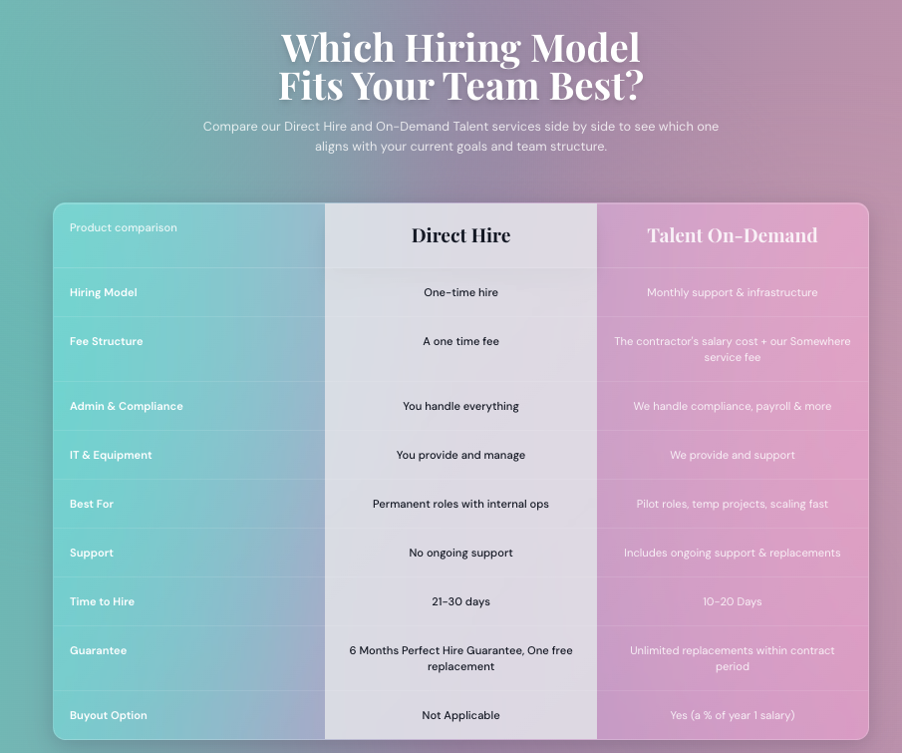

Choose the Offshore Hiring Model Built for Your Team
Whether you want a direct long-term hire or a supported offshore team structure, AXIS helps you scale with the right level of control, support, and flexibility.
Product Comparison | Embedded Direct Hire | Managed Offshore Team
Hiring Model | One-time offshore placement | Ongoing offshore talent support and team infrastructure
Fee Structure | One-time placement fee after a successful hire | Monthly talent cost plus AXIS management and support fee
Admin & Compliance | Your team manages employment, admin, and compliance after placement | AXIS supports employment administration, payroll coordination, compliance, and ongoing operations
IT & Equipment | Your team provides tools, systems access, and equipment requirements | AXIS can help coordinate tools, equipment, access setup, and operational support
Best For | Permanent roles where you want the offshore hire embedded directly into your internal team | Companies that want offshore talent plus ongoing management, support, and infrastructure
Support | Hiring support through candidate sourcing, vetting, interview coordination, and onboarding guidance | Ongoing support for performance alignment, replacements, coordination, and team continuity
Time to Hire | Typically 2–4 weeks depending on role complexity and candidate availability | Typically 1–3 weeks depending on role scope, support requirements, and hiring volume
Replacement Support | Replacement support available within the agreed guarantee period | Replacement support included during the active service period
Buyout Option | Not applicable because the talent is hired directly by your company | Available if you want to transition managed talent into a direct internal hire

Button
Start Hiring With AXIS


Roles AXIS Can Help You Build Around
AXIS helps businesses hire offshore professionals for the roles that create real operational leverage across the business.
From executive support and customer operations to sales, marketing, finance, recruiting, administration, and project coordination, we source talent around the responsibilities your team actually needs covered—not just a job title.
Need a role that is not listed? AXIS can help define the scope, clarify success metrics, and source candidates based on your tools, workflows, communication needs, and performance expectations.
Start Building Your Team
Hire offshore talent matched to your operations, your standards, and your growth goals.

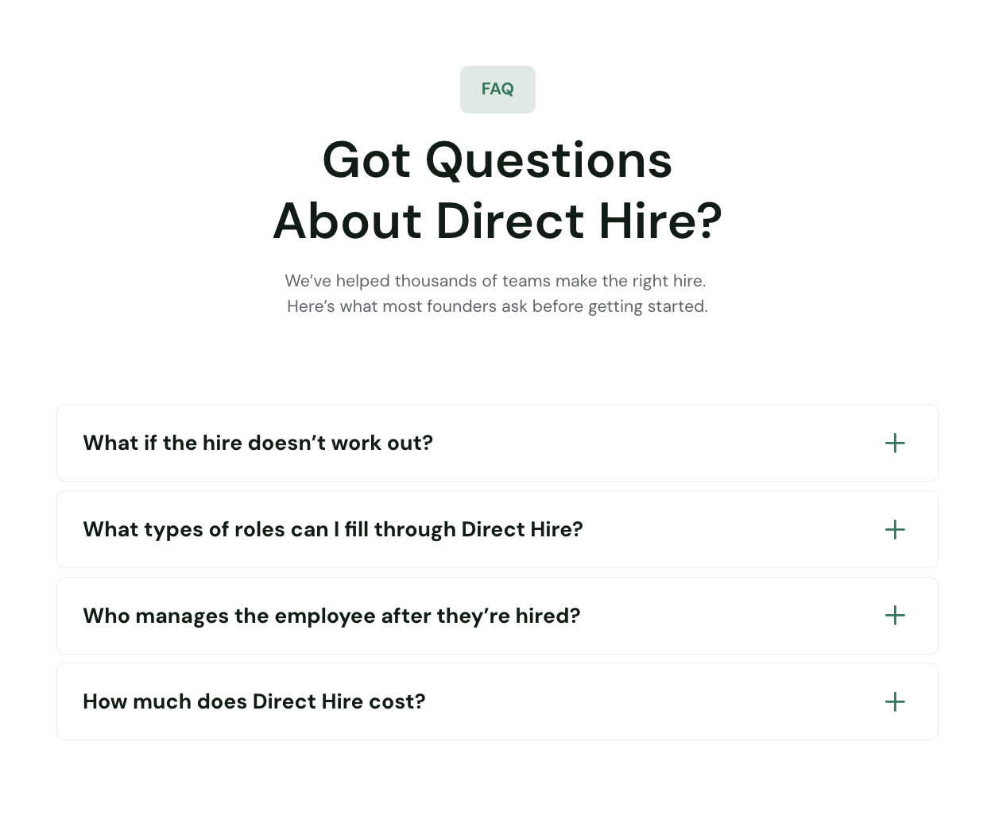
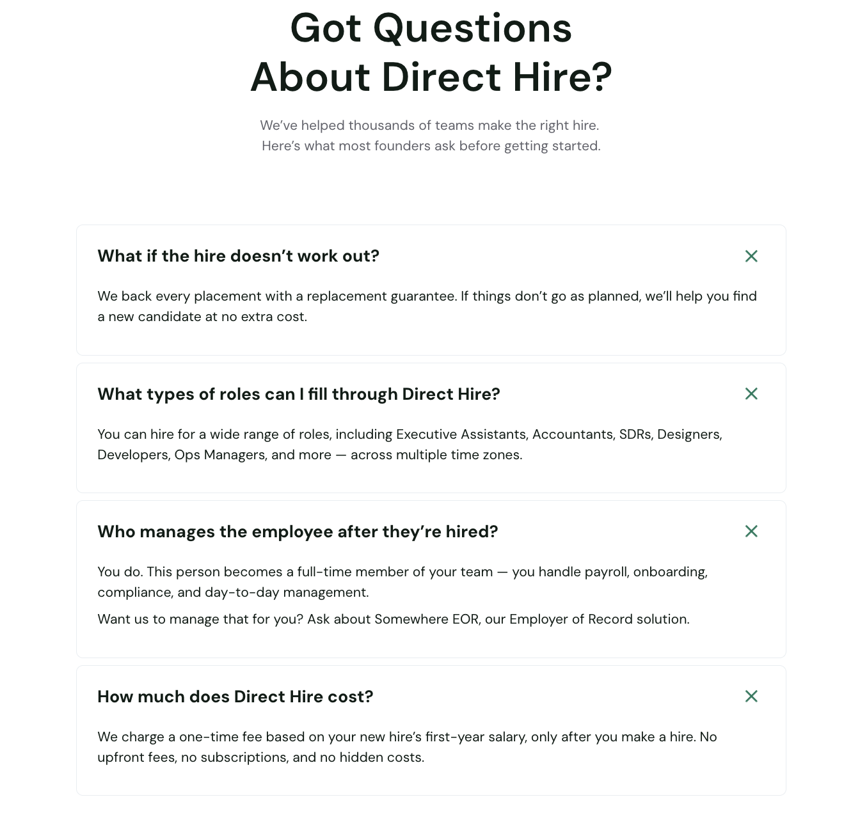
Questions About Direct Hiring With AXIS?
Here are the most common questions companies ask before building an embedded offshore team with AXIS.

FAQ 1

What if the hire does not work out?
Every hiring engagement is designed to reduce risk through structured vetting, expectation alignment, and onboarding support.
If a hire is not the right fit within the agreed replacement period, AXIS will help source another qualified candidate at no extra cost.

FAQ 2

What types of roles can AXIS help us hire?
AXIS helps businesses hire offshore professionals across operations, executive support, customer service, sales support, marketing, finance, recruiting, administration, project coordination, and other business support roles.
If you are not sure which role to hire first, we can help identify where offshore talent will create the most immediate operational leverage.

FAQ 3

Who manages the employee after they are hired?
That depends on your hiring model.
With Embedded Direct Hire, the team member works directly inside your business, and your team manages day-to-day responsibilities, tools, performance, and communication, or through Managed Direct Hire Plus, pricing may include a monthly manager cost.

FAQ 4

How does AXIS pricing work?
AXIS offers simple, success-aligned pricing based on the hiring model you choose.
For direct hire placements, the fee is typically tied to a successful hire. For managed offshore support, pricing may include monthly talent cost plus AXIS support and infrastructure.
We will walk you through the right structure before any search begins, so there are no surprises.

Additional FAQ Options

How quickly can we hire offshore talent?
Timelines vary by role complexity, required skill set, compensation range, and interview speed. Many roles can move from search kickoff to final interviews within a few weeks when expectations are clear, and feedback is timely.

Can AXIS help us decide which role to hire first?
Yes. Many clients come to AXIS knowing their team is stretched, but not knowing which role should come first.
We help map your workload, identify bottlenecks, and recommend offshore roles that can create the fastest capacity relief.

Will the offshore hire work in our time zone?
AXIS can source candidates based on the schedule overlap your business needs. Some roles require full business-hour alignment, while others can succeed with partial overlap and clear deliverables.

How does AXIS vet candidates?
We evaluate candidates based on role experience, communication ability, reliability, work style, salary alignment, and fit with your operating environment.
The goal is not just to find someone qualified—it is to find someone who can succeed inside your team.

