Barangay System: User Training Manual

# Table of Contents

* 1. Introduction
* 2. System Overview
* 3. User Roles and Responsibilities
* 4. Module Walkthroughs

- For Barangay Officials

- For Admin

- For Residents (Users)

* 5. System Navigation
* 6. FAQs
* 7. Support and Contact Information

# 1. Introduction

Welcome to the Barangay Management System. This manual serves as your guide to navigating and using the system effectively based on your role. It outlines all functionalities, from managing residents to processing requests, tracking records, and ensuring transparent barangay operations.

# 2. System Overview

The Barangay Management System is a web-based platform developed to streamline the services of Barangay 400, Sampaloc, Manila. It provides separate modules tailored to barangay officials, admin personnel, and residents, ensuring secure and role-based access to essential features.

# 3. User Roles and Responsibilities

|  |  |
| --- | --- |
| **Role** | **Responsibility** |
| Barangay Officials | Manage resident and official data, approve/deny requests, post events, audit |
| Admin | Handle data backups, track audits, manage roles and reports |
| Residents (Users) | Submit and track requests, edit personal info, view events and officials |

# 4. Module Walkthroughs

## For Barangay Officials

* **Manage Resident Profiling**

View, edit, and register new residents. Approve or deny pending registrations. Flag incomplete or erroneous records.

1. Go to the left menu and press the Resident bar.

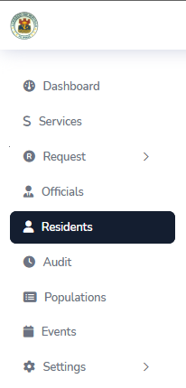

1. After pressing, it will bring you to the Resident page, where you will see the list of Residents.
   1. To add a resident, press the button at the top right.

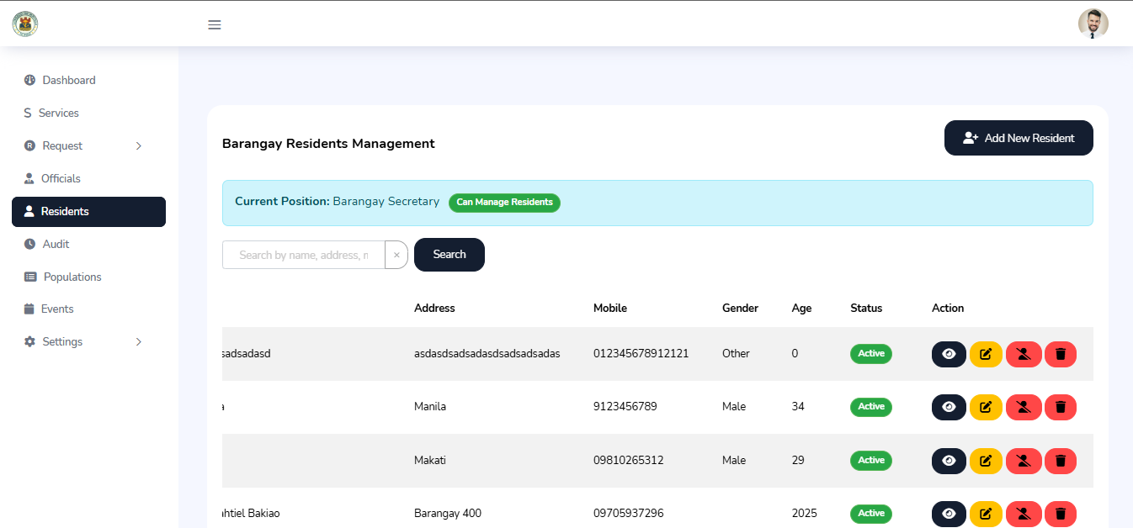

* 1. After pressing the button, it will show a form,

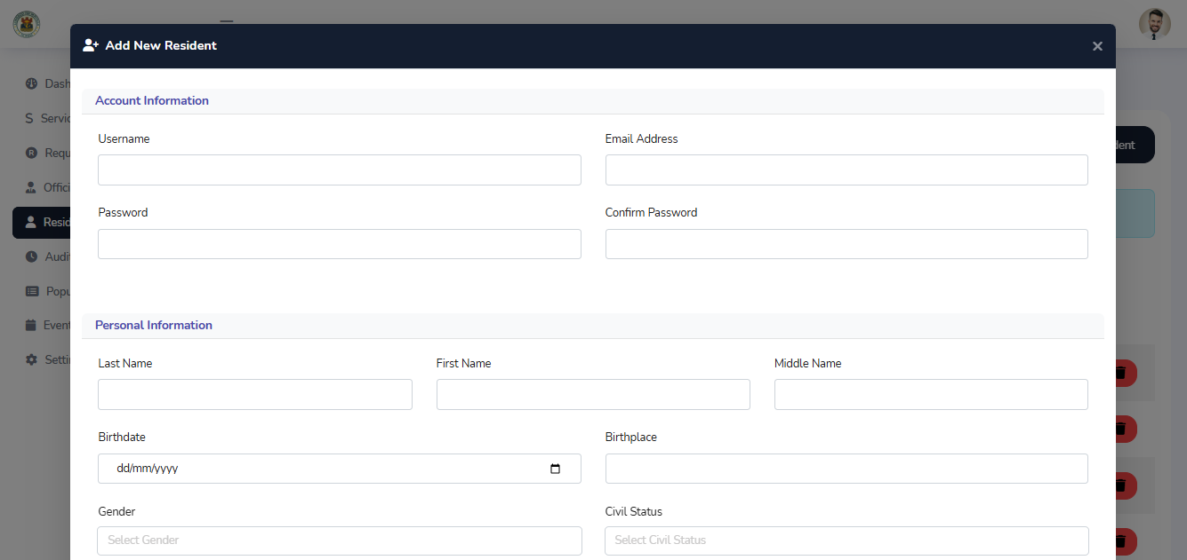

* 1. After putting your details, press the save resident button and it’s done.

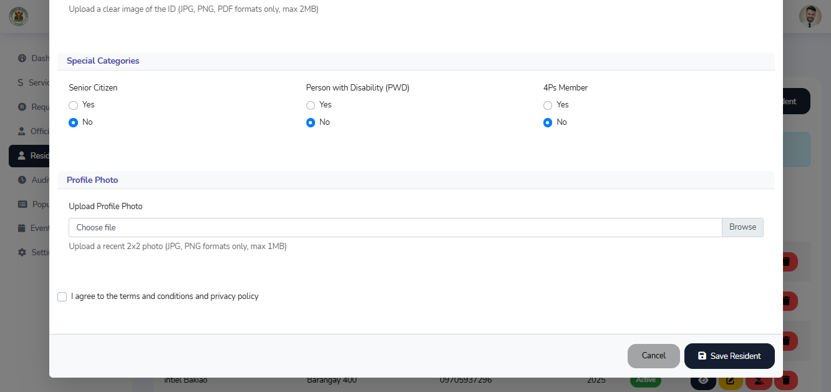

1. To view the Resident details, press the dark blue, with an eye logo in the button.



1. To edit the Resident details, press the yellow, with a pencil logo in the button.



1. To Delete a Resident details, press the red, with a trash can logo in the button.



1. To deactivate a Resident Account, press the red, with a person that is cross out logo in the button.



1. To activate a Resident Account, press the green, with a person that have a check mark as a logo in the button.



* **Certificate, Service, E-Blotter, Grievances Request Management**

Review documents and details, approve/deny with comments. System tracks statuses and notifies users.

1. Go to the left menu and press the requests bar and choose your specific service

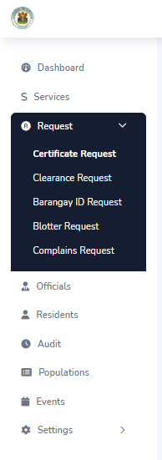

1. After choosing a service, it will redirect you to the requests page.

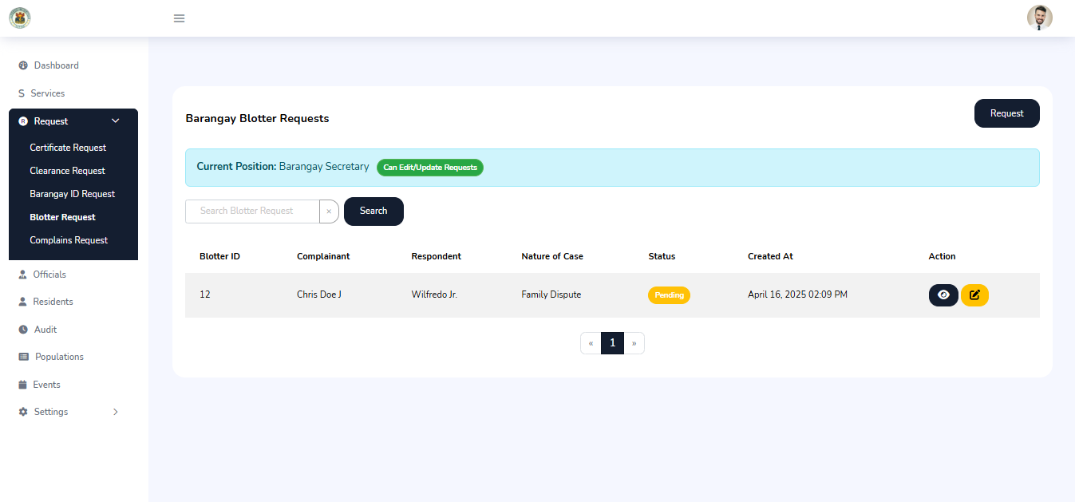

1. In creating a request, go to the top right and press the requests button.



1. After pressing the button, it will show you a form.

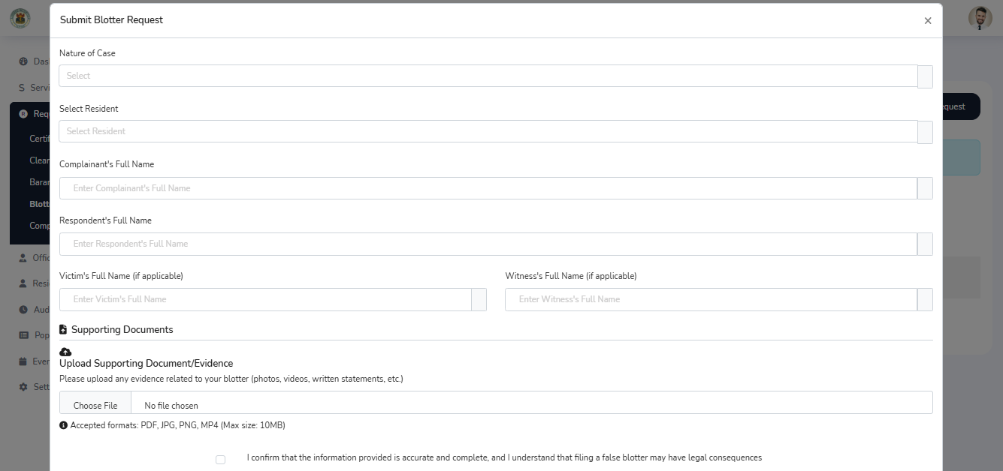

1. After placing your details, press the submit button at the bottom.

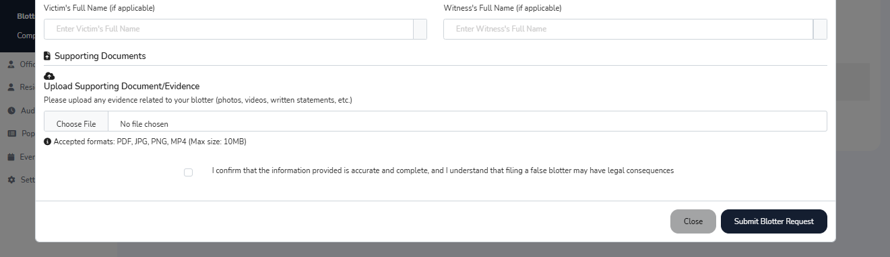

* 1. To view the details, press the dark blue, with an eye logo in the button.



* 1. To edit the details and update the status, press the yellow, with a pencil logo in the button.



* **Manage Officials Profile**

View and update current/past official profiles. Change roles and status. Re-register officials.

1. Go to the Left menu and press the Official bar.

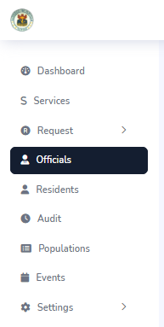

1. After pressing, it will bring you to the official page.

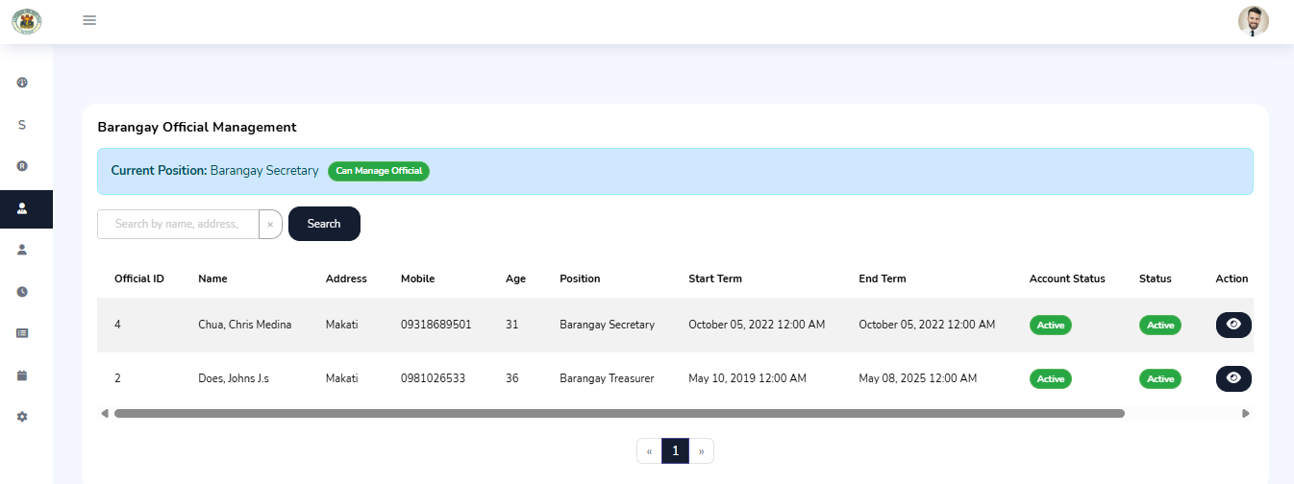

1. There you will see the list of the current officials.
   1. To view the Officials details, press the dark blue, with an eye logo in the button.

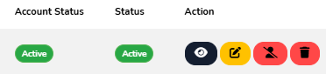

* 1. To edit the Officials details, press the yellow, with a pencil logo in the button.



* 1. To Delete an Officials details, press the red, with a trash can logo in the button.



* 1. To deactivate an Officials Account, press the red, with a person that is cross out logo in the button.



* 1. To activate an Officials Account, press the green, with a person that have a check mark as a logo in the button.

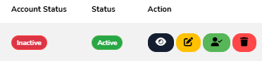

* **Track Population**

Generate reports by gender, senior citizen, PWD, and 4Ps beneficiaries.

1. Go to the left menu and press the population bar.

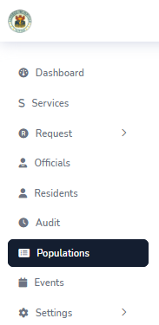

1. After pressing, it will bring you to the population page. There you will see demographics and total population.

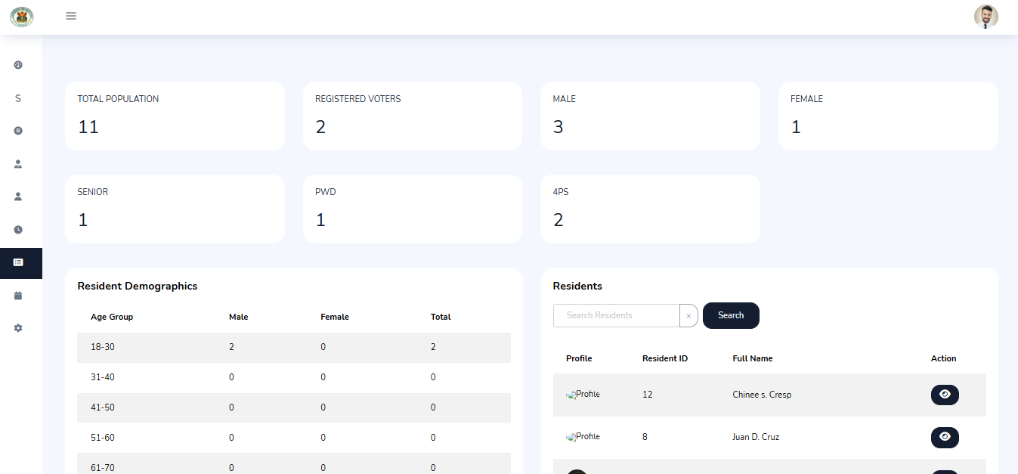

* **Post Barangay Events**

Create announcements, upload images, enable/disable comments, moderate discussions, and block users.

1. Go to the Left Menu and press the Event bar.

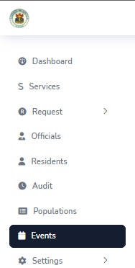

1. After pressing, it will bring you to the Event page. There you will see all the events that you created and posted.

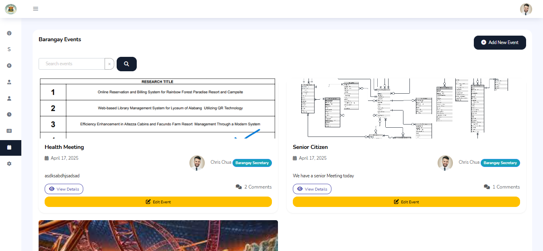

1. To create and post an event go to the top right and press the add new event button.



1. After pressing, it will show you a form.
2. After placing the details of the event, press the create event at the bottom of the form.

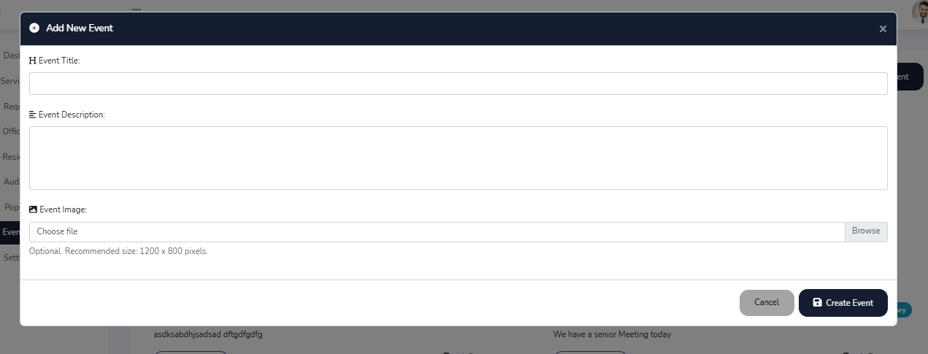

* 1. To edit an event, press the yellow button at the bottom of each event card.

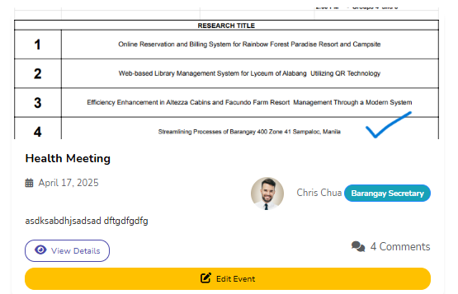

* 1. After pressing the button, it will show you a form to edit it, press the save changes button to update the event.

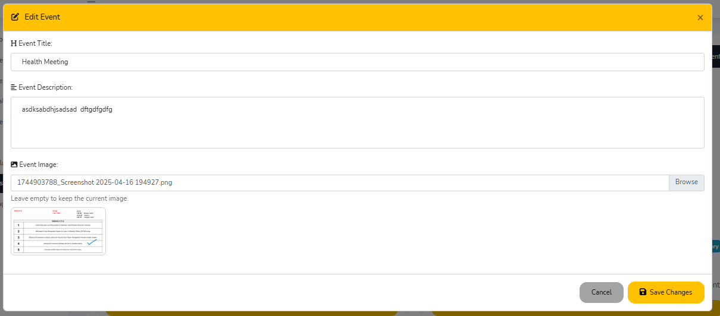

* 1. To comment in the posted event, press the view details button.



* 1. After pressing, it will show you the full details of the events, and the comments.

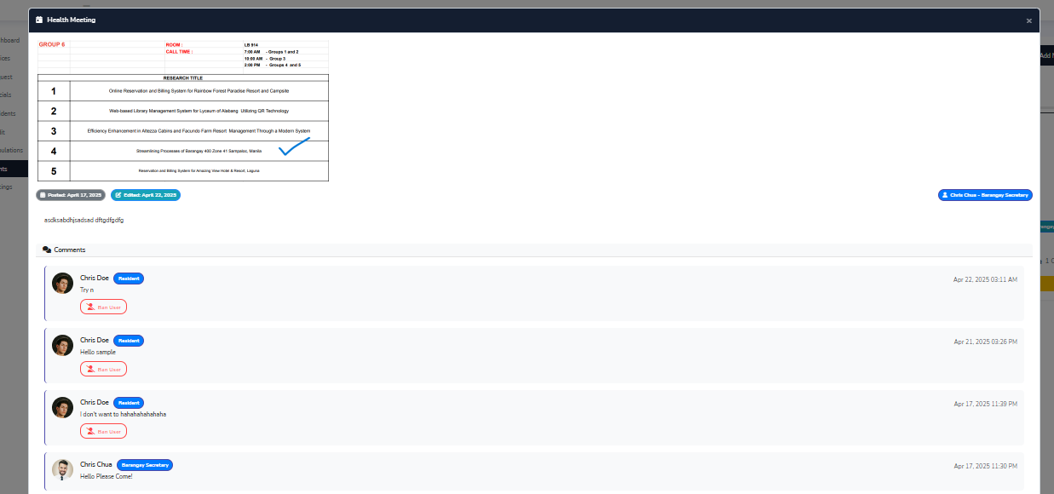

1. To comment, go to the bottom of the form, and place your comment.

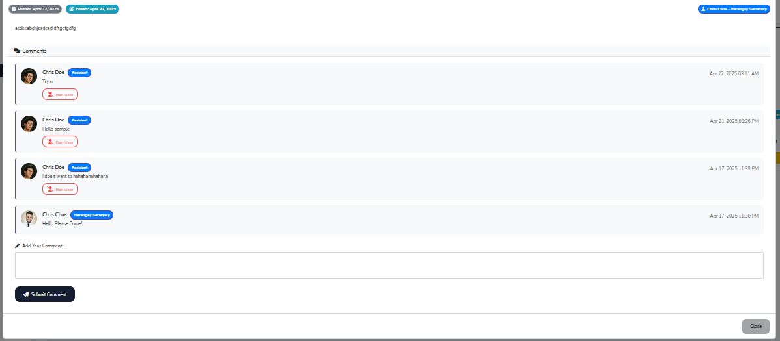

1. To ban a user, press the ban user with a logo of a person that is cross out.



* **Audit Actions**

Monitor activity logs, request handlers, and completion timestamps.

1. Go to the left menu and press the Audit bar.

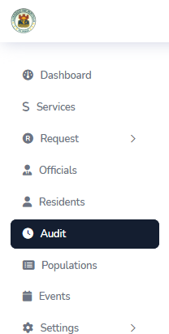

1. After pressing it, it will bring you to the Audit page, there you will track all the activity inside of the system. To view the Audit details, press the dark blue, with an eye logo in the button.

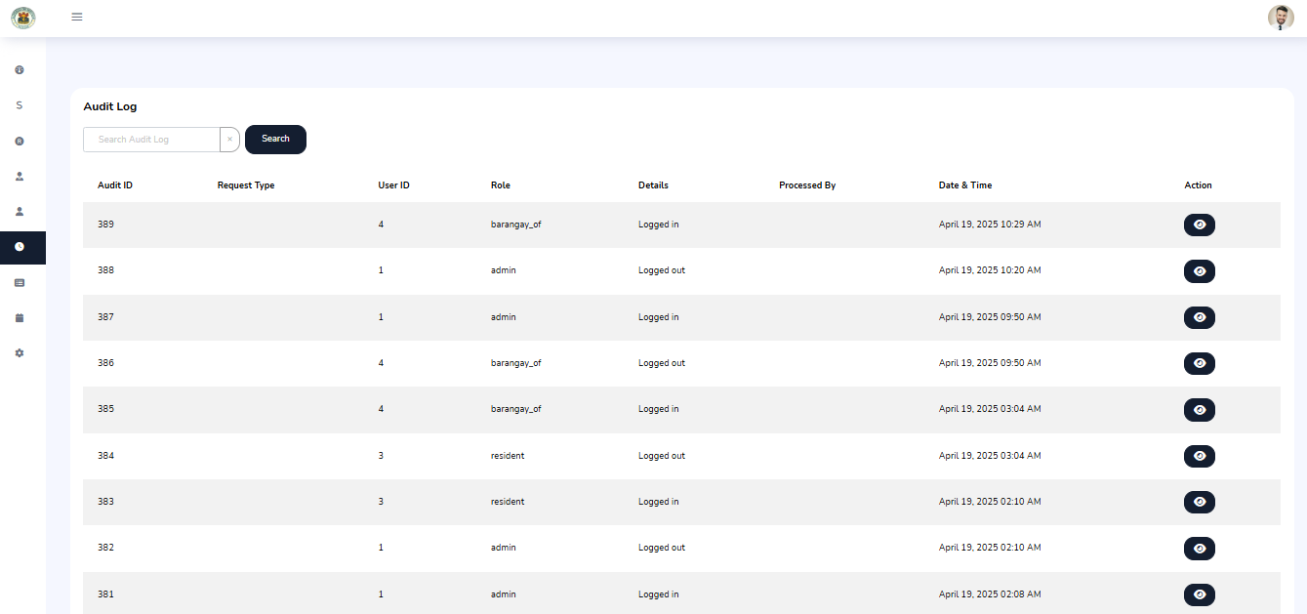

## For Residents (Users)

* **Edit Profile Information**

Update address, contact details, civil status. Change passwords.

1. Go to the left menu, and press settings:

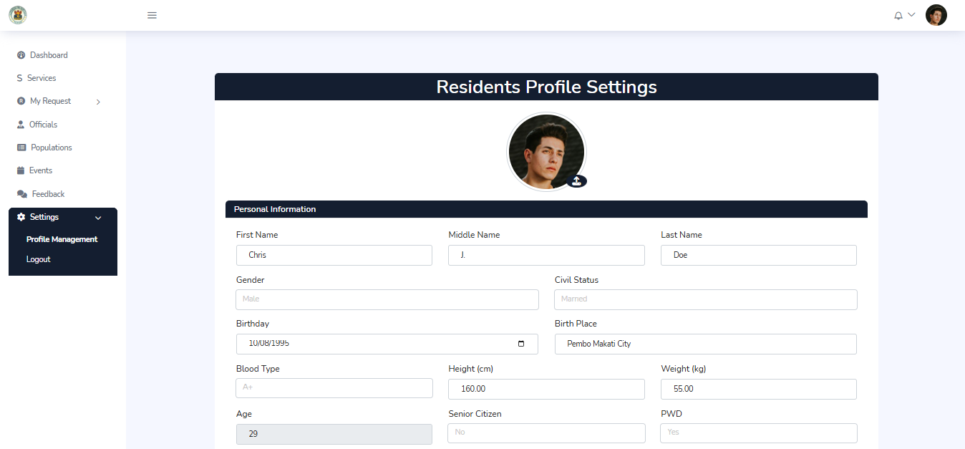

1. In pressing settings, you will see the profile management, in there you can edit your Personal Information.



1. After finishing editing your personal information, just scroll down and press the save changes button to update your profile

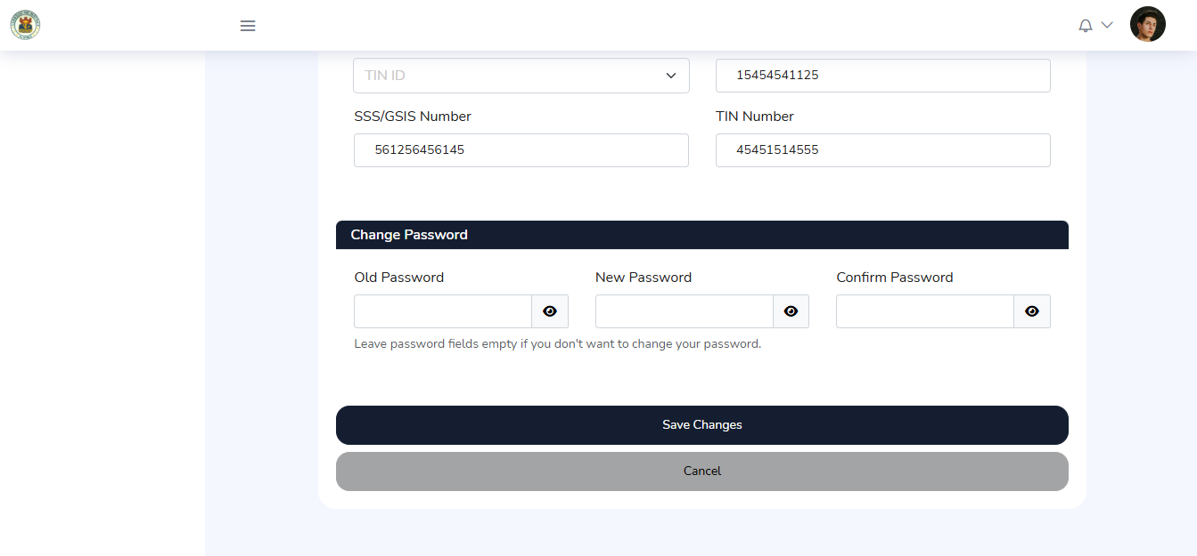

* **Request Submission and Tracking**

Submit requests with documents, track status, and get notifications.

1. To Submit a request, go to the left menu.

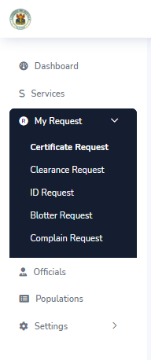

1. In the menu, you will see several bunches of services pick one and click it and it will redirect you the requests page.

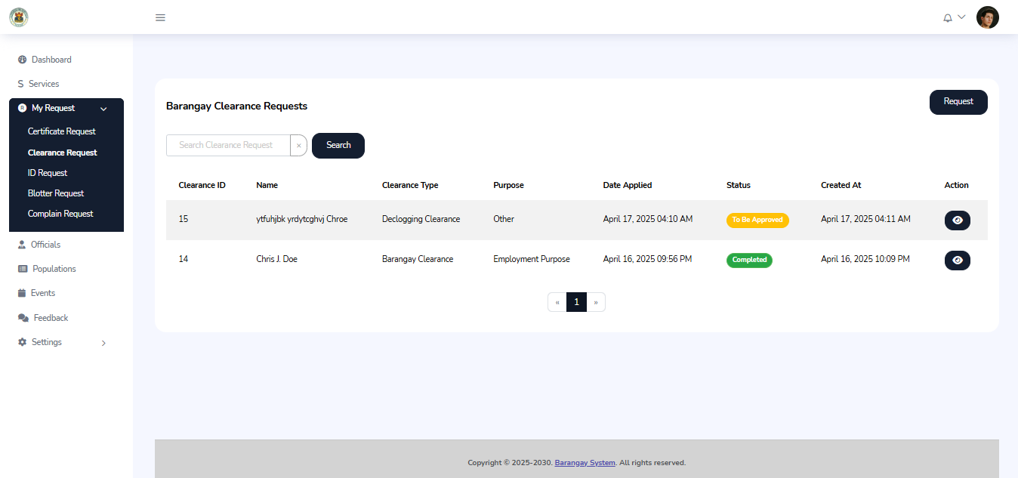

1. After choosing a service, at the top right you will see a button named requests.



1. Press it and it will appear a form.

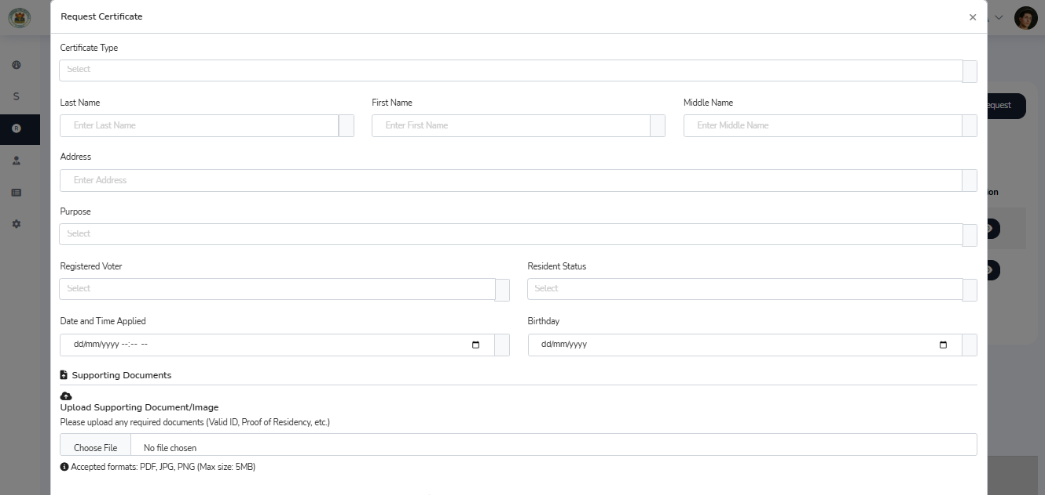

1. After putting your details in the form, pressed submit and you’re done.

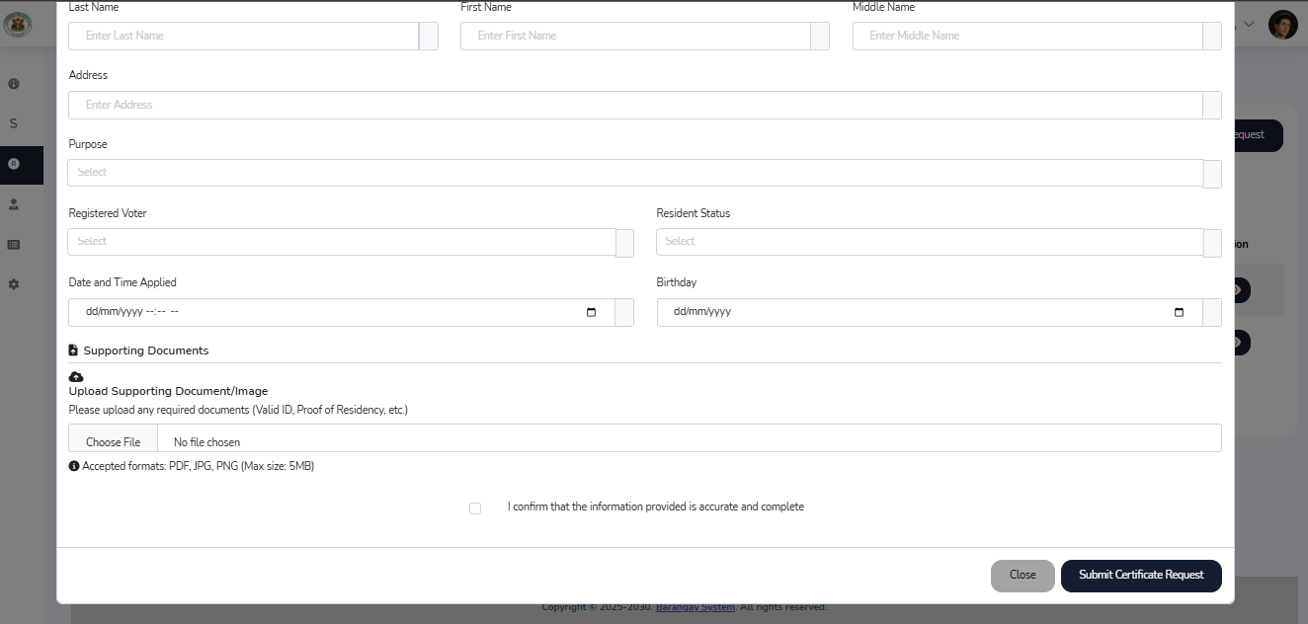

1. After pressing the submit requests button, in the requests you will see if your requests are approved, on-going, or denied.

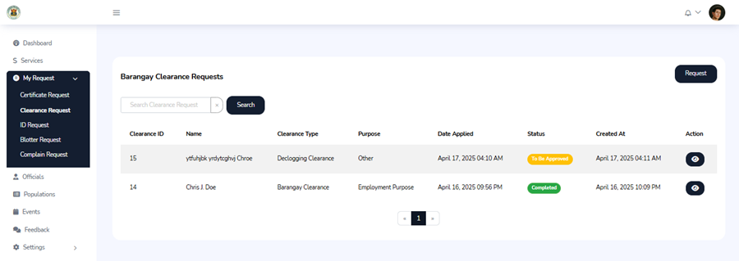

* **View Officials**

See current barangay officials.

1. Go to the Left Menu

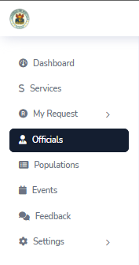

1. Press Official and it will bring you to the official page.

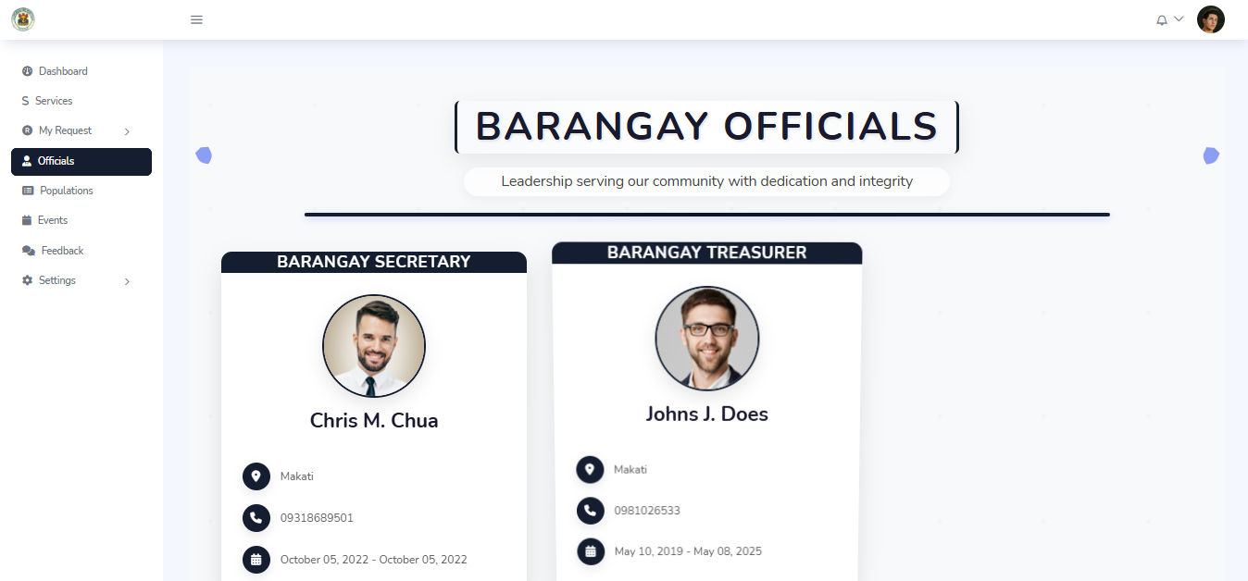

* **View Events**

Browse events and participate via comments.

1. go to the left menu and press events

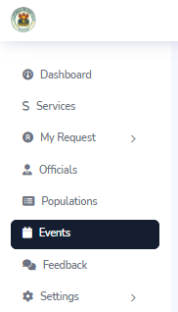

1. after pressing the event, it will bring you to events page and to view the event, and participate in the comments, press the view detail button.

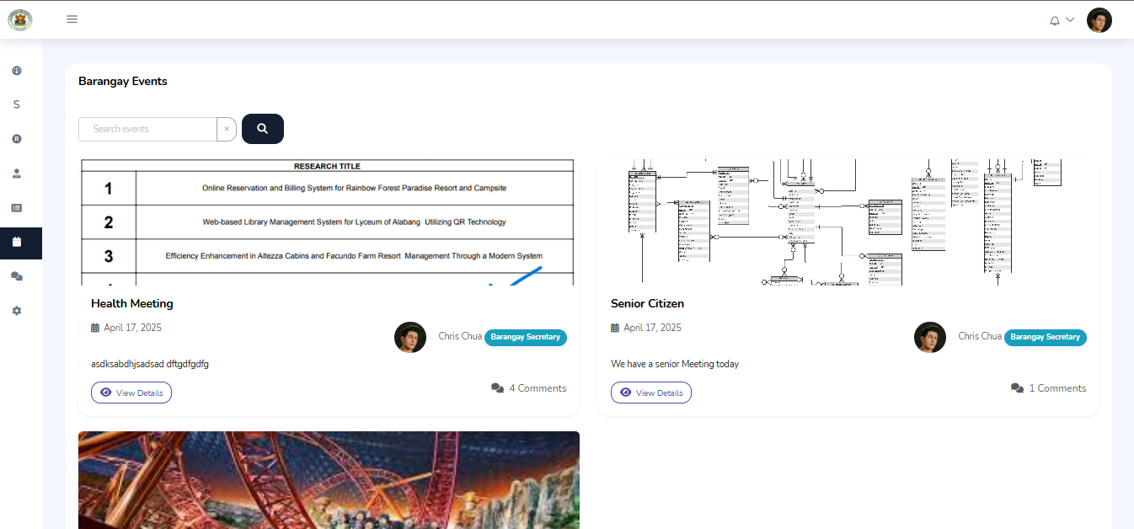

1. after pressing the view detail button, the specific event will show and you will be able to comment.

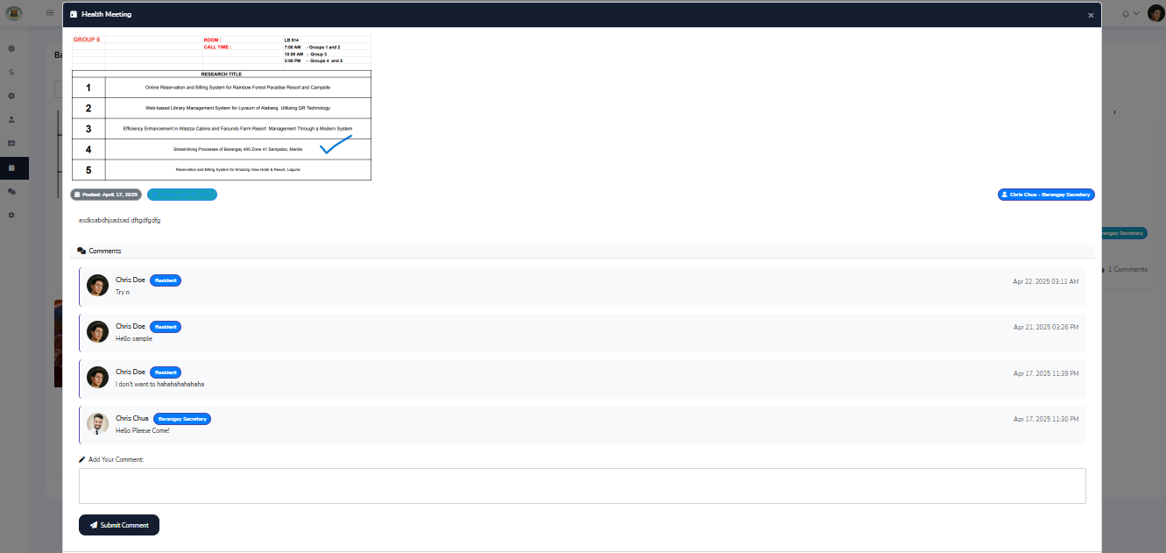

## 5. For Admin

* **Manage Resident Profiling and Backup**

Edit or import resident data. Export to Excel. Perform backups.

* **Officials Management**

Update roles, maintain official records, backup data.

* **Audit Reports**

Access and export full audit logs.

* **Feedback Reports**

View and track user feedback.

# System Navigation

Dashboard: Main page after login.  
Left Menu: Navigate modules (Residents, Requests, Events, etc.).  
Notification Bell: Alerts for updates.  
Profile Icon: Edit info or logout.

# 6. FAQs

* Q: How do I reset my password?

A: Go to profile settings > change password.

* Q: Who can see audit logs?

A: Only Admins have access to audit logs.

* Q: Can I re-submit a denied request?

A: Yes, correct the issue and re-submit.

# 7. Support and Contact Information

For technical support, contact the Barangay IT team:  
📧 barangay400support@example.com  
📞 (02) 123-4567  
🏢 Barangay Hall, Zone 41, Sampaloc, Manila