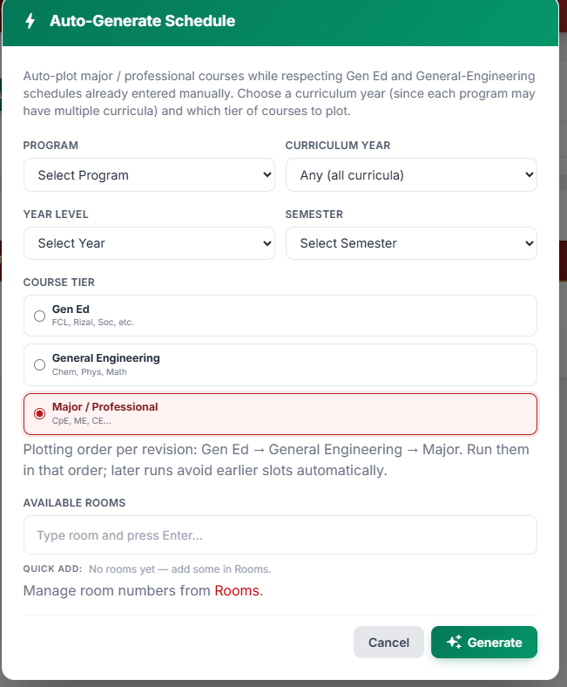
yung ating courses dapat may merging pero hindi mag coconflict ng schedule
sample ganito

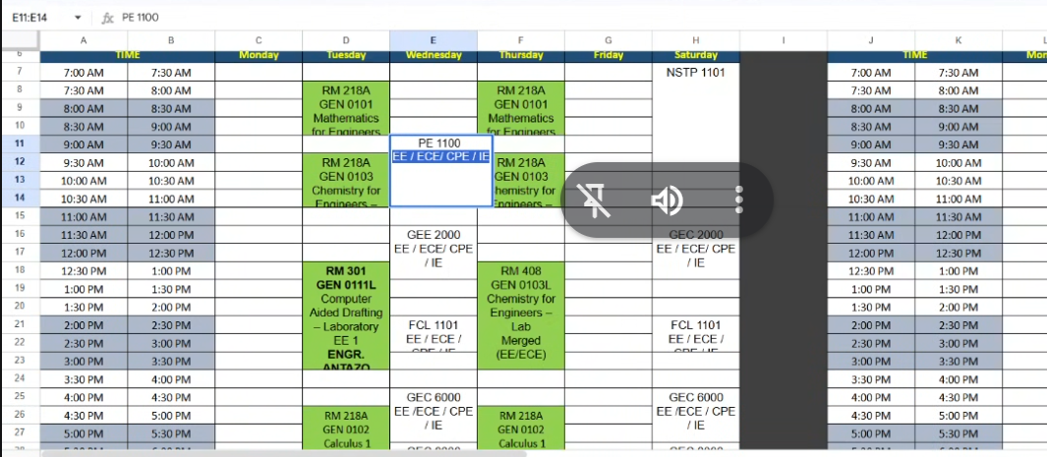

Ang idea lang kapag na plotan siya ng schedule
pwede siya bigyan ng break ng 30 minutes or 1.5 hr 4.5hr bawal na yung 5hr

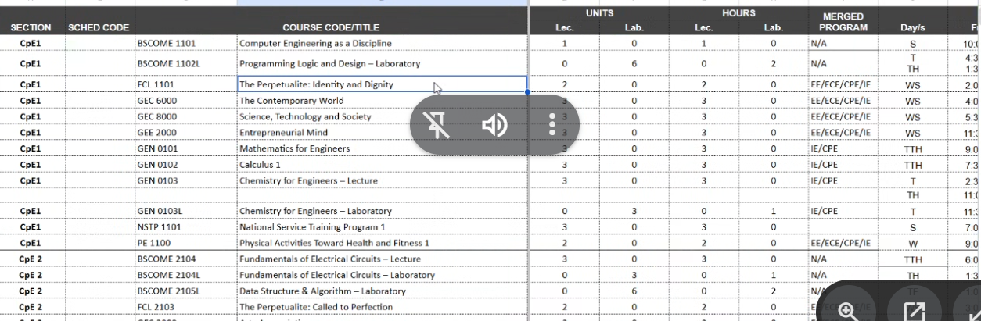
May pairing

- Dapat kapag hindi nag match yung availability ng schedule na sinet ni dean/program chair at faculty mandatory susundin yung kay dean/programchair kapag Gen ED
Conditions
-
- Summary Report kita yung schedule ng every year Same faculty plotting
Schedule plotting
Faculty plotting
Room overall

