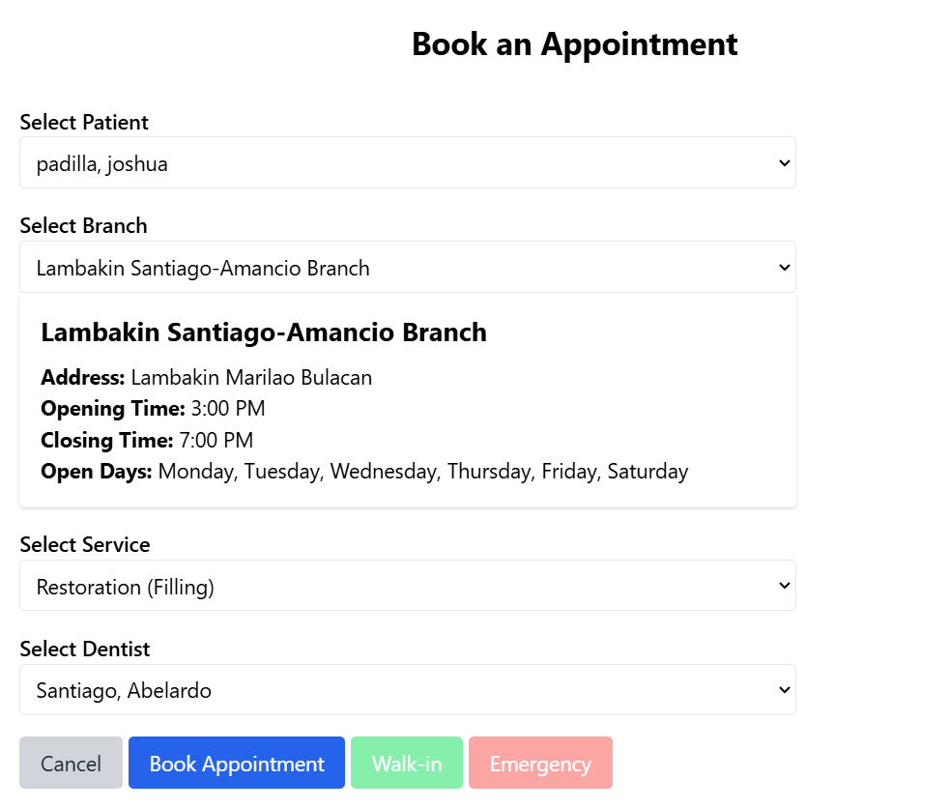
Make The Walk-in and Emergency color not faded just like the Book Appointment.
Kapag pinindot at ayaw dahil sa policy, maglagay ng label or note kung bakit?

Nagbook ako ng walkin sa hindi ko hawak na branch as receptionist, hindi lang nagproprocess at walang nagyayari. Dapat may note na bawal magbook sa ibang branch ng walkin at emergency.

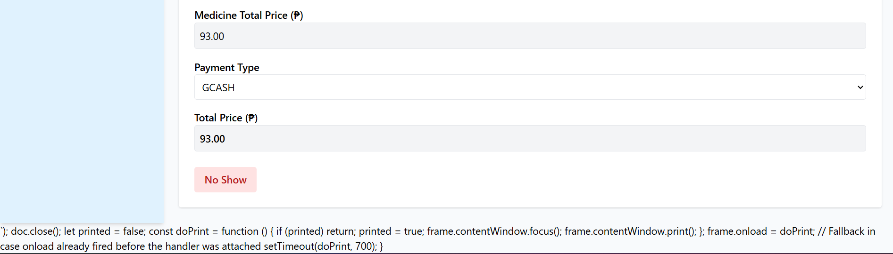
Nino-show ko tapos may error sa baba.

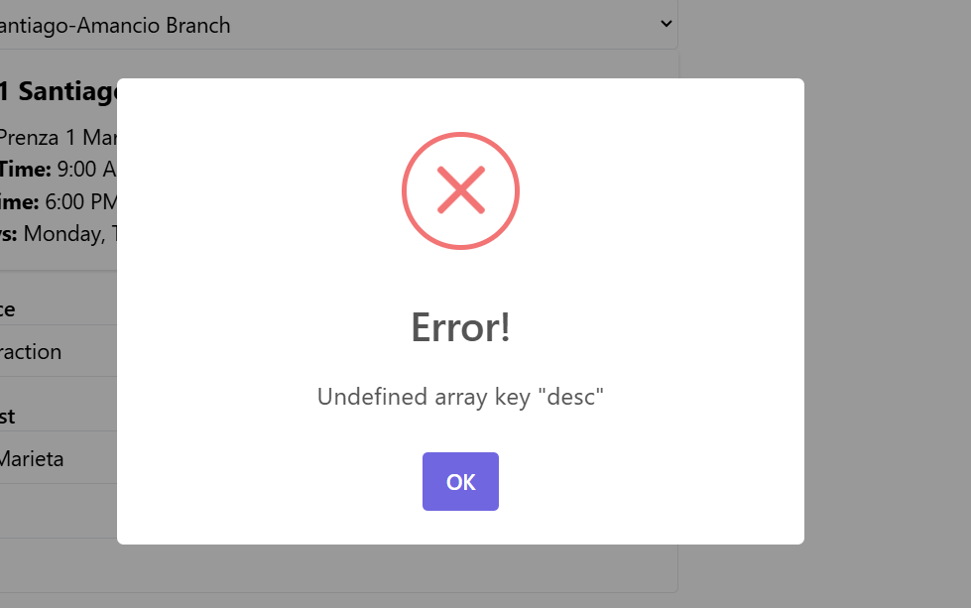
Booking from Reception accounts (Book Appointment)

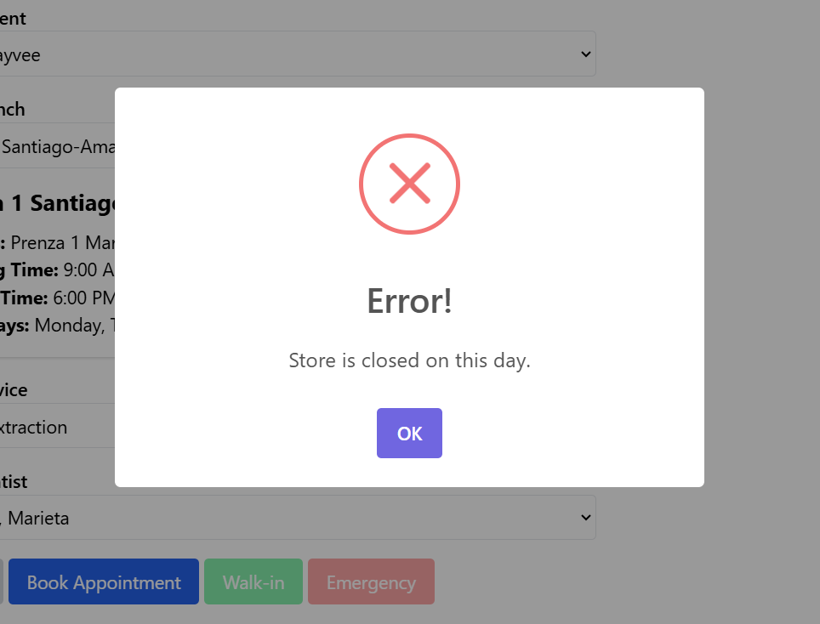
Booking from Receptionist (Walk-in and Emergency)
Chineck na namin, bukas yung clinic at available yung doctor pero nakaclosed.

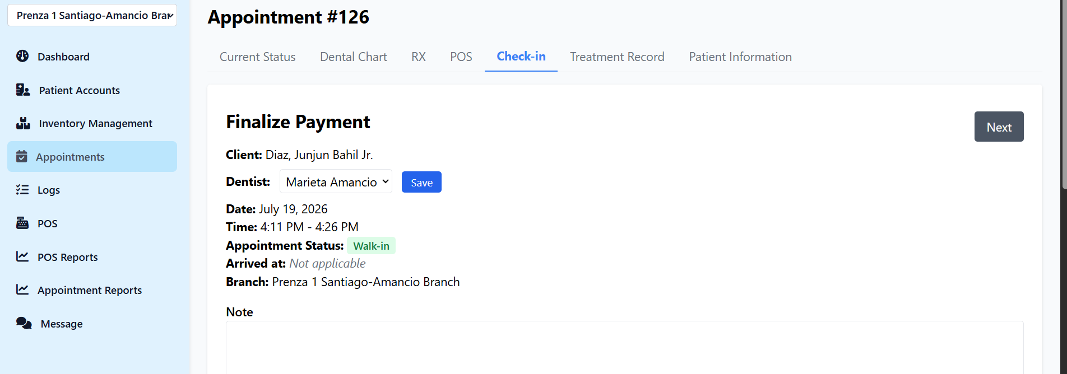

May error sa baba. Nagbukas ako ng appointment.
Paayos ng code para walang code sa baba.

