Revision: 09/11/26
Alpha Testing 2nd time

Security revision:

Character limits: 50 characters on every input in the database..
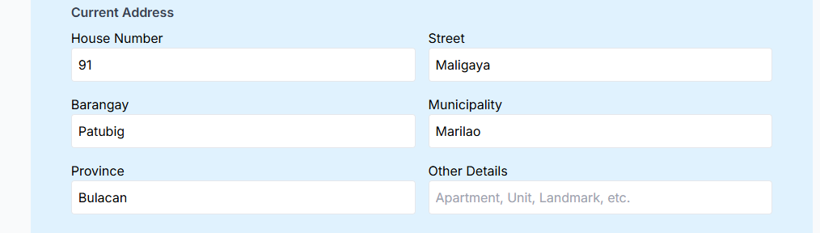

DROPDOWN OPTIONS: Add dropdown menus for applicable fields during registration to reduce typing errors. Address and religion and medicine on RX.

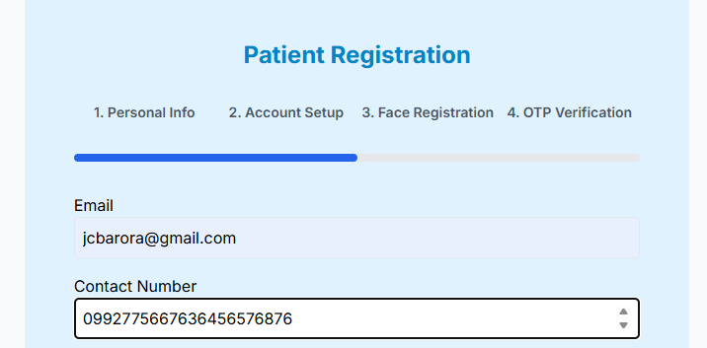

Contact number: 11 digits only. Add placeholder says must start with 09*********.
OTP VERIFICATION: Don’t allow users to skip entering digits in the OTP field.
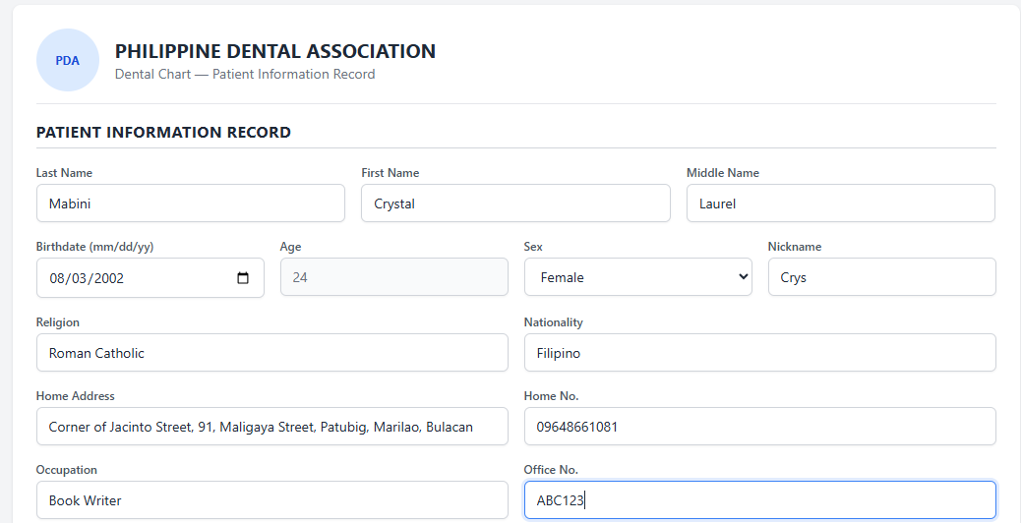
Office No. field: Restrict this input to numbers only.

UI Revision:

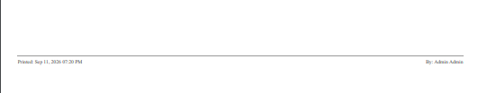
Printing UI: Printing footing label time and user, all printed result.

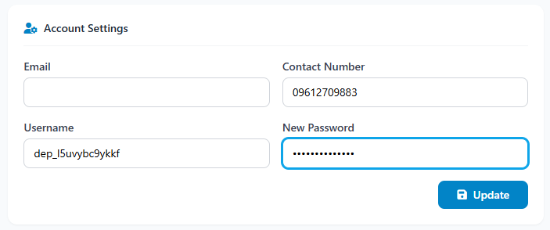
Profile settings: Add an eye icon in the Profile/Account Settings so users can toggle password visibility.

