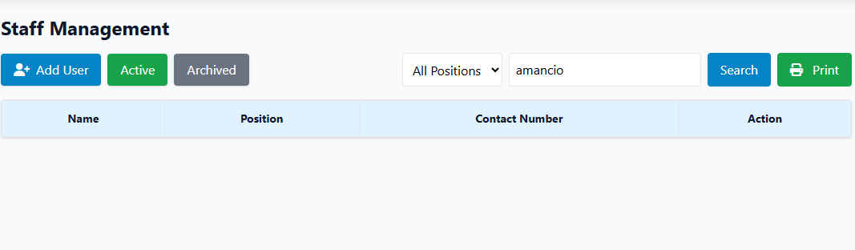
Paayos ng filter, dapat pwede isearch, yung last name, and middle name

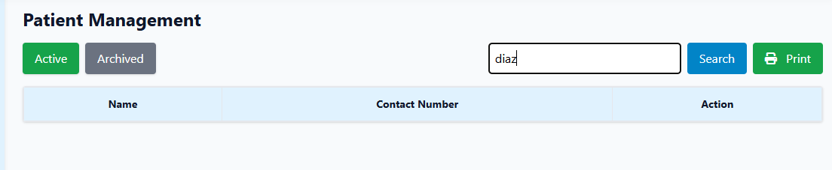
Paayos ng filter, dapat pwede isearch, yung last name, and middle name

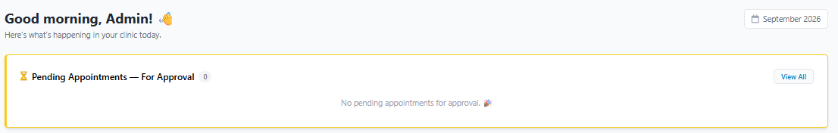

Admin account .dashboard. error sa view all button.
Attempt to read property "id" on null

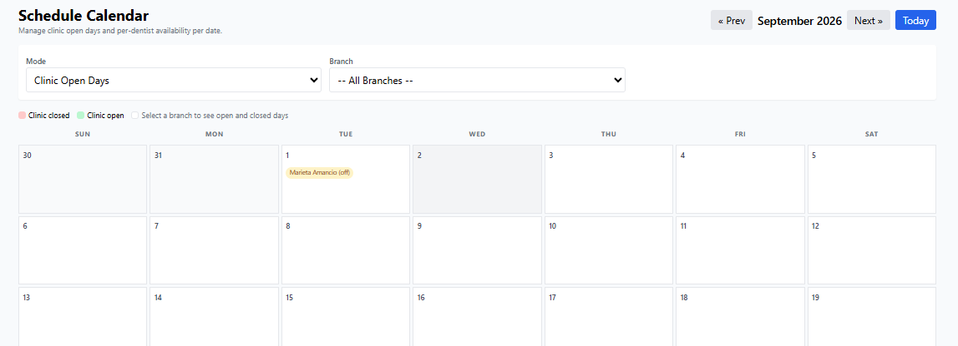
Hindi na dapat mapipindot yung passed date.

