System Revision

Receptionist/ dentist dashboard
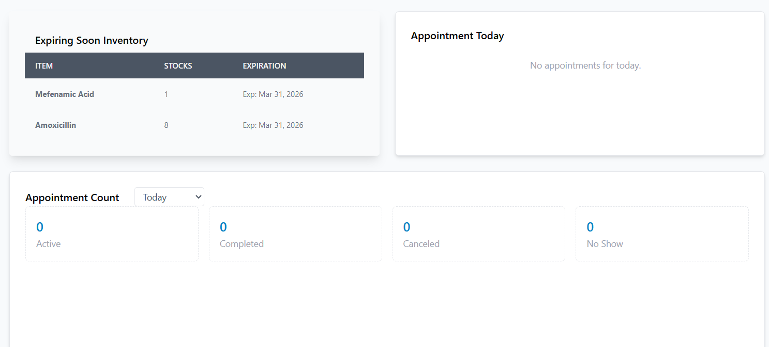
Must be functional/clickable and see it from its history or list.
For example: I click the completed appointment. The system will redirect me to treatment record filtered only by completed appointment.

Receptionist/Dentist > appointment booking
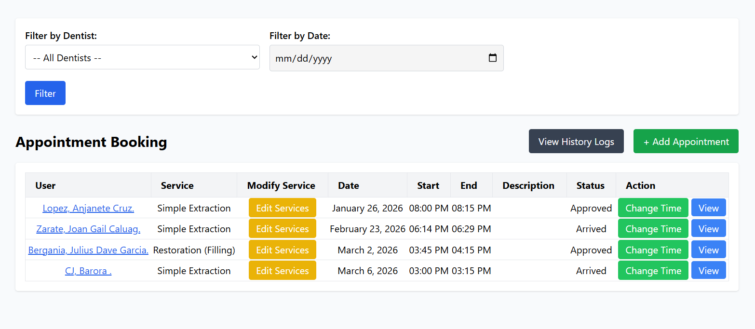
Add status filter
The view button redirects to dental chart first for dentist. (Dental chart, prescription….)
For receptionist, redirected to check in. Dental charts and rx are not editable.

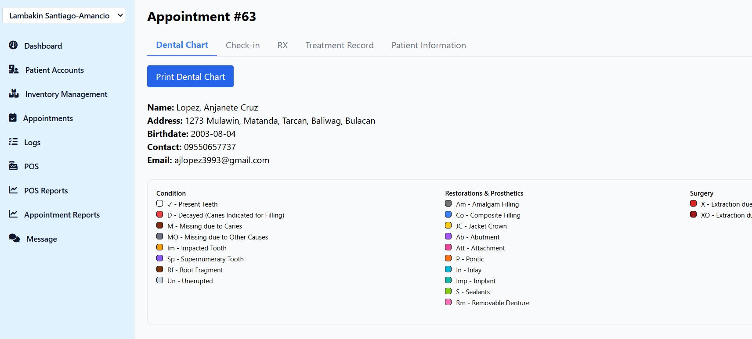
Add POS in between RX and treatment record.
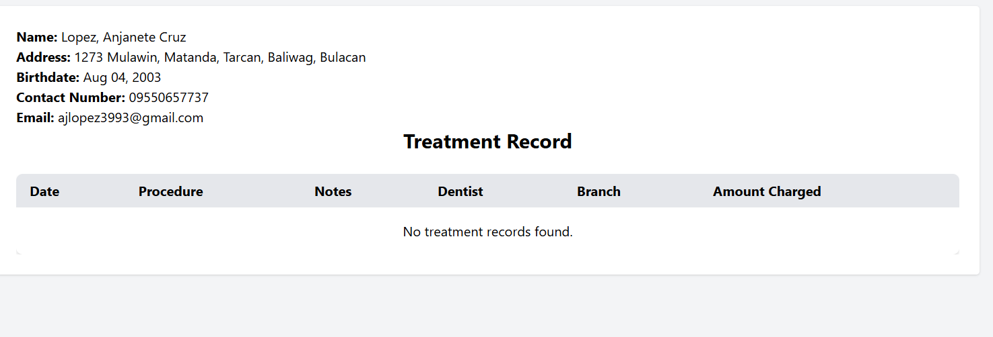
The amount of medicine is included on treatment record.
Only one receipt for treatment and medicine bought.

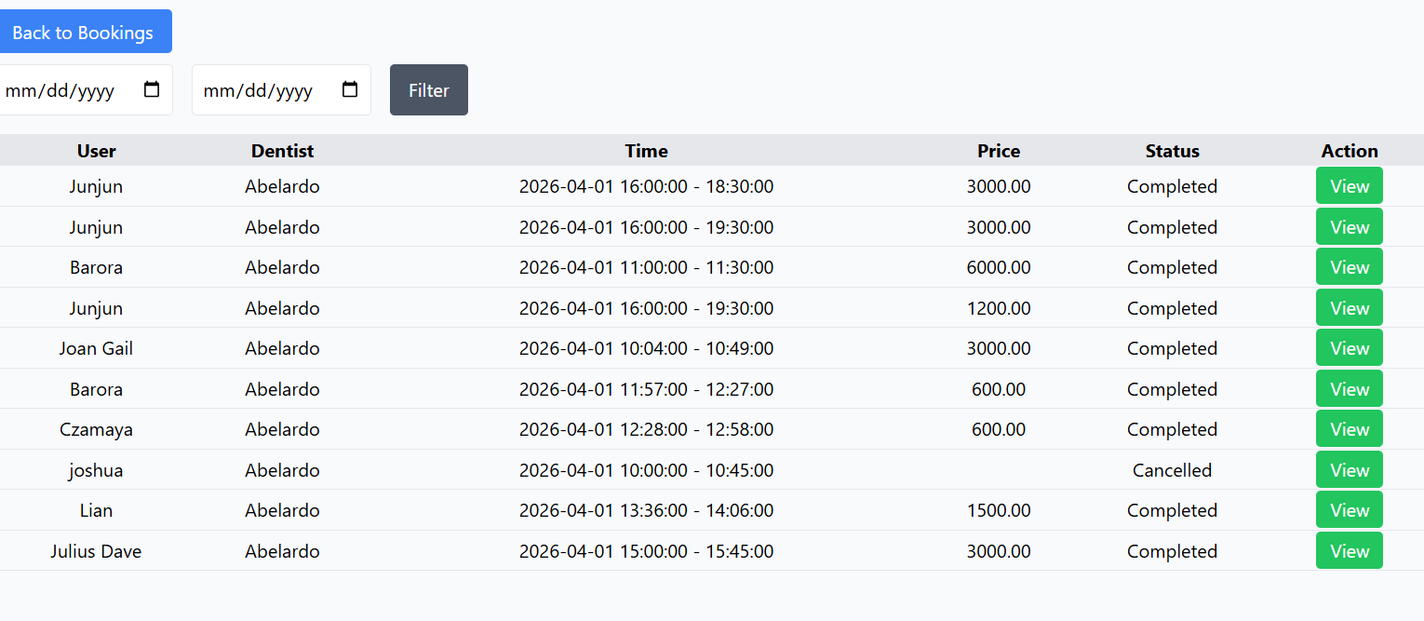
Add filter. Dentist, status

Receptionist / Dentist > POS
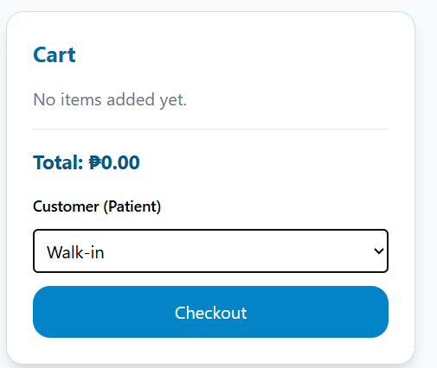

Searchable (type) with suggested

POS Receipt
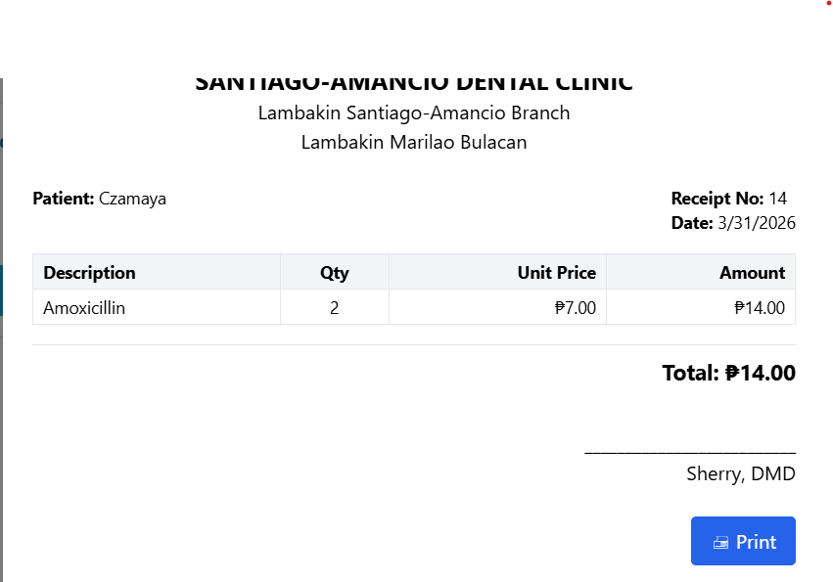
Add amount gave and change.

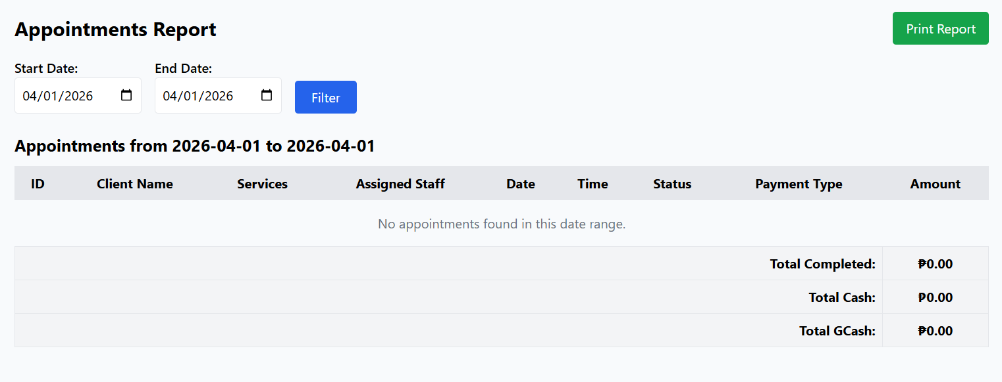
Can filter by dentist, services, status, payment method

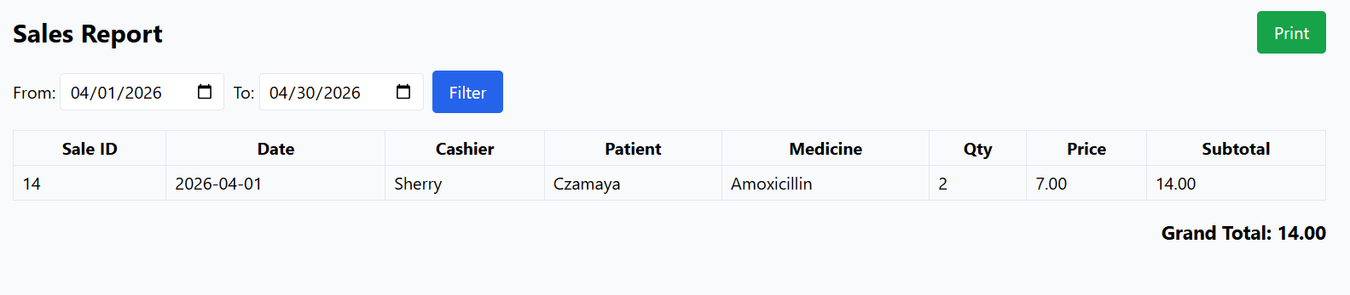
Can filter by cashier, patient, medicine

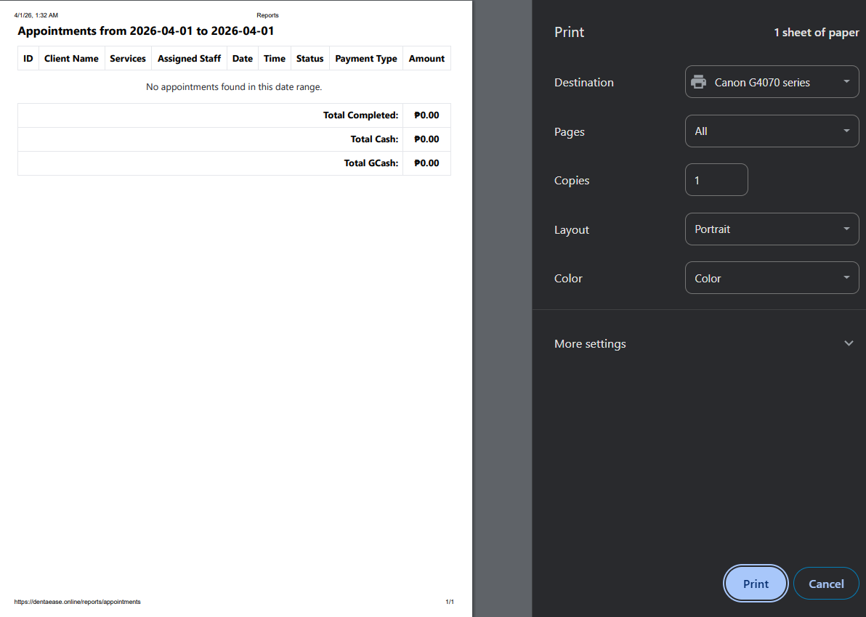
All print out reports must have personalize layout


Parang ganito, gagawan mo lang siya ng header para kapag naiprint mejo formal
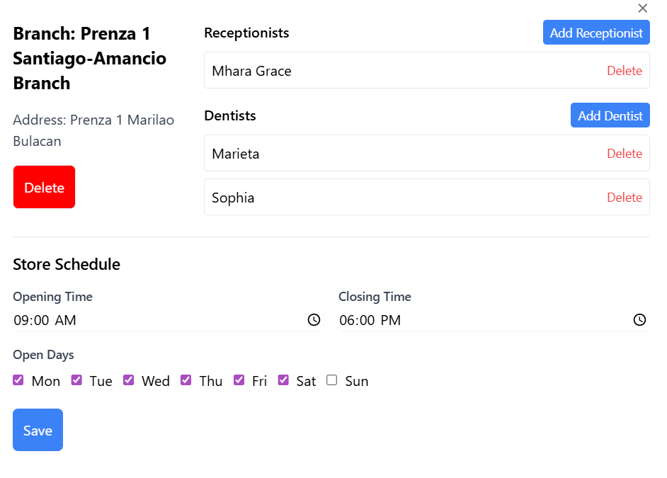
Doctors must have a calendar-based schedule.
Also, Open Days are calendar based

System must have SMS Notification

Patients can create parental control accounts for account safety. 1 parent account can have multiple child account

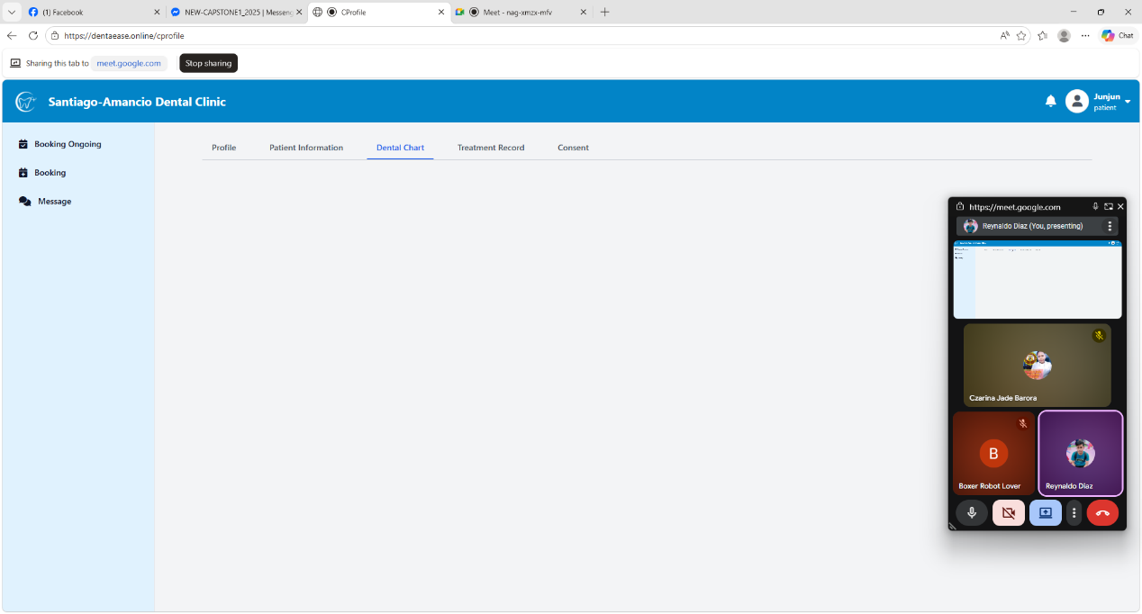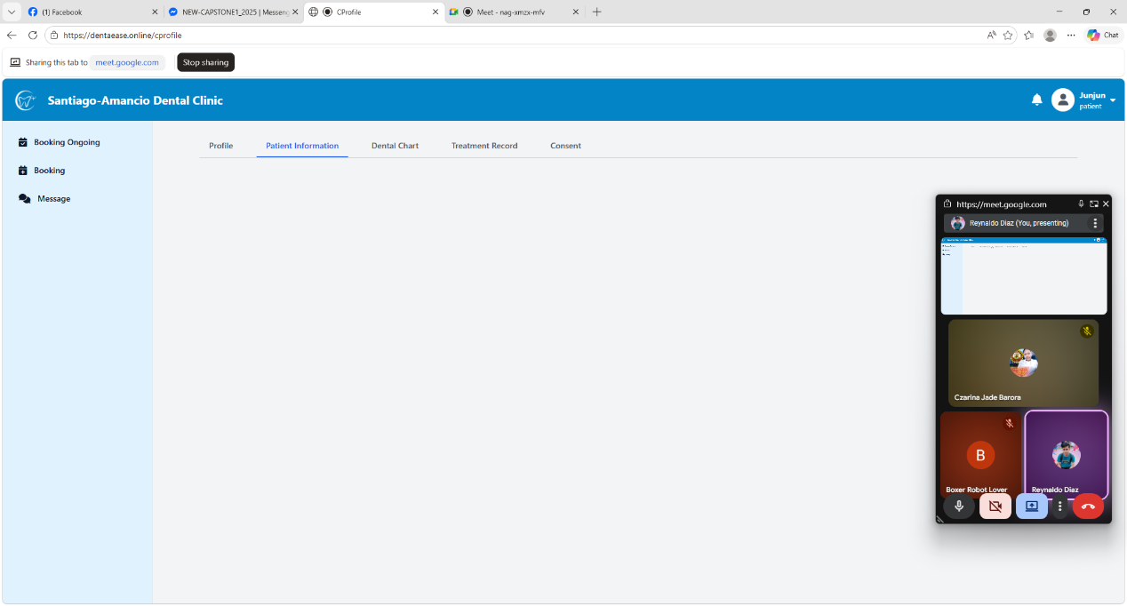

Patient information, dental chart, treatment label (no show of data)
Make patient information appear on the first login consent revision
Kapag newly created account ng patient, walang laman ang Patient Info at hindi ang kanyang Dental Chart
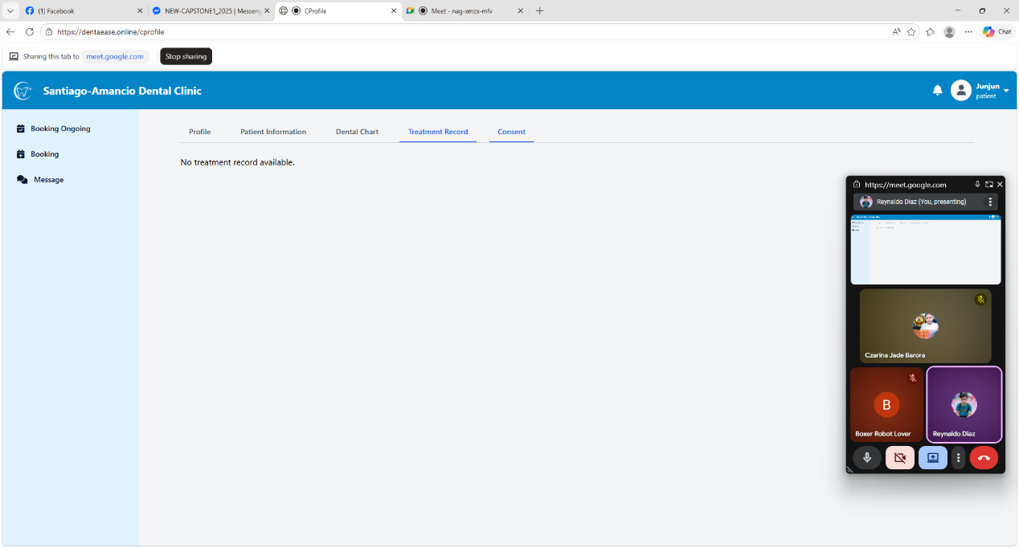

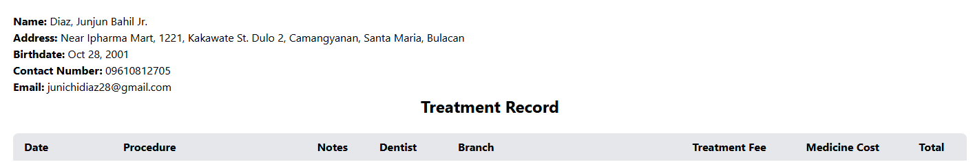

Wala rin laman ang treatment rec.
Suggest lang namin kahit ganito nalang muna ang lumabas, katulad sa dentist account kapag na-view niya treatment record ng patient

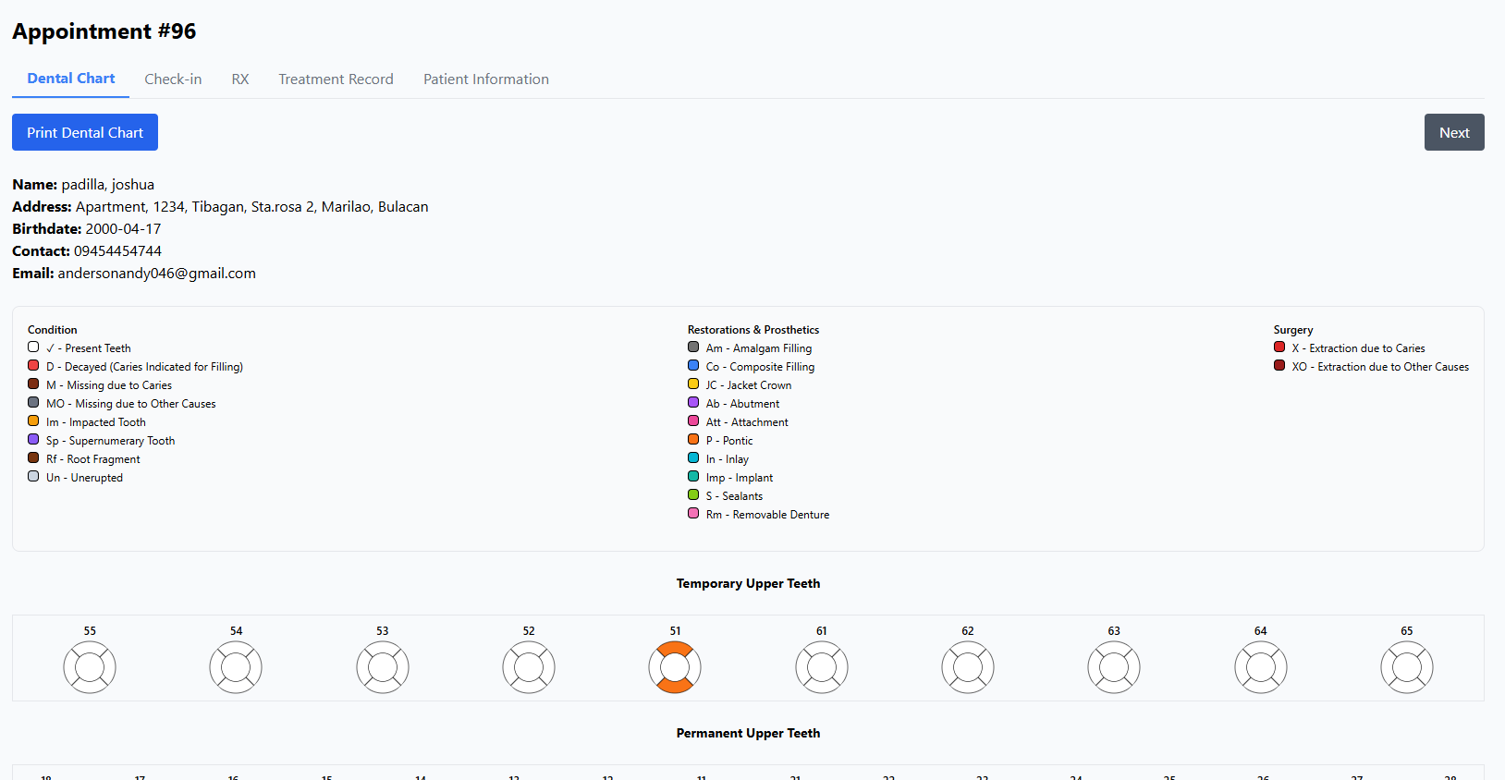
For Viewing nalang si receptionist sa Dental Chart, Receptionist is not allowed to edit graphical tooth chart

