Admin/Dentist/Receptionist > Profile> Recapture Face recognition
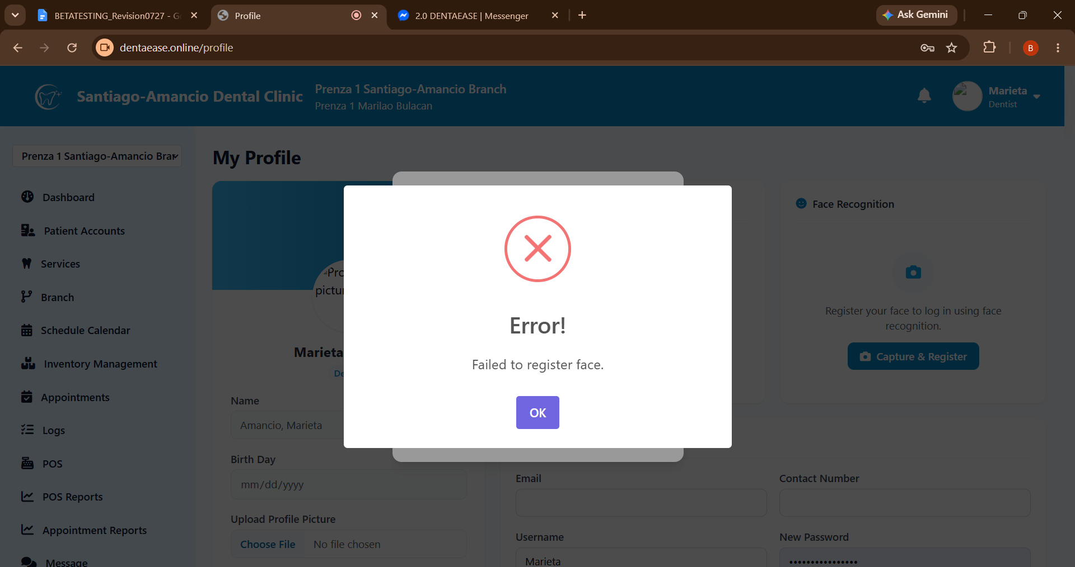
Pafix ng error, laging failed to recognize face.
Palagyan din ng turn left and turn right, at kusang nagcacapture like patient.
—-

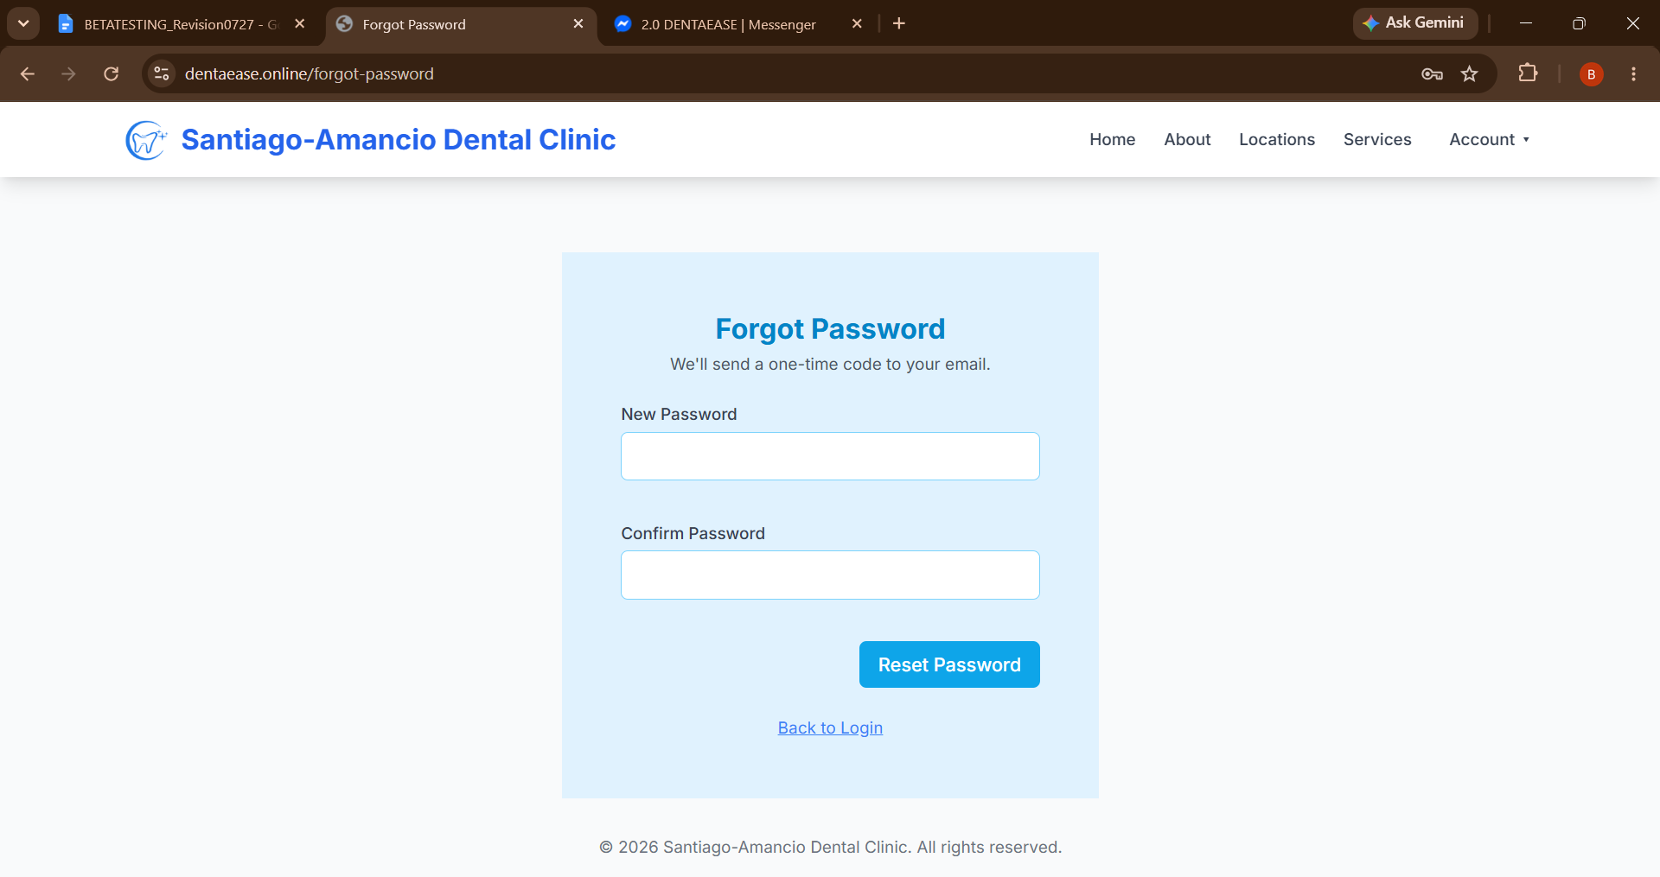’
All Accounts > Forgot Password > OTP > Retype Password
Add eye Icon to for unhide/hide password
Change also the Label > Retype Password
Remove the text “ We’ll send a OTP…”
____

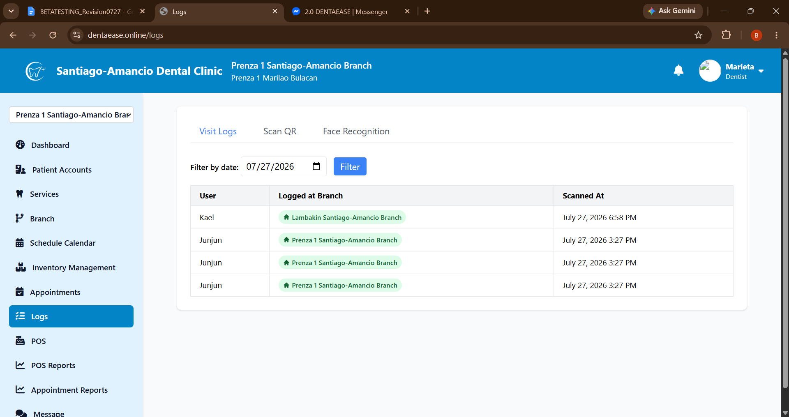
Dentist/Receptionist> Logs
Multiple logs.

Make the text below the label english and professional

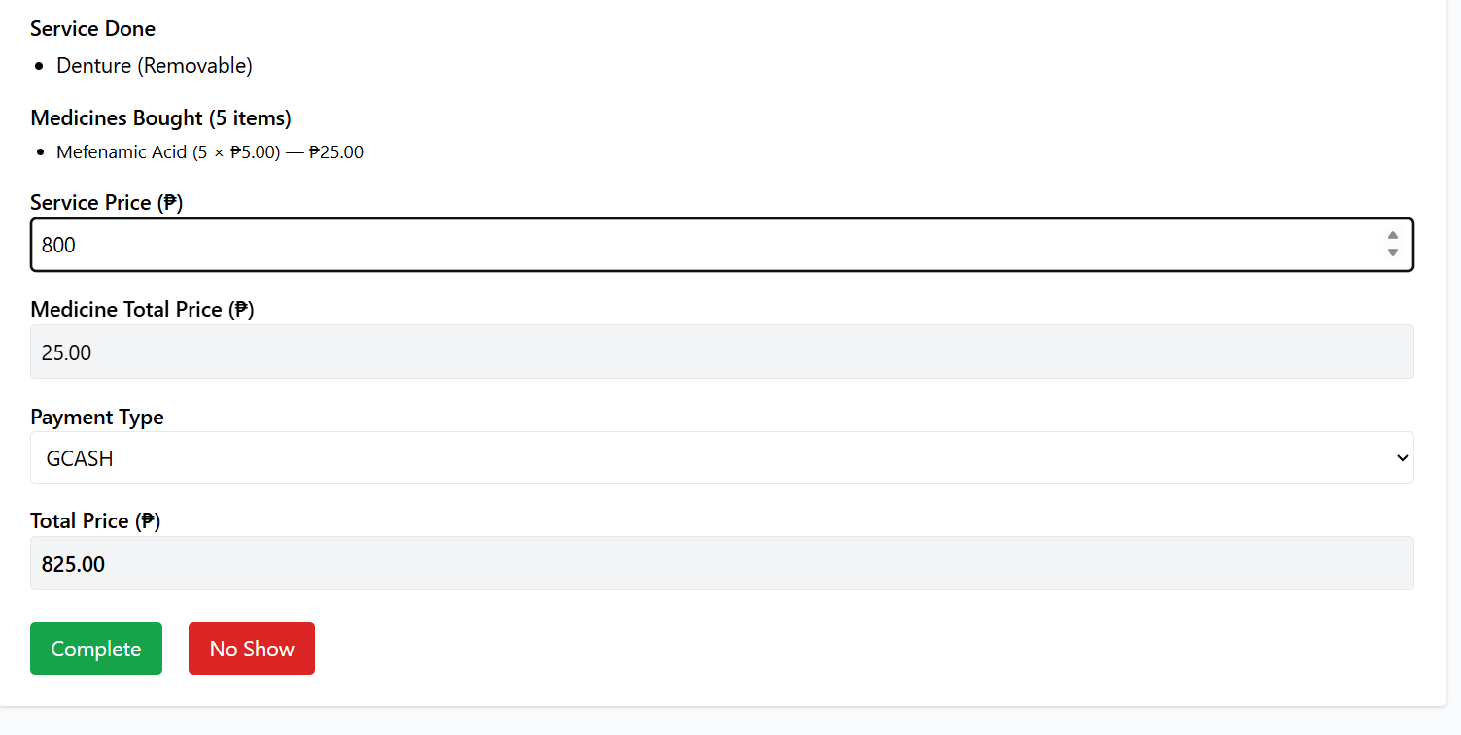
Add change (sukli) label and in receipt.
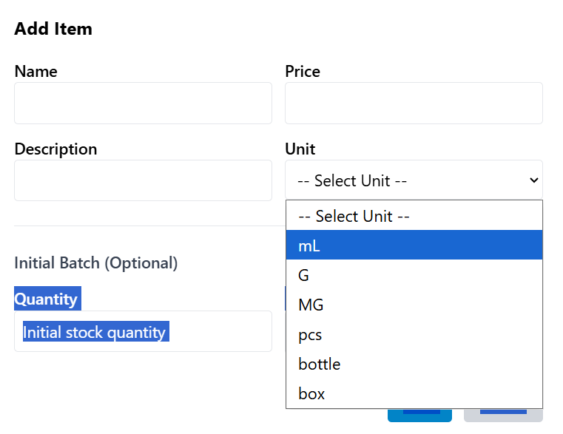
Receptionist/Dentist> Inventory Management
Add unit modification > can add unit, edit or delete

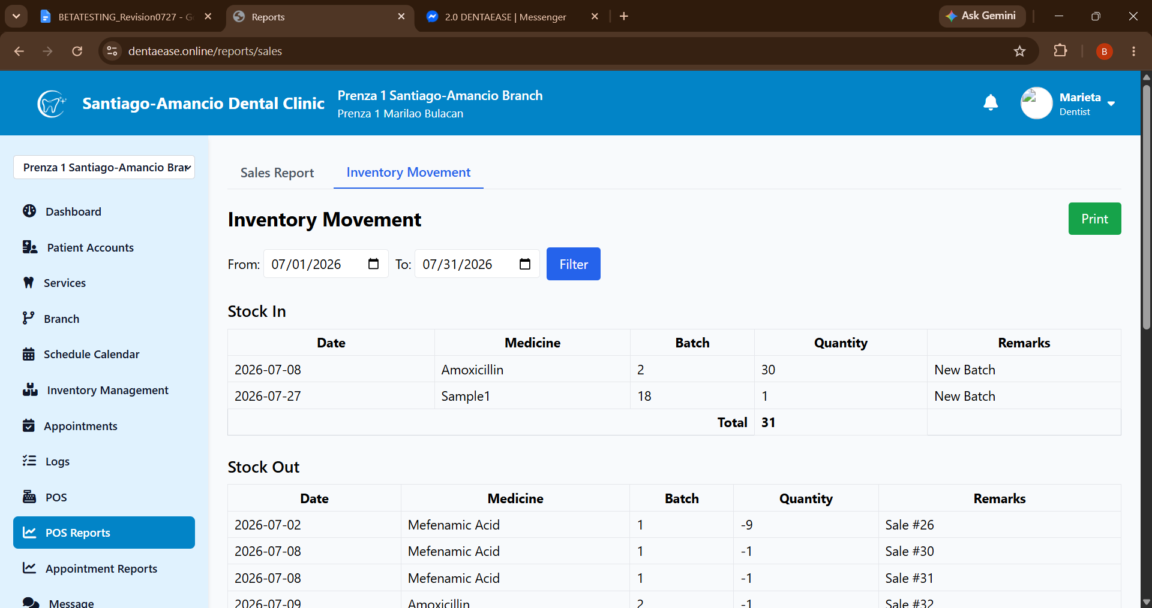
Add Suspend/Deleted Medicine List

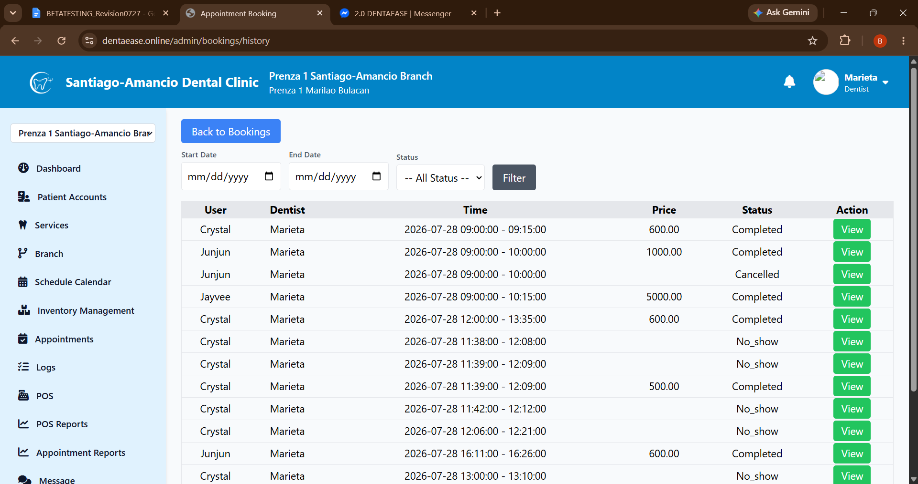
History Date Error > fix to Datetime stamp

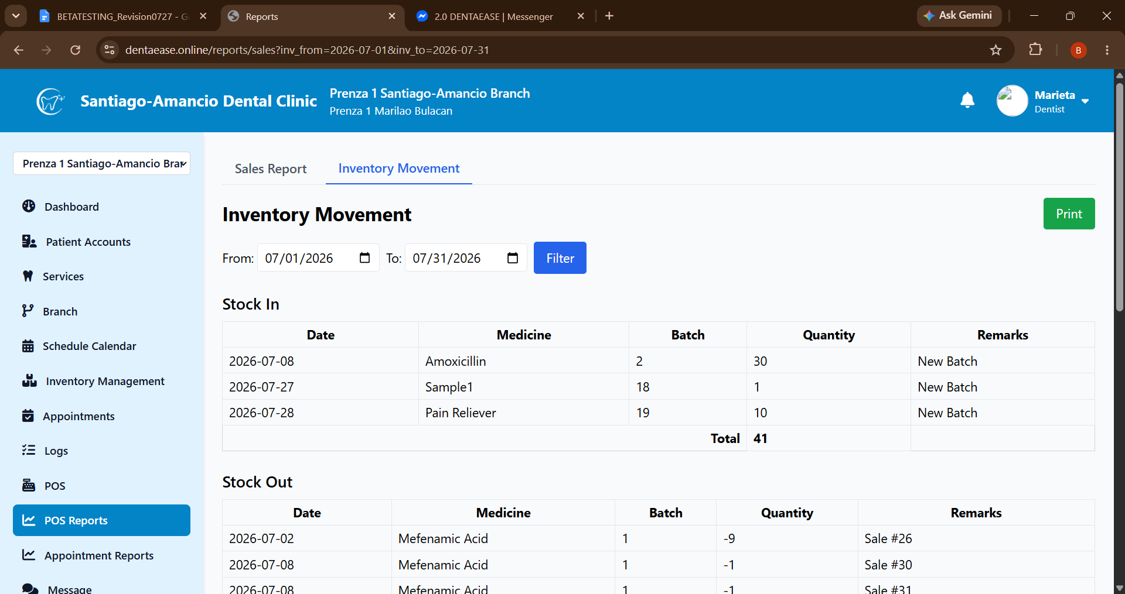
Inventory Movement Filter Button Error: redirecting back to Sales report
Fix button, Filter only inventory movement
MESSAGES
Doctor/Receptionist>
Add Branch to Branch Messages

NOTIFICATION
ADMIN
Add Services
Update Services
Update Branch
Schedule Calendar Updates

DOCTOR/RECEPTIONIST
Archived Patients
Schedule Calendar Updates
Appointment Services Changes
Appointment Date/Time Changes
Emergency Appointment Booking
Appointment History Update
Cancelled Appointment
Expired Medicine
Reminder: Check Pending Appointments (before 1 hour of closing)

Patient
Booking Successfully Done
Booking Approved
Booking Deleted by Dentist/Receptionist
Appointment Change Date, time, services
Appointment no-show

Reminder: You have appointment on …
(Before schedule, 3 days, 1 day, 12 hours, 2 hours)

