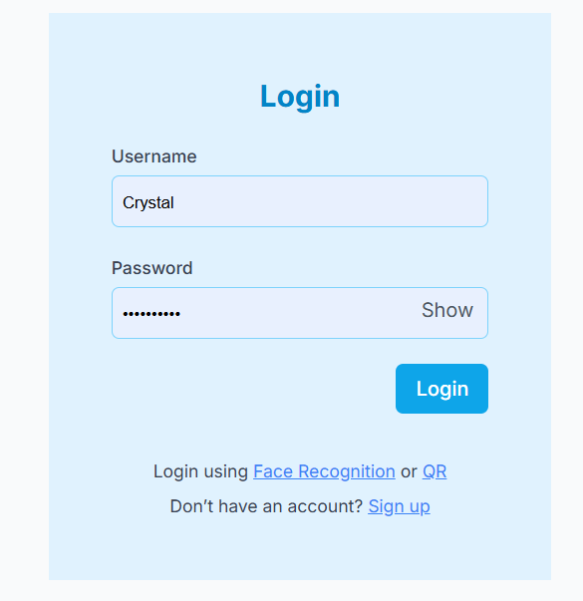
Add ForgotPassword and remember password

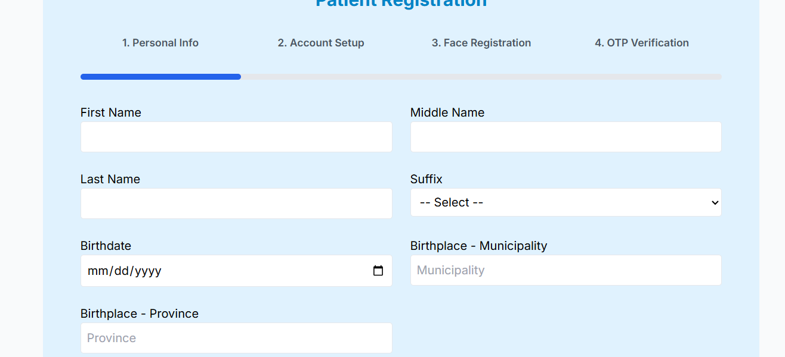
Remember last inputs even after refreshed

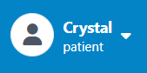
Add hover
Add signs for new messages

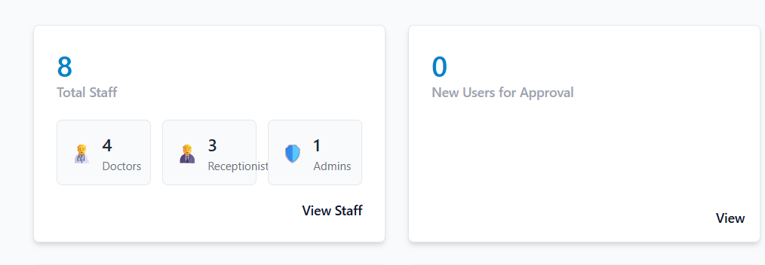
ADMIN DASHBOARD: Remove new users, wider total staff

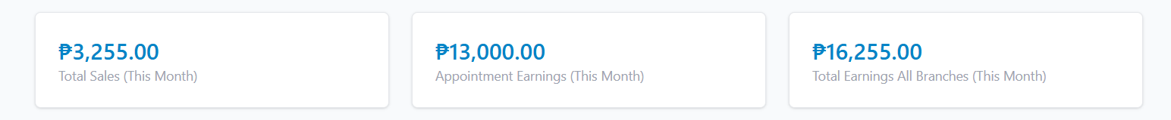
Remove hover

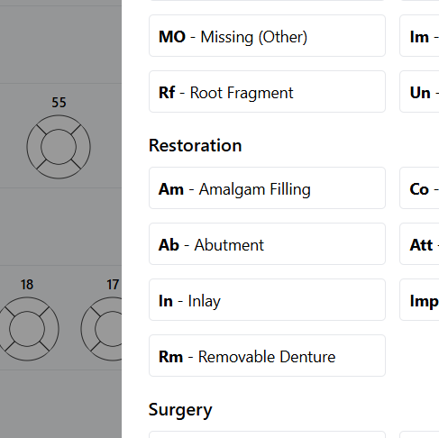
Remove admin access to change dental chart

RECEPTIONIST>ADD APPOINTMENT
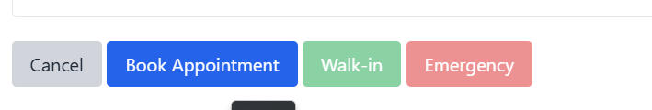

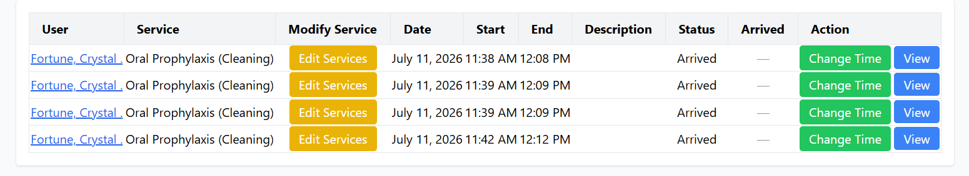
Add Appointment type (Scheduled, walkin, emergency), remove description

Walkin and emergency are clickable, but the button has faded color.

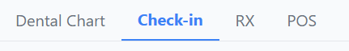

5th Row si check in
Current medication una.
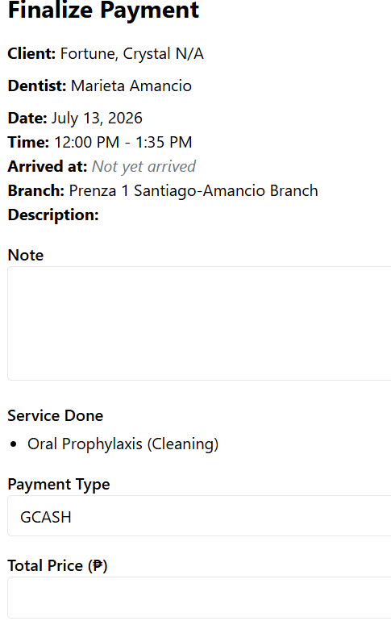
Add Appointment status (scheduled, walkin, emergency)
Gawing not applicable yung “arrived at” kapag walkin at emergency
Add total medicine na binili.

Service Price
Medicine Total Price
Payment Type
Total Price

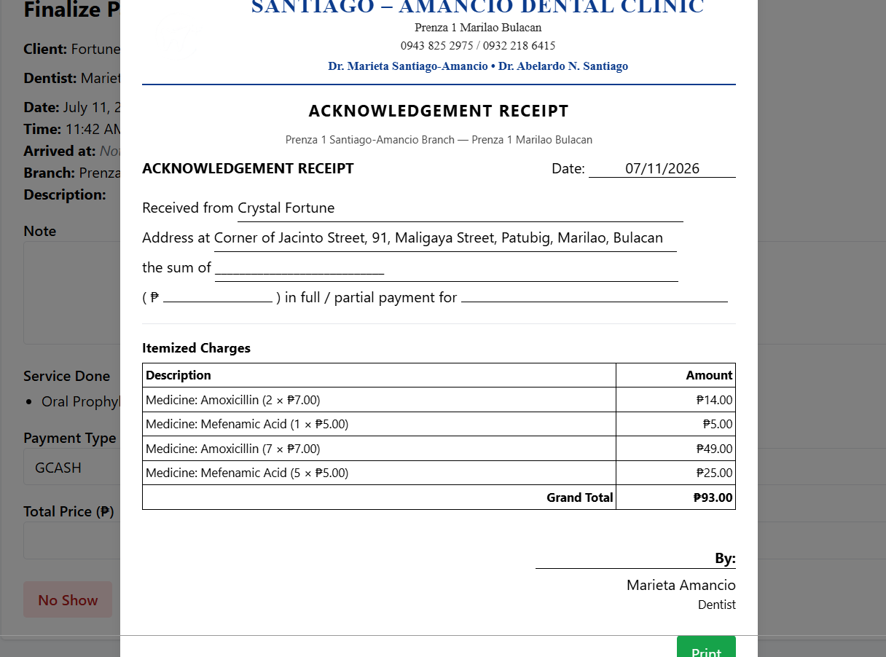
Don't show acknowledgment of receipt when no show clicked.

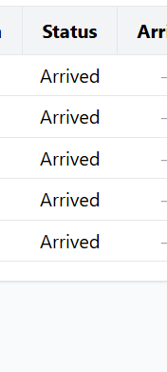
Ni no show kuna pero nakaarrived parin

Acknowledgement receipt ito. Lagyan ngdetails ito.
Yung payment for [Services Done]

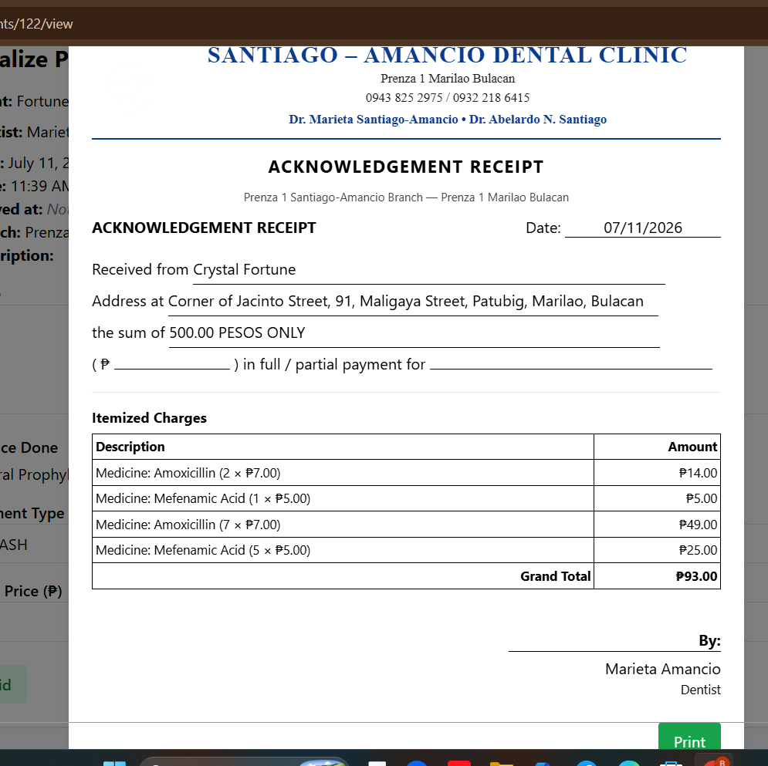
Add close button, make the receipt view small and 100% visible.

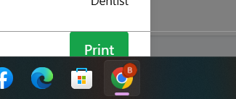
Print button , di gumagana

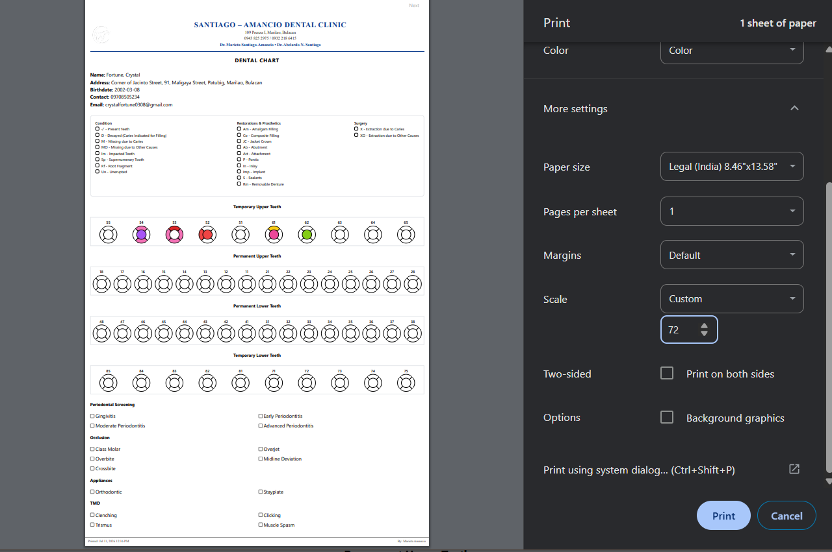
Pwede mo ba to gawin nakadefault settings ng ganito , legal, 1 page lang (72% scale)

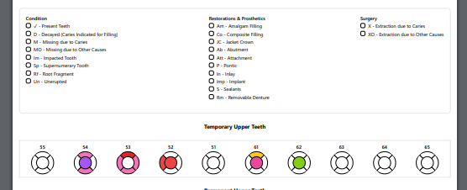
Yung kulay ng legends, di visible sa printable layout

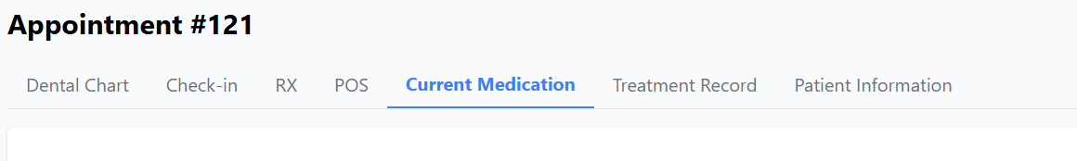
Gawing una yung current Medication, tapos current status instead of current medication

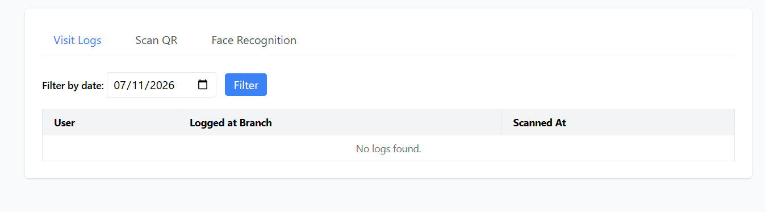
Kung kaya , lahat ng magvivisit at log na walang appointment , kusang makakagawa ng default appointment na walk in, default time, dentist, at branch, ang default sa services is dental checkup.

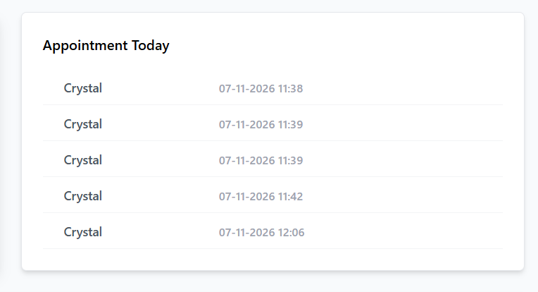
Doesn’t show cancelled, no showed, completed appointment
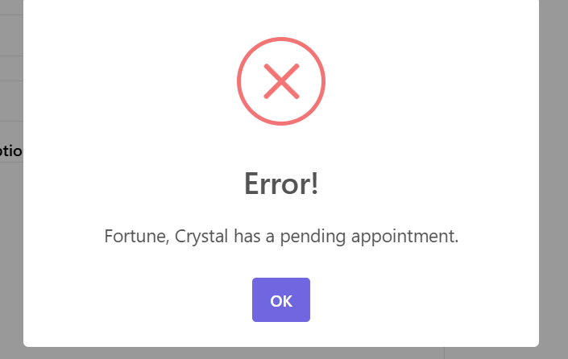
Show here the pending appointment
Show this

