System Revision

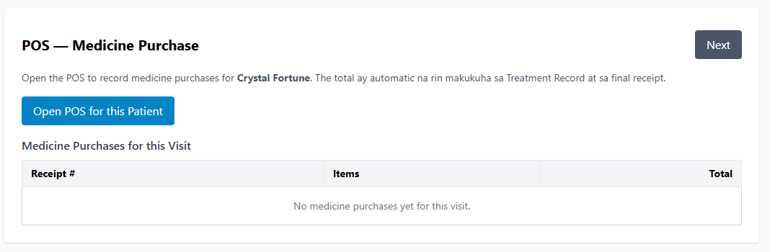
The POS are okay but have glitch error sometimes.
Walang narerecord ditto at sa treatment record minsan.

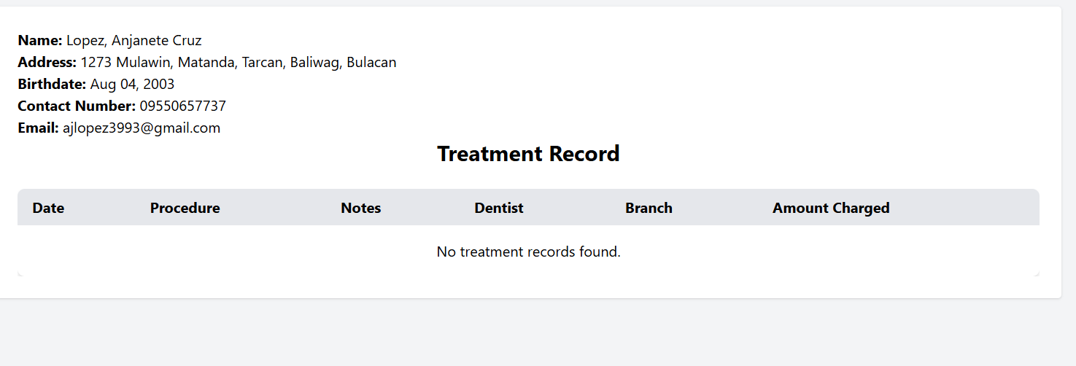
The amount of medicine is included on treatment record.

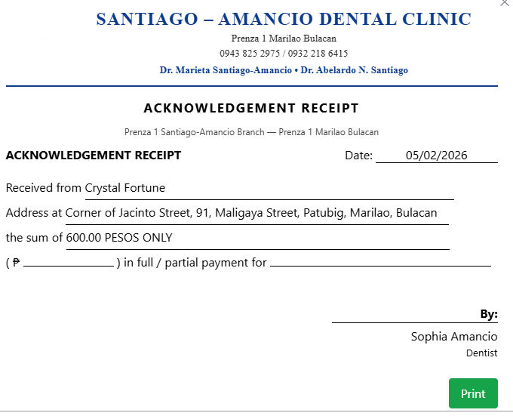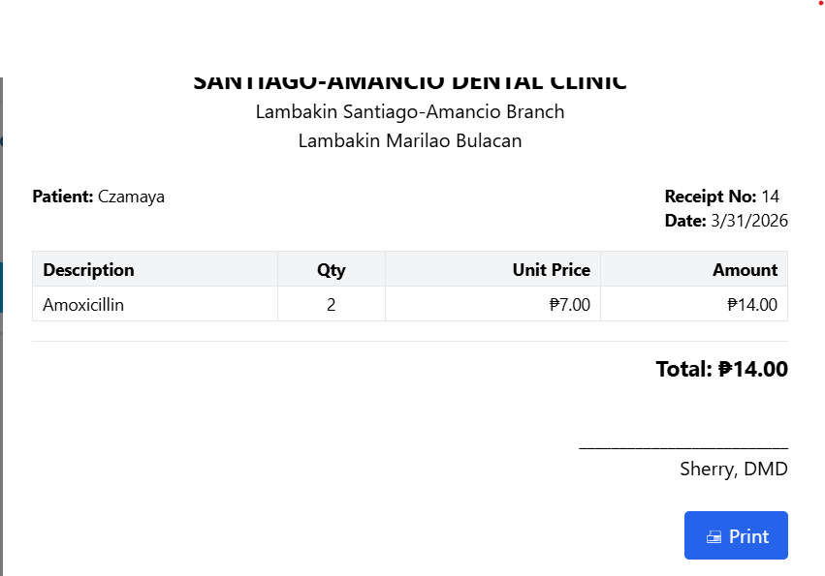
Only one receipt for treatment and medicine bought.
Pagsamahin sila.

Make the staff name complete

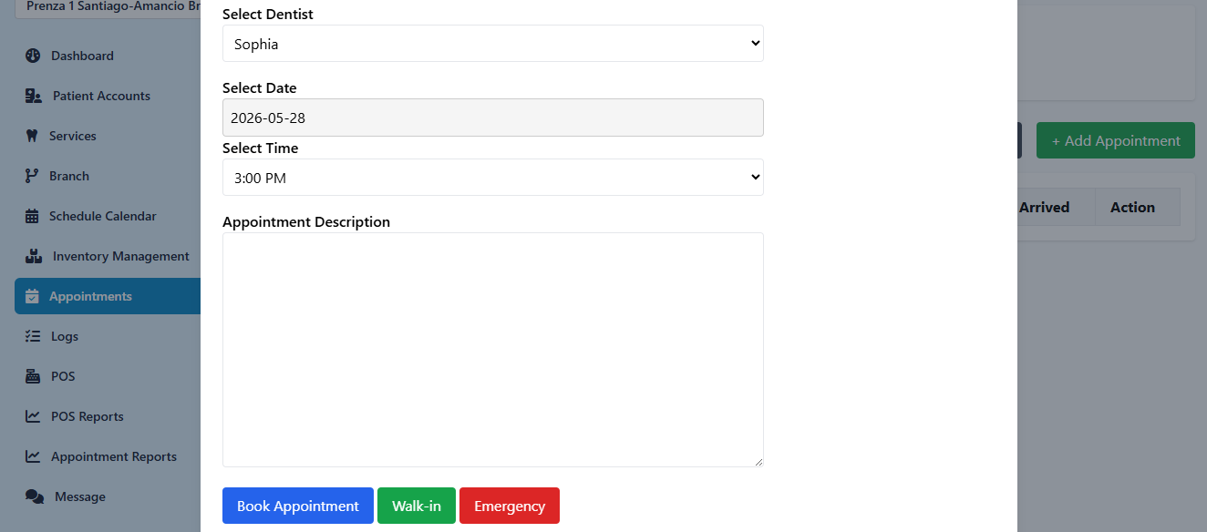
Receptionist/Dentist>Appointments>Add Appointments
wala paring back button
Nagloloko din ata sa pagbook, bumabalik sa date
POS Reports>Inventory Movement
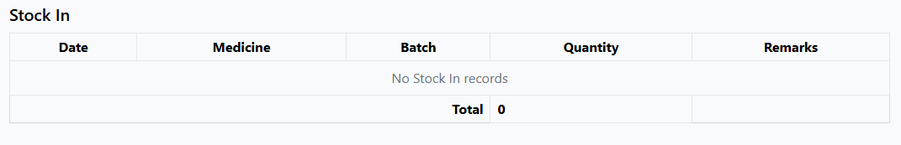
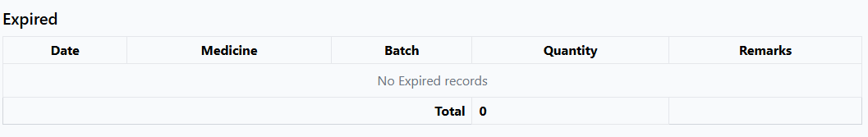
Di gumagana

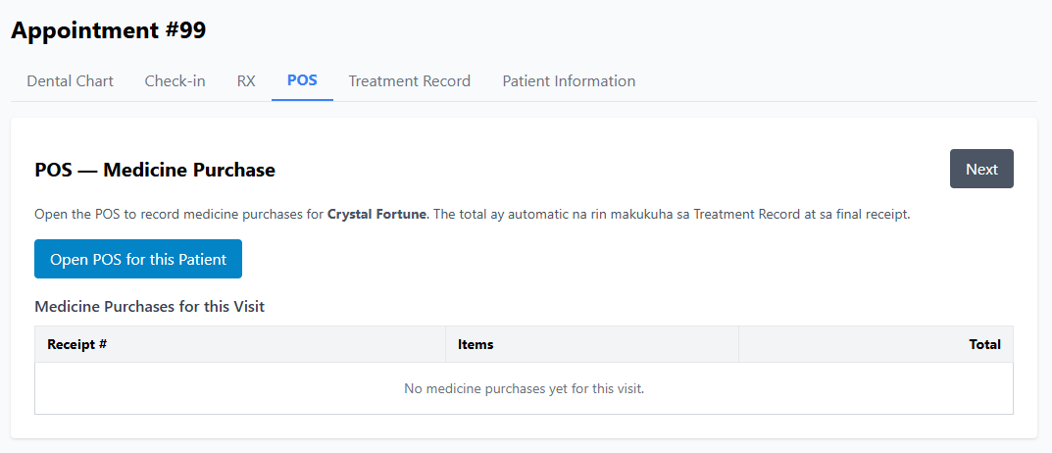
Pagpinindot yung open pos, then after checkout dapat babalik ditto din. At magkakaroon na siya ng record. At narerecord din dyan yung chineckout mismo sa POS Tab kung meron.

