Revision:
1. use color correspond to the action
2. Add medicine status/label/filter for medicine near to expired or out of stock
3. Walang available timeslots kahit hindi naman sarado ang branch at day-off ang dentist sa branch ng Santa Maria, San Jose, at bagong create na branch which is Santa Rosa wala silang available timeslots kahit wala naming booking sa araw na iyon paki-double check Narin ang ibang branch ( Lambakin at Prenza )

ADMIN Account (Schedule Calendar of Dentist and Branch)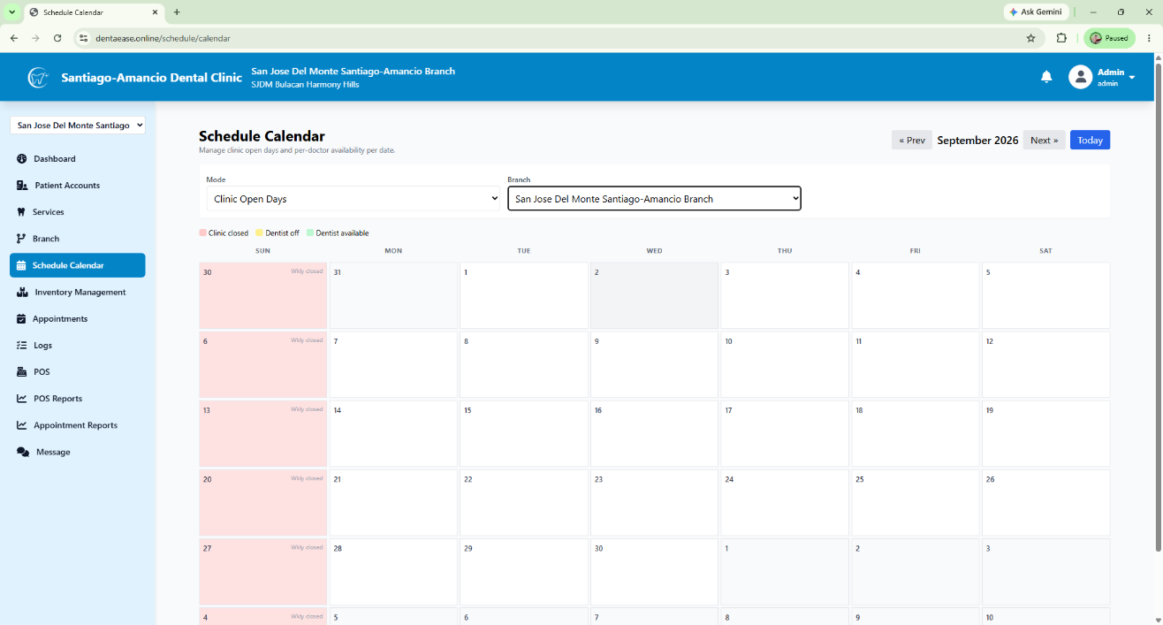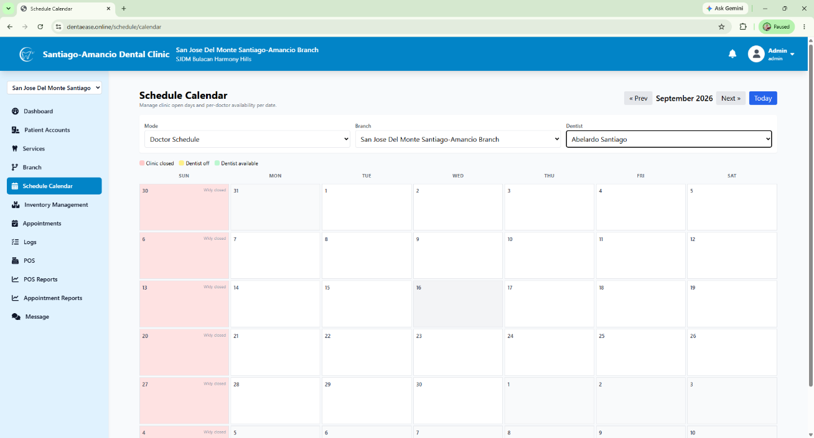

DENTIST Account (Schedule Calendar of Dentist and branch
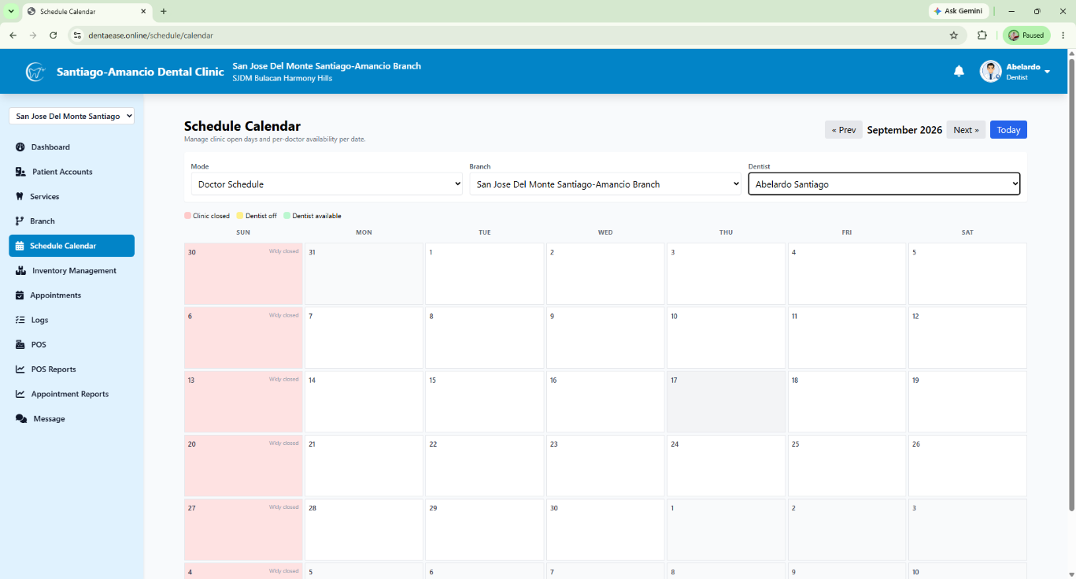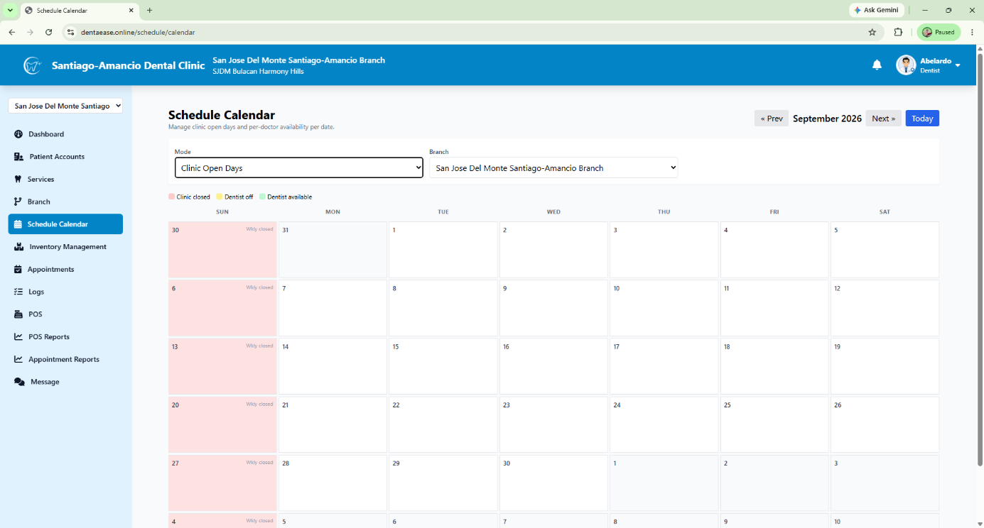

PATIENT Child Account ni Juni Boi (Junjun)
Email: Junjun
Password: junjundiaz123
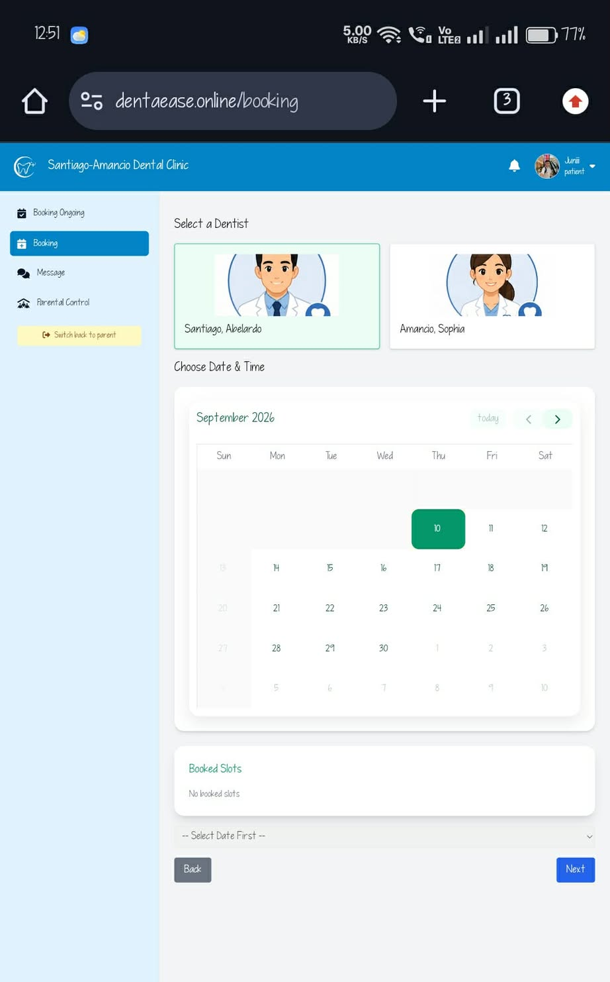

Nagbook ako sa bagong create na branch (Santa Rosa 1) Sept 9 mismong araw pero walang available timeslot gamit ang child account.

