**FIT JOURNEY MANAGEMENT SYSTEM**

**Database Project Documentation**

By

INGCO JOHN BENEDICT

ARJONEL M. MENDOZA, MIT

Lecturer

# **PROJECT OVERVIEW**

The Fit Journey Management System is built to simplify the process of managing users, exercise logs, exercise types, and workout types. This database system serves as a hands-on application of key concepts from the Database Management System course, including database design, SQL scripting, and data handling.

# **ENTITY-RELATIONSHIP DIAGRAM (ERD)**

The ERD represents key entities in the Fit Journey Management System, including ADMIN, EXERCISE_TYPES, LOGS, USERS, and WORKOUT_TYPES. Each entity has attributes essential for data management.

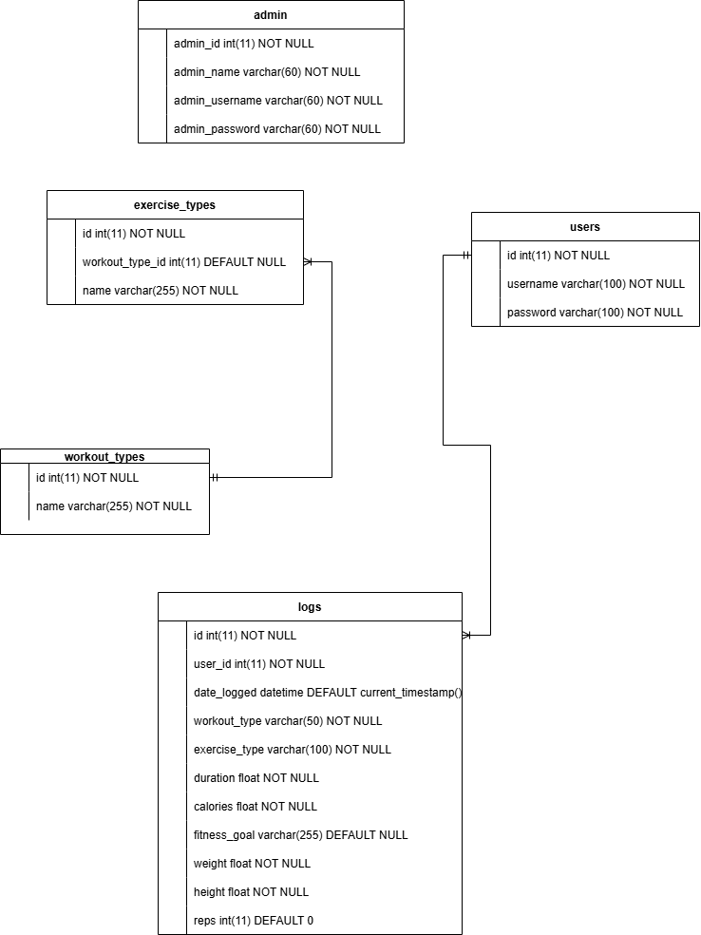

Figure 1. Entity Relationship Diagram

# **Entities and their Relationships**

1. **Exercise types and workout types**

* **Type**: One-to-Many (1:N)
* **Description**: Each exercise type is included by one workout type, but an workout type can include multiple exercise types.

1. **Users and Logs**

* **Type: One-to-Many (1:N)**
* **Description:** Each user can record multiple logs, but each log is associated with only one user.

# **SQL SCRIPTS**

-- Create Database

CREATE DATABASE fitjourney;

-- Use Database

USE fitjourney;

-- Create Tables

CREATE TABLE `admin` (

`admin_id` int(11) NOT NULL,

`admin_name` varchar(60) NOT NULL,

`admin_username` varchar(60) NOT NULL,

`admin_password` varchar(60) NOT NULL

) ENGINE=InnoDB DEFAULT CHARSET=utf8mb4 COLLATE=utf8mb4_general_ci;

CREATE TABLE `exercise_types` (

`id` int(11) NOT NULL,

`workout_type_id` int(11) DEFAULT NULL,

`name` varchar(255) NOT NULL

) ENGINE=InnoDB DEFAULT CHARSET=utf8mb4 COLLATE=utf8mb4_general_ci;

CREATE TABLE `logs` (

`id` int(11) NOT NULL,

`user_id` int(11) NOT NULL,

`date_logged` datetime DEFAULT current_timestamp(),

`workout_type` varchar(50) NOT NULL,

`exercise_type` varchar(100) NOT NULL,

`duration` float NOT NULL,

`calories` float NOT NULL,

`fitness_goal` varchar(255) DEFAULT NULL,

`weight` float NOT NULL,

`height` float NOT NULL,

`reps` int(11) DEFAULT 0

) ENGINE=InnoDB DEFAULT CHARSET=utf8mb4 COLLATE=utf8mb4_general_ci;

CREATE TABLE `users` (

`id` int(11) NOT NULL,

`username` varchar(100) NOT NULL,

`password` varchar(100) NOT NULL

) ENGINE=InnoDB DEFAULT CHARSET=utf8mb4 COLLATE=utf8mb4_general_ci;

CREATE TABLE `workout_types` (

`id` int(11) NOT NULL,

`name` varchar(255) NOT NULL

) ENGINE=InnoDB DEFAULT CHARSET=utf8mb4 COLLATE=utf8mb4_general_ci;

ALTER TABLE `exercise_types`

ADD CONSTRAINT `exercise_types_ibfk_1` FOREIGN KEY (`workout_type_id`) REFERENCES `workout_types` (`id`) ON DELETE CASCADE ON UPDATE CASCADE;

--

-- Constraints for table `logs`

--

ALTER TABLE `logs`

ADD CONSTRAINT `logs_ibfk_1` FOREIGN KEY (`user_id`) REFERENCES `users` (`id`) ON DELETE CASCADE ON UPDATE CASCADE;

COMMIT;

*.*