CHAPTER 4

RESULTS AND DISCUSSION
This chapter presents the findings of the study, which examined the effectiveness of the developed web application in assisting pet owners, veterinarians, and local government units (LGUs) in managing rabies vaccination records and ensuring compliance with the Anti-Rabies Act of 2007. The results provide insights into the system's usability, efficiency, and potential impact on rabies prevention efforts.
4.1 System Development
The system block diagram illustrates the structure of a web application created to support pet owners, veterinarians, and local government units (LGUs) in dealing with rabies vaccination records and compliance with the Anti-Rabies Act of 2007. It sohws how the web application serves as a centralized, automated platform that links all stakeholders involved, simplifies the process of rabies vaccination management, enforces compliance with the Anti-Rabies Act, and facilitates the overall objective of rabies prevention. The efficient communication among pet owners, veterinarians, and LGUs is made possible by the web application, leading to a more efficient and well-organized means of rabies prevention.
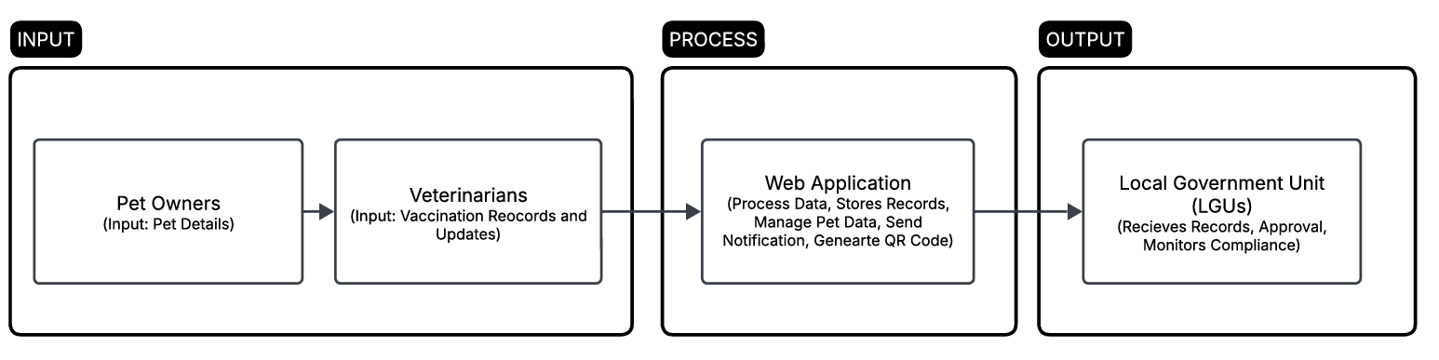
Figure 4.1.1 System Block Diagram of Web Application
At the heart of the system, Pet Owners, themselves are tasked with registering their pets into the web application. They provide simple pet information, including the pet's name, breed, age, and vaccination history. The system enables pet owners to monitor their pet's vaccination status, receive reminders for forthcoming vaccinations, and change their contact details. This direct interaction ensures that pet owners themselves are reminded of their obligations under the Anti-Rabies Act.
The Veterinarians are responsible for maintaining and updating vaccination records for pets. Upon giving vaccinations, veterinarians record minute details into the system, such as the type of vaccine given, date of vaccination. The web application enables veterinarians to directly communicate with pet owners, send updates or reminders, and keep track of vaccinations accurately. Such upgrades are crucial for the proper documentation and retrieval, when necessary, of every pet's vaccination history.
It is the duty of the Local Government Units (LGUs) to coordinate the implementation of the Anti-Rabies Act at the local levels. They have access to veterinarians' data on vaccinations and can monitor for compliance with law. The system gives LGUs access to real-time reports that identify vaccination rates, compliance figures, and areas of concern. LGUs can create compliance reports and, if needed, send enforcement notices to veterinarians or pet owners to act, so that no pet is left unvaccinated. This capability increases the capacity of LGUs to monitor the effectiveness of rabies prevention programs at the local level.
The Web Application System is the hub where all the data inputs are gathered and processed. The system consolidates the different stakeholders—pet owners, veterinarians, and LGUs—by keeping the vaccination records, sending reminders, and creating compliance reports. The system checks for vaccination information and sends notifications automatically to the concerned parties (reminders to pet owners, updates to veterinarians, and compliance reports to LGUs). In the process, the system facilitates the ease of vaccination schedule management and ensures that all the stakeholders involved are in accordance with their attempts to rabies.
4.1.1 Software Description
- Discuss features (Textual Form)
4.2 Prototype Design
    - Software Development
Web Application
-Login Page, Home Page, Admin Page, Registration of Users and Admin, etc…
-Discuss all features, process, functions and procedures and the whole User Interface
-include images/screenshots and discuss fully
Resolution: The smallest change that can be reliably detected
Response time: The time between a triggering event and the resulting action Bandwidth: The amount of information processed per time

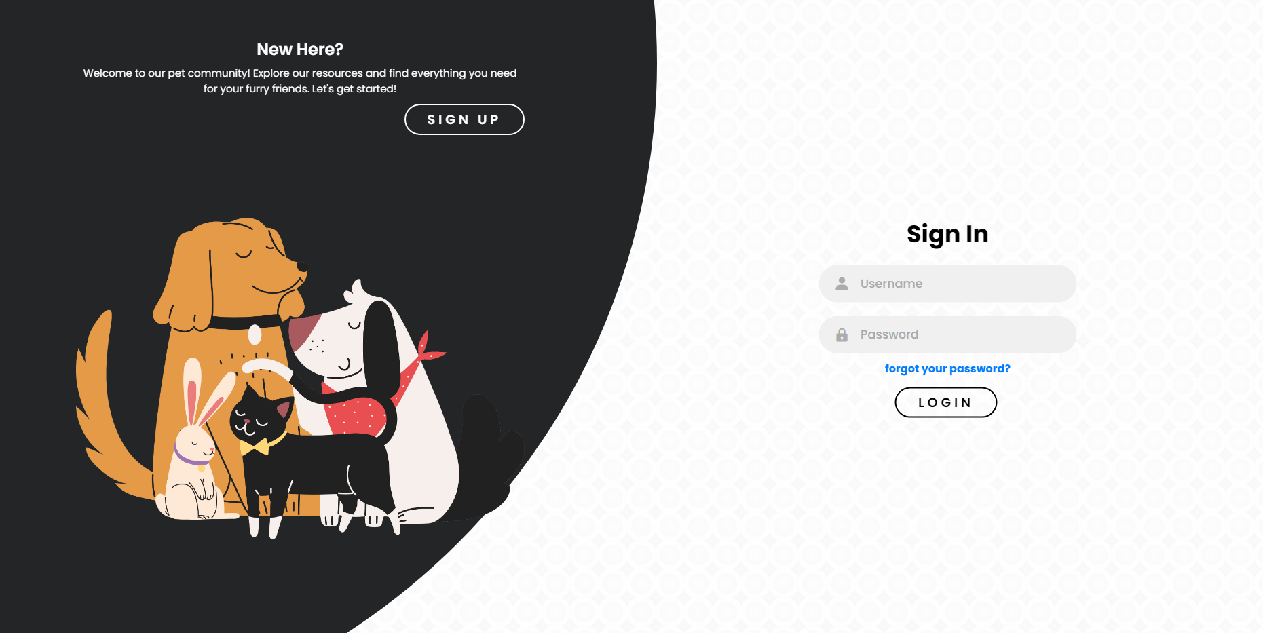
Figure 4.2.1. Sign In Page
Sign-In Page provides secure access to the system for users (pet owners, veterinarians, LGUs). It features fields for Username and Password with an option Forgot Your Password for recovery of the account. Upon entering the credentials, users may click Login to enter the system's functions and safely manage vaccination records. This guarantees only the authorized personnel have access to the sensitive information, thusgiving a boost to the overall web application security and integrity. The loading time takes about xx secs to process.
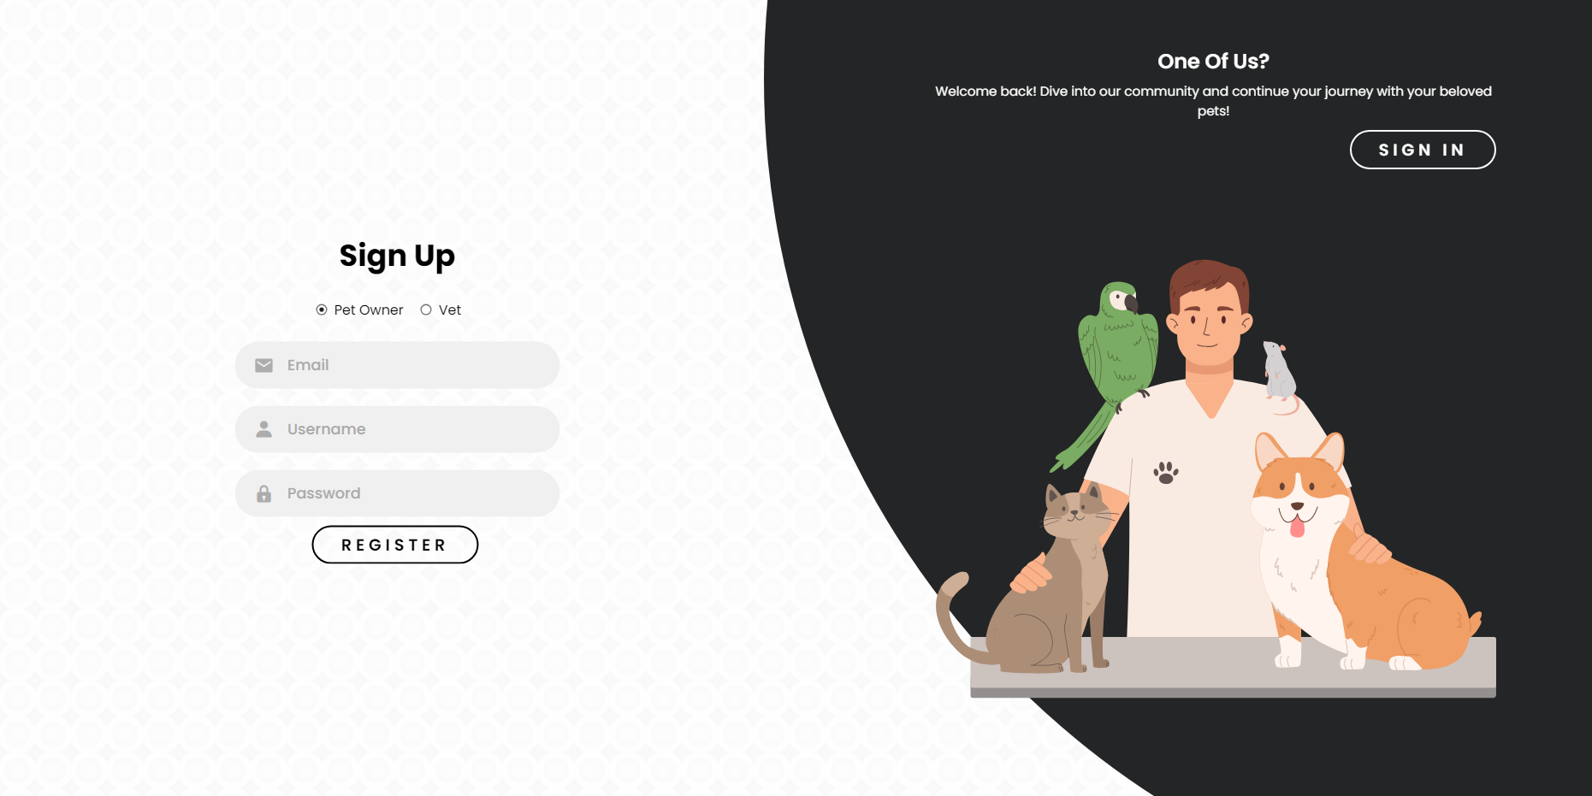
Figure 4.2.2. Sign Up Page for Pet Owner
The pet owner's Sign-Up Page enables new users to sign up and create an account by inputting their Email, Username, and Password. After entering the required information, users can press Register to set up their account and gain access to the system for managing vaccination records of pets. The loading time takes about xx secs to process.
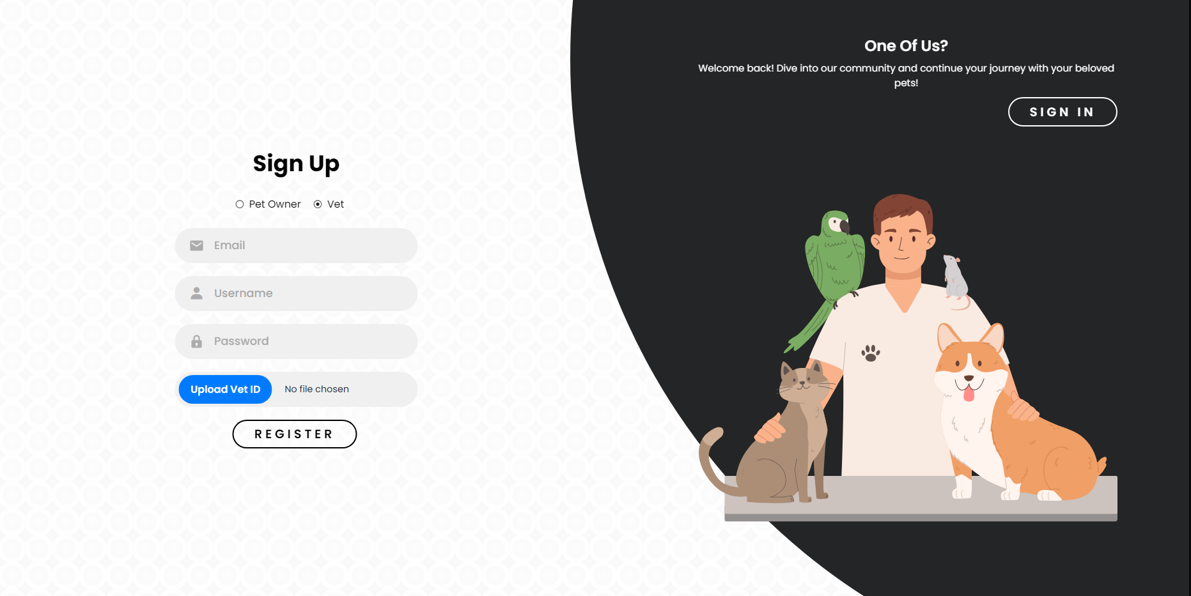
Figure 4.2.3. Sign Up Page for Veterinarian
Vet Sign-Up Page enables new users to register an account by entering their Email, Username, and Password. Apart from these, veterinarians must Upload their Vet ID for authentication. Upon form submission and clicking the Register button, the system checks the details and provides access to the site for pet vaccination records management and other veterinary functions. The loading time takes about xx secs to process.
PET OWNER SECTION:
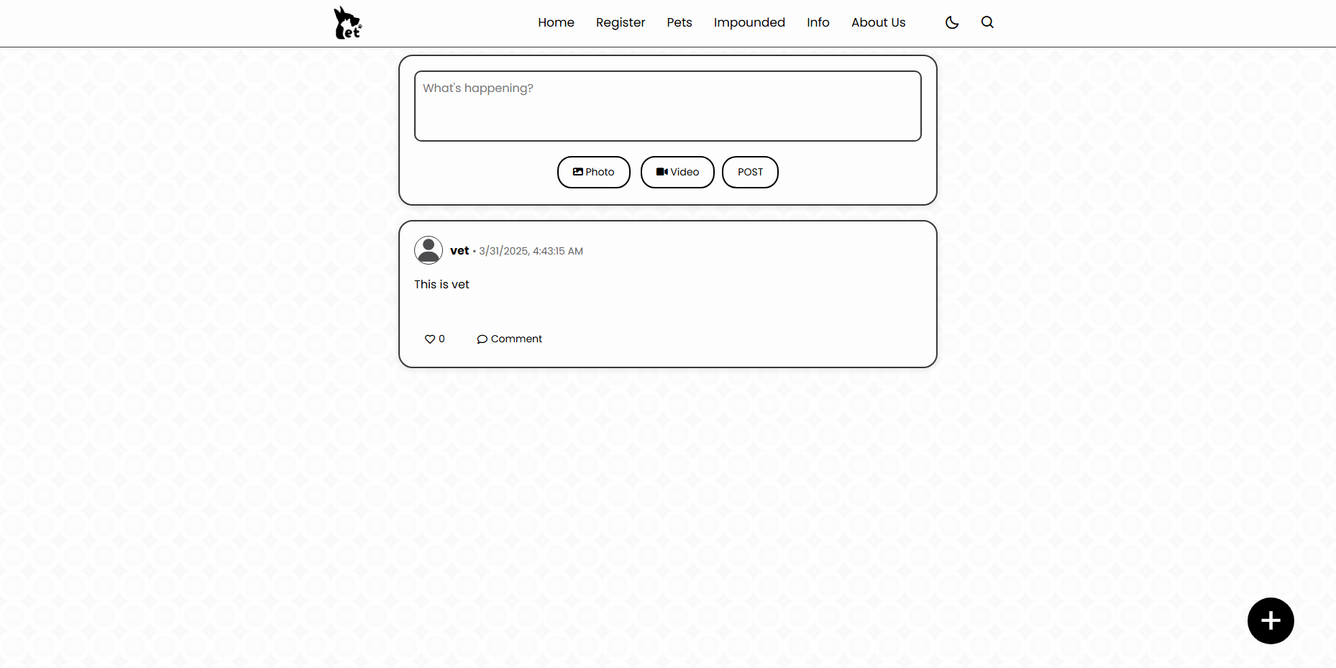
Figure 4.2.4. Home Page for Pet Owner
The Pet Owners Home Page is the master dashboard that provides easy access to major features. Users can easily access sections such as Register (for new pet additions), Pets (for viewing and maintaining pet records), Impounded (for lost or found pet records), and Info (for rabies vaccination status updates). The About Us area gives details regarding the platform, whereas the Night Mode feature supports a darker theme for easier reading during nighttime. The Search option facilitates locating individual pet records or updates. The page is created in the form of a news feed, and pet owners can post updates, share news, and remain updated about vaccination schedules and other related issues.
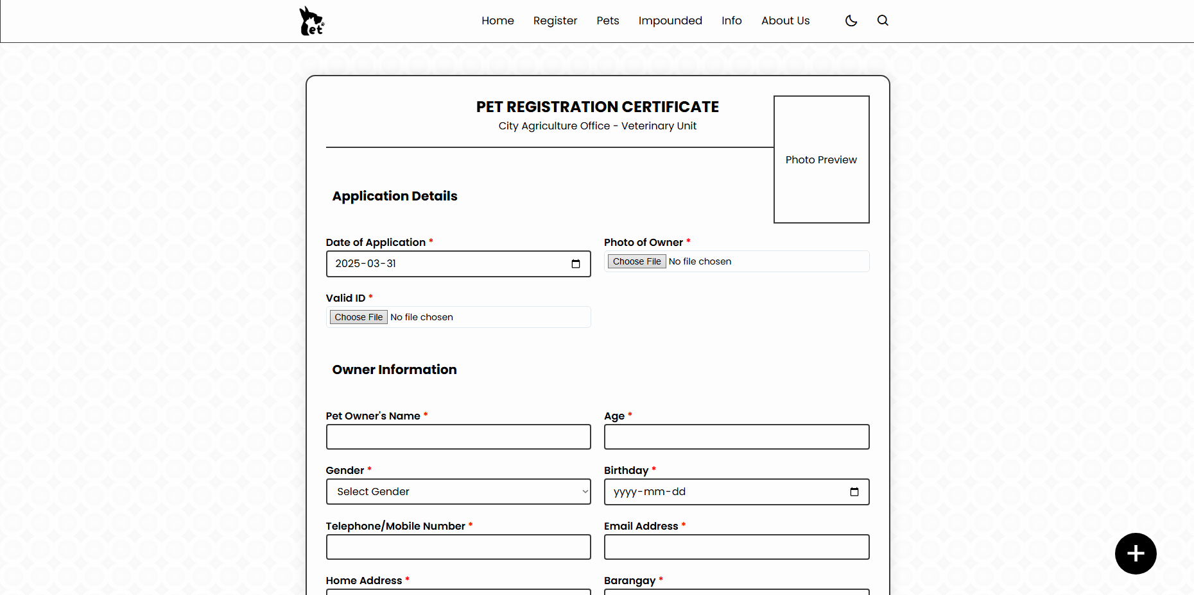
Figure 4.2.5. Pet Registration Page for Pet Owners
The Pet Owners Registration Page allows users to register their pets by providing information that is applicable. Pet owners can upload the pet photo, owner photo, and identification proof for verification purposes. The form will also accept the owner's information such as name, age, gender, birthday, email, contact number, and address. Basic information on the pet and vaccination status, is needed, along with the contact details of the veterinarian who administered the vaccination. Finally, the owner needs to sign and date the form to complete the registration. The time it takes to submit the application takes xx secs.
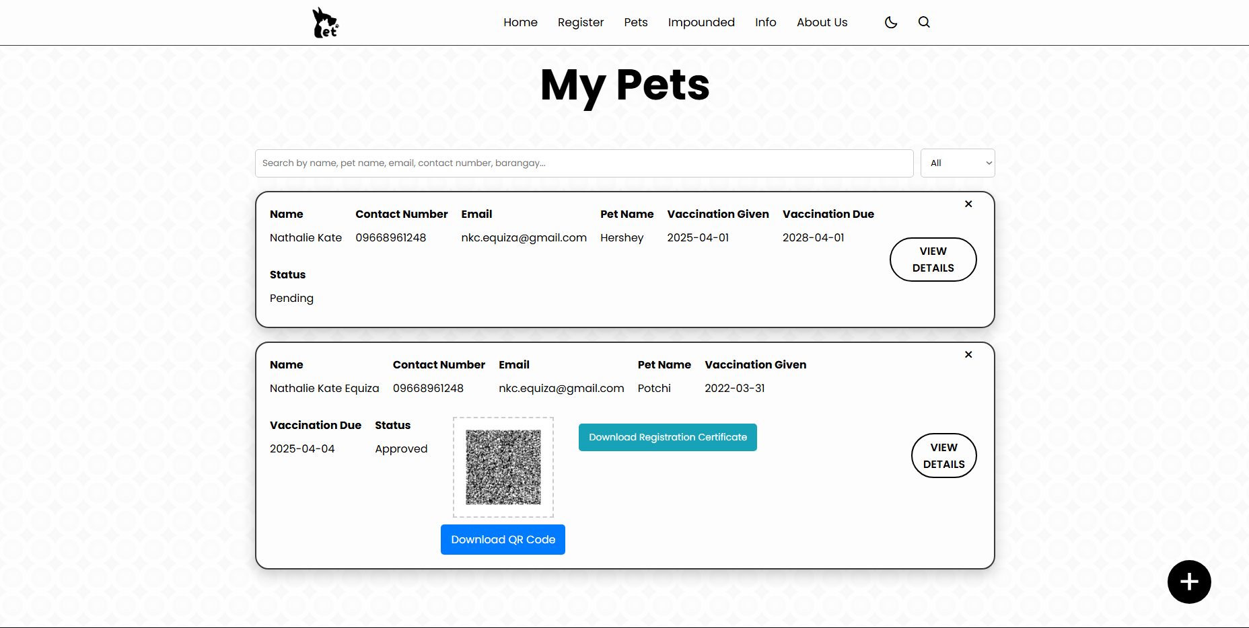
Figure 4.2.6. Registered Pets Page for Pet Owners
The Registered Pet Page for owners of pets shows important information regarding the pet and the owner. It shows the owner's name, contact number, email, as well as the pet's name, vaccination administered, vaccination due, and status (up to date, overdue). A QR code is also created that holds all the important pet details, allowing pet owners to easily access or share important details in case the pet is lost. The time it takes to generate the QR code takes xx secs.
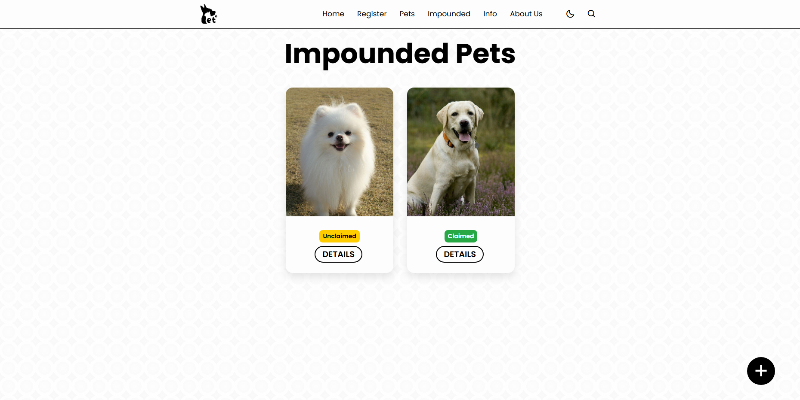
Figure 4.2.7. Impounded Pets Page for Pet Owners
The Impounded Page for pet owners gives details of pets that were found or impounded. It consists of two categories: Unclaimed Pets, which shows animals still waiting for their owners, and Claimed Pets, showing animals that have already been reunited with their owners. The page assists pet owners in monitoring missing pets in their neighborhood and taking action to retrieve their animals if need be. The time it takes to load takes xx secs.

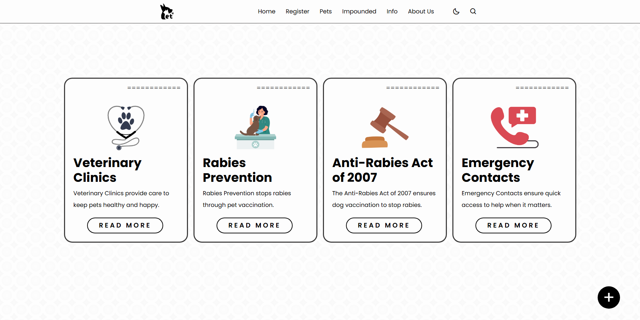
Figure 4.2.8. Information Page for Pet Owners
The Info Page is important in that it offers key information for pet owners. The page contains a listing of Vet Clinics to conveniently access veterinary facilities in the local area, Rabies Prevention guidelines, and details of the Anti-Rabies Act to educate the owners about responsible pet practice. The page further offers a listing of Emergency Contacts so that the owners have speedy access to contact numbers during emergent circumstances. The time it takes to load each tab takes xx secs.
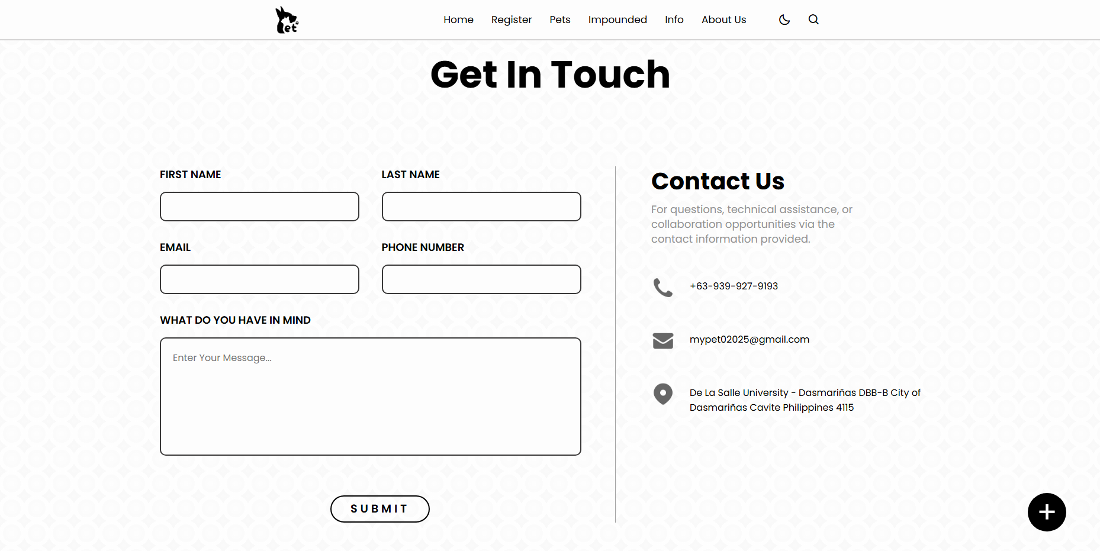
Figure 4.2.9. About Us Page for Pet Owners
The About Us Page for pet owners creates a platform where one can learn more about the site and what they do. One is free to fill in their basic information such as first name, last name, phone number, email, and comment or give feedback regarding the service. It also has contact information for the web developer, so users can contact them in case of support or questions. The loading time takes about xx secs to process.
VETERINARIAN SECTION
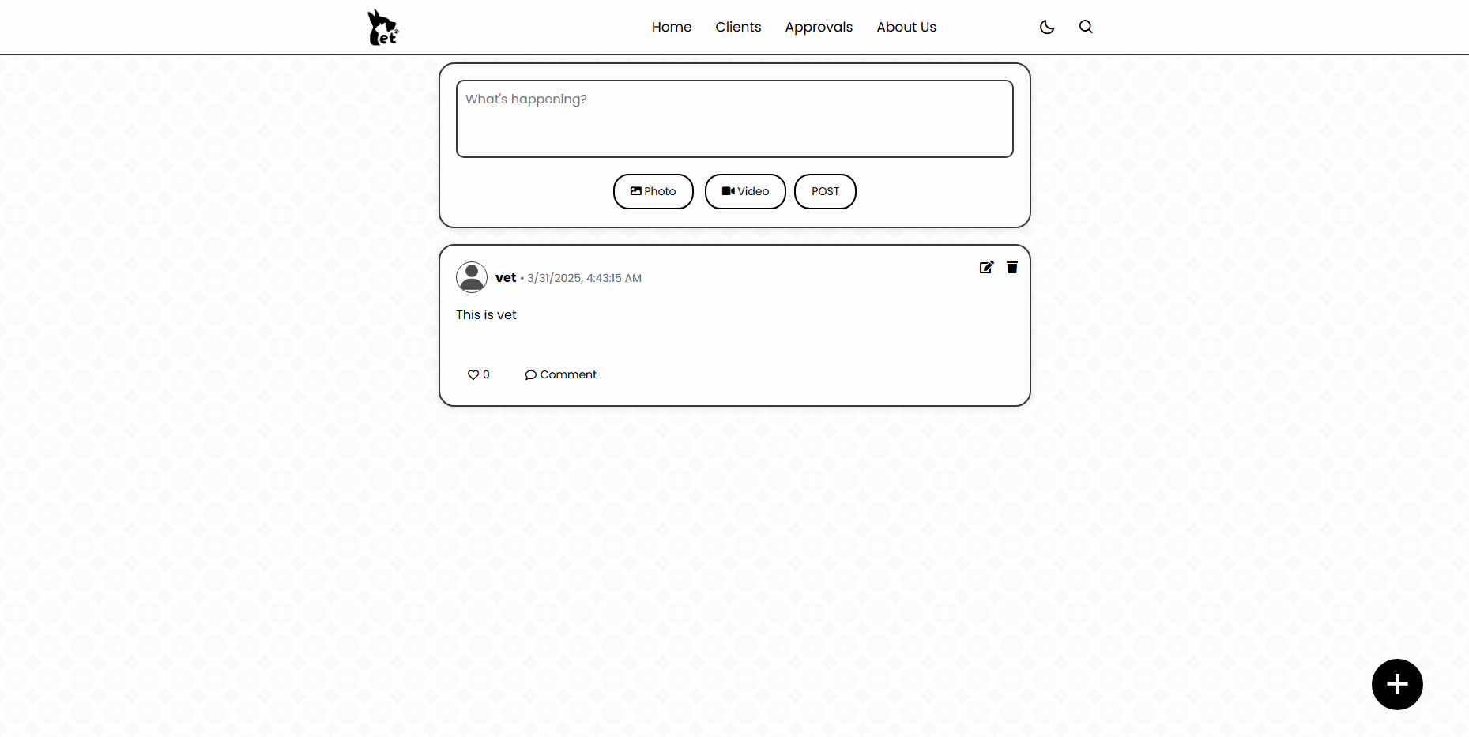
Figure 4.2.10. Home Page for Veterinarian
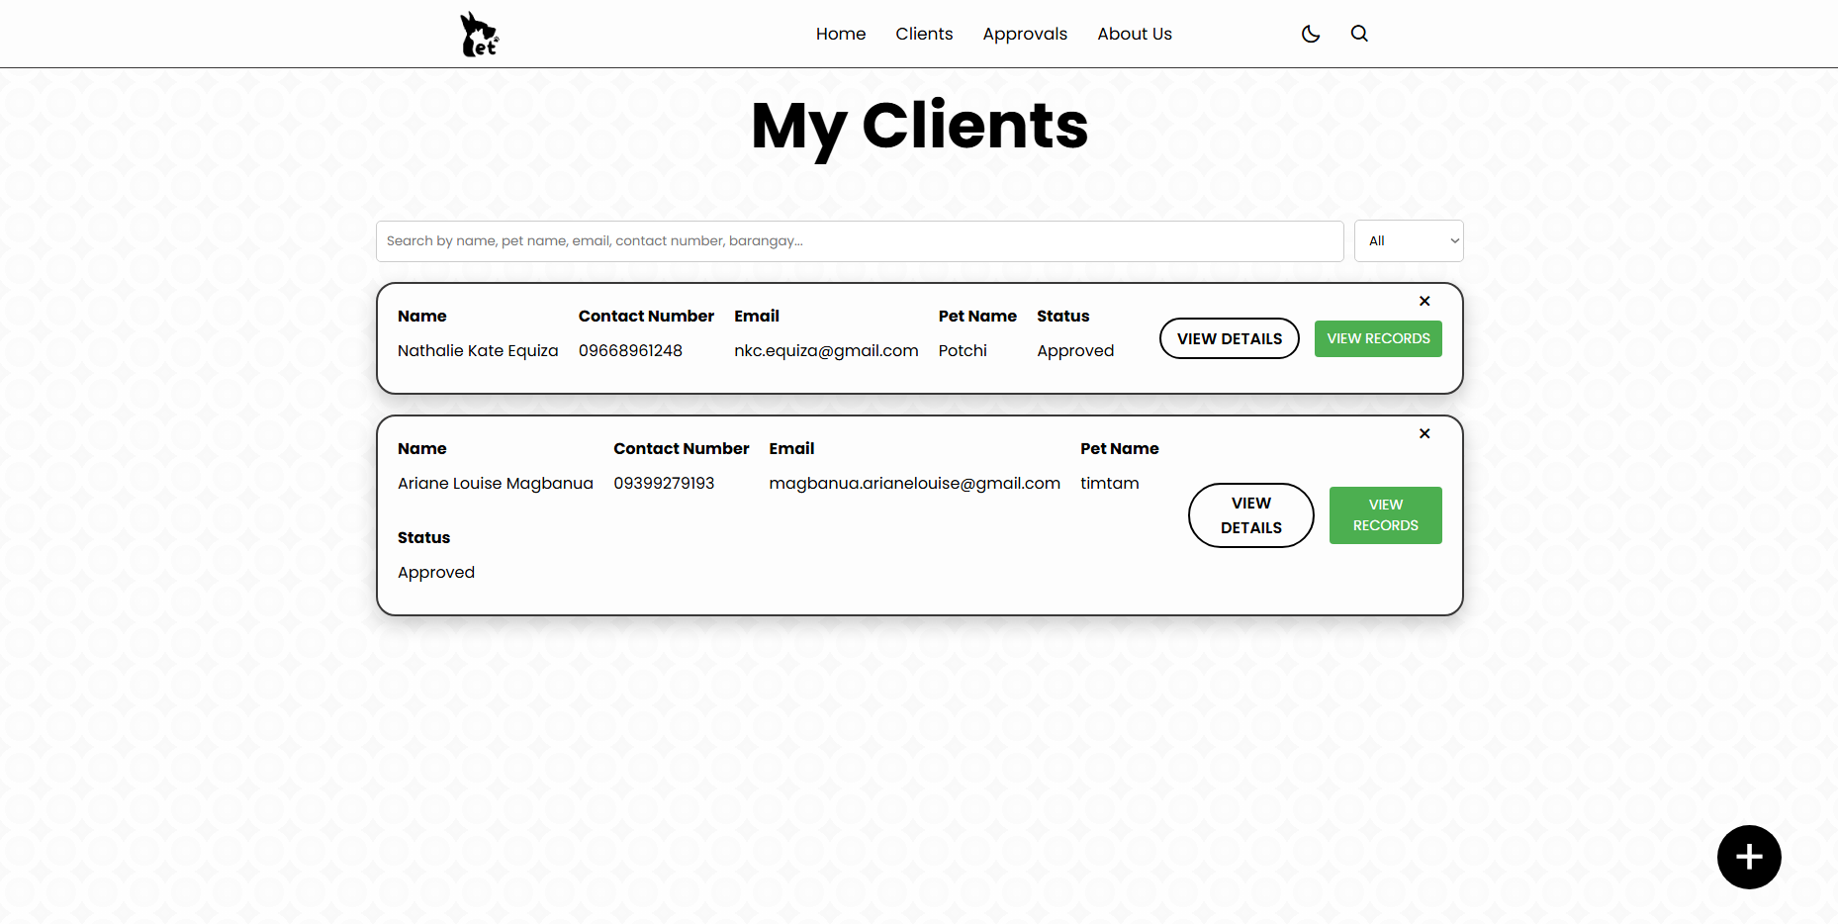
Figure 4.2.11. Clients Page for Veterinarian
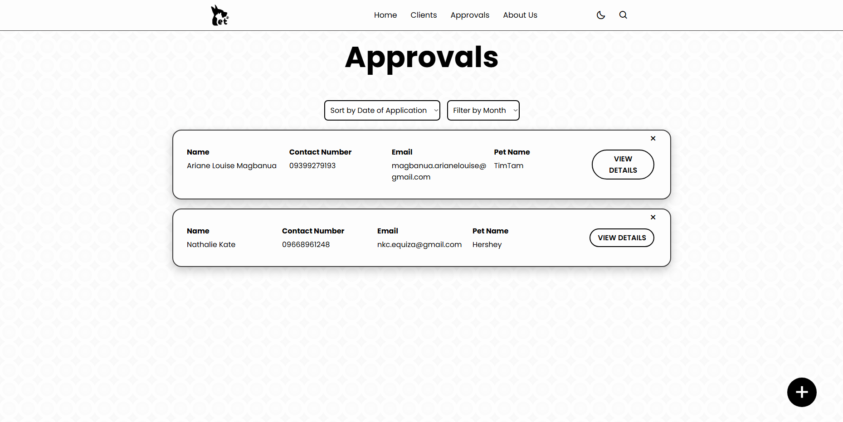
Figure 4.2.12. Approvals Page for Veterinarian
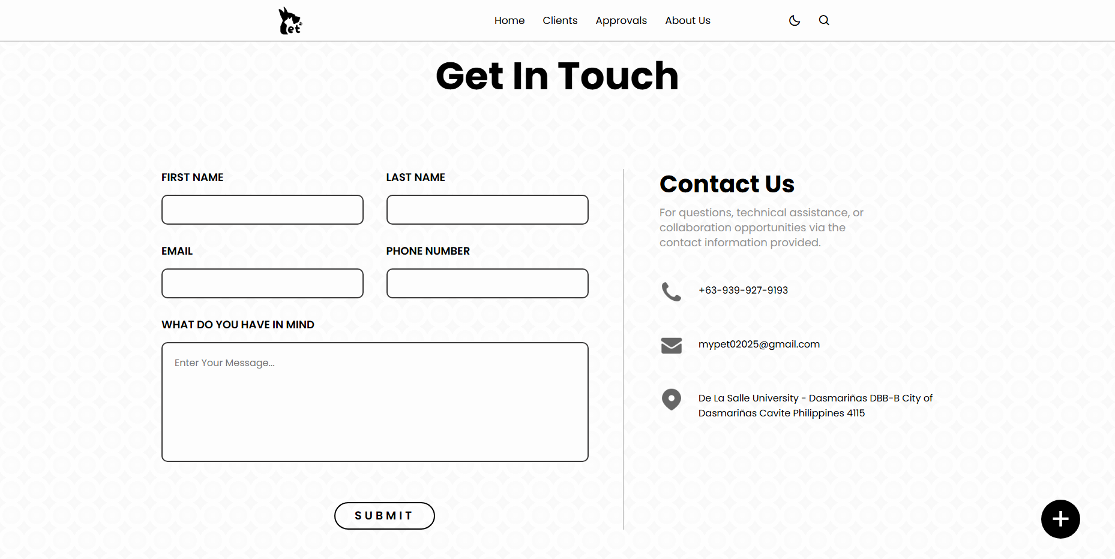
Figure 4.2.13. About Us Page for Veterinarians

LGU SECTION
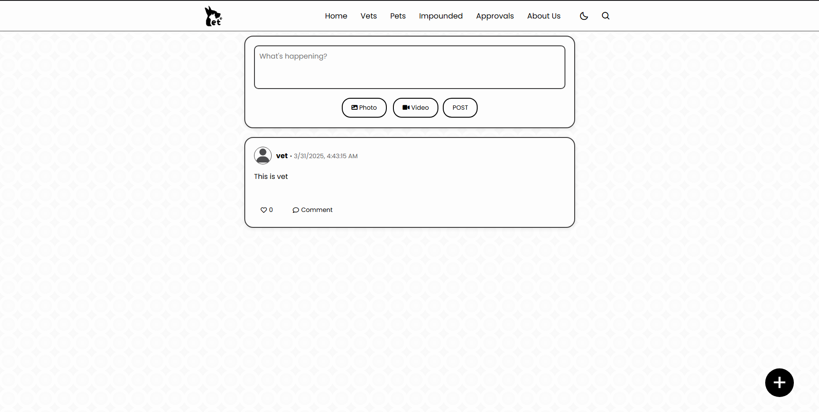
Figure 4.2.14. Home Page for LGU
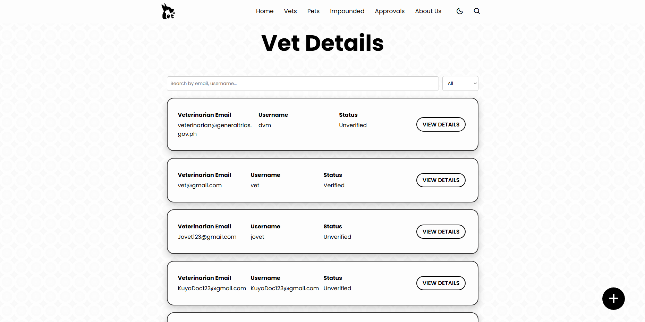
Figure 4.2.15. Veterinarian Details Page for LGU
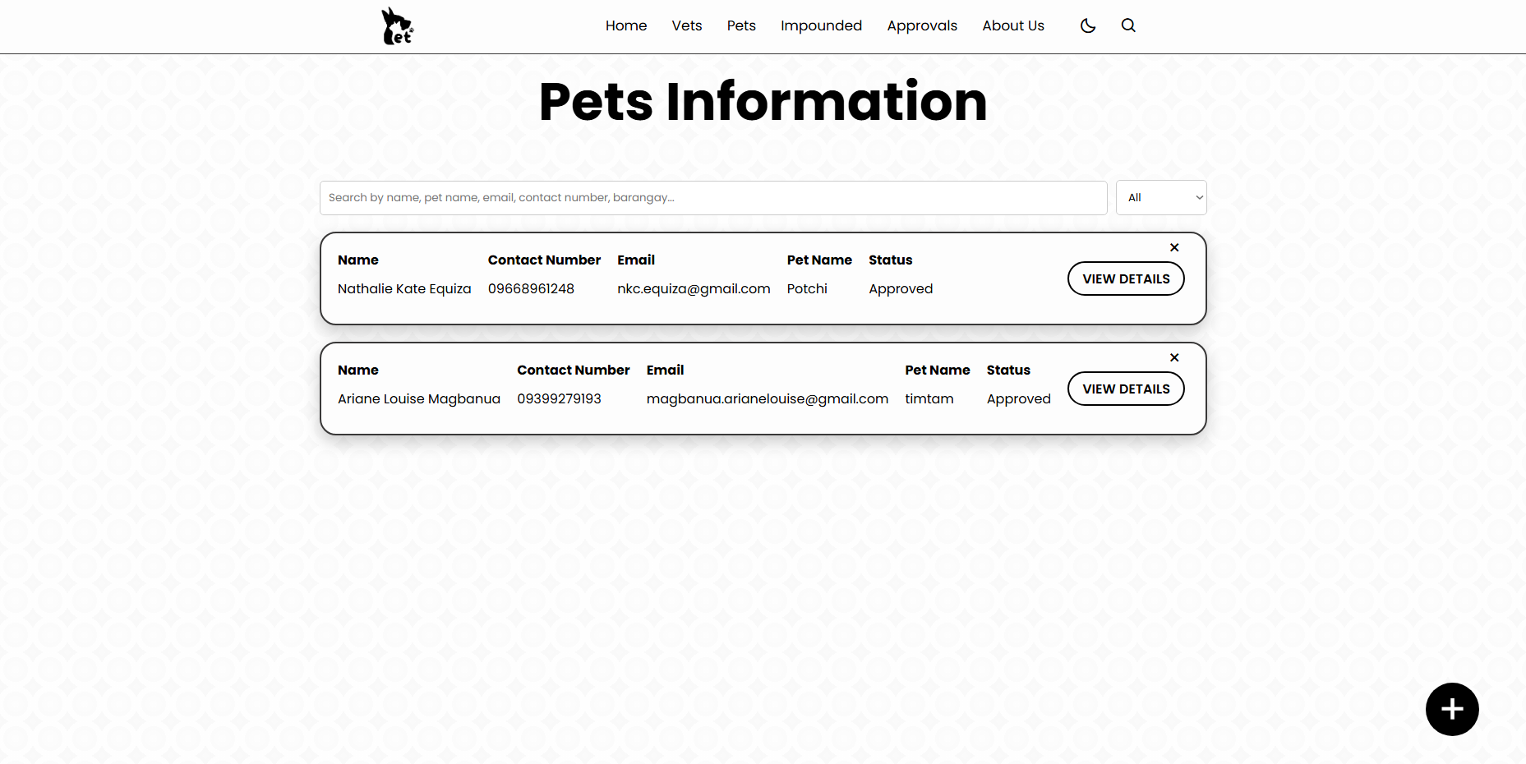
Figure 4.2.16. Pets Information Page for LGU
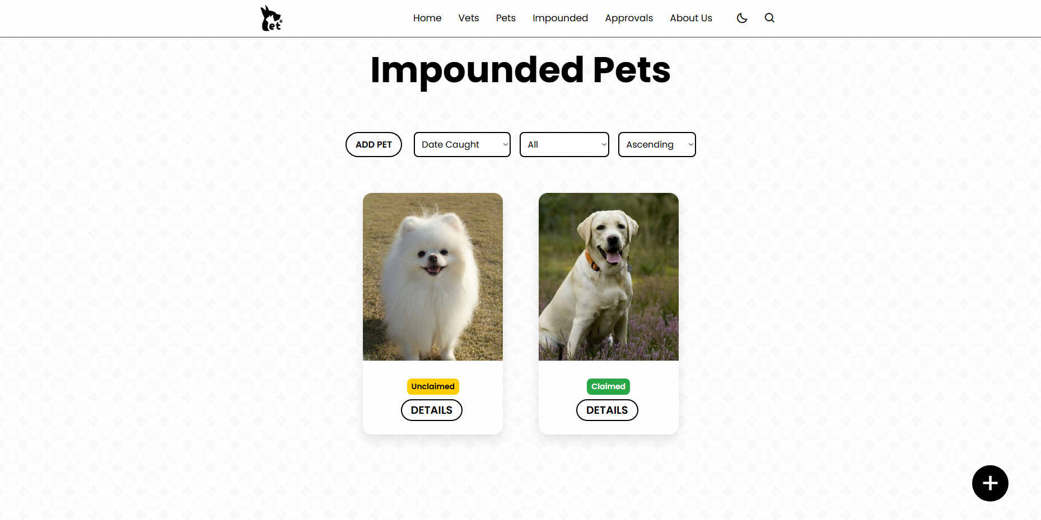
Figure 4.2.17. Impounded Pets Page for LGU
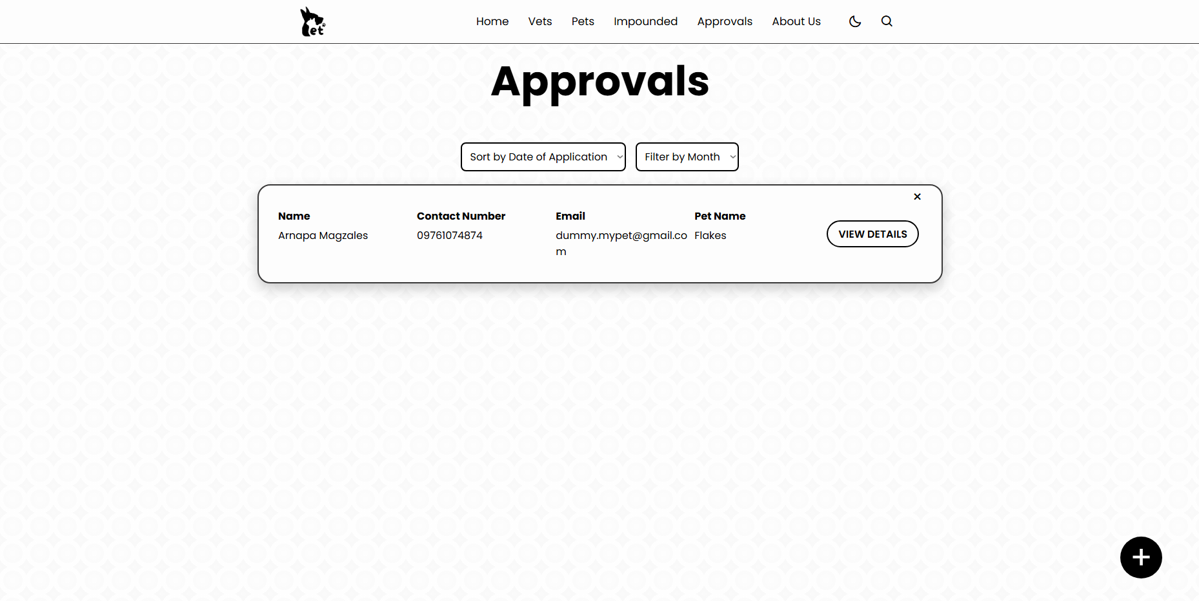
Figure 4.2.18. Approvals Page for LGU
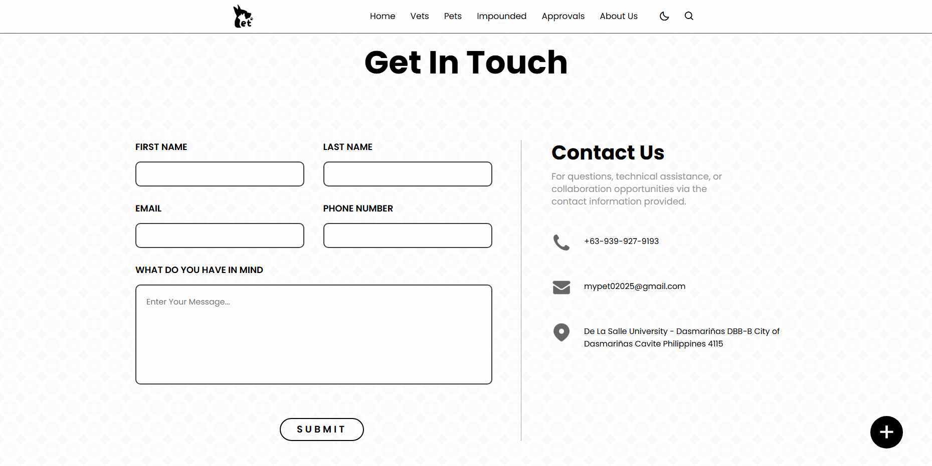
Figure 4.2.19. About Us Page for LGU
4.2.2 Database Design
The database for the "Development of a Web-Application for the Local Government Unit for Implementing the Anti-Rabies Act" is designed to store and manage data related to pet registration, impounded pets, user interactions, and community engagement. Below is a brief discussion of its key tables:

Column Name | Data Type | Description
UserID | int(11) (PK) | Unique user ID
Name | varchar(60) | Full name of the User
Bio | text | Short bio of the user
Username | varchar (255) | Unique username
Gender | varchar (60) | Gender of the user
Email | varchar(255) | User email (unique)
Password | varchar(255) | Hashed password
ProfilePic | varchar(255) | File path for profile picture
BirthDate | date | Birthdate of the user
Contact | varchar(60) | Contact number
Link_Address | longtext | Address details
Role | varchar(255) | Role (e.g., pet owner, admin)
license_proof | varchar(255) | Path or URL to the license of the users
otp_code | varchar(10) | One-time password code for verification
otp_expiry | datetime | Expiry date and time of the OTP
status | int(11) | 0 = unverified, 1 = verified, 2 = deleted
figure 4.-.- User Database Table
Users Database Table: The users table stores essential information about individuals who access the system, including pet owners, veterinarians, and government officials. This table contains details such as the user's full name, email address, contact number, and assigned role (e.g., administrator, pet owner, or veterinarian). By maintaining these records, the system ensures secure authentication and role-based access control.

Column Name | Data Type | Description
pet_id | int (11) (PK) | Unique pet ID
pets_UserID | int(11) | ID of the owner
pet_photo_owner | varchar(255) | Owner’s photo
pet_validIDName | varchar(255) | Owner’s valid ID image file
pet_date_application | date | Date of pet registration
pet_owner_name | varchar(60) | Name of the pet owner
pet_owner_age | int(11) | Age of the owner
pet_owner_gender | varchar(60) | Gender of the owner
pet_owner_birthday | date | Birthdate of the owner
pet_owner_telMobile | varchar(60) | Owner’s contact number
pet_owner_email | varchar(60) | Owner’s email address
pet_owner_home_address | varchar(60) | Owners home address
pet_owner_barangay | varchar(255) | Barangay of the owner
pet_name | varchar(60) | Name of the pet
pet_age | varchar(60) | Age of the pet
pet_gender | varchar(60) | Gender of the pet
pet_species | varchar(60) | Species of the pet (e.g., Dog)
pet_breed | varchar(60) | Breed o the pet
pet_weight | varchar(60) | Weight of the pet
pet_color | varchar(60) | Color of the pet
pet_marks | varchar(60) | Distinguishing marks of the pet
pet_birthdate | date | Pet’s date of birth
pet_antiRabies_vac_date | date | Date of last anti-rabies vaccination
pet_antiRabies_expi_date | date | Expiration date of the anti-rabies vaccination
pet_antiRabPic | varchar(255) | File path of the vaccination proof
pet_vet_clinic | varchar(255) | Name of the vet clinic
pet_vet_name | varchar(60) | Name of the Veterinarian
pet_vet_clinic_address | varchar(255) | Address of the vet clinic
pet_vet_contact_info | varchar(255) | File path of the owner’s signature
pet_date_signed | date | Date when the owner signed the registation
pet_qr_code | varchar(255) | QR code for pet identification
pet_status | varchart(255) | Status of the pet’s registration (e.g., pending, declined_by_vet)
fig 4.-.- Pets Info Database Table
Pets Info Database Table: This table maintains records of registered pets, linking them to their respective owners. It stores pet details such as species, breed, age, and vaccination status. The inclusion of a foreign key that references the users table ensures that each pet is associated with a registered owner. This table plays a crucial role in tracking pet vaccination compliance and facilitating responsible pet ownership.

Column Name | Data Type | Description
imp_id | int(11) (PK) | Unique ID for the impounded pet
imp_date_caught | date | Date when the pet was caught
imp_location_found | varchar(255) | Location where the pet was found
imp_location_impound | varchar(255) | Location where the pet was impounded
imp_days_rem | int(11) | Number of days remaining before the action is taken
impo_impounded_photo | varchar(255) | File path of the impounded pet’s photo
impo_notes | text | Additional notes about the pet
imp_status | varchar(50) | Current status of the impounded pet (e.g., Unclaimed, Pending)
imp_claim_by | int(11) | ID of the user claiming the pet (nullable)
fig 4.-.- Impounded Pets Database Table
Impounded Pets Database Table: The impounded_pets table documents animals that have been captured and placed under local government custody. It includes details such as the date of capture, the location where the pet was found, and the deadline for claiming the pet before further actions are taken. The table is linked to the pets_info table, enabling authorities to verify ownership and determine the next course of action, such as reunification with the owner.

Column Name | Data Type | Description
post_id | int(11) (PK) | Unique identifier for each post
post_date | timestamp | Date and time of post creation, updated on modification
post_user_id | int(11) | ID of the user who created the post (Foreign Key to users.UserID)
post_content | text | Content of the post (text-based).
post_images | longtext | Stores image URLs or paths (supports multiple images)
post_status | int(11) | Status of the post (0=deleted, 1=existing)
fig 4.-.- Community Posts Database Table
Community Posts Database Table: The system includes a feature that allows users to create and share posts related to lost pets, and public awareness campaigns. The posts table stores information about user-generated content, including the title, description, category, and timestamp of the post. This feature enhances public participation and serves as a platform for spreading information relevant to pet welfare and disease control.

Column Name | Data Type | Description
comments_id | int(11) (PK) | Unique identifier for each comment
comments_post_id | int(11) | ID of the post being commented on (Foreign Key to post_content.post_id)
comments_user_id | int(11) | ID of the user who made the comment (Foreign Key to users.UserID)
comments_text | text | The actual comment text
comments_date | timestamp | Timestamp of the comment, updated on modification
fig 4.-.-
Post Comments Database Table: To foster interaction within the community, users can comment on posts. The post_comments table stores comments made on specific posts, capturing details such as the comment text, user ID, and timestamp. This feature allows for discussions on lost pet reports, and other pet-related concerns.

Column Name | Data Type | Description
like_id | int(11) (PK) | Unique identifier for each like
like_user_id | int(11) | ID of the user who liked the post (Foreign Key to users.UserID)
like_post_id | int(11) | ID of the post that was liked (Foreign Key to post_content.post_id)
like_action | varchar(60) | Type of like action (e.g., “heart”)
fig 4.-.-
Post Likes Database Table: In addition to comments, users can express support for posts through a "like" feature. The post_likes table records instances of users liking posts, thereby increasing engagement and visibility of important community announcements.

Column Name | Data Type | Description
chat_id | int(11) (PK) | Unique identifier for each chat message
sender_id | int(11) | ID of the user sending the message (Foreign Key to users.UserID)
receiver_id | int(11) | ID of the user receiving the message (Foreign Key to users.UserID)
message_text | text | Content of the message
message_media | varchar(255) | Path or URL to any attached media (optional)
message_status | int(11) | Status of the message (0=deleted, 1=existing)
message_seen | int(11) | Seen status (1=seen, 0=unseen)
fig 4.-.- Chat Messages Database Table
Chat Messages Database Table: To facilitate direct communication between users, the system includes a messaging feature. The chat_messages table stores messages exchanged between users, ensuring private and secure communication regarding lost pet reports, and other concerns.

Column Name | Data Type | Description
ph_id | int(11) (PK) | Unique identifier for each pet history update
ph_pet_id | int(11) | ID of the pet (Foreign Key to pets_info.pet_id)
ph_pet_antiRabies_vac_date | date | Date when the pet received the anti-rabies vaccination
ph_pet_antiRabies_expi_date | date | Expiry date of the anti-rabies vaccination
ph_update_at | timestamp | Timestamp of the update, automatically updated on modification
fig 4.-.- Pets Info History Update:
Pets Info History Update: The pets_info_history_update table keeps track of updates to a pet’s anti-rabies vaccination records. This table stores the historical vaccination data of pets, ensuring that previous vaccination dates and expiry dates are preserved whenever updates occur. It helps in maintaining a timeline of a pet’s vaccination history, which is crucial for monitoring compliance with anti-rabies laws and regulations.

4.3 Validation
For your Guide Only

Data Gathering Design Validation

- Available Tools | -Design |  | -Functionality Test
-Experts (what the system/ | -Code |  | -Performance Test
Product is for) | -Build |  | -Usability Test
-End-users (what they want/ | Product, |  | -Experts
Expect from the system/product) | Software, |  | -End-users
-Interview | Device/Prototype
-Survey
-Observation -Questionnaire
-etc.
4.3.1 System Testing
4.3.2 Functionality Test
4.3.3 Performance Test
4.3.4 Usability Test
4.3.5 Compatibility Test
4.3.6 Speed Test
4.3.7 Feedback from End-users (validators, benefactors)
4.3.8 Comparative Analysis Between manual and Automated
4.3.8 Cost Analysis
.
.
.
And so on, if only applicable
Note:
Data should be presented in Tabular Form, Graphical Form and Discuss fully with interpretation
Include Table Heading/Title, units and Interpretation
Include Data visualization Appendix:
Include Photodocs of Testing
Certification by the clients (Experts and End-users)
Discussion of the whole Testing process (number of participants, locations, comments and suggestions/feedback, photos)
-report accurately
-even the results are negative, report it and say the information nicely and we are after in your recommendations based on their negative feedback.

Safety: The risk to humans or the environment
Accuracy: The difference between the expected truth and the actual parameter
Precision: The number of distinguishable measurements
Maintainability: The flexibility with which the device can be modified
Testability: The ease with which proper operation of the device can be verified
Compatibility: The conformance of the device to existing standards, if can be used in different platforms
Mean time between failure: The reliability of the device, the life of a product Nonrecurring engineering cost (NRE cost): The one-time cost to design and test
Unit cost: The cost required to manufacture one additional product
Time-to-market: The time required to deliver the product to the customer
Human factors: The degree to which our customers like/appreciate the product

System Quality Metrics
Quality | Operational Definition
Functionality | The ability of the system to perform its specific functions.
Reliability and performance | The ability of the system to provide a consistent correct output and maintain fast response for the user.
Ease of Use | The ability of the system to provide a userfriendly layout east navigation and operation.
Significance | The ability of the System to solve the statement of the problem of the study.
Sustainability | Further improvements in terms of the system’s functionality.

