REGISTRATION PAGE

Create Your Account
Welcome to the St. Francis Square Realty Real Estate Portal
Create an account to schedule a site viewing, reserve your preferred property, and monitor your transactions online.

Personal Information
First Name *
[______________________________]
Middle Name (Optional)
[______________________________]
Last Name *
[______________________________]
Suffix (Jr., Sr., III, etc.)
[__________________________________]
Date of Birth *
[ Select Date ]

Sex *
- ○ Male
- ○ Female
- ○ Prefer not to say
Mobile Number *
[______________________________]
Email Address *
[______________________________]
Account Credentials
Username *
6–20 characters. Letters and numbers only.
[______________________________]

Password *
Password must contain at least:
- 8 characters
- One uppercase letter
- One lowercase letter
- One number
- One special character
[______________________________]
Confirm Password *
[______________________________]
☐ Show Password
Verification
☐ I am not a robot.
Privacy Consent
☐ I certify that the information provided is true and correct.
☐ I have read and agree to the Terms and Conditions and Privacy Policy.
☐ I authorize St. Francis Square Realty Corporation to collect and process my personal information in accordance with the Data Privacy Act of 2012 (Republic Act No. 10173) for reservation processing and other legitimate business purposes.

Buttons
[ CREATE ACCOUNT ]
[ CLEAR ]
Already have an account?
Sign In

FUNCTION

The Registration Page allows prospective buyers to create an Initial Account in the St. Francis Square Realty Real Estate Management System (SFSR-REMS). Users are required to provide their personal information, create secure login credentials, complete CAPTCHA verification, and agree to the Terms and Conditions, Privacy Policy, and Data Privacy Consent. Upon successful registration, the system validates the submitted information and creates an Initial Account, enabling users to schedule property trippings, submit reservation applications, upload documentary requirements and proof of payment, and monitor their reservation status.

Once the reservation is approved and the Contract to Sell has been signed, the Permanent Client Account is created and activated by authorized St. Francis Square Realty Corporation personnel. The client is then provided with the permanent login credentials. For record integrity and audit purposes, the assigned username remains permanent and cannot be changed, while the client is required to change the initial system-generated password upon first login to maintain account security.

LOGIN PAGE

Welcome Back!
Sign in to access your Client Portal.

Login Credentials

Username
[________________________________]
Password
[________________________________]
☐ Show Password
☐ Remember Me

Buttons
[ SIGN IN ]
Forgot your password?
Reset Password
Don't have an account?
Create an Account

FUNCTION

The Login Page allows registered users to securely access the St. Francis Square Realty Real Estate Management System (SFSR-REMS) using their username and password. The page includes options to show or hide the password, remember login credentials, and reset a forgotten password.
Upon successful authentication, the system grants access based on the user's account type. Users with an Initial (Temporary) Account may browse available condominium units, schedule site viewings, submit reservation applications, upload documentary requirements and proof of payment, and monitor their reservation status.
Once the reservation has been confirmed and the Contract to Sell has been signed, authorized St. Francis Square Realty Corporation personnel issue and activate the Permanent Client Account. Clients with a Permanent Account are provided with additional features, including viewing account details, uploaded documents, Statements of Account (SOA), payment history, announcements, and transaction notifications. For security and record integrity, the assigned username remains permanent, while the client may change the initial system-generated password upon first login.

Note: After Signing In
Once logged in, clients can:
Temporary Account:
- Browse available condominium units
- Reserve a unit
- Schedule a site viewing
- Upload documentary requirements
- Upload proof of payment
- View reservation status

Permanent Account (If reservation confirmed, SFS will issue permanent log in account)
- Browse available condominium units
- Can Reserve a unit again
- Schedule a site viewing
- Upload documentary requirements
- Upload proof of payment
- View reservation status
- View Account Details
- View Documents Uploaded
- View Statement of Account (SOA)
- Monitor payment history
- Receive announcements and notifications

RESERVATION

*Before the buyer navigate to the reservation page he/she needs to choose unit in the list.

Property Details
Developer
St. Francis Square Realty Corporation

Project: ▼
Unit Number: ▼(based on available unit
Unit Type: ▼ (system generated, based on the chosen unit)
- Studio
- One Bedroom
- Two Bedroom
- Three Bedroom
- Penthouse
Floor Area: __________ sqm system generated – based on the database
Floor: ▼
Price per Square Meter: ₱______________ system generated – based on the database
Unit Purchase Price: ₱________________ system generated – based on the database

Parking Space (Optional)
☐ No Parking
☐ With Parking
If with Parking:
Parking Space No.: ▼
Parking Type (system generated – based on the database)
- Regular
- Premium
- Tandem
Parking Area: ________ sqm
Parking Purchase Price: ₱________________ (system generated – based on the database)

ST. FRANCIS SQUARE REALTY CORPORATION

CONDOMINIUM UNIT RESERVATION APPLICATION
Please complete this reservation application accurately. Fields marked with (*) are required. Your reservation application will be subject to document verification, payment verification, and approval by St. Francis Square Realty Corporation.

Reservation No.: _______________________ (System Generated)
Reservation Date: _______________________ (System Generated)
Sales Agent: _______________________
Project: __________________ (System Generated)
Unit No.________________ (System Generated)
Parking Space No. ___________ (System Generated)

STEP 1 – BUYER INFORMATION
Personal Information
First Name:* ___________________________ (System Generated, get the info in the database log in)
Middle Name: ___________________________
Last Name:* ___________________________
Date of Birth:* ___________________________
Sex:* ○ Male ○ Female
Civil Status:* ▼
- Single
- Married
- Widowed
- Separated
Nationality:* ___________________________
TIN: ___________________________

Contact Information
Mobile Number:* ___________________________
Email Address:* ___________________________

Current Address
House/Unit No.: _______________________
Street: _______________________
Barangay: _______________________
City/Municipality: _______________________
Province: _______________________
ZIP Code: _______________________

PURCHASE PRICE
Description | Amount
Unit Purchase Price | ₱____________
Parking Purchase Price | ₱____________
Total Purchase Price | ₱____________

STEP 2 – PAYMENT TERMS
Reservation Fee
₱_________________ (System Generated- put 50,000.00)

Down Payment
Select Down Payment Percentage
▼
- 10%
- 20%
- 30%
- 40%
- 50%

Promotional Discount
▼ None
▼ Promotional Discount
Discount Amount
₱_________________

Down Payment Installment
Select Payment Term
▼
- Spot Cash
- 6 Months
- 12 Months
- 18 Months
- 24 Months
- 30 Months
- 36 Months

Balance Payment
Financing Option
▼
- Bank Financing
- PAG-IBIG Fund
- Cash Payment

STEP 3 – PAYMENT SUMMARY
Description | Amount
Total Purchase Price | ₱____________
Down Payment | ₱____________
Less: Reservation Fee | (₱____________)
Less: Promotional Discount | (₱____________)
Net Down Payment Required | ₱____________
Monthly Down Payment | ₱____________
Balance on Total Purchase Price | ₱____________
Note: All computations are automatically generated by the system based on the selected payment terms.

Discount amount – if 40% to 50% downpayment – 10% discount of total purchase price
If 30% downpayment – 5% discount of total purchase price
If 20% downpayment – 10% of the downpayment
If 10% downpayment – no discount
System will compute the discount and automatically display

STEP 4 – REVIEW RESERVATION DETAILS
Before submitting your reservation application, please review the information below.
Buyer Information
- Buyer Name
- Mobile Number
- Email Address
- Address
Property Information
- Project
- Tower
- Floor
- Unit Number
- Unit Type
- Floor Area
- Parking Space (if applicable)
Payment Information
- Reservation Fee
- Down Payment
- Promotional Discount
- Monthly Down Payment
- Financing Option
- Total Purchase Price
- Balance on Total Purchase Price

Action Buttons
[ REVIEW DETAILS ]
Displays the complete reservation summary.
[ EDIT INFORMATION ]
Returns to the reservation form to update any incorrect information before submission.

STEP 5 – UPLOAD PROOF OF RESERVATION PAYMENT
Upload your reservation payment receipt.
Accepted File Types
✔ PDF
✔ JPG
✔ JPEG
✔ PNG
Maximum File Size: 10 MB
Choose File
📎 ___________________________

Payment Information
Payment Date
📅 ___________________________
Reference Number

Payment Channel
▼
- Bank Deposit
- Online Banking
- GCash
- Maya
- Check
- Cash
Amount Paid
₱_________________

STEP 6 – DOCUMENTARY REQUIREMENTS

Upload your valid government issued ID
Accepted File Types
✔ PDF
✔ JPG
✔ JPEG
✔ PNG
Maximum File Size: 10 MB
Choose ID type
Choose File
📎 ___________________________

The following documents shall be uploaded after the reservation application has been submitted or upon request by the Sales Department.
☐ BIR Form No. 1904 / TIN
☐ Proof of Billing
☐ Certificate of Employment / Proof of Income
☐ Marriage Certificate (if applicable)
☐ Special Power of Attorney (if applicable)
☐ Other Supporting Documents
Note: Uploaded documents will undergo OCR-based document validation. Final verification and approval shall be performed by authorized personnel.

STEP 7 – TERMS AND CONDITIONS
- The reservation application shall be processed only after the reservation fee has been verified by the Billing Department.
- Once payment has been verified, the selected unit shall be placed under On Hold status while the reservation is being evaluated.
- The Buyer shall submit all required documentary requirements within thirty (30) calendar days from the reservation date.
- The reservation fee shall form part of the purchase price and is NON-REFUNDABLE and NON-TRANSFERABLE, except when the reservation is cancelled by St. Francis Square Realty Corporation due to reasons attributable to the company or as otherwise required by applicable law.
- Failure to submit the required documents, failure to comply with the approved payment schedule, submission of false or fraudulent information, or voluntary withdrawal of the reservation application may result in cancellation of the reservation in accordance with company policy and applicable laws.
- Submission of proof of payment does not automatically constitute payment confirmation. All payments remain subject to verification by the Billing and Accounting Departments.
- All uploaded documents shall be processed using OCR technology to assist in document validation. Final approval shall be made by authorized company personnel.
- This reservation is personal to the Buyer and may not be assigned or transferred without the prior written consent of St. Francis Square Realty Corporation.
- The Developer reserves the right to make reasonable changes to building plans, specifications, finishes, and materials due to engineering requirements, government regulations, or material availability.
- The Developer reserves the right to approve, reject, or cancel any reservation application that does not comply with company policies or legal requirements.
- Personal information collected through this system shall be processed in accordance with the Data Privacy Act of 2012 (Republic Act No. 10173) and shall be used solely for reservation processing, financing, billing, customer support, and other legitimate business purposes.

STEP 8 – BUYER'S DECLARATION
☐ I certify that all information provided in this reservation application is true, complete, and correct.
☐ I have carefully reviewed all information entered in this reservation application.
☐ I understand that submitting this reservation application does not automatically approve my reservation.
☐ I understand that my uploaded proof of payment and documentary requirements are subject to verification.
☐ I have read, understood, and voluntarily agree to the Reservation Terms and Conditions.

ACTION BUTTONS
[ REVIEW RESERVATION DETAILS ]
Reviews all buyer, property, and payment information before submission.
[ EDIT INFORMATION ]
Returns to the reservation form for corrections.
[ UPLOAD PROOF OF PAYMENT ]
Uploads the reservation payment receipt.
[ SUBMIT RESERVATION APPLICATION ]
Submits the reservation application for company review.

SYSTEM CONFIRMATION
After clicking Submit Reservation Application, the system displays:
Reservation Application Submitted Successfully!
Thank you for choosing St. Francis Square Realty Corporation.
Your reservation application has been successfully submitted.
Reservation Reference No.: RES-2026-000001
Current Status: Pending Payment and Document Verification
Our Sales, Billing, and Documentation Departments will verify your payment and uploaded documents. You may monitor the progress of your application through your Client Portal. You will receive a notification once your reservation has been reviewed.

FUNCTION & INSRUCTION HOW THE RESERVATION PROCESS

The Reservation Management Module enables prospective buyers to submit an online condominium unit reservation through the Web-Based Real Estate Portal of the St. Francis Square Realty Real Estate Management System (SFSR-REMS). The module automates the reservation process by capturing buyer information, property details, payment terms, proof of reservation payment, and documentary requirements. It also performs automatic computation of reservation fees, down payment, monthly amortization, and purchase price based on the selected payment terms.

The module is integrated with the centralized database to synchronize reservation information with the Internal Management System in real time. Once a reservation application is submitted, the selected condominium unit is automatically tagged as "On Hold" to prevent multiple reservations for the same unit. The reservation then undergoes payment verification, document validation, and approval by the authorized departments before the reservation is confirmed.

Reservation Process Flow
Step 1 – Property Selection
The buyer selects the desired condominium project and available unit. The system automatically displays the corresponding unit details, floor area, selling price, and optional parking space based on the selected property.

Step 2 – Buyer Information
The system automatically retrieves the buyer's basic information from the registered Initial Account. The buyer completes any remaining personal, contact, and address information required for the reservation.

Purchase Price
The system automatically computes and displays the total purchase price of the selected unit, including the parking space, if applicable.
Step 3 – Payment Terms
The buyer selects the preferred down payment percentage, installment period, promotional discount (if available), and financing option. The system automatically computes the applicable payment schedule.

Payment Summary
The system generates a complete payment summary, including the reservation fee, net down payment, monthly down payment, promotional discount, and remaining balance.

Step 4 – Review Reservation Details
The buyer reviews all reservation information before submission. The system allows the buyer to edit any incorrect information or proceed with the reservation.

Step 5 – Upload Proof of Reservation Payment
The buyer uploads the proof of reservation payment together with the payment details, including the payment date, reference number, payment channel, and amount paid.

Step 6 – Upload Documentary Requirements
The buyer uploads the required documentary requirements in PDF, JPG, JPEG, or PNG format. The system performs Document Type Validation to verify whether the uploaded file matches the selected document type. If an incorrect document is detected, the system immediately notifies the buyer and requests the correct document before submission. Once the correct document type is confirmed, Optical Character Recognition (OCR) extracts the document information, while the Levenshtein Distance Algorithm compares the extracted text with the expected information stored in the database to assist authorized personnel during document validation.
Step 7 – Terms and Conditions
The buyer reads and accepts the Reservation Terms and Conditions before proceeding with the application.

Step 8 – Buyer's Declaration

Step 9 – Submit.

Reservation Processing

After the buyer submits the reservation application, the system automatically generates a Reservation Reference Number, saves the transaction in the centralized database, and sets the reservation status to Pending Payment Verification.

The Account Receivable first verifies the reservation fee, it will be coordinated to the cash clerk if payment was credited to the bank account. Once the payment has been verified and approved, the selected unit is automatically tagged as On Hold across both the Web-Based Real Estate Portal and the Internal Management System, preventing other prospective buyers from reserving the same unit.

The reservation then proceeds to the Documentation Department, where the uploaded identification documents and other documentary requirements undergo Document Type Validation, OCR processing, and Levenshtein Distance validation to assist authorized personnel in verifying the submitted information. The reservation fee and uploaded identification documents are subject to final verification by the authorized personnel.

If the payment and documentary requirements are successfully verified, the reservation is approved, and the unit status is automatically changed from On Hold to Sold, making it unavailable for reservation on both integrated platforms. Official receipt will be issued by cash clerk and will be uploaded by the billing

If deficiencies are found, the buyer is notified through the Client Portal and is given 24 hours to submit the missing or corrected payment or documentary requirements. If the buyer fails to comply within the given period, the reservation is listed in the system's Expired Reservation Report for monitoring.

The system does not automatically cancel expired reservations. Instead, authorized St. Francis Square Realty Corporation personnel review the expired reservations and, upon management approval, manually process the cancellation through the Internal Management System. The reservation record is retained in the database and tagged as Cancelled for audit and historical purposes, while the condominium unit is automatically returned to Available status and becomes open for reservation again.

Once the buyer signs the Contract to Sell, the Documentation Staff creates and activates the Permanent Client Account. The client is then issued the permanent login credentials, allowing access to additional Client Portal features such as viewing the Statement of Account (SOA), payment history, uploaded documents, announcements, notifications, and transaction monitoring. For security and record integrity, the assigned username remains permanent, while the client is required to change the initial system-generated password upon first login.

business workflow:

Login → Browse Available Units → Select Unit → Complete Reservation → Upload Payment & ID → System verify upload document if correct→ Submit reservation → Unit becomes On Hold → Payment Verification & Documentation Verification by St francis Employee → Sales Approval → Unit becomes Sold → Contract Signing → Permanent Client Account Issued.

Note: See Picture as reference for details and how reservation process.. You may design your own interface

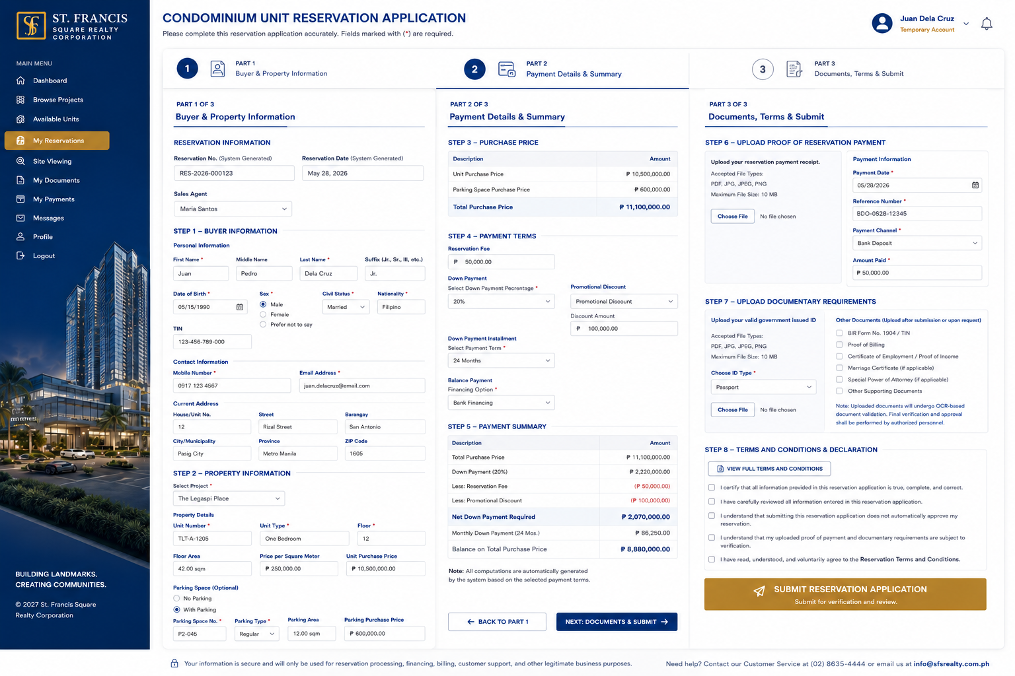

Note: Gusto ko din sana ang menu(option) pag sa portal na ni buyer is nasa gilid. Mas neat kasi tignan. Para nasa isang side lang. gaya sa picture.

