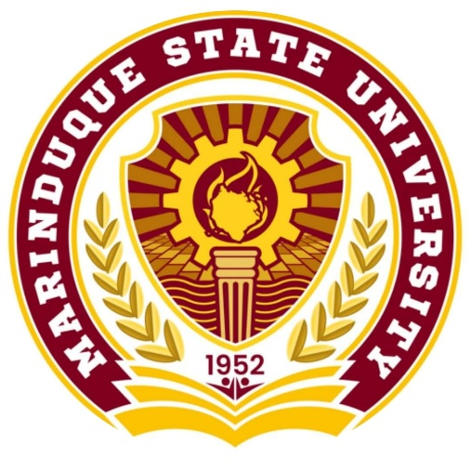

MARINDUQUE STATE UNIVERSITY

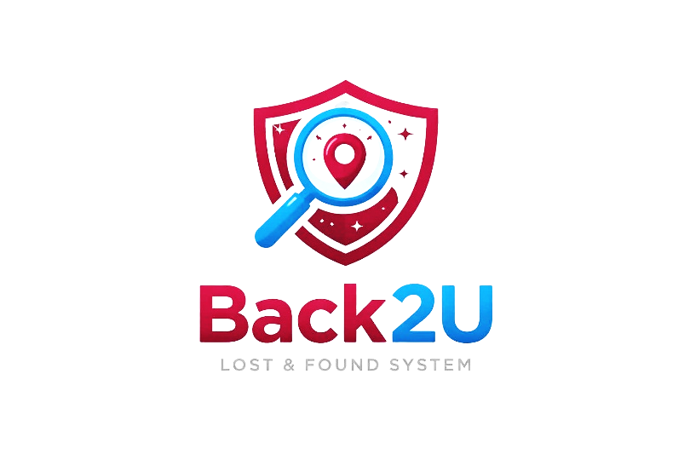

System Logo


Color Theme ( maroon/burgundy/white)
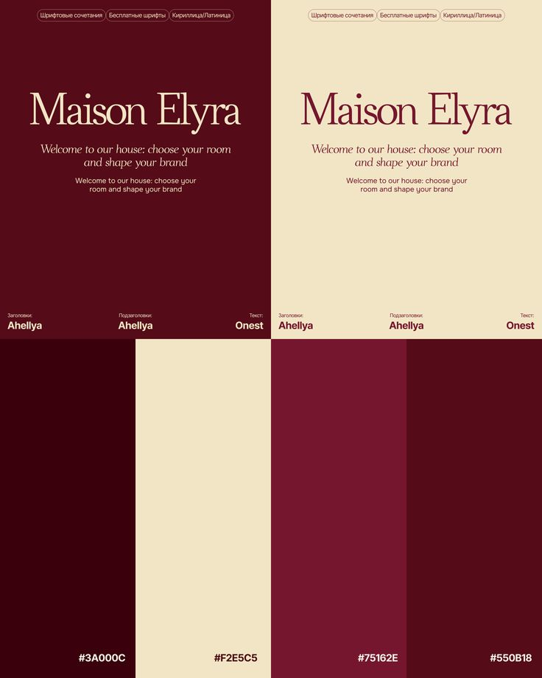

Software Name - Back2U instead of Returnix
Background
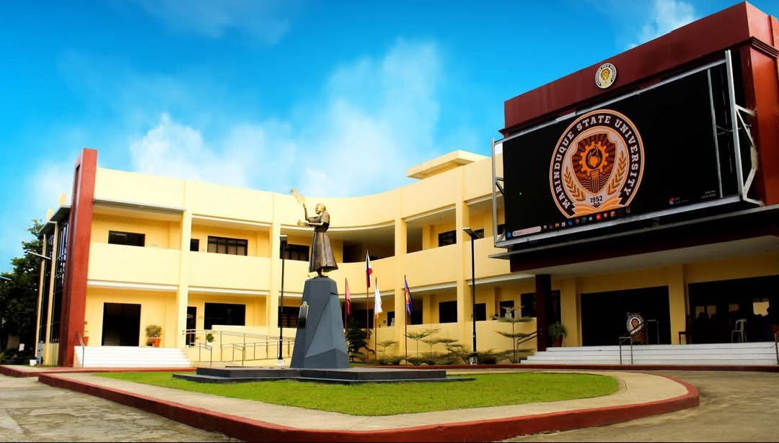

Either this or this one
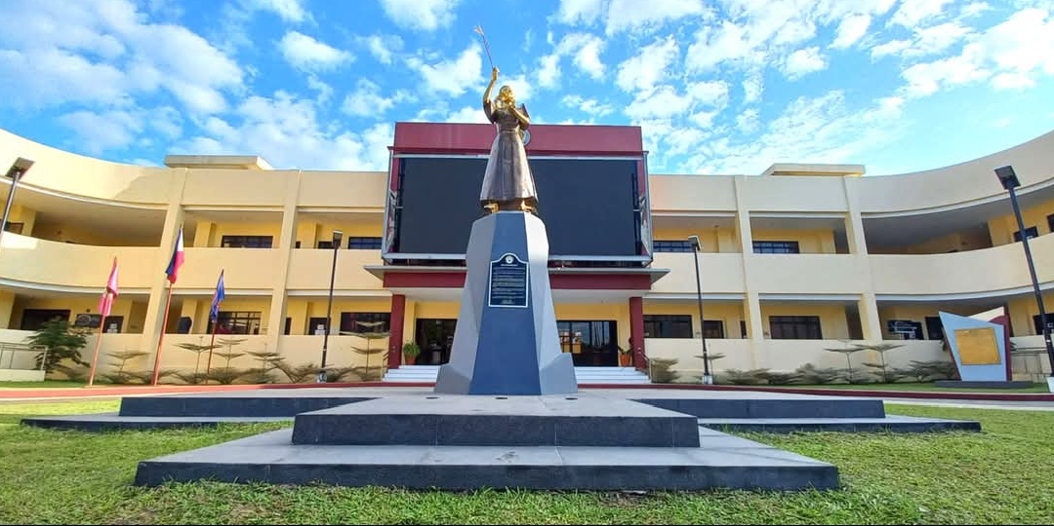

Other Concern
- Is it okay po na may mag no-notif din sa user through email about sa claim status po so that mas manonotify din po agad ang user.
- And okay lang po ba if for example nag report ng lost item ang isang user pero wala ung item nya sa report or pinost ng security personnel which is wala yong item nya sa search and matching Items so, much better po sana if may maga email din sa user na something like ( Sorry but for now we don’t have any items that is similar to your report items we will notify you once we already have similar items like yours so you can search for matching and claim if it yours). for example lang po sana

