Data Science Assignment — Tasks 1–3
Clustering, Dimensionality Reduction, Feature Selection, Time-Series Forecasting & Sentiment Analysis
Author: Allen Mendiola
Tools: Python, scikit-learn, statsmodels, Matplotlib/Seaborn, TextBlob/VADER
This document collates the written responses, results and interpretations for all parts. Each part has an accompanying Python script that reproduces the figures and numbers cited here.

Task 1 — Part 1: Customer Segmentation with K-Means (Mall_Customers)
Script: task1/part1/task1_part1_kmeans.py

Method
- Features used: Age, Annual Income (k$), Spending Score (1–100), standardised with StandardScaler. CustomerID is an identifier; Gender is kept only for profiling.
- Elbow method (inertia) and Silhouette analysis were run for k = 2..10.
- The inertia curve bends clearly around k = 5 (elbow). The silhouette score is high and stable from k = 5 (0.417) onward, peaking marginally at k = 6 (0.428). k = 5 was chosen as it sits at the elbow and yields the cleanest, most interpretable, well-separated segments.
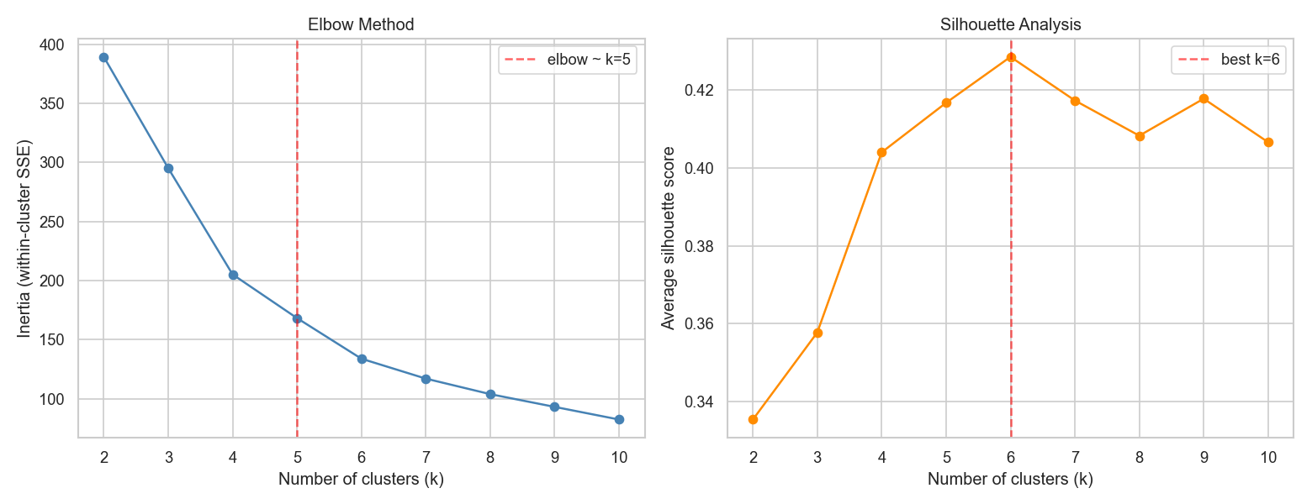
Figure 1.1.1 — Elbow method and silhouette analysis.
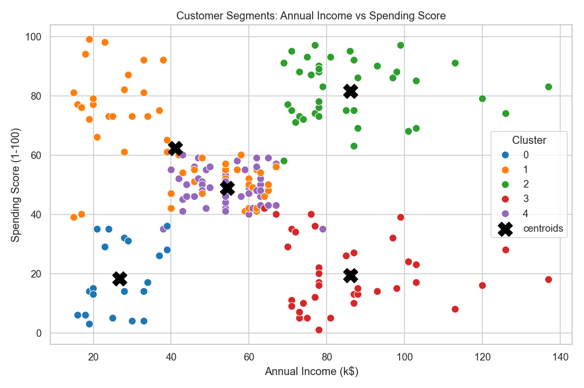
Figure 1.1.2 — Final 5 segments: Annual Income vs Spending Score (centroids in black).

Cluster profiles & business insights (k = 5)
- Cluster 2 — Premium / Target (n=40): high income (~86k), high spending (~82), avg age 33. Best ROI for loyalty programmes, premium products and personalised offers.
- Cluster 3 — Wealthy but frugal (n=39): high income (~86k), low spending (~19). Untapped potential — investigate why they don't spend; targeted incentives could convert them.
- Cluster 1 — Young enthusiasts (n=54): young (~25), moderate income (~41k), high spending (~62). Trend-driven, responsive to promotions and social campaigns.
- Cluster 4 — Mainstream / Standard (n=47): older (~56), mid income/spend. Stable core customers; retain with value bundles.
- Cluster 0 — Low value (n=20): low income (~27k), low spending (~18). Low-cost engagement only (discounts, essentials).

Question 1 — Why is choosing the number of clusters crucial? Elbow vs Silhouette.
The number of clusters defines the segmentation itself. Too few clusters merge distinct customer groups (e.g. premium spenders blended with frugal high-earners), so marketing is mistargeted; too many clusters fragment the base into tiny, non-actionable groups and overfit noise. The Elbow method plots within-cluster SSE (inertia) against k and looks for the 'elbow' where adding clusters stops yielding large gains — it is fast and intuitive but subjective when the bend is gradual. Silhouette analysis measures how well each point fits its own cluster versus the nearest other cluster (range −1..1); it gives a quantitative, comparable score and also reveals mis-assigned points. Prefer the Elbow for a quick first estimate; prefer Silhouette when the elbow is ambiguous or when you need an objective, defensible choice. Using both together (as done here) is best practice.

Question 2 — Key limitations of K-Means and how to address them.
- Poor initialisation: random seeds can converge to bad local optima. Mitigation: k-means++ initialisation (default here) and n_init multiple restarts.
- Sensitivity to outliers: means are pulled by extreme values. Mitigation: remove/cap outliers, or use K-Medoids / robust scaling.
- Assumes spherical, equal-size clusters (Euclidean): fails on elongated or density-varying shapes. Mitigation: Gaussian Mixture Models, DBSCAN or spectral clustering.
- Requires k in advance and needs feature scaling: address with Elbow/Silhouette and standardisation (both done here).

Task 1 — Part 2: PCA on the Wine Quality Dataset (winequality-red)
Script: task1/part2/task1_part2_pca.py

Preprocessing & results
- No missing values. 11 physicochemical features were standardised (mean 0, std 1); the target `quality` was excluded from PCA.
- Minimum components to retain ≥90% variance: 7 (cumulative variance reaches 90.83% at PC7). PC1 explains 28.2% and PC2 17.5% (45.7% together).
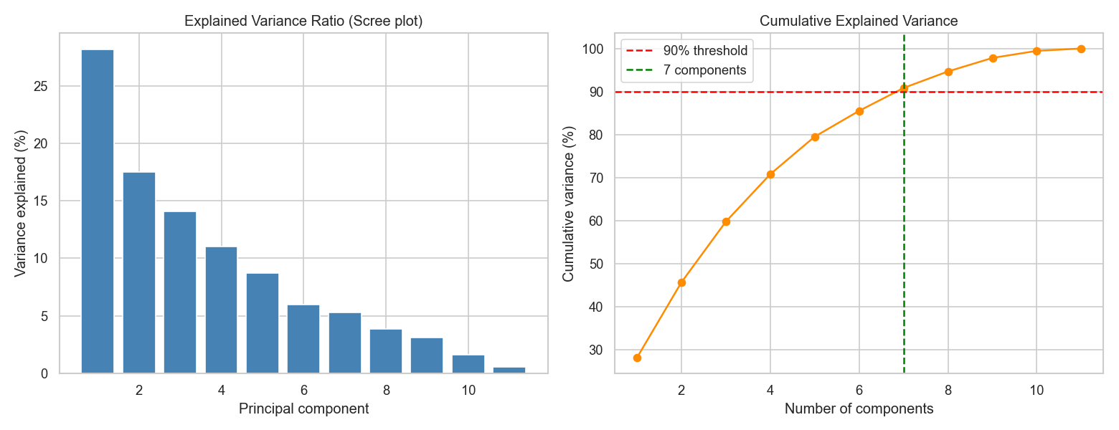
Figure 1.2.1 — Scree plot and cumulative explained variance (90% line at 7 components).
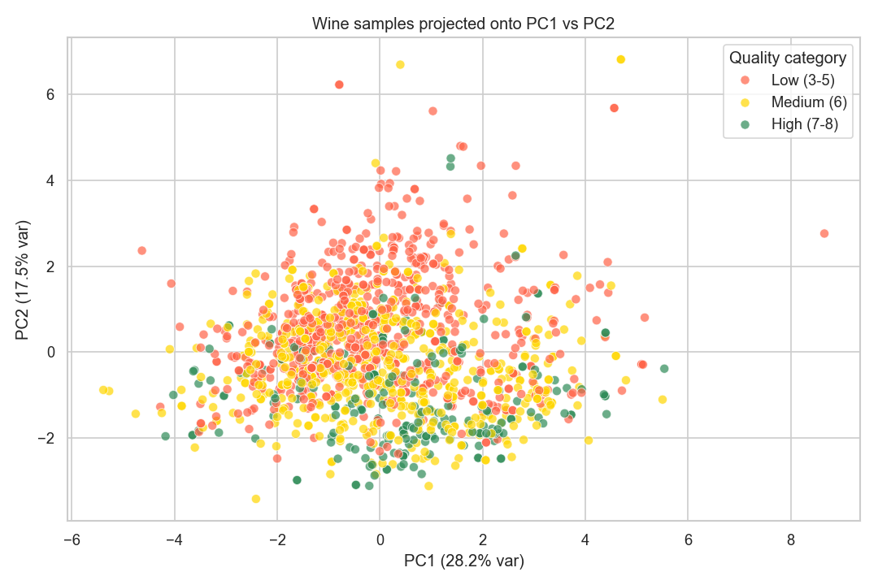
Figure 1.2.2 — Wines in PC1–PC2 space coloured by quality category.

Interpretation / reflection
- Components for 90% variance: 7 of 11 — modest reduction, indicating the variance is spread across many features rather than concentrated in a few.
- 2D plot observation: the three quality categories (Low 3–5, Medium 6, High 7–8) overlap heavily — there are NO clean, separable clusters by quality in the first two PCs. Quality is only weakly aligned with the directions of greatest variance.
- Feature correlations/redundancy: PC1 is an 'acidity' axis (high positive loadings on fixed acidity, citric acid, density; strong negative on pH). PC2 is a 'sulphur dioxide' axis (free + total SO₂). These groupings reveal correlated/redundant feature blocks.

Classification: original features vs reduced components
A LogisticRegression classifier (3 quality classes, 5-fold CV accuracy) was trained on the original features versus the PCA-reduced components:
- Original 11 standardised features: 0.612
- PCA, 7 components (≥90% variance): 0.607 — essentially the same accuracy with 4 fewer dimensions, showing PCA preserves almost all predictive signal while reducing dimensionality.
- PCA, 2 components: 0.538 — a clear drop, confirming the first two PCs alone are insufficient (consistent with the overlapping 2D scatter).
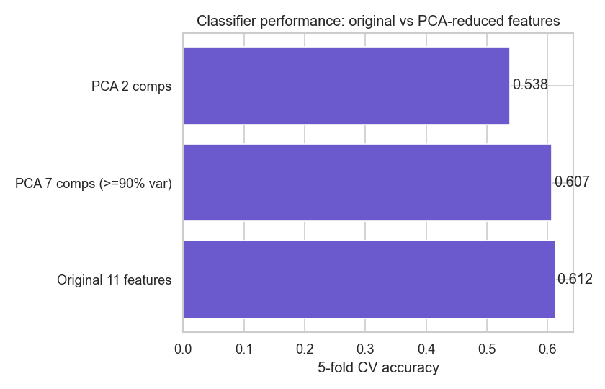
Figure 1.2.3 — Classifier accuracy: original vs PCA-reduced features.

Question 1 — How does PCA identify redundant/less-informative features?
PCA rotates the data onto orthogonal axes ordered by variance. Features that are strongly correlated load together on the same component, so their shared information is captured once — exposing redundancy (here acidity-related features cluster on PC1, SO₂ features on PC2). Components with very small explained variance (the last PCs) correspond to directions where the data barely changes; features dominating only those directions carry little discriminative information and can often be dropped, reducing dimensionality without losing much signal.

Question 2 — Why standardise before PCA, and what happens if we skip it?
PCA maximises variance, and variance is scale-dependent. Without standardisation a feature with a large numeric range (e.g. total sulfur dioxide, tens–hundreds) would dominate the first components purely because of its units, while small-scale features (e.g. chlorides or density near 1) are ignored — the result reflects measurement units, not true structure. Standardising to mean 0 / variance 1 puts all features on equal footing so PCA captures genuine correlation structure.

Task 1 — Part 3: Time-Series Decomposition & Forecasting
Script: task1/part3/task1_part3_timeseries.py

1. Data generation & visualisation
- Synthetic daily series of 425 points = 365 (train) + 60 (test): linear upward trend (0.10/day) + weekly 7-day sine seasonality (amplitude 10) + Gaussian noise (mean 0, std 3).
- The upward trend is clearly visible; the weekly pattern is strong and regular (amplitude 10 vs noise std 3); the noise is comparatively low, so the structure dominates.
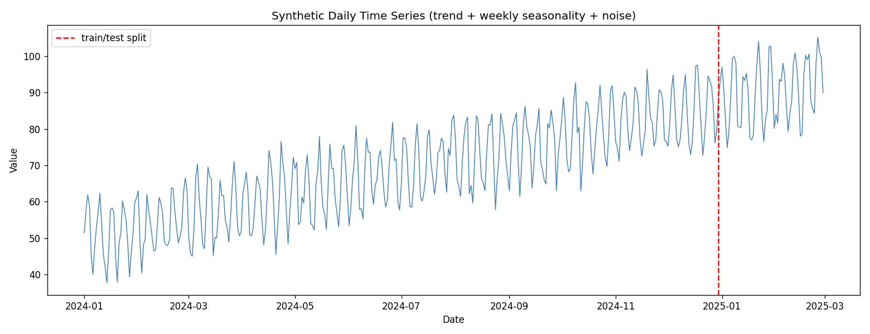
Figure 1.3.1 — Generated time series with train/test split.

2. Decomposition (period = 7)
- Both additive and multiplicative seasonal_decompose were applied. Because the series is built additively, the additive model captures seasonality best: its residual mean ≈ 0.009 (centred on zero). The multiplicative residuals centre on ≈ 1.0 by construction but show slightly more structure, as expected for a non-multiplicative process.
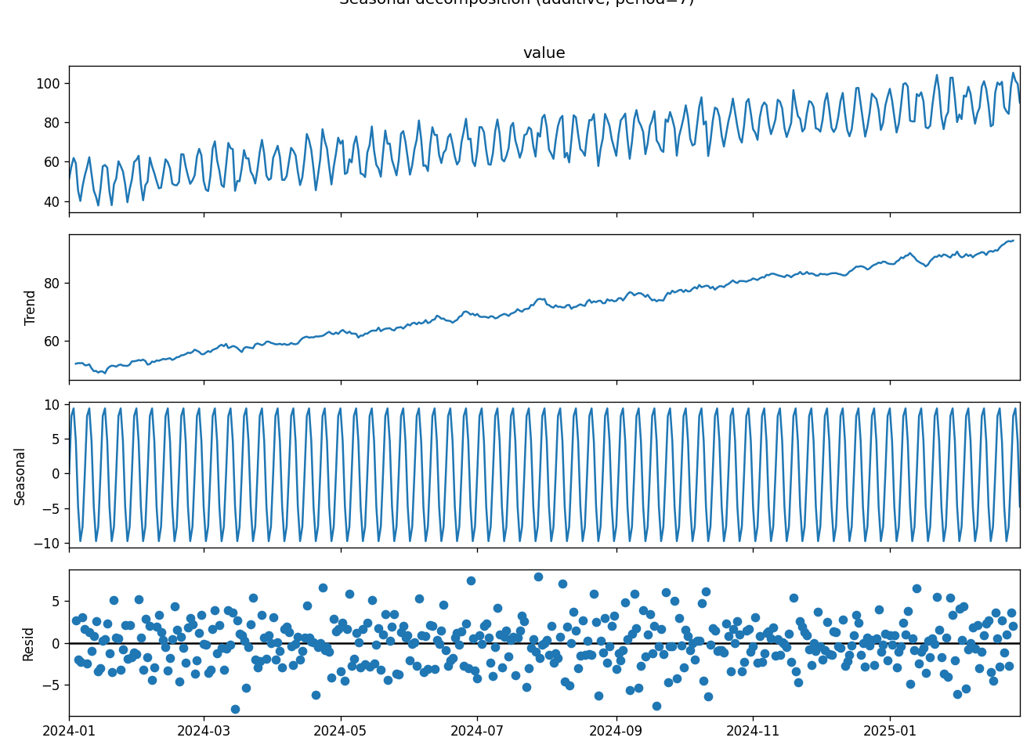
Figure 1.3.2 — Additive decomposition (observed, trend, seasonal, residual).

3–4. Forecasting (60 days) & evaluation
Three methods forecast the 60-day horizon. Accuracy on the test set:
- 7-day Moving Average — MAE 7.86, MSE 80.91, MAPE 8.57%
- Simple Exponential Smoothing (SES) — MAE 7.62, MSE 74.72, MAPE 8.42% (best)
- ARIMA(1,1,1) — MAE 8.64, MSE 106.68, MAPE 9.19%
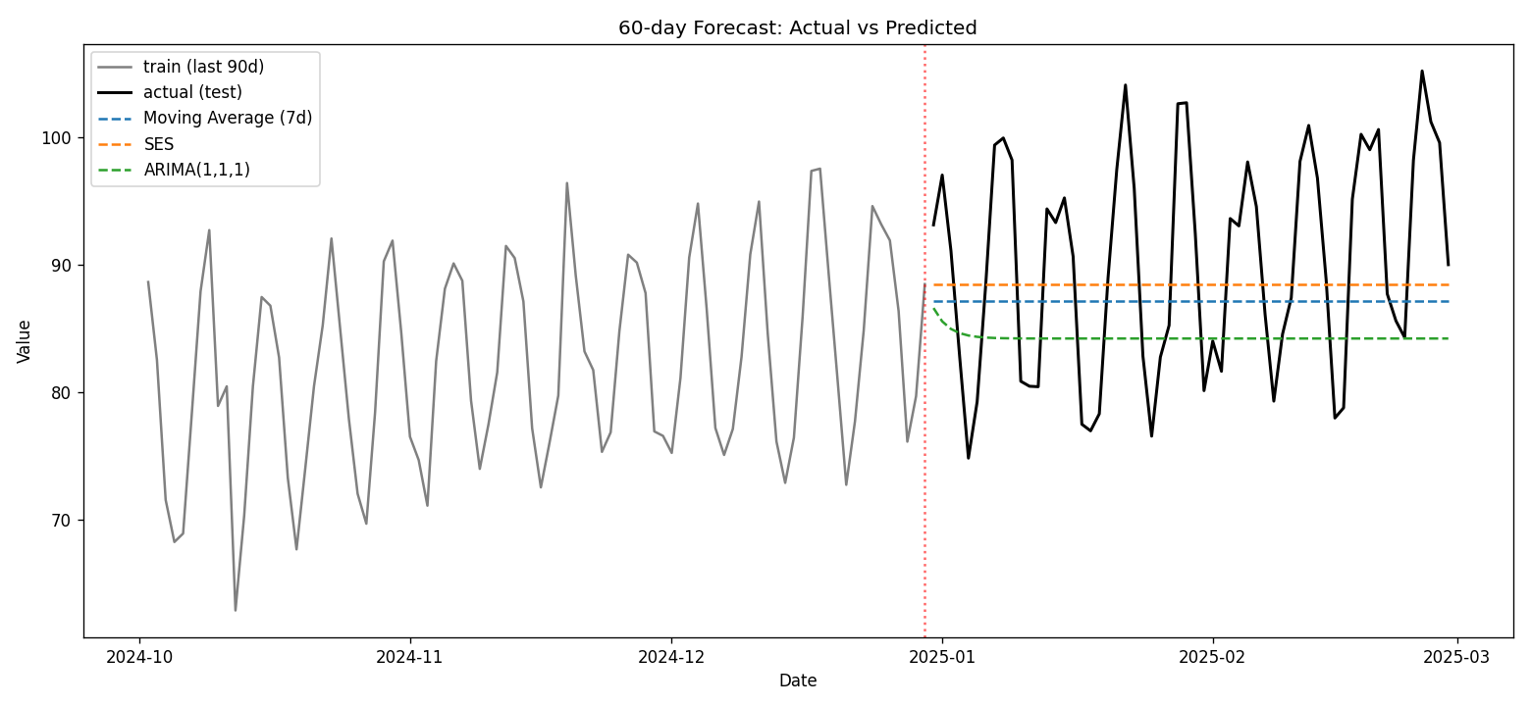
Figure 1.3.3 — Actual vs predicted (3 methods).
SES gives the lowest errors here, but all three under-perform on the seasonal structure: none of them model the weekly cycle, so they essentially track the trend/level and miss the peaks and troughs. This is expected and motivates seasonal models (e.g. SARIMA / Holt-Winters).

5. Interpretation & reflection
- Why does SES flatten after training? SES forecasts a constant equal to the last smoothed level — it has no trend or seasonal term, so every future point is the same value (a flat line).
- What do decomposition residuals reveal? With residuals centred on ~0 (additive) and no remaining pattern, the trend + seasonal components captured the signal well; leftover structure would indicate an inadequate model or wrong period.
- ARIMA vs Moving Average on seasonality: plain ARIMA(1,1,1) and a Moving Average both ignore seasonality — ARIMA models autocorrelation/trend via differencing and AR/MA terms but needs a seasonal extension (SARIMA) to handle the weekly cycle; the MA simply smooths recent values.
- Real-world uses: Moving Average — quick smoothing/denoising of noisy KPIs; SES — short-horizon demand with no trend/season; ARIMA — trended series with autocorrelation (sales, finance).
Discussion — Why decompose before forecasting? It exposes trend, seasonality and noise separately, so you choose a model that matches the structure (e.g. a seasonal model when a strong weekly cycle exists) and can de-seasonalise data. ARIMA's limitation in seasonal data: non-seasonal ARIMA cannot represent repeating cycles; it needs SARIMA (seasonal orders) or external seasonal features, otherwise it systematically misses periodic peaks/troughs — exactly what we observed.

Task 2 — Part 1: Hierarchical Clustering (Wholesale customers)
Script: task2/part1/task2_part1_hierarchical.py

Method & linkage comparison
- Channel and Region were dropped (categorical IDs). The six spend features were log1p-transformed (heavy right skew) then standardised.
- Dendrograms were built for single, complete, average and ward linkage. Single and average linkage 'chain' — they peel off 1–2 outliers and leave one giant cluster (sizes 438/1/1), so their high silhouette (~0.5) is misleading. Complete (402/33/5) and especially Ward (262/53/125) give balanced, interpretable clusters; Ward was chosen with k = 3.
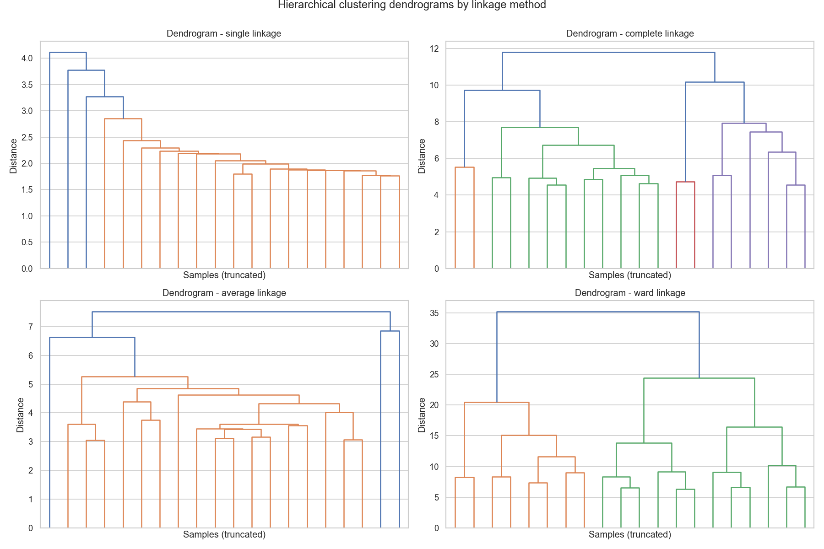
Figure 2.1.1 — Dendrograms for four linkage methods.
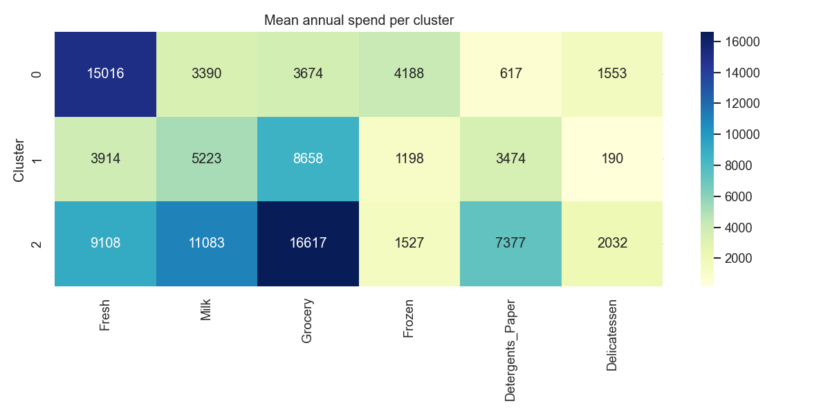
Figure 2.1.2 — Mean annual spend per cluster (Ward, k=3).

Business insights (Ward, k = 3)
- Cluster 0 (n=262) — 'Fresh-focused': high Fresh spend, low Grocery/Detergents. Likely restaurants, cafés and HoReCa buyers. Push fresh-produce deals and reliable cold-chain delivery.
- Cluster 2 (n=125) — 'Retail / Grocery': high Milk, Grocery, Detergents_Paper and Delicatessen. Supermarkets / large retailers. Offer bulk pricing and category bundles.
- Cluster 1 (n=53) — 'Small grocery': moderate Grocery/Detergents, low Fresh. Smaller stores; mid-tier bundles and growth incentives.

Question 1 — Why choose the right number of clusters? How do dendrograms help? Linkage effect.
As in K-Means, the cluster count determines whether segments are meaningful and actionable. A dendrogram visualises the full merge hierarchy and the distance at which clusters join; cutting it where there is a large vertical gap (a long un-merged branch) suggests a natural number of clusters without committing to k in advance. The linkage method defines how inter-cluster distance is measured and strongly shapes the result: single linkage (nearest points) tends to chain and produce long, stringy clusters sensitive to outliers; complete linkage (farthest points) yields compact, similar-sized clusters; average linkage is a middle ground; Ward minimises within-cluster variance and gives balanced, spherical clusters — usually the most interpretable for customer segmentation, which is why single/average chained here while Ward did not.

Question 2 — Limitations of hierarchical clustering vs K-Means; mitigation for wholesale data.
- Computational cost: O(n²) memory/time — does not scale to very large customer bases (K-Means is much faster). Mitigate with sampling or Ward on a representative subset.
- No reassignment: early merges are permanent, so mistakes propagate (K-Means iteratively reassigns). Mitigate by comparing linkages and validating with silhouette.
- Sensitivity to outliers/scale and skew: heavy-tailed spend distorts distances. Mitigate with log transform + standardisation (done here) and outlier capping.
- Shared with K-Means: results depend on distance metric and scaling; both struggle with arbitrarily shaped clusters (use DBSCAN there).

Task 2 — Part 2: Preprocessing & Feature Selection (Telco Churn)
Script: task2/part2/task2_part2_churn.py

1. Preprocessing & scaling
- Dropped customerID. TotalCharges had 11 blank entries → coerced to numeric and imputed with the median. Categorical columns one-hot encoded → 40 features. Target: Churn (Yes=1).
- Scaler boxplots: RobustScaler handles outliers best (it uses median/IQR, so extreme MonthlyCharges/TotalCharges values are compressed); StandardScaler centres values around zero (mean 0, unit variance); MinMaxScaler squeezes into [0,1] but is the most distorted by outliers.
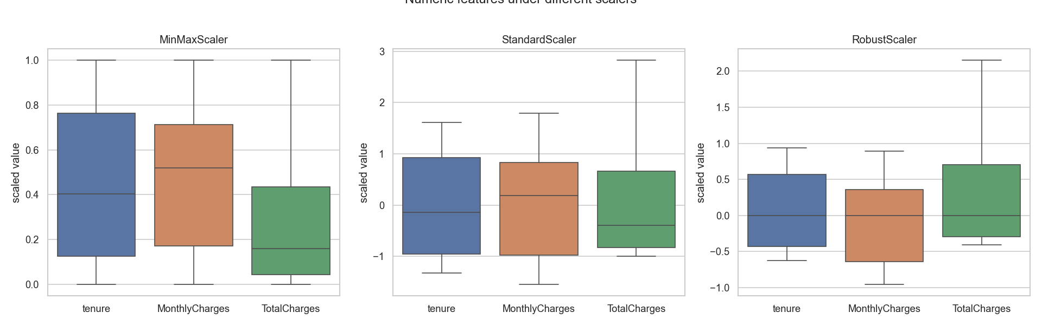
Figure 2.2.1 — Numeric features under MinMax / Standard / Robust scaling.

2. Variance Threshold
- VarianceThreshold(0.01) removed 0 features. After encoding, every column has variance above 0.01 — there are no near-constant dummies (no category is rarer than ~1%), so nothing is discarded. The filter is still informative: it confirms there is no dead/constant feature to drop.

3. SelectKBest (chi²) vs RFE
- SelectKBest(chi², k=10) selected mostly service/contract dummies: Fiber-optic internet, OnlineSecurity_No, TechSupport_No, Contract_Month-to-month, Contract_Two-year, Electronic-check payment, and several 'No internet service' indicators.
- RFE(LogisticRegression, 10) selected the numeric drivers tenure, MonthlyCharges, TotalCharges plus Fiber-optic, Contract terms and service indicators.
- Overlap = 5 (Contract_Month-to-month, Contract_Two-year, InternetService_Fiber-optic, DeviceProtection_No-internet-service, TechSupport_No-internet-service).
- Why they differ: chi² is a univariate filter scoring each feature's association with the target independently, so it favours strong single dummies and (being non-negative-only) ignores the continuous tenure/charges directly; RFE is a multivariate wrapper that ranks features by their contribution within a logistic model, so it keeps the numeric predictors and accounts for interactions/redundancy. Filters are faster; wrappers are model-aware but costlier.

4. LASSO for feature selection
- LassoCV (α ≈ 0.00145 by 5-fold CV) kept 21 of 40 features with non-zero coefficients, shrinking the rest to exactly zero. Strongest signals: TotalCharges/tenure (negative → longer tenure lowers churn), Fiber-optic internet, Month-to-month contract, Electronic-check payment, no TechSupport/OnlineSecurity (all positive → higher churn).
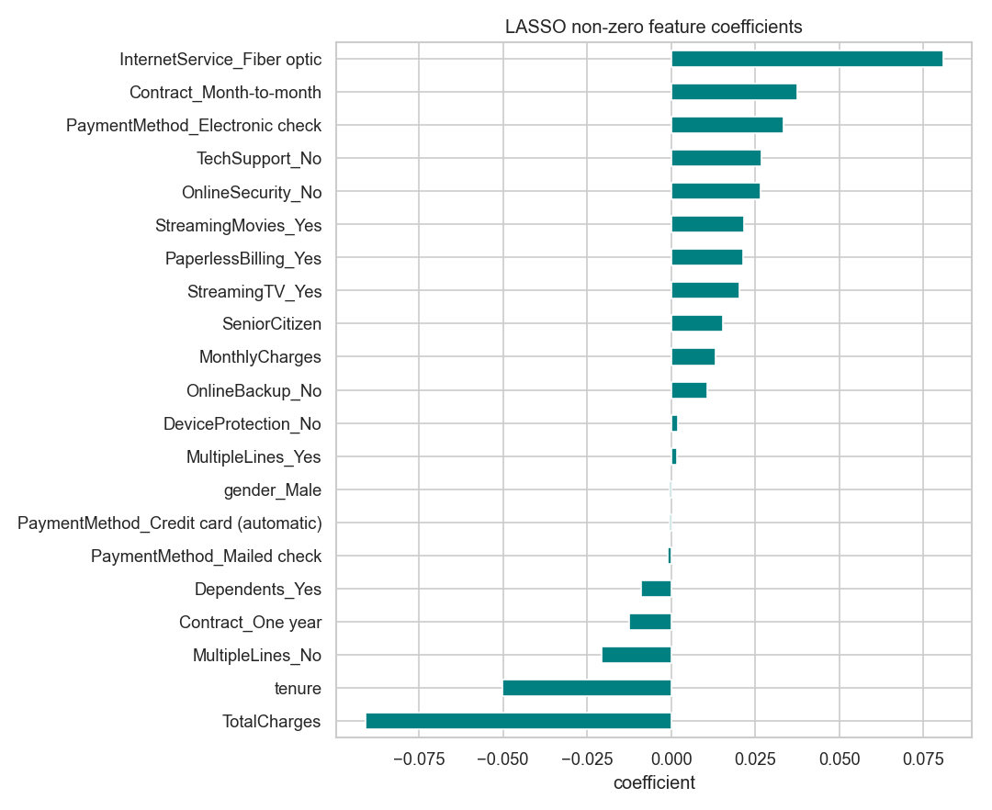
Figure 2.2.2 — LASSO non-zero coefficients.
- How LASSO handles correlated/redundant features: its L1 penalty tends to pick one feature from a correlated group and zero out the others, producing a sparse, less-redundant model — though the particular one chosen can be somewhat arbitrary among correlated features.

5. Final pipeline & evaluation
- Pipeline: median imputation + StandardScaler (numeric) and most-frequent imputation + OneHot (categorical) → SelectFromModel(LassoCV) → LogisticRegression. LASSO selected 19 features.
- Test metrics — Accuracy 0.805, ROC-AUC 0.843, RMSE 0.371, MAE 0.274. Strong, well-calibrated churn classifier from a compact feature set.

Discussion questions
1. Why encode AND scale before LASSO/PCA with mixed data types? LASSO and PCA are numeric and scale-sensitive: categorical variables must be encoded (e.g. one-hot) to become numeric, and all features must be scaled so the L1 penalty / variance maximisation treats them comparably. Skipping scaling lets large-range features dominate and distorts which coefficients are shrunk or which components are formed.
2. How do embedded methods (LASSO) differ from filter and wrapper methods? Filter methods (e.g. chi², variance threshold) score features independently of any model — fast but ignore feature interactions. Wrapper methods (e.g. RFE) repeatedly train a model on feature subsets — accurate but expensive. Embedded methods like LASSO perform selection inside model training via a penalty term, getting model-aware selection at a single-fit cost — a balance between the two.

Task 3 — Part 1: DBSCAN Clustering (Wine dataset)
Script: task3/part1/task3_part1_dbscan.py

Method & results
- 13 physicochemical features standardised. min_samples = 10 (data has only 178 rows). The k-distance graph (k=10) gives a knee around eps ≈ 3.1, but at that radius almost all points are density-connected into one blob — the clusters have similar density and no clear density gap.
- Experimenting over eps × min_samples, the most informative configuration is eps = 2.2, min_samples = 10 → 2 clusters with silhouette 0.394 and 89 noise points.
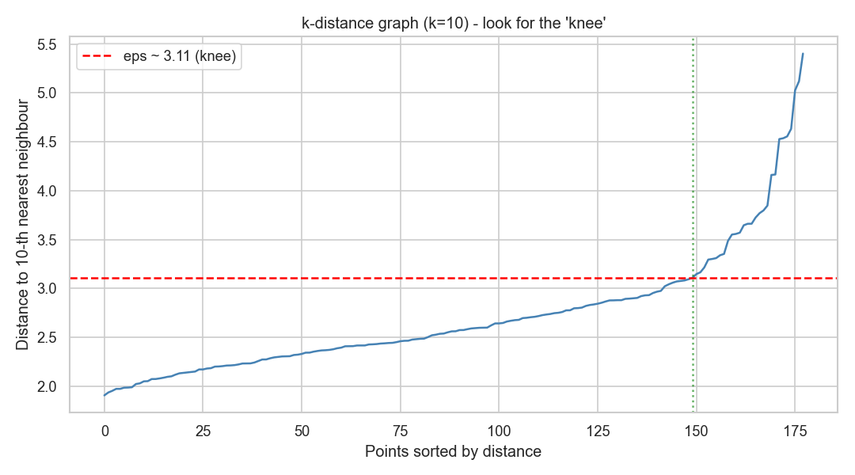
Figure 3.1.1 — k-distance graph for choosing eps.
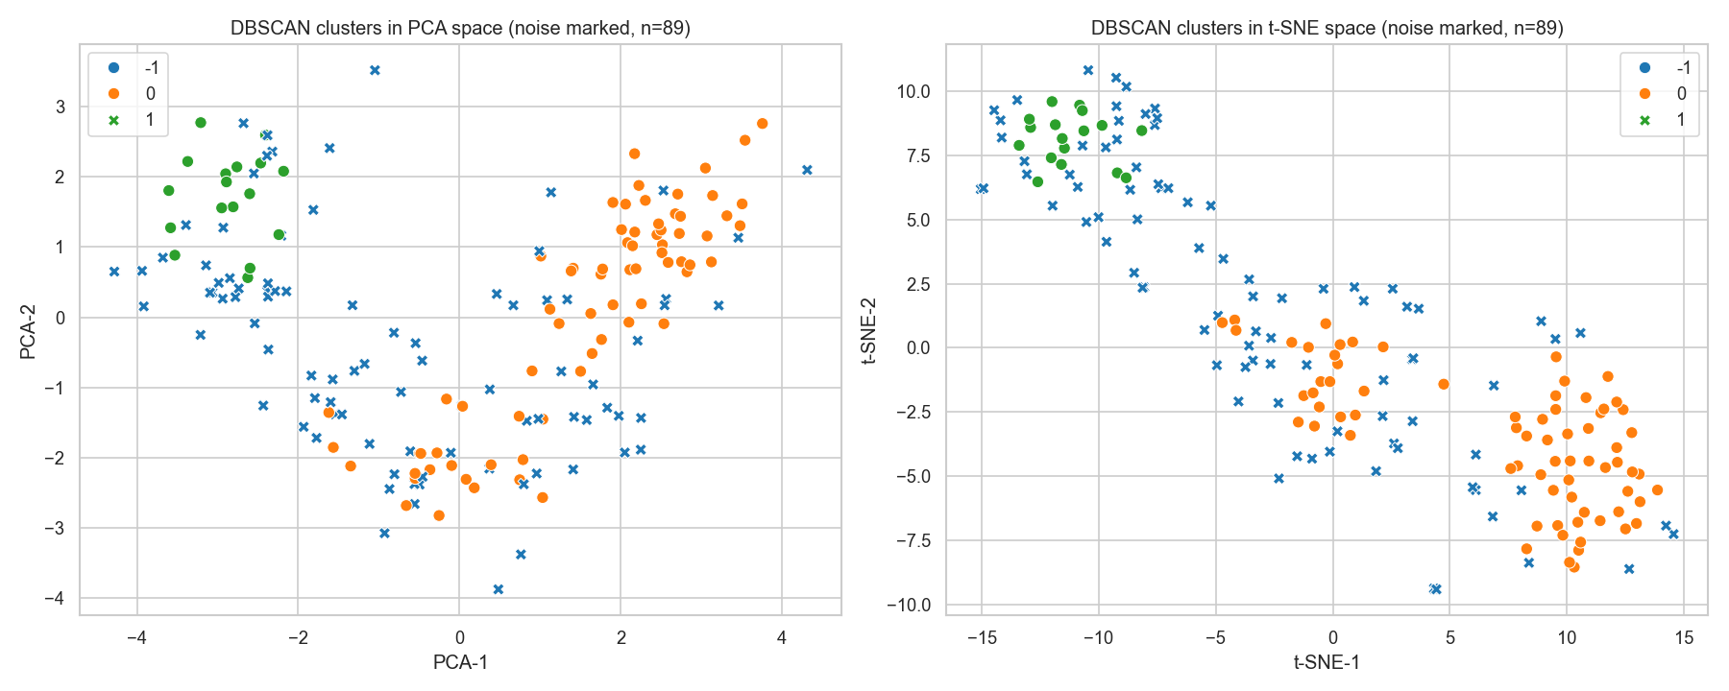
Figure 3.1.2 — DBSCAN clusters in PCA and t-SNE space (noise marked).

Noise & insights
- Outliers/noise (label −1, 89 points) are wines that lie in low-density regions between the dense cores — chemically 'in-between' wines that don't fit either dense group. DBSCAN flagging them prevents them from distorting the cluster profiles (unlike K-Means, which forces every point into a cluster).
- Cluster 0: higher Flavanoids (~2.7) and Proline (~926) — richer, fuller-bodied profile. Cluster 1: high Malic acid (~3.8) and Color intensity (~8.1), low Flavanoids — a chemically distinct wine class. This separation is useful for quality control and wine-type identification.
- Note: this dataset is roughly convex with similar-density groups, so DBSCAN is not the ideal algorithm here (K-Means/GMM separate the three known cultivars more cleanly) — itself a useful finding about when DBSCAN does and doesn't shine.

Question 1 — Why is DBSCAN suitable for wine-type data (arbitrary shapes + noise)?
DBSCAN groups points by density rather than distance to a centroid, so it can discover clusters of arbitrary, non-spherical shape and does not require the number of clusters in advance. Crucially it labels low-density points as noise, isolating anomalous or borderline wines instead of forcing them into a group. For complex chemical data with irregular structure and outliers this is advantageous — though, as seen above, it works best when clusters actually differ in density/are separated by sparse regions.

Question 2 — How do eps and min_samples affect the result?
eps sets the neighbourhood radius and min_samples the minimum points to form a dense core. Small eps (or large min_samples) makes the density requirement strict → many points become noise and clusters fragment or vanish (e.g. eps=2.0 left 139 points as noise). Large eps (or small min_samples) merges everything into one cluster and hides structure (eps≈3.1 gave a single cluster). The two must be tuned together — typically min_samples ≥ dim+1 and eps from the knee of the k-distance graph — trading off the number of clusters against how many points are treated as noise.

Task 3 — Part 2: Rule-Based Sentiment Analysis (Tech Tweets)
Script: task3/part2/task3_part2_sentiment.py

Method & results
- 5,000 tweets (balanced: ~1,650–1,684 per class). Cleaning: lowercase; removed URLs, @mentions, the # symbol, punctuation and numbers; collapsed whitespace.
- Polarity scored with TextBlob and VADER. Labels: polarity > 0 → positive, < 0 → negative, = 0 → neutral (VADER used its standard ±0.05 compound thresholds).
- Accuracy vs the ground-truth labels: TextBlob 0.670, VADER 0.691.
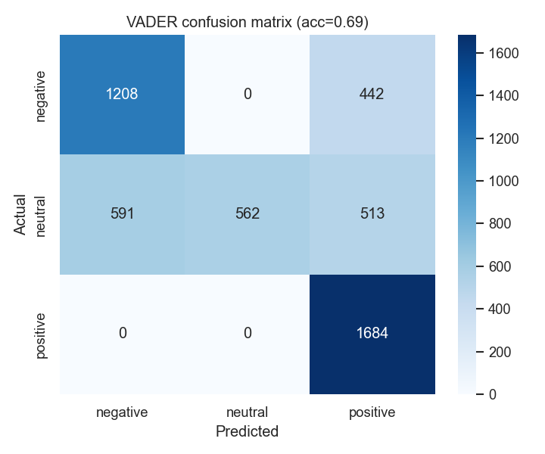
Figure 3.2.1 — VADER confusion matrix.
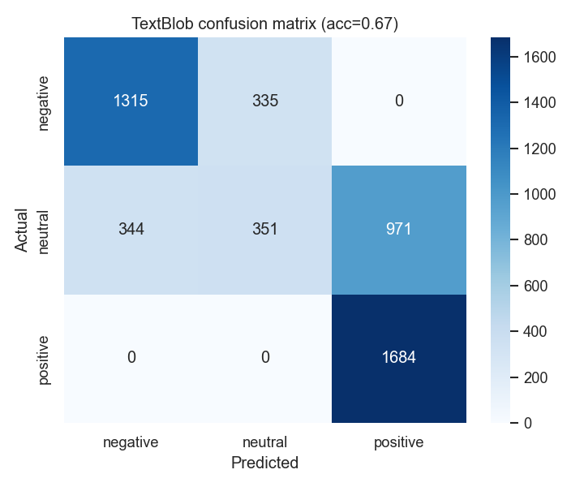
Figure 3.2.2 — TextBlob confusion matrix.

Interpretation & reflection
- How well did the rule-based method perform? Moderately — ~67–69% accuracy. Both tools handle clearly positive and negative tweets well (positive recall ≈ 1.0, negative recall 0.7–0.8) but fail badly on NEUTRAL tweets (TextBlob neutral recall 0.21, VADER 0.34): they over-predict positive, pushing many neutral tweets into the positive class.
- Examples of wrong predictions: 'Still exploring Apple. Too early to judge.' (neutral) → predicted positive; 'Amazon update broke everything. Please fix it!' (negative) → predicted neutral (idiomatic negativity missed); 'Not good, not bad. Apple is just average.' (neutral) → mis-scored due to the word 'good/bad' cancelling imperfectly.
- Common issues: sarcasm and irony, negation, mixed sentiment in one tweet, and domain/idiomatic phrasing ('broke everything') that lexicons don't weight correctly. Neutral is the hardest class because rule-based polarity rarely lands exactly at zero.
- When prefer rule-based over ML? When there is no labelled training data, when you need a fast, transparent, explainable baseline, for short social text (VADER is tuned for it), or limited compute. ML/transformer models win when labelled data exists and higher accuracy / context handling (sarcasm, negation) is required.

Discussion questions
How do TextBlob/VADER work? They are lexicon-and-rule based: each word has a pre-assigned sentiment score in a dictionary; the tool aggregates these word scores (VADER also applies heuristics for negation, punctuation, capitalisation and intensifiers) into an overall polarity/compound score, which is then thresholded into positive/negative/neutral. No training data is needed.
Limitations of rule-based sentiment analysis: cannot truly understand context, sarcasm, irony or complex negation; struggles with mixed sentiment and domain-specific/idiomatic language; depends on lexicon coverage (out-of-vocabulary slang scores 0); and tends to mislabel neutral text — all visible in the ~30% error rate here.

