Building a Vlog Application With Django
Instructions: Answer the following questions. Develop your project creatively and provide detailed explanations with code snippets in report. There is not any page/word limit for report writing.
Section 1: Models (20 Points)
1. Design Django model for VlogPost with the following fields:
a. VlogPost model: title, video_url, description, author, published_date, tags.
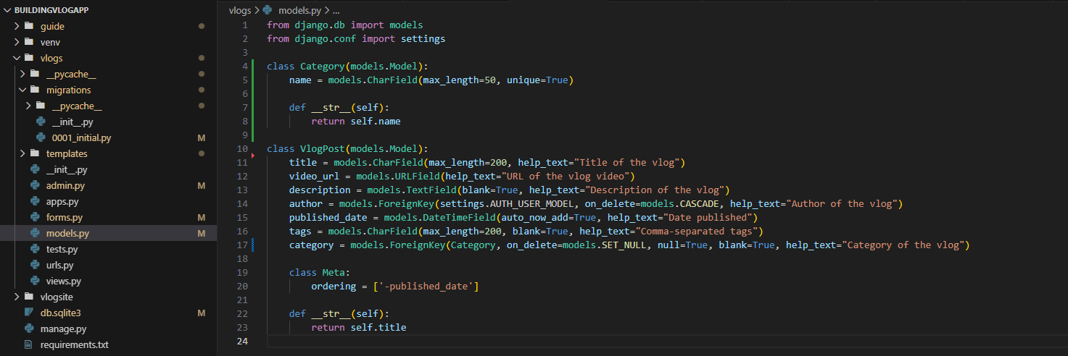
b. Specify the field types and any constraints. Include a code example and explain each field's purpose. (20 Points)
- title
  - Type : models.CharField (storing strings characters)
  - Constraints : max_length=200 (maximum of 200 characters)
  - Purpose : storage of the vlog title

- video_url
  - Type : models.URLField(storing URLs or Link)
  - Constraints : valid URL format
  - Purpose : storage of the vlog link video (Example: https://www.youtube.com/watch?v=fSzV1fecCw8)

- description
  - Type : models.TextField (storing large text data)
  - Constraints : blank=true (this is allowed to be empty or blank)
  - Purpose : description or summary data
- author
  - Type: models.ForeignKey (many to one relationship)
  - Constraints: on_delete=models.CASCADE (when deleting the author automatically deleted their vlogpost)
  - Purpose : to connect the author on their vlogpost and to easily delete both records instantly

- Published_date
  - Type : models.DateTimeField (generating date and time today)
  - Constraints : auto_now_add=true
Automatically generate date and time today and set on their records
  - Purpose : to record when their vlog was published
- tags
  - Type : models.CharField (storing strings characters same)
  - Constraints :
max_length=200 (maximum of 200 characters)
blank=True (this is allowed to be empty or blank)
  - Purpose : to storing comma-separated values (Example: “travel”,”trending”,”education”)

Section 2: Views (20 Points)
1. ListView and DetailView for VlogPost:
a. Write a ListView class to display a list of all vlogs with pagination (10 vlogs per page). Provide the code and explain the pagination logic. (5 Points)
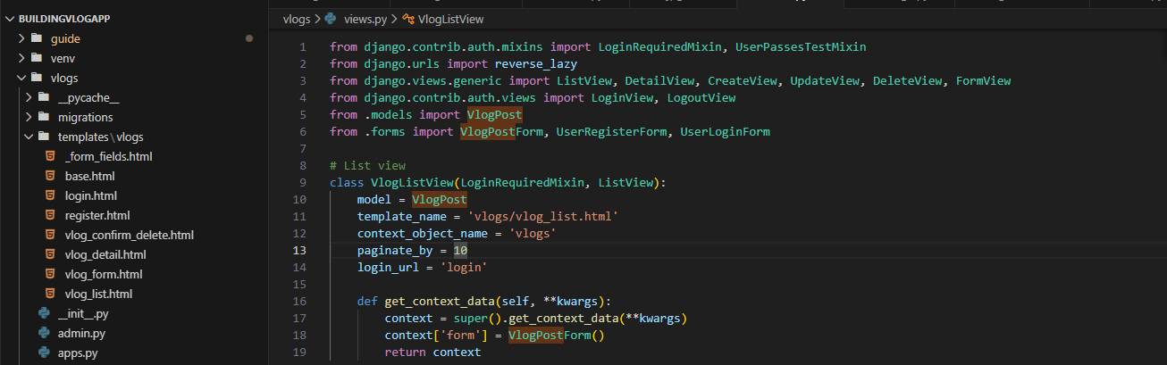
- On line 13 I declared paginate_by = 10 to limit the fetched post from .models VlogPost per page into 10

- If you have 35 posts in total
  - Page 1 = posts 1-10
  - Page 2 = posts 11-20
  - Page 3 = posts 21-30
  - Page 4 = posts 31-35

b. Write a DetailView for a single VlogPost, based on its id. Include an example URL pattern for this view. (5 Points)
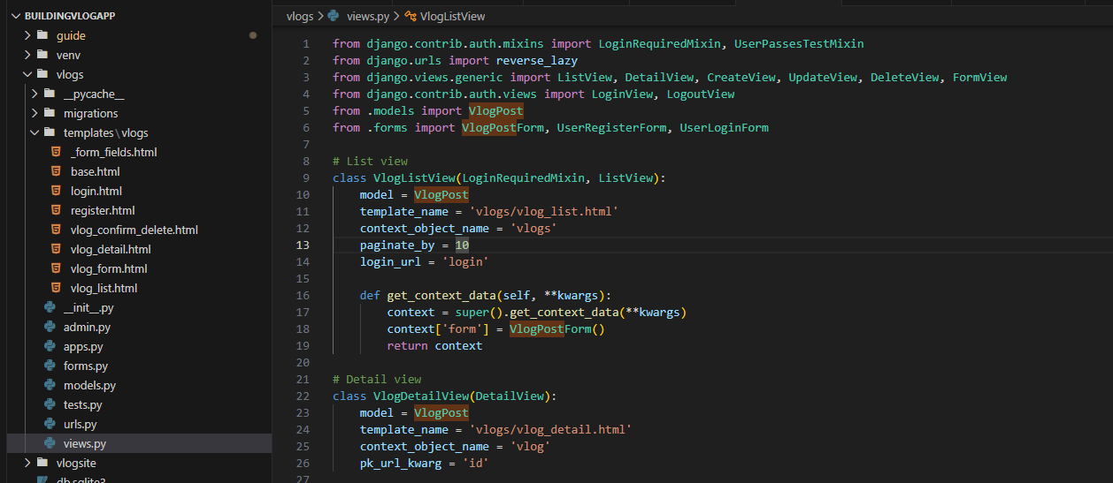
- urlpatterns = [ path('vlog/<int:id>/', VlogDetailView.as_view(), name='vlog-detail'),]
- Example URL ( http://127.0.0.1:8000/vlog/11/ )

2. Create and Update Views for VlogPost:
a. Write a CreateView for creating a new VlogPost, using VlogPostForm. Describe the purpose of this view and how it handles form submission. (5 Points)
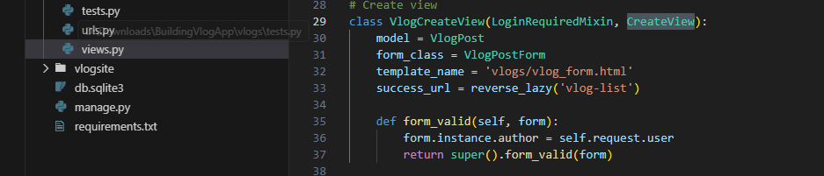
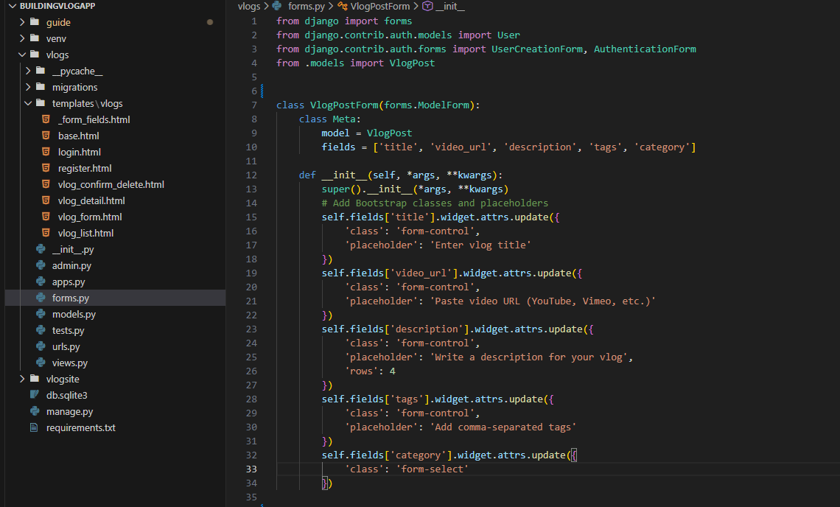
- Purpose : VlogCreateView allows the authenticated users to create new VlogPost by filling out the form VlogPostForm
- Form handling : the form displaying the template vlogs/vlog_form.html and when it comes submitted the form_valid() is excuted automatically inside the form validation method and after successfully savings the user is redirecting to the success_url

b. Write an UpdateView for editing an existing VlogPost, explaining how the view identifies the specific vlog to update. Provide code examples in report too. (5 Points)
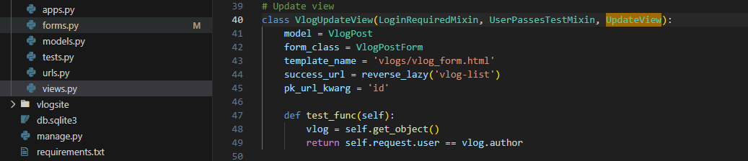
- on line 45 pk_url_kwarg = ‘id’ the program tell on Django to use ‘id’ from url/link to find vlog details
- to specify the vlog details extract the vlogs ‘id’ from the url
Example: http://127.0.0.1:8000/vlog/11/
- to ensure only the author can update or edit their details the program returns true if the current logged-in user (self.request.user) is the author of the vlog; otherwise, access is denied

Section 3: Templates (10 Points)
1. Detail Template for Vlog Post:
a. Create a vlog_detail.html template to display a single vlog, with fields such as title, video_url, description, author, published_date, and tags. Provide the HTML structure. (10 Points)
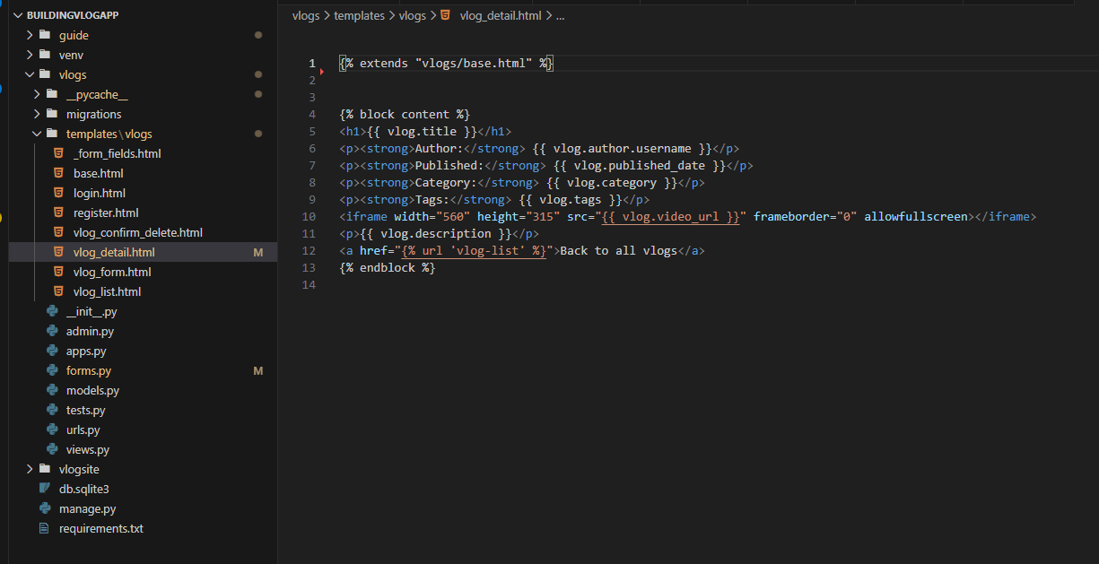

Section 4: Django Forms and Modal Forms (20 Points)
1. Creating a VlogPost Form:
a. Write a Django form for the VlogPost model, including fields for title, video_url, description, and tags. Show the code for this form in forms.py (10 Points)
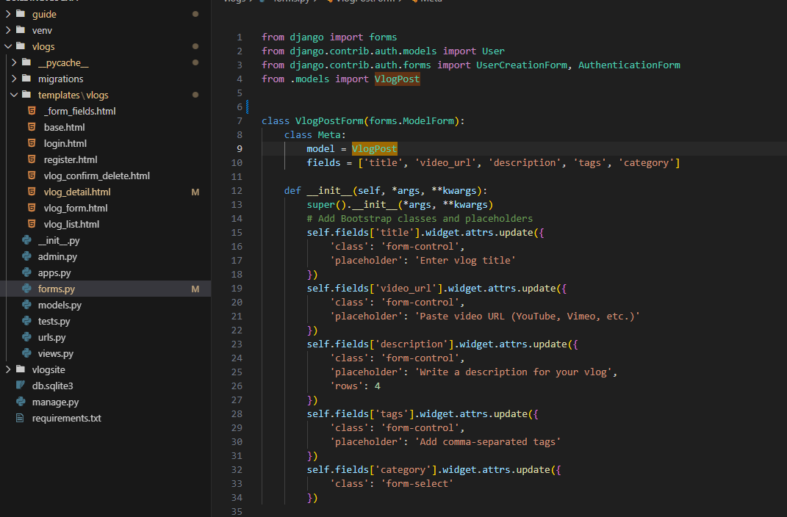

2. Modal Form for VlogPost Creation:
a. Explain how to create a modal form for adding a new Vlog Post in a template, including the necessary HTML structure to trigger the modal. (10 Points)
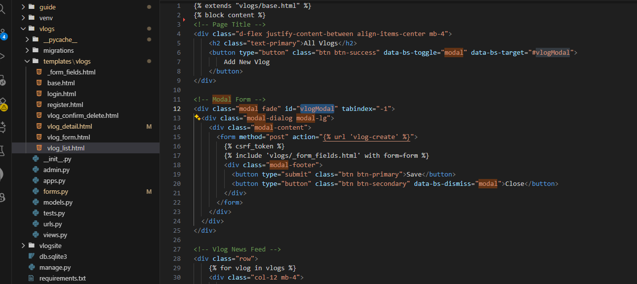
to create modal i will coded first the UI using bootsrap and I extend vlogs/base.html that contains bootsrap cdn
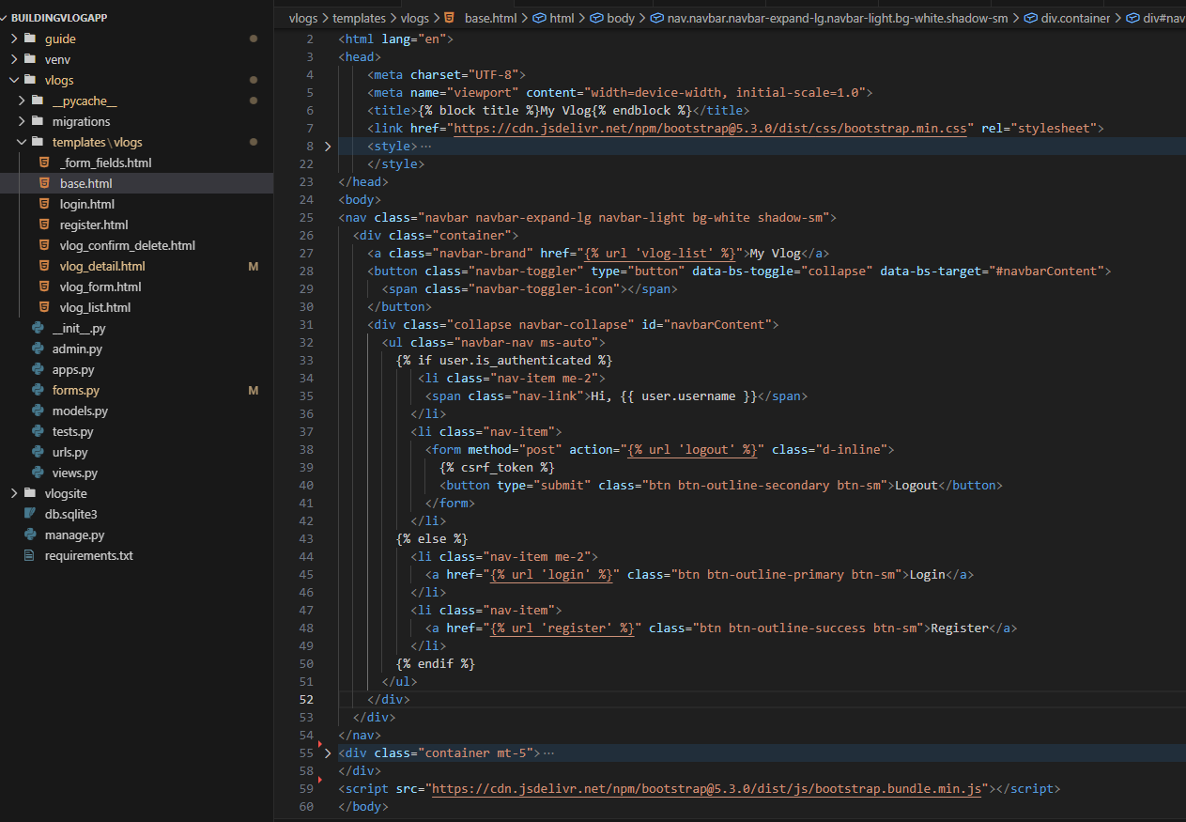
on line 7 we can see the cdn of https://cdn.jsdelivr.net/npm/bootstrap@5.3.0/dist/css/bootstrap.min.css
for UI design and the https://cdn.jsdelivr.net/npm/bootstrap@5.3.0/dist/js/bootstrap.bundle.min.js
to enable interactive components such as data-bs-toggle="modal" to trigger modal when clicked and data-bs-target="#vlogModal" to specify which modal want to open
Section 5: URL Configuration (10 Points)
1. Define URL Patterns:
Write URL patterns for the following views:
Displaying all vlogs (/vlog/).
Displaying a single vlog post by id (/vlog/<int:id>/).
Creating a new vlog (/vlog/new/).
Editing a vlog by id (/vlog/edit/<int:id>/).
Provide the code for urls.py with these patterns. (10 Points)
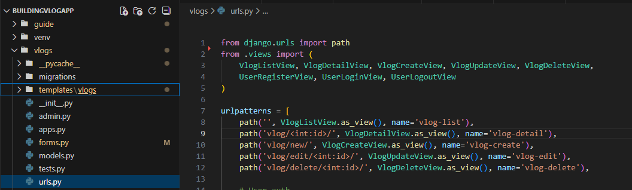

Section 6: Admin Interface Customization (10 Points)
1. Admin Setup for VlogPost and Category:
Register Vlog Post and Category models in Django admin. Provide the code for admin.py. (5 Points)
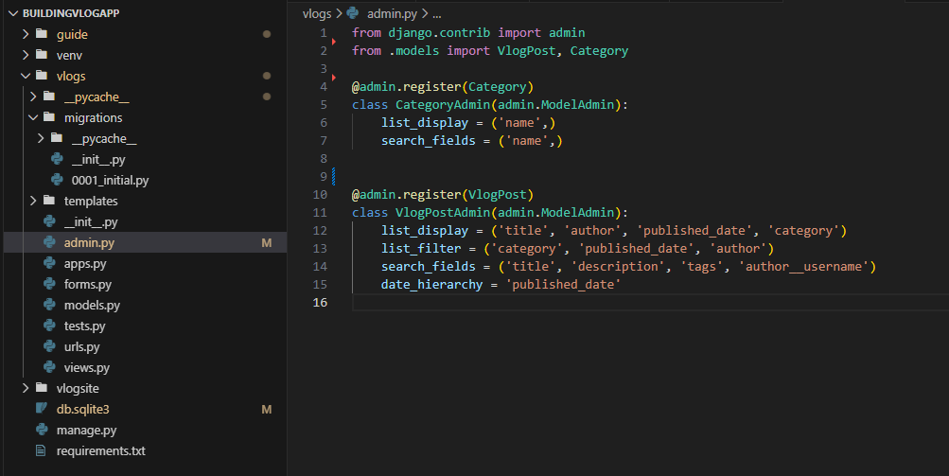

Registering Category in Django admin
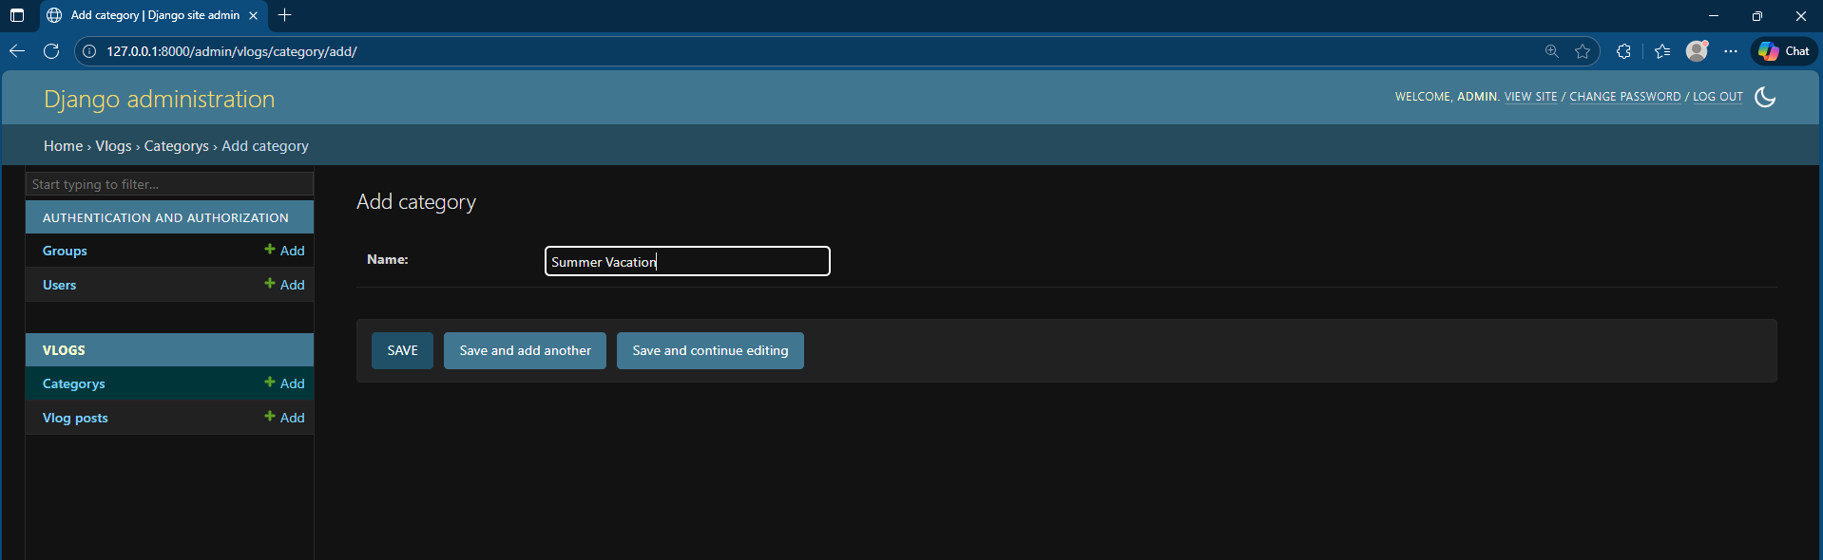
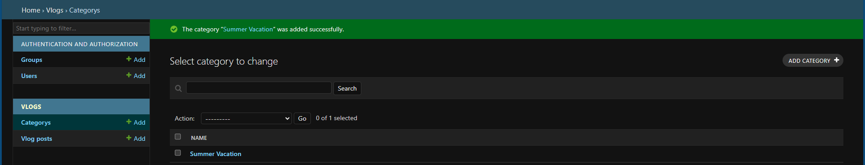

Registering Vlog Post in Django admin
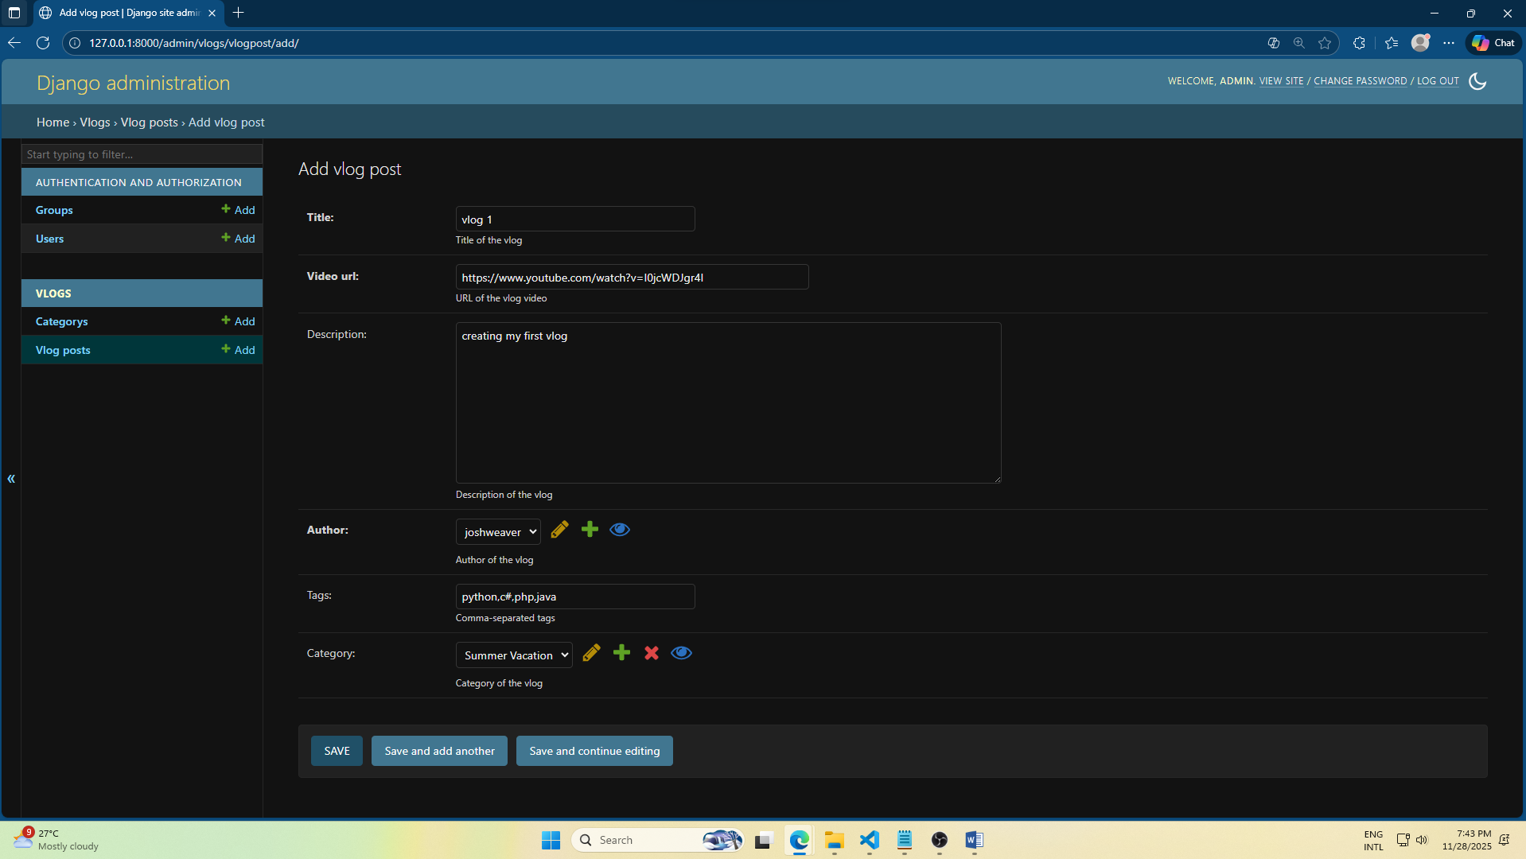

2. Customizing the Admin Interface:
Customize the VlogPost admin to display title, author, published_date, and category in the list view, and enable filtering by category. Provide the code and explain the customization. (5 Points)
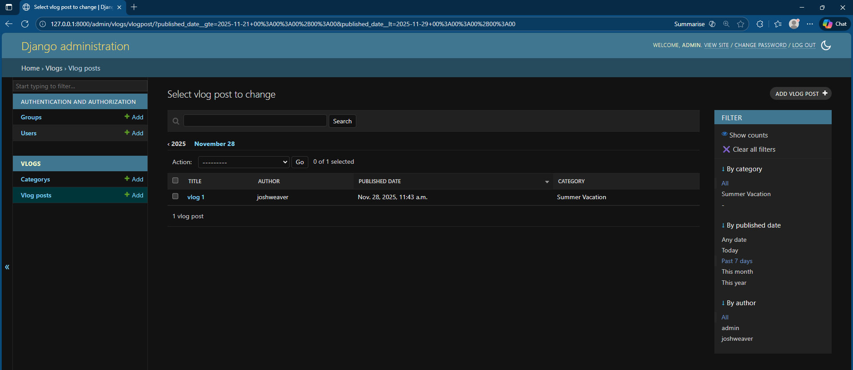

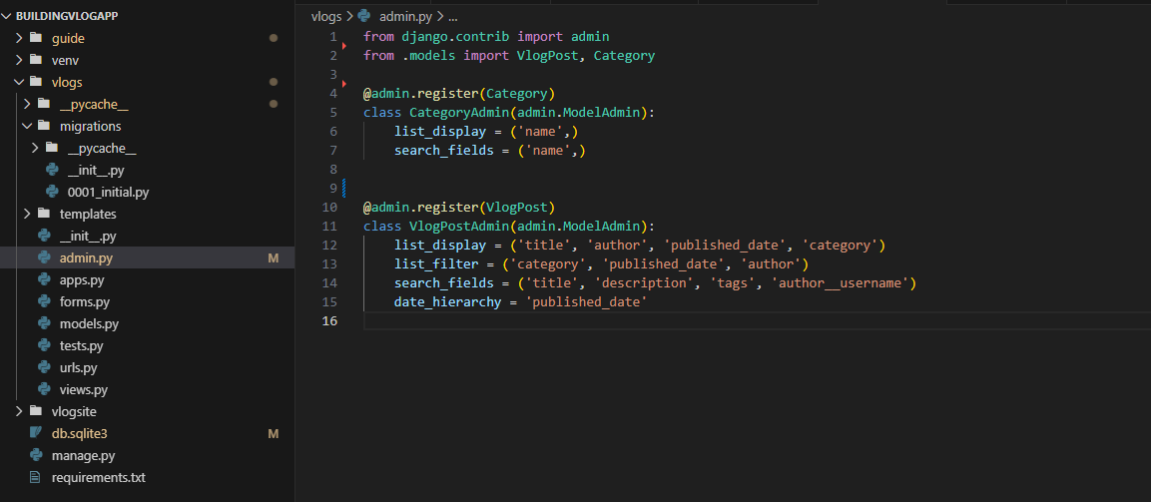

- list_display = choose field who appear on the admin table for each VlogPost (‘title’,’author’,’published_date’,’category’)
- list_filet = to add option filter appears on the sidebar of admin to quickly filter post
- search_fields = to add search box in the admin to search specific fields
- date_hierarchy = to add useful navigation for quickly navigating post either by year, months or day

