ISM 4403 Homework Week 2

Week 2 discussion.

First, I would like to state my understanding of the assignment. The lab asks the student to copy data into excel and call its file path in R. Once, this is completed show the code you used. Then go on GitHub and download the data and chart it like the example on GitHub.

I am having trouble using *read.xls("C:\Users\Owner\Desktop\coding\ISM4403_advanced_business_analytics_local\homework\week2")* I don’t know to read in files using this method. How do I copy the path on the file?

The method I used was

*read_excel("week2_flat_file.xlsx")* This is the method I was taught, it works but not what on the assignment is asking for.

Tasks:

1. Create a new Excel spreadsheet from the following table.

|  |  |  |  |  |
| --- | --- | --- | --- | --- |
| id | Height (inches) | gender | Hair color | Eye Color |
| 1 | 67 | male | brown | brown |
| 2 | 64 | female | brown | green |
| 3 | 74 | male | blond | blue |
| 4 | 73 | Male | brown | brown |
| 5 | 60 | female | red | green |
| 6 | 61 | female | brown | green |
| 7 | 73 | female | blond | blue |
| 8 | 70 | female | brown | blue |
| 9 | 56 | female | blond | brown |
| 10 | 57 | male | blond | brown |

Import the the sheet into R and print it as in section 4.2.1.1 of R for Business Analytics.

**Paste your code here**

read_excel("week2_flat_file.xlsx")

**End of Paste**

> read_excel("week2_flat_file.xlsx")

# A tibble: 10 x 5

id `Height (inches)` gender `Hair color` `Eye Color`

*<dbl>* *<dbl>* *<chr>* *<chr>* *<chr>*

1 1 67 male brown brown

2 2 64 female brown green

3 3 74 male blond blue

4 4 73 Male brown brown

5 5 60 female red green

6 6 61 female brown green

7 7 73 female blond blue

8 8 70 female brown blue

9 9 56 female blond brown

10 10 57 male blond brown

**Paste your results here**

**End of Paste**

1. Using the World Bank Development Indicators import and chart the United States, Canada and Mexico’s GDP per capita as demonstrated on <https://github.com/vincentarelbundock/WDI>/.

**Paste your resulting code here**

**#load in the libraries**

**library(WDI)**

**library(ggplot2)**

**WDIsearch('gdp')**

**WDIsearch('gdp')[1:10,]**

**WDIsearch('gdp.*capita.*constant')**

**#download the data**

**df = WDI(indicator='NY.GDP.PCAP.KD', country=c('MX','CA','US'), start=1960, end=2012)**

**head(df)**

**#plot the data**

**ggplot(dat, aes(year, NY.GDP.PCAP.KD, color=country)) + geom_line() +**

**xlab('Year') + ylab('GDP per capita')**

**#all learning/references are from**

[**https://www.youtube.com/watch?v=Hpjnp1hwa8c**](https://www.youtube.com/watch?v=Hpjnp1hwa8c)

[**https://github.com/vincentarelbundock/WDI**](https://github.com/vincentarelbundock/WDI)

**OUTPUT**

> library(ggplot2)

Use suppressPackageStartupMessages() to eliminate package

startup messages.

> ggplot(dat, aes(year, NY.GDP.PCAP.KD, color=country)) + geom_line() +

+ xlab('Year') + ylab('GDP per capita')

> library(WDI)

> library(ggplot2)

**END OF Paste**

**Paste your resulting graph here**

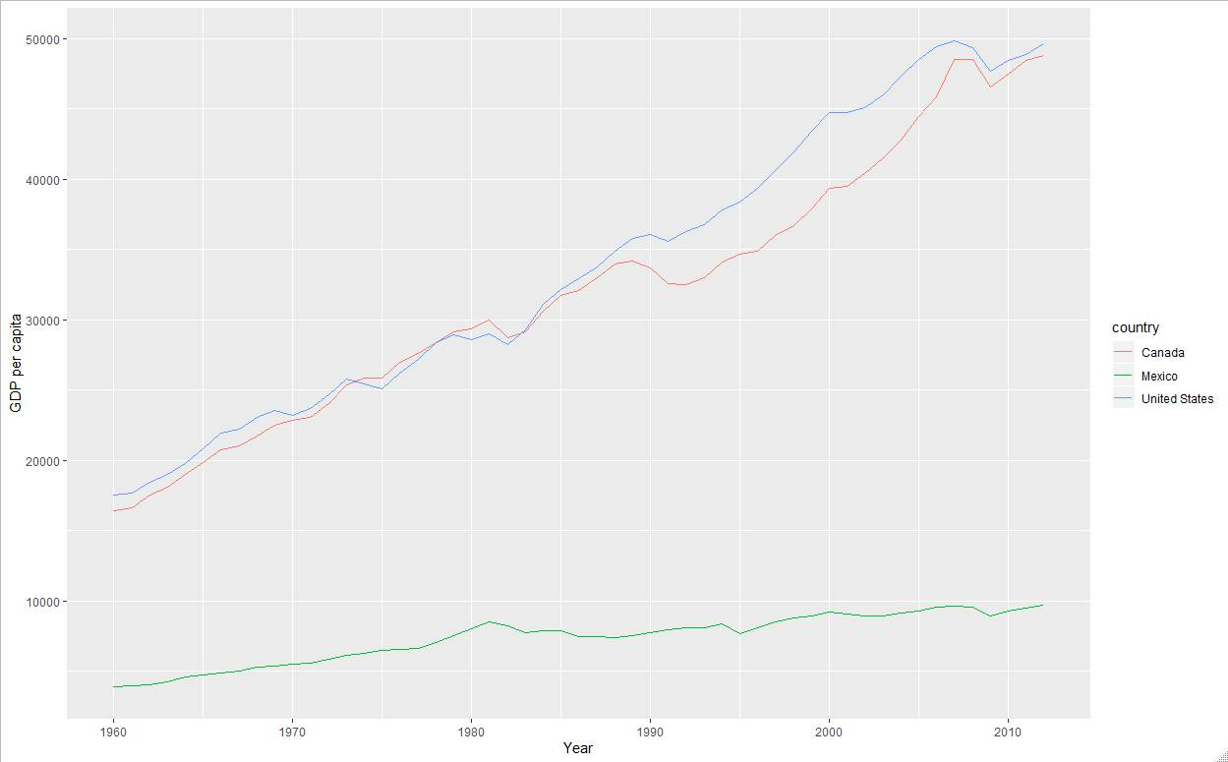

**END of Paste**

**Rubric:**

35 points for pasting correct sheet after being loaded into R.

35 For connecting to the GDI system by installing the module.

30 for generating a Graph from the gdi system.