# ZidooDigitalDemo

一、About file

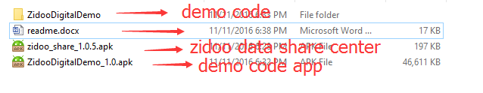

1. ZidooDigitalDemo and ZidooDigitalDemo_1.0.apk

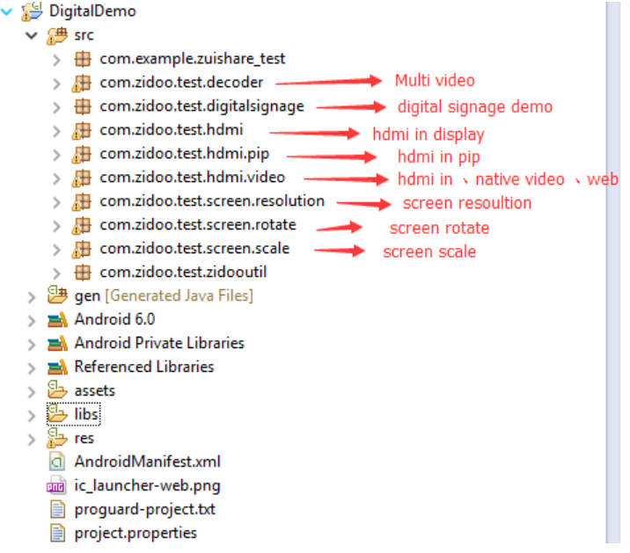

1. ZidooDigitalDemo_1.0.apk

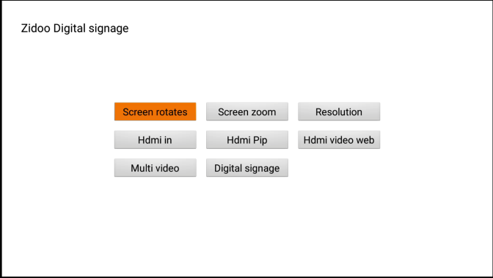

1. Screen rotates

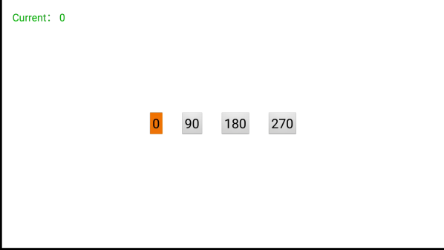

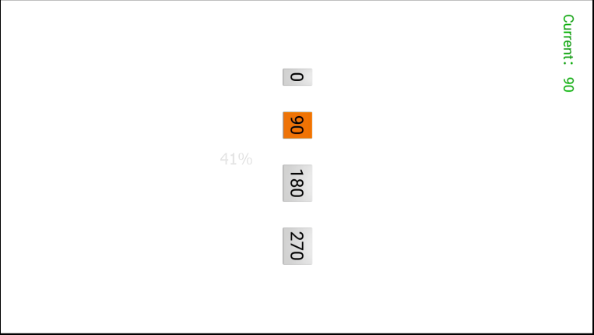

1. Screen zoom

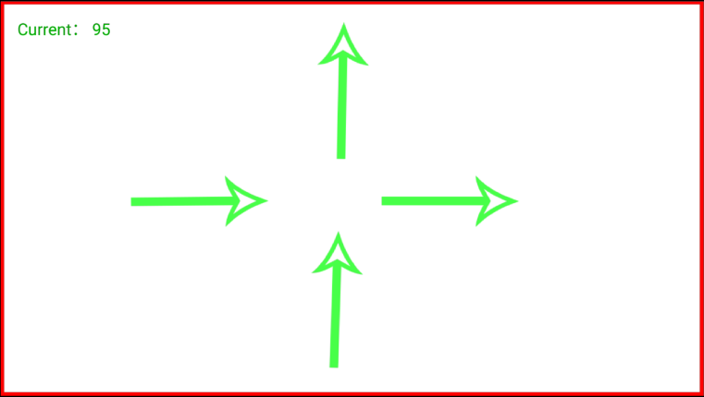

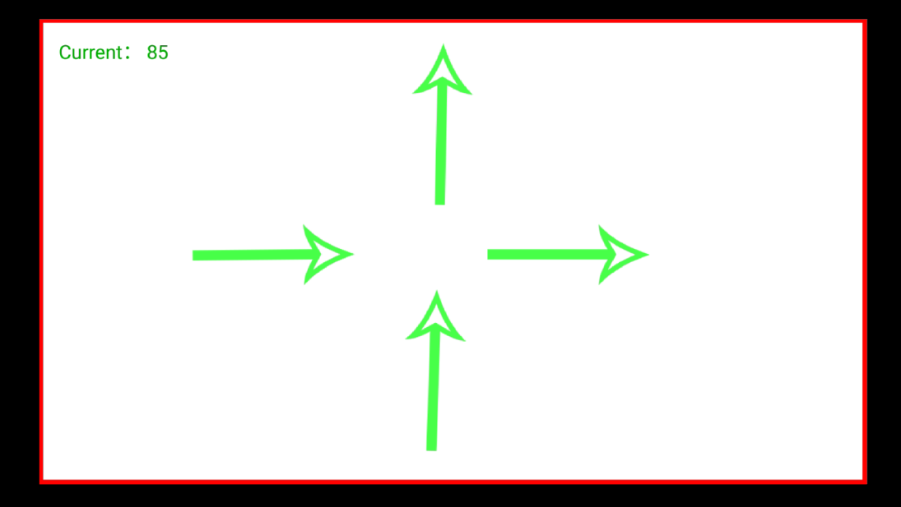

1. Resolution

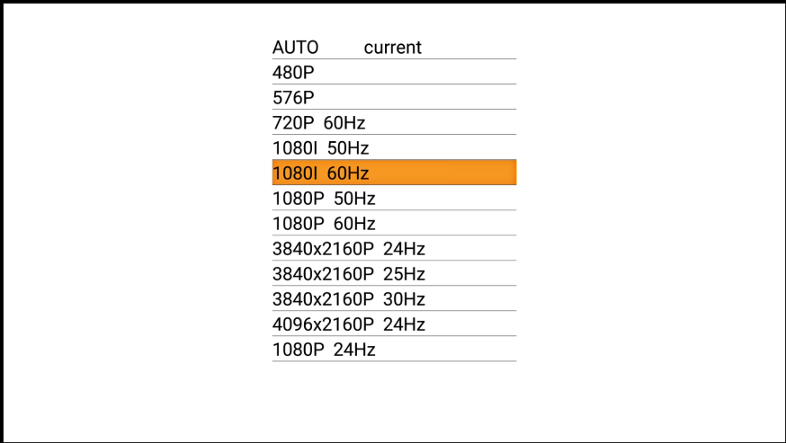

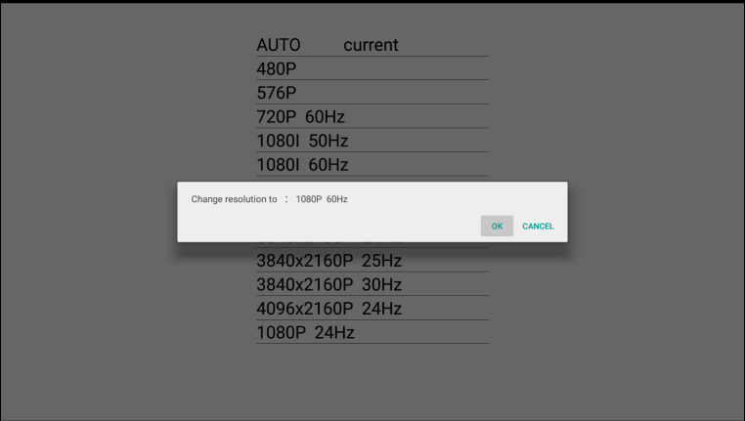

1. Hdmi in

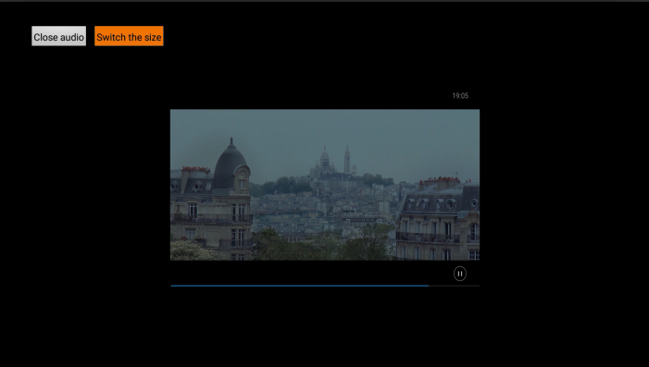

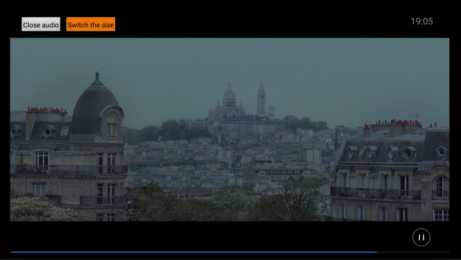

1. Hdmi pip



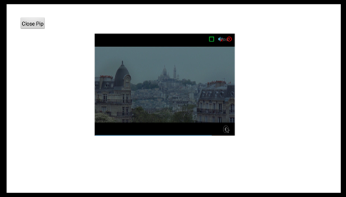

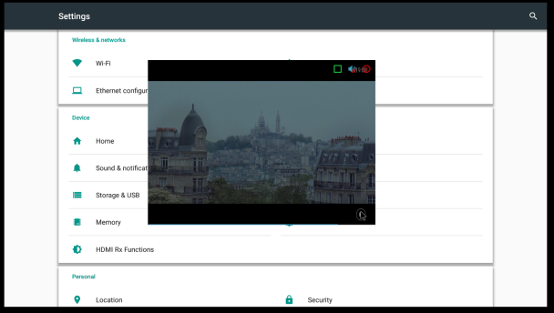

1. Hdmi video web

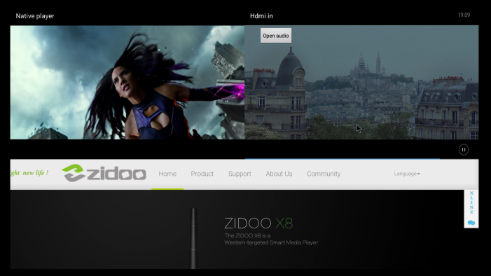

1. Multi video

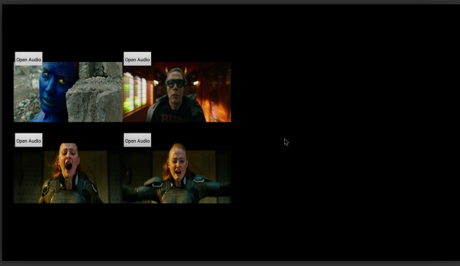

1. Digital signage

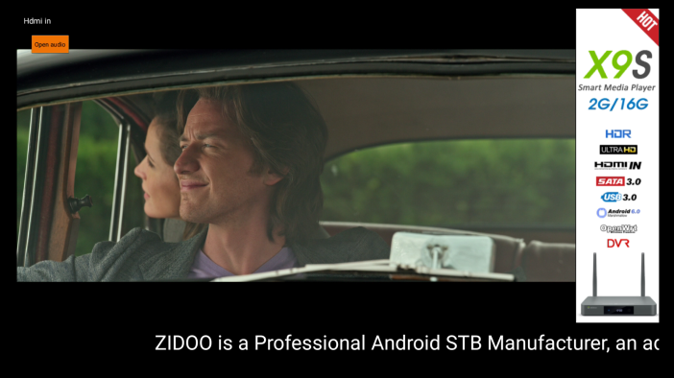

2、zidoo_share_1.0.5.apk

Please install this application to ensure that the above features can be achieved！

---------------------------------------------------------------------------------------------------------------------------------

ZIDOO China Office

Add : Room 12 D,Block A Central Great Searchings,Xixiang Ave,BaoAn District,Shenzhen.

Tel : +86 755 23500280

Fax : +86 755 23500292

Email: sales@zidoo.tv

Sales Team

Sales Skype: zidoo-wings

Sales Email: sales@zidoo.tv

Become A Distributor: http://www.zidoo.tv/Contact/distributor.html

OEM/ODM: myq@zidoo.tv

OEM Requirements: http://www.zidoo.tv/Contact/oem.html

Support Team

Support Email: service@zidoo.tv

After Service: http://www.zidoo.tv/Contact/afterservice.html