Support Vector Machine : (notes taken from CS229 SVM for easier reading)

First assume are linearly separable.
Hyperplane : subspace with n-1 dimension, mathamatically : w.x+b, for simplicity , just let y = {-1,1}
General Idea : We find a hyperplane wich min. distance of data point to the plane (geometric margin ) is greatest. for all samples
f = y(w.x + b) , f : functional margin, w.x+b is the prediction , y is the actual sampled data,
if prediction is correct => f +ve , otherwise f -ve
w have to be normalized -> w/|w| for fair comparison
=> f = y((w/|w|).x+(b/|w|))

Function Margin vs Geomertric Margin

GM is just scaled version of FM by |w|, GM = FM/|w|
FM only tell whether properly classified (properly classified => +ve or missclassified -ve), GM can tell the the confidence.
FM is introduced to provide intuition to distance maximization ( thinking this way, FM is more like geometric, but in actual computation ,
we need GM for correctness of confidence. It is because can always scale up FM to increase the distance of data point to hyperplane, which is
meaningless. ) (ref : https://stackoverflow.com/questions/20058036/svm-what-is-a-functional-margin)

Simplified Derivation :
For a particular sample i (xi,yi)

Geometric Margin = min (ri)
where GM = ri = functional margin / |w| = yi( (w/|w|).xi + b/|w| )

Optimal separating Hyperplane (w,b) for data is the plane where GM is largest.

Ie maximize M subject to ri >= M for all i (w,b)

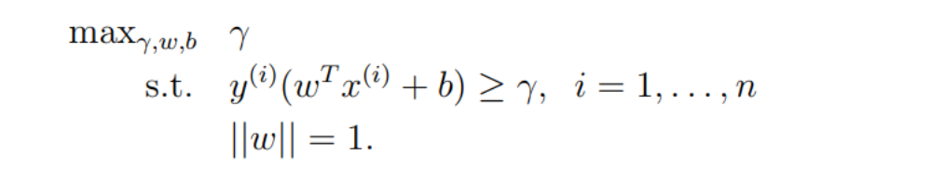
=>
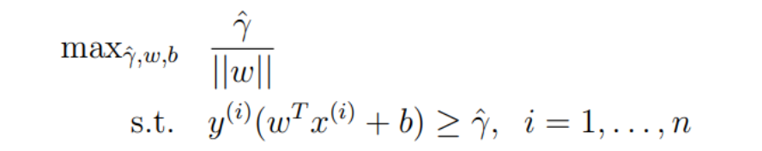

=>
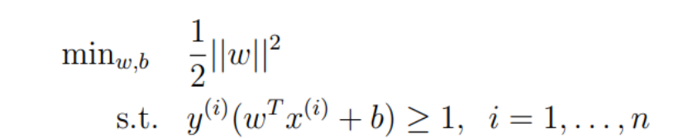

It is finally a convex optimization problem :
minimize 1/2 * |w|^2

subject to yi(w.xi)+b>=1 for all i
and can be solved by QP software.

Primal Problem (1) :
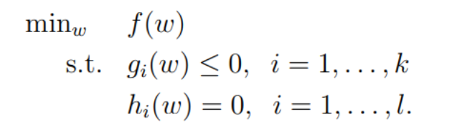
Note : second and third lines are called primal constraints
Similar to Lagrangian way of solving constraint problem, define (2) :
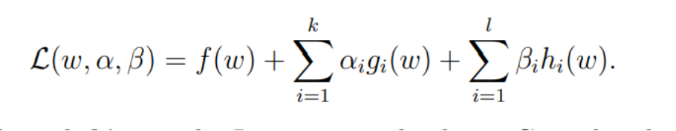
Define (3) :

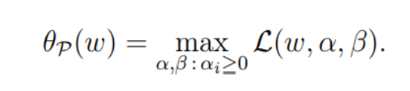
= infinity if primal constraint not satisified,
that is :
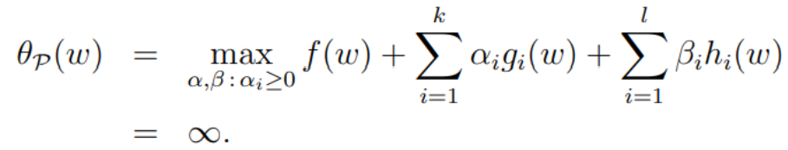
=> (4)

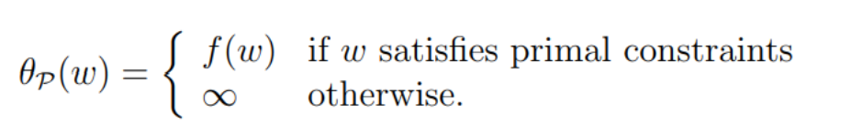
=f(w) by setting alpha and beta all zero, it is at its max. because g<0 , alpha >0 and h=0

from (1) and (4) , this becomes the following. (5).

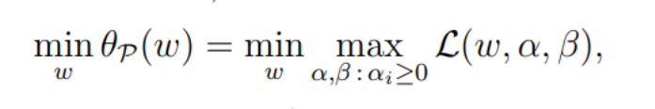
= p* , called value of primal problem.

Dual Problem
define (5)
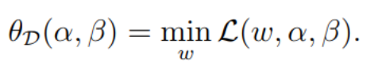
then (6)
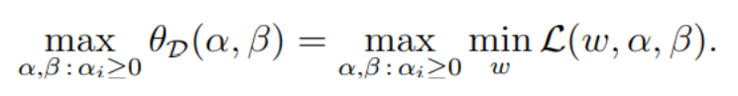
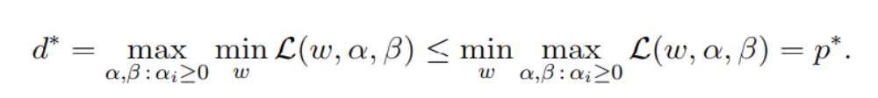
define (7), inequality is right : “worst of best” >= “best of worst”

Under certain conditions (d* = p*) , implies that min f(w)=p* can be found by Dual problem instead of Primal problem.

If assumptions hold true :
- gi convex,
- h affine(Ax+b),
- gi feasible (exist some w where gi(w) < 0 for all I)
Then :
exist w*,alpha*,beta*, such that
(a) w* is soln to primal problem,
(b) alpha*, beta* soln to dual problem
(c) p* = d* = L(w*,alpha*,beta*)
(d) w*,alpha*,beta* satisifes following KTT conditions

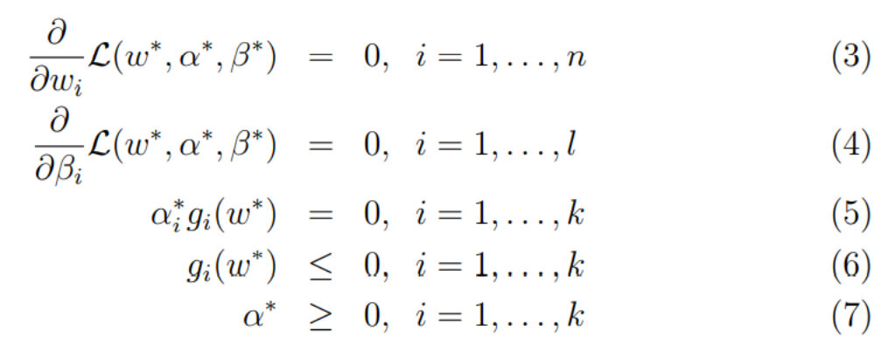
Also If some w*,alpha*,beta* satisifes KTT conditions, then these are solution to primal and dual problem.

Going back to SVM :

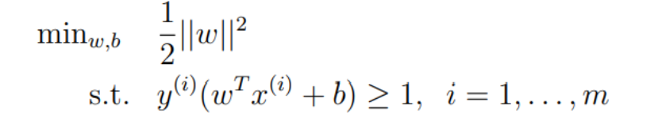

------ (&)

It is in fact a primal problem where
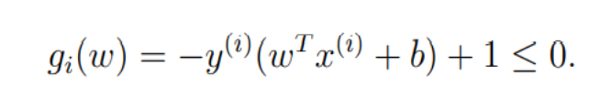
L of SVM problem is : (*)
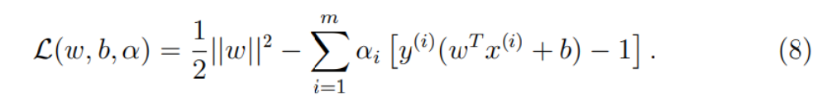
where all beta = 0

We are going to solve it as a dual problem , ie according to (5), we find min by finding derivative of L with respect to w and b ( not beta , b is in * ) and set to zero, which is :
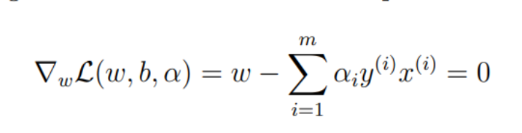
=> (**)
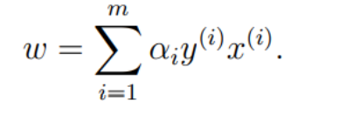
And (***)
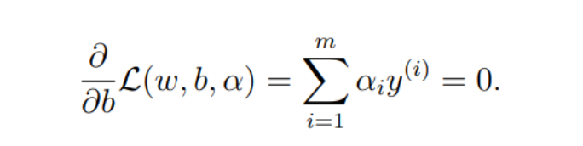
set(***) and (**) to (*), we get

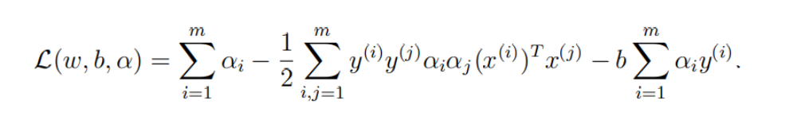
then by (***) =>

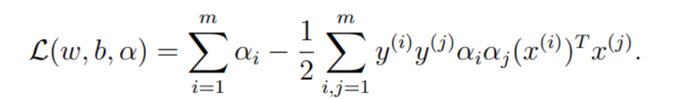
(****)

from (****), <xi,yi> is inner product.
Second line : notice (6)
Third Line : from (***)
We are now solving this problem (11) , by getting into the max part of dual problem (6).
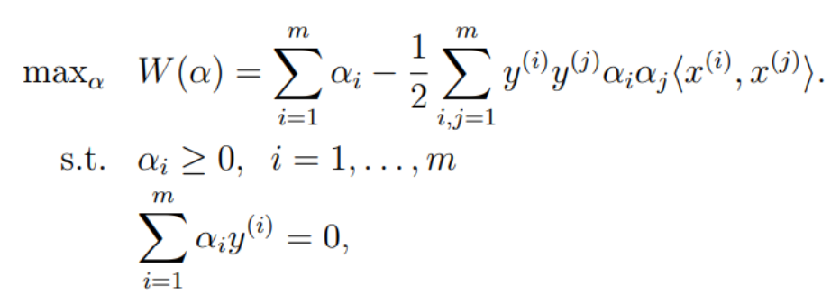

Important : solving this problem mean solving (&)

TODO : show that KTT conditions are satisified in this SVM problem.
Important Points to note :
1. solving dual problem = solving primal problem.
2. max problem can be represented only by inner product : <xi,xj>, allows kernel method.
3. it is max. only by variating alpha alpha I

Then we can use SMO algo find the max and then use (**) to find w*
with w* , then can find b*

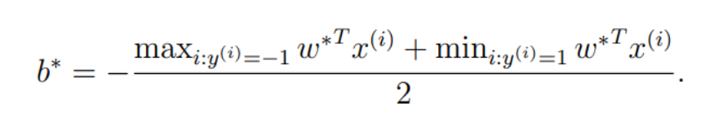

Consider KKT(5) ,KKT dual complementarity condition, it implies that
alpha*i > 0 => g(w*) = 0 ---- ($)

Assume we have modeled the hyperplane now and we are doing prediction:
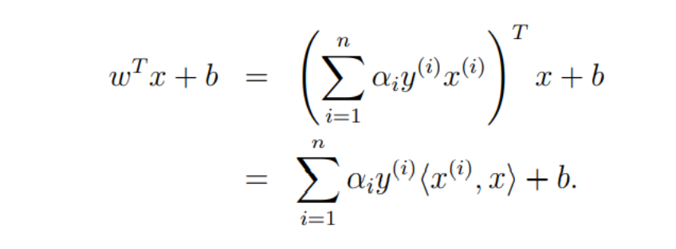

Few points :
- inner product only, in classification wTx+b > 0 => y =1 , < 0 => y = 0
- alpha > 0 only when g(w*) = 0, (in KKT(5) , ($)), those xi which are support vector makes g(w*) = 0, therefore in classification , we only consider xi which are support vectors, other set 0 by alpha = 0

Kernel Method :
Feature mapping is applied to escalate the dimension to allow samples to be separable by hyperplane, generally samples are not linearly separable.

Trival example of feature mapping :
epi(x) = (1,x,x^2)T and sample = (t1,t2,t3) => t1+x*t2+x*t3

Use LMS with feature mapping: (kernel trick)
- applying feature mapping does not means much increased complication
- next theta can expressed updated linear combination of original features and updated inner product of orignal attributes

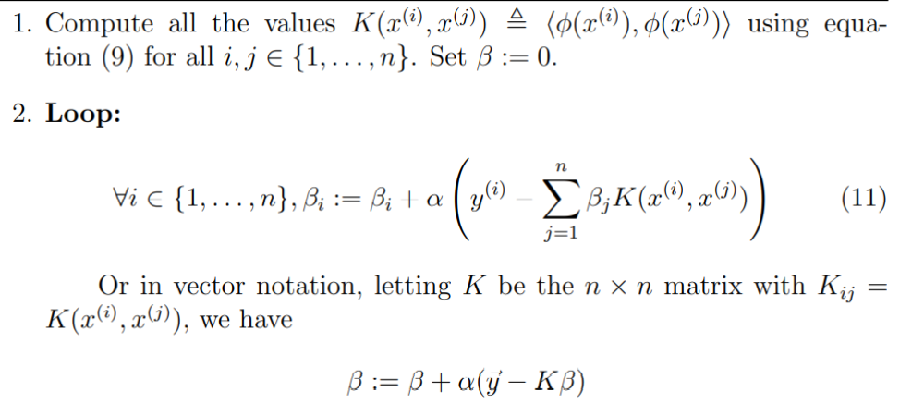

- K(xi,xj) (inner product of )is easy to compute but epi(xi) itself may be complicated.
- K(xi,xj) preserve <xi,xj> similarity , epi(xi) close to epi(xj) => K(xi,xj) large
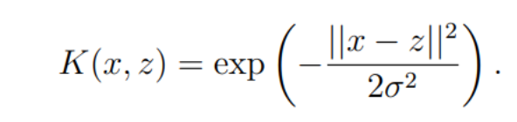
- Example : Gaussian Kernel :
- Consider a matrix(Kernel matrix)
- Kij = K(xi,xj) = Kji ,
- Kernel matrix is symmetric positive semi-definite <=> valid kernel (Mercer Theorem)

SMO algorithm :
With Regularization.

