#include <iostream>

#include <iomanip>

using namespace std;

int main()

{

//Problem 2.5

double subtotal = 0.0;

double gratuity = 0.0;

double total = 0.0;

cout << "Please enter the subtotal." << endl;

cin >> subtotal;

cout << "Please enter the gratuity rate as a decimal." << endl;

cin >> gratuity;

total = subtotal + (subtotal * gratuity);

cout << "The gratuity is $" << fixed << setprecision(2) << subtotal * gratuity << endl;

cout << "The total is $" << total << endl;

return 0;

}

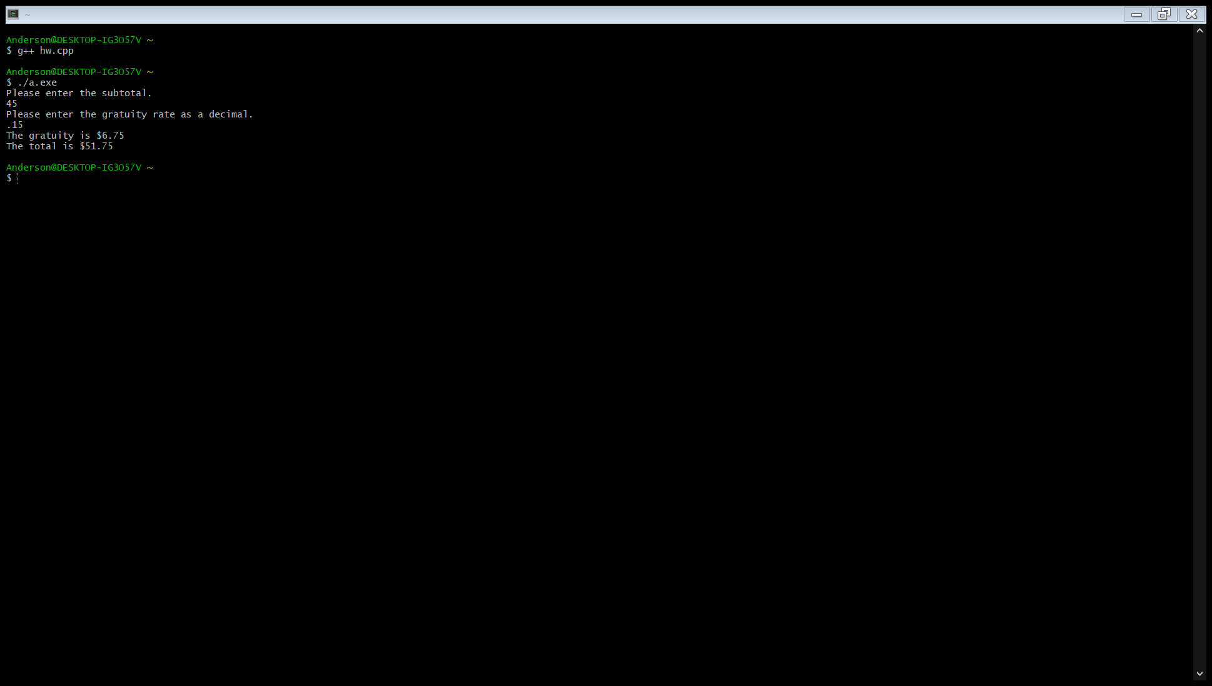

#include <iostream>

#include <iomanip>

using namespace std;

int main()

{

//Problem 2.6

int userInt = 0;

int total = 0;

cout << "Enter an integer between 0 and 1000." << endl;

cin >> userInt;

if (userInt >= 100)

{

for (int i = 0; i < 3; i++)

{

total += (userInt % 10);

userInt = userInt / 10;

}

}

else if (userInt >= 10)

{

for (int i = 0; i < 2; i++)

{

total += (userInt % 10);

userInt = userInt / 10;

}

}

else

{

total += (userInt % 10);

userInt = userInt / 10;

}

cout << "The total of all digits in your integer is " << total;

return 0;

}

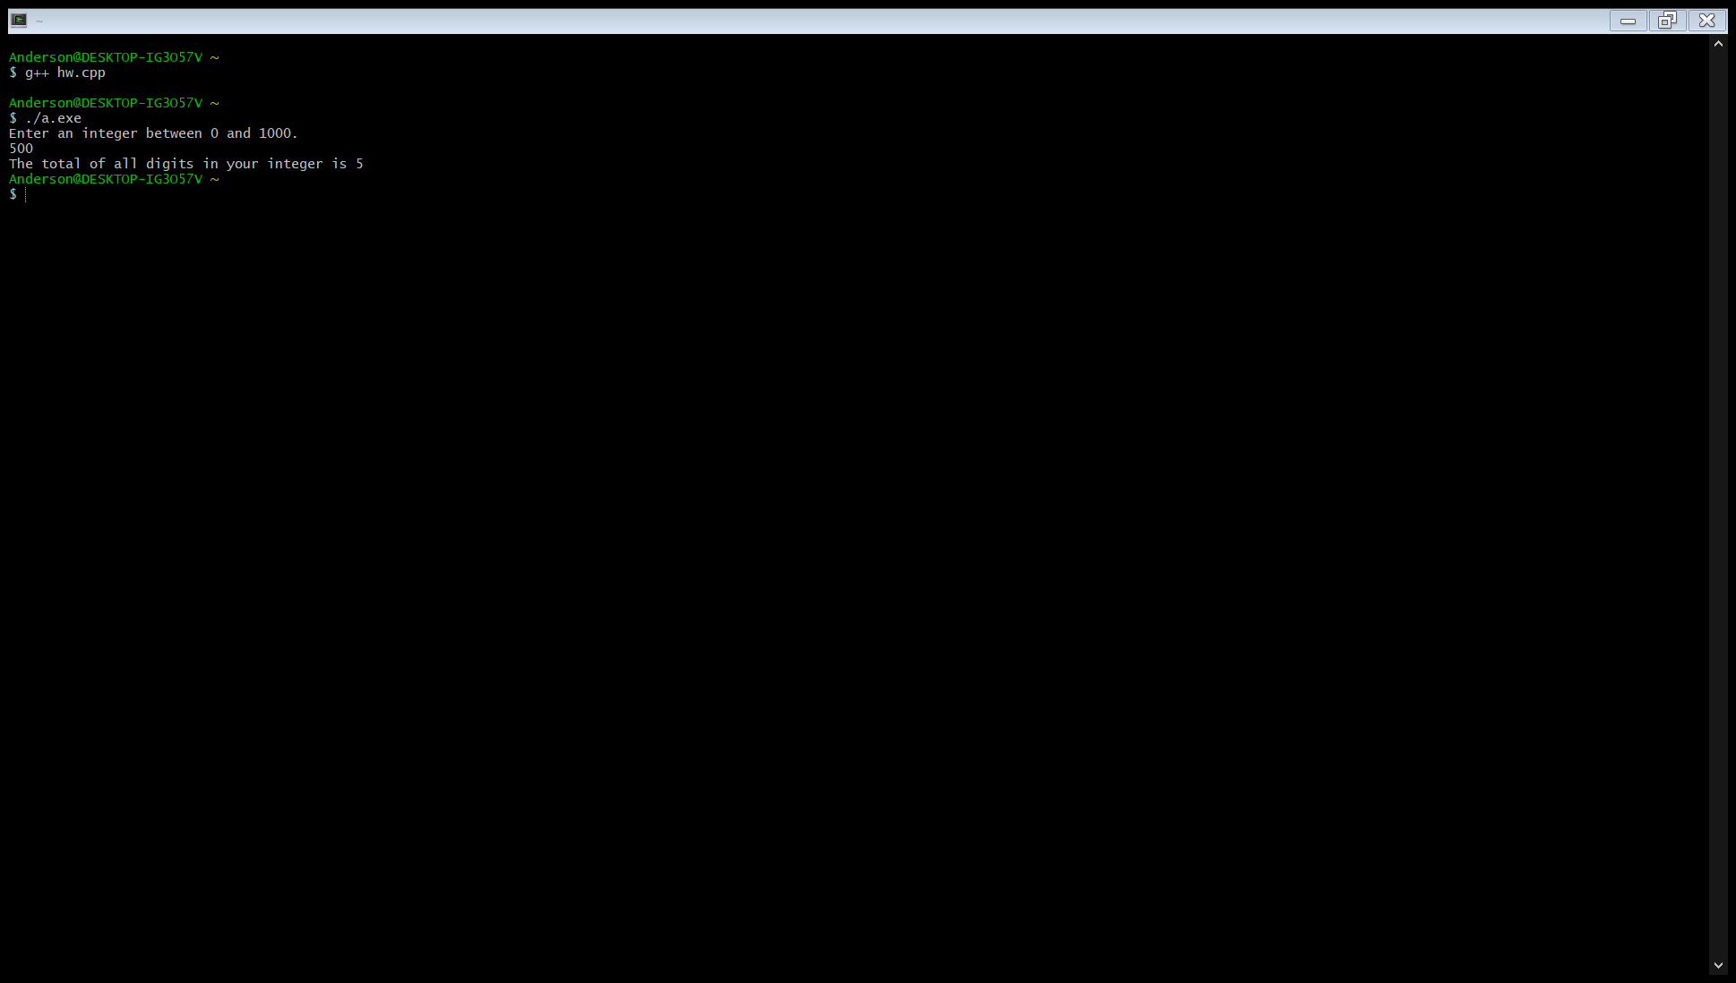

//Problem 2.13

#include <iostream>

using namespace std;

int main()

{

double monthlySavings = 0.0;

const double INTEREST_RATE = .05;

double total = 0.0;

cout << "Please enter your monthly saving amount." << endl;

cin >> monthlySavings;

for (int i = 0; i < 6; i++)

{

total += monthlySavings * (1 + INTEREST_RATE);

}

cout << "The total after six months is $" << total << endl;

return 0;

}

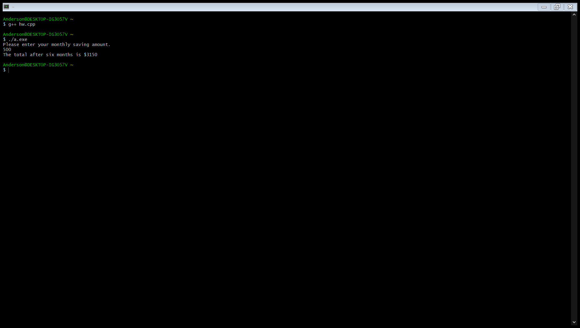

#include <iostream>

#include <math.h>

using namespace std;

int main()

{

double a, b, c = 0.0;

double discriminant = 0.0;

double root1, root2 = 0.0;

cout << "Please enter a value for a." << endl;

cin >> a;

cout << "Please enter a value for b." << endl;

cin >> b;

cout << "Please enter a value for c." << endl;

cin >> c;

discriminant = (b * b) - 4 * a * c;

if (discriminant > 0)

{

cout << "There are two roots." << endl;

root1 = (-b + sqrt((b * b) - 4 * a * c)) / (2 * a);

root2 = (-b - sqrt((b * b) - 4 * a * c)) / (2 * a);

cout << "The two roots are " << root1 << " " << root2;

}

else if (discriminant == 0)

{

cout << "There is one root." << endl;

root1 = root2 = (-b) / (2 * a);

cout << "The root is " << root1;

}

else

cout << "There are no real roots." << endl;

return 0;

}

