Generative AI Tools — Initial Prompt
.NET Technical Interview Exercise — Task Management REST API
GenAI tool used: Claude Code (Anthropic)

Overview
This document contains the initial prompt I used with Claude Code to scaffold the task management REST API. Development is driven by the user story below; the prompt turns that story into explicit acceptance criteria, architectural constraints, and a controlled, checkpoint-based process rather than a one-shot code generation request.

The Prompt
I'm building a task management REST API in .NET 10 (C#, ASP.NET Core Web API).
It will be code-reviewed by a technical interview panel, so prioritize clean,
idiomatic, explainable code over clever solutions.

User story:
"As a busy professional, I want to create, organize, and track my personal tasks
with statuses and due dates, so that I can prioritize my work and never miss a
deadline."

Acceptance criteria:
- Users can register and log in; authentication uses JWT bearer tokens.
- Users can only see and manage their own tasks — ownership is enforced
server-side, taking the user id from JWT claims, never from the request body.
- Each task has: title, description, status (Pending / InProgress / Completed),
and due date.
- A task cannot be created without a title or with a due date in the past.

Architecture — follow Clean Architecture strictly:
- Solution with 5 projects: Domain (entities, no dependencies), Application
(services, DTOs, FluentValidation validators, repository interfaces —
no reference to EF Core), Infrastructure (EF Core + SQL Server, repository
implementations, migrations, seeding, JWT generation, password hashing with
PasswordHasher<T>), Api (thin controllers, DI, middleware, Swagger), and
UnitTests (xUnit + Moq + FluentAssertions).
- Dependency rule: Api -> Infrastructure -> Application -> Domain. Never violate it.

API surface:
- AuthController: POST /api/auth/register, POST /api/auth/login (both anonymous),
GET /api/auth/me (authorized).
- TasksController ([Authorize]): GET /api/tasks (optional status filter),
GET/PUT/DELETE /api/tasks/{id}, POST /api/tasks.
- Proper HTTP semantics: 201 with Location on create, 204 on delete, 404 for
missing or non-owned tasks, 400 with field-level ProblemDetails for validation,
401 for bad credentials without revealing which field was wrong. Global
exception middleware — never leak stack traces.

Database: SQL Server, EF Core code-first. Users table (id, unique username,
unique email, password hash) and Tasks table (id, title, description, status,
due date, FK to user, timestamps). Seed a demo user and sample tasks on startup
in Development.

Process — follow strictly:
1. Propose the build order first and wait for my approval before writing code.
2. Use TDD for the Application layer: write the failing test, show me it fails,
then implement, then show it passing. Commit at each red/green state with
conventional commit messages.
3. Stop after completing each layer, summarize your decisions and any
uncertainties, and wait for my go-ahead.
4. If anything is ambiguous, ask me instead of assuming.

Prompt Design Rationale
- Context before task — Stating up front that the code will be reviewed by a panel biases the model toward simple, idiomatic, explainable solutions instead of over-engineered abstractions.
- User story drives requirements — The acceptance criteria are derived directly from the user story, so business rules (ownership, title required, no past due dates) originate from the requirement, not from the tool.
- Constraints stated as invariants — Rules that AI-generated code commonly gets wrong — the Clean Architecture dependency direction, and never trusting a user id from the request body — are declared explicitly so violations can be caught during review.
- Checkpoints instead of one-shot generation — The model must propose a build order, stop after each layer, and wait for approval. Every layer is reviewed by me before the next one is generated.
- Verifiable TDD — Requiring failing tests first and commits at each red/green state produces a git history that demonstrates the methodology, not just the end result.
- Ambiguity handling — The model is instructed to ask rather than assume, keeping design decisions with the developer.

Claude Code replied — asking before assuming, exactly as the process rules instructed:
Good — empty repo, .NET 10 SDK (10.0.301) is installed. Before proposing the build order I have a few decisions that the spec leaves open; rather than assume, here they are:
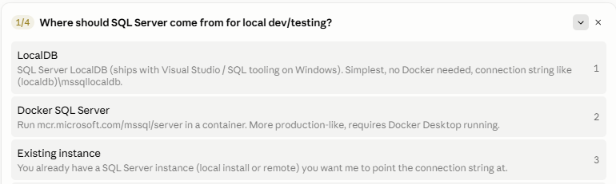
Use my existing local SQL Server instance. It is already installed, so there is no Docker dependency, and EF Core migrations, seeding and queries still run against the real SQL Server provider instead of an in-memory substitute — keeping the persistence behavior realistic.
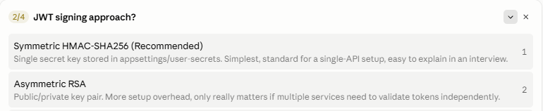
Option 1 — symmetric HMAC-SHA256. This is a single API validating its own tokens, so an RSA key pair adds setup overhead with no benefit here; a single secret kept in user-secrets is the standard choice and the easiest to explain and review.
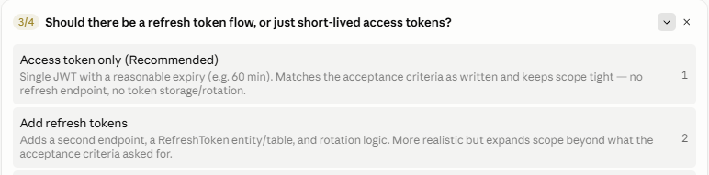
Option 1 — access token only, with a short expiry. Refresh tokens would add an endpoint, a table and rotation logic that the acceptance criteria never asked for; I would rather keep the scope tight than over-engineer.
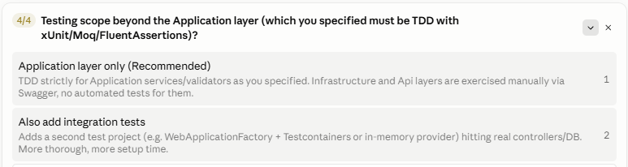
Option 1 — TDD on the Application layer only. That is where the business rules live, and unit tests should not hit a real database, so repositories are mocked with Moq. The Infrastructure and Api layers are verified manually through Swagger.
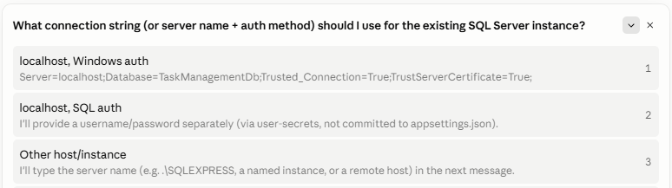
Option 1 — localhost with Windows authentication. For a development environment, Trusted_Connection keeps credentials out of the configuration files entirely, so there is nothing sensitive to manage or accidentally commit.
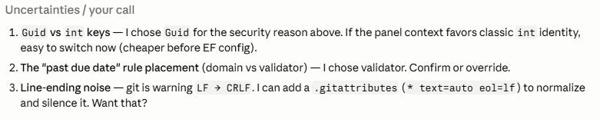
1. Keep the Guid keys — non-sequential ids cannot be enumerated, which complements the server-side ownership checks: a guessed URL still returns 404, and the id itself reveals nothing.
2. Keep the past-due-date rule in the FluentValidation validator — it is a rule about creating a task, not a domain invariant: an existing task legitimately becomes overdue with time, so the domain must be allowed to hold past due dates.
3. Standardize line endings on CRLF and enforce it with a .gitattributes file, so the repository stays consistent across machines and the warnings disappear from the git history.

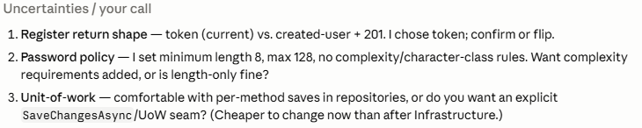

- Register return shape: explain the trade-offs in more detail before I decide — I do not want to commit to an API contract without understanding the REST implications of each option.
- Password policy: strengthen it — minimum length 8, maximum 128, and require upper- and lowercase letters plus at least one special character. A length-only rule is too weak for an exercise centered on authentication.
- Unit of Work: add the explicit SaveChangesAsync/UoW seam now. It is cheaper to introduce before the Infrastructure layer exists, and it keeps transaction boundaries in the service layer if the application grows.
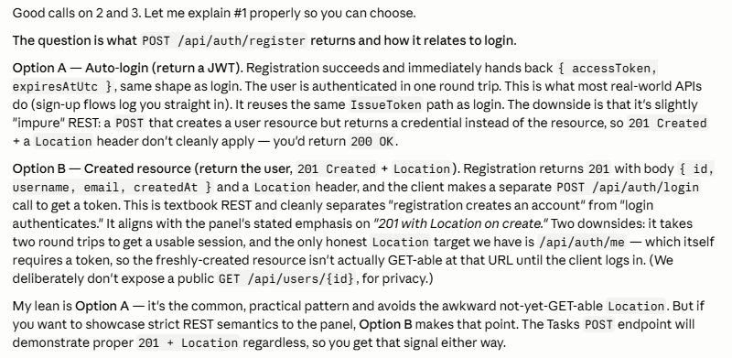
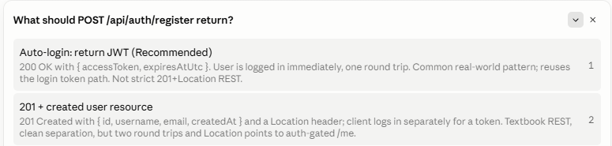
Option 1 — auto-login, returning the JWT. It is the pattern real-world sign-up flows use, it reuses the same token-issuing path as login, and it avoids a Location header pointing at an auth-gated endpoint. Strict 201 + Location semantics are still demonstrated by POST /api/tasks, so the panel sees both patterns anyway.

