Abstract
1. Crops that provide a resource pulse from a mass-blooming event can play a role in supporting wild bee diversity and health, particularly in crop landscapes where natural forage can be limited. However, benefits of short-term resource pulses are likely shaped by the landscape context and may vary considerably among bee groups with differing life histories and foraging strategies.
2. We evaluated how canola (Brassica napus) affected bee head widths and abundance across a gradient of landscapes. Our project involved sampling of bee and wildflower communities in natural habitats and canola fields of the historical Palouse Prairie region in eastern Washington.
3. Across the 11 most prevalent bee genera, there was a non-uniform response to proximity and proportion of canola in the landscape. The abundance of Andrena and Lasioglossum declined with increasing canola saturation in the landscape, but Ceratina, Halictus, and Nomada increased in abundance with increasing plant richness. Notably, Bombus, Osmia, and Nomada head widths decreased with increasing canola in the landscape.
4. In the Palouse, effects of mass blooms on bee abundance and health metrics may be driven by decreased floral diversity, increased pathogen and parasite exposure, or limited nesting opportunities – all which could be attributed to the management of large monocultures.
5. Our study suggests that solitary bees with limited foraging ranges depend more on local habitat quality rather than landscape-level patterns. In contrast, generalists with larger foraging ranges are more affected by the quality of foraging at broader spatial scales.

Keywords: canola, floral resources, landscape context, native bees, plant-pollinator interactions
1 | INTRODUCTION
In agricultural regions that have been modified and have limited natural pollinator habitat, crops providing mass-blooming floral resources such as canola offer abundant but short-term forage resources in otherwise resource scarce landscapes (Holzschuh et al., 2013; Westphal et al., 2009). Crops that provide mass flowering pulses also mediate ecological alterations in agricultural habitats, specifically in crop fields that border natural spaces (Gardner et al., 2021; Holzshuh et al., 2013). However, as monocultures of crop fields bloom for only short windows of time (2-4 weeks) that rarely span the entire active period of all wild bees in a particular region (spring through autumn), resource variability exists both within seasons and across landscapes (Gardner et al., 2021; Riedinger et al., 2015; Westphal et al., 2009). Agriculture can impact wild bee communities by replacing native ecosystems and shifting the temporal windows when floral resources are available, affecting the stability of pollinator communities (Lau et al. 2023). However, whether pulsed floral resources affect individual bee health are less well studied.
Factors that may mitigate the impact of a mass bloom event on health of individual bees are the size of local natural areas and their proximity to the bloom. Studies on landscape-level effects on bee communities have largely focused on the role of natural habitat surrounding crops, as these natural areas provide floral resources and nesting sites that improve pollinator diversity and stability (Bloom et al., 2019; Lichtenberg et al., 2017). Floral resources often improve wild bee diversity and abundance and in some cases, crop yields (Garibaldi et al., 2013, Lichtenberg et al., 2017; Pywell et al., 2015). Greater abundance of natural areas near crop fields might also promote ‘healthy’ bees that would be expected to accrue minimal benefits from mass blooming crop resources. In contrast, in resource starved areas, major mass blooming crops that provide key floral resources might provide relatively large benefits to wild bees (Eberle et al., 2015; Lichtenberg et al. 2023; Olsson et al., 2025).
Increasing diversity of habitats adjacent to mass-blooming crops can lead to more abundant wild bee populations (Gardner et al., 2021; Olsson et al., 2025). At the same time, monocultures with short blooms may attract bees away from more diverse natural habitats, altering individual bee health by reducing diet breadth. While large natural areas near crop fields often increase bee community diversity and stability of pollination (Bloom et al., 2019; Lichtenberg et al., 2017), the potential inverse impact of mass-blooming crops on the body size of individual pollinators is understudied. The studies that do exist have largely tested effects of mass-blooming crops on bumble bees, where temporal availability and total food amount can affect colony growth and reproduction, as high-quality floral landscapes promote long-term lineage survival (Carvell et al., 2017, Hemberger et al., 2020). While these patterns underscore the importance of evaluating how mass blooms affect bees, testing effects on a broader range of bee species and landscapes is needed.
Canola (Brassica napus) is a cold-hardy oilseed crop that has become increasingly sown in the Palouse region of eastern Washington and northern Idaho States. Canola is a reliable crop in rotation with wheat and legumes that aids in weed control and nutrient cycling while providing a unique income stream (Esser & Hennings, 2012). Canola is a mass-blooming crop that flowers between 2 to 3 weeks per year, and the bright yellow flowers are attractive to a diverse group of bees (Lichtenberg et al., 2023; Olsson et al., 2025). Between 2015 and 2022, canola production in Washington expanded from 22,427 acres to 119,541 acres, with similar growth in northern Idaho (USDA-NASS, 2022b). In this region there is heavy fragmentation of the native Palouse prairie, with only 0.1% of the original habitat remaining; small remaining prairie fragments are dominated by native perennial bunchgrasses, shrubs, and wildflowers (Looney & Eigenbrode, 2012). A diverse community of bees is found within these Palouse prairie remnants, with 174 species found in a recent study (Rhoades et al., 2017). As canola offers a new and abundant food resource for bees in the region, the risk for destabilization of these remnant communities must be assessed to understand the long-term stability and health of pollinator communities in this region.
Here we assessed plant-pollinator community stability and individual bee size in natural areas adjacent to canola, a common mass-blooming crop (Lichtenberg et al., 2023; Olsson et al., 2025). Although canola is known to affect bee community diversity and abundance in the Palouse (Lichtenberg et al., 2023; Olsson et al. 2025) it is relatively unknown whether this pulsed floral resource affects bee health. Bee size is highly correlated to food provisioning in the larval stage and thereby a rough proxy for food quality (Roulston & Cane, 2000; Lawson et al., 2017). To test this, we completed bee and plant biodiversity studies in natural areas before, during, and after nearby canola bloom. We then assessed impacts of canola on bee community structure and bee head width (a proxy for health) (Roulston and Cane 2000). Our study reveals how pulsed resources from monocultures of a mass-blooming crop can affect bee community structure and the health of individual bees, although effects can vary strongly across genera and landscapes.

2 | MATERIALS AND METHODS

2.1 | Study sites and sample timing
Bee and plant sampling was conducted at 19 sites in eastern Washington State during the summer of 2022; 10 sites were within semi-natural or natural habitat, and 9 sites were within canola fields . For ‘natural’ sites, reserves or wildlife parks that bordered canola fields were selected, while ‘semi-natural’ sites were wildflower patches at least 2.5 ha (1-acre) in size and located outside of the crop matrix or along a roadside near a canola field. All sites were within 10 km of a canola crop field, with the nearest sampling occurring at 11 m from canola and the furthest at 8.1 km from canola (Figure 1). The furthest sites were intentionally selected to examine wild bee communities beyond the flight range to a canola field in an attempt to remove the landscape-scale influence of canola. The percentage of canola within a 2 km buffer around each habitat sampling area ranged from 0 to 43%. The 2km buffer was selected to encompass the maximum foraging range of solitary wild bees (Zurbuchen et al. 2010). Surveys were conducted three times during the 2022 growing season at pre-, peak-, and post-canola bloom to capture bee communities that emerged throughout the bloom cycle. The bloom progression was defined as follows: (a) pre-bloom: less than 20% bloom, which was between 2 June and 15 June; (b) peak-bloom: 60 to 80% bloom, which was between 28 June and 8 July; and (c) post-bloom: less than 30% of blooms remaining, with the majority of the field progressed to seed production, which was between 19 July and 2 August.

2.2 | Bee survey and body size measurements
Four 50m sweep net transects were placed in each site and marked in 5 m intervals. Transects were chosen during pre-bloom sampling in areas with flowers blooming, and remained in the same location. Bees were collected by sweep netting along the transect for 10 min, walking in each direction along the transect with each 5 m interval sampled for 1 min. Sweep nets were emptied into a Ziploc bag and stored in -20 °C freezers. Samples were identified to genus using keys (Michener, 2007, Packer et al., 2007); identifications were verified by Dr. Silas Bossert of Washington State University and Dr. Karen Wright at the Washington Bee Atlas. For all bees, we measured head width and intertegular space using a digital caliper to 0.01 mm (Hagen and Dupont 2013); head width and intertegular space are highly correlated in wild bees and serve as two proxies for bee body size (Hagen & Dupont, 2013). Due to strong correlation between head width and intertegular distance (r = 0.947), we opted to use only head width for simplicity and efficiency of analyses.

2.4 | Plant biodiversity survey and landscape context
We conducted plant diversity surveys for each site during each of the three sampling periods. At each site, the same transects as bee surveys were used. Plant surveys were typically conducted on the same days as bee sampling, but if not the same day, plant surveys were always done within a week of bee sampling. We placed a 1 m² quadrat within each of the four transects. Placement was changed between periods to include flowers blooming at different times during the season, and to avoid resampling the same flowers . We recorded all plants in bloom within each quadrat. Unknown plant species were identified using iNaturalist (3.2.6) (iNaturalist, 2022). For plants requiring further identification, samples were collected and later pressed for identification using Washington State University herbarium resources.
Landscape context surrounding each site was assessed using the USDA Cropland Data Layer (USDA-NASS, 2022a). For simplicity, landscape types were sorted into ten categories: non-flowering agriculture, barren, development, tree fruit crops, forest and tree crops, wetland / open water, pasture, canola, and other flowering agriculture. The amount of each landscape type in a 2 km buffer around sites was calculated using R (4.5.2) (R Core Team, 2025).

2.5 | Community metrics and statistical analyses
Abundance, richness, and Shannon diversity were calculated for bee and plant communities at each site for each canola bloom period. Abundance was the sum of all individuals at each site per bloom period, and richness was the number of bee genera or plant species at each site per bloom period. Shannon diversity of bee and plant communities at each site during each bloom period was calculated using the vegan package in R (Oksanen et al., 2017, ver. 2.6-6.1).
All statistical analyses were performed in R v. 4.5.2 (R Core Team, 2025), with all data cleaning and figure generation performed in the tidyverse ecosystem (Wickham et al., 2019, ver. 2.0.0). To test whether canola altered bee health, we modeled bee head width (mm) as a function of site type (whether bees were collected directly within canola fields or in surrounding landscapes), the proportion of canola in the surrounding 2 km (canola saturation), their two-way interaction, and sampling date (continuous, day of year), using a linear mixed model fit with the R package lme4 (Bates et al. 2015, ver. 1.1-35.3). There was large variation in head width size across genera (0.96 to 5.38 mm), and we included genus as a normally distributed random intercept to capture this nested variation. As some genera may respond differently to canola, we also allowed the effect of canola saturation to vary for each genus as a random slope (Zuur et al. 2010). We restricted analyses to include only genera for which sample sizes were ten or more. Preliminary models revealed no effects of sampling date so this term was later removed. For the linear mixed model We report estimates (β) and 95% confidence intervals on the scale of the linear predictor.
To test whether bee community composition was shaped by canola and plant communities, we built a permutation MANOVA to model the bee community matrix as a function of site type, sample date, plant richness, plant diversity, and canola saturation. The variable canola saturation reflects a high dimensional spatial pattern, and its relationship with bee community composition is likely nonlinear. For example, a value of 0.5 indicates a 2 km radius where half of the area is canola, but the actual spatial arrangement can fall in the continuum between a checkerboard mosaic (maximally fragmented) and a black and white cookie (two large continuous patches). To flexibly model how bees may respond to this variable, we included a spline term with 5 degrees of freedom (Chambers & Hastie, 1992). This permutation MANOVA was fit with the R package, vegan::adonis2 (Oksanen et al., 2025, ver. 2.6-6.1). To interpret the results, we used a canonical analysis of principal coordinates (CAP) with one constrained axis representing the variation in site type (whether bees were collected in canola or surrounding areas). We then overlayed species vectors, and the continuous variables: canola saturation and plant richness with generalized additive model (GAM) surface overlays using the R package, gamm4 (Wood & Scheipl, 2025, ver. 0.2-6). While all bee genera were used in the PERMANOVA, only genera with CAP loadings in the top 20th percentile are shown as species vectors.

3 | RESULTS
We collected 2050 bee individuals from 5 families and 29 genera, with the most common genera being Andrena (n = 604), Lasioglossum (n = 577), Ceratina (n = 367), Halictus (n = 159), and Nomada (n = 102). Honey bees (Apis mellifera) only accounted for 2.1% of bees (n = 43). Across sites, bee richness ranged from 1 to 14 genera, while Shannon diversity ranged from 0.00 to 2.20. Our plant transects found 64 genera across 31 families. The most common plant species were Allium acuminatum (18.7%) and Symphoricarpos albus (17.0%). Plant richness and Shannon diversity ranged from 1 to 24 and 0.00 to 2.65, respectively.
At the population level, bees collected in canola fields had larger head widths compared to bees collected outside of canola (β = 0.30, 95% CI = 0.24 to 0.37, P < 0.01) (Figure 2). For bees collected outside of canola, head width varied independently of canola saturation (β
= -0.35, 95% CI = -0.98 to 0.27, P = 0.28), but bees collected in canola had a negative relationship between head width and canola saturation (β = -0.85, 95% CI = -1.29 to -0.40, P < 0.01) (Figure 2). While the population-level model estimated a dependence between canola saturation and whether bees were collected in canola fields, we note that the random-slope term indicated strong genus-level heterogeneity; some genera were more severely impacted by increasing canola saturation, while others showed less sensitivity (Figure 3). These genus-level slopes are best linear unbiased predictions using partial pooling, meaning they reflect the genus-level deviation and uncertainty from the overall model. These slope terms should be interpreted as estimated departures from the population-level slope rather than independent regression coefficients (Zuur et al., 2010).
Bee community composition varied with canola saturation (F₅ = 1.38, R² = 0.13, P = 0.04), plant richness (F₁ = 1.80, R² = 0.03, P = 0.06), and whether collection occurred in or outside of canola (F₁ = 5.30, R² = 0.10, P < 0.01). We confirmed that the effect of canola field collection was not due to differences in within-group variability via permutation tests for homogeneity of multivariate dispersions (F₁ = 0.03, P = 0.87, permutations = 999). Horizontal separation in bee community composition by collection in or outside of canola (CAP1) accounted for 9.17% of total variation, suggesting that differences in bee communities are at least partly explained by whether bees were collected in or outside of canola fields. The first unconstrained axis (MDS1) captured 17.2% of residual variation (variation not explained by the model predictors).
Notably, species vectors for Andrena and Lasioglossum align with and are strongly loaded along the canola saturation variable (Figure 4A). This implies that the abundance of these species declines with increasing canola saturation. Alternatively, variation in the abundance of Ceratina, Halictus, and Nomada is orthogonal to canola saturation and instead correlated with separation in the canola collection variable (Figure 4A). Variation in plant richness also aligns with the canola collection variable (along the constrained axis) as predicted, where sites outside of canola fields had greater plant richness; while sites in canola fields contained only canola (Figure 4B). Nevertheless, the alignment between plant richness and the Ceratina, Halictus, and Nomada vectors indicates these genera increase in abundance with increasing plant richness. The genera, Lasioglossum and Andrena have abundances that are primarily orthogonal to plant richness (Figure 4B).

4 | DISCUSSION
Many studies that assess effects of canola or other mass blooming crops have focused on wild bee communities with the goal of improving crop pollination (Bänsch et al., 2021; Lichtenberg et al., 2023; Olsson et al., 2025). Yet, few studies have examined how the health of individual bees within natural landscapes is affected by nearby mass-blooming crops (but see Diekötter et al., 2010; Hanley et al., 2011). Our results suggest canola may act as both a resource and a constraint to bee populations. Bees tended to have larger head widths at sampling sites inside canola fields, consistent with increased growth associated with mass-blooming crops (Westphal et al., 2009). However, as canola became more abundant in the broader landscape, head width declined for bees collected in canola. Head widths were also greatest when bees were collected in canola fields that had sparse canola saturation in the landscape. We interpret these interactions as reflecting optimal nutrition; bees in diverse and heterogeneous landscapes with access to canola, even in sparse amounts, may have increased nutrition compared to bees in landscapes devoid of canola. However, as canola acreage increases, it displaces diverse native plant communities (Cohen et al., 2021), which may offset the value of its nutritional pulse.
A greater diversity of floral resources and native plants often supports larger bodied bee species (Grab et al., 2019), and bumble bees produce larger workers in more complex landscapes (Persson & Smith, 2011). Head width – and overall body size – in bees across guilds is largely determined by pollen amount and protein content provisioned during the larval stage (Roulston & Cane, 2000; Lawson et al., 2017). Nesting ecology of Osmia and other species may also play a large role in affecting head width (Roulston & Cane, 2000, Harmon-Threatt, 2020). Almost all Osmia species in North America nest in preexisting cavities discovered by the nesting female (Cane & Griswold, 2009), and high rates of tilling in canola can reduce subterranean preexisting cavity-nesting resources available (Lichtenberg et al., 2023). While our study was limited by genus-level identification, we hypothesize that tillage could inadvertently select for smaller Osmia species that we were not able to detect in our sampling. Further, Osmia, Nomada, and Bombus showed greater sensitivity to canola saturation than other genera. While Nomada are kleptoparasites and extraordinarily understudied, there could be many factors at play that may lead Osmia and Bombus to display decreasing head width with increasing canola saturation.
Mass-flowering crops are commonly associated with increased bee abundance (Cohen et al., 2021; Holzschuh et al., 2013; Riggi et al., 2024), but our results showed the opposite. We found that abundance of most bee genera were not related to canola saturation, however abundance of Andrena and Lasioglossum sharply declined with canola saturation. The
neutral or declining bee abundance associated with a mass flowering crop may be explained temporally. For example, early season mass-flowering crops can dilute wild bee abundance in neighboring wild habitats (Riggi et al., 2024). While we detected no effect of sampling date, our study lacked bee surveys in canola prior to bloom, muddling this comparison. That plant richness and canola saturation were uncorrelated, and bees showed disparate responses to these variables, may be explained by the landscape context in which canola exists. Canola is planted rotationally with legumes in a wheat-dominated landscape in the Palouse region. Fields are large, reaching up to 250 ha in size, and are often surrounded on all sides by other crops (Looney & Eigenbrode, 2012; Lichtenberg et al., 2023). While we included natural sites at reserves and parks such as Turnbull National Wildlife Refuge, Hudson Biological Reserve at Smoot Hill, Kamiak Butte County Park, and Asotin Creek Wildlife Area in this study, the majority of non-crop land in this region is found within field margins and along roadsides. Habitat patches are also very small and unconnected, with limited presence of narrow wildlife corridors (Looney & Eigenbrode, 2012).
The single season sampling we report here limits the inference we can make on nutritional patterns with canola. Most of the bees collected in this observational study are solitary and univoltine, so generational effects from maternal resource provisioning could not be observed. However, resource provisioning effects in honey and bumble bees can be measured over the course of a single season (Roger et al., 2017; Sauthier et al., 2017). Unique to our study is that the potential nutritional benefit of canola appears only applicable when canola is sparse in the landscape. Despite the lack of long-term, maternal-effect testing, we reason that our results highlight that the effects of mass-flowering crops on bees are not straightforward and necessitate further study. Canola, in general, is wind pollinated and canola in Washington is primarily grown for biofuel, however canola seed production does require managed honey bee pollination for production (Sowers et al. 2014, Bjerke et al. 2020). While honey bee stocking is not widespread in Washington canola, it does occur unofficially to a small degree in the Palouse – commercial honey bees in transit back to their state of origin will be placed in or around canola fields for short periods of “rest” after contract pollination in almonds, tree fruits, and small fruits in California, Oregon, and Washington (Anonymous grower, personal communication, 2023). This study was designed with the assumption that managed bees would be more present in Palouse canola fields than this study was able to detect. The added presence of commercial honey bees would have increased the risk of introducing pathogens and parasites to the wild bee communities in and around canola, while also increasing competition between honey bees and wild bees (Mallinger et al. 2017).
Around 98% of bees collected over the course of this study belonged to non-eusocial genera, these bees are characterized by a limited foraging range (150 to 600 m) when compared to social bee groups such as Bombus spp. (1.5 km) and Apis mellifera (9.5 km) (Gathmann & Tscharntke, 2002; Osborne et al., 2008). Bee taxa are affected by the composition of agroecosystems differently depending on range (Woodcock et al., 2013, Gardner et al., 2021).Bees are central place foragers, except perhaps kleptoparasites, requiring food resources to be aggregated within flight range to their nest which they provision multiple times per day (Zurbuchen et al., 2010). T Smaller solitary bees would be expected to be more impacted by local habitat rather than changes on a landscape level, while social groups with larger ranges and body sizes such as honeybees and bumble bees are more responsive to landscape level change (Bänsch et al., 2021; Olsson et al., 2025; Woodcock et al., 2013).
Overall, we found that the effects of canola on wild bee populations in the Palouse were not uniform and were largely context-dependent. In an agricultural region dominated by wheat, canola in low proportions can provide a short-term floral resource pulse that benefits bees. In contrast, higher levels of canola in the landscape were associated with reduced head width and abundance in some genera of wild bees. This could be explained by decreased floral diversity, increased pathogen and parasite exposure, or limited opportunities for cavity-nesters. Landscape-driven responses varied across genera, although Bombus and Osmia showed particular sensitivity to increasing canola in the broader landscape. We suggest that local habitat quality outweighs broader landscape-level patterns for most bees on the Palouse Prairie, as solitary groups with limited foraging ranges are dominant in this system. Yet, our findings highlight the nuance in wild bee responses to agricultural landscapes, as mass flowering crops do not provoke uniform effects on bee health and abundance. Rather, mass flowering crops can induce both positive and negative effects on wild bees, and these outcomes depend on flowering crop saturation within the landscape, surrounding habitat composition, and species-specific life histories.

REFERENCES
Bänsch, S., Tscharntke, T., Gabriel, D., & Westphal, C. (2021). Crop pollination services: complementary resource use by social vs solitary bees facing crops with contrasting flower supply. Journal of Applied Ecology, 58, 476–485. https://doi.org/10.1111/1365-2664.13777.
Bates, D., Mächler, M., Bolker, B., & Walker, S. (2015). Fitting linear mixed-effects models using lme4. Journal of Statistical Software, 67, 1-48. https://doi.org/10.18637/jss.v067.i01.
Bjerke, J., Caldbeck, B., Coleman, B., Crowder, D., Dalley, C., Epstein, D., Gunter, J., Hiatt, C., Hoover, S., Knodel, J., Nelson, B., Olsson, R., Royer, T., Thorenson, D., Steeger, T., & Verhoek, R.(2020). Best Management Practices (BMPS) for Pollinator Protection in Canola Fields. U.S. Canola Association and The Honey Bee Health Coalition.
Bloom, E. H., Northfield, T. D., & Crowder, D. W. (2019). A novel application of the Price equation reveals that landscape diversity promotes the response of bees to rare plant species. Ecology Letters, 22, 2103-2110. https://doi.org/10.1111/ele.13406.
Cane, J., & Griswold, T. (2009). Substrates and materials used for nesting by North American Osmia bees (Hymenoptera: Apiformes: Megachilidae). Annals of the Entomological Society of America, 100, 350–358. https://doi.org/10.1603/00138746(2007)100[350:SAMUFN]2.0.CO;2.
Carvell, C., Bourke, A. F. G., Dreier, S., Freeman, S. N., Hulmes, S., Jordan, W. C., Redhead, J. W., Sumner, S., Wang, J., & Heard, M. S. (2017). Bumblebee family lineage survival is enhanced in high-quality landscapes. Nature, 543, 547–549. https://doi.org/10.1038/nature21709.
Chambers, J. M., & Hastie, T. J. (1992). Generalized additive models. In Chapman & Hall Computer Science Series, Statistical Models in S (pp. 249–304). Wadsworth & Brooks/Cole.
Cohen, H., Smith, G. P., Sardiñas, H., Zorn, J. F., McFrederick, Q. S., Woodard, S. H., & Ponisio, L. C. (2021). Mass-flowering monoculture attracts bees, amplifying parasite prevalence. Proceedings of the Royal Society B: Biological Sciences, 288, 20211369. https://doi.org/10.1098/rspb.2021.1369.
Diekötter, T., Kadoya, T., Peter, F., Wolters, V., & Jauker, F. (2010). Oilseed rape crops distort plant–pollinator interactions. Journal of Applied Ecology, 47, 209–214. https://doi.org/10.1111/j.1365-2664.2009.01759.x.
Eberle, C. A., Thom, M. D., Nemec, K. T., Forcella, F., Lundgren, J. G., Gesch, R. W. Riedell, W. E., Papiernik, S. K., Wagner, A., Peterson, D. H., & Eklund, J. J. (2015). Using pennycress, camelina, and canola cash cover crops to provision pollinators. Industrial Crops and Products, 75, 20-25. https://doi.org/10.1016/j.indcrop.2015.06.026.
Esser, A., & Hennings, R. (2012). Winter canola feasibility in rotation with winter wheat. Washington State University Extension, 4 pp. https://pubs.extension.wsu.edu/product/winter-canola-feasibility-in-rotation-with-winter-wheat/ (accessed 24 Dec 2025).
Gardner, E., Breeze, T. D., Clough, Y., Smith, H. G., Baldock, K. C. R., Campbell, A., Garratt, M. P. D., Gillespie, M. A. K., Kunin, W. E., McKerchar, M., Potts, S. G., Senapathi, D., Stone, G. N., Wackers, F., Westbury, D. B., Wilby, A., & Oliver, T. H. (2021). Field boundary features can stabilise bee populations and the pollination of mass-flowering crops in rotational systems. Journal of Applied Ecology, 58, 2287–2304. https://doi.org/10.1111/1365-2664.13948.
Garibaldi, L. A., Steffan-Dewenter, I., Winfree, R., Aizen, M. A., Bommarco, R., Cunningham, S. A., Kremen, C., Carvalheiro, L. G., Harder, L. D., Afik, O., Bartomeaus, I., Benjamin, F., Boreux, V., Cariveau, D., Chacoff, N. P., Dudenhoffer, J. H., Freitas, B. M., Ghazoul, J., Greenleaf, S., … Klein, A. K. (2013). Wild pollinators enhance fruit set of crops regardless of honey bee abundance. Science, 339, 1608-1611. https://doi.org/10.1126/science.123020.
Gathmann, A., & Tscharntke, T. (2002). Foraging ranges of solitary bees. Journal of Animal Ecology, 71, 757–764. https://doi.org/10.1046/j.1365-2656.2002.00641.x.
Grab, H., Brokaw, J., Anderson, E., Gedlinske, L., Gibbs, J., Wilson, J., Loeb, G., Isaacs, R., & Poveda, K. (2019). Habitat enhancements rescue bee body size from the negative effects of landscape simplification. Journal of Applied Ecology. https://doi.org/10.1111/1365-2664.13456.
Hagen, M., & Dupont, Y. L. (2013). Inter-tegular span and head width as estimators of fresh and dry body mass in bumblebees (Bombus spp.). Insectes Sociaux, 60, 251–257. https://doi.org/10.1007/s00040-013-0290-x.
Hanley, M. E., Franco, M., Dean, C. E., Franklin, E. L., Harris, H. R., Haynes, A. G., Rapson, S. R., Rowse, G., Thomas, K. C., Waterhouse, B. R., & Knight, M. E. (2011). Increased bumblebee abundance along the margins of a mass-flowering crop: evidence for pollinator spill-over. Oikos, 120, 1618–1624. https://doi.org/10.1111/j.1600-0706.2011.19233.x.
Harmon-Threatt, A. (2020). Influence of nesting characteristics on health of wild bee communities. Annual Review of Entomology, 65, 39–56. https://doi.org/10.1146/annurev-ento-011019-024955.
Hemberger, J., Frappa, A., Witynski, G., & Gratton, C. (2020). Saved by the pulse? Separating the effects of total and temporal food abundance on the growth and reproduction of bumble bee microcolonies. Basic and Applied Ecology, 45, 1–11. https://doi.org/10.1016/j.baae.2020.04.004.
Holzschuh, A., Dormann, C. F., Tscharntke, T., & Steffan-Dewenter, I. (2013). Mass-flowering crops enhance wild bee abundance. Oecologia, 172, 477–484. https://doi.org/10.1007/s00442-012-2515-5.
Lau, P.W., Esquivel, I.L., Parys, K.A., James, K., & Chakrabarti, P. (2023). The nutritional landscape in agroecosystems: a review on how resources and management practices can shape pollinator health in agricultural environments. Annals of the Entomolgical Society of America. 116(5):261–275. https://doi.org/10.1093/aesa/saad023
Lawson, S. P., Helmreich, S. L., & Rehan, S. M. (2017). Effects of nutritional deprivation on development and behavior in the subsocial bee Ceratina calcarata (Hymenoptera: Xylocopinae). Journal of Experimental Biology, 220, 4456-4462. https://doi.org/10.1242/jeb.160531.
Lichtenberg, E. M., Kennedy, C. M., Kremen, C., Batary, P., Berendse, F., Bommarco, R., Bosque-Pérez, N. A., Carvalheiro, L. G., Snyder, W. E., Williams, N. M., Winfree, R., Klatt, B., Astrom, S., Faye, B., Brittain, C., Chaplin-Kramer, R., Clough, Y., Connelly, H., Danforth, B., … Crowder, D.W. (2017). A global synthesis of the effects of diversified farming systems on arthropod diversity within fields and across agricultural landscapes. Global Change Biology, 23, 4946-4957. https://doi.org/10.1111/gcb.13714.
Lichtenberg, E. M., Milosavljevic, I., Campbell, A. J., & Crowder, D. W. (2023). Differential effects of soil conservation practices on arthropods and crop yields. Journal of Applied Entomology, 147, 931-940. https://doi.org/10.1111/jen.13188.
Looney, C., & Eigenbrode, S. D. (2012). Characteristics and distribution of Palouse Prairie remnants: Implications for conservation planning. Natural Areas Journal, 32, 75–85. https://doi.org/10.3375/043.032.0109.
Mallinger, R.E., Gaines-Day, H.R., & Gratton, C. (2017). Do managed bees have negative effects on wild bees?: A systematic review of the literature. PLOS ONE. 12(12):e0189268. https://doi.org/10.1371/journal.pone.0189268
Michener, C. D. (2007). The Bees of the World. Johns Hopkins University Press.
Oksanen, J., Simpson, G. L., Blanchet, F. G., Kindt, R., Legendre, P., Minchin, P. R., O’Hara, R. B., Solymos, P., Stevens, M. H. H., Szoecs, E., Wagner, H., Barbour, M., Bedward, M., Bolker, B., Borcard, D., Borman, T., Carvalho, G., Chirico, M., de Caceres, M., … Weedon, J. (2025). vegan: community ecology package. https://cran.r-project.org/web/packages/vegan/index.html (accessed 24 Dec 2025).
Olsson, R. L., Pfeiffer, V. W., Lee, B. W., Oeller, L., & Crowder, D. W. (2025). Wild and managed bee communities in canola respond to landscape context and farm management. Apidologie, 56, 51. https://doi.org/10.1007/s13592-025-01176-x.
Osborne, J. L., Martin, A. P., Carreck, N. L., Swain, J. L., Knight, M. E., Goulson, D., Hale, R. J., Hale, R. J., & Sanderson, R. A. (2008). Bumblebee flight distances in relation to the forage landscape. Journal of Animal Ecology, 77, 406–415. https://doi.org/10.1111/j.1365-2656.2007.01333.x.
Packer, L., Genaro, J., & Sheffield, C. (2007). The bee genera of Eastern Canada. Canadian Journal of Arthropod Identification, 3, 1–32. https://doi.org/10.3752/cjai.2007.03.
Persson, A. S., & Smith, H. G. (2011). Bumblebee colonies produce larger foragers in complex landscapes. Basic and Applied Ecology, 12, 695–702. https://doi.org/10.1016/j.baae.2011.10.002.
Pywell, R. F., Heard, M. S., Woodcock, B. A., Hinsley, S., Ridding, L., Nowakowski, M., & Bullock, J. M. (2015). Wildlife-friendly farming increases crop yield: evidence for ecological intensification. Proceedings of the Royal Society B: Biological Sciences, 282, 20151740. https://doi.org/10.1098/rspb.2015.1740.
R Core Team (2025). R: A Language and Environment for Statistical Computing. R Foundation for Statistical Computing. https://www.R-project.org/.
Rhoades, P. R., Griswold, T., Ikerd, H., Waits, L., Bosque-Perez, N., & Eigenbrode, S. (2017). The native bee fauna of the Palouse Prairie (Hymenoptera: Apoidea). Journal of Melittology, 66, 1–20. https://doi.org/10.17161/jom.v0i66.5703.
Riedinger, V., Mitesser, O., Hovestadt, T., Steffan-Dewenter, I., & Holzschuh, A. (2015). Annual dynamics of wild bee densities: Attractiveness and productivity effects of oilseed rape. Ecology, 96, 1351–1360. https://doi.org/10.1890/14-1124.1.
Riggi, L. G. A., Raderschall, C. A., Fijen, T. P. M., Scheper, J., Smith, H. G., Kleihn, D., Holzschuh, A., Aguilera, G., Badenhausser, I., Bansch, S., Beyer, N., Blitzer, E. J., Bommarco, R., Danforth, B., Gonzalez-Varo, J. P., Grab, H., Le Provost, G., Poveda, K., Potts, S. G., … Lundin, O. (2024). Early-season mass-flowering crop cover dilutes wild bee abundance and species richness in temperate regions: a quantitative synthesis. Journal of Applied Ecology, 61, 452–464. https://doi.org/10.1111/1365-2664.14566.
Roger, N., Michez, D., Wattiez, R., Sheridan, C., & Vanderplanck, M. (2017). Diet effects on bumblebee health. Journal of Insect Physiology, 96, 128–133. https://doi.org/10.1016/j.jinsphys.2016.11.002.
Roulston, T. H., & Cane, J. H. (2000). The effect of diet breadth and nesting ecology on body size variation in bees (Apiformes). Journal of the Kansas Entomological Society, 73, 129–142.
Sauthier, R., I’Anson Price, R., & Grüter, C. (2017). Worker size in honeybees and its relationship with season and foraging distance. Apidologie, 48, 234–246. https://doi.org/10.1007/s13592-016-0468-0.
Sowers, K., Lang, M.B., Pan, B. (2014). The Rise of the Canola Industry in Washington State. Washington State University Extension. Field Day Abstracts: Highlights of Research Progress Report No.: 14:1.
USDA National Agricultural Statistics Service (2022a). Cropland Data Layer. https://nassgeodata.gmu.edu/CropScape/ (accessed 17 Apr 2023).
USDA National Agricultural Statistics Service (2022b). National Agricultural Statistics Service– Quick Stats. https://data.nal.usda.gov/dataset/nass-quick-stats (accessed 17 Apr 2023).
Westphal, C., Steffan-Dewenter, I., & Tscharntke, T. (2009). Mass-flowering oilseed rape improves early colony growth but not sexual reproduction of bumblebees. Journal of Applied Ecology, 46, 187–193. https://doi.org/10.1111/j.1365-2664.2008.01580.x.
Wickham, H., Averick, M., Bryan, J., Chang, W., McGowan L. D., Francois, R., Grolemund, G., Hayes, A., Henry, L., Hester, J., Kuhn, M., Pedersen, T. L., Miller, E., Bache, S. M., Muller, K., Ooms, J., Robinson, D., Seidel, D. P., Spinu, V., … Yutani, H. (2019). Welcome to the tidyverse. Journal of Open Source Software, 4, 1686. https://doi.org/10.21105/joss.01686.
Wood, S., & Scheipl, F. (2025). gamm4: Generalized additive mixed models using “mgcv” and “lme4.” https://cran.r-project.org/web/packages/gamm4/index.html (accessed 24 Dec 2025).
Woodcock, B. A., Edwards, M., Redhead, J., Meek, W. R., Nuttall, P., Falk, S., Nowakowski, M., & Pywell, R. F. (2013). Crop flower visitation by honeybees, bumblebees and solitary bees: behavioural differences and diversity responses to landscape. Agriculture, Ecosystems & Environment, 171, 1–8. https://doi.org/10.1016/j.agee.2013.03.005.
Zurbuchen, A., Landert, L., Klaiber, J., Muller, A., Hein, S., & Dorn, S. (2010). Maximum foraging ranges in solitary bees: Only few individuals have the capability to cover long foraging distances. Biological Conservation, 143, 669–676. https://doi.org/10.1016/j.biocon.2009.12.003.
Zuur, A. F., Ieno, E. N., & Elphick, C. S. (2010). A protocol for data exploration to avoid common statistical problems. Methods in Ecology and Evolution, 1, 3-14. https://doi.org/10.1111/j.2041-210X.2009.00001.x.
TABLE 1. Statistics from the PERMANOVA fitting a matrix of bee community composition as a function of canola fields (whether bees were collected directly in or outside of canola fields), collection date, canola saturation (the proportion of canola in the surrounding 2 km radius), plant richness, and plant Shannon diversity. Canola saturation was fit with a spline term (df = 5).
Factor | df | Σ(squares) | R² | F | P
Canola fields (yes / no) | 1 | 1.44 | 0.099 | 5.30 | 0.0010
Collection date | 1 | 0.14 | 0.010 | 0.55 | 0.88
Canola saturation (2 km) | 5 | 1.75 | 0.13 | 1.38 | 0.040
Plant richness | 1 | 0.46 | 0.034 | 1.80 | 0.062
Plant Shannon diversity | 1 | 0.19 | 0.014 | 00.74 | 0.69
Residual error | 38 | 9.62 | 0.71 | - | -
Total | 47 | 13.5 | 1.00 | - | -

FIGURE LEGENDS
FIGURE 1. Map of 19 field sites in eastern Washington State. 10 pink circles show a 2 km buffer around each natural or semi-natural habitat site. 9 canola sites are defined in yellow, showing variance in overlap between 2 km buffers and canola acreage across sites.
FIGURE 2. Population-level predictions of bee head width. Regressions from a linear mixed model are depicted by solid lines, with 95% CIs shown as dashed ribbons. The points show the raw data, with blue and red points depicting collection sites outside or inside of canola fields, respectively. Canola saturation is the proportion of canola within a 2 km radius of each site.
Figure 3. Linear unbiased predictions (partial pooled estimates) from the linear mixed model of bee head width. Points show predicted deviation from the population-level mean effect of canola saturation, and whiskers are 95% CIs. Points in black deviate significantly from the mean effect.
Figure 4. Variation in bee community composition with canonical analysis of principal (CAP) coordinates. CAP1 is a constrained ordination reflecting all variation in community composition captured by the canola site term (blue and red points indicate depict collection sites outside or inside of canola fields, respectively). Points show site and date combinations, and ellipses are 95% CIs. Vectors represent bee genera with CAP loadings in the top 20th percentile. The vector direction shows the axis along which the species increases in abundance across the ordination space and the vector length represents the magnitude of the correlation between abundance and the ordination axes. Isoclines are GAM surface overlays for the predictors (A) canola saturation (the proportion of canola within a 2 km radius of each site) and (B) plant species richness.
Figure 1
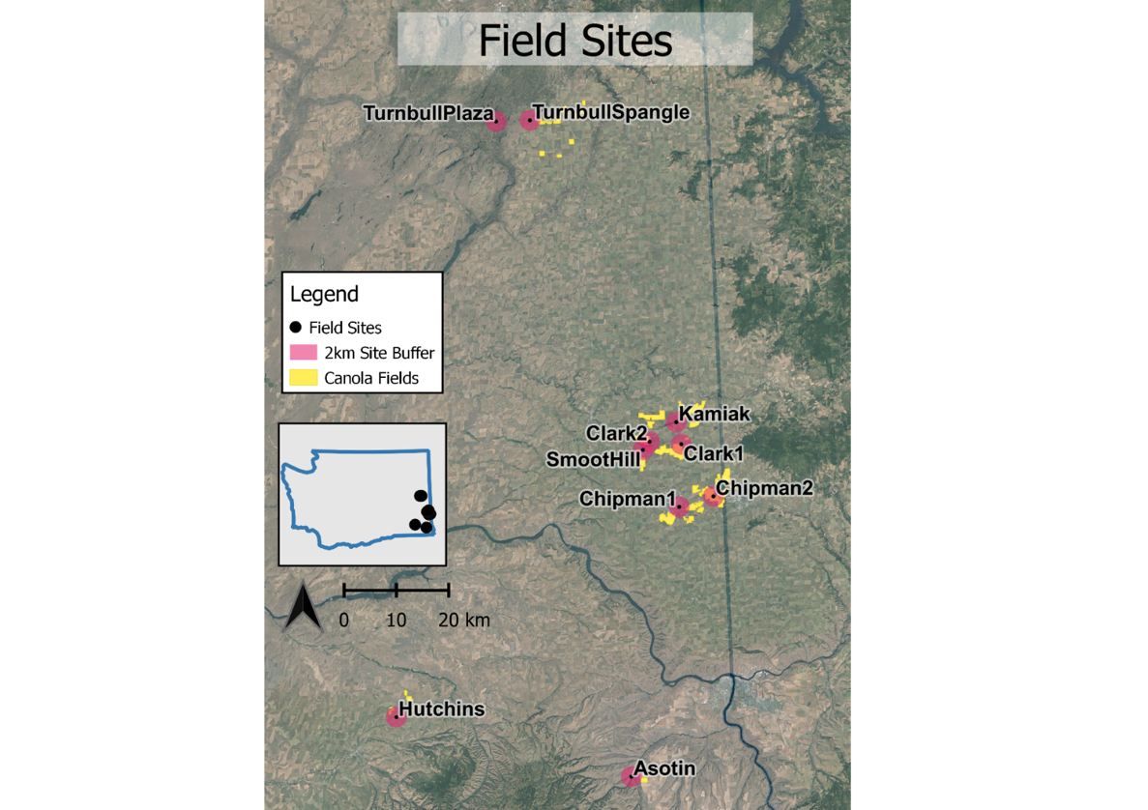
Figure 2
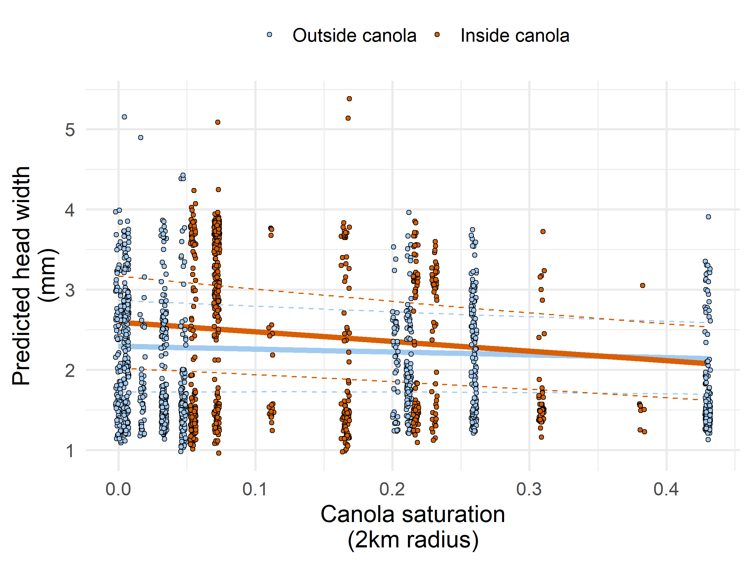
Figure 3
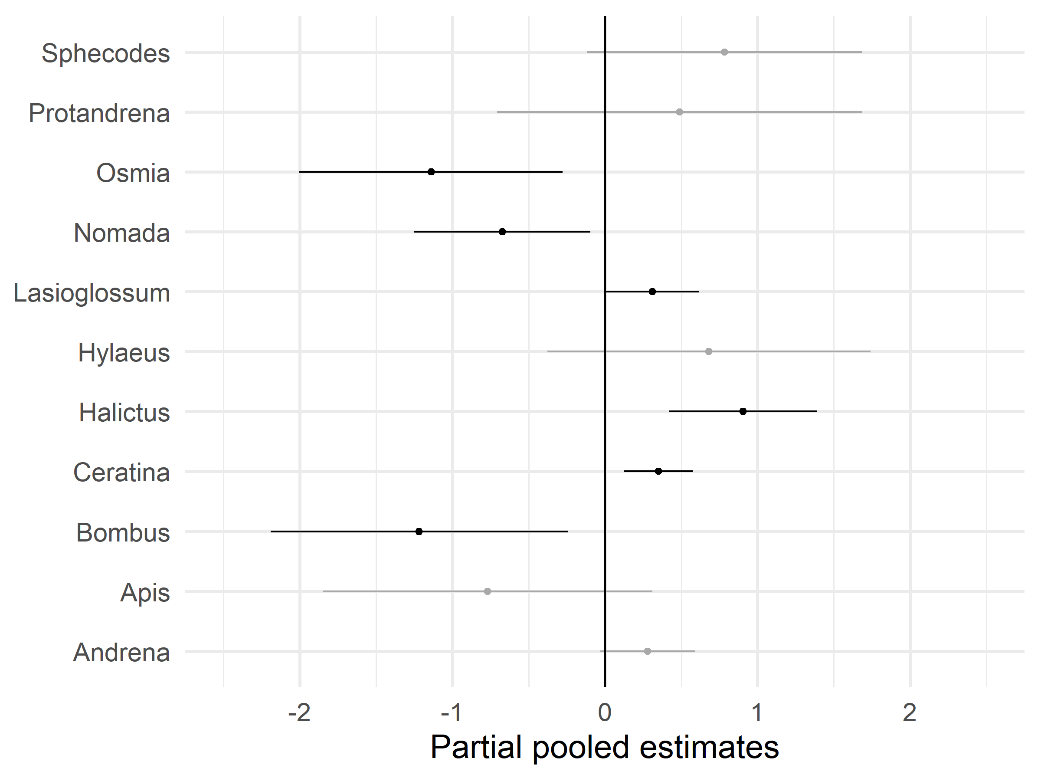
Figure 4
