This IS IRI ionospheric model

<http://omniweb.gsfc.nasa.gov/vitmo/iri2012_vitmo.html>

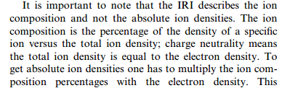

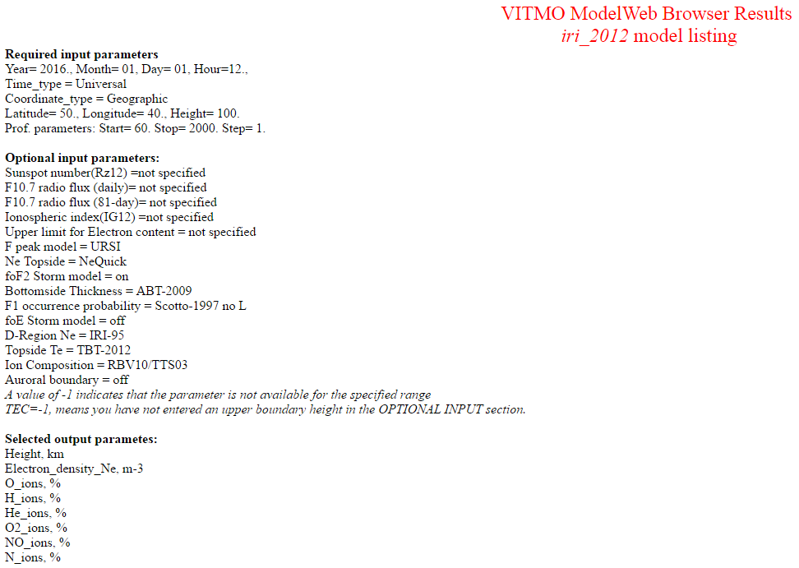

**Selected output parametes:**   
Year  
Month  
Day  
DOY  
Hour  
Height, km  
CGM_Latitude, degree  
CGM_Longitude, degree  
Electron_density_Ne, m-3  
O_ions, %  
H_ions, %  
He_ions, %  
O2_ions, %  
NO_ions, %  
N_ions, %