|  |
| --- |
|  |
| BIFROST SLIT SYSTEM MOTION SAT |
|  |

|  | Name | Role/Title |
| --- | --- | --- |
| Owner | Anders Sandström | Electronics Engineer Motion Control & Automation |
| Reviewer | Thomas Gahl | Group Leader Motion Control & Automation |
| Approver | Liam Whitelegg | Instrument Lead Engineer for BIFROST |

TABLE OF CONTENT PAGE

1. Background 3

1.1. Equipment in scope 3

2. Requirements 3

3. CONTROL SYSTEM 3

4. METHOD 4

4.1. General Inspection 4

4.1.1. Mechanical 4

4.1.2. Electrical 4

4.2. Motion 4

4.2.1. Initial motion test 4

4.2.2. Repeatability 4

4.2.3. Accuracy 4

4.2.4. Switch performance 5

4.2.5. Resolver performance 5

5. CONTROL SYSTEM 5

5.1. Feedback systems 5

5.1.1. Resolver 5

6. MethOD 5

7. references 5

list of tables

Table 1 <<Sample table title>> 2

list of Figures

Figure 1 <<Sample figure text>> 2

# Background

The ESS Instrument BIFROST have acquired 3 slit sets form JJ X-RAY. One extra slit set was delivered to ESS MCAG group.

This document covers SAT of all 4 slit systems performed by ESS MCAG group.

## Equipment in scope

Each JJ X-RAY slit consists of two blades that can be individually positioned in the vertical direction, Figure 1.

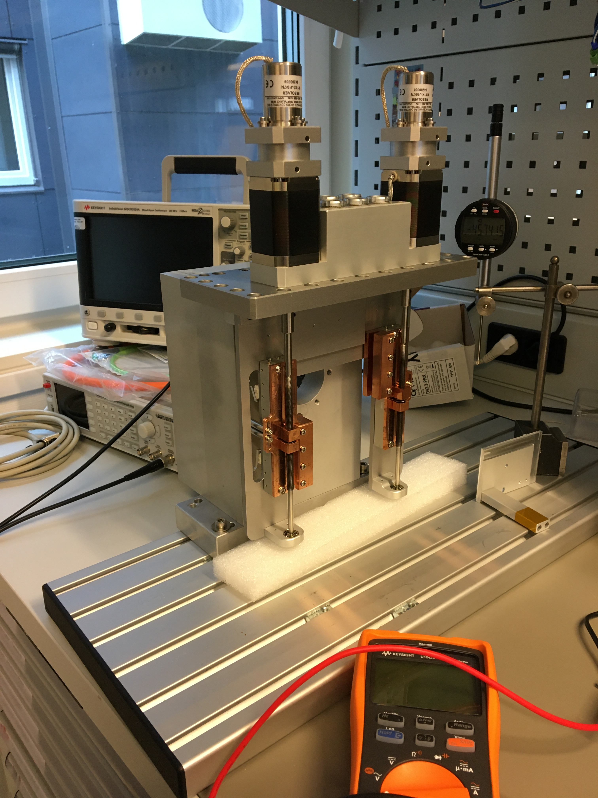

Figure 1: JJ X-RAY: Slit set

Each axis is equipped with the following components:

* Stepper motor: AML-D42.3 [8]
* Resolver: AMCI R11X-J10/N [10]
* Limit switches (fwd and bwd): Saia-Burgess F4T7YC-GP-UL
* Stroke: Approx. 70mm
* Leadscrew (1mm pitch)

# Requirements

The following requirements have been set by the BIFROST team:

1. Stroke: 40mm
2. Accuracy: +-0.1mm
3. Repeatability: +-0.05mm
4. Resolution: 0.01mm minimum

# CONTROL SYSTEM

The SAT was performed with an EtherCAT [1] based control system called ecmc [2]. The configuration files for the SAT have been added to a git repository [3].

All hardware needed for the tests have been integrated into the same system which then leads to that all sampled data have the same timebase.

## Hardware

The following control hardware was used:

1. EL7037: Stepper motor drive [4]
2. EL1808: Digital input for switches [5]
3. EL2808: Digital output to feed switches [6]
4. El7201: Resolver interface [7]
5. ILD2300: Micro Epsilon laser triangulation sensor [8].

## EL7037 Stepper drive

The EL7037 stepper drive was configured in a similar way as was done in the JJ X-RAY FAT procedure, [9]:

1. Control mode: Open loop
2. Run current: 0.61A
3. Standby current: 0.087A
4. Micro stepping: 64fold (resolution 12800steps/rev)
5. Velocity: 0.75mm/s (slower than the 2.5mm/s what JJX-RAY used at FAT)

## EL7201 Resolver interface

The EL7201 resolver interface delivers a single turn resolution of 20bits (1048576 counts/rev).

## Feedback systems

Two different sensors are used as position feedback for the tests.

1. ILD2300 : Micro Epsilon Laser triangulation sensor [9].
2. Resolver : AMCI R11X-J10/N [10]

### Laser triangulation sensor Micro Epsilon ILD2300

The Micro Epsilon ILD2300 sensor was used as external measurement system. The ILD2300 have the following specs:

1. Range: 50mm
2. Linearity: +-10 μm
3. Resolution: 0.8 μm

This sensor can only cover parts of the approximate 70mm stroke.

### Resolver, AMCI R11X-J10/N

The AMCI resolver was delivered with the slits mounted on the second shaft of the motor. The AMCI R11X-J10/N resolver have the following specs:

1. Accuracy: 7arcmin (0.12deg)
2. Input voltage: 7V
3. Input freq: 5000Hz
4. Transformation ratio: 0.95+-5%

The accuracy of 7arcmin corresponds to a linear accuracy of 0.32μm.

# METHOD

Each axis of the 4 slit sets, in total 8 axes, have been tested in the same way.

As a first step, a general inspection of the slit set from a mechanical and electrical perspective was performed. If no issues were found during the general inspection then motion tests was performed.

## General Inspection

Inspection of all axis components from a mechanical and electrical perspective.

### Mechanical

The following checklist was followed:

* Ensure no loose components.
* Ensure no risk of collisions.
* Status of limit switches and cams
* Lemo connectors fixed

### Electrical

Mainly tests of electrical wiring:

1. Measure coil resistance of stepper motor (A and B).
2. Measure coil resistance of resolver (ROTOR, SIN, COS).
3. Measure limit switch connections.

## Motion Tests

The motion tests have been divided into the following parts:

1. Initial motion test
2. Repeatability
3. Accuracy
4. Switch performance
5. Resolver performance

### Initial Motion Test

Motion of the whole stroke was tested with a low velocity. During this test special attention was on the following topics:

1. Noises from the equipment was observed and noted down.
2. Limit switches was tested and adjusted if needed.

As a last step, a homing sequence was performed by setting the stepper open loop counter to zero at low limit disengage flank (0 to 1).

### Repeatability

The repeatability was measured by moving to three different target positions distributed over the stroke,

1. 15mm
2. 35mm
3. 55mm

Each target position was approached 10 times from both positive and negative direction from a 2mm offset. The repeatability for each position is represented by the largest difference between the positions achieved during the test.

### Accuracy

Accuracy was measured by moving to 12 different target position distributed over the stroke starting at 5mm increasing with 5mm up to 60mm. The test was performed in both directions.

The accuracy is represented by the largest difference between target position and the actual value achieved.

### Switch Performance

The switch performance was measured by latching positions at engage/disengage of the switch. The switches were engaged and disengaged 10 times. The switch performance is represented by position range of latched position values

### Resolver Performance

The resolver performance was measured at standstill at 8 different angles of the resolver (45 degree offset). This to quantify the quality of the signal for different angles of the resolver. The resolver performance is defined as the standard deviation of 75 values at each position.

### Data Acquisition

During the motion tests (2-5) the following data was acquired:

1. ILD2300 sensor position
2. R11X-J10/N Resolver position
3. Stepper open loop counter position
4. Switch status

Data was acquired with a sampling rate of 100Hz.

# Results

## Slit set 11358: Axis 1

### General Inspection

### Mechanical

1. High grinding noise during rotation. Sound is intensified during a certain angle of the shaft.

# references

1. EtherCAT organization, <https://www.ethercat.org>
2. ecmc, open source motion control, <https://accelconf.web.cern.ch/icalepcs2017/talks/mocpl05_talk.pdf>
3. Control system configurations and raw data, <https://github.com/anderssandstrom/ecmc_bifrost_slits_sat/>
4. EL7037, <https://www.beckhoff.com/english.asp?ethercat/el7037.htm>
5. EL1808, <https://www.beckhoff.com/english.asp?ethercat/el1808.htm>
6. EL2808, <https://www.beckhoff.com/english.asp?ethercat/el2808.htm>
7. EL7201, <https://www.beckhoff.com/english.asp?ethercat/el7201.htm>
8. AML 42.3 Stepper motor, <https://arunmicro.com/products/D42-3_UHV_Compatible_Stepper_Motor/>
9. Micro-Epsilon laser triangulation sensor, <https://www.micro-epsilon.com/displacement-position-sensors/laser-sensor/optoNCDT_2300_basic/>
10. AMCI r11 Resolver, <https://www.amci.com/plc-automation-products/r11-size-11-brushless-resolver-sensors>
11. Bifrost Divergence Slits DTU Physics Test Plan 18032, Revision 4 of Oct 27th, 2020
12. ecmc motion system test report 11358 Axis 1:
13. 11358

Document Revision history

| Revision | Reason for and description of change | Author | Date |
| --- | --- | --- | --- |
| 1 | First issue | <<Name>> | <<YYYY-MM-DD>> |
|  | <<Keep only full number revisions when approving document>> |  |  |
|  |  |  |  |